Machine Learning with Scikit-learn
Supervised and Unsupervised Learning Algorithms, Explained and Applied

Table of Contents

Introduction
Machine Learning (ML) is the core discipline behind Data Science and AI — it is the set of techniques that let a computer learn patterns from data and make predictions or decisions without being explicitly programmed for every scenario. Scikit-learn is the most widely used Python library for classical machine learning, offering a consistent, simple API across dozens of algorithms for classification, regression, clustering, and dimensionality reduction.
This document covers eight core algorithms split into two families. Supervised learning algorithms — Linear Regression, Logistic Regression, Decision Trees, Random Forest, and Support Vector Machines — learn from labeled data, where the 'correct answer' is already known for each training example. Unsupervised learning algorithms — K-Means Clustering, PCA, and Hierarchical Clustering — work with unlabeled data, finding structure or patterns on their own. Every algorithm is demonstrated on the same employee dataset used throughout this series, with real charts, real metrics, and practice questions.

Supervised vs Unsupervised Learning
Aspect | Supervised Learning | Unsupervised Learning
Data used | Labeled (has a known target/output) | Unlabeled (no known output)
Goal | Predict a target value or category | Discover structure or groupings
Example task | Predict salary, classify performance | Segment employees, reduce dimensions
Algorithms in this doc | Linear/Logistic Regression, Trees, Forest, SVM | K-Means, PCA, Hierarchical Clustering
How success is measured | Accuracy, R², precision/recall, etc. | Silhouette score, explained variance, etc.

The Scikit-learn Workflow
Almost every scikit-learn model follows the same basic pattern, regardless of the algorithm: split the data, create the model, fit it to training data, then predict and evaluate on unseen data.
from sklearn.model_selection import train_test_split

# 1. Split data into training and test sets
X_train, X_test, y_train, y_test = train_test_split(
X, y, test_size=0.2, random_state=42
)

# 2. Create the model
model = SomeAlgorithm()

# 3. Fit the model on training data
model.fit(X_train, y_train)

# 4. Predict on unseen test data
y_pred = model.predict(X_test)

# 5. Evaluate how well it did
# (accuracy, R-squared, confusion matrix, etc. depending on the task)
Splitting the data is essential: a model is only useful if it works on data it hasn't already memorized. random_state fixes the randomness so results are reproducible, and test_size controls what fraction of the data is held back for evaluation (0.2 means 20%).

Installing Scikit-learn
pip install scikit-learn

Sample Dataset
All examples use the same 220-row employee dataset with columns Department, Age, YearsExperience, Salary, and PerformanceScore. For classification examples, a binary label 'HighPerformer' (1 if the employee is a high performer, 0 otherwise) is derived from PerformanceScore and YearsExperience.

PART 1 — SUPERVISED LEARNING
In supervised learning, the model is trained on data where the correct answer (the 'label' or 'target') is already known. The model learns a mapping from input features to that target, so it can predict the target for new, unseen data. When the target is a continuous number (like salary), this is a regression problem. When the target is a category (like High Performer / Not High Performer), this is a classification problem.

1. Linear Regression
Linear Regression predicts a continuous numeric value by fitting a straight line (or a flat plane, in higher dimensions) through the data that minimizes the distance between the line and the actual data points. It's the simplest and most interpretable regression algorithm, and a natural starting point for any regression task.

1.1 Task: Predicting Salary from Years of Experience
from sklearn.linear_model import LinearRegression
from sklearn.model_selection import train_test_split
from sklearn.metrics import mean_squared_error, r2_score
import numpy as np

X = df[["YearsExperience"]]
y = df["Salary"]

X_train, X_test, y_train, y_test = train_test_split(
X, y, test_size=0.2, random_state=42
)

model = LinearRegression()
model.fit(X_train, y_train)
y_pred = model.predict(X_test)

print("Coefficient:", round(model.coef_[0], 2))
print("Intercept:", round(model.intercept_, 2))
print("RMSE:", round(np.sqrt(mean_squared_error(y_test, y_pred)), 2))
print("R-squared:", round(r2_score(y_test, y_pred), 3))
Result: Coefficient: 3069.43 Intercept: 33298.55 RMSE: 5283.92 R-squared: 0.898
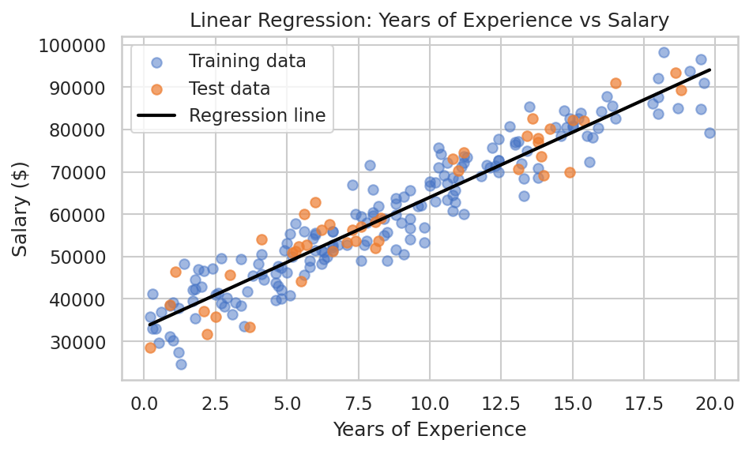
Salary rises steadily with experience; the fitted line captures the overall trend.

1.2 Interpreting the Results
The coefficient (3069.43) means that, on average, each additional year of experience is associated with about $3,069 more in salary. The R-squared value of 0.898 means the model explains roughly 90% of the variation in salary using experience alone — a strong fit for a single-feature model. RMSE (Root Mean Squared Error) expresses the typical prediction error in the same units as the target, so predictions are typically off by around $5,284.
Practice Questions — Linear Regression
- Add PerformanceScore as a second feature to the regression and see whether R-squared improves.
- Split the data with a different test_size (e.g. 0.3) and observe how the metrics change.
- Use the trained model to predict the salary of a hypothetical employee with 12 years of experience.
- Plot the residuals (actual minus predicted salary) to check whether errors are randomly scattered or show a pattern.
- Train a separate linear regression using only employees from the IT department and compare its coefficient to the full-dataset model.

2. Logistic Regression
Despite the name, Logistic Regression is a classification algorithm, not a regression one. It predicts the probability that an observation belongs to a particular class, using a sigmoid function to map any input to a value between 0 and 1, then applies a threshold (usually 0.5) to make the final class prediction.

2.1 Task: Predicting HighPerformer
from sklearn.linear_model import LogisticRegression
from sklearn.preprocessing import StandardScaler
from sklearn.metrics import accuracy_score, confusion_matrix, classification_report

features = ["PerformanceScore", "YearsExperience", "Age", "Salary"]
X = df[features]
y = df["HighPerformer"]

X_train, X_test, y_train, y_test = train_test_split(
X, y, test_size=0.25, random_state=42, stratify=y
)

# Logistic Regression is sensitive to feature scale, so we standardize first
scaler = StandardScaler()
X_train_s = scaler.fit_transform(X_train)
X_test_s = scaler.transform(X_test)

model = LogisticRegression()
model.fit(X_train_s, y_train)
y_pred = model.predict(X_test_s)

print("Accuracy:", round(accuracy_score(y_test, y_pred), 3))
print(classification_report(y_test, y_pred))
Result: Accuracy: 0.855 — the model correctly classified about 86% of test employees as High Performer or not.
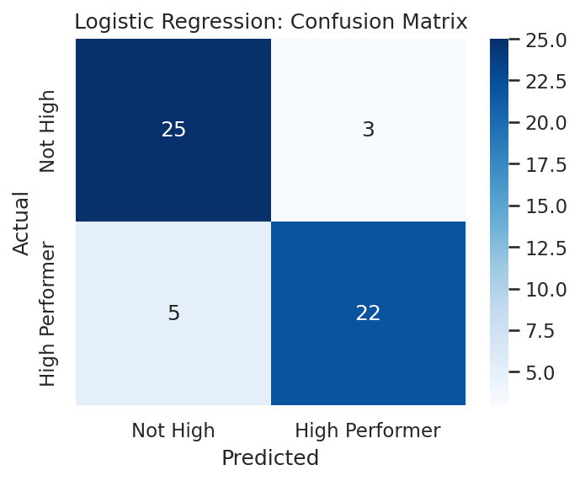
Confusion matrix: rows are actual class, columns are predicted class.

2.2 Reading the Confusion Matrix
A confusion matrix breaks predictions down by actual vs predicted class. The diagonal cells (top-left and bottom-right) are correct predictions; the off-diagonal cells are mistakes. Precision measures how many of the predicted 'High Performer' cases were actually correct, while recall measures how many of the actual High Performers the model successfully found — both are reported in the classification_report output alongside accuracy.
Practice Questions — Logistic Regression
- Change the classification threshold from 0.5 to 0.6 using predict_proba() and see how precision and recall shift.
- Remove the StandardScaler step and compare accuracy — explain why scaling matters for this algorithm.
- Train a logistic regression using only two features (PerformanceScore and YearsExperience) and compare accuracy to the full model.
- Plot the ROC curve for this model using sklearn.metrics.RocCurveDisplay and read off the AUC score.
- Use model.coef_ to identify which feature has the strongest influence on the prediction.

3. Decision Trees
A Decision Tree splits the data repeatedly based on feature values, forming a tree of yes/no questions that leads to a final prediction. Trees are easy to visualize and interpret — you can literally read off the exact rules the model used to reach a decision — but a single deep tree can overfit training data easily.

3.1 Task: Classifying HighPerformer
from sklearn.tree import DecisionTreeClassifier, plot_tree
import matplotlib.pyplot as plt

model = DecisionTreeClassifier(max_depth=3, random_state=42)
model.fit(X_train, y_train)
y_pred = model.predict(X_test)

print("Accuracy:", round(accuracy_score(y_test, y_pred), 3))

plt.figure(figsize=(11, 6))
plot_tree(model, feature_names=features, class_names=["Not High", "High Performer"],
filled=True, rounded=True)
plt.show()
Result: Accuracy: 0.800
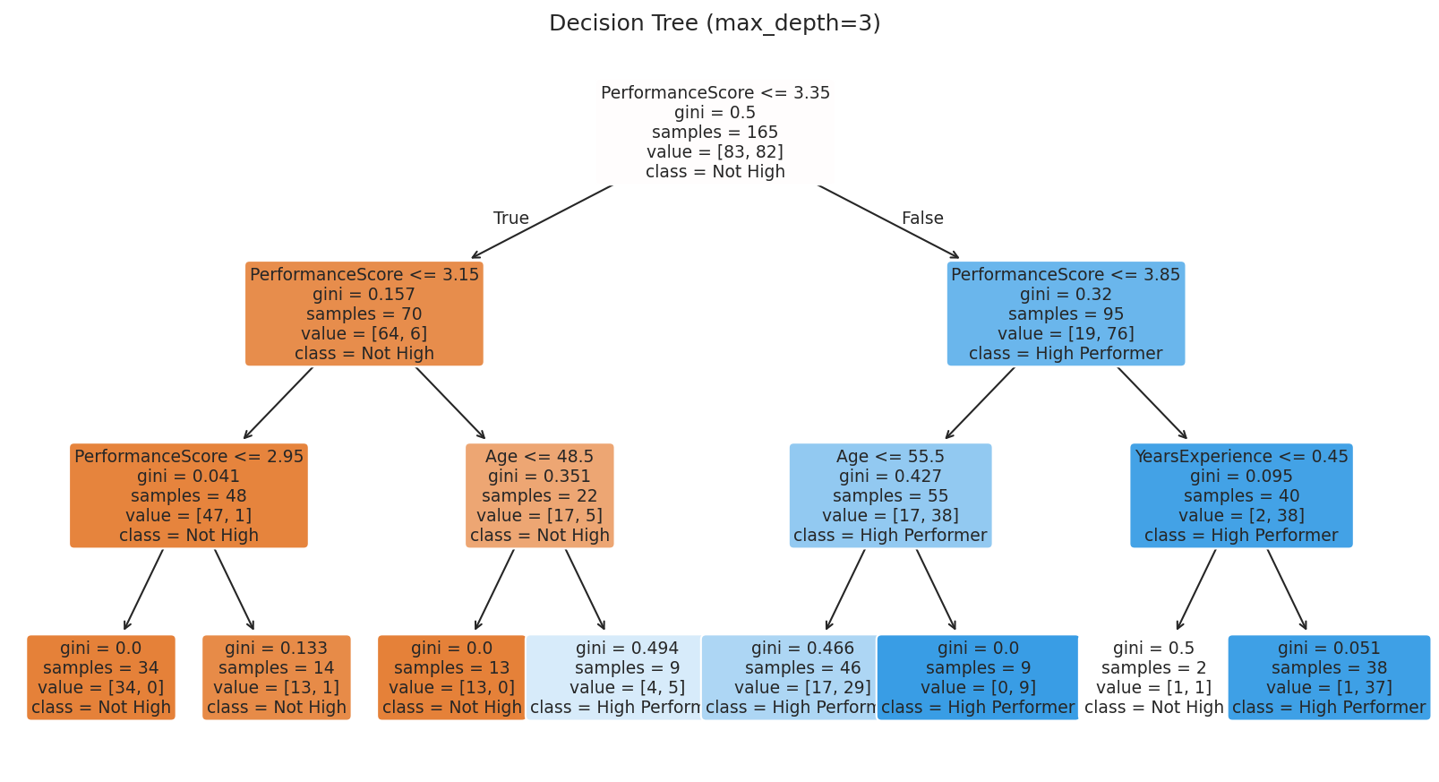
The tree splits first on PerformanceScore, then refines with Age and YearsExperience. 'gini' measures how mixed each node is (0 = perfectly pure).

3.2 Why Limit max_depth?
An unrestricted decision tree will keep splitting until every leaf is perfectly pure, which usually means it has memorized the training data rather than learned a generalizable pattern — a problem called overfitting. Limiting max_depth (here, to 3) forces the tree to keep only its most useful, general splits, which usually improves performance on new, unseen data even though training accuracy may go down slightly.
Practice Questions — Decision Trees
- Train decision trees with max_depth values of 2, 4, and None (unlimited) and compare their test accuracy.
- Use model.feature_importances_ to see which feature the tree relied on most.
- Change the splitting criterion from 'gini' to 'entropy' and check whether the resulting tree structure changes.
- Print the tree as text using sklearn.tree.export_text() instead of a visual plot.
- Prune the tree using the min_samples_leaf parameter and observe how the tree's shape simplifies.

4. Random Forest
A Random Forest is an ensemble of many decision trees, each trained on a random subset of the data and a random subset of features. Each tree 'votes' on the final prediction, and the majority vote wins. Averaging across many imperfect trees usually produces a model that is more accurate and far less prone to overfitting than any single tree.

4.1 Task: Classifying HighPerformer
from sklearn.ensemble import RandomForestClassifier

model = RandomForestClassifier(n_estimators=200, max_depth=5, random_state=42)
model.fit(X_train, y_train)
y_pred = model.predict(X_test)

print("Accuracy:", round(accuracy_score(y_test, y_pred), 3))

importances = pd.Series(model.feature_importances_, index=features)
print(importances.sort_values(ascending=False))
Result: Accuracy: 0.800
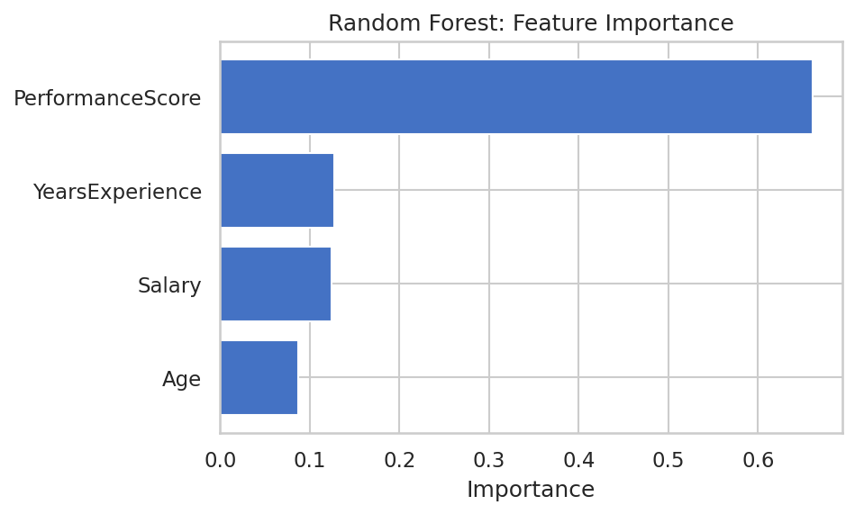
Feature importance shows how much each feature contributed to the forest's decisions overall.

4.2 Decision Tree vs Random Forest
Aspect | Single Decision Tree | Random Forest
Structure | One tree | Many trees (e.g. 200), combined by voting
Overfitting risk | High if unrestricted | Much lower — averaging smooths errors
Interpretability | Very easy to visualize | Harder — feature importance instead of a single tree diagram
Typical accuracy | Good baseline | Usually better on complex data
Key parameter | max_depth | n_estimators (number of trees) and max_depth

Practice Questions — Random Forest
- Train random forests with n_estimators set to 10, 100, and 500, and compare accuracy and training time.
- Compare the feature importances from the Random Forest to the single Decision Tree's importances — are they consistent?
- Use RandomForestClassifier's oob_score_ (out-of-bag score) as an alternative way to estimate accuracy without a separate test set.
- Try max_features='sqrt' vs max_features=None and observe the effect on accuracy.
- Use the trained forest to predict HighPerformer for 3 new, hypothetical employees you define yourself.

5. Support Vector Machine (SVM)
A Support Vector Machine finds the boundary that best separates classes by maximizing the margin — the distance between the boundary and the nearest points of each class ('support vectors'). With a kernel (like RBF), SVMs can also draw curved, flexible boundaries, making them effective even when classes aren't linearly separable.

5.1 Task: Classifying HighPerformer (2 Features, for Visualization)
from sklearn.svm import SVC

X2 = df[["PerformanceScore", "YearsExperience"]].values
y2 = df["HighPerformer"].values

X2_train, X2_test, y2_train, y2_test = train_test_split(
X2, y2, test_size=0.25, random_state=42, stratify=y2
)

scaler = StandardScaler()
X2_train_s = scaler.fit_transform(X2_train)
X2_test_s = scaler.transform(X2_test)

model = SVC(kernel="rbf", C=1.0, gamma="scale")
model.fit(X2_train_s, y2_train)
y2_pred = model.predict(X2_test_s)

print("Accuracy:", round(accuracy_score(y2_test, y2_pred), 3))
Result: Accuracy: 0.800
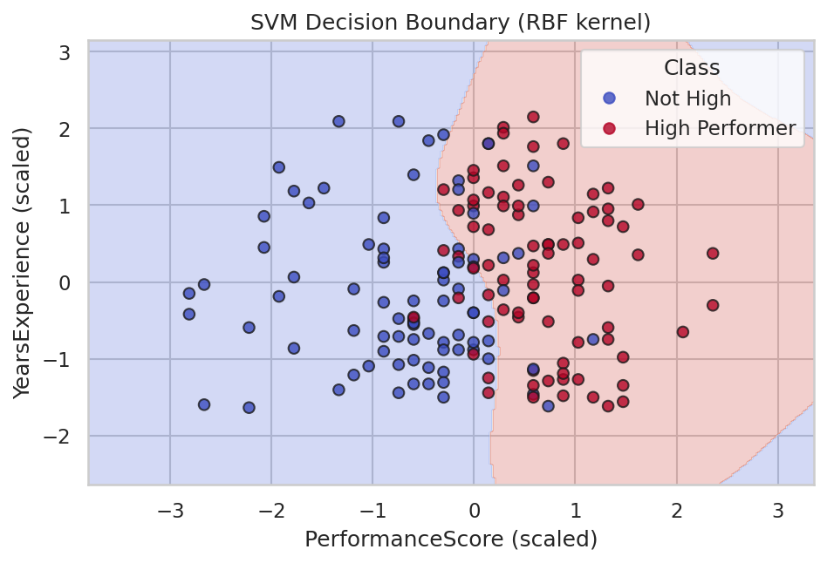
The shaded regions show what the SVM would predict for any point in this space; the curved boundary comes from the RBF kernel.

5.2 Choosing a Kernel
Kernel | Boundary Shape | When to Use
linear | Straight line/plane | Classes are roughly linearly separable
rbf (default) | Flexible, curved | Complex, non-linear relationships (most common choice)
poly | Polynomial curve | Known polynomial-like relationship between features
sigmoid | S-shaped | Rarely used; behaves similarly to a small neural network

The C parameter controls the trade-off between a wider margin and fewer misclassified training points — a smaller C allows more margin violations (simpler boundary), while a larger C fits the training data more tightly (risking overfitting).
Practice Questions — Support Vector Machine
- Retrain the SVM with kernel='linear' and compare the shape of the decision boundary to the RBF version.
- Try C values of 0.1, 1, and 10 and observe how the decision boundary's shape changes.
- Add a third feature (Salary) to the SVM and evaluate the new accuracy, even though it can no longer be visualized in 2D.
- Use GridSearchCV to search for the best combination of C and gamma automatically.
- Compare the SVM's accuracy to the Logistic Regression model's accuracy on the same two features.

PART 2 — UNSUPERVISED LEARNING
Unsupervised learning algorithms work with data that has no labeled target. Instead of predicting a known answer, they discover hidden structure — grouping similar observations together (clustering) or simplifying data down to its most important underlying patterns (dimensionality reduction).

6. K-Means Clustering
K-Means groups data into a chosen number of clusters (k) by repeatedly assigning each point to its nearest cluster center, then recalculating each center as the average of its assigned points, until the centers stop moving. It's fast, simple, and one of the most widely used clustering algorithms.

6.1 Choosing k with the Elbow Method
Since K-Means requires choosing k in advance, the 'elbow method' plots inertia (how tightly clustered the points are) against different values of k, and looks for the point where adding more clusters stops helping much.
from sklearn.cluster import KMeans
from sklearn.preprocessing import StandardScaler

features = ["Salary", "YearsExperience", "PerformanceScore"]
X = StandardScaler().fit_transform(df[features])

inertias = []
for k in range(1, 9):
km = KMeans(n_clusters=k, random_state=42, n_init=10)
km.fit(X)
inertias.append(km.inertia_)
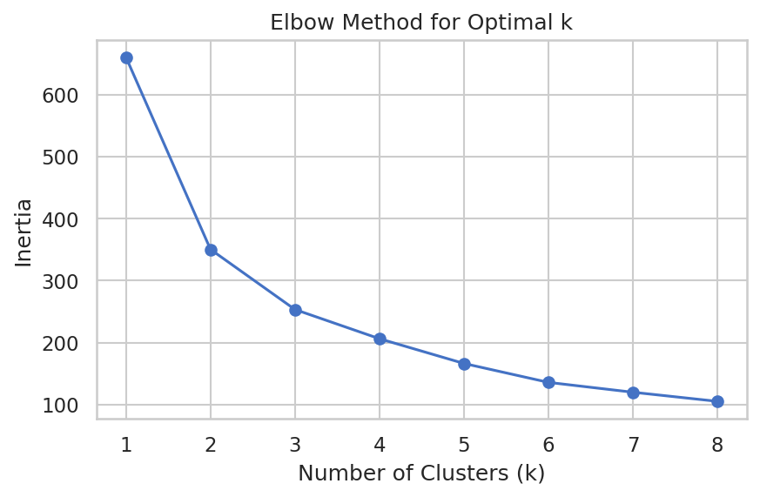
Inertia drops sharply until around k=3, then flattens out — the 'elbow'.

6.2 Fitting the Final Model
from sklearn.metrics import silhouette_score

kmeans = KMeans(n_clusters=3, random_state=42, n_init=10)
df["Cluster"] = kmeans.fit_predict(X)

print("Silhouette score:", round(silhouette_score(X, df["Cluster"]), 3))
print(df["Cluster"].value_counts())
Result: Silhouette score: 0.357 | Cluster sizes — Cluster 0: 65, Cluster 1: 72, Cluster 2: 83
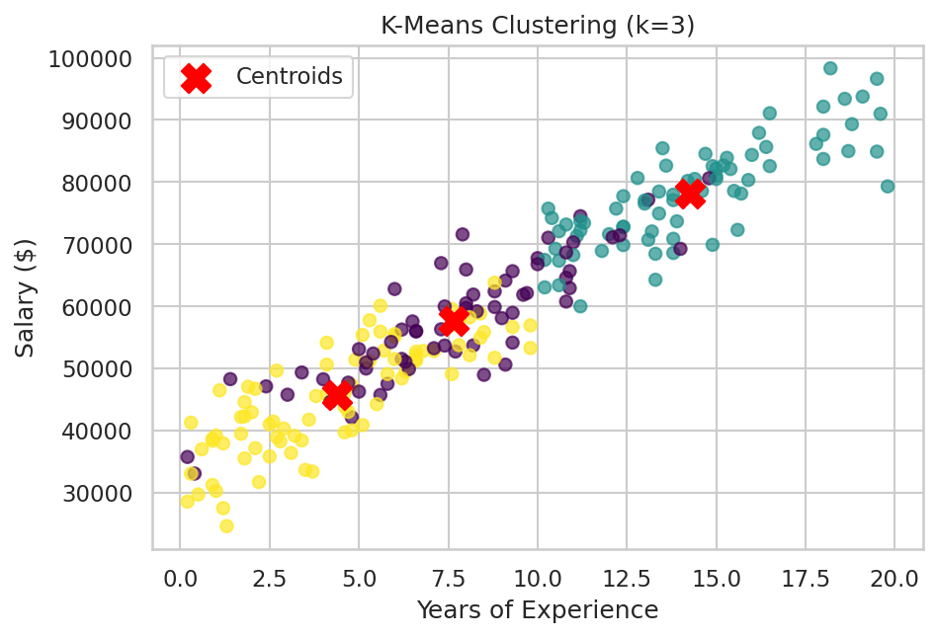
Three employee segments based on salary, experience, and performance, with centroids marked in red.

6.3 Interpreting the Silhouette Score
The silhouette score measures how well-separated the clusters are, ranging from -1 to 1. A score around 0.357 indicates reasonably distinct clusters, though with some overlap — typical for real-world data where groups aren't perfectly separated.
Practice Questions — K-Means Clustering
- Re-run K-Means with k=4 and k=5, and compare the silhouette scores to the k=3 result.
- Try clustering using only Salary and PerformanceScore (drop YearsExperience) and see how the clusters change.
- For each cluster, calculate the average Salary, YearsExperience, and PerformanceScore, and write a one-sentence profile of each group.
- Run K-Means without standardizing the features first, and observe how the clusters differ — explain why scaling matters here.
- Use the fitted kmeans.predict() method to assign a brand-new, hypothetical employee to one of the 3 clusters.

7. Principal Component Analysis (PCA)
PCA reduces a dataset with many correlated numeric features down to a smaller number of new, uncorrelated features called principal components, each capturing as much of the original variance as possible. It's commonly used to visualize high-dimensional data in 2D or 3D, and to speed up other algorithms by reducing feature count.

7.1 Reducing 4 Features to 2 Principal Components
from sklearn.decomposition import PCA
from sklearn.preprocessing import StandardScaler

features = ["Age", "Salary", "PerformanceScore", "YearsExperience"]
X = StandardScaler().fit_transform(df[features])

pca = PCA(n_components=2)
components = pca.fit_transform(X)

df["PC1"] = components[:, 0]
df["PC2"] = components[:, 1]

print("Explained variance ratio:", pca.explained_variance_ratio_)
print("Total variance explained:", pca.explained_variance_ratio_.sum())
Result: Explained variance ratio: [0.684, 0.250] | Total variance explained: 0.934 (93.4%)
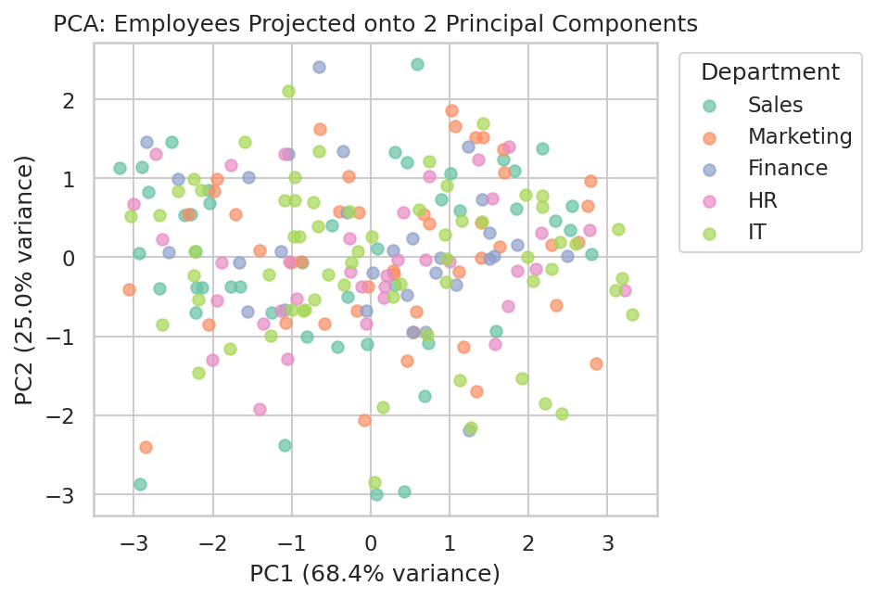
Employees projected onto their two principal components, colored by department.

7.2 How Many Components Are Enough? (Scree Plot)
A scree plot shows how much variance each additional component explains, helping decide how many components are worth keeping.
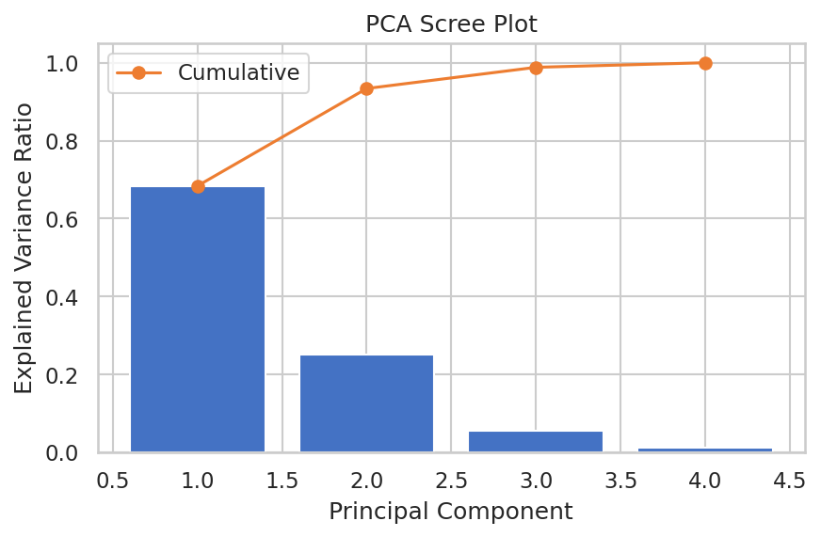
The first two components together explain over 93% of the total variance in the original four features.

7.3 What Do the Components Mean?
Principal components are new axes — linear combinations of the original features — chosen to capture the most variance possible. PC1 alone explains 68.4% of the variance, meaning most of the meaningful spread in the data (largely driven by Salary and YearsExperience, which are strongly correlated) can be summarized in a single number.
Practice Questions — PCA
- Run PCA with n_components=4 (all original features) and confirm that the explained variance ratios sum to 1.0.
- Use pca.components_ to see how much each original feature contributes to PC1 and PC2.
- Combine PCA with K-Means: reduce the data to 2 components first, then cluster on the reduced data, and compare results to clustering on the original features.
- Try PCA without standardizing the features first, and explain why the results become misleading.
- Use the 2 principal components as input features to a Logistic Regression model predicting HighPerformer, and compare its accuracy to using the original features.

8. Hierarchical Clustering
Hierarchical Clustering builds a tree of nested clusters rather than requiring the number of clusters to be chosen upfront. Agglomerative (bottom-up) clustering starts with every point as its own cluster and repeatedly merges the two closest clusters until only one remains. The result can be visualized as a dendrogram, which shows exactly how and when each merge happened.

8.1 Building a Dendrogram
from scipy.cluster.hierarchy import dendrogram, linkage
import matplotlib.pyplot as plt

sample = df.sample(30, random_state=42)
X = StandardScaler().fit_transform(sample[["Salary", "YearsExperience", "PerformanceScore"]])

Z = linkage(X, method="ward")

plt.figure(figsize=(9, 5))
dendrogram(Z, labels=sample["EmployeeID"].values, leaf_rotation=90)
plt.title("Hierarchical Clustering Dendrogram")
plt.xlabel("Employee ID")
plt.ylabel("Distance")
plt.show()
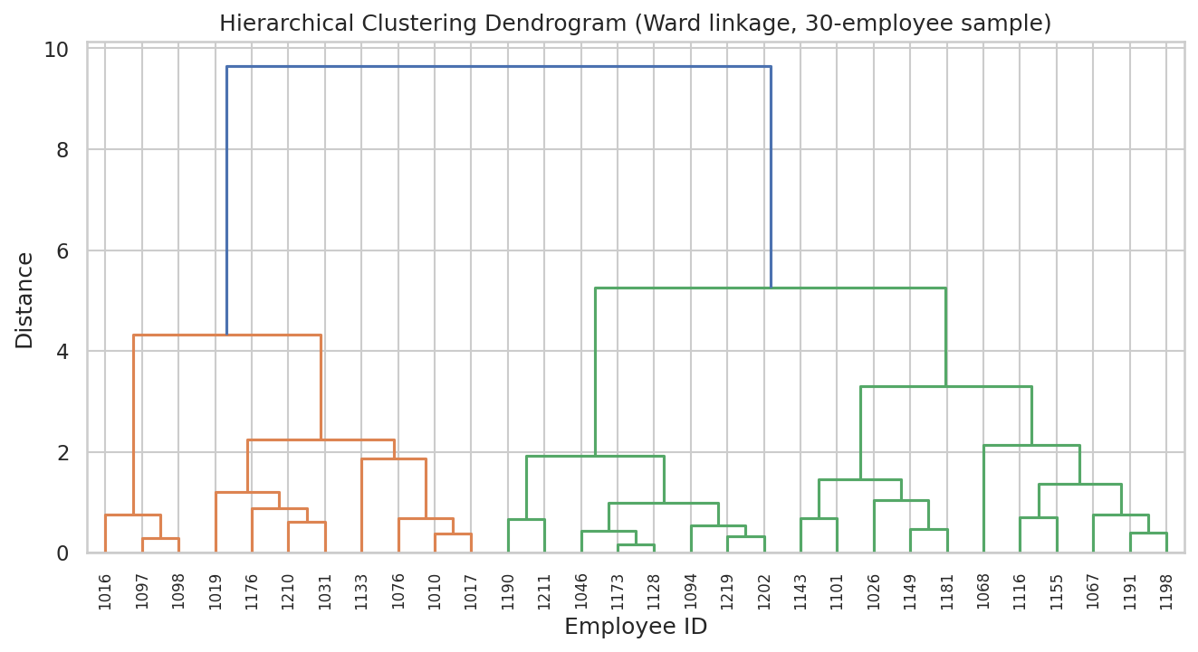
Each merge joins the two most similar clusters; cutting the tree at a chosen height determines the final number of clusters.

8.2 Cutting the Tree into Clusters
Once the dendrogram is built, a horizontal cut at any height produces a specific number of clusters — cutting lower gives more, smaller clusters; cutting higher gives fewer, larger ones. AgglomerativeClustering performs this directly by specifying n_clusters.
from sklearn.cluster import AgglomerativeClustering

model = AgglomerativeClustering(n_clusters=3, linkage="ward")
sample["Cluster"] = model.fit_predict(X)

print(sample["Cluster"].value_counts())
Result: Cluster sizes — Cluster 0: 11, Cluster 1: 11, Cluster 2: 8 (out of the 30-employee sample)
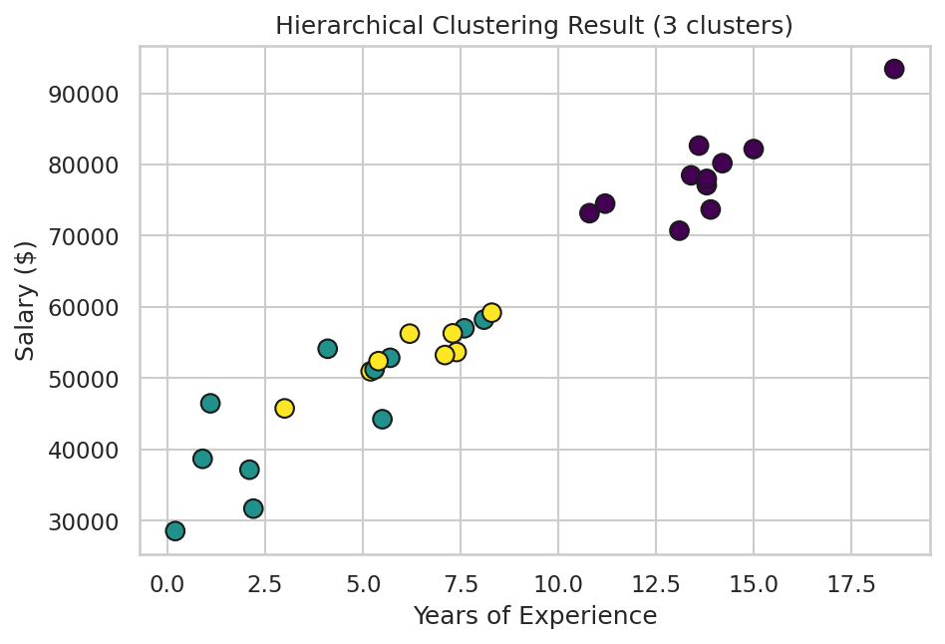
The same 30 employees, now colored by their assigned hierarchical cluster.

8.3 K-Means vs Hierarchical Clustering
Aspect | K-Means | Hierarchical Clustering
Number of clusters | Must be chosen in advance (k) | Can be decided after seeing the dendrogram
Scalability | Fast, scales well to large datasets | Slower, better suited to smaller datasets
Output | Flat set of clusters | Nested tree of clusters at every level
Determinism | Depends on random initialization | Fully deterministic given the linkage method

Practice Questions — Hierarchical Clustering
- Rebuild the dendrogram using linkage method 'average' instead of 'ward' and compare the resulting tree shape.
- Cut the dendrogram at a different height to produce 4 clusters instead of 3, and compare cluster sizes.
- Run hierarchical clustering on the full 220-employee dataset instead of the 30-employee sample, and discuss how readable the dendrogram remains.
- Compare the cluster assignments from Hierarchical Clustering to those from K-Means on the same sample — do they largely agree?
- Use scipy's fcluster function to extract flat cluster labels directly from the linkage matrix Z at a chosen distance threshold.

