Data Visualization with Matplotlib and Seaborn
Communicating Insights Through Charts and Dashboards

Table of Contents

Introduction
A chart can communicate a pattern in data far faster than a table of numbers ever could. Matplotlib and Seaborn are the two most widely used Python libraries for turning raw data into charts and dashboards. Matplotlib is the foundational plotting library — flexible and highly customizable, but sometimes verbose. Seaborn is built on top of Matplotlib and is designed specifically for statistical visualization, offering attractive default styles and powerful support for visualizing relationships across multiple variables at once. This document covers both libraries through practical, hands-on examples: line charts, bar charts, histograms, scatter plots, box plots, heatmaps, pair plots, count plots, and combining several charts into a single dashboard.

Matplotlib vs Seaborn
Aspect | Matplotlib | Seaborn
Best for | Full control over every chart element | Quick, attractive statistical charts
Default styling | Basic, needs manual polishing | Polished out of the box
Works with Pandas | Yes (some manual work) | Yes, built around DataFrames
Multi-variable plots | Manual subplot layout | Built-in (pairplot, heatmap, etc.)
Relationship to Matplotlib | The foundation | Built on top of Matplotlib

In practice, the two are almost always used together: Seaborn for fast, good-looking statistical charts, and Matplotlib underneath for fine-tuning titles, labels, and layout.

Installing the Libraries
pip install matplotlib seaborn
import matplotlib.pyplot as plt
import seaborn as sns
import pandas as pd

sns.set_theme(style="whitegrid") # applies Seaborn's clean default style globally

Sample Dataset
Every chart in this document is built from the same employee dataset, so you can see how different chart types reveal different things about the same data. It contains Department, Age, Salary, PerformanceScore, and YearsExperience for 150 employees, plus a separate table of monthly sales figures for 2024 and 2025.

1. Line Charts (Matplotlib)
Line charts are the standard choice for showing how a value changes over a continuous sequence, most often time. They make trends, seasonality, and comparisons between two time series easy to spot at a glance.
import matplotlib.pyplot as plt

fig, ax = plt.subplots(figsize=(6.5, 4))
ax.plot(monthly_sales["Month"], monthly_sales["Sales_2024"], marker="o", label="2024")
ax.plot(monthly_sales["Month"], monthly_sales["Sales_2025"], marker="o", label="2025")

ax.set_title("Monthly Sales Trend (in $000s)")
ax.set_xlabel("Month")
ax.set_ylabel("Sales ($000s)")
ax.legend()

plt.show()
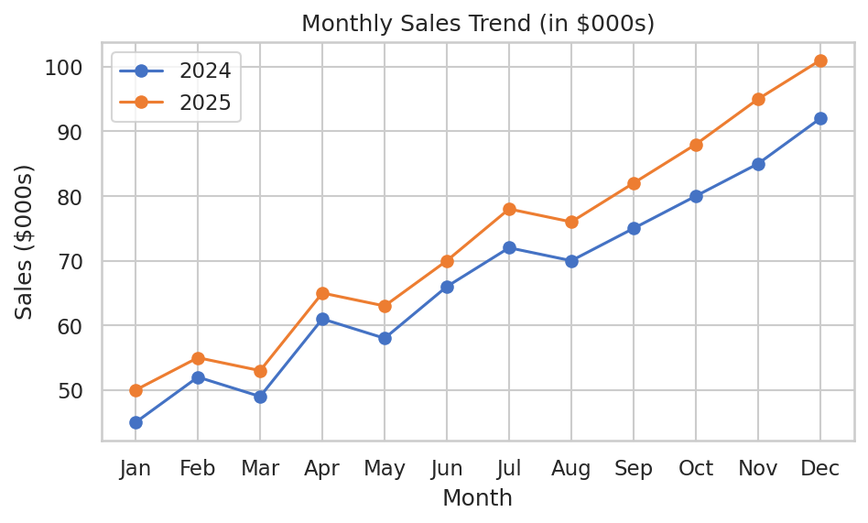
Monthly sales for 2024 vs 2025, showing a clear upward trend for both years.
Practice Questions — Line Charts
- Plot a line chart of your own choosing showing daily temperature over a 2-week period.
- Add a third line to the sales chart above representing a 2026 forecast, and give each line a different color.
- Plot cumulative sales over the year (running total) as a single line chart using cumsum().
- Recreate the line chart with dashed lines instead of solid lines, using the linestyle parameter.
- Add horizontal gridlines and a shaded background region marking the 'Q4' months on the sales chart.

2. Bar Charts (Matplotlib)
Bar charts compare a numeric value across categories. They work best when the categories are unordered or only loosely ordered, such as departments, products, or regions.
avg_salary = df.groupby("Department")["Salary"].mean().sort_values(ascending=False)

fig, ax = plt.subplots(figsize=(6.5, 4))
ax.bar(avg_salary.index, avg_salary.values, color="#4472C4")

ax.set_title("Average Salary by Department")
ax.set_xlabel("Department")
ax.set_ylabel("Average Salary ($)")

plt.show()
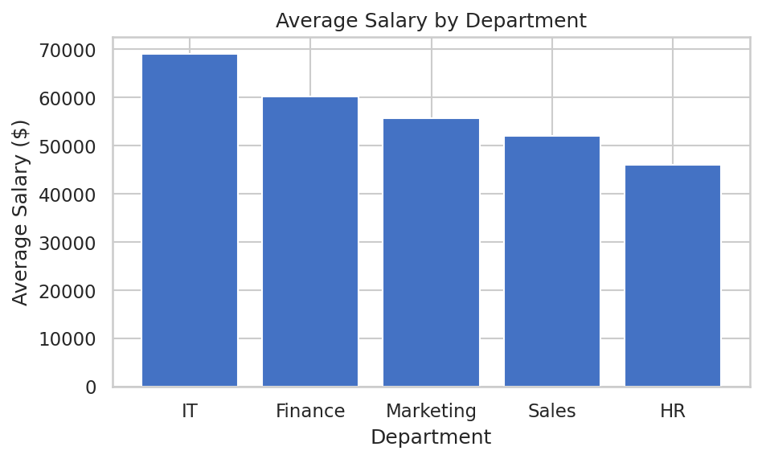
Average salary by department, sorted from highest to lowest.
Practice Questions — Bar Charts
- Create a horizontal bar chart (ax.barh) showing headcount per department instead of average salary.
- Create a grouped bar chart comparing average salary and average performance score side by side for each department (hint: you'll need two sets of bars).
- Color each bar differently based on whether the department's average salary is above or below the company-wide average.
- Add data labels above each bar showing the exact average salary value.
- Create a bar chart of the top 5 highest-paid individual employees by name.

3. Histograms (Matplotlib)
A histogram shows the distribution of a single numeric variable by grouping values into bins and counting how many observations fall into each bin. It answers questions like 'what does the spread of salaries look like?' rather than comparing named categories.
fig, ax = plt.subplots(figsize=(6.5, 4))
ax.hist(df["Salary"], bins=20, color="#4472C4", edgecolor="white")

ax.set_title("Distribution of Employee Salaries")
ax.set_xlabel("Salary ($)")
ax.set_ylabel("Number of Employees")

plt.show()
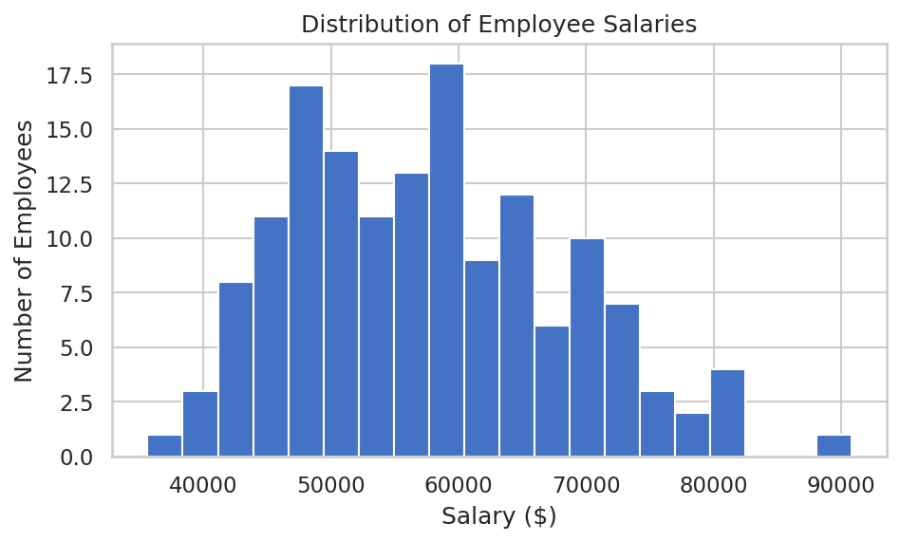
Salary distribution across all 150 employees, binned into 20 groups.
Practice Questions — Histograms
- Plot a histogram of employee ages using 15 bins instead of 20, and compare how the shape changes.
- Overlay two histograms — Salary for the IT department and Salary for the HR department — on the same axes with transparency (alpha) so both are visible.
- Plot a histogram of PerformanceScore and describe in a comment whether the distribution looks skewed or symmetric.
- Add a vertical line (ax.axvline) marking the mean salary on top of the salary histogram.
- Convert the histogram's y-axis from raw counts to density/percentage using the density=True parameter.

4. Scatter Plots (Matplotlib)
A scatter plot shows the relationship between two numeric variables, with each point representing one observation. It's the go-to chart for spotting correlation, clusters, or outliers between two continuous measures.
fig, ax = plt.subplots(figsize=(6.5, 4))
ax.scatter(df["YearsExperience"], df["Salary"], color="#4472C4", alpha=0.6)

ax.set_title("Years of Experience vs Salary")
ax.set_xlabel("Years of Experience")
ax.set_ylabel("Salary ($)")

plt.show()
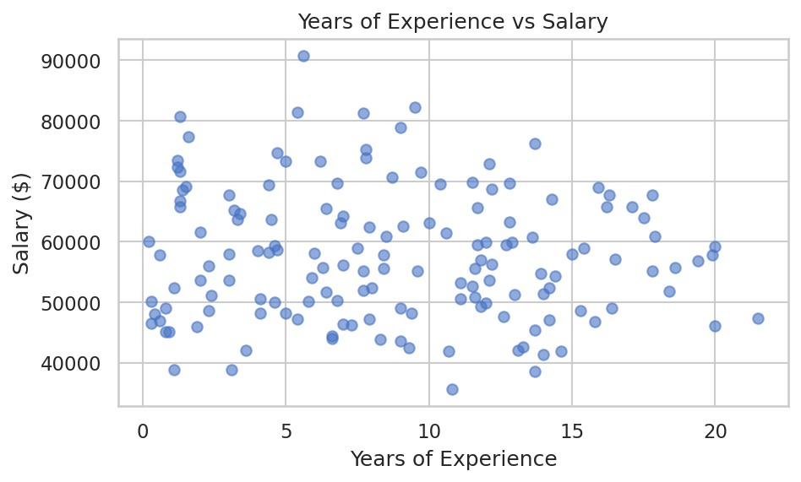
Each point is one employee, plotting years of experience against salary.
Practice Questions — Scatter Plots
- Create a scatter plot of Age vs PerformanceScore and visually assess whether there appears to be any relationship.
- Color the points in the Experience vs Salary scatter plot by Department using the c parameter with a numeric mapping.
- Resize each point in a scatter plot based on PerformanceScore, so higher performers appear as larger dots.
- Add a trend line to the Experience vs Salary scatter plot using numpy's polyfit function.
- Create a scatter plot comparing Salary vs PerformanceScore, and mark any employee earning over $80,000 with a different color.

5. Box Plots (Seaborn)
A box plot summarizes a numeric variable's distribution using five key statistics: minimum, first quartile, median, third quartile, and maximum, while also flagging outliers. It's especially useful for comparing spread across several categories at once.
import seaborn as sns

fig, ax = plt.subplots(figsize=(6.5, 4))
sns.boxplot(data=df, x="Department", y="Salary", ax=ax)

ax.set_title("Salary Distribution by Department")
plt.show()
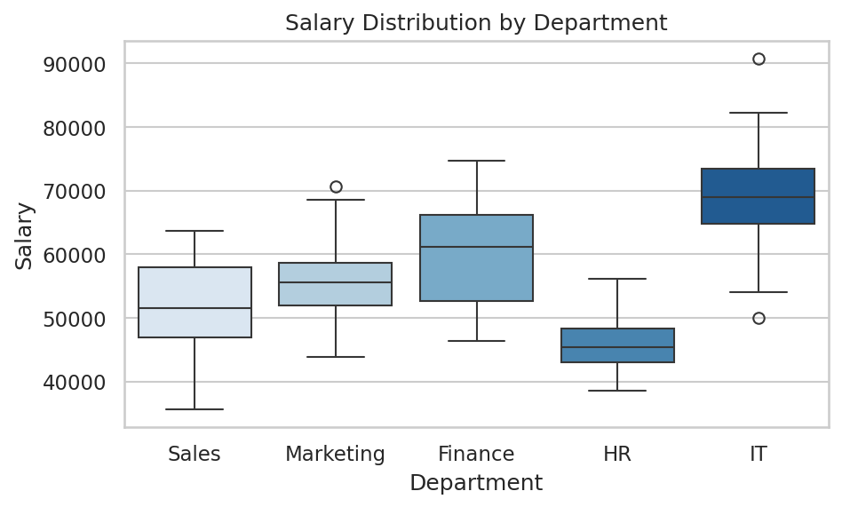
Salary spread per department — the box shows the middle 50% of values, with the line marking the median.
Practice Questions — Box Plots
- Create a box plot comparing PerformanceScore across departments.
- Add a hue parameter to the box plot to further split each department's salary box by a second category, such as an above/below average performance flag.
- Identify from the box plot which department has the widest salary spread, and confirm it by calculating the standard deviation directly.
- Create a violin plot (sns.violinplot) of the same data and compare what extra detail it reveals versus the box plot.
- Use the box plot to identify which departments, if any, have salary outliers.

6. Heatmaps (Seaborn)
A heatmap uses color intensity to represent values in a matrix, making it easy to spot patterns across two dimensions at once. The most common use is visualizing a correlation matrix, where each cell shows how strongly two numeric variables move together.
corr = df[["Age", "Salary", "PerformanceScore", "YearsExperience"]].corr()

fig, ax = plt.subplots(figsize=(5.5, 4.5))
sns.heatmap(corr, annot=True, cmap="Blues", fmt=".2f", ax=ax)

ax.set_title("Correlation Heatmap")
plt.show()
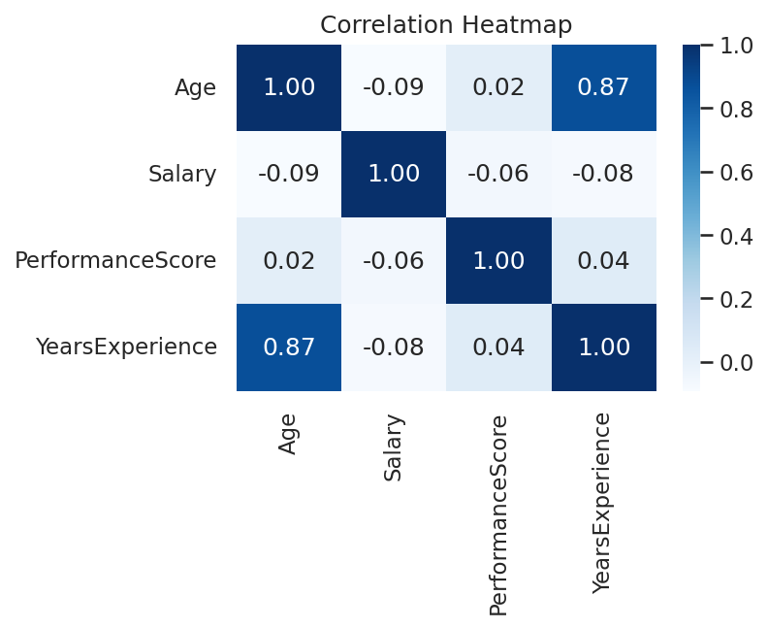
Correlation between Age, Salary, PerformanceScore, and YearsExperience. Values closer to 1 indicate a stronger positive relationship.
Practice Questions — Heatmaps
- Generate a correlation heatmap using a different color map, such as 'coolwarm' or 'viridis', and compare readability.
- Create a pivot table of average Salary by Department and a binned Age group, then visualize it as a heatmap.
- Remove the annotation numbers from the heatmap (annot=False) and discuss when that might still be useful.
- Create a heatmap showing the count of employees for every combination of Department and a Performance Tier (High/Medium/Low).
- Mask the upper triangle of the correlation heatmap so each pair of variables is shown only once.

7. Pair Plots (Seaborn)
A pair plot builds a grid of scatter plots for every pair of numeric variables in a dataset, with histograms (or density curves) along the diagonal. It is one of the fastest ways to get an overview of relationships across many variables at once, especially early in exploratory data analysis.
g = sns.pairplot(
df[["Age", "Salary", "PerformanceScore", "Department"]],
hue="Department",
corner=True
)
g.fig.suptitle("Pair Plot of Employee Attributes", y=1.02)
plt.show()
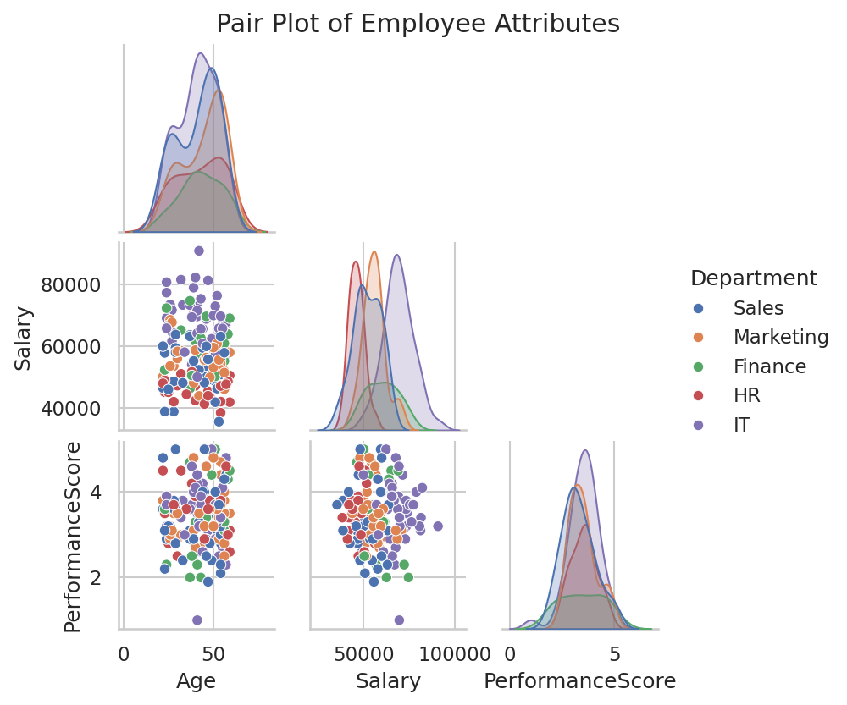
Every pairwise relationship between Age, Salary, and PerformanceScore, colored by Department.
Practice Questions — Pair Plots
- Create a pair plot of just Age, Salary, and YearsExperience without the hue parameter, and note what changes.
- Create a pair plot with hue set to a Performance Tier (High/Medium/Low) category instead of Department.
- Change the diagonal plots in a pair plot from histograms to KDE (density) curves using the diag_kind parameter.
- Use a pair plot to visually identify which two variables in the dataset appear most strongly related.
- Create a pair plot restricted to only the IT and Sales departments by filtering the DataFrame first.

8. Count Plots (Seaborn)
A count plot shows the number of occurrences of each category in a column — essentially a bar chart where Seaborn calculates the counts for you automatically, without needing a separate groupby step.
fig, ax = plt.subplots(figsize=(6.5, 4))
sns.countplot(
data=df, x="Department", ax=ax,
order=df["Department"].value_counts().index
)
ax.set_title("Number of Employees per Department")
plt.show()
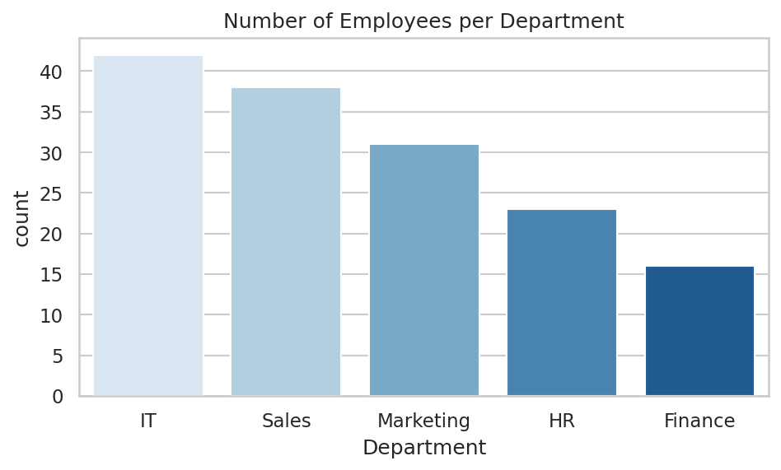
Headcount per department, ordered from most to fewest employees.
Practice Questions — Count Plots
- Create a count plot showing how many employees fall into each Performance Tier (High/Medium/Low).
- Create a count plot of Department, split further by a Gender or Location column if available in your own dataset.
- Change the count plot's orientation to horizontal for a dataset with long category names.
- Compare a count plot of Department against the equivalent output of df['Department'].value_counts() to confirm they match.
- Add percentage labels above each bar in a count plot, showing what share of the total each department represents.

9. Building a Simple Dashboard (Subplots)
A dashboard combines several related charts into a single view, so a viewer can understand multiple aspects of the data at a glance without switching between separate images. Matplotlib's subplots() function creates a grid of axes that can each hold a different chart, including ones drawn with Seaborn.
fig, axes = plt.subplots(2, 2, figsize=(9, 7))

axes[0, 0].plot(monthly_sales["Month"], monthly_sales["Sales_2025"], marker="o")
axes[0, 0].set_title("2025 Monthly Sales")

axes[0, 1].bar(avg_salary.index, avg_salary.values, color="#ED7D31")
axes[0, 1].set_title("Avg Salary by Department")

axes[1, 0].hist(df["PerformanceScore"], bins=15)
axes[1, 0].set_title("Performance Score Distribution")

sns.boxplot(data=df, x="Department", y="Salary", ax=axes[1, 1])
axes[1, 1].set_title("Salary Spread by Department")

fig.suptitle("Company Performance Dashboard", fontsize=14, fontweight="bold")
plt.tight_layout()
plt.show()
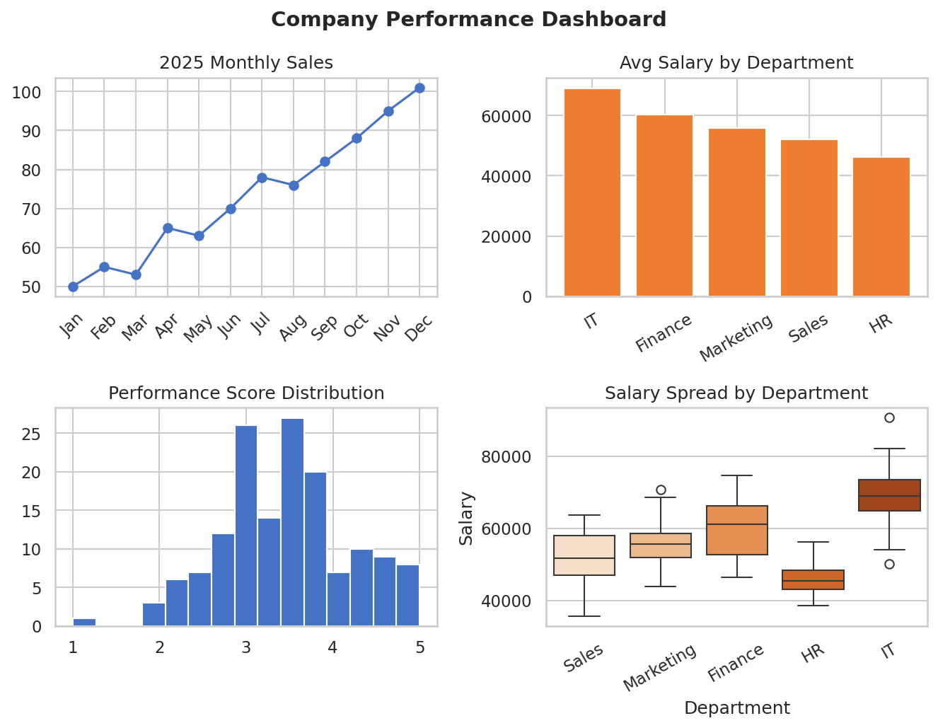
Four related charts combined into a single company performance dashboard.
Practice Questions — Building a Dashboard
- Build a 2x2 dashboard of your own using four different chart types from this document, all based on a dataset you choose.
- Add a shared title and consistent color scheme across all four subplots in a dashboard.
- Rearrange the dashboard into a 1x3 layout instead of 2x2, and adjust figsize so nothing overlaps.
- Save the finished dashboard to a PNG file using fig.savefig() at 150 DPI for use in a report.
- Add a fifth chart to the dashboard by changing the grid to a 3x2 layout and leaving one panel empty (hint: axes[2, 1].axis('off')).

