**SOFTWARE ENGINEERING (CS305) PROJECT**

**What is Included in this docs?**

* **Description**
* **Screenshots**
* **Tables in Database**
* **Use-Case Diagram**
* **Flow Diagram**

**Description about Habit-Tracker App**

**This project consists of Goal-Tracker web app. A Goal tracker app is a digital tool designed to help users develop and maintain good Goals by keeping track of their progress over time. Users can set goals for themselves, and then use the app to log each time they complete a task related to that goal. The app offers a range of features, such as customizable reminders, streak tracking, and progress graphs, to help users stay motivated and engaged. This apps can be used for a wide variety of Goals, such as exercise, meditation, reading, and more, and can be a helpful tool for anyone looking to improve their daily routines and achieve their goals.**

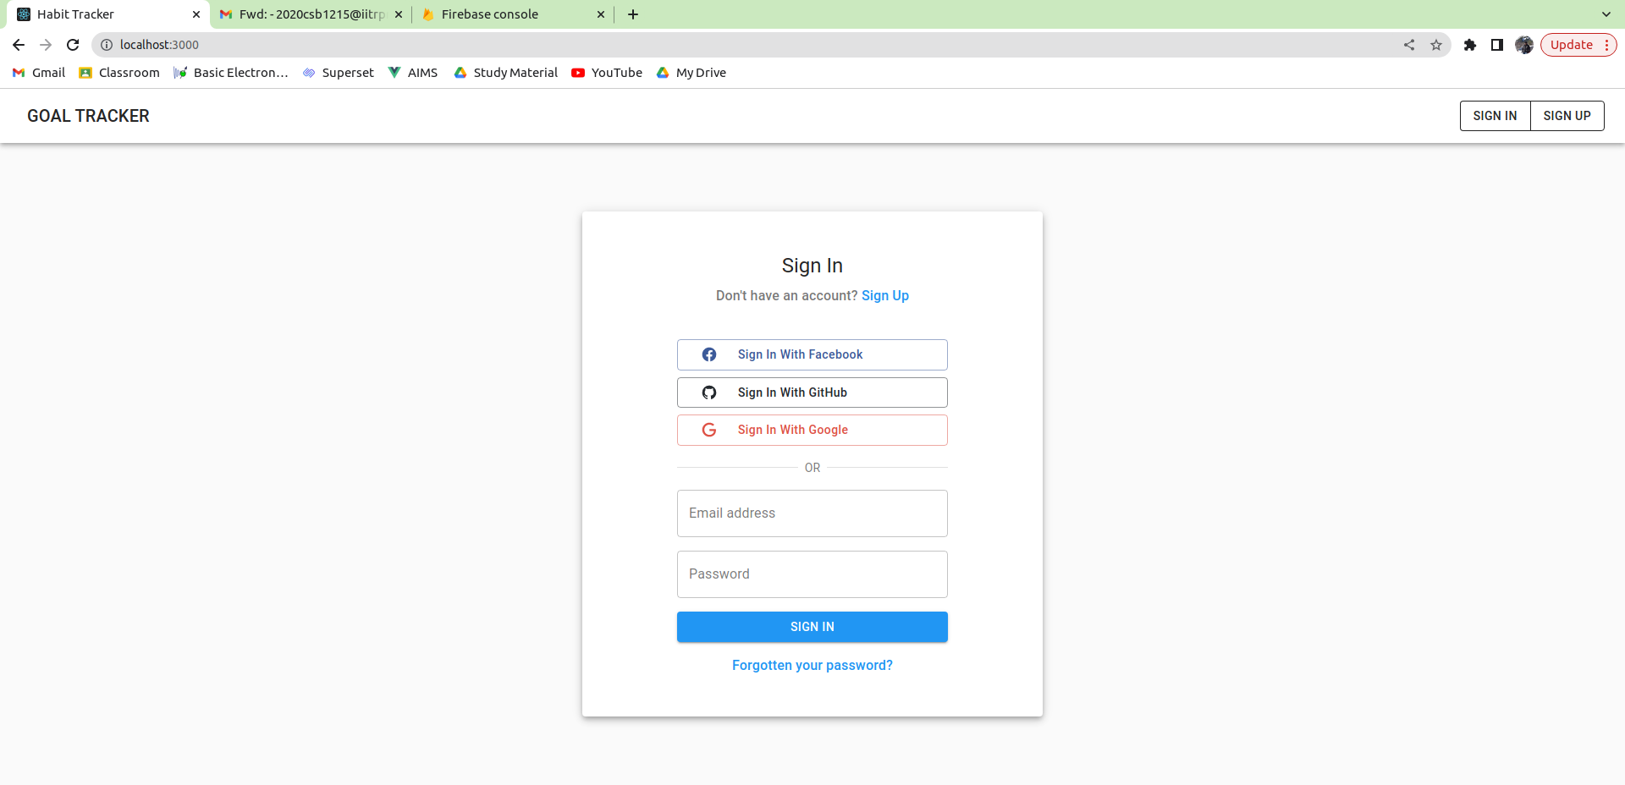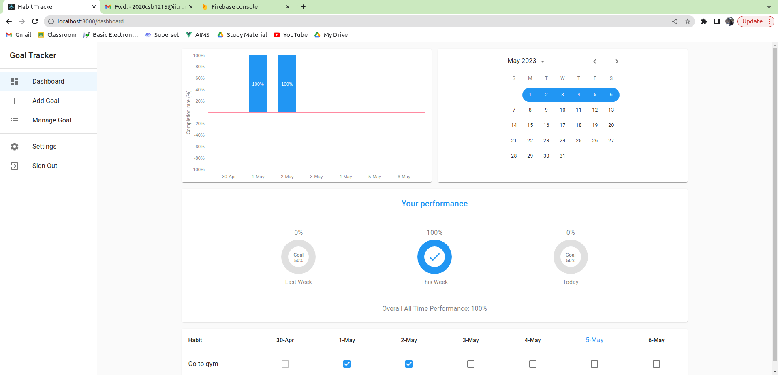

Signin/Signup page

Dashboard

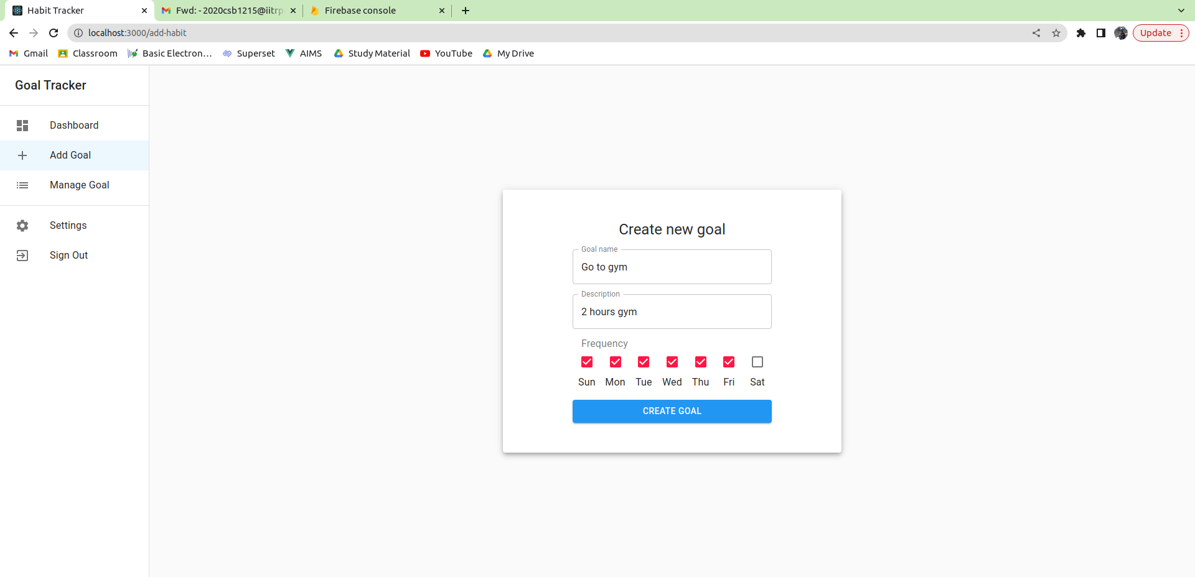

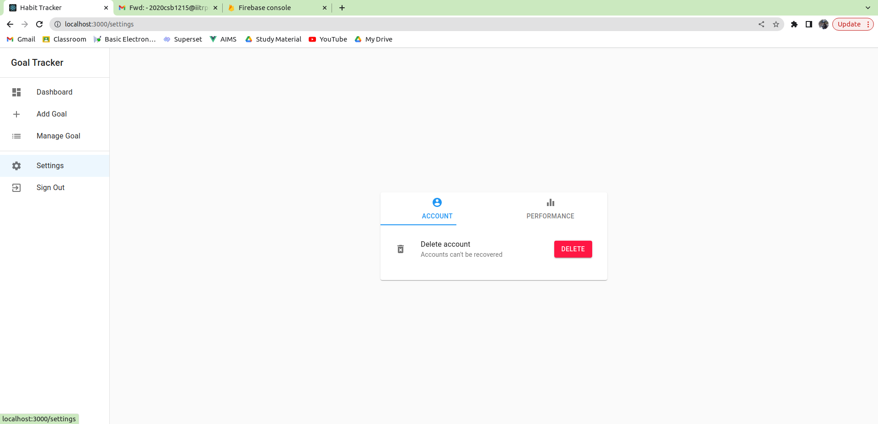

Goal Added in Goal Screen

Settings Screen (Account)

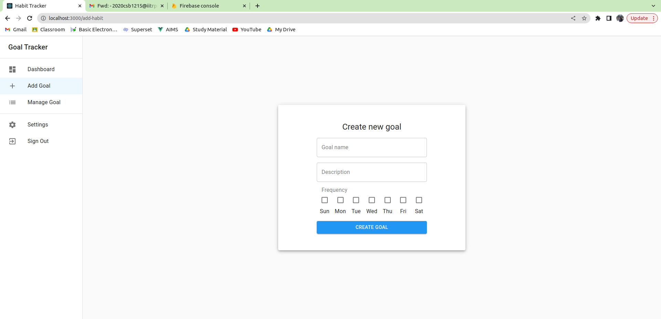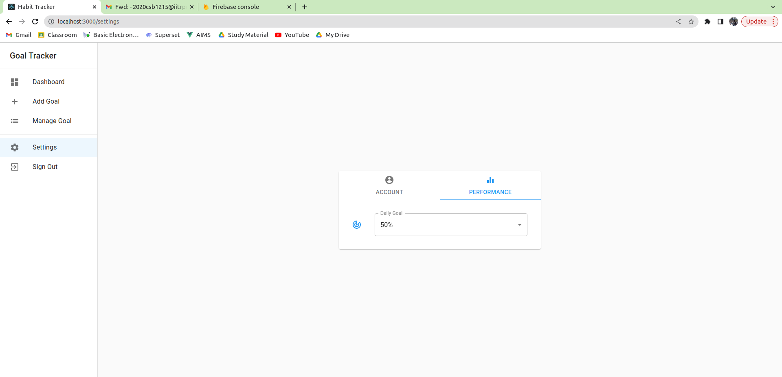

Add Goal Screen

Settings Screen (Performance)

**TABLES IN DATABASE**

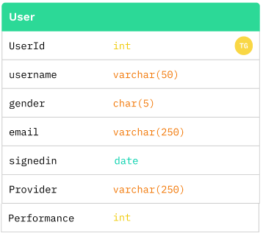

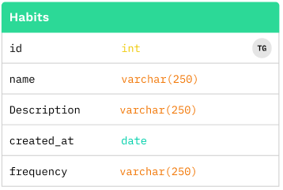

**USE CASE Diagram**

