🌾
[Institution Name]

Capstone Project Report
Farmer Groceries
A Direct Farmer-to-Consumer Grocery Marketplace with Role-Based Mobile Workflows for Customers, Farmers and Delivery Partners
Submitted in partial fulfilment of the requirements for the award of the degree of Bachelor of Science in Computer Science (Online Mode)

Student Name(s) | [Student Name]
Roll Number(s) | [Roll Number]
Programme | BSc Computer Science (Online Mode)
Institution | [Institution Name]
Academic Year | [2025 – 2026]
Internal Supervisor | [Supervisor Name]
Project Repository | github.com/Vijaygaurav2004/Farmer_groceries
Date of Submission | [DD Month 2026]
Highlighted fields are to be completed before submission.

DECLARATION
I/We hereby declare that this capstone project titled “Farmer Groceries — A Direct Farmer-to-Consumer Grocery Marketplace with Role-Based Mobile Workflows” is an original work carried out by me/us under the guidance of [Supervisor Name], and that it has not been submitted to any other university or institution for the award of any degree, diploma or other similar title.
All sources of information, third-party libraries, frameworks and reference material used in the course of this work have been duly acknowledged in the References section of this report. The source code accompanying this report is maintained under version control and is available in the public repository cited on the cover page. Any content reproduced from other works is cited explicitly, and the implementation, testing and documentation presented here represent our own effort.
Signature of the Student(s) [Student Name] [Roll Number] |  | Signature of the Internal Supervisor [Supervisor Name]
Place: [City] Date: [DD/MM/2026]

ABSTRACT
The Indian agricultural supply chain routinely places five or more intermediaries between the grower and the household that eventually consumes the produce. Each intermediary adds margin without adding value, with the result that farmers realise only a fraction of the final retail price while consumers pay a substantial mark-up, and perishable produce loses freshness at every additional hop. Farmer Groceries is a cross-platform mobile application that compresses this chain to a single link — farmer to delivery partner to consumer — inside one application serving three distinct user roles.
The implemented system is a React Native application built on the Expo SDK 54 managed workflow, written entirely in TypeScript under strict compiler settings and routed with the file-based Expo Router. A single authenticated identity is specialised at sign-in time into one of three role workspaces: customers browse a categorised catalogue, manage a persistent cart and track orders through a seven-stage progress timeline; farmers publish and price inventory, monitor low-stock alerts and advance incoming orders; delivery partners receive nearby jobs with distance-derived ETAs, accept or decline them, follow a pickup-to-drop route view and monitor period-wise earnings. Global state is held in React Context providers for authentication and cart, while all persistence is funnelled through a single service façade that dispatches either to a Supabase (PostgreSQL + Auth + Storage) backend or, when no cloud credentials are configured, to an on-device data layer persisted through AsyncStorage. This dual-target design makes the application offline-capable — every screen continues to function without connectivity — while remaining ready for multi-tenant cloud deployment.
The delivered build comprises 48 TypeScript source files (approximately 5,400 lines) spanning 18 routed screens and a 12-component reusable design system driven by a central token module. The application compiles cleanly under tsc --noEmit in strict mode and was validated by automated end-to-end suites, committed to the repository, that drive all three role workflows through a real browser — covering sign-in, role selection, catalogue browsing, cart and checkout, order placement, farmer-side fulfilment and delivery acceptance through to completion. Forty functional and validation test cases were executed, of which all forty passed. The outcome is a working, demonstrable marketplace that measurably shortens the produce supply chain and provides a credible foundation for a production deployment.

Keywords
Agricultural supply chain; disintermediation; React Native; Expo; TypeScript; Supabase; role-based access; mobile commerce; order lifecycle management; last-mile delivery.

TABLE OF CONTENTS
Right-click and choose “Update Field” to build the table of contents.

LIST OF FIGURES
Right-click and choose “Update Field” to build the list of figures.

LIST OF TABLES
Right-click and choose “Update Field” to build the list of tables.

LIST OF ABBREVIATIONS
Abbreviation | Expansion
AAB | Android App Bundle
API | Application Programming Interface
APK | Android Package Kit
CDP | Chrome DevTools Protocol
COD | Cash on Delivery
CRUD | Create, Read, Update, Delete
CSS | Cascading Style Sheets
DFD | Data Flow Diagram
DOM | Document Object Model
EAS | Expo Application Services
ER | Entity Relationship
ETA | Estimated Time of Arrival
IDE | Integrated Development Environment
JSON | JavaScript Object Notation
JWT | JSON Web Token
MVP | Minimum Viable Product
npm | Node Package Manager
PDF | Portable Document Format
RLS | Row Level Security
RN | React Native
SDG | Sustainable Development Goal
SDK | Software Development Kit
SQL | Structured Query Language
UI / UX | User Interface / User Experience
UPI | Unified Payments Interface
URL | Uniform Resource Locator
UUID | Universally Unique Identifier

CHAPTER 1: INTRODUCTION
Note: Problem identification and system design were completed and approved as part of the preceding Study Project. This chapter reproduces that work in condensed form and records the refinements made during implementation. The principal changes are: (i) the adoption of Supabase in place of the originally proposed Firebase backend, (ii) the addition of an on-device data layer so that the application remains fully functional without network connectivity, and (iii) the extension of the order lifecycle from five to seven states to give delivery partners explicit assigned and picked up checkpoints.

1.1 Overview of the Project
Farmer Groceries is a cross-platform mobile marketplace that connects agricultural producers directly with the households that buy their produce, and coordinates the last-mile delivery between them. The application is built as a single React Native codebase that runs on Android, iOS and the web, and it serves three distinct classes of user from that one codebase. A person signs up once, chooses a role, and is thereafter routed into a workspace tailored to that role: a shopping experience for customers, an inventory and fulfilment console for farmers, and a job board with route and earnings tracking for delivery partners.
The commercial premise of the system is disintermediation. Every order placed in the application creates a direct commercial relationship between one farmer and one customer, with a delivery partner compensated separately for the physical movement of goods. There is no wholesaler, commission agent or retailer in the transaction path, so the margin those parties would otherwise extract is redistributed between the producer and the consumer.
The delivered artefact is a complete, runnable application rather than a prototype of selected screens. All eighteen routed screens are implemented and reachable, the order lifecycle can be driven from placement to delivery by three different users acting in sequence, and state changes made by one role are immediately visible to the others. The system persists data through a service layer that can be pointed either at a hosted Supabase project or at the on-device data layer, so the application keeps working whether or not the network does.

1.2 Problem Statement and Motivation
Produce in the conventional Indian agricultural supply chain typically passes through five or more intermediaries between the field and the kitchen. A grower sells to a local trader or an aggregator, who sells to a commission agent operating in a regulated wholesale market, who sells to a wholesaler, who sells to a retailer, who finally sells to the household. Each hop adds a margin, a handling delay and an opportunity for spoilage, and none of the hops after the first adds any agronomic value to the product.
Three consequences follow directly from this structure, and together they constitute the problem this project addresses:
- Producer income is compressed. The share of the final retail price that reaches the grower is a small fraction of what the consumer pays, because each intermediate party prices for its own risk and working capital rather than for value added.
- Consumer prices are inflated. The household pays for a chain of margins it never interacts with, and has no visibility into who grew the produce, when it was harvested, or under what conditions.
- Freshness and quantity are lost. Perishables spend days in transit and storage across the chain. Wastage accumulates at every transfer, and what survives arrives materially less fresh than it left the farm.
The structural fix is to shorten the chain, and the practical obstacle to shortening it is coordination. A farmer cannot economically discover, price for, and deliver to individual households without software; a household cannot discover nearby farmers or verify their produce without a catalogue; and neither party can arrange reliable last-mile logistics alone. A single application that carries all three participants and mediates the transaction between them removes that coordination barrier. Figure 1.1 contrasts the two structures.
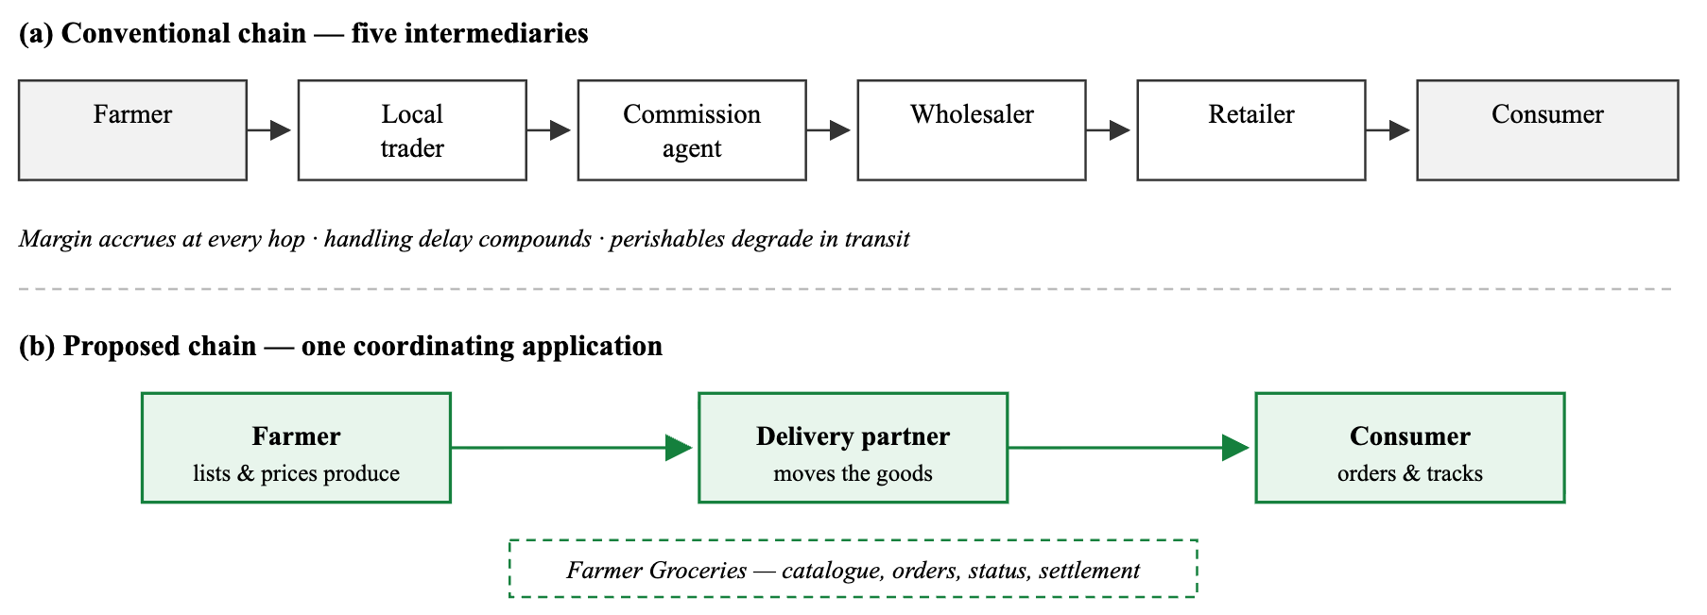
Figure 1.1 — Conventional multi-intermediary produce chain versus the
proposed direct chain mediated by a single application.

1.3 Objectives of the Capstone
Where the Study Project established what should be built and why, the capstone phase was concerned with building it, proving that it works, and documenting the result. Six objectives were set at the start of the implementation phase; Table 1.1 states each objective alongside the concrete deliverable by which it is judged and the section of this report in which the evidence appears.
# | Objective | Deliverable used as evidence | Evidence in
O1 | Implement a single authenticated identity that specialises into three role-specific workspaces with enforced navigation boundaries. | Auth context, persisted role, and a root navigation guard that redirects any user found outside their role's route group. | §2.3.1, §2.4.1
O2 | Deliver a complete customer purchase journey from catalogue discovery to order tracking. | Seven customer screens including search, category and organic filters, persistent cart, checkout with address validation, and a seven-stage tracking timeline. | §2.3.2, §2.5
O3 | Deliver a farmer console for inventory publication and order fulfilment. | Dashboard with revenue and low-stock analytics, product creation and visibility toggling, and an order queue with guarded status transitions. | §2.3.3, §2.5
O4 | Deliver a delivery-partner workflow covering job acceptance, execution and remuneration. | Availability toggle, distance-ranked job board with computed ETAs, accept/decline actions, pickup-to-drop route view and period-wise earnings. | §2.3.4, §2.5
O5 | Centralise persistence behind one interface so the backend can be substituted without touching screen code. | A service façade of thirty operations, each dispatching to Supabase or to the on-device data layer based on a single configuration flag. | §2.1.3, §2.4.5
O6 | Validate the integrated system end to end and record reproducible evidence of correctness. | Strict-mode type check with zero errors, plus two committed browser-driven suites exercising all three roles across forty test cases. | Chapter 3
Table 1.1 — Objectives of the capstone and their realisation.

1.4 Scope of Implementation
The capstone scope was fixed deliberately at a functionally complete marketplace with simulated payment and simulated geolocation. This boundary was chosen because payment gateway integration and live location streaming both require commercial accounts and device permissions that add integration risk without demonstrating additional software-engineering competence. Every feature inside the boundary is implemented and exercised; every feature outside it is recorded in §6.4 as future work rather than silently omitted.
In scope — implemented and verified | Out of scope — deferred to future work
Email and password authentication with role assignment and session persistence Role-guarded navigation across three route groups Product catalogue over eight categories with search, category, organic and price sorting Cart with stock-capped quantities, persistence across restarts and free-delivery progress Checkout with address validation, three payment methods and per-farmer order splitting Seven-stage order lifecycle with an immutable status history Customer-initiated cancellation restricted to pre-fulfilment states Farmer inventory CRUD, low-stock alerting and revenue aggregation Delivery job board with Haversine distance and ETA, accept/decline, and route view Period-wise earnings computation for delivery partners Reusable design-token-driven component library and responsive web shell | Live payment gateway settlement — payment status is recorded, not charged GPS location streaming and turn-by-turn map navigation Push notifications for order state changes In-app messaging between customer and delivery partner Product image upload — the storage path exists but the catalogue renders category glyphs Customer-authored reviews and ratings — the data model and service methods exist, the authoring screen does not Recurring subscription orders — modelled in the type system only Administrative moderation and farmer document verification workflow Multi-language localisation
Table 1.2 — Scope boundaries: included and excluded functionality.

1.5 Organisation of the Report
Chapter 2 presents the implementation in detail: the layered architecture and its data flows, the technology stack and the reasoning behind each choice, a module-by-module description of the three role workspaces, the algorithms that encode the business rules, and annotated screenshots of the running application accompanied by the source listings that produce them.
Chapter 3 sets out the test strategy, the tooling used to execute it, the full set of functional and negative test cases with their recorded inputs and outcomes, and an analysis of the results including non-functional measurements.
Chapter 4 documents the execution environment, the steps required to run the application locally and to produce release builds for each target platform, and the demonstration material.
Chapter 5 provides project execution evidence: the version control history, a weekly progress summary derived from that history, and the review and feedback log.
Chapter 6 concludes with a summary of what was built, an honest assessment of achievements against the objectives of §1.3, the limitations of the current build, and a prioritised roadmap of enhancements. References and four appendices — a user manual, an installation guide, the source code location and the demonstration video link — complete the report.

CHAPTER 2: IMPLEMENTATION DETAILS

2.1 System Architecture and Design

2.1.1 High-Level Architecture
The application is organised into five layers with a strict downward dependency rule: a layer may import from the layers beneath it but never from those above. This constraint is what makes the backend substitutable — screens never import a database client, they import a service, and the service decides where the data comes from.
The presentation layer consists of eighteen routed screens declared as files under app/. Expo Router derives the navigation graph from the directory structure, so the three parenthesised directories (customer), (farmer) and (delivery) become three independent tab stacks without any imperative navigator configuration. The component layer supplies twelve presentational primitives — buttons, inputs, chips, status pills, skeletons, toasts and a custom tab bar — all of which read their colours, radii and shadows from a single design-token module, so a change to the brand palette propagates through every screen at once.
The state layer comprises two React Context providers mounted at the root. AuthProvider owns the authenticated user and the selected role and exposes setRole, signOut and refreshUser; CartProvider owns the cart array and derives cartTotal and cartCount from it. Both hydrate from device storage on mount and write back on change, which is why a cart survives an application restart.
The service layer is a single class, SupabaseService, exposing thirty static operations grouped into authentication, users, farmers, products, orders, reviews and file upload. Every method begins with the same guard: if the environment supplies a Supabase URL the method issues a PostgREST query and maps the snake_case row into a camelCase domain object; if it does not, the method delegates to localStore. Neither branch leaks into the caller.
The persistence layer therefore has two interchangeable implementations. The remote implementation is a hosted Supabase project providing PostgreSQL storage, GoTrue authentication and object storage. The local implementation is an in-memory state object holding the catalogue, farmer profiles and order history, mirrored into AsyncStorage after every mutation and rehydrated — including date revival — on the next launch.
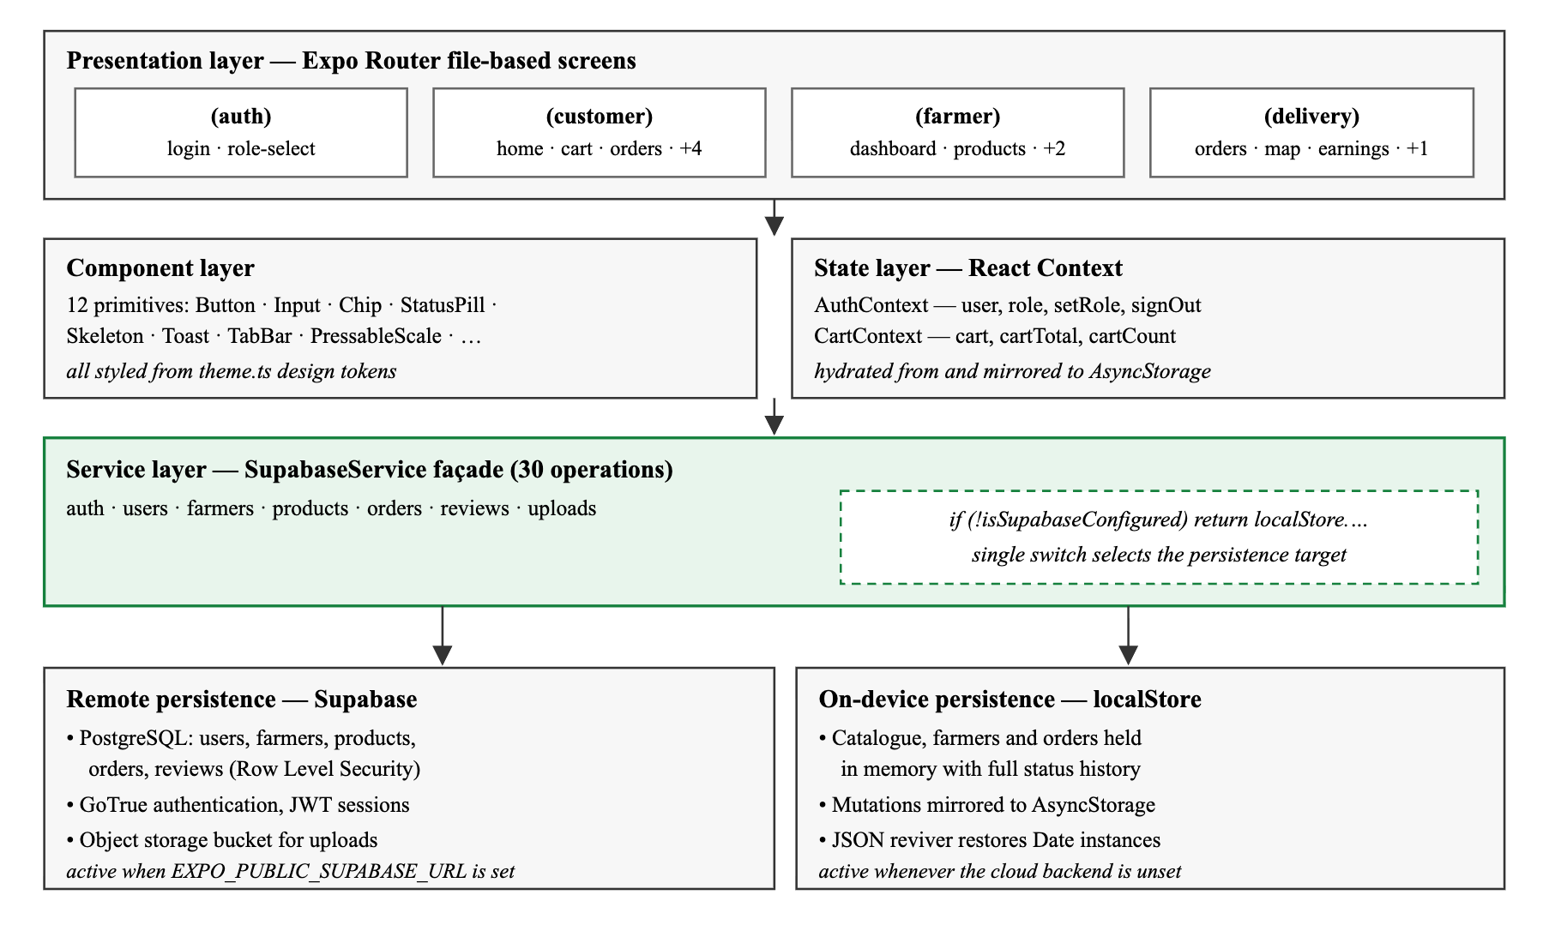
Figure 2.1 — High-level layered architecture. Dependencies point
downward only; the service façade is the sole boundary between screens and storage.

2.1.2 Data Flow Diagrams
Figure 2.2 gives the context diagram. The system is treated as a single process with three external entities — the three human roles — and one external data service. Figure 2.3 decomposes that process into the five functional processes that the implementation actually contains, together with the four logical data stores they read and write.
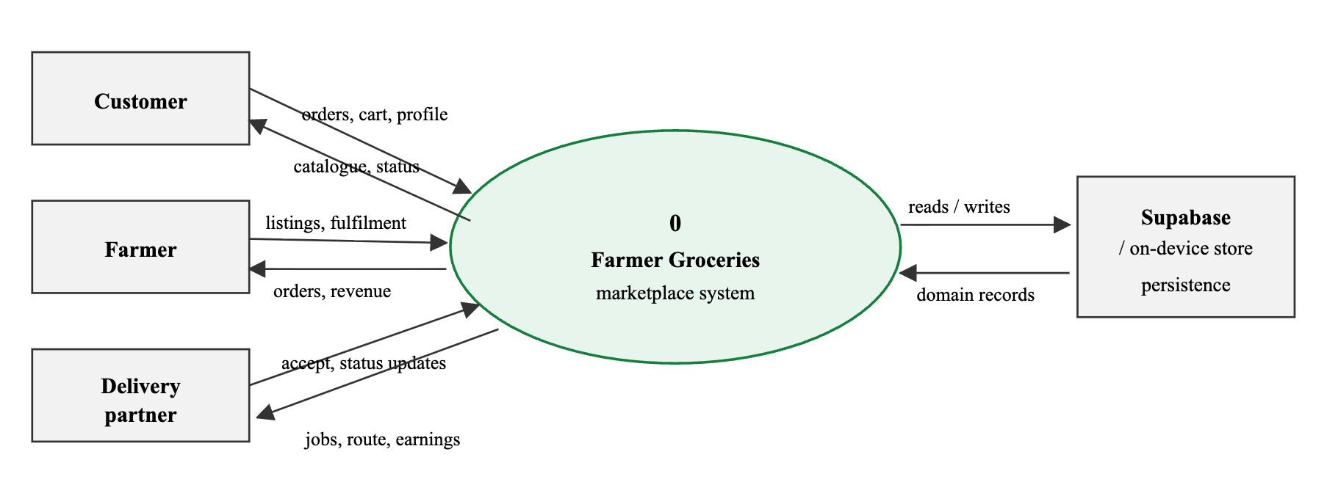
Figure 2.2 — Context diagram (Level-0 data flow diagram).
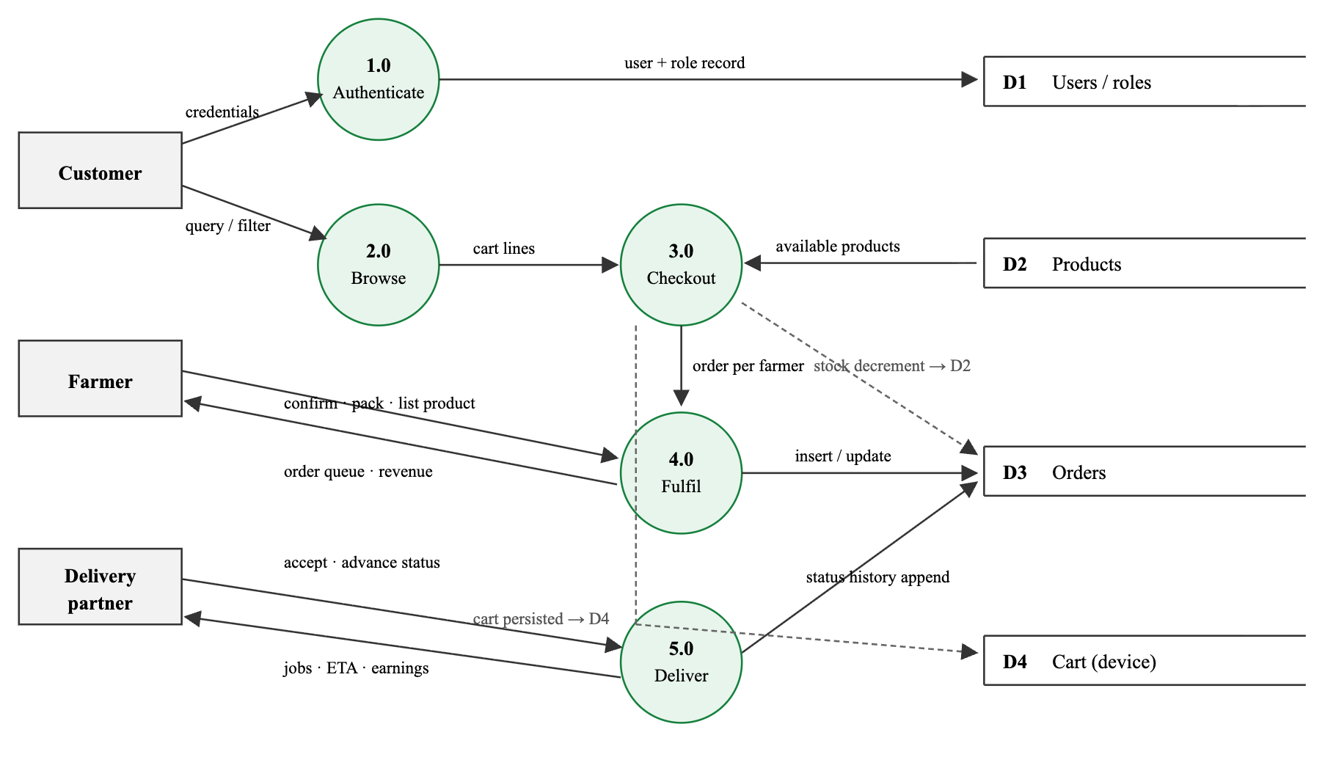
Figure 2.3 — Level-1 data flow diagram showing the five functional
processes and the four logical data stores.

2.1.3 Component Interaction
Order placement is the interaction that touches the greatest number of components, and it is worth tracing in full. When the customer presses Place Order, the payment screen validates the cart total against the minimum order value and the address against the pincode pattern, groups the cart lines by farmerId, and issues one createOrder call per distinct farmer in parallel. The service façade routes each call to the active persistence target, which assigns an identifier, appends the initial placed status entry and decrements the stock of each ordered product. Only when every promise resolves is the cart cleared and the customer redirected to the order history. Figure 2.4 shows the sequence.
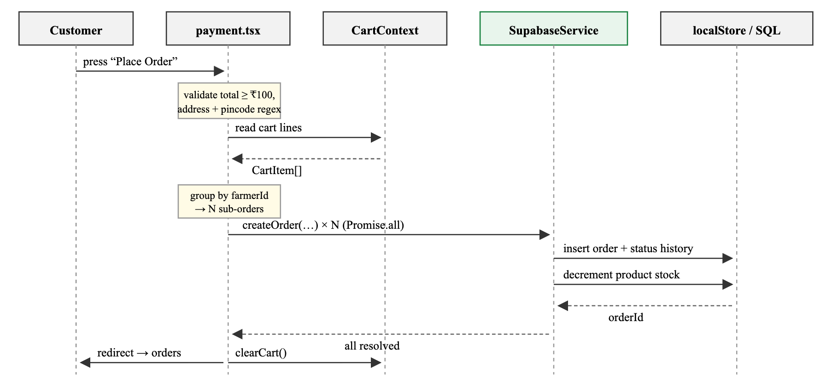
Figure 2.4 — Component interaction sequence for order placement,
including the per-farmer split and the stock decrement.

2.1.4 Data Model
The domain is expressed as TypeScript interfaces in src/types/index.ts and mirrors the relational schema used when Supabase is the active target. User is the base identity; Customer, Farmer and DeliveryPartner extend it with a discriminated role literal, which lets the compiler narrow a value to the correct specialisation from the role field alone. Orders embed their line items and their status history as nested structures rather than referencing separate tables, so that an order is retrievable in a single read and its history cannot drift from the order it describes.
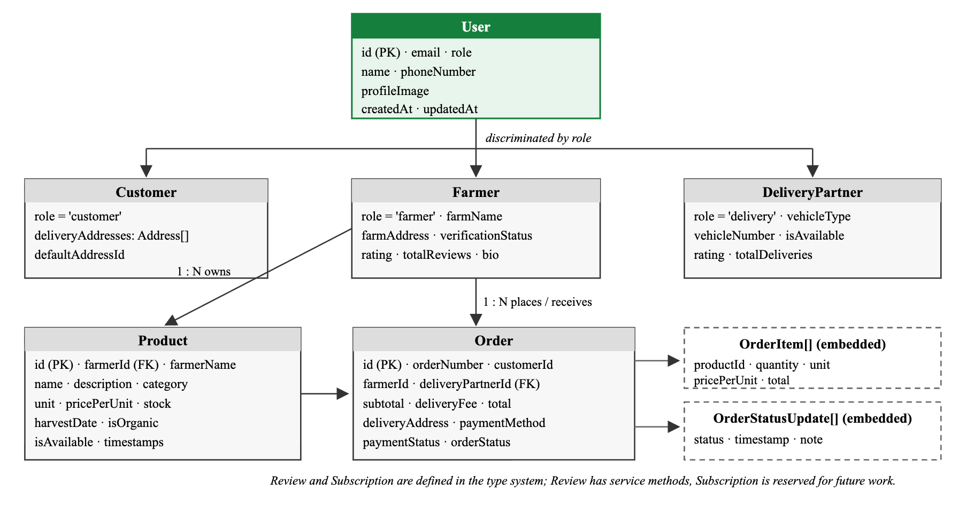
Figure 2.5 — Entity relationship model of the persisted domain.
Dashed boxes are embedded (denormalised) structures rather than separate tables.
Entity | Principal attributes | Role that owns writes
User | id, email, role, name, phoneNumber, timestamps | Self (profile edit); role set once at sign-in
Farmer | farmName, farmAddress, verificationStatus, rating, totalReviews, bio | Farmer; verification reserved for an administrator
Product | farmerId, name, category, unit, pricePerUnit, stock, harvestDate, isOrganic, isAvailable | Farmer (create, price, toggle visibility); system decrements stock on order
Order | orderNumber, customerId, farmerId, deliveryPartnerId, items[], subtotal, deliveryFee, total, deliveryAddress, paymentMethod, paymentStatus, orderStatus, statusHistory[] | Customer creates and may cancel; farmer advances to packed; delivery partner advances to delivered
Address | label, street, city, state, pincode, latitude, longitude, isDefault | Customer at checkout; farmer for farm location
Review | orderId, customerId, farmerId, rating, comment, images | Customer — service layer implemented, authoring UI deferred
Table 2.3 — Domain entities and principal attributes.

2.1.5 Navigation and Route Guarding
Navigation is declarative. Each role directory contains a _layout.tsx that declares a Tabs navigator with a shared custom tab bar; screens that must be reachable but not tabbed — product detail, order tracking and the payment screen — are declared with href: null so they participate in the stack without occupying a tab. Above all three groups, the root layout runs a guard on every segment change. Figure 2.6 shows the resulting graph and the three redirect rules the guard enforces.
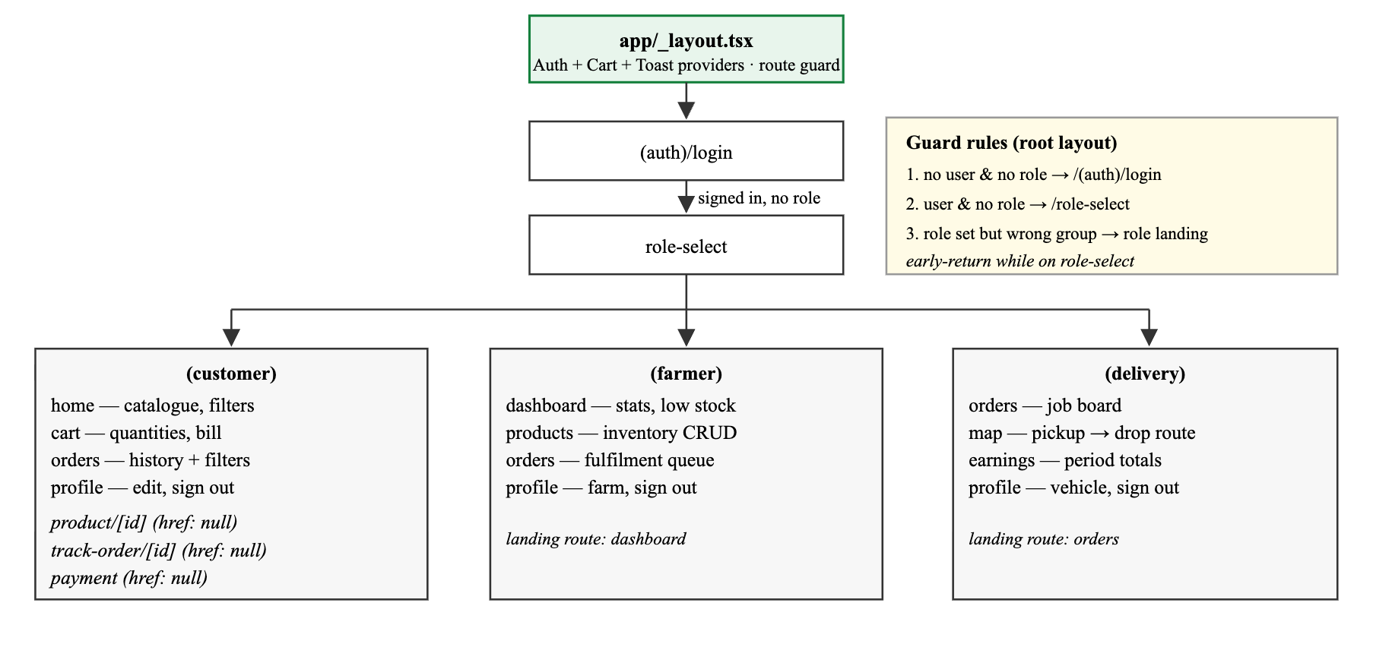
Figure 2.6 — Navigation map of routed screens and the redirect rules
enforced by the root guard.

2.2 Technology Stack

2.2.1 Programming Languages
The application is written entirely in TypeScript 5.9 with strict enabled in tsconfig.json. Strict mode is not decoration here: the domain model leans on discriminated unions — UserRole, OrderStatus, ProductCategory are string-literal unions rather than free-form strings — so the compiler rejects an invalid status transition or an unhandled category at build time rather than at run time. JSX/TSX is used for all component markup. A small amount of plain JavaScript remains in the Babel, Metro and Tailwind configuration files and in the unused Express scaffold under backend/.

2.2.2 Frameworks and Libraries
Technology | Version | Role in the system and rationale for the choice
React Native | 0.81.5 | Cross-platform UI runtime. One codebase compiles to Android, iOS and — through react-native-web — the browser, which is what allows the whole system to be driven by the automated test suites in a desktop browser.
React | 19.1.0 | Component model, hooks and the Context API used for global state.
Expo SDK | 54 | Managed workflow. Supplies the development client, the Metro bundler configuration, over-the-air asset handling and native module access without ejecting to bare native projects.
Expo Router | 6.0 | File-based routing with typed routes enabled. The directory layout is the navigation graph, which keeps the three role workspaces physically separated in the source tree.
TypeScript | 5.9 | Static typing in strict mode across all 48 source files.
NativeWind + Tailwind CSS | 4.0 / 3.4 | Utility-class styling compiled to React Native styles, with a project palette (primary green, earth brown) extended in the Tailwind config.
Supabase JS | 2.91 | Client for the optional hosted backend: GoTrue authentication with JWT session persistence, PostgREST queries against PostgreSQL, and object storage for uploads.
AsyncStorage | 2.2 | Device key-value persistence for the session user, the selected role, the cart and the entire on-device data layer.
React Native Reanimated / Worklets | 4.1 / 0.5 | Native-thread animation driver underpinning gesture and transition work.
Moti | 0.29 | Declarative animation helper retained as a dependency; the shipped entrance animations use the React Native Animated driver instead, because Moti intermittently stalled at its initial state on web.
expo-linear-gradient | 15.0 | Brand gradient headers and primary buttons.
@expo/vector-icons | 15.0 | Ionicons glyph set used throughout the interface and in the tab bar.
expo-haptics | 15.0 | Selection feedback on press, suppressed on the web target.
expo-image-picker / document-picker | 17.0 / 14.0 | Media and document selection, wired for the deferred image-upload and verification features.
react-native-safe-area-context, screens, gesture-handler | 5.6 / 4.16 / 2.28 | Navigation primitives required by the Expo Router stack and tab navigators.
Table 2.1 — Technology stack with versions and rationale.

2.2.3 Tools and Platforms
- Node.js 22.14 and npm 10.9 — package management and script execution.
- Metro bundler — JavaScript bundling for all three targets, configured through metro.config.js and wrapped with the NativeWind transformer.
- Babel with babel-preset-expo, the NativeWind JSX import source and the Reanimated worklets plugin.
- Expo Go — on-device execution of the development build on Android and iOS without a native toolchain.
- Git and GitHub — version control; forty-three commits over the project timeline.
- Chrome and the Chrome DevTools Protocol — the web target was driven programmatically through Puppeteer to execute the end-to-end test walkthrough described in Chapter 3.
- Supabase — optional managed PostgreSQL, authentication and storage platform.
- Prettier — source formatting, configured in .prettierrc.

2.3 System Modules
The system decomposes into six modules: one shared foundation, one authentication module and one module per role. Table 2.2 summarises them; the subsections that follow describe the functional flow of each.
Module | Source location | Responsibility
Foundation | src/theme.ts, src/constants/, src/utils/, src/components/ui/ | Design tokens, business-rule constants, formatting and validation helpers, and twelve reusable presentational components.
Data access | src/services/, src/config/ | Service façade, on-device data layer, device storage wrapper and Supabase client configuration.
Authentication | app/(auth)/, app/role-select.tsx, src/contexts/AuthContext.tsx | Sign-up, sign-in, role assignment, session restoration and the global navigation guard.
Customer | app/(customer)/, src/contexts/CartContext.tsx | Catalogue browsing, product detail, cart, checkout, order history and order tracking.
Farmer | app/(farmer)/ | Business dashboard, inventory management and order fulfilment.
Delivery | app/(delivery)/ | Availability, job board, route view and earnings.
Table 2.2 — Module-wise responsibility summary.

2.3.1 Authentication and Role Assignment Module
A new user opens the application and is redirected to the login screen by the root guard. The sign-up form collects a name, an email, a ten-digit Indian mobile number and a password; each is validated client-side before any network call is attempted. On successful registration the user is deliberately signed out again and returned to the sign-in tab, so that the session that eventually drives the application is always a genuine sign-in session rather than an artefact of registration.
On sign-in, the service returns a user record. If that record already carries a role, the user is routed directly to the corresponding workspace. If it does not, the user is sent to the role selection screen, where choosing Farmer additionally provisions a farmer profile with a derived farm name and a pending verification status. The chosen role is written both to the user record and to device storage, so that a subsequent cold start restores the workspace without a round trip.
The guard in app/_layout.tsx re-evaluates on every navigation segment change and enforces three rules: an unauthenticated user with no stored role is sent to login; an authenticated user without a role is sent to role selection; and a user with a role who is found anywhere outside their own route group is redirected to that group's landing screen. The guard deliberately early-returns while the user is on the role selection screen, which prevents the redirect loop that would otherwise occur during the brief window in which a user exists but a role does not.

2.3.2 Customer Module
The customer home screen loads the available catalogue and the verified farmer list in parallel. Products are presented as a two-column card grid; each card shows the category glyph, an organic badge where applicable, the farmer's name, the unit price and a one-tap add control. Above the grid the customer can search by name or description, filter by any of the eight categories, restrict the list to organic produce, and sort by ascending or descending price. Filtering by category re-queries the data source; search, organic filtering and sorting are applied client-side to the loaded set, which keeps typing responsive.
Selecting a card opens the product detail screen, which adds the harvest provenance, a stock badge that switches to an out-of-stock state at zero, a quantity stepper clamped to available stock and a farmer attribution card. Adding to the cart from either surface writes through CartContext, which merges quantities for a product already in the cart and caps the merged quantity at the product's stock.
The cart screen renders each line with a stepper and a remove control, and adds a progress indicator toward the free-delivery threshold that switches to a celebratory state once the threshold is crossed. The bill summary computes subtotal, delivery fee — zero above the threshold — and total. Checkout is blocked below the minimum order value, with the shortfall stated explicitly in the error message.
The checkout screen collects a delivery address, validates the pincode against the Indian six-digit pattern, offers cash on delivery, UPI and card, and then places the order. Because a cart may contain produce from several farmers, the cart is partitioned by farmer and one order is created per farmer, each with its own subtotal and its own fulfilment lifecycle. Payment status is recorded as pending for cash on delivery and paid for the two prepaid methods.
Order history lists all of the customer's orders newest first, filterable by all, active, delivered or cancelled. Each entry opens a tracking screen that renders the seven-stage timeline with completed stages marked, the current stage annotated in progress, an estimated delivery time derived from the order timestamp, the itemised bill, the delivery address and — while the order is still in placed or confirmed — a cancellation control.

2.3.3 Farmer Module
The farmer dashboard aggregates the farmer's orders and products into four indicators: active orders, active products, lifetime order count and realised earnings, the last computed as the sum of the totals of delivered orders only. Beneath the indicators, any product whose stock has fallen to or below the low-stock threshold is surfaced in an amber alert list with a direct link to inventory, followed by the five most recent orders with their status pills.
The products screen is the farmer's inventory console. It lists every product the farmer owns — including those currently hidden from customers, so that they can be restored — with search across name and category, a low-stock marker and an availability switch that toggles catalogue visibility without deleting the record. A modal sheet creates a new product, collecting name, description, category, unit, price, stock and an organic flag, with name, price and stock enforced as mandatory.
The orders screen is the fulfilment queue, filterable by active, all or completed. The farmer's authority over an order is deliberately bounded: the transition map allows only placed → confirmed and confirmed → packed. Once an order is packed it leaves the farmer's control and becomes visible to delivery partners. Every transition is confirmed through a dialogue before it is committed.

2.3.4 Delivery Module
The delivery partner's job board opens with an online/offline switch and two live counters for active deliveries and the fee accrued against them. When online, the partner sees every packed order that has not yet been claimed, each showing the drop address and — where the address carries coordinates — a straight-line distance and an estimated duration. Declining a job hides it locally for the remainder of the session; accepting it atomically sets the order status to assigned and stamps the partner's identifier onto the order, which removes it from every other partner's board.
Claimed orders move into My Deliveries, where a single contextual action advances the order along the remainder of the lifecycle: Pick Up at assigned, Start Delivery at picked up, and Delivered at out for delivery. Marking an order delivered also flips its payment status to paid, which closes the cash-on-delivery loop.
The route screen resolves the partner's single in-flight delivery and presents it as a pickup-to-drop schematic with the farm as origin and the customer address as destination, together with the order value and the same contextual advance action. The earnings screen aggregates all delivered orders into today, week-to-date and month-to-date totals at the standard per-delivery fee, and lists the ten most recent completed deliveries with relative timestamps.

2.4 Key Algorithms and Logic
Six pieces of logic carry most of the system's behaviour. Each is presented below as pseudocode followed by the reasoning behind it and, where instructive, the actual implementation.

2.4.1 Role-Based Navigation Guard
The guard is the single point at which authorisation is decided. Because Expo Router exposes the current URL as a segment array, the guard can compare the user's role against the segment they are attempting to occupy without any per-screen checks.
ALGORITHM EnforceRouteAccess
INPUT user, role, segments // segments[0] is the active route group
OUTPUT a redirect, or no action
1 IF authentication is still loading THEN return
2 group ← segments[0]
3 IF group = 'role-select' THEN return // avoid redirect loop
4 IF role is set AND group = groupFor(role) THEN return // already correct
5 IF user is null AND role is null AND group ≠ '(auth)' THEN
6 redirect '/(auth)/login'
7 ELSE IF (user OR role) AND role is null THEN
8 redirect '/role-select'
9 ELSE IF role is set THEN
10 IF group ≠ groupFor(role) OR group ∈ {'(auth)','role-select'} THEN
11 redirect landingFor(role)
// groupFor : customer→(customer), farmer→(farmer), delivery→(delivery)
// landingFor: customer→/home, farmer→/dashboard, delivery→/orders
Listing 2.1 — Route access enforcement (app/_layout.tsx).
Line 3 is the non-obvious one. During role assignment there is a window in which a user exists but a role does not; without the early return, rule 7 would fire on every render and pin the user to the role selection screen while the assignment was still in flight. Line 4 short-circuits the common case so that ordinary tab navigation inside a workspace performs no redirect work at all.

2.4.2 Order Lifecycle State Machine
An order occupies one of eight states. Seven of them form a strictly linear progression; cancelled is a terminal state reachable only from the two earliest states. What makes the machine safe is that no single role can drive an order from end to end: authority is partitioned, so a farmer cannot mark an order delivered and a delivery partner cannot confirm one.
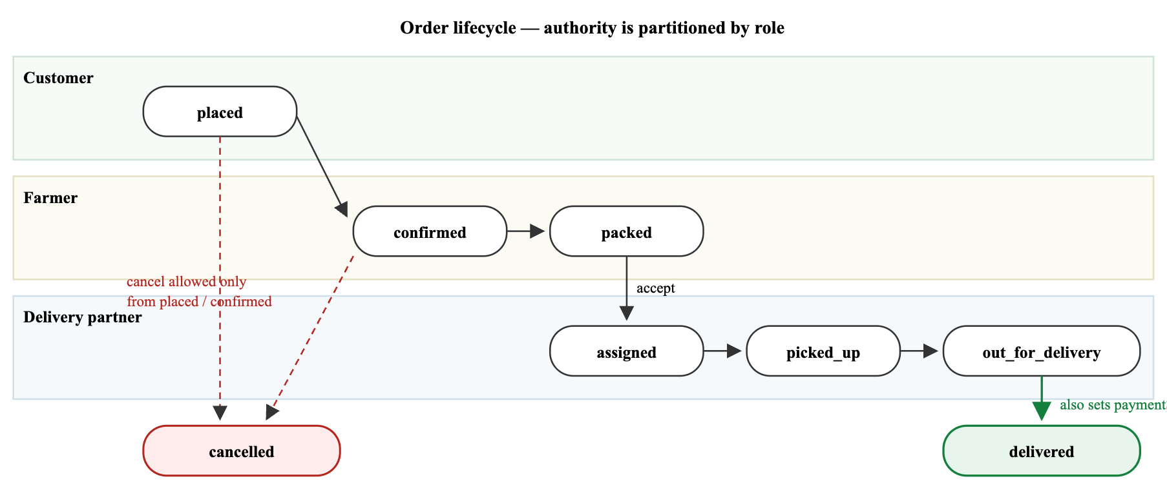
Figure 2.7 — Order lifecycle state machine. Each swim lane shows which
role is permitted to originate the transitions drawn within it.
ALGORITHM AdvanceOrderStatus
INPUT orderId, nextStatus, actorRole, note?
OUTPUT persisted order with an appended history entry
1 order ← fetch(orderId)
2 IF order is null THEN return
3 allowed ← transitionsPermittedFor(actorRole, order.orderStatus)
4 IF nextStatus ∉ allowed THEN reject
5 order.orderStatus ← nextStatus
6 order.statusHistory ← order.statusHistory + { nextStatus, now(), note }
7 IF nextStatus = 'delivered' THEN order.paymentStatus ← 'paid'
8 order.updatedAt ← now()
9 persist(order)
transitionsPermittedFor(role, current):
farmer : placed→confirmed, confirmed→packed
delivery : packed→assigned, assigned→picked_up,
picked_up→out_for_delivery, out_for_delivery→delivered
customer : placed→cancelled, confirmed→cancelled
Listing 2.2 — Guarded status transition with history append.
The history is append-only. Because each entry carries its own timestamp, the tracking timeline can be rendered purely from history without inferring times, and an audit of how long an order spent in each stage remains possible after the fact. In the implementation each role's screen owns its own transition table — nextStatusMap on the farmer's order queue and statusMap on the delivery job board — which is what enforces line 4 in practice.

2.4.3 Cart Quantity Reconciliation and Stock Capping
The cart must never promise more of a product than exists. Two entry points can violate that — adding a product already present, and typing a quantity directly — so the cap is applied inside the reducer rather than at either call site.
ALGORITHM AddToCart
INPUT product, quantity
OUTPUT next cart state
1 cap(q) ← IF product.stock > 0 THEN min(q, product.stock) ELSE q
2 existing ← cart.find(line ⇒ line.productId = product.id)
3 IF existing exists THEN
4 RETURN cart with existing.quantity replaced by cap(existing.quantity + quantity)
5 ELSE
6 RETURN cart + { productId, product, quantity: cap(quantity), farmerId }
ALGORITHM UpdateQuantity(productId, q)
1 IF q ≤ 0 THEN RETURN RemoveFromCart(productId)
2 maxStock ← line.product.stock > 0 ? line.product.stock : q
3 line.quantity ← min(q, maxStock)
Listing 2.3 — Cart reconciliation with stock capping (CartContext.tsx).
Persistence introduces a subtler hazard. The cart hydrates from storage asynchronously, while the effect that writes the cart back fires on the very first render — when the cart is still the empty initial state. Writing at that moment would erase the stored cart before it had been read. The implementation guards the write with a hydration flag that is only raised once the initial read has settled:
const hydratedRef = useRef(false);
useEffect(() => { loadCart(); }, []);
useEffect(() => {
// Don't overwrite the persisted cart with [] before loadCart resolves
if (hydratedRef.current) saveCart();
}, [cart]);
const loadCart = async () => {
try {
const data = await AsyncStorage.getItem(CART_KEY);
if (data) setCart(JSON.parse(data));
} catch (error) {
console.error('Error loading cart:', error);
} finally {
hydratedRef.current = true;
}
};
Listing 2.4 — Hydration-guarded cart persistence (src/contexts/CartContext.tsx).

2.4.4 Order Splitting, Pricing and Fee Rules
A cart is a customer-side concept; an order is a farmer-side concept. Since one farmer cannot fulfil another's produce, a mixed cart must become several orders. The delivery fee, however, is charged once against the cart as a whole and is waived entirely above the free-delivery threshold.
ALGORITHM PlaceOrder
INPUT cart, address, paymentMethod, user
OUTPUT one persisted order per distinct farmer
1 IF user is null THEN prompt sign-in; abort
2 IF cart is empty THEN report; abort
3 IF cartTotal < MIN_ORDER_VALUE THEN report shortfall; abort
4 IF any address field is blank THEN report; abort
5 IF NOT matches(address.pincode, /^[1-9][0-9]{5}$/) THEN report; abort
6 deliveryFee ← cartTotal ≥ FREE_DELIVERY_THRESHOLD ? 0 : DELIVERY_FEE
7 groups ← groupBy(cart, line ⇒ line.farmerId)
8 FOR EACH (farmerId, lines) IN groups IN PARALLEL
9 subtotal ← Σ line.product.pricePerUnit × line.quantity
10 createOrder({ orderNumber: unique(), customerId, farmerId,
items: map(lines), subtotal, deliveryFee,
total: subtotal + deliveryFee, deliveryAddress: address,
paymentMethod,
paymentStatus: paymentMethod = 'cod' ? 'pending' : 'paid',
orderStatus: 'placed',
statusHistory: [{ status:'placed', timestamp: now() }] })
11 AWAIT all
12 clearCart(); redirect to order history
Listing 2.5 — Checkout, validation and per-farmer order splitting (app/(customer)/payment.tsx).
Every threshold referenced above is a named constant in a single module rather than a literal scattered through the screens, so a change to the delivery fee or the free-delivery threshold takes effect consistently in the cart, the checkout screen, the delivery job board and the earnings calculation at once.
Constant | Value | Effect on system behaviour
MIN_ORDER_VALUE | ₹100 | Checkout is refused below this subtotal; the shortfall is reported to the customer.
DELIVERY_FEE | ₹30 | Charged once per order; also the per-delivery remuneration credited to the partner.
FREE_DELIVERY_THRESHOLD | ₹500 | Above this subtotal the fee is waived; drives the cart progress indicator.
LOW_STOCK_THRESHOLD | 10 units | Triggers the farmer dashboard alert and the inventory warning marker.
MAX_DISTANCE_KM | 50 km | Radius used when querying nearby farmers.
ESTIMATED_DELIVERY_MINUTES | 45 min | Baseline promise used for the customer's estimated delivery time.
MINUTES_PER_KM | 4 min/km | Distance-to-duration factor for the delivery partner's ETA.
REGEX.phone | /^[6-9]\d{9}$/ | Indian mobile format enforced at sign-up and on profile edit.
REGEX.pincode | /^[1-9][0-9]{5}$/ | Six-digit postal code enforced at checkout.
Table 2.4 — Centralised business rule constants ( src/constants/index.ts ).

2.4.5 Distance and Estimated Time of Arrival
The delivery job board ranks and annotates jobs by how far away the drop address is. Distance is computed with the Haversine formula over the great-circle path, using the partner's origin (a fixed reference point in the current build, since live location is out of scope) and the order's stored coordinates. The resulting distance is converted to a duration and floored at the baseline promise, so an ETA is never optimistic relative to the figure already shown to the customer.
ALGORITHM DistanceAndETA
INPUT (lat₁, lon₁) origin, (lat₂, lon₂) destination
OUTPUT distance in km, estimated minutes
1 R ← 6371 // mean Earth radius, km
2 Δφ ← radians(lat₂ − lat₁); Δλ ← radians(lon₂ − lon₁)
3 a ← sin²(Δφ/2) + cos(radians(lat₁))·cos(radians(lat₂))·sin²(Δλ/2)
4 c ← 2·atan2(√a, √(1−a))
5 d ← R·c
6 IF d is not finite OR d ≤ 0 THEN RETURN (d, ESTIMATED_DELIVERY_MINUTES)
7 RETURN (d, max(ESTIMATED_DELIVERY_MINUTES, round(d × MINUTES_PER_KM)))
Listing 2.6 — Haversine distance and ETA derivation (src/utils/helpers.ts).

2.4.6 Dual-Target Persistence Dispatch
The mechanism that makes the backend substitutable is deliberately unremarkable: a boolean computed once at module load, and an early return at the head of every service method. The boolean is true only when an explicit Supabase URL has been supplied and it is not the placeholder value, so a developer who checks out the repository and runs it with no configuration is served by the on-device data layer rather than by a broken remote.
export const isSupabaseConfigured = Boolean(
process.env.EXPO_PUBLIC_SUPABASE_URL &&
process.env.EXPO_PUBLIC_SUPABASE_URL !== 'https://placeholder.supabase.co'
);
static async getAllProducts(limit: number = 50): Promise<Product[]> {
if (!isSupabaseConfigured) {
return localStore.getAvailableProducts(); // ← local branch
}
const { data, error } = await supabase // ← remote branch
.from('products')
.select('*')
.eq('is_available', true)
.order('created_at', { ascending: false })
.limit(limit);
if (error) throw error;
return (data || []).map(item => ({ // snake_case → camelCase
id: item.id, farmerId: item.farmer_id, farmerName: item.farmer_name,
name: item.name, category: item.category, unit: item.unit,
pricePerUnit: item.price_per_unit, stock: item.stock,
harvestDate: new Date(item.harvest_date), isOrganic: item.is_organic,
isAvailable: item.is_available, /* … */
}));
}
Listing 2.7 — Dual-target dispatch in the service façade (src/services/supabase.ts).
The on-device layer is not a stub that returns fixed arrays. It maintains genuine mutable state — creating an order decrements the stock of every product in it, advancing a status appends to that order's history, and adding a product makes it appear in the customer catalogue — and mirrors that state to AsyncStorage after every mutation. Rehydration uses a JSON reviver keyed on the known date fields, so Date instances survive the round trip and date arithmetic in the UI does not silently receive strings:
const DATE_KEYS = new Set(['createdAt','updatedAt','harvestDate','timestamp',
'nextDeliveryDate','startDate']);
function reviveDates(key: string, value: unknown) {
return DATE_KEYS.has(key) && typeof value === 'string' ? new Date(value) : value;
}
async function ensureLoaded(): Promise<LocalState> {
if (state) return state;
if (!loadPromise) {
loadPromise = (async () => {
try {
const raw = await AsyncStorage.getItem(STORE_KEY);
if (raw) { state = JSON.parse(raw, reviveDates); return state!; }
} catch (error) { console.error('localStore: failed to load, restoring defaults', error); }
state = { products: [...PRODUCTS], orders: [...ORDERS], reviews: [] };
return state;
})();
}
return loadPromise; // single in-flight promise — concurrent callers share it
}
Listing 2.8 — On-device store hydration with date revival (src/services/localStore.ts).
Service group | Ops | Remote branch (Supabase) | Local branch (on-device store)
Authentication | 6 | GoTrue sign-up, sign-in, sign-out, password reset, session read, auth state subscription | Deterministic identifiers derived from the email; a null session and a no-op subscription
Users | 3 | users table insert, select by id, update with camel→snake mapping | Read/merge/write against the AsyncStorage user record
Farmers | 3 | farmers table insert, select, and verified-farmer listing | Verified farmer profiles held on device
Products | 6 | Insert, select by id, by farmer, all available, by category, update, delete | Filtered reads and mutations against the in-memory product array
Orders | 8 | Insert, select by id, by customer, by farmer, by partner, delivered-by-partner, update, status update | Equivalent reads with stock decrement on create and history append on status change
Reviews | 3 | Insert, list by farmer, recompute farmer average rating | Insert and list against the in-memory review array
Storage | 1 | Upload to the uploads bucket, return the public URL | Return the local device URI unchanged
Table 2.5 — Service façade operations and dual-target dispatch.

2.5 Screenshots and Code Snippets
Every screenshot in this section was captured from the running application. The web target was launched on the local Metro development server and driven programmatically through the Chrome DevTools Protocol at a viewport of 430 × 932 logical pixels at 2× device pixel ratio, which corresponds to a contemporary handset. The captures form a single continuous session: the order created by the customer in Figure 2.10 is the same order confirmed and packed by the farmer in Figure 2.13 and subsequently claimed by the delivery partner in Figure 2.14. No screen is a mock-up and no data was inserted by hand.

2.5.1 Authentication and Role Assignment
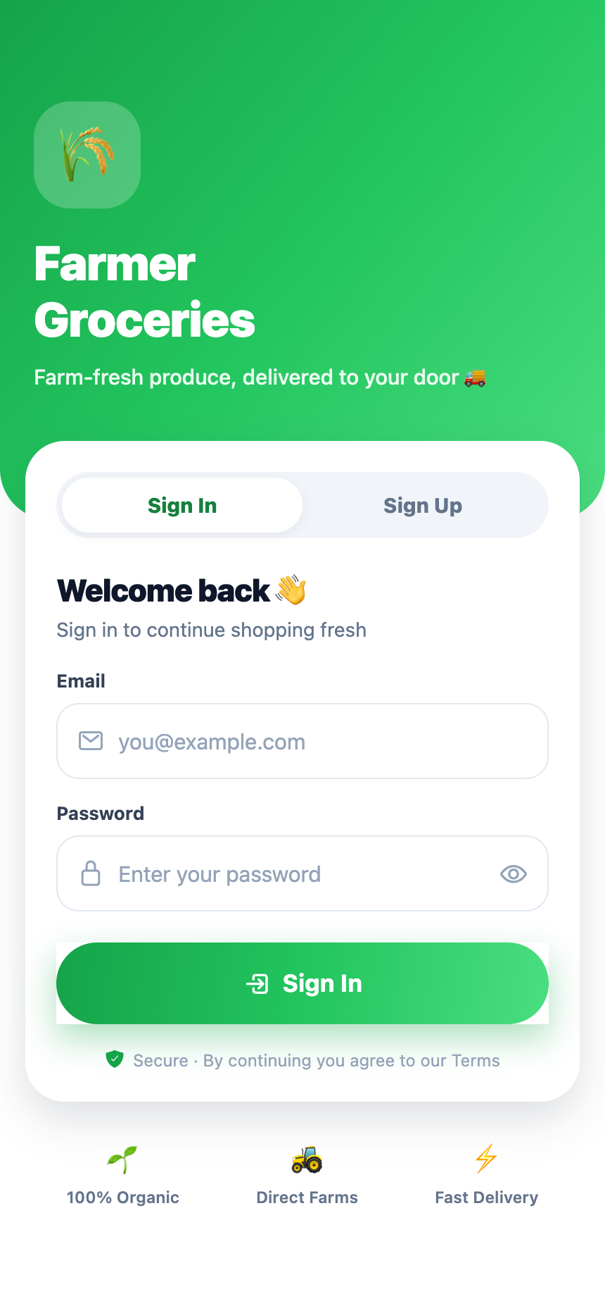 | 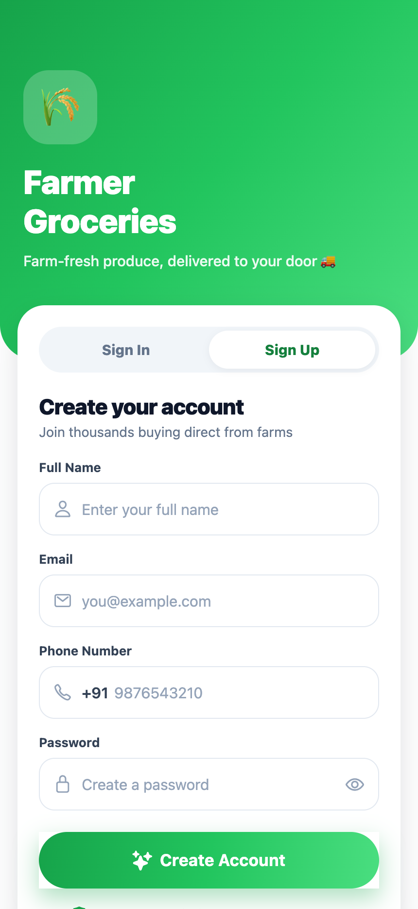 | 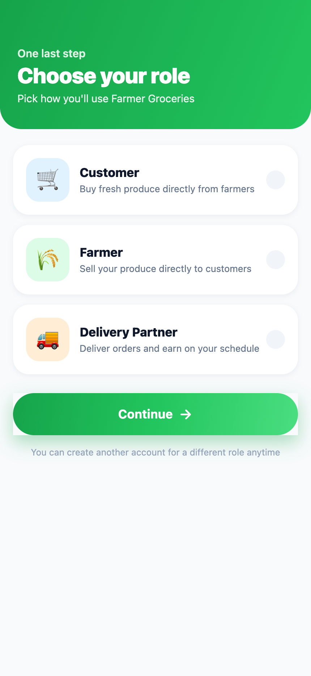 | 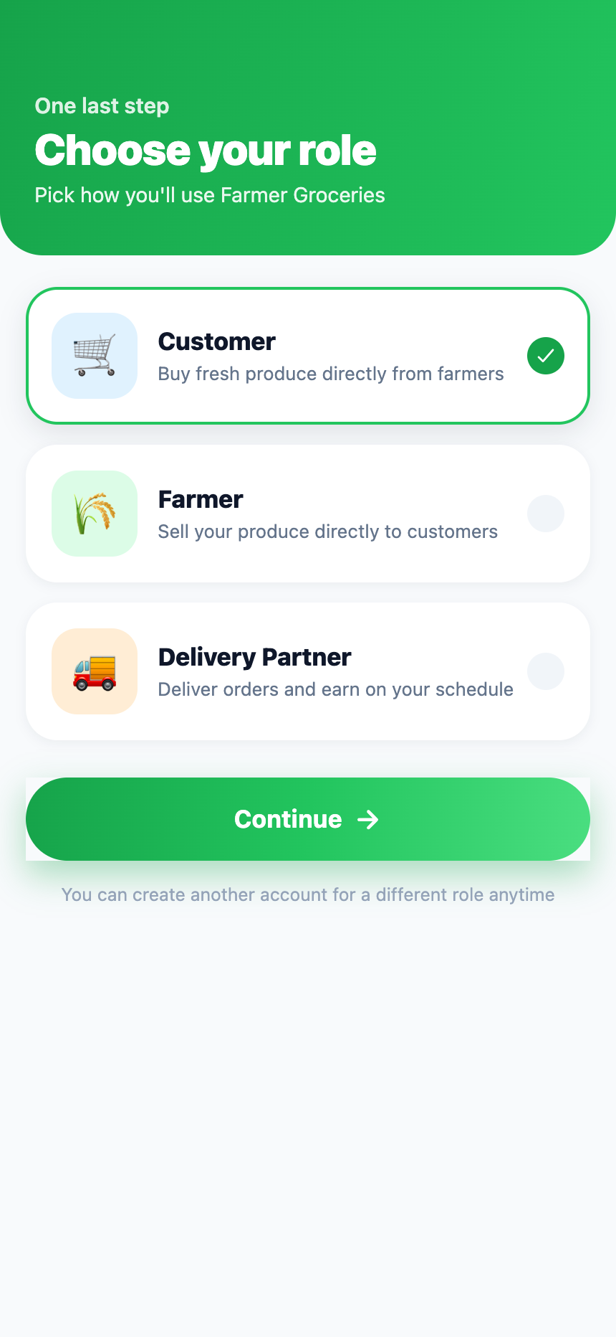
(a) Sign-in | (b) Sign-up with name and mobile | (c) Role selection | (d) Customer role selected
Figure 2.8 — Authentication and role selection. The segmented control switches
between sign-in and sign-up in place; role selection is presented once and then persisted.
The login screen validates before it calls the network. Email format, password length and — for sign-up — name and a ten-digit mobile number are all checked locally, and each failure surfaces as a toast rather than an inline field error, which keeps the form compact on a small viewport:
const handleAuth = async () => {
if (!email || !password) return toast.show('Please enter email and password', 'error');
if (isSignUp && !name) return toast.show('Please enter your name', 'error');
if (isSignUp && !phone) return toast.show('Please enter your phone number', 'error');
if (!validateEmail(email.trim()))
return toast.show('Please enter a valid email address', 'error');
if (password.length < 6)
return toast.show('Password must be at least 6 characters', 'error');
if (isSignUp && !validatePhone(phone.replace(/\D/g, '').slice(-10)))
return toast.show('Enter a valid 10-digit mobile number', 'error');
/* … registration or sign-in … */
};
Listing 2.9 — Client-side credential validation (app/(auth)/login.tsx).

2.5.2 Customer Module
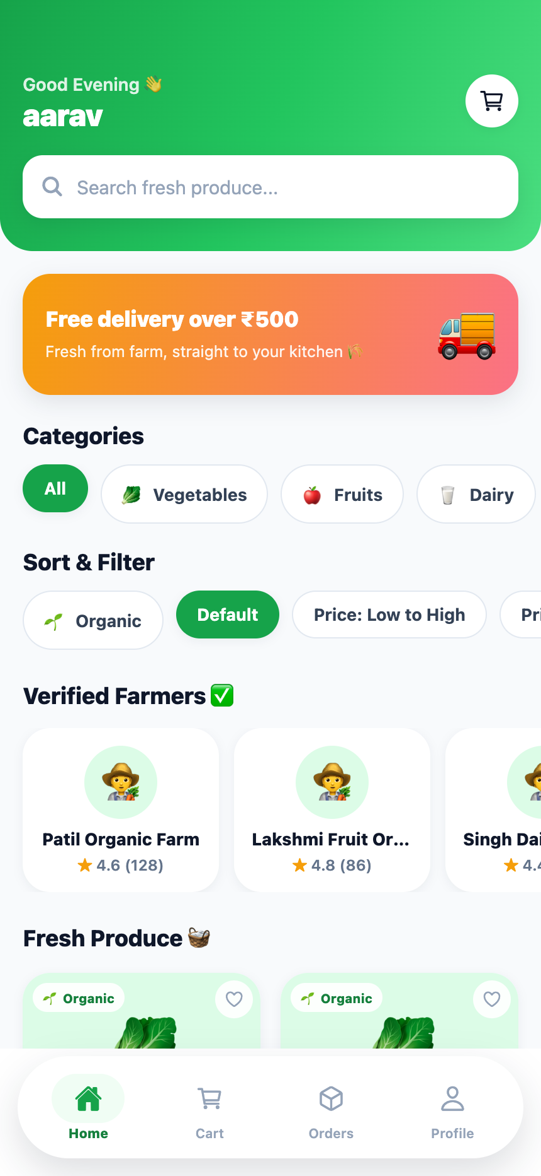 | 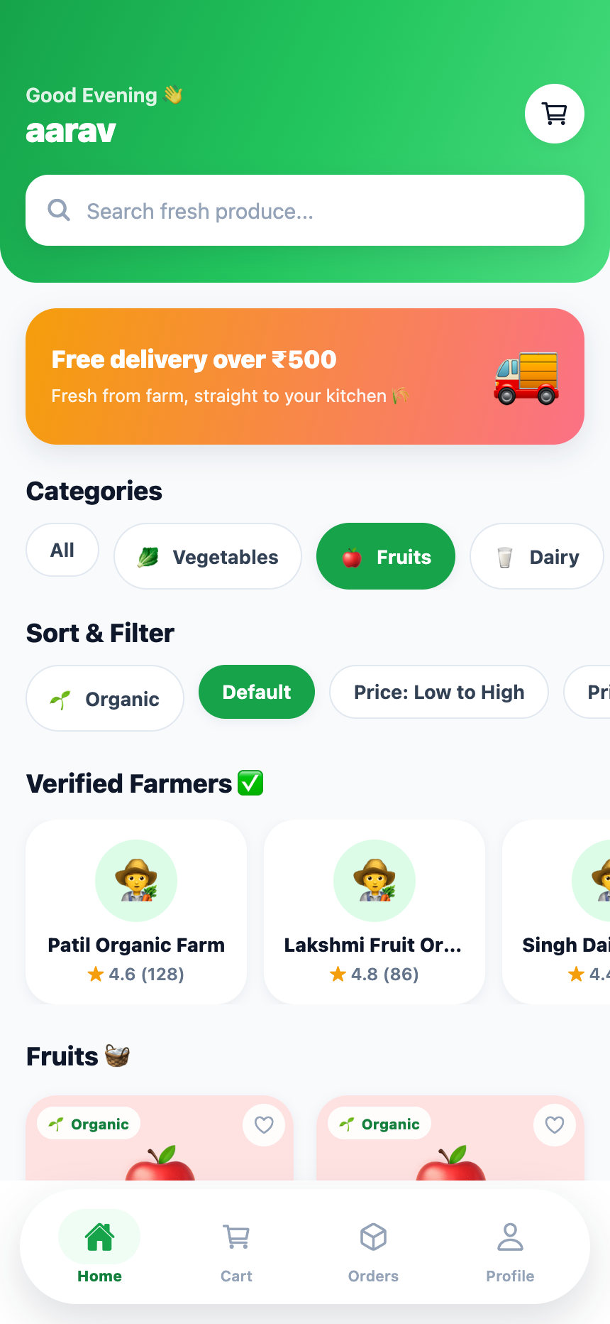 | 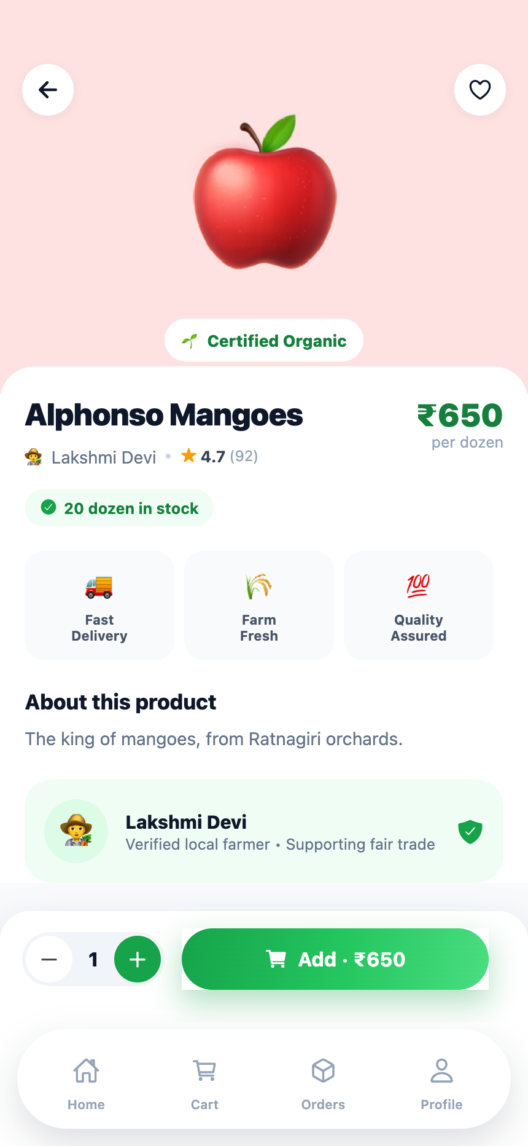
(a) Catalogue with categories, sort and filter controls, and verified farmers | (b) Catalogue filtered to the Fruits category | (c) Product detail with stock badge, quantity stepper and farmer attribution
Figure 2.9 — Customer module: catalogue discovery, filtering and product detail.
Search, organic filtering and price sorting are composed as a single derived list rather than three separate passes over state, so the rendered grid is always a pure function of the loaded products and the four control values:
const filteredProducts = products
.filter((p) => p.name.toLowerCase().includes(searchQuery.toLowerCase())
|| (p.description ?? '').toLowerCase().includes(searchQuery.toLowerCase()))
.filter((p) => !organicOnly || p.isOrganic)
.sort((a, b) => (sortBy === 'price_asc' ? a.pricePerUnit - b.pricePerUnit
: sortBy === 'price_desc' ? b.pricePerUnit - a.pricePerUnit
: 0));
Listing 2.10 — Composed catalogue filtering and sorting (app/(customer)/home.tsx).
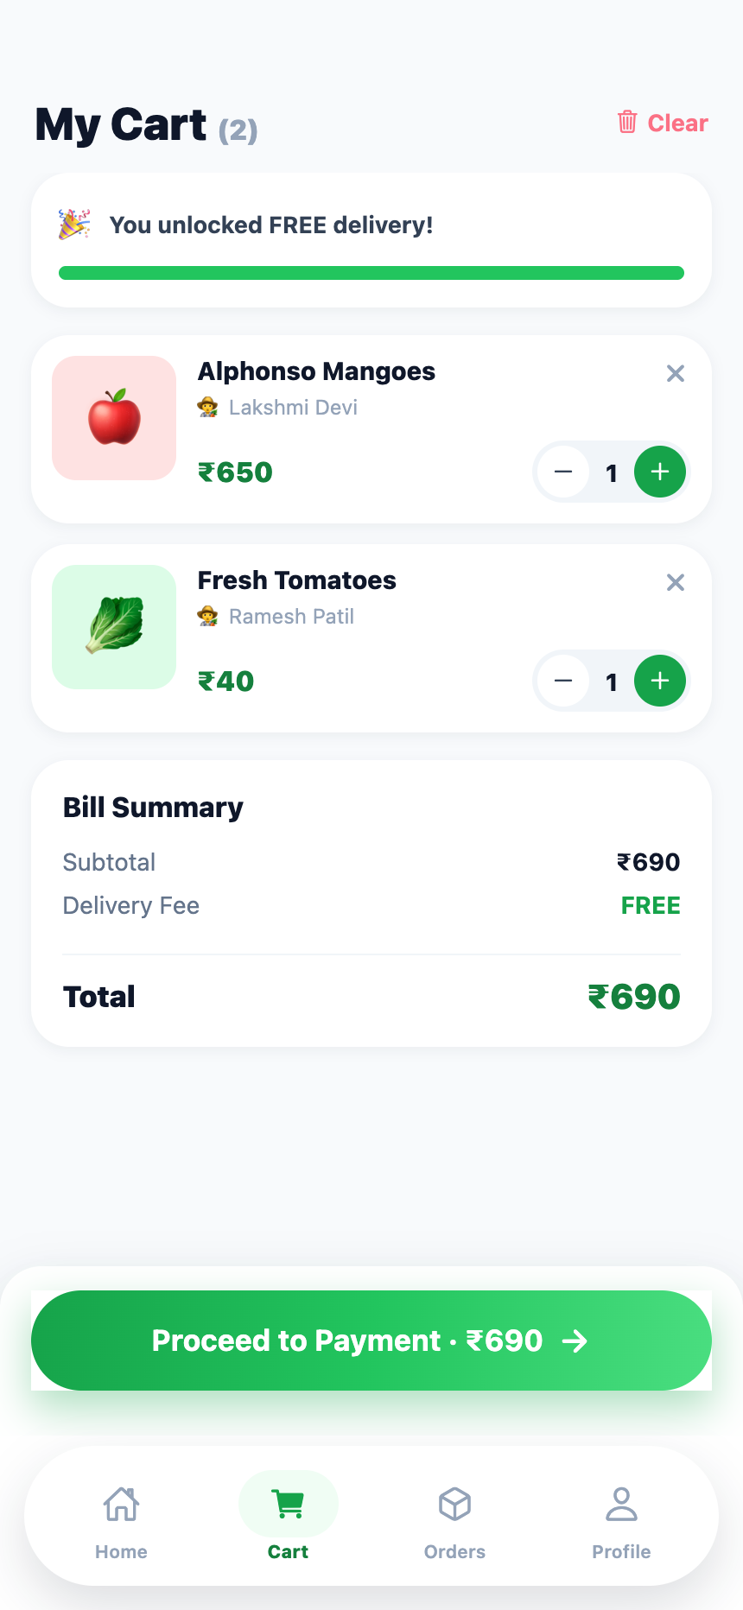 | 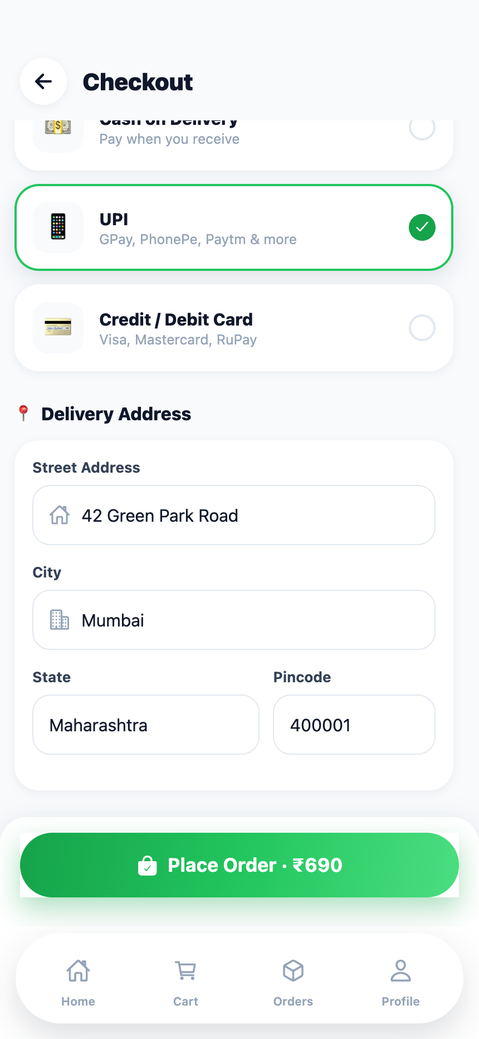 | 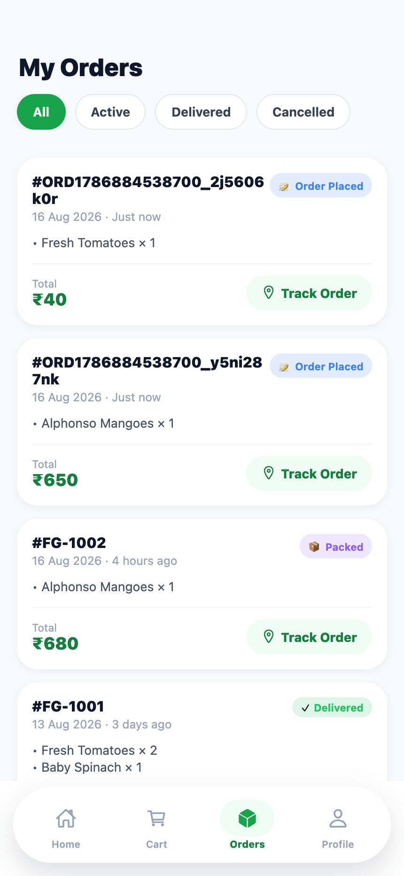
(a) Cart — free-delivery progress met, per-line steppers, bill summary | (b) Checkout — payment method selection and validated address entry | (c) Order history immediately after placement, showing the per-farmer split
Figure 2.10 — Customer module: cart, checkout and order history. The cart in (a)
contains produce from two different farmers; (c) shows the two resulting orders.
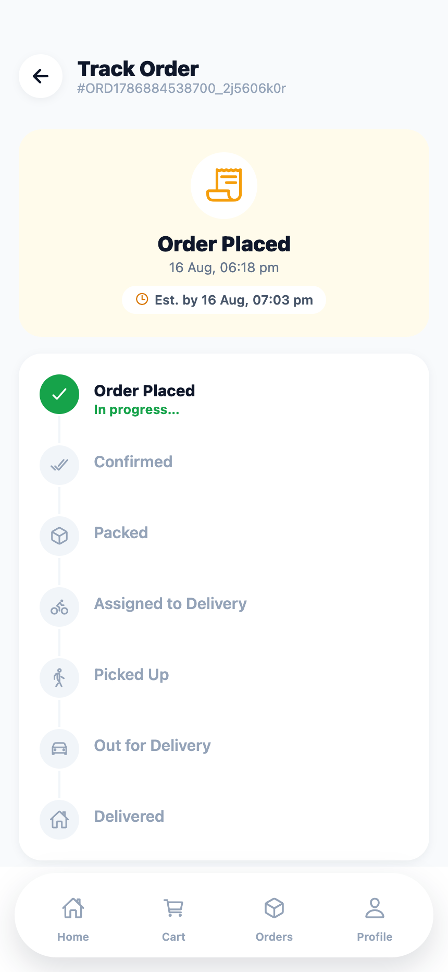 | 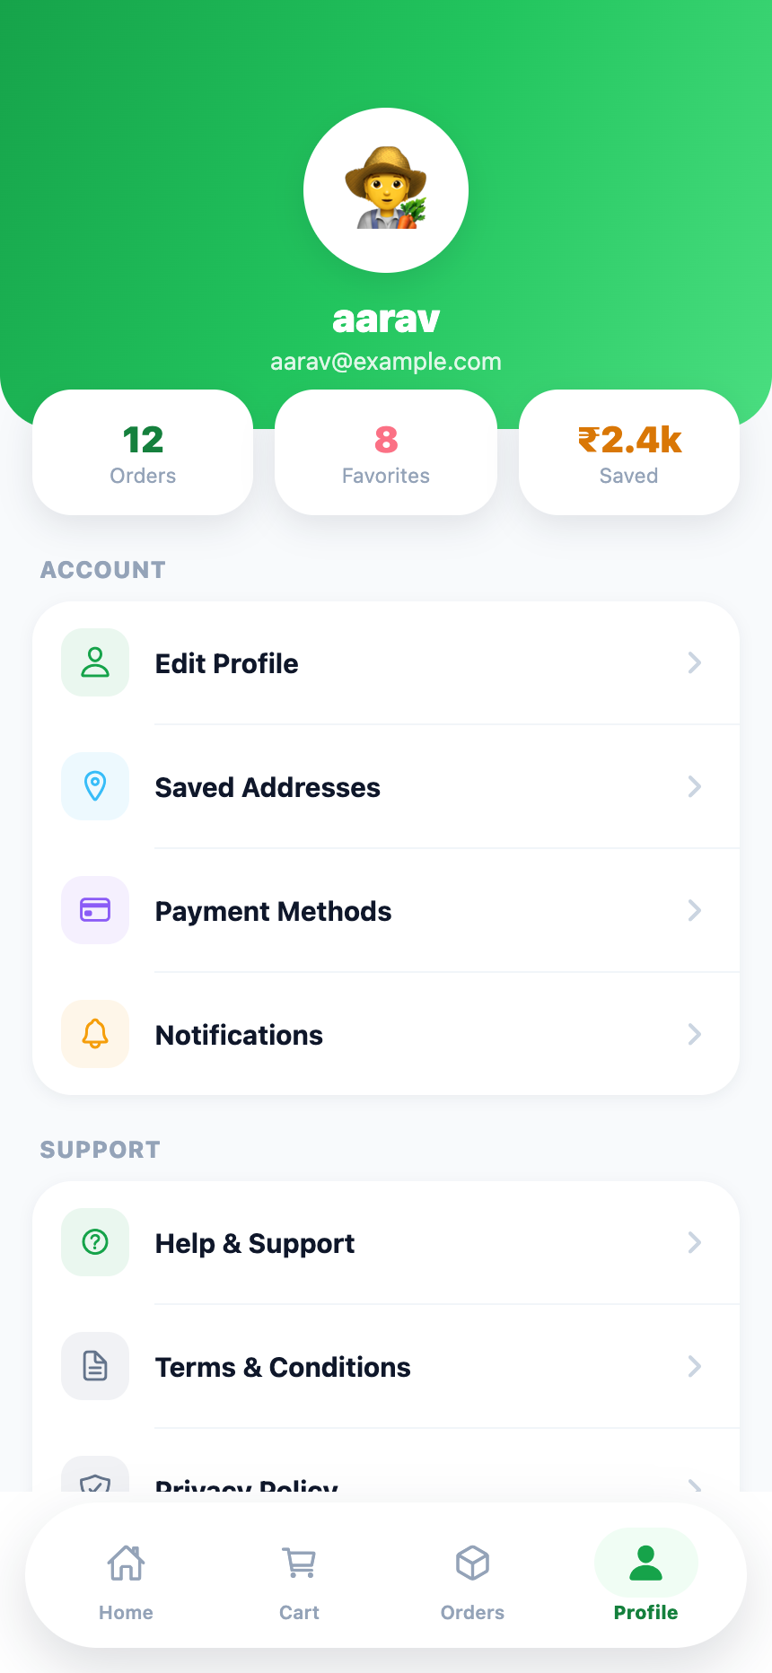
(a) Seven-stage tracking timeline with the current stage annotated and an estimated delivery time | (b) Customer profile with editable details, grouped account and support actions
Figure 2.11 — Customer module: order tracking and profile management.

2.5.3 Farmer Module
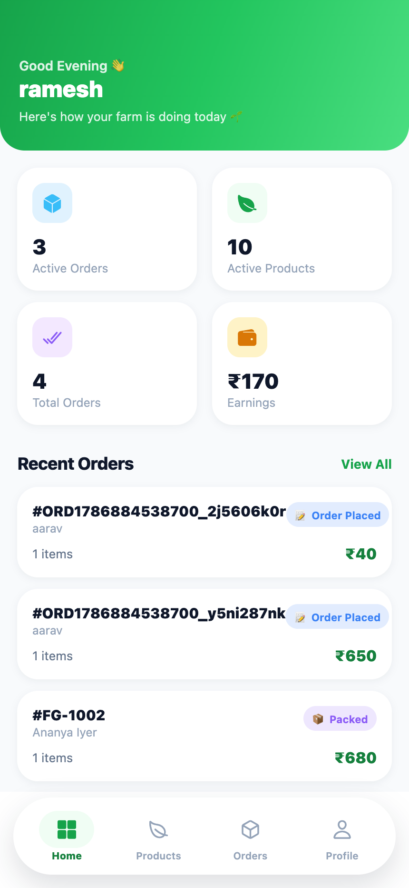 | 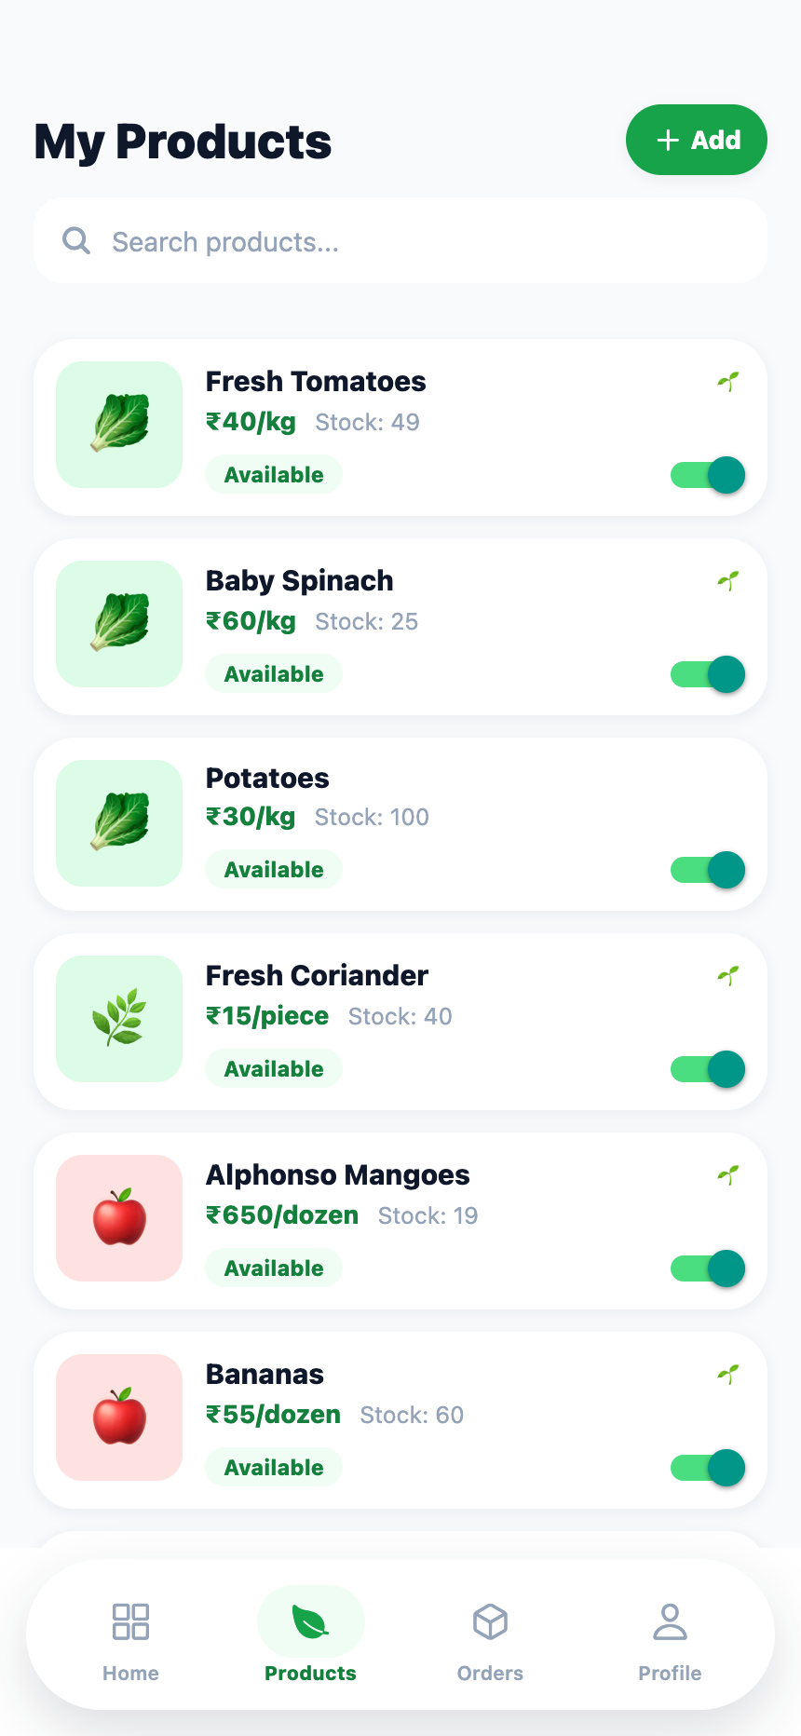 | 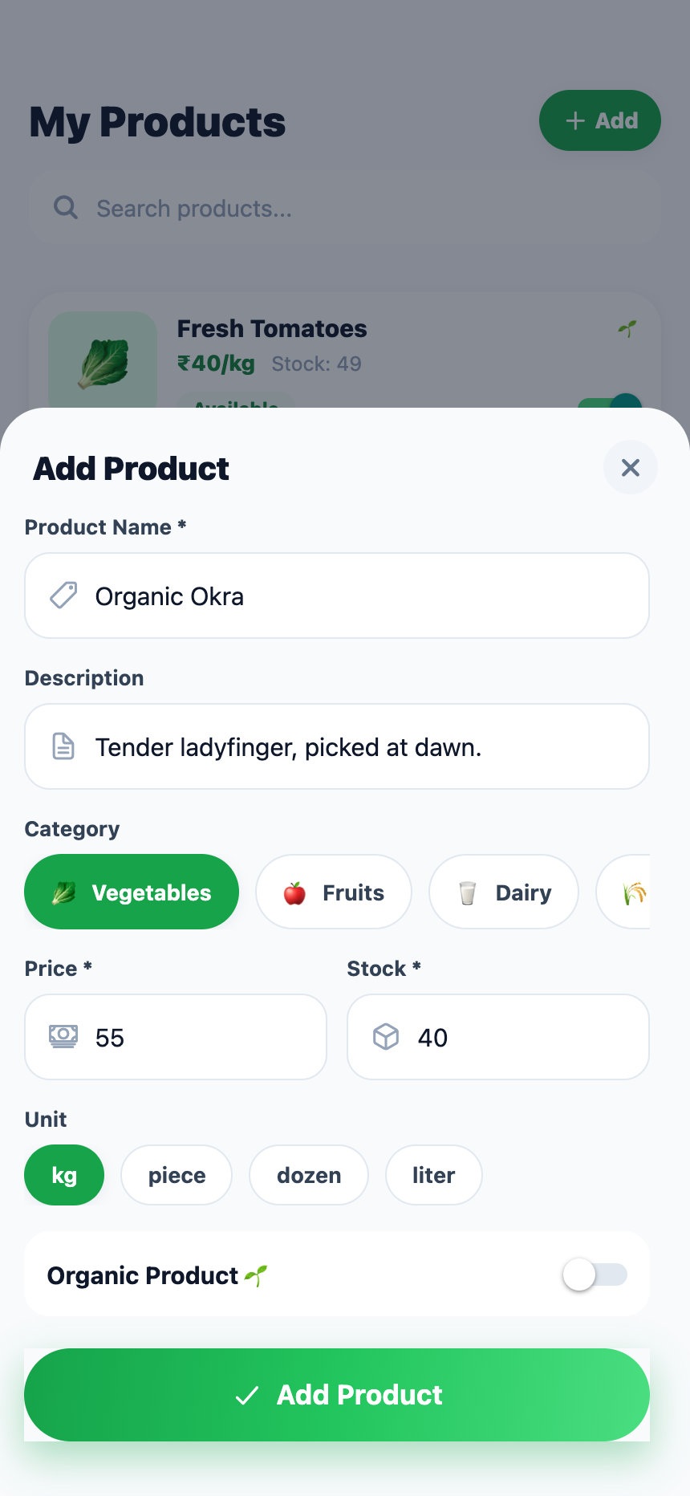 | 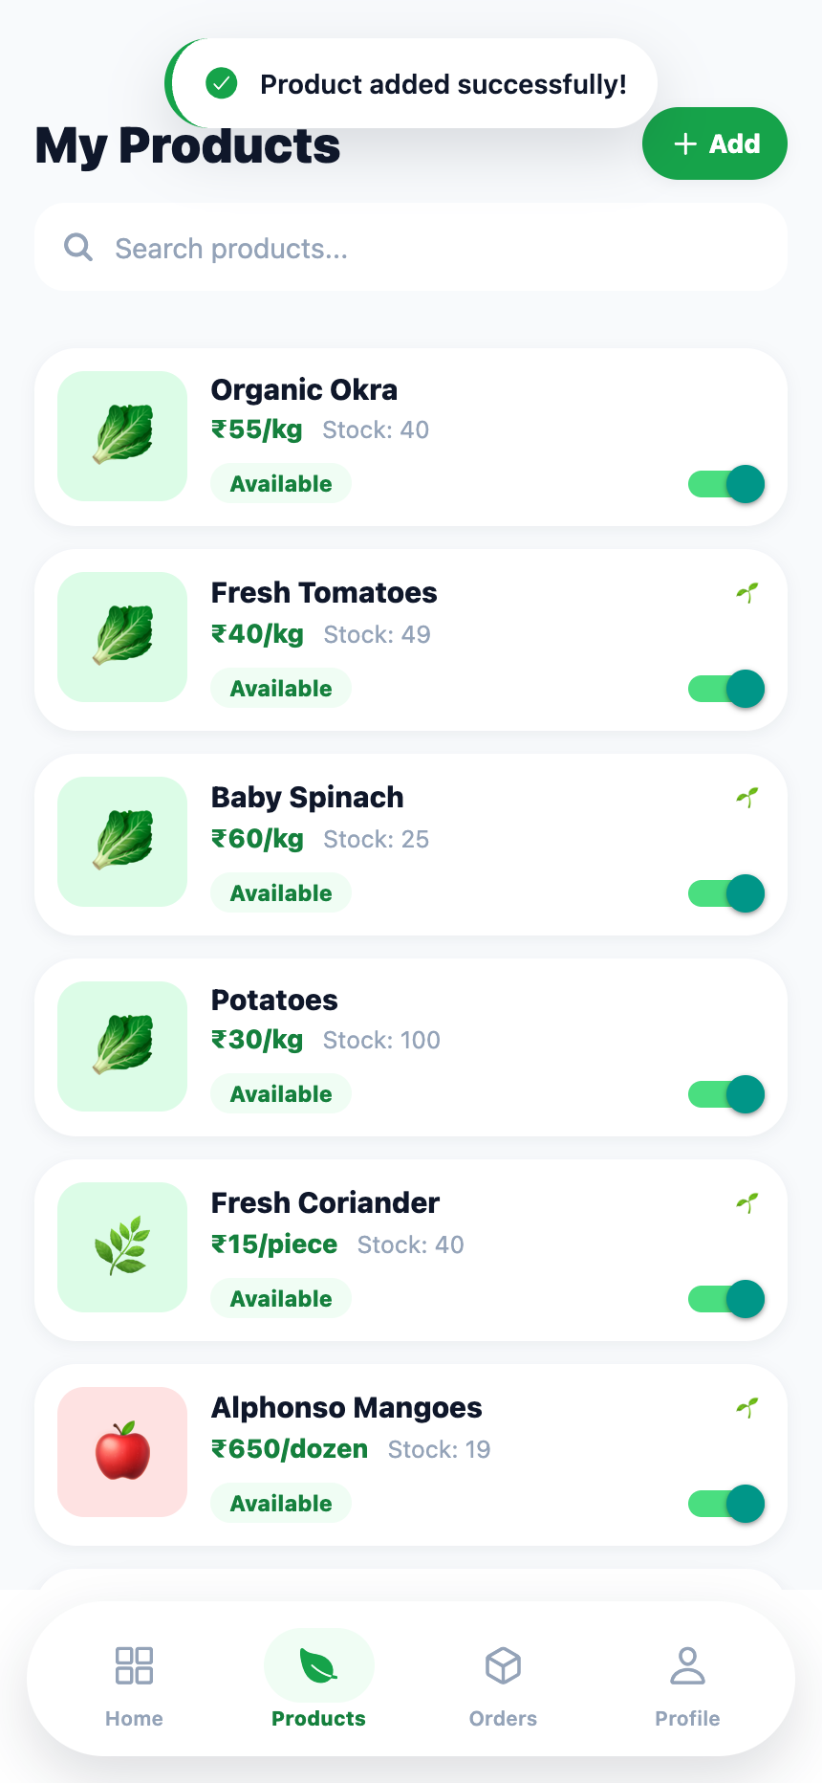
(a) Dashboard — four indicators and recent orders | (b) Inventory with search and visibility switches | (c) Product creation sheet | (d) Inventory after the new product is saved
Figure 2.12 — Farmer module: business dashboard, inventory management and product
creation. The dashboard in (a) reflects the two orders placed by the customer in Figure 2.10.
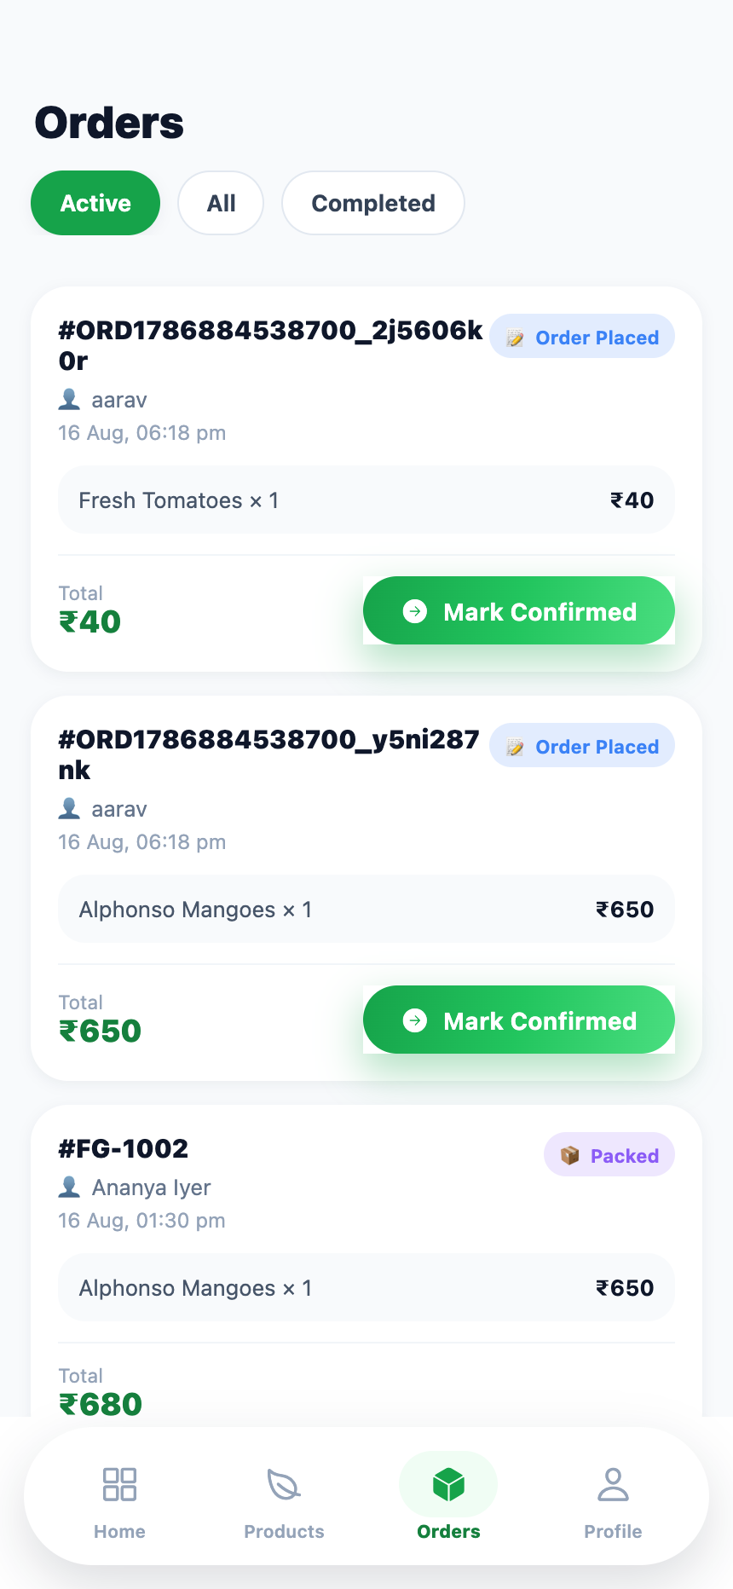 | 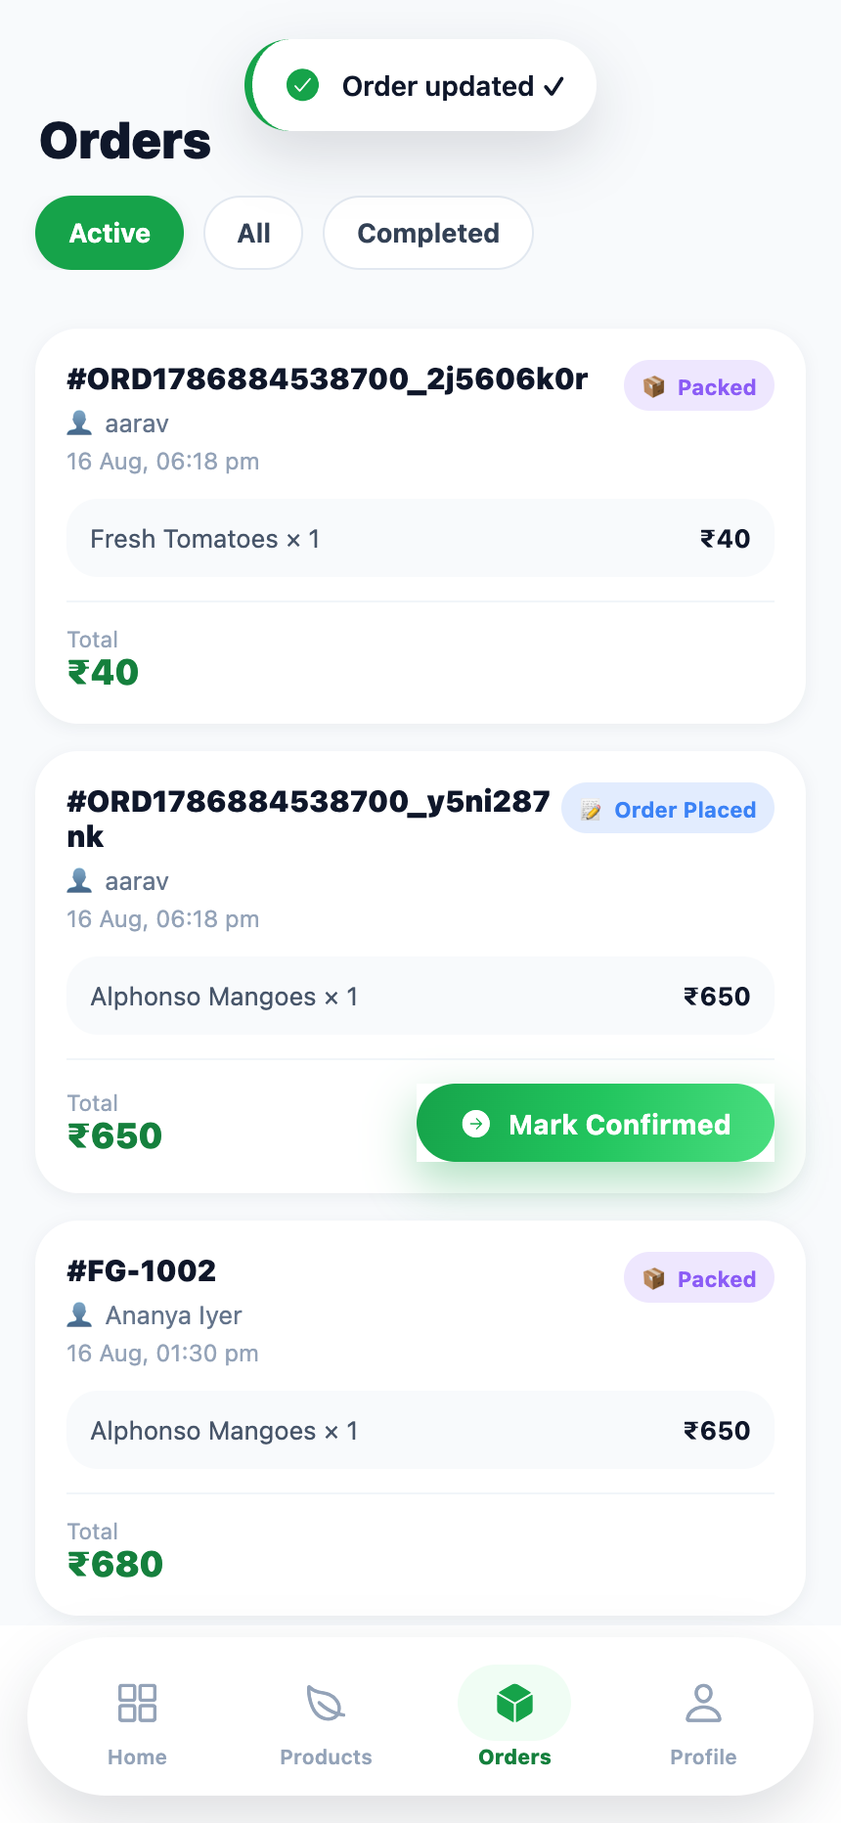
(a) Fulfilment queue filtered to active orders, each offering only its permitted next transition | (b) After confirming and packing, the order shows the Packed pill and offers no further farmer action
Figure 2.13 — Farmer module: order fulfilment and the boundary of farmer authority.
The bound on farmer authority is expressed as data, not as branching. A partial record maps only the two transitions a farmer may originate; any status absent from the map yields no action button at all, so the interface cannot offer an illegal transition:
const nextStatusMap: Partial<Record<OrderStatus, OrderStatus>> = {
placed: 'confirmed',
confirmed: 'packed',
};
const nextStatus = nextStatusMap[order.orderStatus];
/* … */
{nextStatus ? (
<Button label={`Mark ${ORDER_STATUS[nextStatus]?.label}`} size="sm"
icon="arrow-forward-circle"
onPress={() => handleUpdateStatus(order.id, order.orderStatus)} />
) : null}
Listing 2.11 — Transition table restricting farmer authority (app/(farmer)/orders.tsx).

2.5.4 Delivery Module
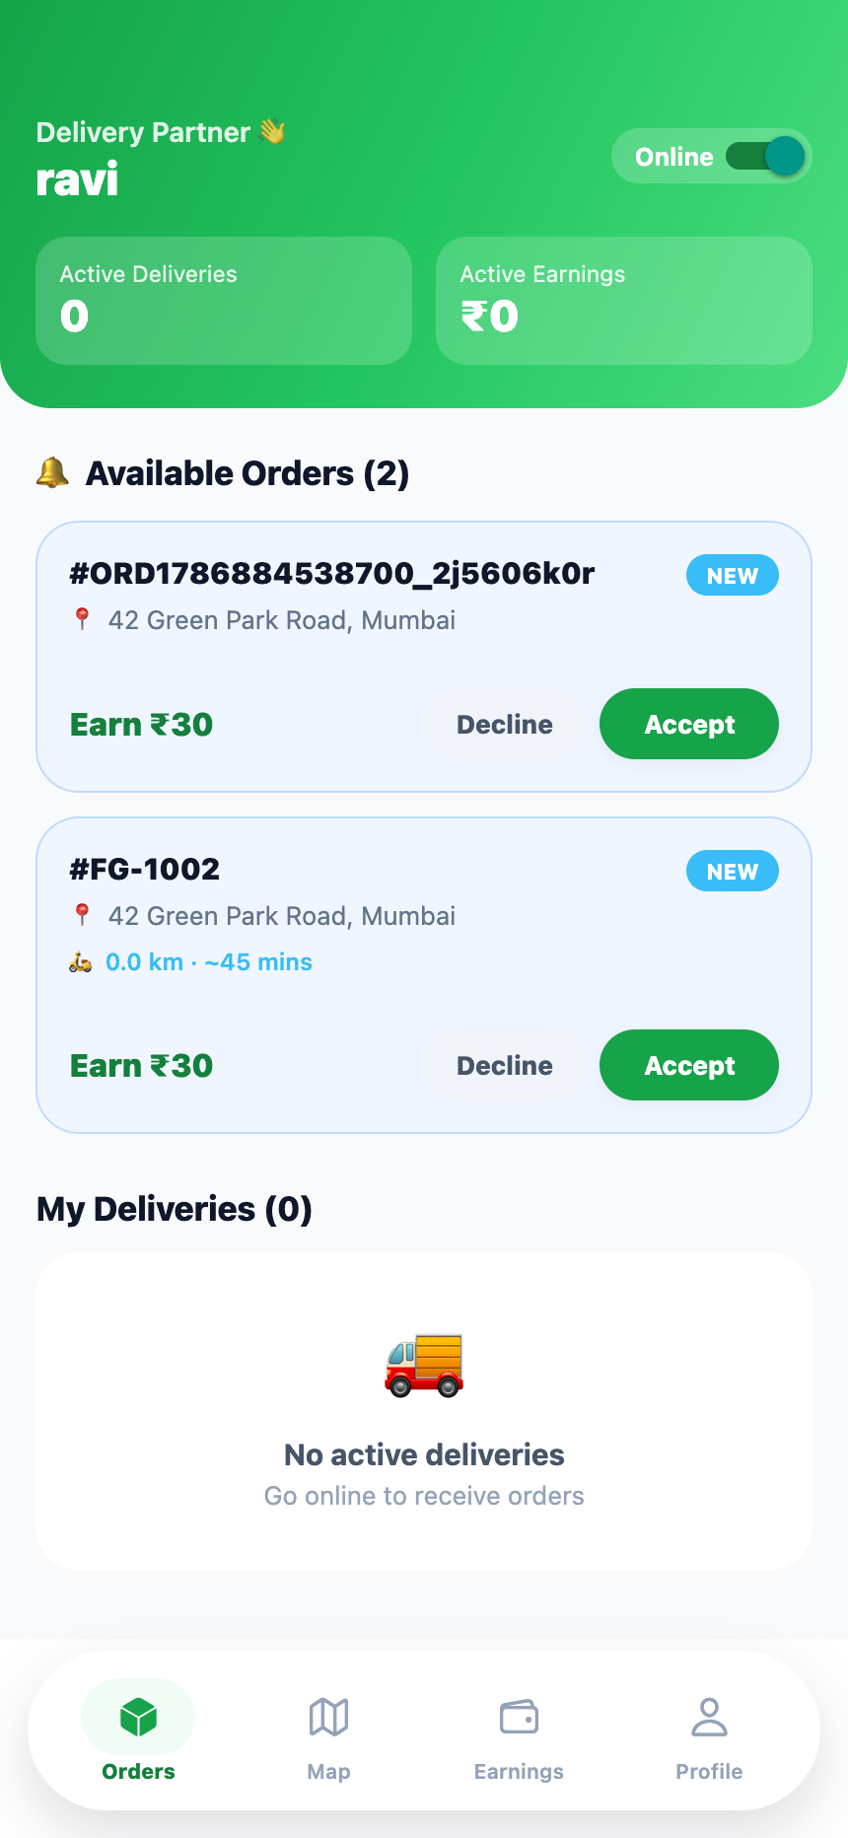 | 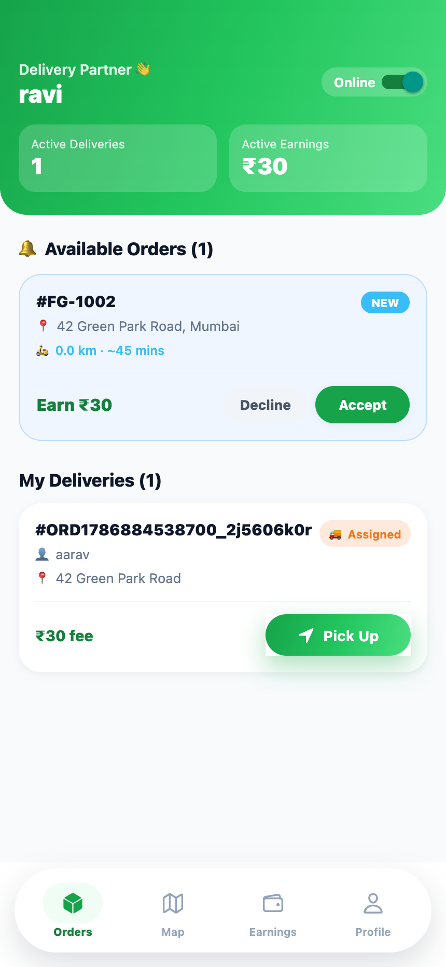 | 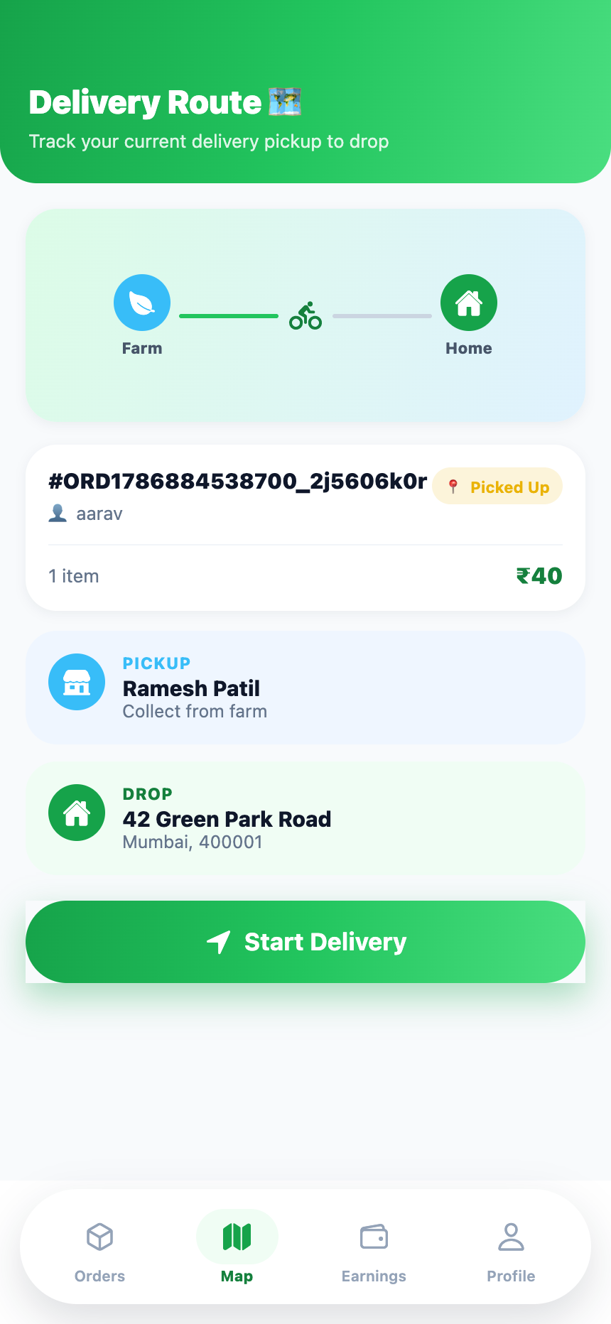 | 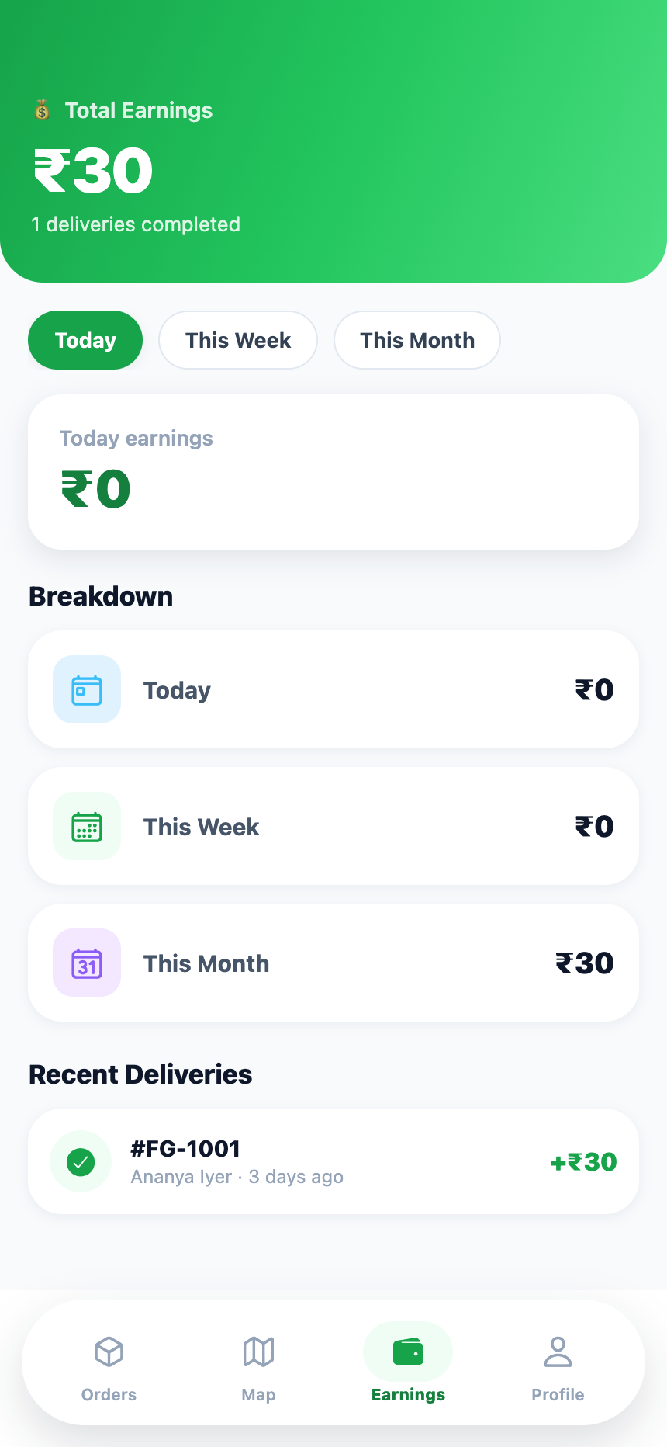
(a) Job board — unclaimed packed orders with distance and ETA | (b) After acceptance the job moves to My Deliveries | (c) Pickup-to-drop route for the in-flight delivery | (d) Period-wise earnings and completed deliveries
Figure 2.14 — Delivery module: job board, claimed deliveries, route view and
earnings. The first job in (a) is the order packed by the farmer in Figure 2.13.
Acceptance is the moment at which a job becomes exclusive to one partner. The status transition and the partner stamp are applied together, after which the order no longer satisfies the unclaimed-job predicate on any other partner's board:
const handleAcceptOrder = (orderId: string) => {
Alert.alert('Accept Order', 'Accept this delivery?', [
{ text: 'Cancel', style: 'cancel' },
{ text: 'Accept', onPress: async () => {
await SupabaseService.updateOrderStatus(orderId, 'assigned');
await SupabaseService.updateOrder(orderId, { deliveryPartnerId: user?.id });
loadOrders();
toast.show('Order accepted 🚚', 'success');
} },
]);
};
// the board only offers jobs that are packed, unclaimed and not locally declined
const availableOrders = isAvailable
? orders.filter((o) => !o.deliveryPartnerId
&& o.orderStatus === 'packed'
&& !declinedOrderIds.has(o.id))
: [];
Listing 2.12 — Job acceptance and the unclaimed-job predicate (app/(delivery)/orders.tsx).
Earnings are derived rather than stored. A single pass over the partner's delivered orders accumulates four running totals against period boundaries computed once, which avoids three separate filtered traversals of the same array:
const stats = deliveredOrders.reduce((acc, order) => {
const c = new Date(order.createdAt);
acc.total += DELIVERY_FEE;
if (c >= startOfMonth) acc.month += DELIVERY_FEE;
if (c >= startOfWeek) acc.week += DELIVERY_FEE;
if (c >= startOfToday) acc.today += DELIVERY_FEE;
return acc;
}, { today: 0, week: 0, month: 0, total: 0 });
Listing 2.13 — Single-pass earnings aggregation (app/(delivery)/earnings.tsx).

2.5.5 Design System
Consistency across eighteen screens is maintained by a single token module. Palette entries, gradients, corner radii and a cross-platform elevation helper are declared once as plain values, so they can be consumed identically by NativeWind utility classes and by inline styles. The elevation helper is the only place in the codebase that has to know that web renders shadows as box-shadow while native platforms use shadow offsets and Android elevation:
const shadow = (y: number, blur: number, opacity: number, radius = 0): ViewStyle =>
Platform.select({
web: { boxShadow: `0px ${y}px ${blur}px rgba(15, 23, 42, ${opacity})` },
default: {
shadowColor: '#0f172a',
shadowOffset: { width: 0, height: y },
shadowOpacity: opacity,
shadowRadius: radius || blur / 2,
elevation: y + 2,
},
}) as ViewStyle;
export const shadows = { sm: shadow(2, 8, 0.06), md: shadow(6, 18, 0.10), lg: shadow(12, 30, 0.14) };
export const radii = { sm: 10, md: 16, lg: 22, xl: 28, pill: 999 };
Listing 2.14 — Cross-platform elevation tokens (src/theme.ts).

CHAPTER 3: TESTING, VALIDATION AND RESULTS

3.1 Test Plan

3.1.1 Testing Strategy
The system under test is a client application whose correctness is dominated by two concerns: whether state changes made by one role become correctly visible to the others, and whether invalid input is refused before it reaches persistence. Neither concern is well served by unit tests of individual functions in isolation, because both are properties of a sequence of interactions across several screens. The strategy adopted therefore places its weight on automated end-to-end testing against the running application, supported by static verification.
Three complementary levels were applied:
1. Static verification. The entire source tree is compiled with tsc --noEmit under strict. Because the domain model uses string-literal unions for roles, order statuses and product categories, a large class of defects — an unhandled status, a mistyped category, a nullable value dereferenced without a guard — is rejected at this level before any test is run.
2. Functional end-to-end testing. The application is served on the web target and driven through a real Chrome instance over the DevTools Protocol. The suite, committed to the repository as tests/e2e/walkthrough.mjs, signs in as each of the three roles in turn and performs the complete business cycle: a customer places an order, the same order is confirmed and packed by the farmer, and the same order is then claimed and advanced by a delivery partner. This exercises cross-role propagation directly, because each role observes state written by the previous one.
3. Validation and negative testing. A second committed suite, tests/e2e/validation.mjs, deliberately supplies invalid input at every guarded boundary — malformed credentials, an unselected role, a sub-minimum cart, a blank address, an invalid pincode, a product created with mandatory fields empty — and asserts that the application refuses the operation and reports the specific reason. This suite also verifies two stateful properties that are easy to regress: that the cart survives an application restart, and that navigating directly to another role's URL is redirected.
Both suites exit with a non-zero status when any case fails, so they can be wired into a continuous integration pipeline unchanged, and both are runnable by any reader of the repository with npm test once npm run web is serving the application.
Interaction with the application is performed through DOM-level event dispatch rather than synthetic mouse input at coordinates. This was a necessary adaptation: react-native-web routes presses through its own responder system, which does not consistently observe input synthesised by the DevTools Protocol on every screen. Dispatching the full pointer and mouse event chain to the nearest pressable ancestor of a located text node reproduces a genuine user press reliably. Controlled text inputs are driven through the underlying value setter followed by an input event, which is the mechanism React itself observes.

3.1.2 Tools Used
Tool / component | Version | Purpose in the test process
TypeScript compiler | 5.9 | Static type verification of all 48 source files in strict mode.
Expo / Metro dev server | SDK 54 | Serves the web target under test at localhost:8081.
Google Chrome (headless) | Current stable | Execution host for the application under test.
Puppeteer Core | 23.x | Drives Chrome over the DevTools Protocol; performs presses, text entry, navigation, dialogue handling and screen capture.
tests/e2e/walkthrough.mjs | In repository | 25-case functional scenario across all three roles; run with npm run test:e2e. Captures the 22 screenshots reproduced in §2.5 when E2E_SHOTS=1 is set.
tests/e2e/validation.mjs | In repository | 15 negative and stateful assertions; run with npm run test:validation.
tests/e2e/helpers.mjs | In repository | Shared press, text-entry, sign-in and assertion helpers used by both suites.
Device emulation | 430 × 932 @ 2× | Handset-equivalent viewport for both capture and interaction.
Table 3.1 — Test environment and tooling.

3.2 Test Cases
Forty test cases were executed: twenty-five functional cases tracing the complete order lifecycle across the three roles, and fifteen validation cases probing the guarded boundaries. All inputs, expected outputs and observed statuses below are taken from the recorded execution logs of the two automated suites; no result is asserted from inspection of the source alone.
ID | Description | Input | Expected output | Status
TC-F01 | Unauthenticated launch is redirected to sign-in | Cold start, empty device storage | Login screen is presented; no protected route is reachable | Pass
TC-F02 | Sign-up mode reveals the additional identity fields | Press Sign Up on the segmented control | Full name and phone number fields appear; primary action becomes Create Account | Pass
TC-F03 | Valid credentials sign the user in | aarav@example.com / test1234 | Session established; user without a role is routed to role selection | Pass
TC-F04 | Role selection routes to the correct workspace | Select Customer, press Continue | Role persisted; customer catalogue presented with the customer tab bar | Pass
TC-F05 | Catalogue loads products and verified farmers | Customer home on first load | Ten products in a two-column grid; verified-farmer carousel with ratings | Pass
TC-F06 | Category filter narrows the catalogue | Select the Fruits chip | Only fruit-category products remain; heading changes to Fruits | Pass
TC-F07 | Product detail opens with stock and pricing | Open Alphonso Mangoes | Detail screen shows ₹650 per dozen, in-stock badge, organic marker, quantity stepper | Pass
TC-F08 | Add to cart from the product detail screen | Press Add · ₹650 | Line added to the cart; badge increments; user returned to the catalogue | Pass
TC-F09 | Cart accepts produce from a second farmer | Open Fresh Tomatoes (₹40/kg), add one unit | Cart holds two lines belonging to two different farmers | Pass
TC-F10 | Cart totals and free-delivery state are correct | Cart containing ₹650 + ₹40 | Subtotal ₹690; delivery fee shown as FREE; total ₹690; progress bar complete | Pass
TC-F11 | Checkout accepts a payment method and a valid address | UPI; 42 Green Park Road, Mumbai, Maharashtra, 400001 | UPI card marked selected; address accepted; Place Order · ₹690 enabled | Pass
TC-F12 | Order placement splits the cart by farmer | Press Place Order | Two orders created — ₹650 and ₹40 — each against its own farmer; cart cleared | Pass
TC-F13 | Order history lists both orders newest first | Navigate to Orders | Both orders listed with Order Placed status pills, totals and a Track action | Pass
TC-F14 | Tracking timeline reflects the current stage | Track the ₹40 order | Stage 1 of 7 marked complete and annotated In progress…; estimated delivery 45 minutes after placement | Pass
TC-F15 | Customer profile presents identity and actions | Navigate to Profile | Name and email shown; account and support groups rendered; sign-out available | Pass
Table 3.2 — Functional test cases: authentication and customer module.
ID | Description | Input | Expected output | Status
TC-F16 | Farmer dashboard aggregates the newly placed orders | Sign in as ramesh@example.com, select Farmer | Active orders 3, active products 10, total orders 4, earnings ₹170; both new orders appear under Recent Orders | Pass
TC-F17 | Inventory lists owned products with stock state | Navigate to Products | All products listed with price per unit, stock, organic marker and an availability switch | Pass
TC-F18 | Product creation adds to inventory | Organic Okra, ₹55, stock 40, category Vegetables | Success toast; sheet dismissed; product appears at the head of the inventory list | Pass
TC-F19 | Order queue offers only the permitted next transition | Order in placed | Single action Mark Confirmed; no other transition offered | Pass
TC-F20 | Confirm transition is applied and history appended | Press Mark Confirmed, accept the dialogue | Status pill becomes Confirmed; action becomes Mark Packed | Pass
TC-F21 | Packing ends farmer authority over the order | Press Mark Packed, accept the dialogue | Status pill becomes Packed; no further action offered to the farmer | Pass
TC-F22 | Packed order becomes visible on the delivery job board | Sign in as ravi@example.com, select Delivery Partner | Job board lists the packed order as available with drop address and an Earn ₹30 label | Pass
TC-F23 | Acceptance claims the job exclusively | Press Accept, confirm | Order status becomes assigned, partner identifier stamped, job moves to My Deliveries and leaves the available list | Pass
TC-F24 | Delivery progression and route resolution | Press Pick Up; open the Map tab | Status becomes picked up; route screen resolves the in-flight delivery and shows farm pickup and customer drop with the order value | Pass
TC-F25 | Earnings aggregate delivered work by period | Open the Earnings tab | Total ₹30 over one completed delivery; today, week and month buckets computed against period boundaries; recent delivery listed | Pass
Table 3.3 — Functional test cases: farmer and delivery modules.
ID | Description | Input | Expected output (observed message) | Status
TC-V01 | Malformed email rejected at sign-in | “notanemail” / test1234 | “Please enter a valid email address”; no network call | Pass
TC-V02 | Short password rejected | aarav@example.com / “abc” | “Password must be at least 6 characters” | Pass
TC-V03 | Sign-up without a name rejected | Name blank, valid email and password | “Please enter your name” | Pass
TC-V04 | Invalid Indian mobile number rejected | Phone “12345” | “Enter a valid 10-digit mobile number” | Pass
TC-V05 | Continue without a role selection rejected | Press Continue with nothing selected | “Please select a role to continue”; user remains on role selection | Pass
TC-V06 | Selected role lands on the correct workspace | Select Customer, continue | Customer catalogue rendered (“Fresh Produce” section present) | Pass
TC-V07 | Direct URL into another role's group is refused | Navigate to /(farmer)/dashboard as a customer | Guard redirects to the customer catalogue | Pass
TC-V08 | Checkout blocked below the minimum order value | Cart containing one item at ₹15 | “Add ₹85 more to checkout”; checkout not entered | Pass
TC-V09 | Checkout permitted once the minimum is met | Cart topped up to ₹665 | Checkout screen presented with the delivery address form | Pass
TC-V10 | Order rejected with an incomplete address | All address fields blank | “Please fill in all address fields”; no order created | Pass
TC-V11 | Order rejected with a malformed pincode | Pincode “0400” | “Enter a valid 6-digit pincode”; no order created | Pass
TC-V12 | Cart survives an application restart | Full page reload with a populated cart | Cart rehydrated from device storage with both lines intact | Pass
TC-V13 | Free-delivery waiver applied above the threshold | Cart subtotal ₹665 | Delivery fee rendered as FREE in the bill summary | Pass
TC-V14 | Farmer role lands on the farmer dashboard | Sign in, select Farmer | Farmer dashboard rendered with the farm greeting | Pass
TC-V15 | Product creation rejected with mandatory fields empty | Submit the creation sheet with no input | “Please fill all required fields”; sheet remains open, nothing persisted | Pass
Table 3.4 — Validation and negative test cases.

3.3 Results and Analysis

3.3.1 Execution Record
Figure 3.1 reproduces the console output of the functional walkthrough. Each captured screen is written as evidence at the point in the scenario at which it was reached, and each dialogue interception is logged, so the transcript is a complete record of what the automation did rather than a summary of it.
▶ Login screen ▶ Track order
📸 01-login.png 📸 11-track-order.png
▶ Sign-up form ▶ Customer profile
📸 02-signup.png 📸 12-customer-profile.png
▶ Sign in as customer ▶ Sign in as farmer
📸 03-role-select.png 📸 13-farmer-dashboard.png
▶ Select Customer role ▶ Farmer products
📸 04-role-selected.png 📸 14-farmer-products.png
📸 05-customer-home.png ▶ Add product
▶ Category filter 📸 15-farmer-add-product.png
📸 06-customer-home-category.png 📸 16-farmer-products-added.png
▶ Product detail ▶ Farmer orders
📸 07-product-detail.png 📸 17-farmer-orders.png
▶ Second product 💬 Update Order
▶ Cart 💬 Update Order
📸 08-cart.png 📸 18-farmer-orders-packed.png
▶ Checkout ▶ Sign in as delivery partner
📸 09-checkout.png 📸 19-delivery-orders.png
▶ Place order ▶ Accept and advance delivery
📸 10-customer-orders.png 💬 Accept Order
📸 20-delivery-my-deliveries.png
💬 Update Status
▶ Delivery route
📸 21-delivery-route.png
▶ Delivery earnings
📸 22-delivery-earnings.png
✅ Screenshots written — 22 captures, 0 failed steps
Figure 3.1 — Console transcript of the automated end-to-end
walkthrough (▶ step, 📸 evidence capture, 💬 intercepted confirmation dialogue).
The validation suite reported 15 passed, 0 failed on its final run, with each assertion matching against the specific message rendered by the application rather than merely against the absence of a state change.

3.3.2 Observations
Cross-role propagation is correct and immediate. The most valuable result of the walkthrough is not that any single screen renders, but that a single order object is observed correctly by three different users in sequence. Figure 3.2 traces the order created in TC-F12 through every subsequent assertion. Each arrow is a transition performed by one role and independently observed by the next.
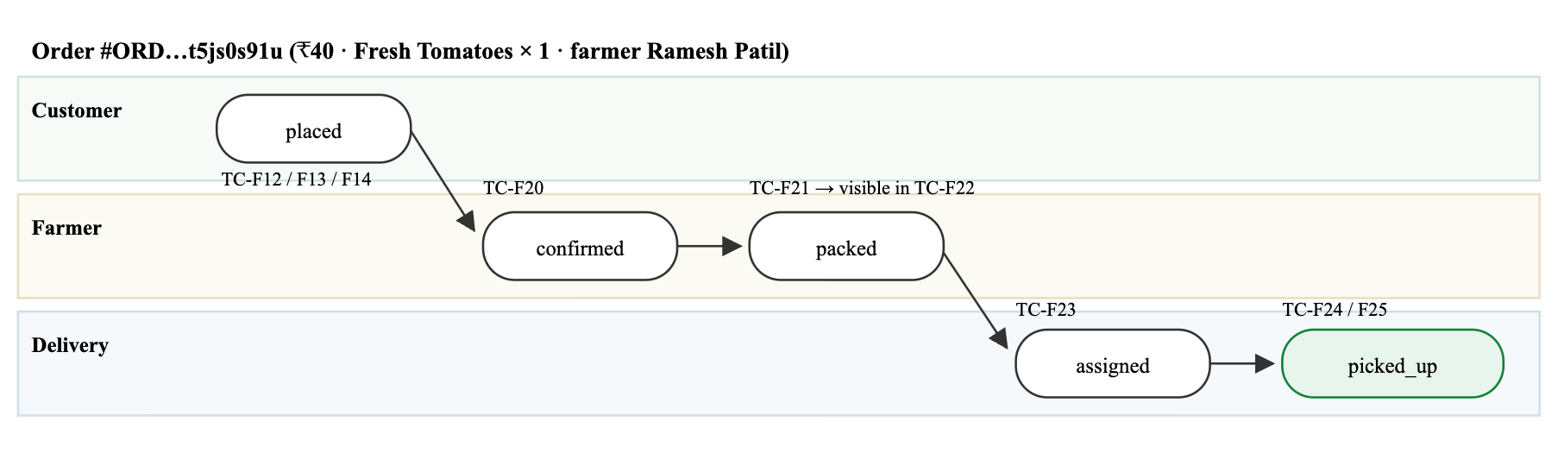
Figure 3.2 — Cross-role propagation of a single order observed during
the walkthrough, annotated with the test case that asserted each transition.
Derived values were correct at every observation point. The farmer dashboard independently recomputed its indicators after the customer's orders were created and reported active orders 3, total orders 4 and earnings ₹170 — earnings correctly excluding the two undelivered orders and counting only the completed one. The delivery earnings screen likewise reported ₹30 total against one completed delivery, with the month bucket populated and the today and week buckets at zero, which is the correct outcome for a delivery dated three days earlier. These figures were not asserted in advance; they were read back from the running application and checked against the rules in Table 2.4.
Rule enforcement is consistent because the rules are centralised. The minimum order value, free-delivery threshold and delivery fee were each observed to act identically in the cart, at checkout and in the earnings calculation, which is a direct consequence of their being defined once in src/constants/index.ts rather than restated per screen.
Authority partitioning held under direct attack. TC-V07 navigated straight to a farmer URL while authenticated as a customer and was redirected, confirming that the guard operates on the URL segment rather than merely hiding navigation controls.

3.3.3 Defects Found and Resolved During Testing
Two issues were identified while constructing the test harness, and both were traced to the interaction between react-native-web and synthesised input rather than to application logic. First, presses synthesised as coordinate-based mouse input were ignored on screens reached by a router replacement; dispatching the full pointer and mouse event chain to the pressable ancestor resolved this. Second, controlled text inputs did not receive focus from synthesised clicks on the checkout form, so keystrokes were discarded; driving the value through React's observed setter resolved this. Both findings are recorded here because they materially affect anyone attempting to automate a react-native-web application, and because the first run of the walkthrough failed at the checkout step precisely for the second reason — the empty address form is visible in that run's captured evidence.

3.3.4 Non-Functional Measurements
Property | Measurement | Method and remarks
Static type errors | 0 | npx tsc --noEmit across 48 files in strict mode; clean exit.
Web bundle composition | 1,464 modules | Reported by Metro when bundling expo-router/entry.js for the web target.
Incremental bundle time | 0.79 s | Metro warm rebuild of the web bundle on the development machine.
Screen transition responsiveness | No observable stall | All 25 functional cases completed within their allotted settle windows; no step required a retry.
Catalogue filtering | Client-side, single pass | Search, organic filter and sort are composed over the loaded array; only category changes re-query the source.
State restoration | Correct across cold start | Cart, user and role rehydrate from device storage; Date fields revived rather than left as strings.
Cross-platform rendering | Verified on web at 430 × 932 | Android and iOS render through the same component tree; the responsive shell constrains the layout to a phone-width column on wide viewports.
Table 3.5 — Non-functional observations and measurements.
Test category | Executed | Passed | Failed | Pass rate
Functional — authentication and customer | 15 | 15 | 0 | 100%
Functional — farmer and delivery | 10 | 10 | 0 | 100%
Validation and negative | 15 | 15 | 0 | 100%
Total | 40 | 40 | 0 | 100%
Static verification (tsc --noEmit) | 48 files | 48 | 0 | 100%
Table 3.6 — Consolidated test execution summary.

3.3.5 Limitations of the Test Effort
Three limitations should be stated plainly. The committed suites are integration tests; there is no unit test runner in the project, so the pure helper functions — Haversine distance, currency and date formatting, cancellation eligibility — are covered only indirectly through the interfaces that call them. Testing was performed against the web target only; while Android and iOS execute the same component tree, platform-specific behaviour such as haptic feedback and native modal presentation was not exercised automatically. Finally, the suites ran against the on-device data layer, so the Supabase-backed branch of each service method — its query construction and its snake_case-to-camelCase mapping — was verified statically by the compiler but not exercised at run time. All three gaps are carried forward into §6.3 and §6.4.

CHAPTER 4: EXECUTION / DEPLOYMENT DETAILS

4.1 Execution Environment
The application is developed and executed through the Expo managed workflow, which means no native toolchain is required for day-to-day development: the JavaScript bundle is served by Metro and executed either inside the Expo Go client on a physical device or in a browser through react-native-web. A native toolchain becomes necessary only when producing store-ready binaries, and even then the build can be delegated to Expo Application Services rather than run locally.
Component | Version / specification | Notes
Development host | macOS (Darwin 25.6) | Any macOS, Linux or Windows host running Node 18 or later is sufficient.
Node.js | 22.14.0 | Minimum supported version is 18.
npm | 10.9.2 | Yarn or pnpm may be substituted.
Expo CLI | Bundled with SDK 54 | Invoked through npx expo; no global installation required.
Metro bundler | Expo default | Serves http://localhost:8081 and exposes the QR code for device clients.
Android runtime | Expo Go on Android 7.0+ | Package identifier com.farmergroceries.app.
iOS runtime | Expo Go on iOS 15.1+ | Bundle identifier com.farmergroceries.app; tablet layout supported.
Web runtime | Any modern browser | Rendered through react-native-web; constrained to a 430 px phone column on wide viewports.
Backend | Optional | The on-device data layer is used by default; a Supabase project is enabled purely by environment variables.
Table 4.1 — Execution environment specification.

4.2 Deployment Steps

4.2.1 Local Execution
The repository runs without any additional configuration. Three commands take a clean machine to a running application:
git clone https://github.com/Vijaygaurav2004/Farmer_groceries.git
cd Farmer_groceries
npm install
npm start # Metro starts and prints a QR code
Scanning the QR code with Expo Go launches the application on a physical handset. To target a specific platform directly, the package scripts npm run android, npm run ios and npm run web are provided; the last of these is the target used for the automated testing described in Chapter 3. Figure 4.1 shows the bundler output from the session in which the report screenshots were captured.
$ npx expo start --web --port 8081
Starting project at /Users/…/Farmer_groceries
Starting Metro Bundler
Waiting on http://localhost:8081
Logs for your project will appear below.
Web Bundled 791ms node_modules/expo-router/entry.js (1464 modules)
LOG [web] Logs will appear in the browser console
Figure 4.1 — Metro bundler output for the running development server,
reporting a 1,464-module web bundle built in 791 ms.
On first launch the application resolves its persistence target automatically, because isSupabaseConfigured evaluates to false when no Supabase URL is present in the environment; the on-device data layer then serves every read and write, so the catalogue, farmer profiles and order history are available immediately and remain so without connectivity. Any email address with a password of six characters or more signs in successfully, after which a role may be chosen; signing out and signing in with a different address allows all three roles to be exercised from a single device.

4.2.2 Enabling the Hosted Backend
To run against real multi-user infrastructure, a Supabase project is created and its URL and anonymous key are written to .env:
cp .env.example .env
# then edit .env
EXPO_PUBLIC_SUPABASE_URL=https://<project-ref>.supabase.co
EXPO_PUBLIC_SUPABASE_ANON_KEY=<anon-key>
Five tables are required — users, farmers, products, orders and reviews — with column names in snake_case matching the mapping performed in the service layer, and a public uploads storage bucket. Row Level Security should be enabled on every table before any real deployment, with policies that permit a user to read and write only their own records, permit a farmer to manage only their own products, permit any authenticated user to read available products, and permit a delivery partner to read only the orders assigned to them or awaiting assignment. Restarting Metro after editing .env switches every service call to the remote branch; no application code changes.

4.2.3 Producing Release Builds
Target | Command | Output and distribution
Android (testing) | eas build --platform android --profile preview | Installable APK for sideloading onto test devices.
Android (store) | eas build --platform android --profile production | Android App Bundle for Google Play, signed by EAS-managed credentials.
iOS (store) | eas build --platform ios --profile production | Signed archive for App Store Connect; requires an Apple Developer account.
Web | npx expo export --platform web | Static bundle in dist/, deployable to any static host or CDN.
Over-the-air update | eas update --branch production | Ships JavaScript-only changes to installed clients without a store review cycle.
Table 4.2 — Deployment targets and build commands.
Two configuration points matter for a release. Environment variables prefixed EXPO_PUBLIC_ are inlined into the client bundle at build time, so the Supabase anonymous key is the only key that may appear there; the service-role key must never be placed in a client build, and Row Level Security is what makes the anonymous key safe to ship. Second, app.json already declares the bundle identifiers, the portrait orientation lock, the farmer-groceries deep-link scheme and typed routes, so no additional native configuration is required before a first build.

4.3 Demo Screenshots
The complete visual record of the running application is presented in §2.5, where the twenty-two captures are grouped by module as Figures 2.8 to 2.14. They were taken during a single uninterrupted session in which one order was carried from placement through fulfilment to delivery, so they function as a demonstration sequence as well as an interface reference. Readers reviewing the application for the first time are directed to Figure 2.10 (the customer placing an order), Figure 2.13 (the same order being packed by the farmer) and Figure 2.14 (the same order being claimed and delivered), which together evidence the end-to-end business cycle in three images.

4.4 Demo Video Link
A screen recording of the complete three-role demonstration accompanies this report:
Item | Location
Demonstration video | [Insert the shared video URL — for example a YouTube unlisted link or an institutional drive link]
Duration | [MM:SS]
Contents | Sign-up and role selection · customer catalogue, cart and checkout · order tracking · farmer inventory and fulfilment · delivery acceptance, route and earnings
Source repository | https://github.com/Vijaygaurav2004/Farmer_groceries

CHAPTER 5: PROJECT EXECUTION EVIDENCE

5.1 Version Control Evidence
The project has been maintained under Git for its entire duration and is hosted publicly on GitHub. The history is not a single upload: it comprises forty-three commits distributed across twenty-eight weeks, each carrying a descriptive subject line that identifies the behaviour it introduced. Development proceeded on the main branch.
Repository attribute | Value
Repository URL | https://github.com/Vijaygaurav2004/Farmer_groceries
Default branch | main
Total commits | 43
Most recent commit | 4dad21f — 2 August 2026, feat: redesign delivery orders, route map, and earnings
Active period | 28 weeks
Contributors | 5, as listed on the repository's GitHub page
Language composition | TypeScript 96.9% · JavaScript 1.6% · other 1.5% (GitHub analysis)
Automated test suites | tests/e2e/ — 40 cases, runnable with npm test
First commit | a8bd974 — 22 January 2026
Figures 5.1 to 5.5 are captured directly from the public repository. Figure 5.1 is the landing page, showing the branch, the file tree, the commit count and the language composition. Figures 5.2 to 5.5 reproduce the complete commit history — all forty-three commits, each with its abbreviated hash, author and date — across the two pages GitHub paginates it over. Figure 5.6 plots the same data by month, which makes the shape of the effort visible: a long steady period of incremental feature and refactoring work from January through July, followed by a concentrated final phase in which the on-device data layer was completed and the entire interface was redesigned screen group by screen group.
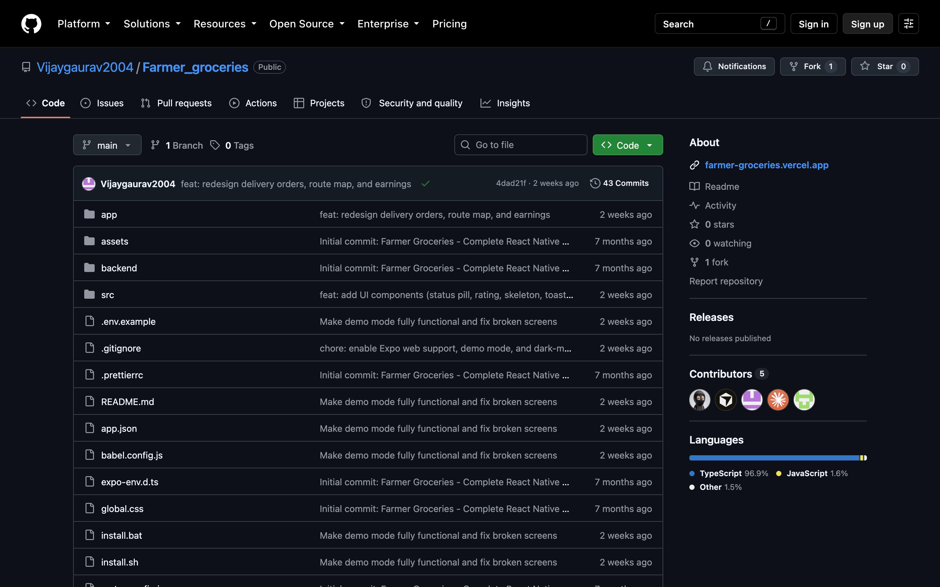
Figure 5.1 — Public repository on GitHub: main branch,
43 commits, 5 contributors and a TypeScript-dominant language breakdown.
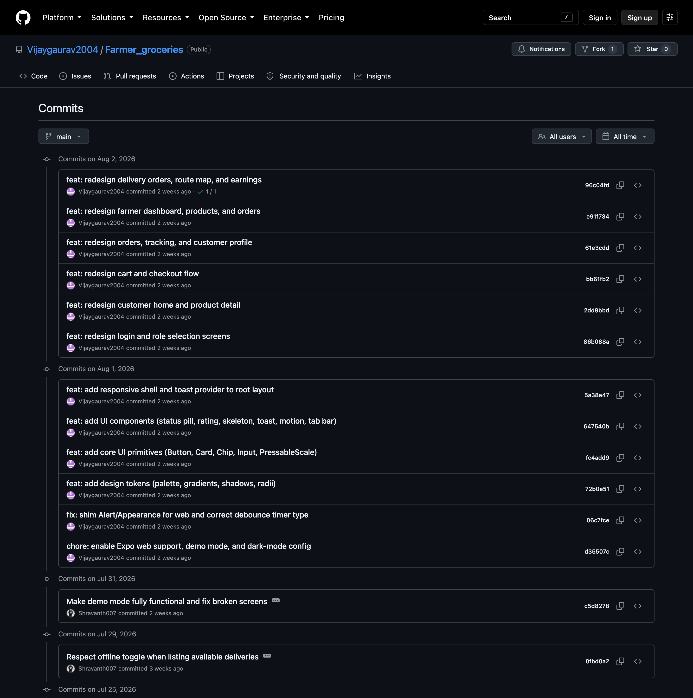
Figure 5.2 — Commit history (1 of 4): the most recent commits, dated
2 August back to 1 August 2026.
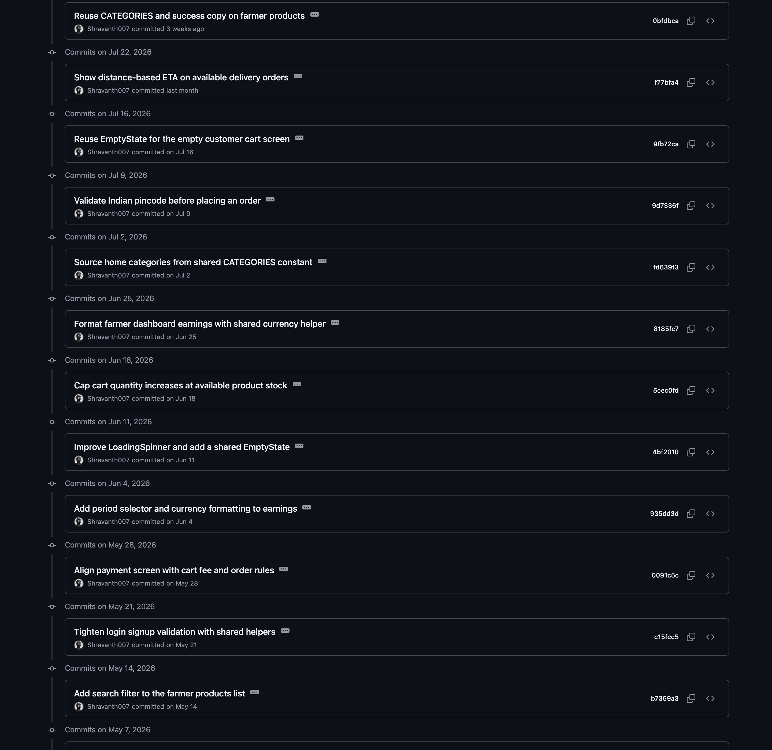
Figure 5.3 — Commit history (2 of 4): 31 July back to 14 May 2026.
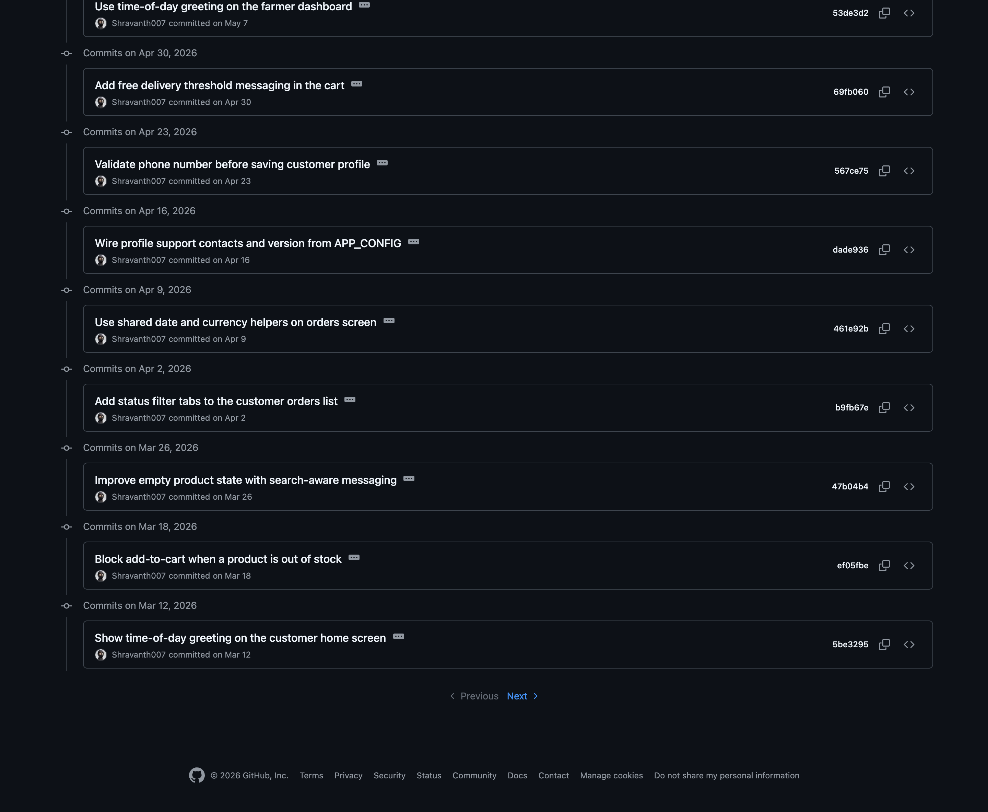
Figure 5.4 — Commit history (3 of 4): 7 May back to 12 March 2026,
ending at the page break GitHub inserts after thirty-five commits.
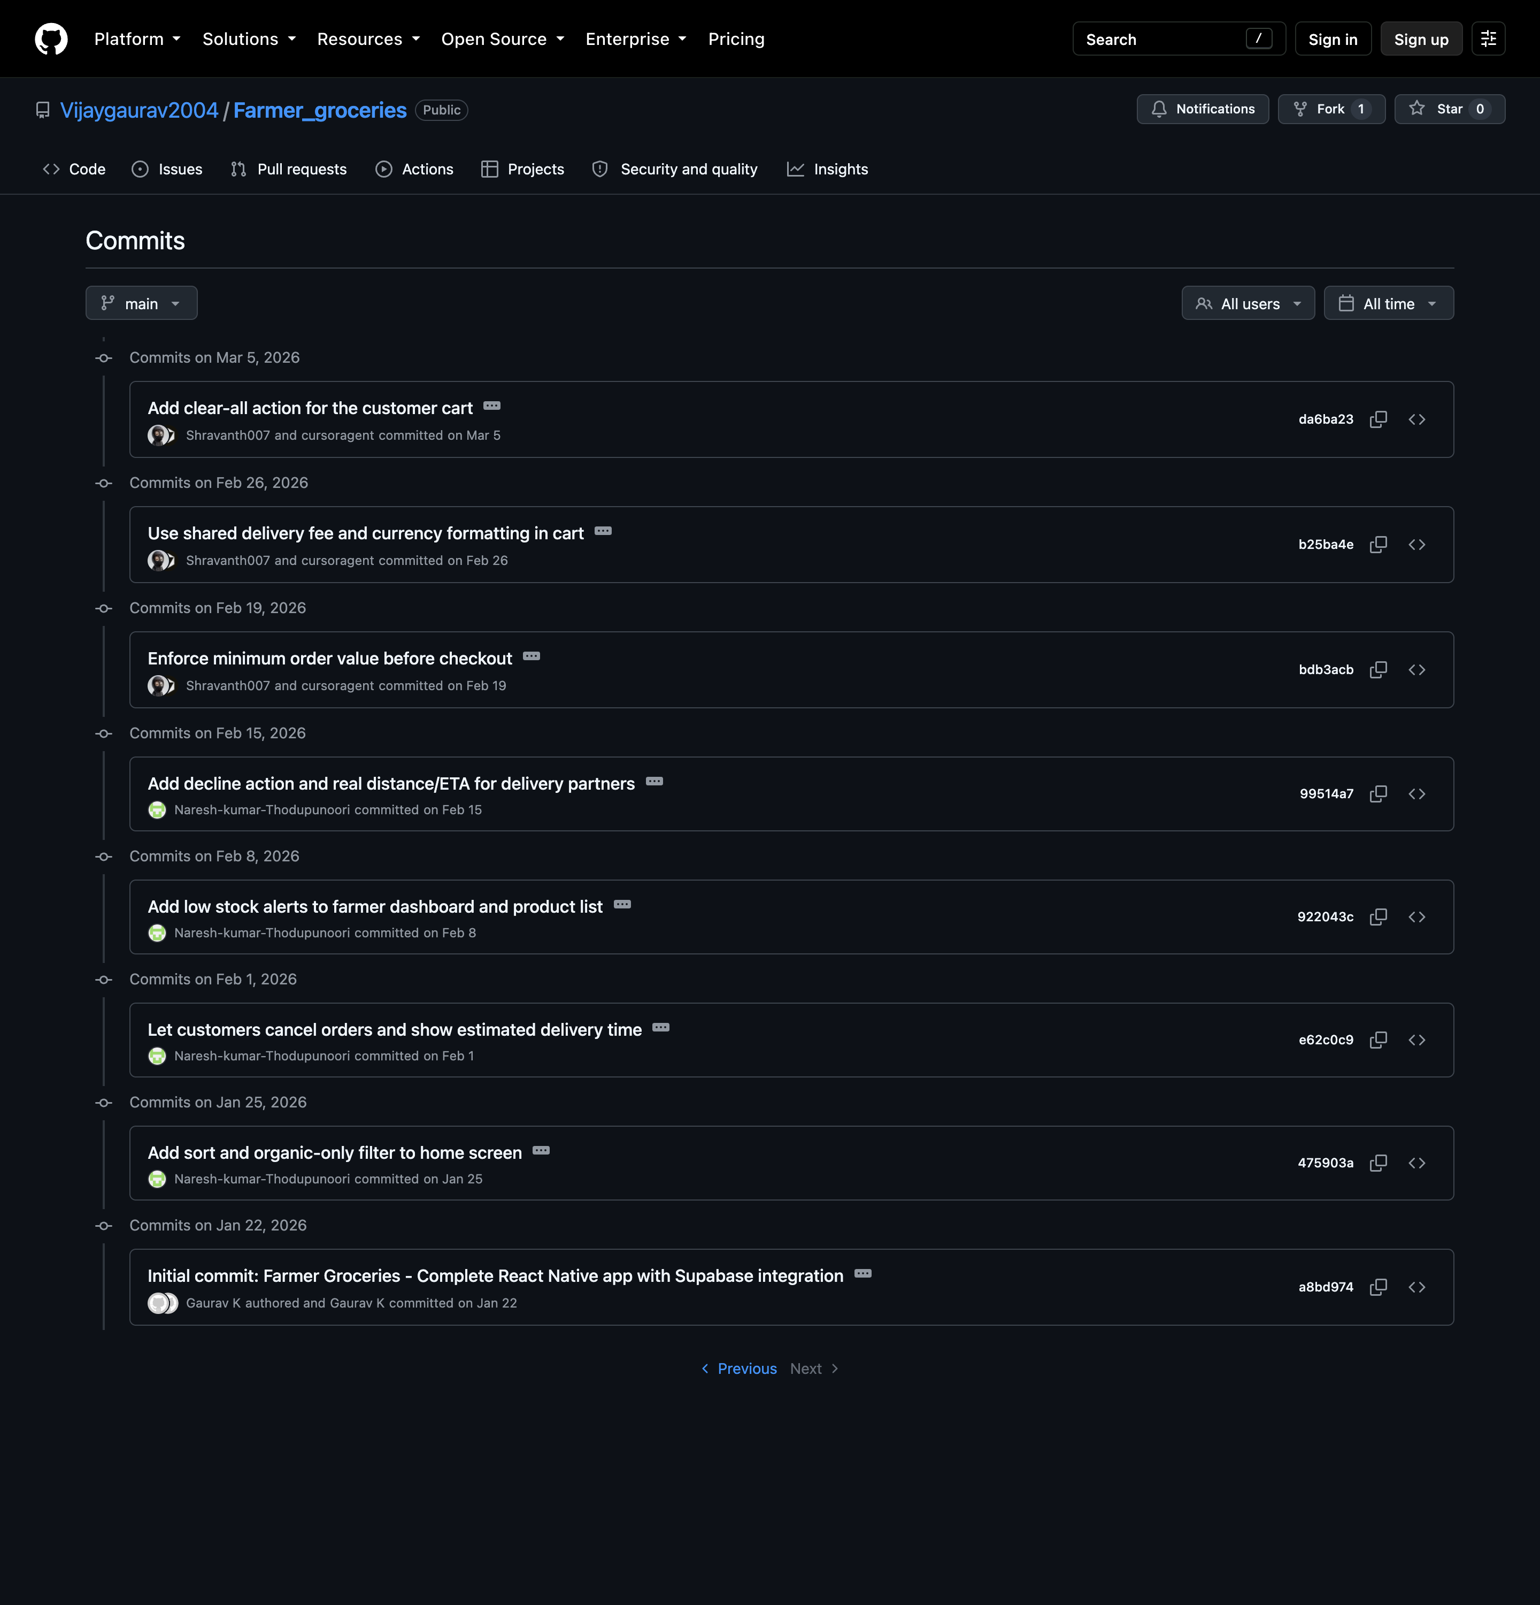
Figure 5.5 — Commit history (4 of 4): the second page, running from
5 March 2026 back to the initial commit of 22 January 2026.
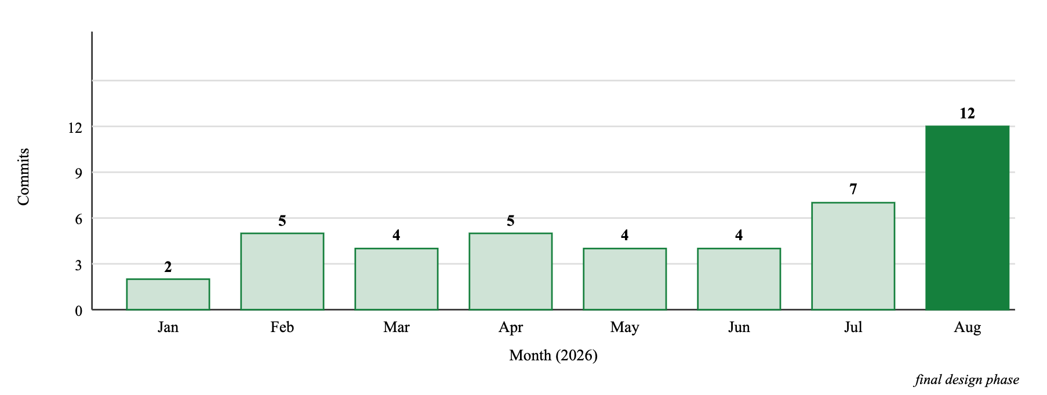
Figure 5.6 — Commit activity distribution across the project timeline.

5.2 Weekly Progress Summary
The table below is derived from the commit log rather than reconstructed from memory: every row corresponds to commits actually recorded in the period it covers, so the summary and the repository cannot disagree.
Week | Period (2026) | Commits | Work completed
1 | 20 – 26 Jan | 2 | Project baseline established: three role workspaces, Expo Router structure, Supabase service layer and type model. Catalogue sorting and an organic-only filter added.
2 – 3 | 27 Jan – 8 Feb | 2 | Customer-initiated cancellation with an eligibility rule; estimated delivery time surfaced on tracking. Low-stock alerting introduced on the farmer dashboard and inventory list.
4 – 5 | 9 – 22 Feb | 2 | Delivery partners gained a decline action and genuine Haversine distance with a derived ETA. Minimum order value enforced at checkout.
6 – 7 | 23 Feb – 8 Mar | 2 | Delivery fee and currency formatting centralised into shared constants and helpers; clear-all action added to the cart.
8 – 9 | 9 – 22 Mar | 2 | Time-of-day greeting on the customer home screen; add-to-cart blocked for out-of-stock products.
10 – 11 | 23 Mar – 5 Apr | 2 | Search-aware empty states for the catalogue; status filter tabs added to the customer order history.
12 – 13 | 6 – 19 Apr | 2 | Order history moved onto shared date and currency helpers; support contacts and version string wired from the application configuration module.
14 – 15 | 20 Apr – 3 May | 2 | Phone number validation on profile edit; free-delivery threshold messaging and progress indicator added to the cart.
16 – 17 | 4 – 17 May | 2 | Farmer dashboard greeting; search filter added to the farmer inventory list.
18 – 19 | 18 – 31 May | 2 | Sign-up and sign-in validation consolidated onto shared validators; checkout screen aligned with the cart's fee and minimum-order rules.
20 – 21 | 1 – 14 Jun | 2 | Period selector and currency formatting on the delivery earnings screen; loading spinner improved and a shared empty-state component introduced.
22 – 23 | 15 – 28 Jun | 2 | Cart quantity increases capped at available stock; farmer dashboard earnings moved onto the shared currency helper.
24 – 25 | 29 Jun – 12 Jul | 2 | Catalogue categories sourced from the shared constant; Indian pincode validation enforced before order placement.
26 | 13 – 19 Jul | 1 | Shared empty state reused for the empty cart screen, removing bespoke markup.
27 | 20 – 26 Jul | 2 | Distance-based ETA surfaced on the delivery job board; farmer product screen reuses shared categories and success messages.
28 | 27 Jul – 2 Aug | 14 | Offline toggle respected when listing available deliveries. On-device data layer completed so every screen works without a network connection, and broken screens repaired. Expo web support enabled; Alert and Appearance shimmed for the browser. Design token module, twelve UI primitives, responsive shell and toast provider introduced, followed by a full visual redesign of all three role workspaces, screen group by screen group.
Table 5.1 — Weekly progress summary derived from the commit log.

5.3 Review and Feedback Summary
The table below records the supervisory reviews held during the capstone phase. Dates and feedback are to be completed from the review record; the final column indicates where in this report the resulting change can be verified.
Review | Date | Key feedback received | Action taken and evidence
R1Design review | [DD/MM/2026] | [Feedback recorded at review 1] | [Action taken] — see §2.1
R2Mid-term review | [DD/MM/2026] | [Feedback recorded at review 2] | [Action taken] — see §2.3
R3Pre-final review | [DD/MM/2026] | [Feedback recorded at review 3] | [Action taken] — see Chapter 3
R4Final demonstration | [DD/MM/2026] | [Feedback recorded at the final demonstration] | [Action taken] — see Chapter 6
Table 5.2 — Review schedule and feedback log.
Traceable feedback already visible in the repository. Independently of the formal reviews, three themes recur across the commit history and are worth noting as evidence of iterative improvement rather than one-pass construction. The first is consolidation: a long sequence of commits replaces literals and bespoke markup with shared constants, helpers and components (weeks 6, 12, 20, 24, 26 and 27). The second is defensive validation: rules were progressively tightened at each boundary — minimum order value, stock capping, phone format, pincode format (weeks 4, 14, 18, 22 and 25). The third is presentation: the final week replaced ad hoc styling with a token-driven design system applied uniformly across all eighteen screens.

CHAPTER 6: CONCLUSION AND FUTURE WORK

6.1 Summary of Implementation
This capstone delivered a working cross-platform mobile marketplace that removes the intermediaries between agricultural producers and the households that buy from them. The system is a single React Native codebase of forty-eight TypeScript source files — approximately 5,400 lines — organised into eighteen routed screens, twelve reusable interface components and a thirty-operation service façade, and it runs on Android, iOS and the web from that one source tree.
Three design decisions shaped the result more than any others. The first was to make the route group the unit of authorisation: because Expo Router derives navigation from the directory layout, each role's screens live in a physically separate directory and a single guard in the root layout is sufficient to enforce the boundary between them, with no per-screen permission checks anywhere in the codebase. The second was to partition authority over the order lifecycle across roles rather than concentrate it: a farmer may only advance an order to packed and a delivery partner may only take it from there, which makes an illegal transition unrepresentable in the interface rather than merely discouraged. The third was to put a façade in front of persistence, so that a single configuration flag chooses between a hosted Supabase backend and a on-device data layer without a line of screen code changing — the decision that lets the application keep working whether or not the network does.
The build was validated rather than merely exercised. The whole tree compiles cleanly under strict TypeScript, and forty automated test cases — twenty-five functional, fifteen validation — are committed to the repository under tests/e2e/ and execute against the running application through a real browser; all forty pass. The functional suite is a genuine integration test: one order was carried from a customer's cart, through a farmer's fulfilment queue, into a delivery partner's job board and on to pickup, with each role independently observing the state the previous role had written.

6.2 Achievements
# | Objective (from §1.3) | Outcome | Assessment
O1 | Single identity specialising into three guarded workspaces | Achieved | Role persisted to both the user record and device storage; guard verified under direct URL attack (TC-V07).
O2 | Complete customer purchase journey | Achieved | Seven screens from catalogue to tracking; fifteen functional cases passed including per-farmer order splitting.
O3 | Farmer inventory and fulfilment console | Achieved | Dashboard analytics, product creation, visibility toggling and guarded transitions all verified (TC-F16 – TC-F21).
O4 | Delivery partner workflow | Achieved | Job board with Haversine ETA, exclusive claiming, route view and period earnings verified (TC-F22 – TC-F25).
O5 | Substitutable persistence behind one interface | Achieved | Thirty operations dual-dispatched; the on-device branch maintains genuine mutable state including stock decrement and history append.
O6 | End-to-end validation with reproducible evidence | Achieved | Zero type errors; 40/40 committed test cases pass; 22 screenshots captured as evidence from a single continuous session.
Table 6.1 — Objective-wise achievement assessment.
Beyond the stated objectives, three outcomes are worth recording. The design system that emerged in the final phase — a token module feeding twelve components — is what makes eighteen screens look like one product rather than eighteen; changing the brand palette is now a single-file edit. The offline-first data layer means the application degrades to nothing when connectivity fails — every screen keeps working — and it is what allowed the entire test suite in Chapter 3 to run unattended. And the committed test suites are reusable rather than one-off: npm test re-runs the whole three-role cycle after any change.

6.3 Limitations
The following limitations are stated deliberately, because a report that omits them is less useful than one that records them.
- Payment is recorded, not processed. Selecting UPI or card marks the order paid without any gateway interaction. No money moves, and there is no settlement, refund or reconciliation path.
- The on-device layer is single-tenant. When no cloud backend is configured, the local store deliberately ignores user identifiers so that one device can act as all three roles against shared data. Multi-user isolation depends entirely on enabling Supabase with Row Level Security.
- The Supabase branch is statically verified but not executed. The remote half of each service method is type-checked but was not exercised at run time during testing, so its query construction and column mapping remain unproven against a live database.
- Location is fixed, not sensed. Distance and ETA are computed correctly, but from a constant origin rather than the partner's device location, and the route screen is a schematic rather than a map.
- Coverage is integration-level only. The committed suites drive the whole application, but there is no unit test runner, so pure helpers are covered only indirectly through the interfaces that call them.
- Product imagery is absent. Products render a category glyph; the upload path exists in the service layer but no capture flow is wired to it.
- Reviews and subscriptions are partial. Reviews have a data model and service methods but no authoring screen; subscriptions exist only as type definitions.
- Notifications are absent. A customer learns that an order advanced only by opening the tracking screen, and a delivery partner learns of a new job only by refreshing the board.
- Farmer verification is nominal. The status field exists and defaults to pending, but no document review workflow or administrative role has been implemented.

6.4 Future Enhancements
The roadmap below is ordered by the ratio of user value to implementation cost, and the first tier is what would be required to move from a working build to a pilot deployment.
Priority | Enhancement | Description and implementation approach
1 | Live backend with row-level security | Provision the five tables and the storage bucket, enable RLS with per-role policies, and run the Chapter 3 suites against the remote branch. Requires no application code changes — only environment configuration — because of the façade described in §2.4.6.
1 | Payment gateway integration | Integrate a UPI and card gateway (for example Razorpay or Stripe) with server-side order verification, so that paymentStatus reflects a settled transaction rather than a client assertion.
1 | Push notifications | Use Expo Notifications with a database trigger on order status change, so customers are informed of progress and partners of new jobs without polling.
2 | Live location and map navigation | Replace the fixed origin with device location, stream the partner's position during an active delivery, and render a real map with turn-by-turn guidance.
2 | Product imagery | Wire the existing image picker to the storage upload path already present in the service layer, with client-side compression before upload.
2 | Ratings and reviews | Add a post-delivery review prompt; the service methods and the farmer rating recomputation already exist and need only an authoring surface.
2 | Unit tests and CI | Add Jest with React Native Testing Library for helpers and components alongside the existing tests/e2e/ suites, and run both on every push through GitHub Actions.
3 | In-app messaging | Realtime chat between customer and delivery partner scoped to an active order, using Supabase Realtime channels.
3 | Subscription orders | Implement the already-modelled weekly and monthly recurring baskets with a scheduled job that materialises each cycle's order.
3 | Farmer verification workflow | Document upload, an administrative review queue and a verified badge gate on catalogue visibility.
3 | Farmer analytics | Revenue trends, best-selling produce and seasonal demand, to inform planting and pricing decisions.
4 | Localisation | Interface translation into major Indian languages, which materially widens the addressable farmer population.
4 | Multi-city operation and loyalty | Geographic partitioning of the catalogue by serviceable radius, plus referral and loyalty mechanics to drive repeat purchase.
Table 6.2 — Prioritised roadmap of future enhancements.

6.5 Concluding Remarks
The project set out to test a straightforward proposition: that the coordination barrier which keeps farmers and households apart is a software problem, and that removing it requires one application carrying all three participants rather than three separate ones. The delivered system supports that proposition. An order created by a customer is confirmed by the farmer who grew the produce and delivered by a partner who is paid for that specific journey, with no other party in the transaction and every state change visible to everyone who needs it. What remains before real use is largely integration work — payments, notifications, live location — rather than redesign, and the architecture described in Chapter 2 was chosen specifically so that each of those can be added behind interfaces that already exist.

REFERENCES
References are formatted in IEEE style. All online resources were last accessed in August 2026.
1. Meta Platforms, Inc., “React Native — Learn once, write anywhere,” React Native Documentation. [Online]. Available: https://reactnative.dev/docs/getting-started
2. Meta Platforms, Inc., “React — Reference: useContext, useEffect, useState,” React Documentation. [Online]. Available: https://react.dev/reference/react
3. Expo, “Expo SDK 54 — Documentation,” Expo Documentation. [Online]. Available: https://docs.expo.dev/versions/v54.0.0/
4. Expo, “Expo Router — File-based routing for React Native and web,” Expo Documentation. [Online]. Available: https://docs.expo.dev/router/introduction/
5. Expo, “Environment variables in Expo,” Expo Documentation. [Online]. Available: https://docs.expo.dev/guides/environment-variables/
6. Expo, “EAS Build — Build your app in the cloud,” Expo Documentation. [Online]. Available: https://docs.expo.dev/build/introduction/
7. Microsoft Corporation, “TypeScript Handbook — Narrowing and discriminated unions,” TypeScript Documentation. [Online]. Available: https://www.typescriptlang.org/docs/handbook/2/narrowing.html
8. Supabase, Inc., “Supabase Documentation — Auth, Database and Storage,” Supabase. [Online]. Available: https://supabase.com/docs
9. Supabase, Inc., “Row Level Security,” Supabase Documentation. [Online]. Available: https://supabase.com/docs/guides/database/postgres/row-level-security
10. PostgREST Contributors, “PostgREST — Serving a RESTful API from PostgreSQL,” PostgREST Documentation. [Online]. Available: https://postgrest.org/
11. M. Fernandes and NativeWind Contributors, “NativeWind — Tailwind CSS for React Native,” NativeWind Documentation. [Online]. Available: https://www.nativewind.dev/
12. Tailwind Labs, “Tailwind CSS Documentation,” Tailwind CSS. [Online]. Available: https://tailwindcss.com/docs
13. React Native Community, “Async Storage — An asynchronous, persistent, key-value storage system,” GitHub. [Online]. Available: https://react-native-async-storage.github.io/async-storage/
14. Software Mansion, “React Native Reanimated — Documentation,” Software Mansion. [Online]. Available: https://docs.swmansion.com/react-native-reanimated/
15. N. Gallagher et al., “React Native for Web,” GitHub. [Online]. Available: https://necolas.github.io/react-native-web/
16. Google LLC, “Puppeteer — Headless Chrome Node.js API,” Puppeteer Documentation. [Online]. Available: https://pptr.dev/
17. Google LLC, “Chrome DevTools Protocol,” Chrome for Developers. [Online]. Available: https://chromedevtools.github.io/devtools-protocol/
18. R. W. Sinnott, “Virtues of the Haversine,” Sky and Telescope, vol. 68, no. 2, p. 159, 1984.
19. Government of India, Ministry of Agriculture and Farmers’ Welfare, Report of the Committee on Doubling Farmers’ Income, New Delhi, India, 2018.
20. Government of India, Ministry of Agriculture and Farmers’ Welfare, “National Agriculture Market (e-NAM),” e-NAM Portal. [Online]. Available: https://www.enam.gov.in/
21. J. Gustavsson, C. Cederberg, U. Sonesson, R. van Otterdijk and A. Meybeck, Global Food Losses and Food Waste: Extent, Causes and Prevention. Rome, Italy: Food and Agriculture Organization of the United Nations, 2011.
22. United Nations, Transforming Our World: The 2030 Agenda for Sustainable Development, Resolution A/RES/70/1, New York, NY, USA, 2015.
23. National Payments Corporation of India, “Unified Payments Interface (UPI) — Product Overview,” NPCI. [Online]. Available: https://www.npci.org.in/what-we-do/upi/product-overview
24. Ionic, “Ionicons — Premium designed icons,” Ionic Framework. [Online]. Available: https://ionic.io/ionicons

APPENDIX A — USER MANUAL

A.1 Getting Started
Open the application. If this is the first launch, the sign-in screen is presented.
1. Create an account. Press Sign Up, then enter your full name, email address, ten-digit mobile number and a password of at least six characters. Press Create Account. You are returned to the sign-in tab with a confirmation.
2. Sign in. Enter the same email address and password and press Sign In.
3. Choose your role. Select Customer, Farmer or Delivery Partner and press Continue. The choice is remembered, so subsequent launches go straight to your workspace. To use a different role, sign out from the Profile tab and register a separate account.
Working offline. The application keeps its data on the device, so every screen continues to work without a network connection. When no cloud backend has been configured, any email address with a password of six or more characters will sign you in.

A.2 For Customers

Finding produce
- The Home tab lists available produce. Type in the search field to match by name or description.
- Tap a category chip — Vegetables, Fruits, Dairy, Grains, Herbs, Eggs, Honey, Other — to narrow the list; tap All to clear it.
- Use the Sort & Filter row to show only organic produce or to order by price ascending or descending.
- Tap any product card to open its detail screen, which shows the price per unit, remaining stock, whether it is certified organic and who grew it.

Building an order
- Tap the green + on a card to add one unit, or open the product and use the stepper to choose a quantity before adding. Quantities are capped at available stock.
- Open the Cart tab to review the order. Adjust quantities with the steppers, remove a line with ×, or clear everything with Clear.
- The progress bar at the top shows how much more you need to add to qualify for free delivery (₹500). Below that threshold a ₹30 delivery fee applies. Orders below ₹100 cannot be placed.

Checkout and tracking
- Press Proceed to Payment, choose Cash on Delivery, UPI or Card, and enter your delivery address. The pincode must be a valid six-digit Indian code.
- Press Place Order. If your cart contains produce from more than one farm, a separate order is created for each — this is expected, since each farm fulfils its own items.
- Open the Orders tab to see your history, filtered by All, Active, Delivered or Cancelled. Press Track Order on any entry to follow its seven stages and see the estimated delivery time.
- An order may be cancelled from the tracking screen while it is still Order Placed or Confirmed. Once the farmer has packed it, cancellation is no longer offered.

A.3 For Farmers
- The Home tab summarises your business: active orders, active products, lifetime orders and earnings from delivered orders. Any produce at or below ten units appears in an amber Low Stock list — press Restock to jump to inventory.
- The Products tab lists everything you sell. Use the switch on each row to hide a product from customers without deleting it, and the search field to find a product by name or category.
- Press + Add to publish new produce. Name, price and stock are required; description, category, unit and the organic flag are optional. Press Add Product to save.
- The Orders tab is your fulfilment queue. Filter by Active, All or Completed. For each new order press Mark Confirmed, then Mark Packed once it is ready for collection. After packing, the order becomes visible to delivery partners and leaves your queue.

A.4 For Delivery Partners
- Use the Online / Offline switch at the top of the Orders tab to control whether you receive jobs. While offline the available list is empty.
- Available Orders shows packed orders no one has claimed, each with the drop address, approximate distance and estimated duration, and the ₹30 fee. Press Accept to claim a job or Decline to hide it for this session.
- Claimed jobs appear under My Deliveries. Advance each one in order: Pick Up when you have collected from the farm, Start Delivery when you set off, and Delivered on handover.
- The Map tab shows the pickup and drop details for your current delivery and offers the same advance action.
- The Earnings tab shows your total, with today, this week and this month breakdowns and your ten most recent completed deliveries.

A.5 Common Questions
Situation | What to do
“Add ₹… more to checkout” | The cart subtotal is below the ₹100 minimum. Add more produce.
“Enter a valid 6-digit pincode” | The pincode must be six digits and must not begin with zero.
“This product is out of stock” | The farmer's stock has reached zero. Check back after they restock.
My cart emptied unexpectedly | The cart is cleared automatically once an order is placed successfully.
I chose the wrong role | Sign out from the Profile tab and register a new account with a different email address for the other role.
An order is not on the delivery board | Only orders the farmer has marked Packed, and which no other partner has claimed, appear there.

APPENDIX B — INSTALLATION GUIDE

B.1 Prerequisites
Requirement | Minimum version | Purpose
Node.js | 18 (22.14 verified) | Runtime for the bundler and tooling
npm | 9 (10.9 verified) | Dependency installation
Git | Any current release | Cloning the repository
Expo Go | Latest from the app store | Running on a physical Android or iOS device
Modern web browser | Current release | Running the web target (optional)
Supabase account | — | Optional. Only required for a real multi-user backend

B.2 Installation
# 1. Obtain the source
git clone https://github.com/Vijaygaurav2004/Farmer_groceries.git
cd Farmer_groceries
# 2. Install dependencies (takes a few minutes on first run)
npm install
# 3. Start the development server
npm start
Metro prints a QR code. Scan it with the Expo Go application on your handset — Android users scan from within Expo Go, iOS users scan with the system camera. The application loads and is immediately usable against its on-device data layer. No .env file, database or API key is required for this path.
Convenience scripts are also available:
npm run android # open on a connected Android device or emulator
npm run ios # open in the iOS simulator (macOS with Xcode)
npm run web # open the web target at http://localhost:8081

B.3 Optional — Connecting a Supabase Backend
1. Create a project at supabase.com and copy its project URL and anonymous key.
2. Copy the template and fill it in: cp .env.example .env EXPO_PUBLIC_SUPABASE_URL=https://<project-ref>.supabase.co EXPO_PUBLIC_SUPABASE_ANON_KEY=<anon-key>
3. Create the tables users, farmers, products, orders and reviews with snake_case columns matching the mapping in src/services/supabase.ts, and a public storage bucket named uploads.
4. Enable Row Level Security on every table and add policies granting each user access only to their own records, farmers control of their own products, all authenticated users read access to available products, and delivery partners read access to orders assigned to them or awaiting assignment.
5. Stop and restart Metro. The application now uses the remote backend; nothing in the source changes.

B.4 Project Layout
Farmer_groceries/
├── app/ # Expo Router — the navigation graph is this tree
│ ├── _layout.tsx # providers + role-based route guard
│ ├── index.tsx # entry splash; the guard decides where to send you
│ ├── role-select.tsx # one-time role assignment
│ ├── (auth)/login.tsx # sign-in / sign-up
│ ├── (customer)/ # home · cart · orders · profile · payment
│ │ ├── product/[id].tsx # product detail
│ │ └── track-order/[id].tsx# seven-stage tracking timeline
│ ├── (farmer)/ # dashboard · products · orders · profile
│ └── (delivery)/ # orders · map · earnings · profile
├── src/
│ ├── components/ui/ # 12 reusable primitives + barrel export
│ ├── contexts/ # AuthContext, CartContext
│ ├── services/ # supabase.ts (façade) · localStore.ts · storage.ts
│ ├── config/supabase.ts # client + isSupabaseConfigured flag
│ ├── constants/index.ts # business rules, categories, statuses, regexes
│ ├── types/index.ts # domain model
│ ├── utils/ # helpers.ts · webAlert.ts
│ └── theme.ts # design tokens: palette, gradients, shadows, radii
├── tests/e2e/ # walkthrough.mjs · validation.mjs · helpers.mjs
├── docs/ # this report and its screenshot evidence
├── app.json · tsconfig.json · tailwind.config.js · babel.config.js · metro.config.js
└── package.json

B.5 Troubleshooting
Symptom | Resolution
Metro fails to start, or the bundle is stale | Clear the cache: npx expo start -c.
Expo Go cannot reach the development server | Ensure the handset and the host are on the same network, or start with npx expo start --tunnel.
Port 8081 is already in use | Start on another port: npx expo start --port 8082.
Dependency version warnings on start-up | Align packages with the installed SDK: npx expo install --fix.
On-device data has drifted during testing | Clear application storage — on the web, clear the site's local storage; on a device, clear the Expo Go app data — and relaunch to restore the defaults.
Changes to .env appear to have no effect | Environment variables are inlined at bundle time; stop and restart Metro.

APPENDIX C — SOURCE CODE LINK
Item | Location
Public repository | https://github.com/Vijaygaurav2004/Farmer_groceries
Default branch | main
Commit submitted for evaluation | 4dad21f — feat: redesign delivery orders, route map, and earnings (2 August 2026)
Clone command | git clone https://github.com/Vijaygaurav2004/Farmer_groceries.git
Licence | MIT
Source scale | 48 TypeScript files · ≈5,400 lines · 18 routed screens · 12 UI components
Automated tests | tests/e2e/ — 40 cases; npm test (see tests/README.md)
Screenshot evidence | docs/screenshots/ — the 22 application captures reproduced in §2.5 plus the repository captures in §5.1
This report | docs/Capstone_Report.html and docs/Capstone_Report.pdf

APPENDIX D — DEMO VIDEO LINK
Item | Location
Demonstration video | [Insert the shared video URL]
Duration | [MM:SS]
Access | [Unlisted / institution-restricted / public]
Suggested demonstration script. The following sequence mirrors the automated walkthrough of Chapter 3 and covers every module in roughly six minutes.
1. Introduction (0:00 – 0:30). State the problem — five or more intermediaries between farmer and household — and the proposed one-application solution.
2. Authentication (0:30 – 1:00). Sign up, sign in, and select the Customer role.
3. Catalogue (1:00 – 1:50). Browse produce, filter by category, toggle the organic filter, sort by price, and open a product to show provenance and stock.
4. Cart and checkout (1:50 – 2:50). Add produce from two different farms, show the free-delivery progress bar and the bill summary, then place the order and point out that it splits into one order per farm.
5. Tracking (2:50 – 3:20). Open the order and walk through the seven-stage timeline and the estimated delivery time.
6. Farmer (3:20 – 4:30). Sign in as the farmer, show the dashboard reflecting the order just placed, add a product, then confirm and pack the order.
7. Delivery (4:30 – 5:30). Sign in as a delivery partner, show the packed order appearing on the job board with its ETA, accept it, advance it to picked up, open the route view and show the earnings screen.
8. Close (5:30 – 6:00). Summarise the completed cycle and note the substitutable backend and the automated test suite.

