Connection Example

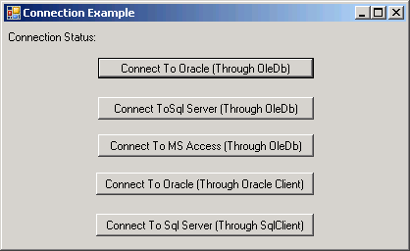

Code:

using System;
using System.ComponentModel;
using System.Data;
using System.Windows.Forms;
using System.Data.OleDb;
using System.Data.SqlClient;
using System.Data.OracleClient;

namespace ConnectionEx
{
public partial class ConnectionForm : Form
{
public ConnectionForm()
{
InitializeComponent();
}

OleDbConnection cn;
OracleConnection ocn;
SqlConnection scn;

private void btnConOracleOleDb_Click(object sender, EventArgs e)
{
try
{
cn = new OleDbConnection();
cn.ConnectionString = "provider=msdaora.1;user id=scott;password=tiger;server=server";
cn.Open();
lblConnectionStatus.Visible = true;
lblConnectionStatus.Text="Connected to Oracle Through OleDb";
}
catch(Exception ex)
{
MessageBox.Show(ex.Message);
}
}

private void btnConSqlOleDb_Click(object sender, EventArgs e)
{
try
{
cn = new OleDbConnection();
cn.ConnectionString = "provider=sqloledb.1;user id=sa;password=;database=master;
server=server";
cn.Open();
lblConnectionStatus.Visible = true;
lblConnectionStatus.Text = "Connected to MS Sql Server Through OleDb";
}
catch (Exception ex)
{
MessageBox.Show(ex.Message);
}
}

private void btnConAccessOleDb_Click(object sender, EventArgs e)
{
try
{
cn = new OleDbConnection();
cn.ConnectionString = "provider=microsoft.jet.oledb.4.0;
data source=C:/Program Files/Microsoft Visual Studio/VB98/Biblio.mdb";
cn.Open();
lblConnectionStatus.Visible = true;
lblConnectionStatus.Text = "Connected to MS Access Through OleDb";
}
catch (Exception ex)
{
MessageBox.Show(ex.Message);
}
}

private void btnConOracleClient_Click(object sender, EventArgs e)
{
try
{
ocn = new OracleConnection();
ocn.ConnectionString = "user id=scott;password=tiger;server=server";
ocn.Open();
lblConnectionStatus.Visible = true;
lblConnectionStatus.Text = "Connected to Oracle Through OracleClient";
}
catch (Exception ex)
{
MessageBox.Show(ex.Message);
}
}

private void btnConSqlClient_Click(object sender, EventArgs e)
{
try
{
scn = new SqlConnection();
scn.ConnectionString = "user id=sa;password=;database=master;server=server";
scn.Open();
lblConnectionStatus.Visible = true;
lblConnectionStatus.Text = "Connected to Sql Server Through SqlClient";
}
catch (Exception ex)
{
MessageBox.Show(ex.Message);
}
}
}
}

