DataReader Example

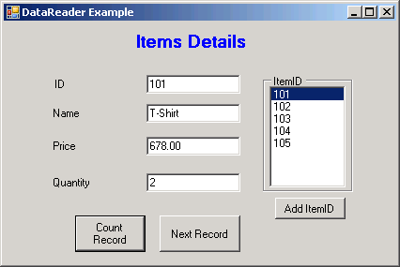
Code:

using System;
using System.Data;
using System.Windows.Forms;
using System.Data.OleDb;

namespace CommandObjectEx
{
public partial class DataReaderForm : Form
{
public DataReaderForm()
{
InitializeComponent();
}
OleDbConnection cn;
OleDbCommand cmd;
OleDbDataReader dr;
OleDbDataReader dr1;
string sqlstr;
int CntRec=0;
private void Form2_Load(object sender, EventArgs e)
{
try
{
cn = new OleDbConnection();
cn.ConnectionString = "provider=msdaora.1;user id=scott;password=tiger;server=server";
cn.Open();
if (cn.State == ConnectionState.Open)
{
MessageBox.Show("Connected To Oracle Databse", "Connection Status");
cmd = new OleDbCommand();
cmd.Connection = cn;
sqlstr = "select * from item";
cmd.CommandText = sqlstr;
dr = cmd.ExecuteReader();
if (dr.Read())
{
txtID.Text = dr[0].ToString();
txtName.Text = dr[1].ToString();
txtPrice.Text = dr[2].ToString();
txtQty.Text = dr[3].ToString();
}
else
{
MessageBox.Show("No Record", "Record Status");
}
}
else
{
MessageBox.Show("Connection Falied", "Connection Status");
}
}
catch (Exception ex)
{
MessageBox.Show(ex.Message);
}
}

private void btnNext_Click(object sender, EventArgs e)
{
try
{
if (dr.Read())
{
txtID.Text = dr[0].ToString();
txtName.Text = dr[1].ToString();
txtPrice.Text = dr[2].ToString();
txtQty.Text = dr[3].ToString();
}
else
{
MessageBox.Show("No More Record", "Record Status");
}

}
catch (Exception ex)
{
MessageBox.Show(ex.Message);
}
}

private void btnAdditemID_Click(object sender, EventArgs e)
{
try
{
cmd = new OleDbCommand();
cmd.Connection = cn;
sqlstr = "select ItemNo from item";
cmd.CommandText = sqlstr;
dr1 = cmd.ExecuteReader();
while (dr1.Read())
{
lstItemID.Items.Add(dr1[0].ToString());
CntRec += 1;
}
dr1.Close();
btnCntRec.Enabled = true;
}
catch (Exception ex)
{
MessageBox.Show(ex.Message);
}
}

private void lstItemID_SelectedIndexChanged(object sender, EventArgs e)
{
try
{
cmd = new OleDbCommand();
cmd.Connection = cn;
sqlstr = "select * from item where ItemNo=" + lstItemID.SelectedItem;
cmd.CommandText = sqlstr;
dr1 = cmd.ExecuteReader();
if (dr1.Read())
{
txtID.Text = dr1[0].ToString();
txtName.Text = dr1[1].ToString();
txtPrice.Text = dr1[2].ToString();
txtQty.Text = dr1[3].ToString();
}
dr1.Close();
}
catch (Exception ex)
{
MessageBox.Show(ex.Message);
}
}

private void btnCntRec_Click(object sender, EventArgs e)
{
try
{
MessageBox.Show("Total Record Is: " + CntRec,"Count Record");
}
catch (Exception ex)
{
MessageBox.Show(ex.Message);
}
}
}
}

