**Assignment-2**

**Name: Vijay Kumar**

**ID:700737910**

Git hub:

https://github.com/Vijaykamsani/ML_Assignment_-70037910/blob/main/Assignment_2.ipynb

Video link: https://drive.google.com/file/d/14qBiipHkDoJlu_BSJ_lvBUdqXsUZx1Ug/view?usp=share_link

**1>**

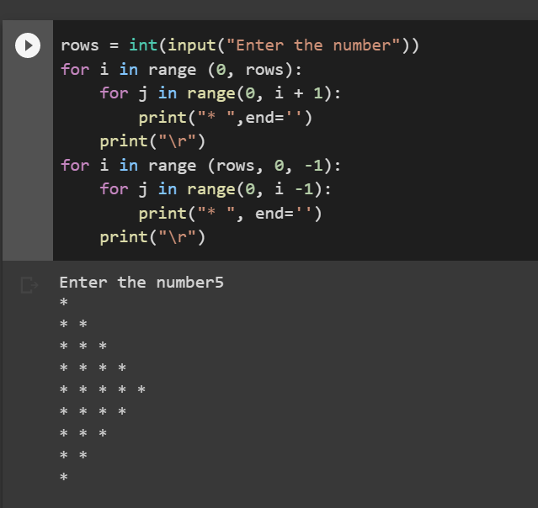

**Comment: Taking input form the user using for loop we are in range form 0 to input and using inner for loop we are printing starts from j to i range . using third for loop we are printing reverse stars**

**2**

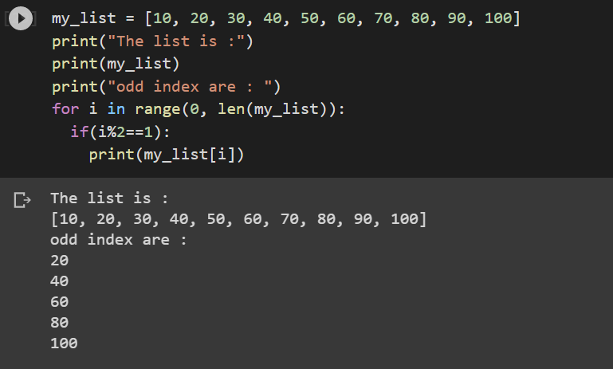

**Using for loop we are in the range of 0 to length of the list, using if statement we are checking the odd value position if we are getting the remainder as 1 then we are printing the list of odd positions**

3>

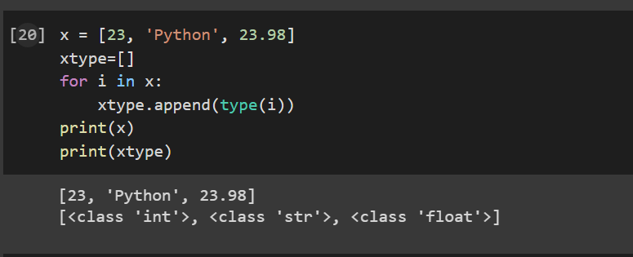

**Using the append variable we are adding the variables to the list and using the “type” syntax are checking the type of the variable in the x array.**

4>

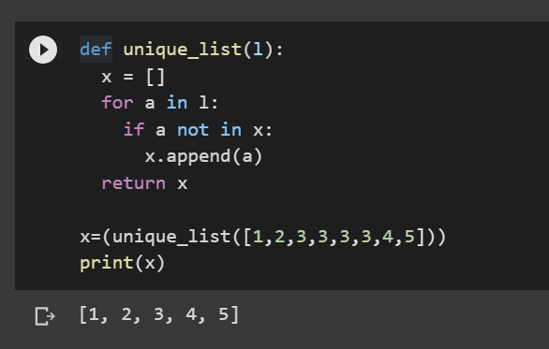

**Using the functions we are writing the unique digits taking the x list to the l and using the append statement we are adding the un repeated the number. If the number are not there then will add using append syntax and if there it not add.**

5>

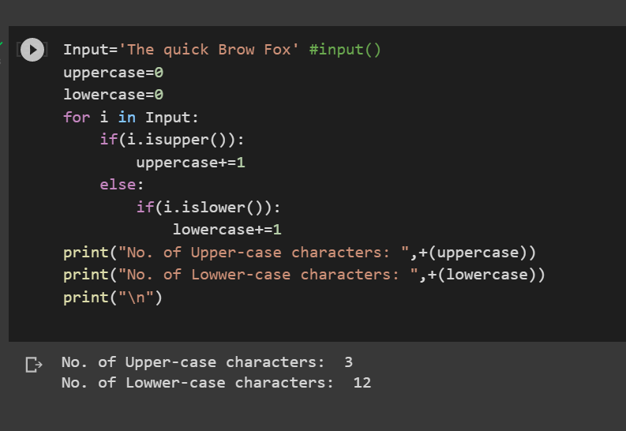

**From the input we are checking uppercase and lowercase. Intilize the variable names as 0 then using for loop we checking each and every string and with the help of if statement it check whether it was upper case or lower case, if it upper case it will increment the value +1 and else it will print lower case. Using print statement we can** **view the total number of upper case and lower case**