**LAPTOP PERFORMANCE PREDICTION WITH MACHINE LEARNING WITH INCREASE IN TECHNOLOGY**

Name: Kamsani Vijay Kumar

Student Id:700737910

Screenshots:

1. Data information

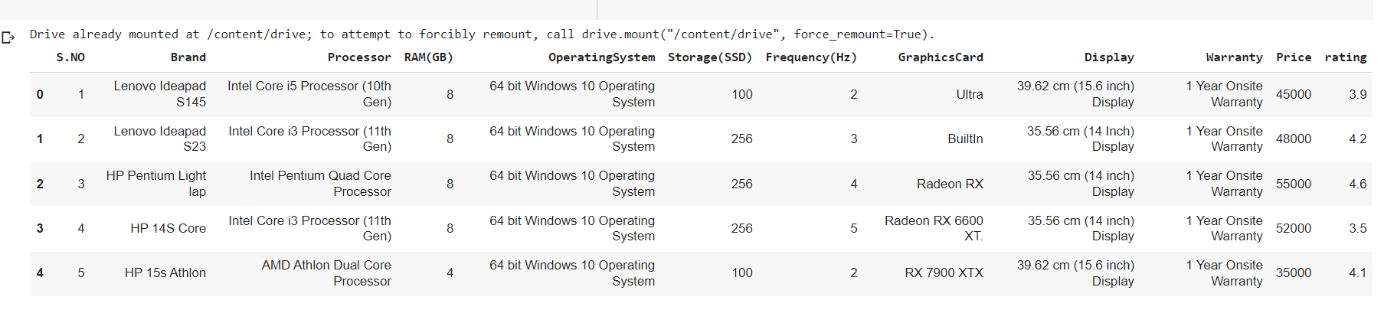

2. Dropped the S.no

1. No. of price count

1. No of rate counting

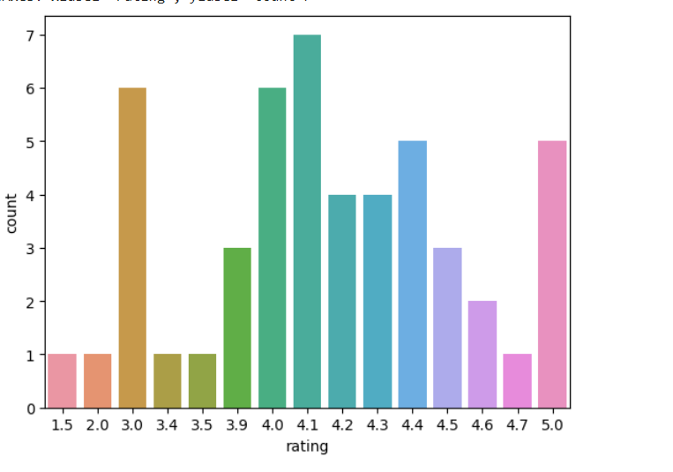

1. Data Info

6.Data Correlation

7.Data Description

8.Heat map

9.price plot

10.Rating

11. Price and rating

12.predicted values

13.Accuracy value of Logistic regression

14.Accuracy value of Naive Bayes

15.Accuracy value of Decision tree

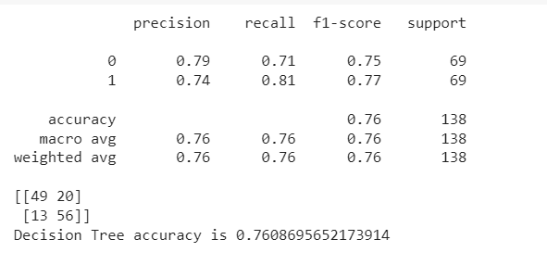

16.comaprsion of Decision tree and KNN

17. User input with provided output

18.Comparsion of Logistic regression, Decision tree and Bernoulli

