

|  |
| --- |
| EEPORT C1 URABA SURVEY and SUGGESTIONS re FUTUFE POLICY. |

The Board will recollect that, following on a great deal of geological work in various parts of Colombia, and certain negotiations with various concessionaire groups in that country, our efforts were finally concentrated on the Colombian State ficsorve in Uraba. After protracted
  
negotiations a modus operandi was agreed upon between the Governnent and our representative (Colonel Yates), the principal conditions for a development contract were out­lined) and, - subject to certain reservations, - approved

by the Board. These conditions, it will be remembered,
  
were of such an exacting and onerous nature that their only ju3tification lay in the belief, - then strongly held in official circles in Colombia, - that the province of Uraba. contained extremely valuable oilbearing land, - for which rcason it had been declared a State reserve.

It will be seen from reports attached,(apoendix C), that a geological survey, - carried out during the last dry season by three parties under the general. direction of our Chief Geologist (Mr.James) has failed to find evidence such as would justify the very high hopes entertained in Colombia respecting the oil potentialities of this province, although Oil-bearing structure, of limited extent and speculative capacity, is considered to exist.

In these circumstances, - and bearing particularly in mind the terms of the provisional contract with the Gov­ernment, no case can be made in justification of our nro­ceedine any further with these particular negotiations.

It has been necessary, - in anticipation of Board concur­rence, - to make this quite clear to the Colombian Govern­ment) (vide copy of telegram dated 3rd July attached) since

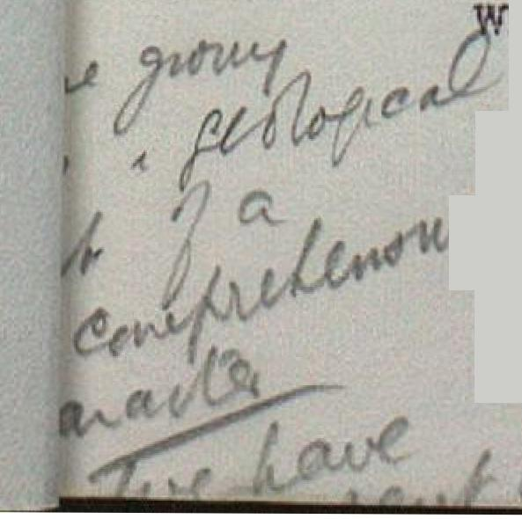- 2 -

the Contract was due for discussion in the Congress during the current month.

The position is now as follows:- We are not in

treaty with any other concessionaires in that country and are under no obligations to the Government except that it will be necessary (a) to confirm by letter, - through Colonel Yates - our decision to proceed no further with the Uraba contract, and (b) to furnish the Minister of Industry with a copy of our complete geological report on Uraba -

(this report is now approaching completion). All our
  
geologists have been withdrawn from Colombia, and Colonel Yates is now in England awaiting decisions respecting future policy.

In this connection I invite perusal of the pro­pos contained in the memorandum of the Managing Director
  
D'Arcy Exploration Co., attached hereto, (Appendix A).

I am strongly of opinion that, whatever might be the future prospect of obtaining concessions in Colombia, we should no longer contemplate negotiations - either with the Government or with private owners, - whilst the Petrol­eum Laws operate so decidedly to our disadvantage. There
  
were special reasons in the case of Uraba for making the best of the legal situation as it actually existed, but it is **very** difficult to concveive of any concession being offered us in future which would justify the adoption of the elaborate safeguards which were contemplated for the operation of the Uraba concession had it proved to be

worth doing so.

At the present time the question of modifications in Oil Legislation in Colombia is much to the fore, and **I** ould endorse the suggestion of Sir A.T. Wilson that we take advantage, - for the reasons given by him, - of the good feeling we believe to exist in Government circles in

A

Colombia towards t rt"`A' e<kr4i-

ny, by endeavoAring to getthe

is C





LPw so amended as to place us in a position comparable with tht of other Comnanies. I feel that the most effective
  
way of approaching the subject would be to send Colonel Yates back to Bogota charged with the sole mission of pre­sentin„.1. to the Government the geological reports on Uraba and a letter - draft h3rewith, (Appendix B) - definitely raising the legal issue on our behalf.

Should this line of procedure be agreed, Colonel Yates will be instructed that no question of concessions,

or management agreement)should be discussed with the Govern­ment) or with unofficial concession holders, until he receives explicit Instructions from us; and that such in­structions will not be given unless and until modifications have been made in the existing Law of a character satisfact­ory to the Board.



It should be added that, should it he possible to obtain the desire.1 modifications in Colombia, the



precedent so created might prove to be of the very greatest importance to us in subsequent negotiations with other St:l.tes in South America.



A.C. HEARN.

17th_julvi_1928.