**Topics: Descriptive Statistics and Probability**

1. **Look at the data given below. Plot the data, find the outliers and find out $μ, σ, σ^{2}$**

|  |  |
| --- | --- |
| **Name of company** | **Measure X** |
| Allied Signal | 24.23% |
| Bankers Trust | 25.53% |
| General Mills | 25.41% |
| ITT Industries | 24.14% |
| J.P.Morgan & Co. | 29.62% |
| Lehman Brothers | 28.25% |
| Marriott | 25.81% |
| MCI | 24.39% |
| Merrill Lynch | 40.26% |
| Microsoft | 32.95% |
| Morgan Stanley | 91.36% |
| Sun Microsystems | 25.99% |
| Travelers | 39.42% |
| US Airways | 26.71% |
| Warner-Lambert | 35.00% |

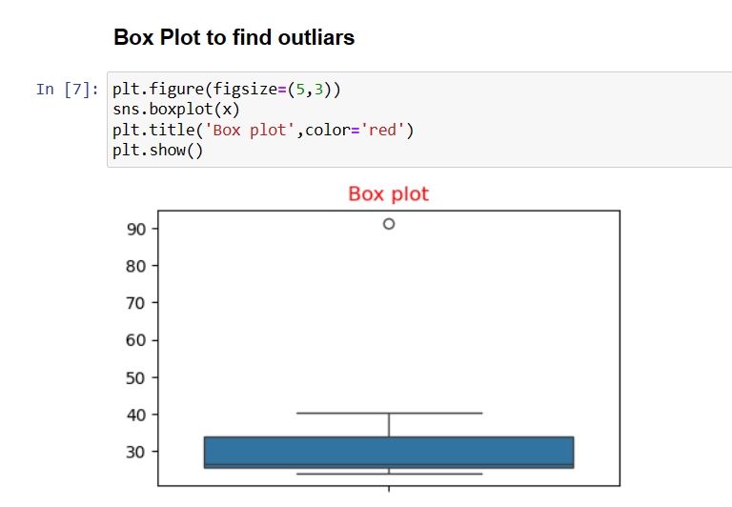

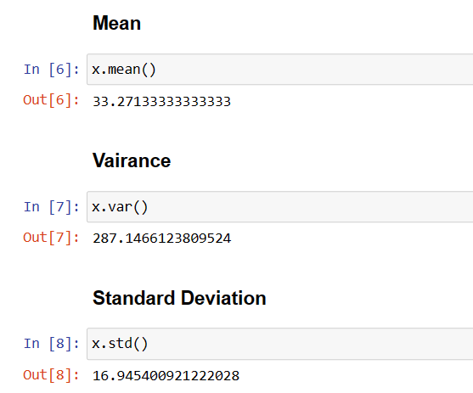



**Answer the following three questions based on the box-plot above.**

1. **What is inter-quartile range of this dataset? (please approximate the numbers) In one line, explain what this value implies.**

* H ere clearly 25 is the outlier.

Median = 7

1st quartile = 5

2nd quartile = 12

IQR = (12-5) = 7

IQR tells us the range of the middle half of the data.

1. **What can we say about the skewness of this dataset?**

* Positively skewed

1. **If it was found that the data point with the value 25 is actually 2.5, how would the new box-plot be affected?**

* In that case there would have been no outliers, and it might have affected in the values of mean and median slightly. The boxplot might have moved towards right slightly.



**Answer the following three questions based on the histogram above.**

1. **Where would the mode of this dataset lie?**

* Between 5 – 8 (Most frequent data)

1. **Comment on the skewness of the dataset**.

* It is Positively skewed

1. **Suppose that the above histogram and the box-plot in question 2 are plotted for the same dataset. Explain how these graphs complement each other in providing information about any dataset.**

* By comparing both of them it is very clear that the data would be positively skewed. Also, would help us finding mean, mode value.

1. **AT&T was running commercials in 1990 aimed at luring back customers who had switched to one of the other long-distance phone service providers. One such commercial shows a businessman trying to reach Phoenix and mistakenly getting Fiji, where a half-naked native on a beach responds incomprehensibly in Polynesian. When asked about this advertisement, AT&T admitted that the portrayed incident did not actually take place but added that this was an enactment of something that “could happen.” Suppose that one in 200 long-distance telephone calls is misdirected. What is the probability that at least one in five attempted telephone calls reaches the wrong number? (Assume independence of attempts.)**

* Probability of call getting misdirected = (1/200)

Hence probability of call not getting misdirected = 1-(1/200) = 199/200

Number of phone calls attempted = 5

Therefore, probability that at least one in 5 attempted call reaches the wrong number is:

=1-(199/200) ^5

= 0.025

1. **Returns on a certain business venture, to the nearest $1,000, are known to follow the following probability distribution**

|  |  |
| --- | --- |
| x | P(x) |
| -2,000 | 0.1 |
| -1,000 | 0.1 |
| 0 | 0.2 |
| 1000 | 0.2 |
| 2000 | 0.3 |
| 3000 | 0.1 |

1. **What is the most likely monetary outcome of the business venture?**

* Here the highest probability is for 2000.

1. **Is the venture likely to be successful? Explain**

* Yes, because the total earnings of the venture is positive in value i.e 800 and highest probability of earning is 2000.

1. **What is the long-term average earning of business ventures of this kind? Explain**

* The long-term average is Expected value = Sum (X * P(X)) = 800$ which means on an average the returns will be + 800$

1. **What is the good measure of the risk involved in a venture of this kind? Compute this measure**

* The good measure of the risk involved in a venture of this kind depends on the Variability in the distribution. Higher Variance means more chances of risk

Var (X) = E(X^2) –(E(X))^2

= 2800000 – 800^2

= 2160000