Hadoop Installtion Steps

# *Installation of Red Hat Enterprise Linux 6.0:*

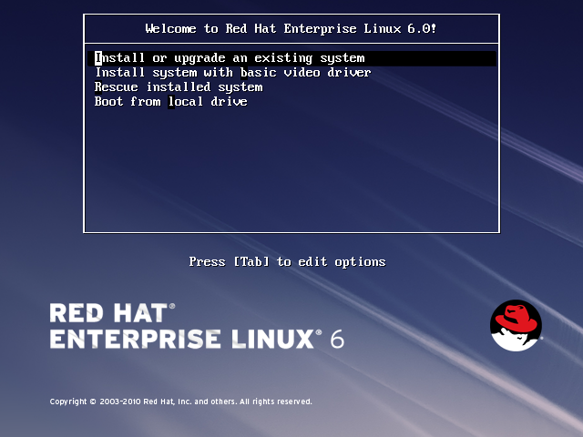Boot the system with RHEL 6.0 DVD. At the boot prompt, hit enter to begin installation:

Skip the media testing process:

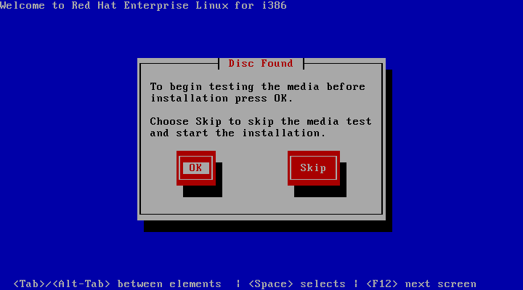

Click Next:



Select your preferred Language and hit Enter:

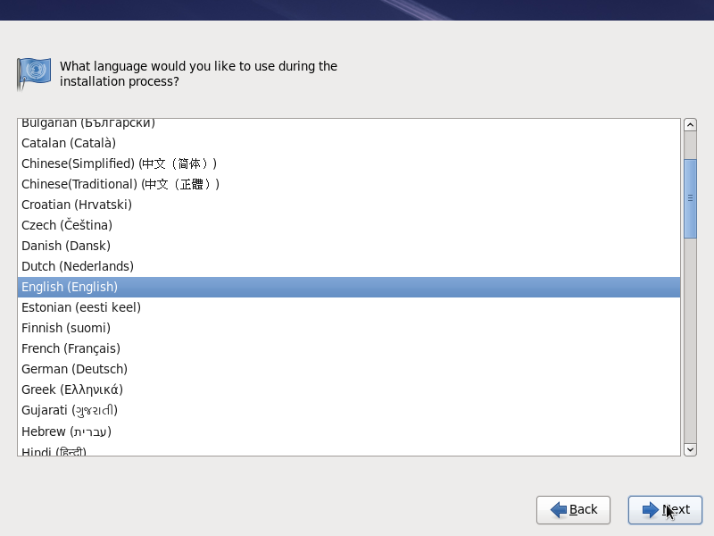

Select your keyboard layout:

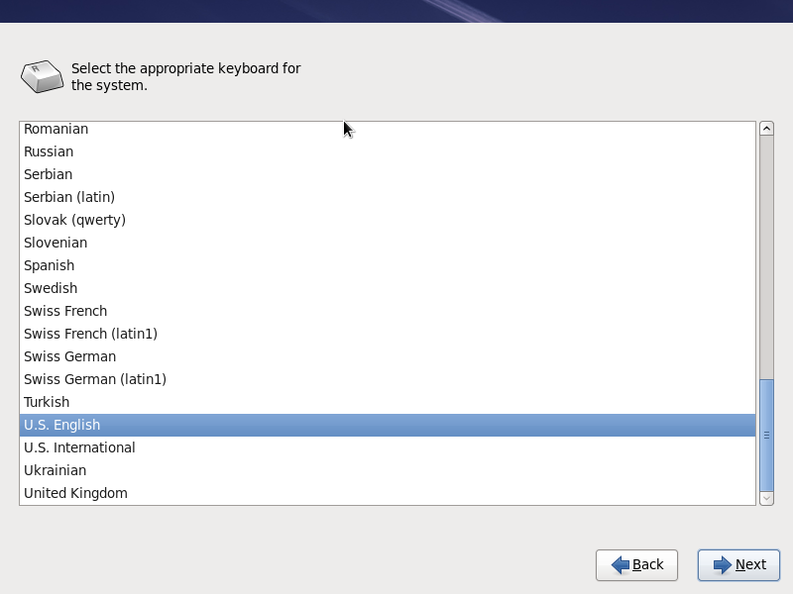

Select Basic storage Devices. If you install this in SAN environment select Specialized Storage Devices and hit Enter:

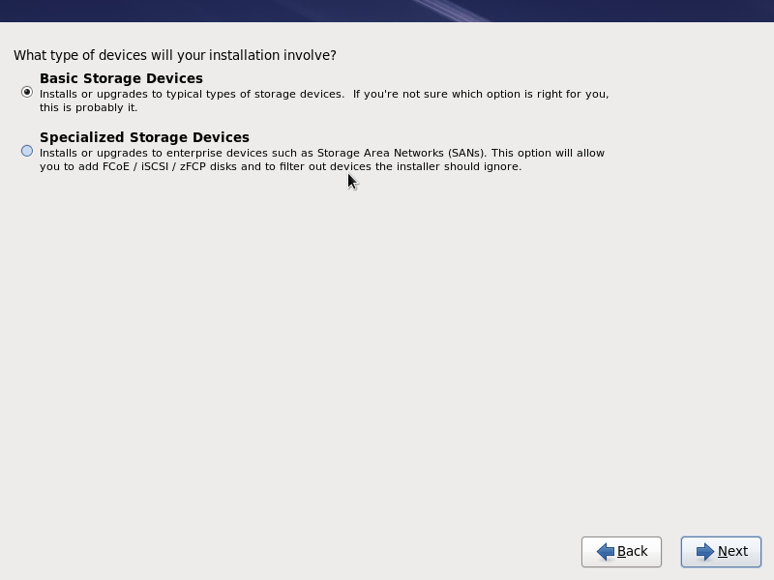

Enter the hostname for your server:

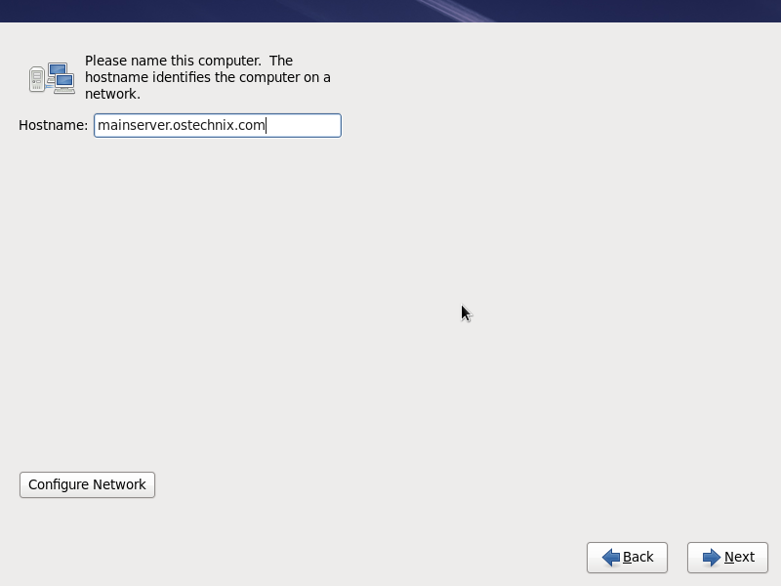

Select your Time Zone and click Next:

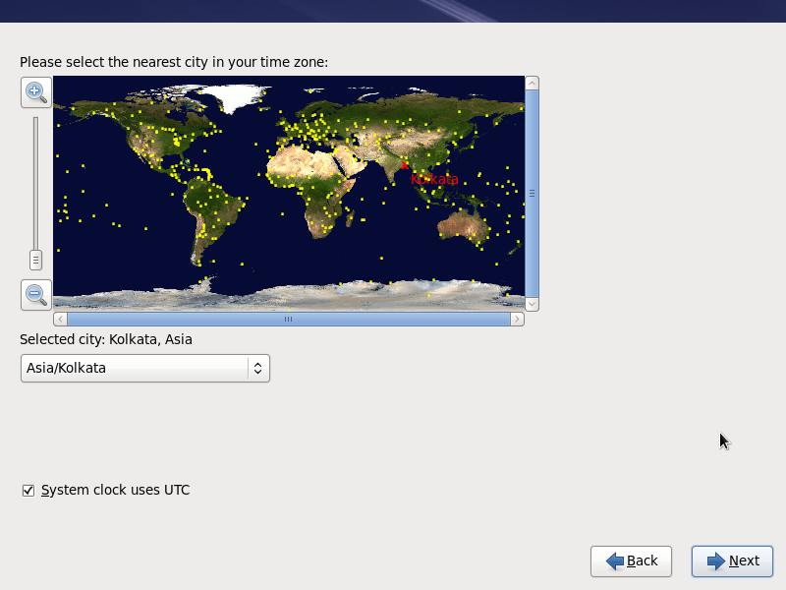

Enter the Root Password and click Next:

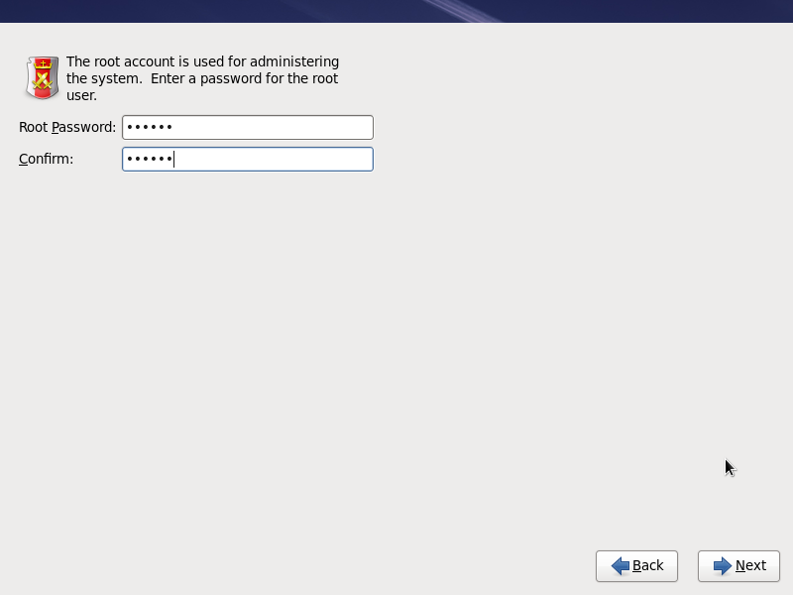

Select the Mode of Partition and click Next:

Use All space: is used when we install red hat directly on machine.

Replace Existing Linux System: is used when creating a virtual machine.

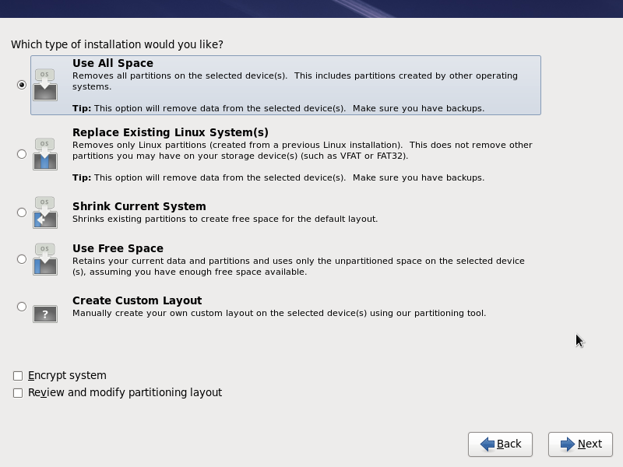

The partition changes will be applied now:

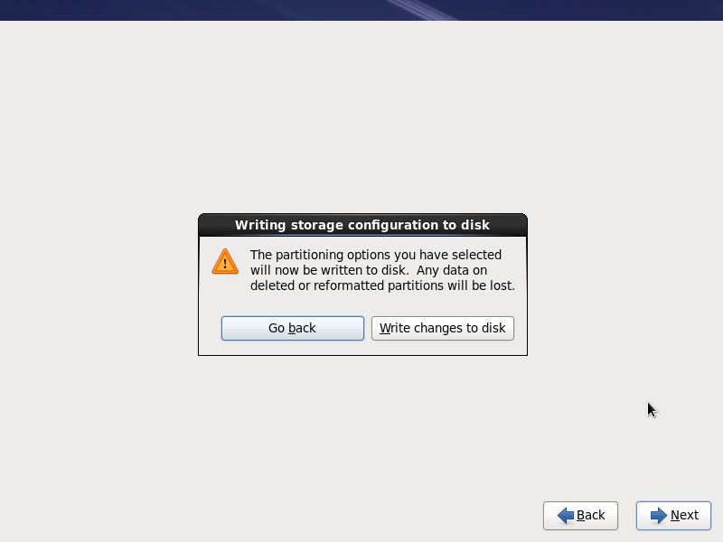

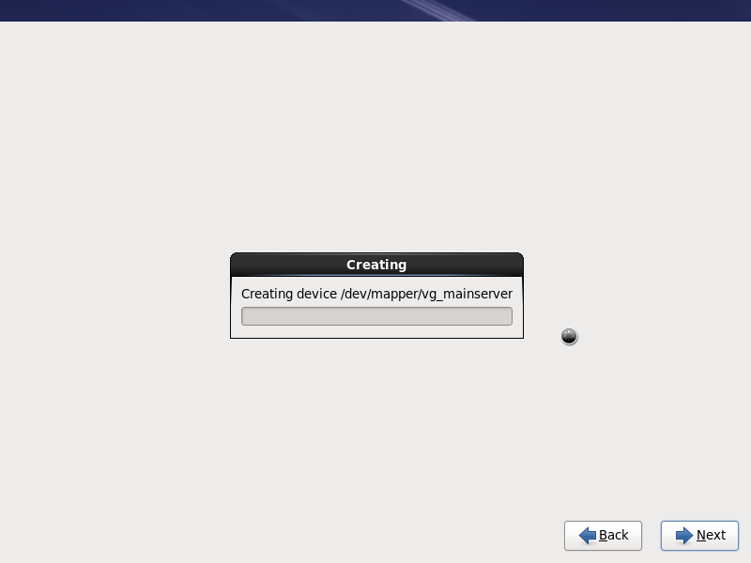

Now select the type of install for this server depends upon the role of the server such as [Desktop](http://en.wikipedia.org/wiki/Desktop_environment), Basic Server, [Web server](http://en.wikipedia.org/wiki/Web_server), Database server or whatever you need for your current environment. Here let us install the Minimal Server. You can customize the server here or you can do it later:

To install Cloudera Manager or Hadoop always choose Web Server.

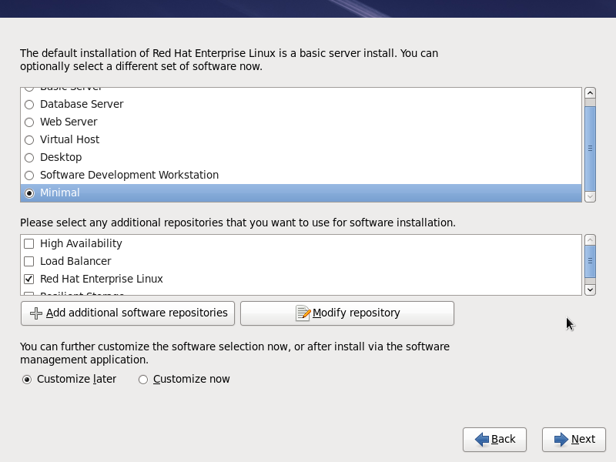

Now the installation will begin. It will take a while depends upon your hardware configuration:

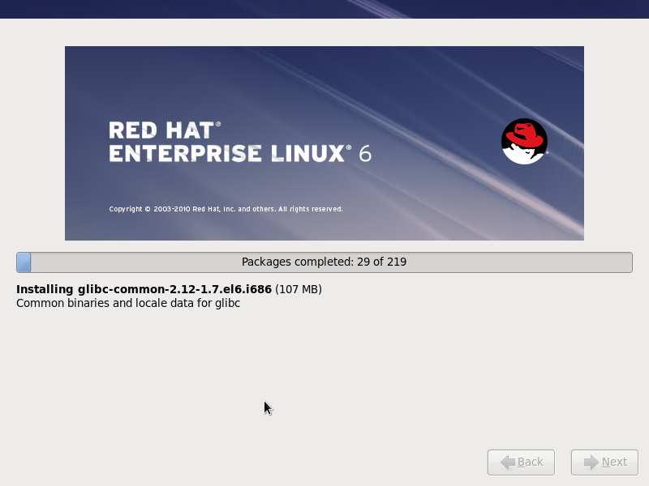

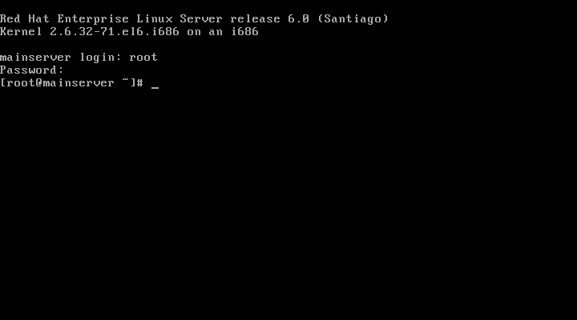

Thats it. Configure the server as per your needs for your environment. We have provided the step to execute for cloudera manager & Hadoop.

After installation for Linux redhat 6 Please login and configure the IP address.

Login:root

Passowrd:123456

vi /etc/sysconfig/network-scripts/ifcfg-eth0

ONBOOT=yes

Change the hostname for the linux machine

vi /etc/sysconfig/network

HOSTNAME=manager.com

Restart the machine but make sure internet is working on linux machine before restart

init 6

Login again & check the hostname & hostname -f

hostname -f

Output -> manager.com

hostname

output -> manager.com

Disable the firewall using chkconfig on restart

chkconfig iptables off

Stop the currently running firewall using service

service iptables stop

stop currently running selinux

setenforce 0

Disable the selinux on restart

vi /etc/selinux/config

Change the ntp configuration for time

vi /etc/ntp.conf

server 0.in.pool.ntp.org

Sync the linux machine time

ntpdate -s 0.in.pool.ntp.org

Check the IP address for this machine

ifconfig

cd /var/www/html/

copy all the required packages from Ubuntu machine to hadoop linux machine, these package is already given by bharat bhushan

RUN this command on ubutnu terminal

scp -r html/CDH root@IP:/var/www/html/

scp rhel-server-6.4-x86_64-dvd.iso root@IP:/root/

scp cloudera-manager-installer.bin root@IP:/root/

scp cloudera-local.repo root@IP:/etc/yum.repos.d/

change permission for all packages on linux machine

cd /var/www/html/

chmod -R 777 *

Mount the red hat iso file in linux machine

mount -o loop rhel-server-6.4-x86_64-dvd.iso /mnt

Start the web server if is is stoped

service httpd start

Enable the web server to start on linux machine restart

chkconfig httpd on

yum clean all

yum list all

Install the createrepo utility for creating new repo in linux machine

yum install createrepo

cd /var/www/html/CDH/5/

Run createrepo utility

createrepo .

vi /etc/yum.repos.d/cloudera-local.repo

change enabled = 1 in cloudera-cdh5 repo

save and quit

Restart the linux machine

init 6

check hostname -f before cloudera-manager installation

hostname should be present

cd /root/

./cloudera-manager-installation.bin --skip_repo_package=1

Cloudera manager is installed

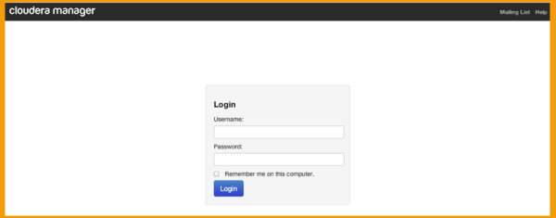Open brawser to install CDH 5 hadoop

Log into the cdh-manager node http://<cdh-manager>:7180 (where ‘<cdh-manager>’ is the FQDN) with username admin and password admin

Choose Cloudera Express or Standard.

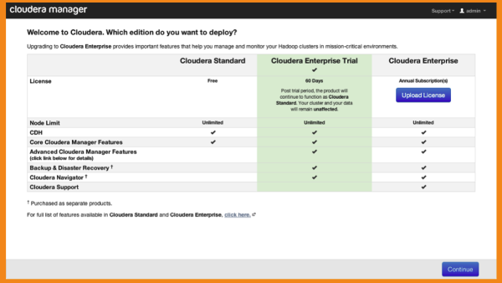

Click Continue in the screen below.

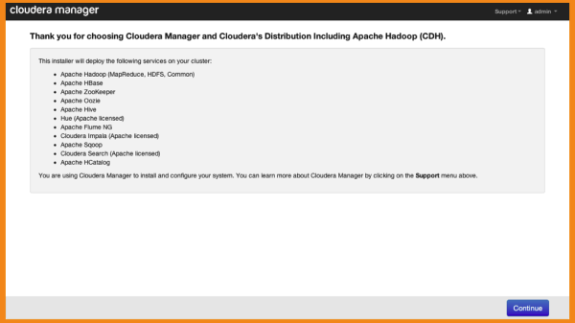

Specify list of hosts for CDH installation e.g., compute-0-[0-3],cdh-manager-0-0

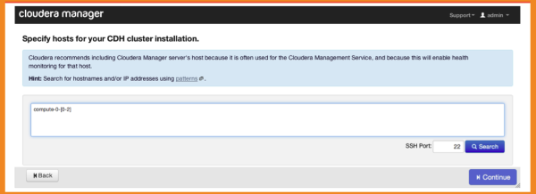

 After all the hosts are identified, hit Continue

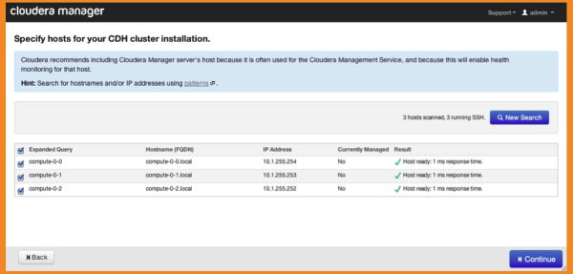

Choose Use Packages and select CDH5 as the version in the screen below.

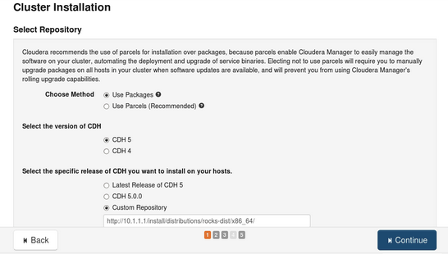

900917033685466

Specify custom repository as the CDH release you want to install. Specifyhttp://IP/CDH/5/ for the URL of the repository where <IP> is the IP address of the cluster’s frontend.

Change parcels repo URL: Click on more options provided on the same screen. There are different URLs available on “More Options” popup. You can change repo URL as per your IP address. As per our case the URL will be : <http://IP/CDH/parcels>

Please provide the password for the root user and password should be same for all the machines.

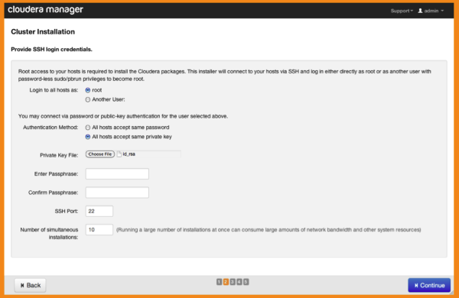

You will then see a screen where the progress of the installation will be indicated. After installation completes successfully, hit Continue.

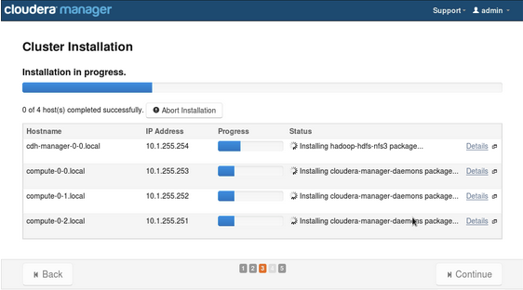

You will then be directed to the following screen where all hosts will be inspected for correctness.

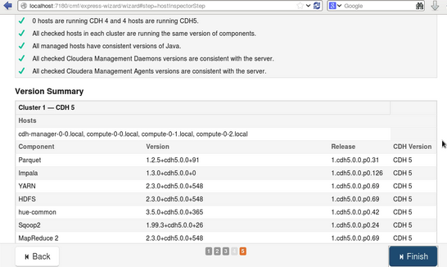

Choose a combination of services you want to install and hit Continue

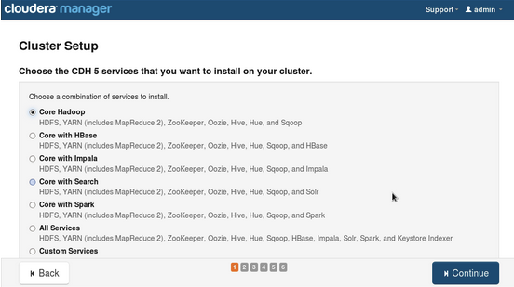

Review that all services were successfully installed.

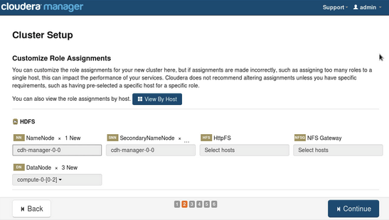

Finally your Hadoop services will be started.

