

DEPARTMENT OF BACHELOR OF ENGINEERING
IBM PROJECT
LIBRARY MANAGEMENT COMMENT OPTIMIZATION
USING DEVOPS/CLEAN CODING

SUBMITTED BY
Atheesh Marudhachalam (2503713820521008)
Eswara kumar D (2503713820521014)
Lingeshwaran S (2503713820521026)
Pragathesh M (2503713825021034)
Venis velan V (2503713820521057)
Vijay P (2503713820521058)
BACHELOR OF TECHNOLOGY
Under the guidance of
AADHI SIVA VAIRAVAN CT – Senior Corporate Trainer
2026 - 2027

Table of Content

Chapter | Title | Page No.
1 | Abstract | 1
2 | Problem Statement | 2
3 | Methodology | 3
3.1 | Analysis of Existing System | 3
3.2 | Identification of Code Quality Issues | 3
3.3 | Comment Analysis and Removal | 4
3.4 | Application of Clean Coding Principles | 4
3.5 | Modularization of the System | 4
3.6 | Refactoring Without Changing Functionality | 4
3.7 | Testing After Refactoring | 4
3.8 | Code Quality Evaluation | 5
3.9 | Documentation and Version Control | 5
3.10 | Final Validation | 5
4 | Data Analysis and Visualization | 6
4.1 | Pandas Analysis | 6,7
4.2 | Matplotlib Visualization | 8
4.3 | Scatter Plot | 9
4.4 | Seaborn Visualization | 10
Chapter | Title | Page No.
5 | DevOps Lifecycle | 11
5.1 | Planning | 11
5.2 | Code | 12
5.3 | Build | 13
5.4 | Test | 13
5.5 | Release | 13
5.6 | Deploy | 13
5.7 | Operate | 14
5.8 | Monitor | 14
6 | Octopus Deploy | 15
7 | Application | 23
7.1 | Screenshots | 23
7.2 | Source code | 34
8 | Feature Scope | 44
9 | Results | 45
10 | References | 46

ABSTRACT:
Software systems require regular maintenance to remain efficient, readable, and easy to enhance. Over time, many applications accumulate outdated, redundant, or unused commands due to repeated modifications, feature additions, and changes in requirements. In a library management system, these unnecessary commands can increase code complexity, reduce readability, introduce maintenance challenges, and make debugging more difficult. As a result, developers spend more time understanding and modifying the code, which affects the overall quality and reliability of the software.
This project focuses on improving an existing library management command system by identifying and removing obsolete and unnecessary commands that no longer correspond to the current implementation. The primary objective is to refactor the codebase using clean coding principles, ensuring that the source code becomes self-explanatory, modular, and maintainable. Instead of relying on lengthy comments or confusing command structures, the project emphasizes meaningful variable names, descriptive method names, proper function decomposition, consistent formatting, elimination of duplicate code, and simplified control flow. These practices make the code easier to understand, modify, and test while reducing the likelihood of introducing errors during future development.
The refactored library management system continues to support essential library operations such as adding books, updating book information, searching for books, issuing books to members, returning borrowed books, managing user records, and maintaining library inventory. However, these operations are implemented using a cleaner and more organized coding approach that improves overall software quality without altering the system's functionality.
By applying clean coding standards, the project demonstrates how code refactoring can significantly enhance software maintainability, scalability, and reliability. The resulting system is more efficient for developers to maintain, easier for new programmers to understand, and better prepared for future enhancements. This project highlights the importance of writing clean, readable, and self-explanatory code as a fundamental practice in modern software development, ensuring that the library management system remains robust, adaptable, and efficient throughout its lifecycle.

PROBLEM STATEMENT:

Software maintenance is one of the most important phases in the software development lifecycle, as applications continuously evolve to meet changing user requirements, fix defects, and incorporate new features. During this process, developers often add comments to explain program logic, document implementation details, or clarify complex sections of the code. Although comments can be useful when written appropriately, they frequently become outdated, redundant, or inconsistent with the actual implementation after multiple modifications. As a result, instead of helping developers understand the code, excessive and obsolete comments create confusion, reduce readability, and increase the effort required to maintain the software.

A Library Management System is a widely used application that manages essential library operations such as maintaining book records, registering members, searching for books, issuing and returning books, tracking due dates, and managing inventory. Over time, continuous updates and enhancements to these modules often leave behind comments that no longer describe the current implementation. In many cases, developers modify the source code but neglect to update the associated comments, causing a mismatch between the documentation and the actual behavior of the system. This inconsistency makes the codebase difficult to understand and increases the possibility of introducing errors during maintenance, debugging, or future development.

Another significant challenge is that excessive comments are often used to compensate for poor coding practices, such as unclear variable names, lengthy methods, duplicate code, deeply nested conditions, and inconsistent formatting. Rather than improving code quality, these comments conceal underlying design issues and make the source code cluttered and difficult to navigate. New developers joining the project may spend considerable time determining whether the comments or the implementation are correct, leading to reduced productivity, increased maintenance costs, and slower software evolution.

The existing Library Management System addressed in this project contains numerous outdated comments and unnecessary code fragments that no longer correspond to the current functionality. These issues reduce code readability, complicate debugging, and make future modifications more time-consuming. Therefore, there is a need to refactor the system by removing redundant comments and replacing them with clean, self-explanatory code that clearly communicates its purpose without relying on excessive documentation.

This project addresses these challenges by applying clean coding principles to improve the quality of the existing Library Management System while preserving its functionality. The refactoring process focuses on removing obsolete comments, eliminating duplicate and unnecessary code, using meaningful variable and method names, breaking large functions into smaller reusable modules, simplifying conditional logic, maintaining consistent formatting, and improving the overall organization of the source code. These improvements ensure that the code itself becomes the primary source of documentation, making it easier for developers to read, understand, test, debug, and maintain.

The refactored system continues to perform all essential library operations, including adding and updating book records, searching the library catalog, issuing and returning books, managing member information, and maintaining inventory records. However, these functionalities are implemented using a cleaner, more structured, and maintainable coding approach that adheres to modern software engineering practices. By emphasizing self-explanatory code instead of excessive comments, the project demonstrates how clean code principles can significantly improve software maintainability, scalability, reliability, and long-term sustainability. The resulting Library Management System is easier to maintain, more efficient for future enhancements, and better suited for collaborative software development.

METHODOLOGY:
The methodology adopted for this project focuses on improving the maintainability and readability of an existing Library Management System through systematic code refactoring and the application of clean coding principles. The proposed approach preserves the existing functionality of the system while improving the internal structure, organization, and quality of the source code.

1. Analysis of the Existing System
The first step is to study the existing Library Management System and understand its major modules and functionalities. The system is analyzed to identify problems such as outdated comments, redundant comments, duplicate code, unclear variable names, lengthy functions, complex conditional statements, and inconsistent coding practices. Each module is reviewed to understand how the current implementation works before making any modifications.

2. Identification of Code Quality Issues
After analyzing the source code, the existing code quality problems are categorized based on their impact on maintainability. Unnecessary and obsolete comments are identified by comparing them with the actual implementation. Other issues such as code duplication, unused code, large methods, poor naming conventions, deeply nested conditions, and inconsistent formatting are also documented. This provides a clear understanding of the areas that require improvement.

3. Comment Analysis and Removal
Comments are examined to determine whether they provide meaningful information about the implementation. Comments that are outdated, redundant, misleading, or simply repeat what the code already expresses are removed. Important documentation that explains complex business rules or necessary implementation details is retained. The objective is not to remove all comments but to reduce unnecessary comments and make the source code sufficiently self-explanatory.

4. Application of Clean Coding Principles
Clean coding principles are applied throughout the refactoring process. Meaningful and descriptive names are assigned to variables, functions, classes, and components. Large functions are divided into smaller and focused functions, while duplicate code is replaced with reusable methods or components. Complex conditional statements are simplified wherever possible. Consistent indentation, formatting, naming conventions, and code organization are also maintained.

5. Modularization of the System
The Library Management System is divided into logical and manageable modules based on their responsibilities. Major operations such as book management, member management, book searching, issuing, returning, and inventory management are organized into separate components or functions. This reduces dependency between different parts of the system and makes individual modules easier to understand, test, modify, and maintain.

6. Refactoring Without Changing Functionality
The identified code is refactored while maintaining the original behavior of the application. The main objective is to improve the internal quality of the software without affecting the functionality available to users. Existing features such as adding books, updating records, searching books, issuing books, returning books, managing members, and tracking inventory continue to operate as expected.

7. Testing After Refactoring
Testing is performed after each major refactoring activity to ensure that the modifications have not introduced functional errors. The major library operations are tested individually and as complete workflows. Input validation, database operations, navigation, search functionality, book issue and return operations, and record updates are verified to ensure that the system continues to produce the expected results.

8. Code Quality Evaluation
The refactored source code is compared with the original implementation to evaluate the improvements. The comparison focuses on factors such as reduction of unnecessary comments, reduction of duplicate code, improved naming, reduced complexity, better modularity, consistent formatting, and improved readability. The maintainability of the code is evaluated based on how easily developers can understand and modify the system.

9. Documentation and Version Control
The changes made during the refactoring process are documented and maintained using version control practices. Each major modification is tracked so that previous versions can be reviewed or restored when necessary. This also supports collaborative development and provides a clear history of improvements made to the Library Management System.

10. Final Validation
Finally, the complete refactored system is executed and validated to ensure that all required library operations function correctly. The final version is reviewed for readability, maintainability, consistency, and reliability. The outcome is a cleaner Library Management System in which the source code clearly communicates its purpose, reducing unnecessary dependence on comments and making future maintenance and enhancement easier.

DATA’S AND DESCIPTION:
1.Using Pandas
import pandas as pd
# Create library dataset
data = {
"Book_ID": [101, 102, 103, 104, 105],
"Book_Name": [
"Python Basics",
"Data Science",
"Machine Learning",
"Web Development",
"Database Systems" ],
"Borrow_Count": [45, 60, 75, 50, 40],
"Comment_Count": [10, 18, 25, 12, 8]
}
# Create DataFrame
df = pd.DataFrame(data)
# Display dataset
print("Library Management Dataset")
print(df)
# Display basic information
print("\nDataset Information:")
print(df.info())
# Display statistical summary
print("\nStatistical Summary:")
print(df.describe())
# Calculate average comments
print("\nAverage Comments:",
df["Comment_Count"].mean())
# Find most commented book
most_commented = df.loc[
df["Comment_Count"].idxmax()
]
print("\nMost Commented Book:",
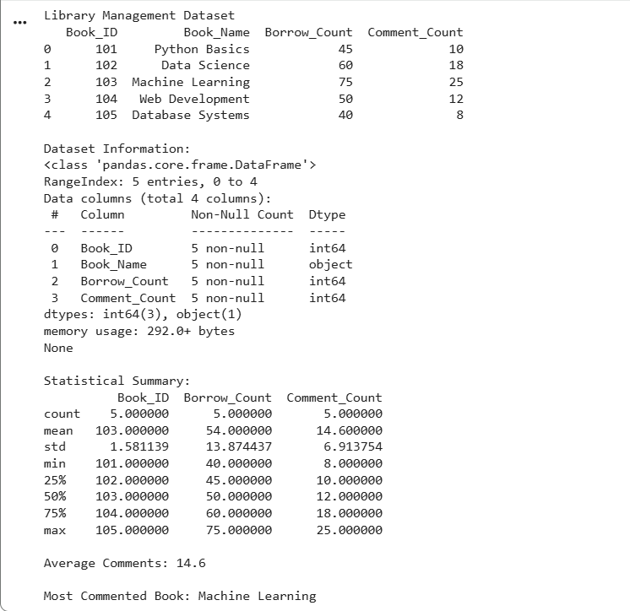
most_commented["Book_Name"])

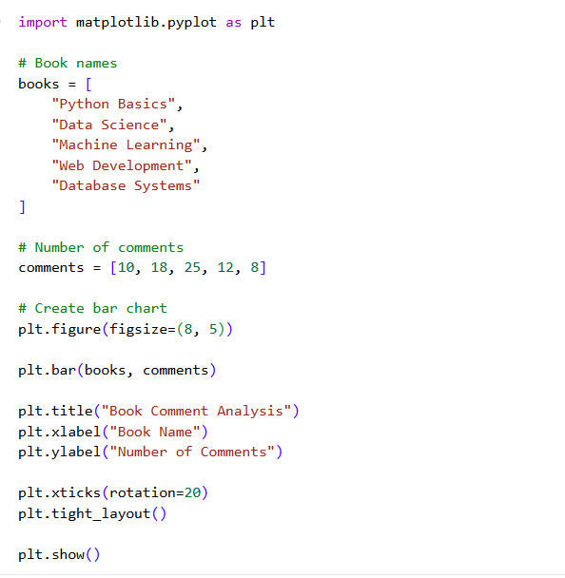
2.Using Matplotlib

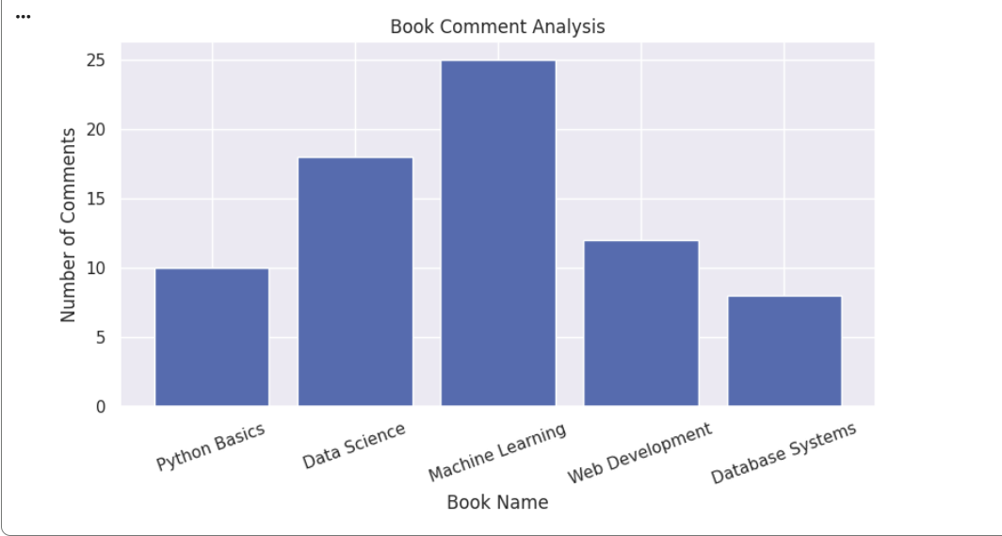

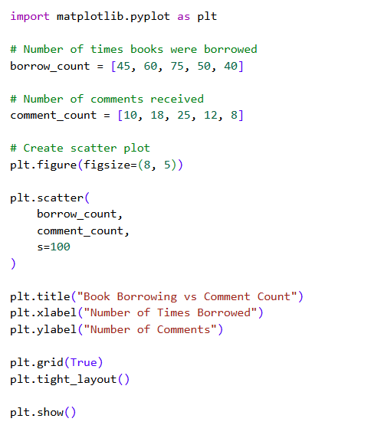
3.Using Scatter Plot

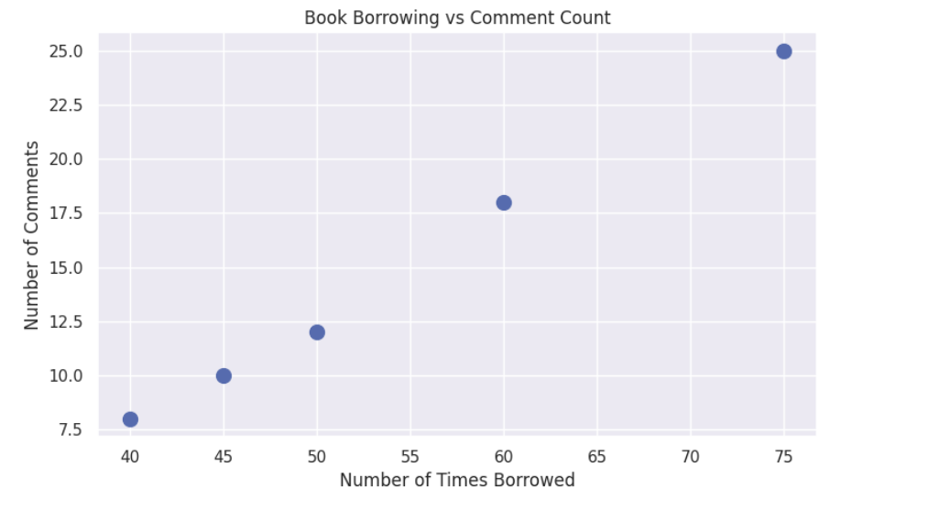

4.Using Seaborn
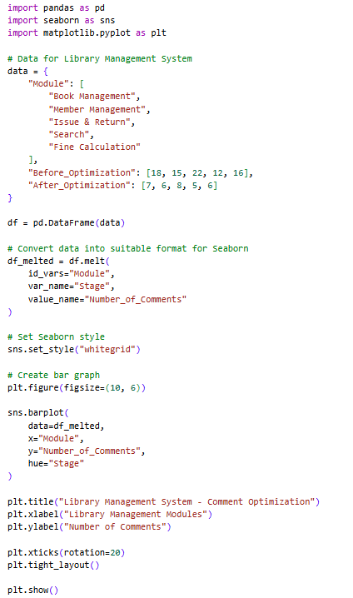

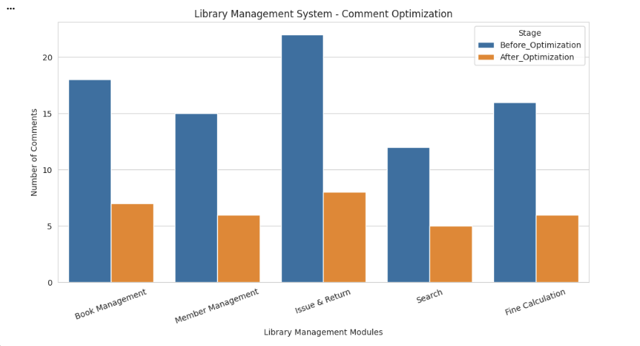

DEVOPS LIFECYCLE:
1.Planning
- Tool used Mural
- Mural is a digital, infinite canvas built for teams to think, plan, and design together — in real time or on their own schedule.
- It replaces the physical whiteboard and sticky notes of an in-person workshop with a flexible online space that any distributed team can open from a browser .
Key features of Mural:
- Infinite Canvas
- Digital Sticky notes
- Real time collaboration
- Structured templates

Planning Chart:
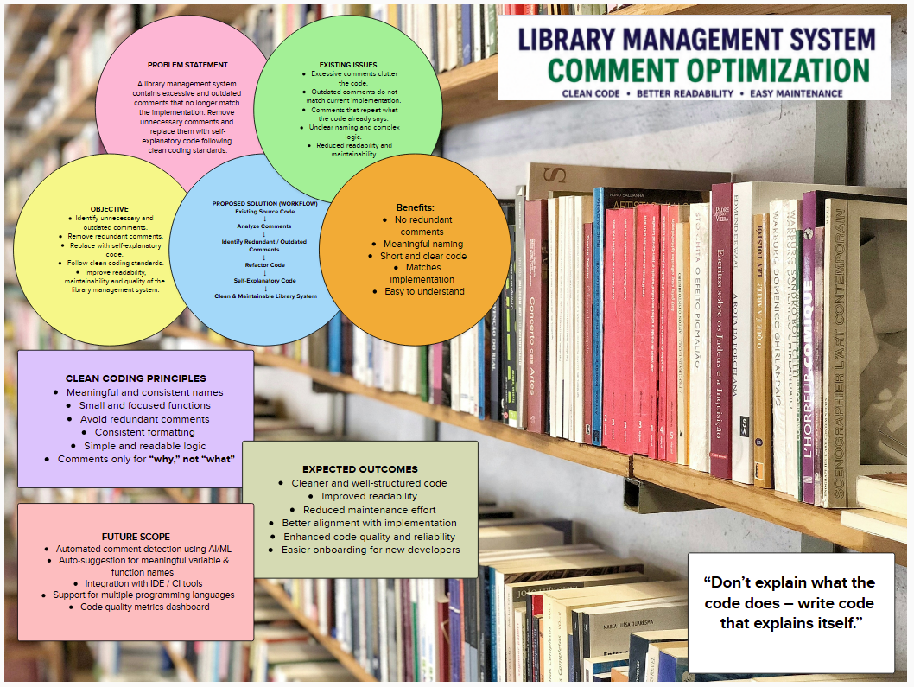

Code
During the Code phase, the Library Management System is developed and optimized according to the requirements of students, staff, and administrators. The main components include authentication, student management, staff management, book management, book issue and return, fine calculation, search, and database operations. In the project, reusable React components can be used for dashboards, book cards, forms, and popup messages to reduce duplicate code. Firebase is used to manage authentication and database-related operations.
Example: When a staff member issues a book, the system checks the student's details and book availability before creating the borrowing transaction.

Build
During the Build phase, the developed source code is converted into a production-ready application. Dependencies are installed, the code is checked for errors, and the frontend is built for deployment. Build optimization helps remove unnecessary files and ensures that the application loads efficiently.
Example: In the project, the React application can be built using npm run build, which generates the production files required for deployment.

Test
During the Test phase, the Library Management System is checked to make sure that all components work correctly. Student login, staff login, administrator access, book search, book issue, book return, and fine calculation are tested. Database operations and authentication are also checked to ensure that incorrect or unauthorized operations are prevented.
Example: If a staff member tries to issue a book that has no available copies, the system should display “Book unavailable” and should not create an issue transaction.

Release
During the Release phase, the tested and optimized version of the Library Management System is prepared for users. The completed features are reviewed, errors are fixed, and the stable version is stored in the GitHub repository. A version number can also be assigned to identify the release.
Example: After completing and testing the student, staff, and admin dashboards, the project can be released as Library Management System v1.0.0.

Deploy
During the Deploy phase, the released Library Management System is made available to users through a hosting platform. The frontend application, database configuration, authentication, and required environment settings are configured before making the system available.

Example: The React-based library project can be deployed using GitHub Pages, allowing students and staff to access the application through a web browser.

Operate
During the Operate phase, the deployed system is maintained for daily library activities. Administrators manage users and permissions, while staff manage books, students, issue transactions, and returns. Database records are maintained and backups or recovery procedures are used to protect important library information.
Example: When a student returns a book, the system updates the transaction and makes the book available again for future borrowing.

Monitor
During the Monitor phase, the Library Management System is continuously observed to identify errors and performance problems. Important activities such as authentication failures, database operations, book transactions, application errors, and system availability can be monitored.
Example: If book issue operations repeatedly fail, the administrator can investigate the database or application logs and identify the cause before it affects more users.

Screenshots of Octopus Deploy:
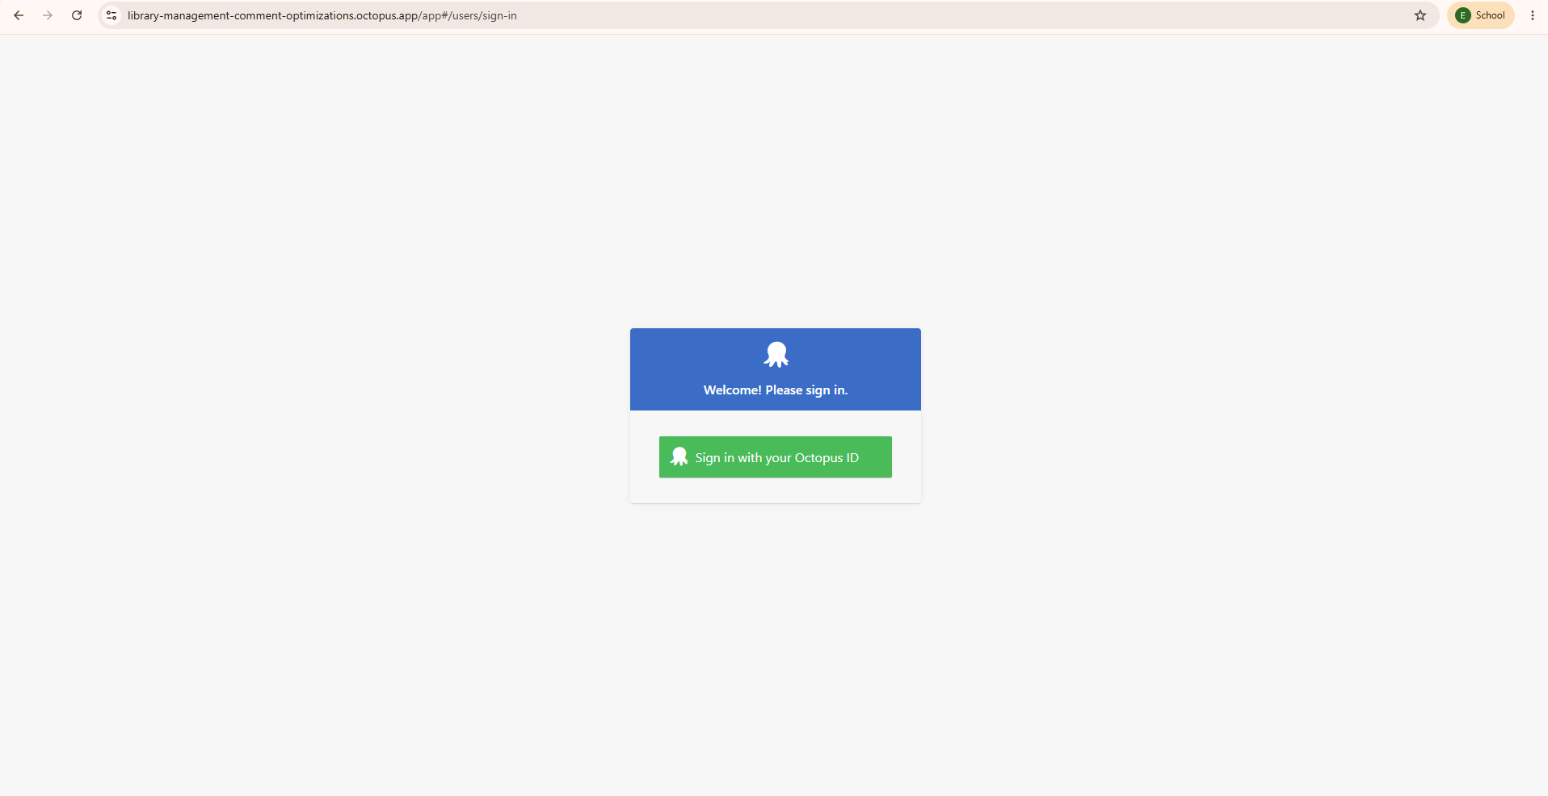
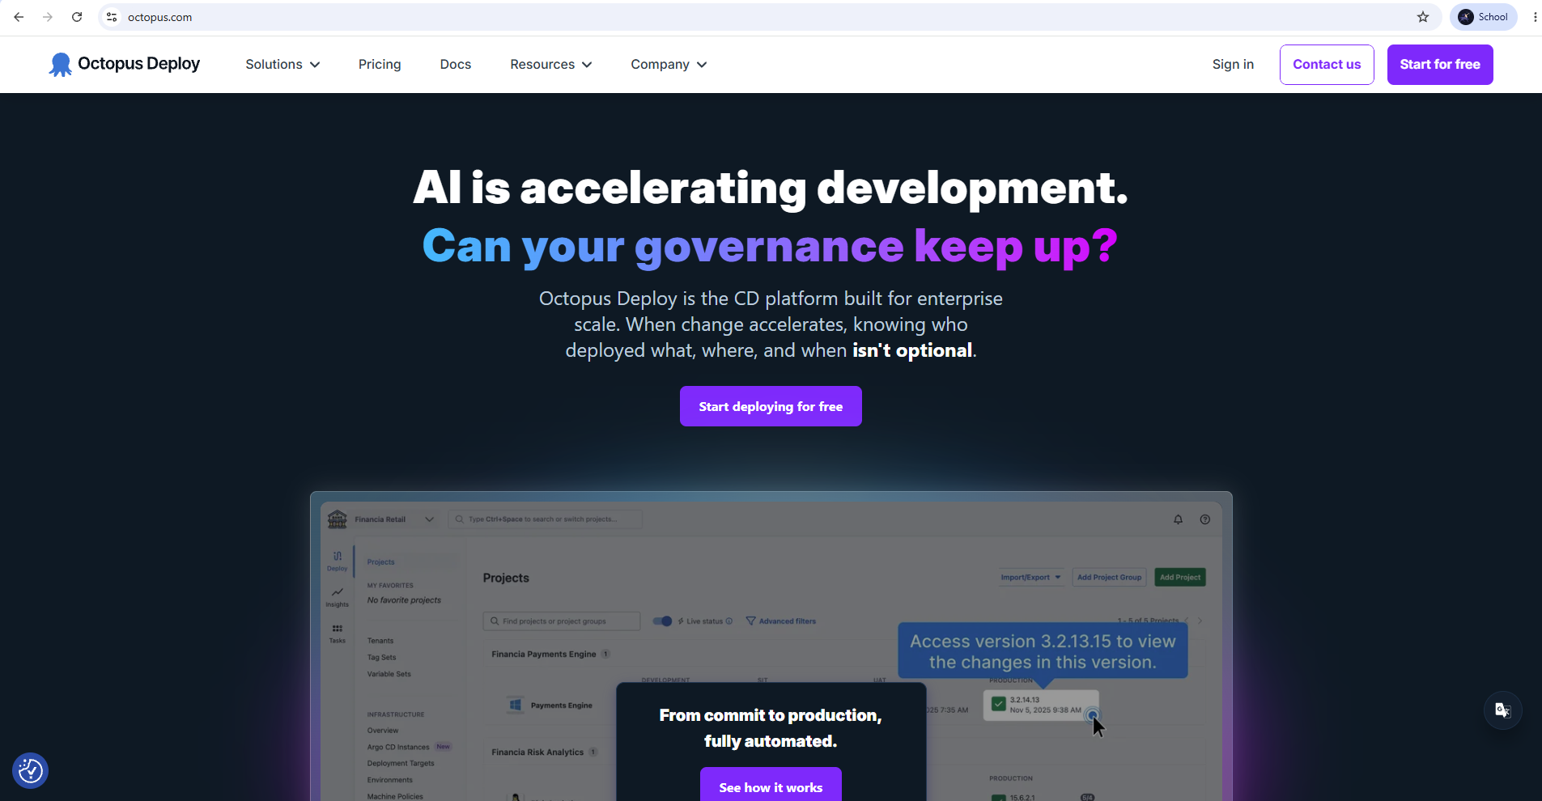
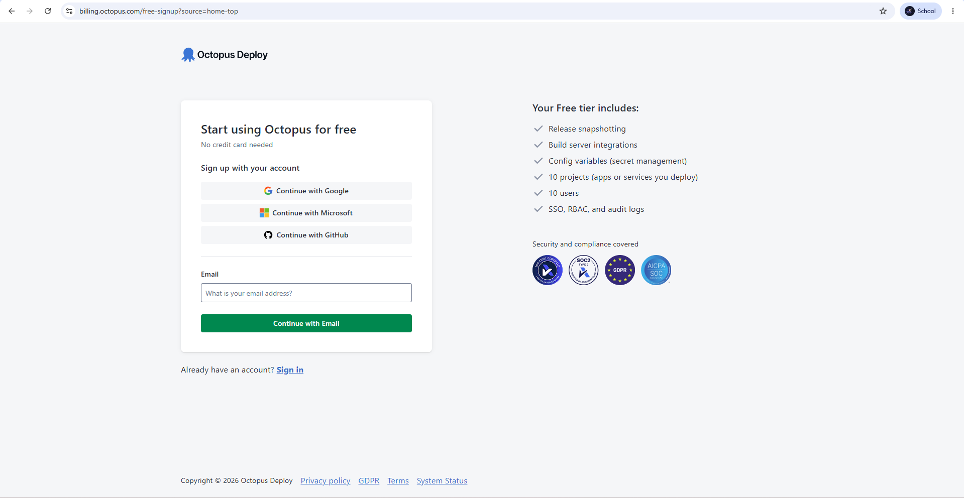

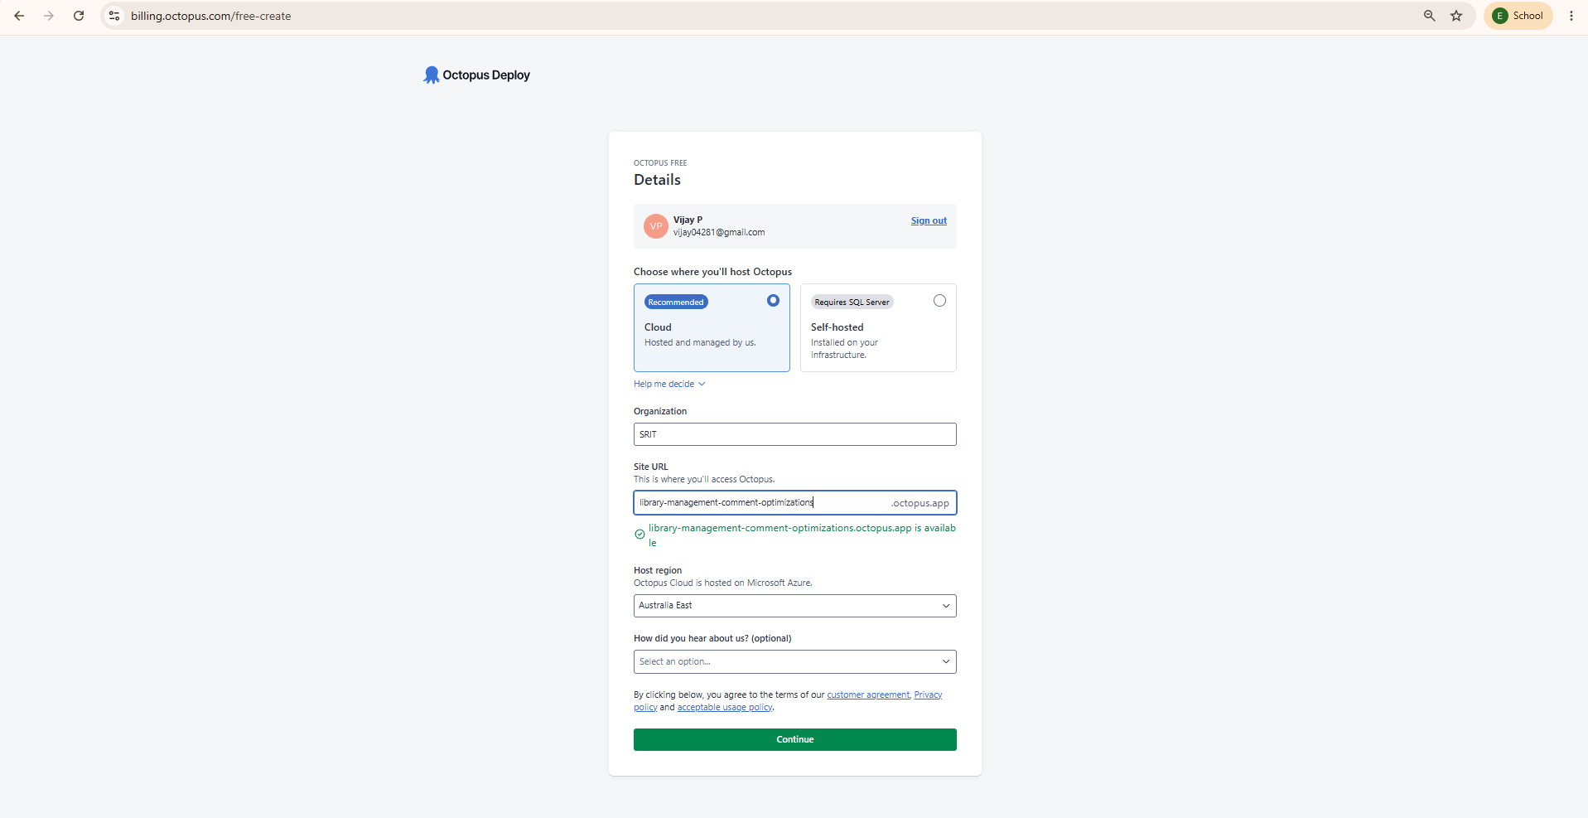
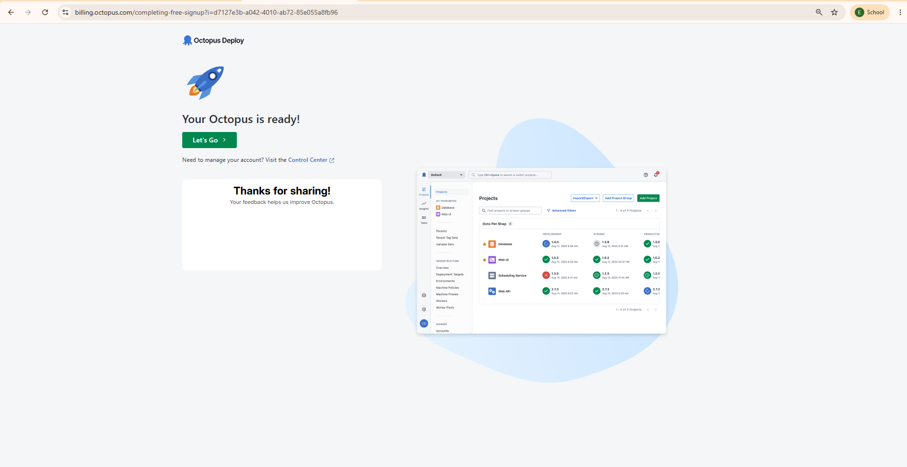
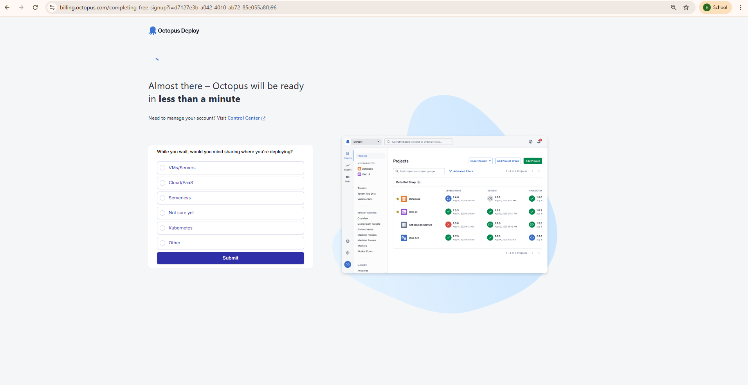
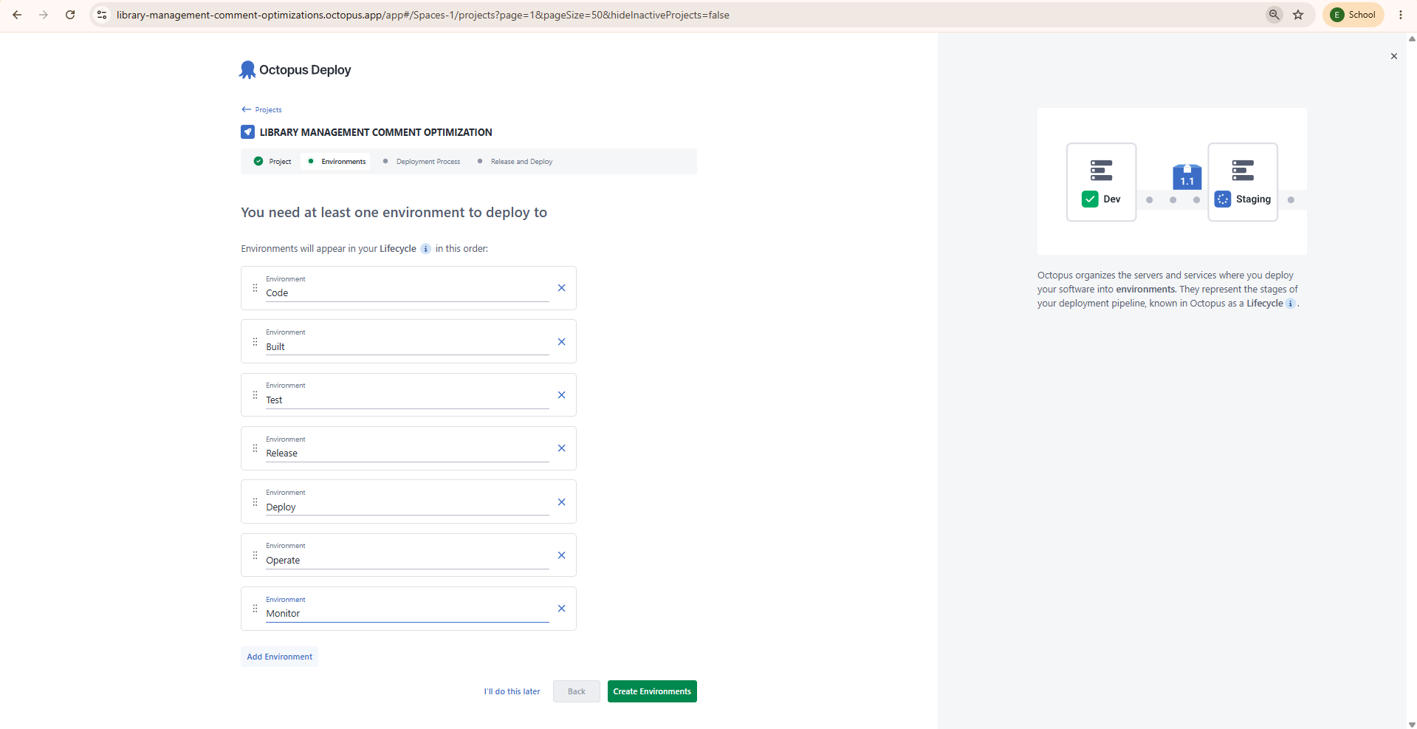

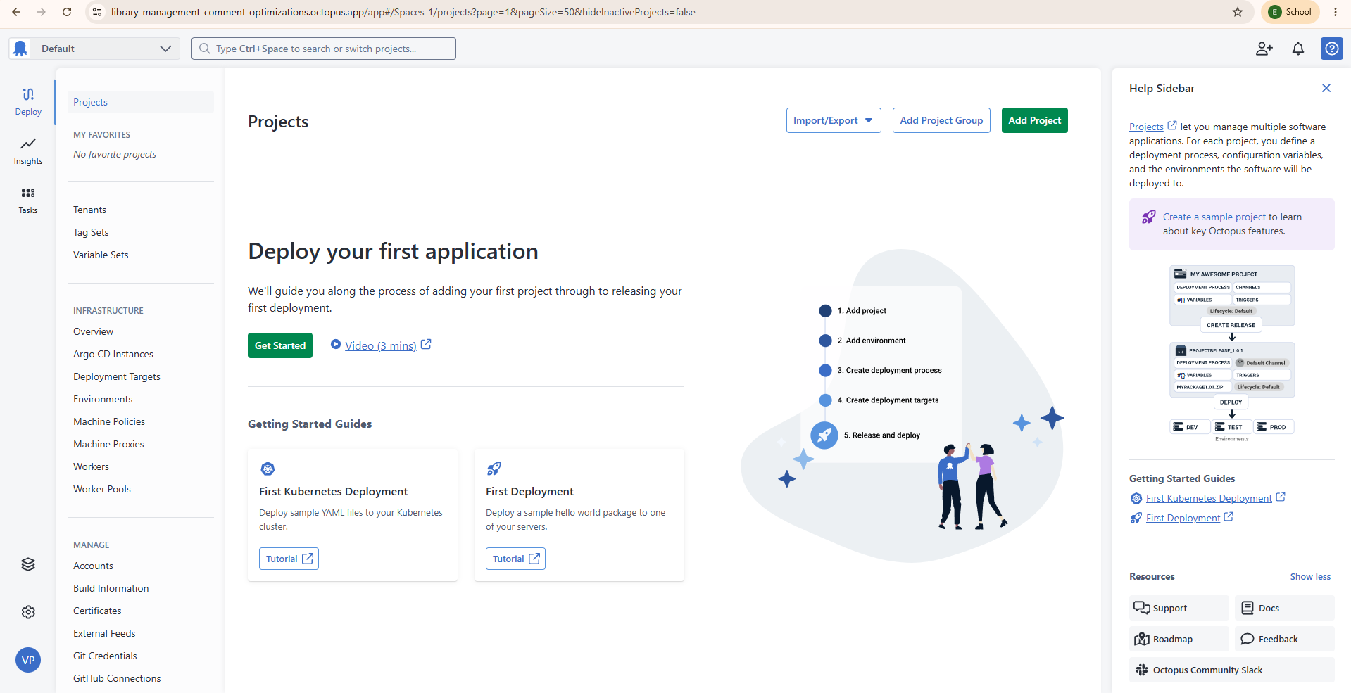

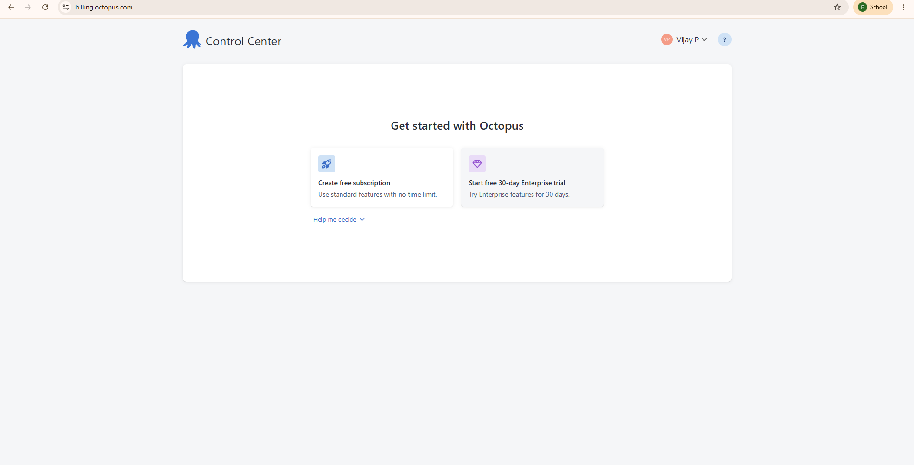
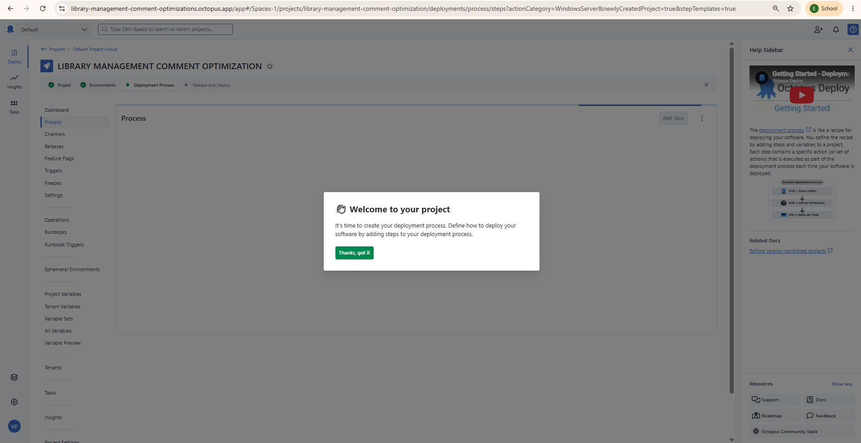

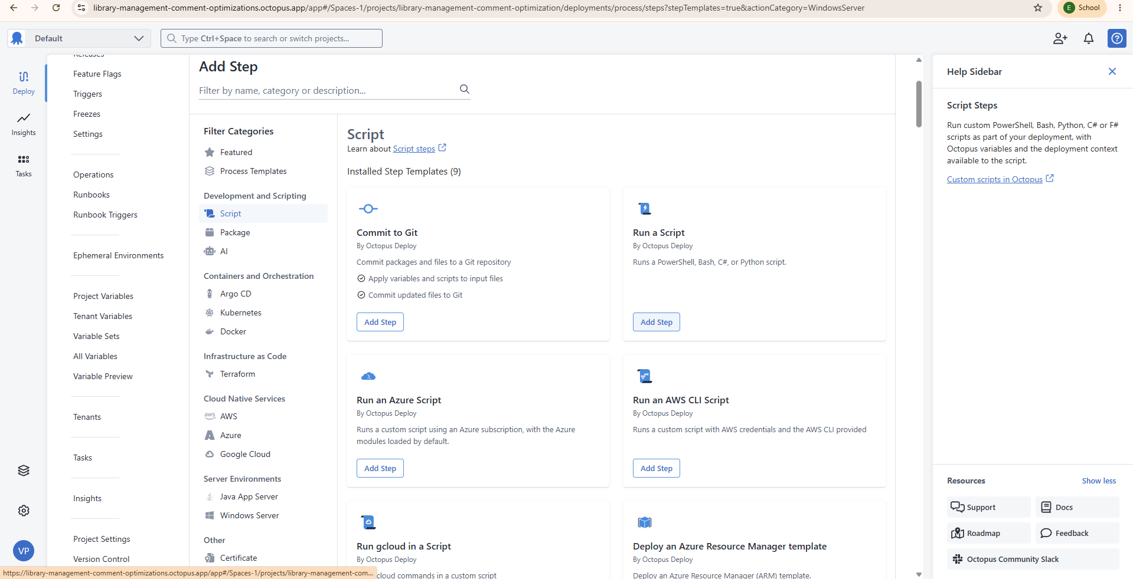

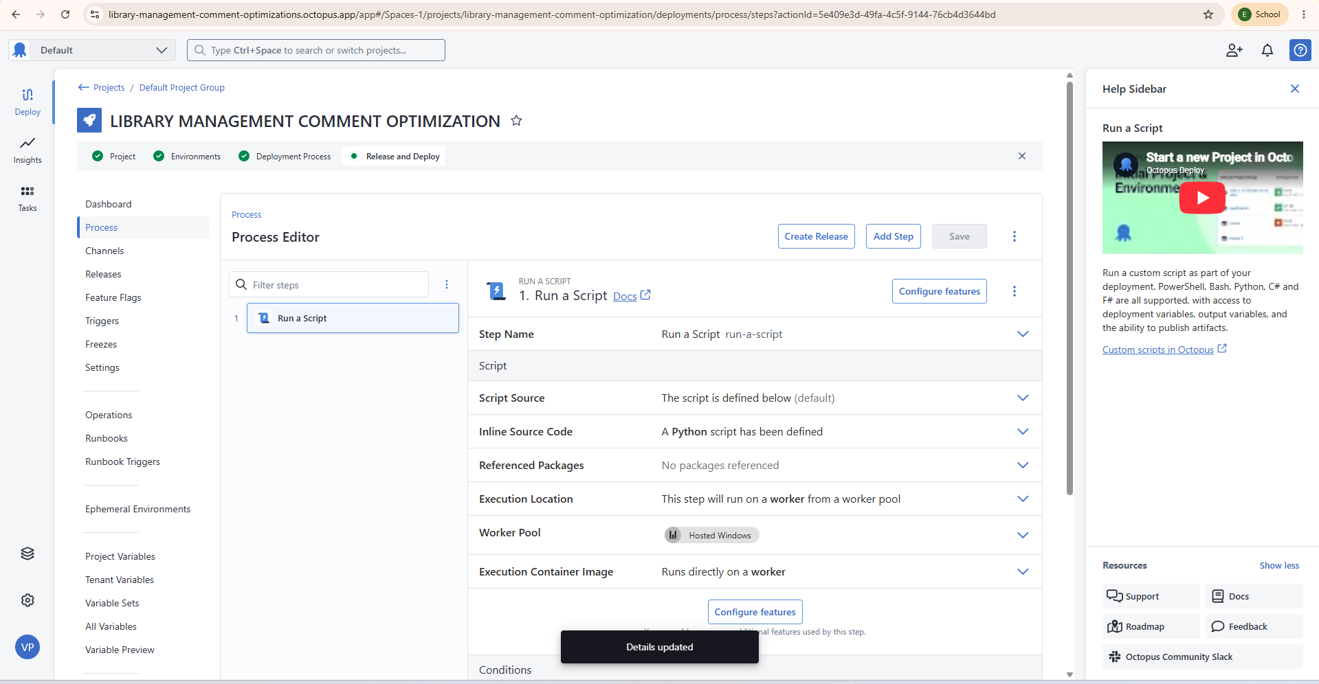

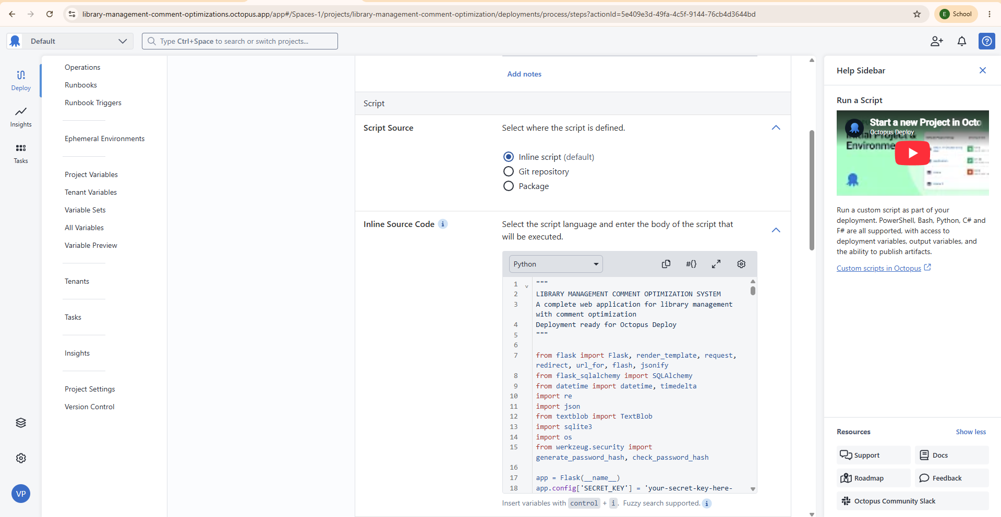

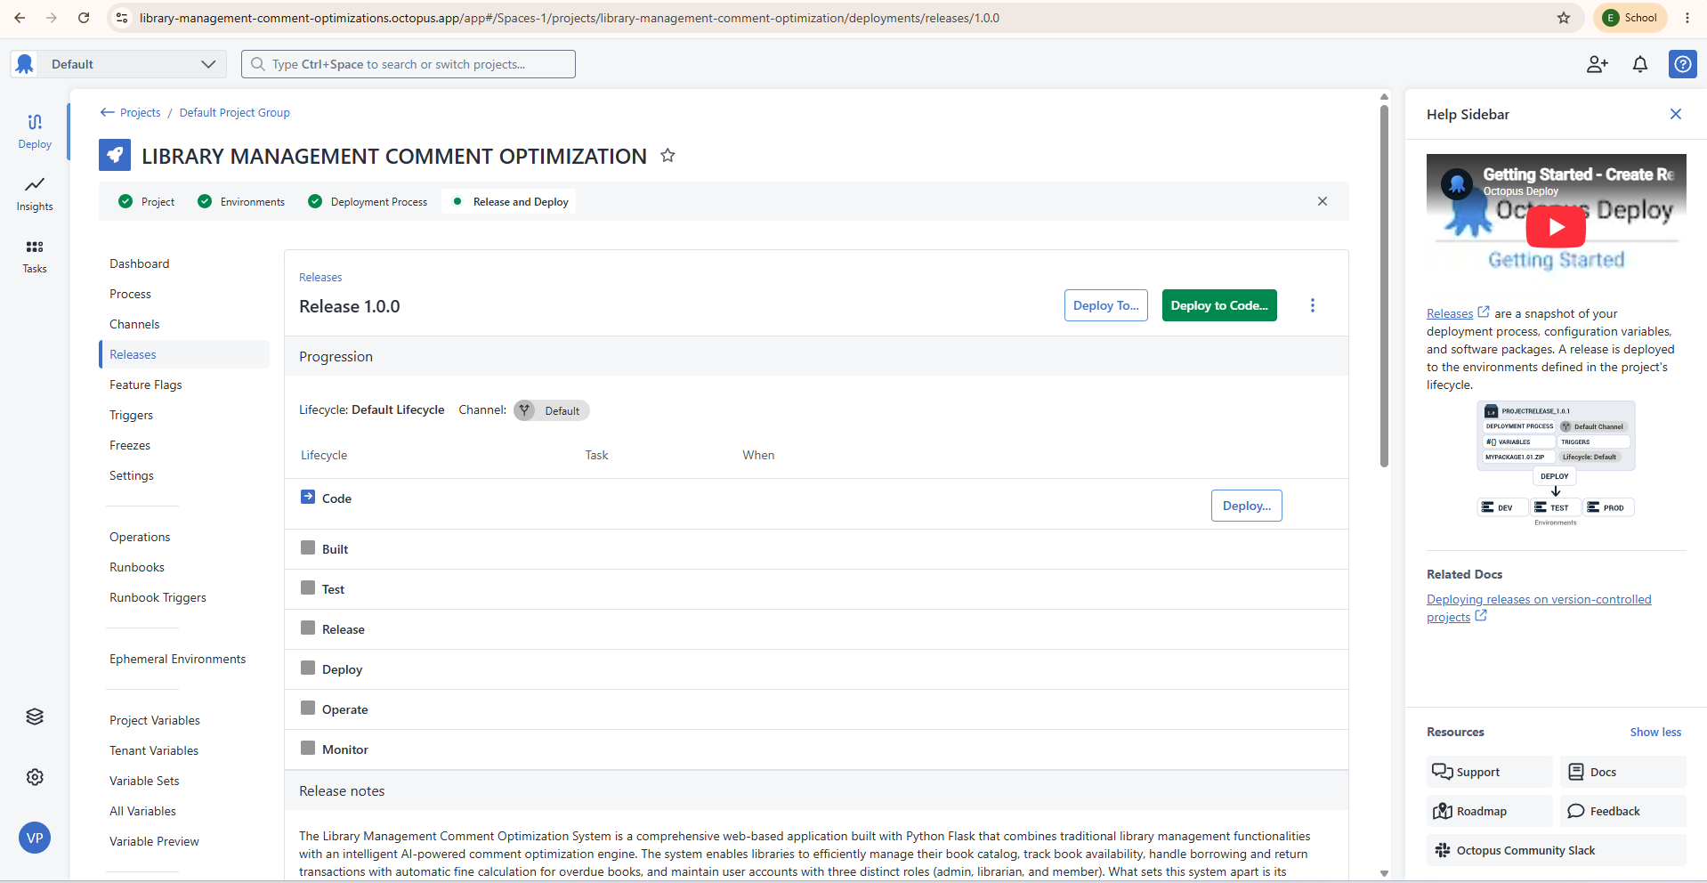

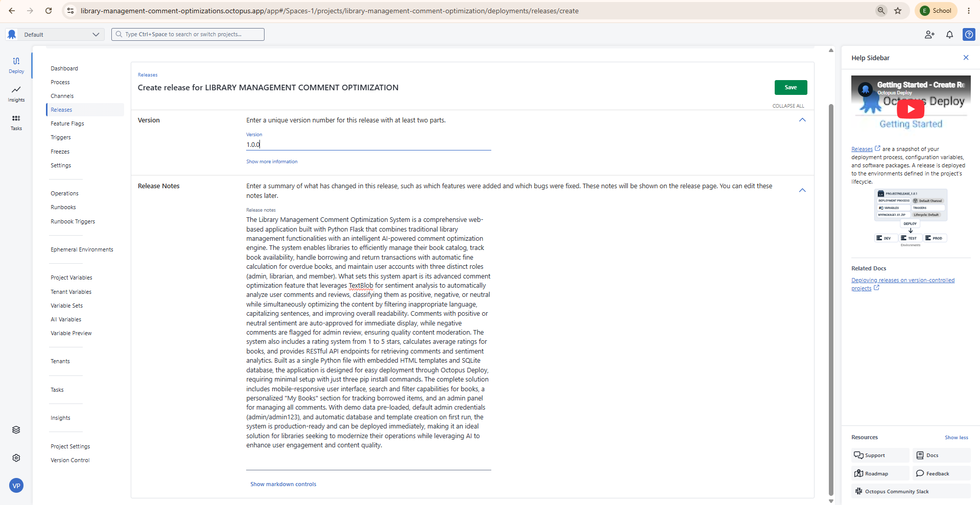

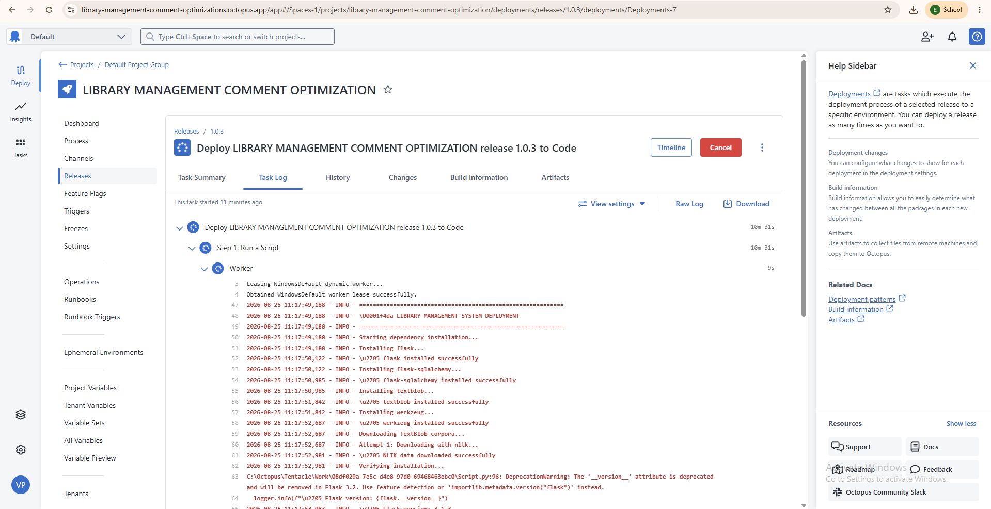

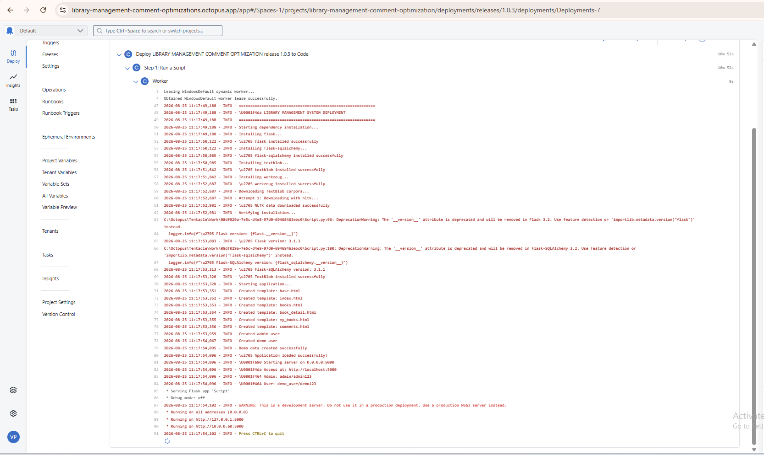

* Running on http://10.0.0.60:5000
Application
Screenshots:

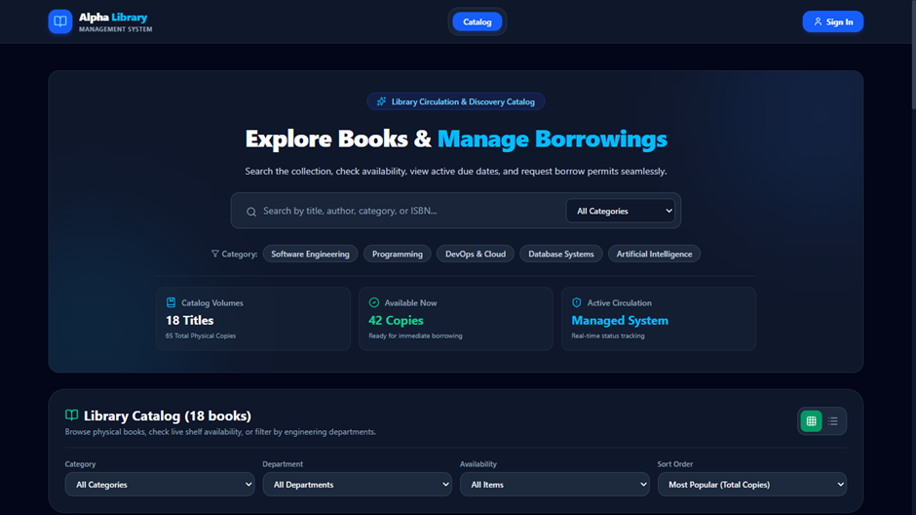
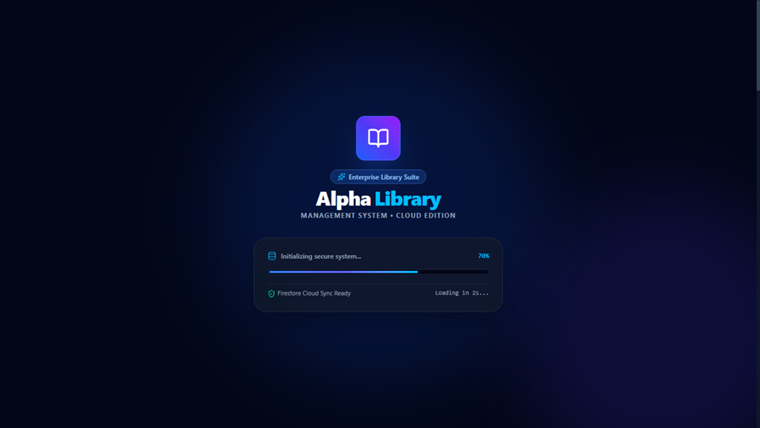

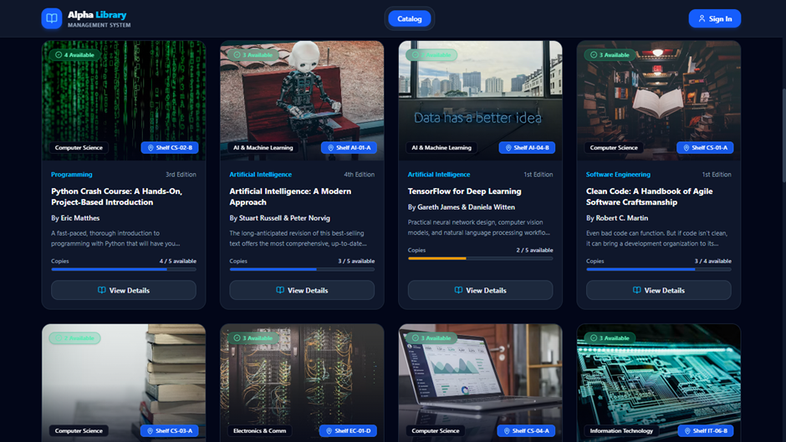

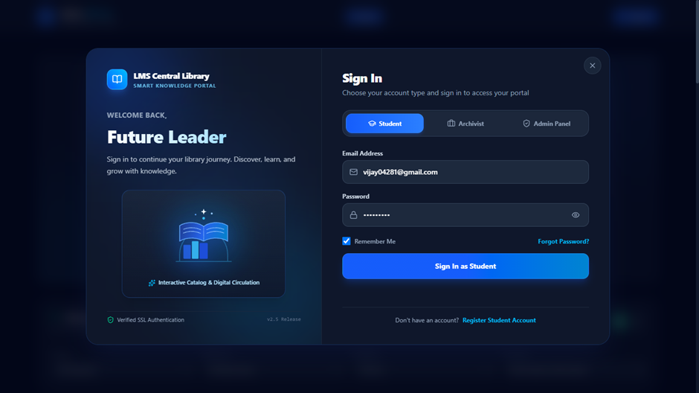

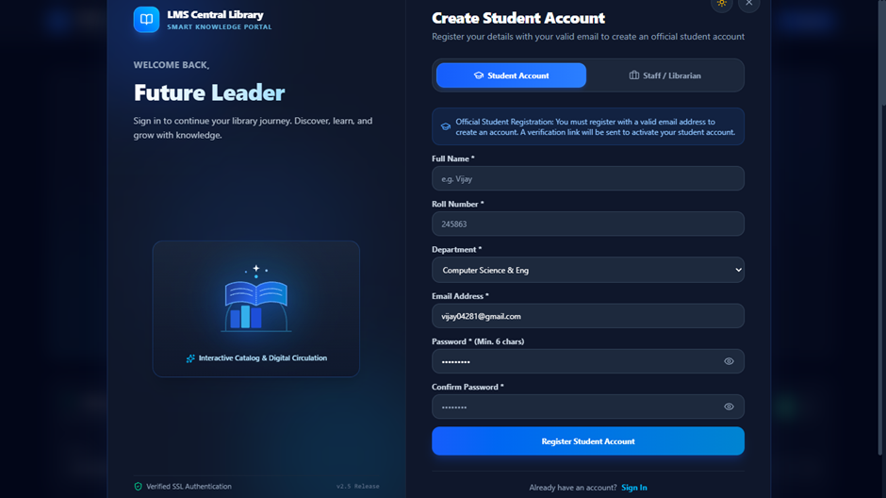

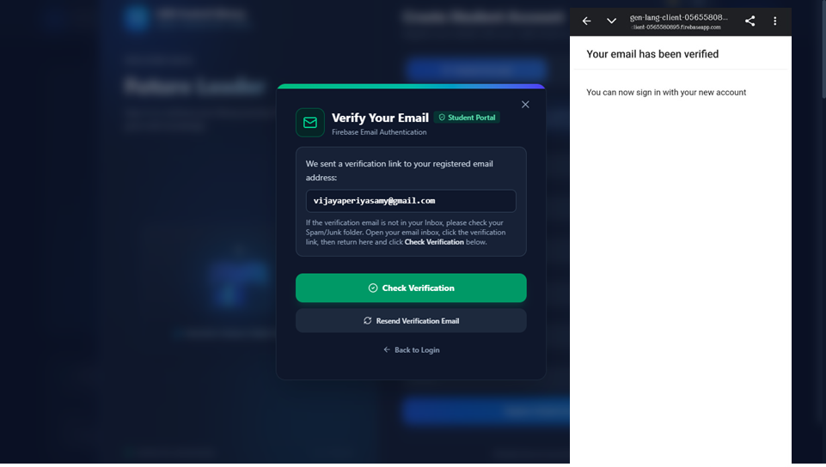

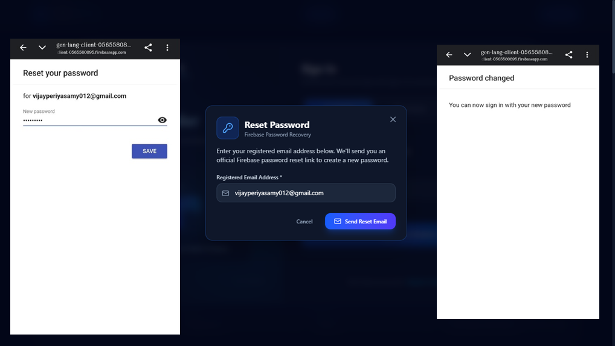

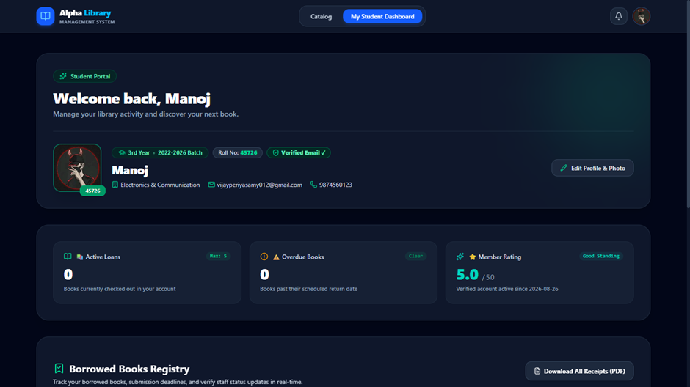

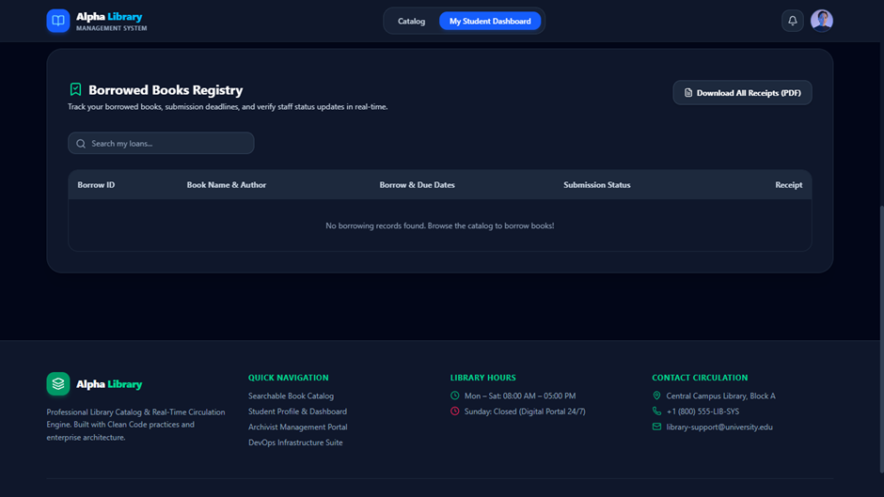

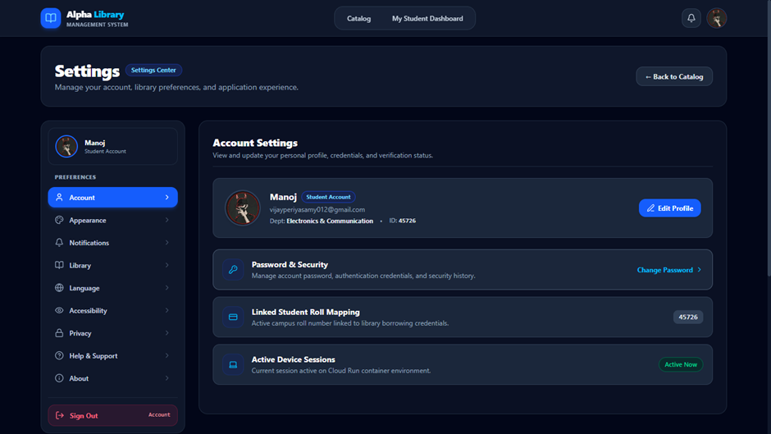
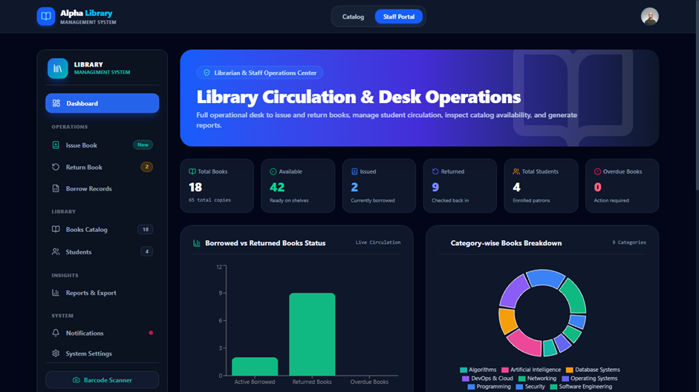

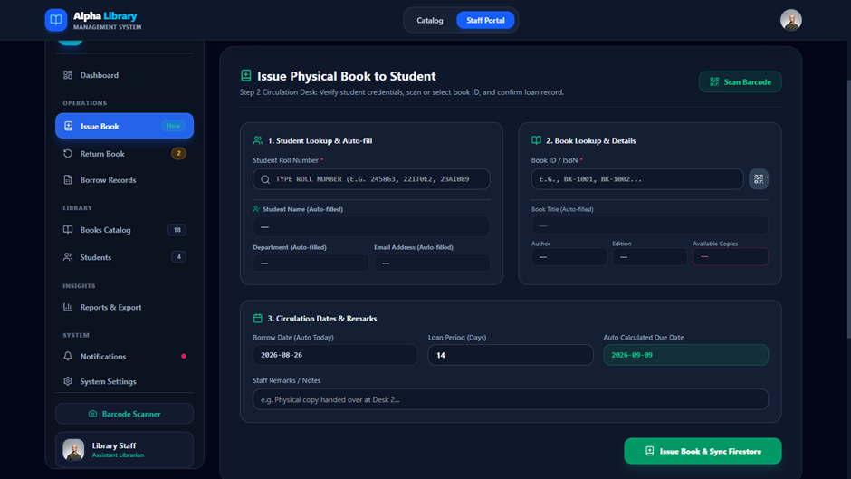

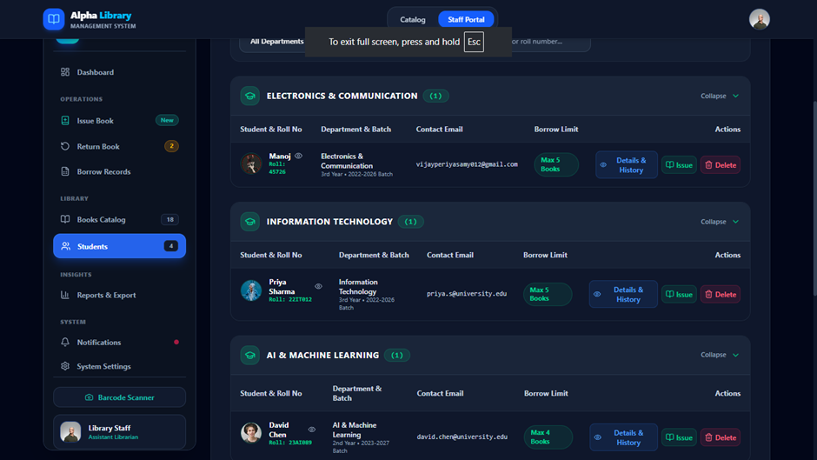

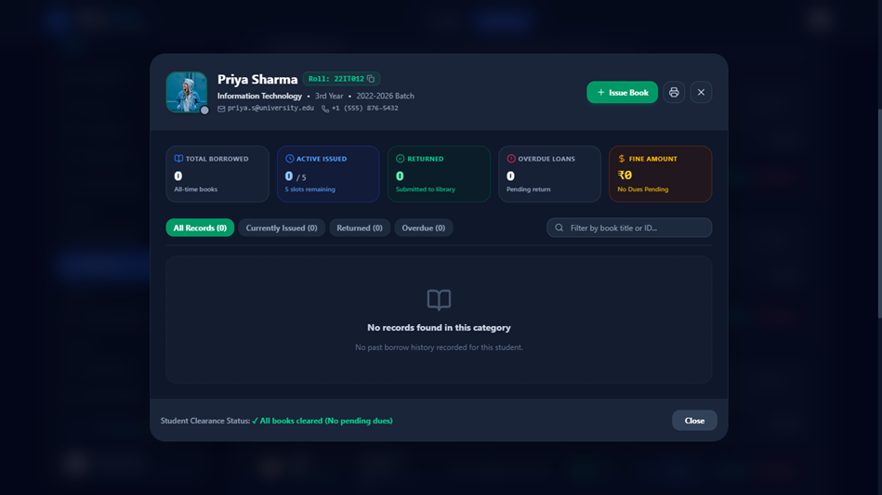

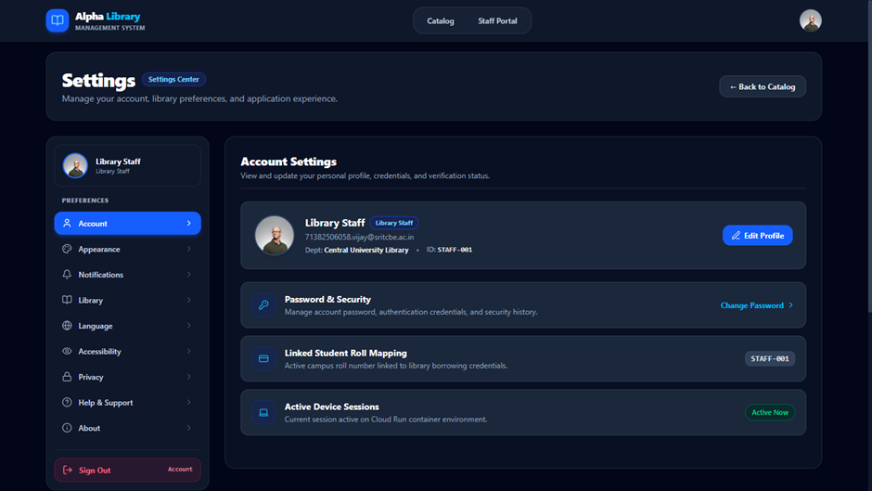



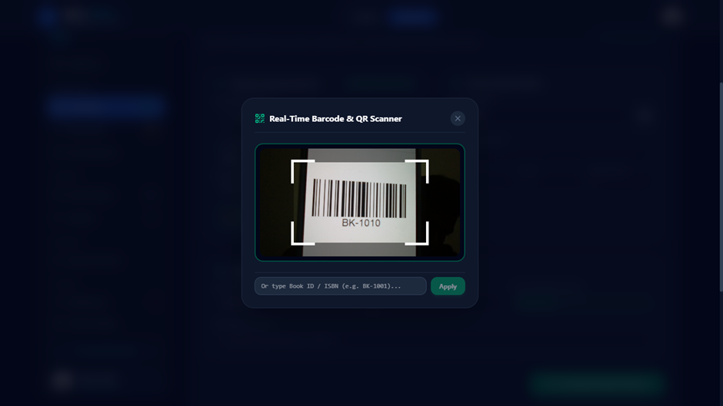

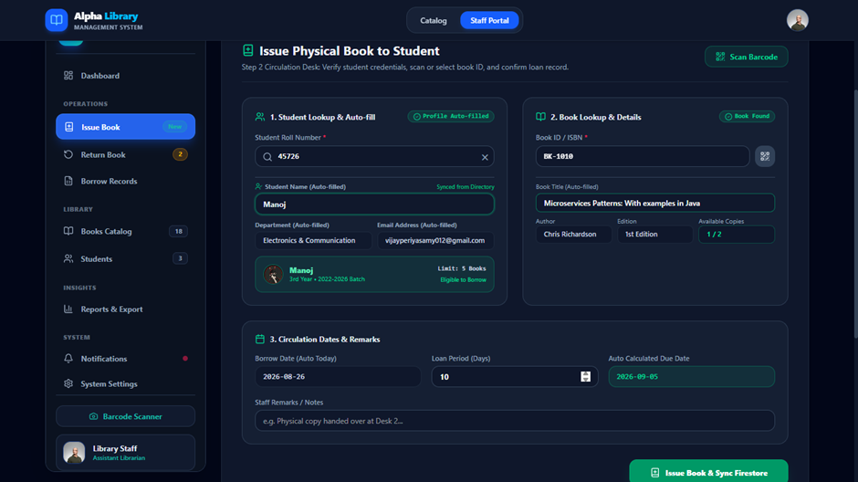

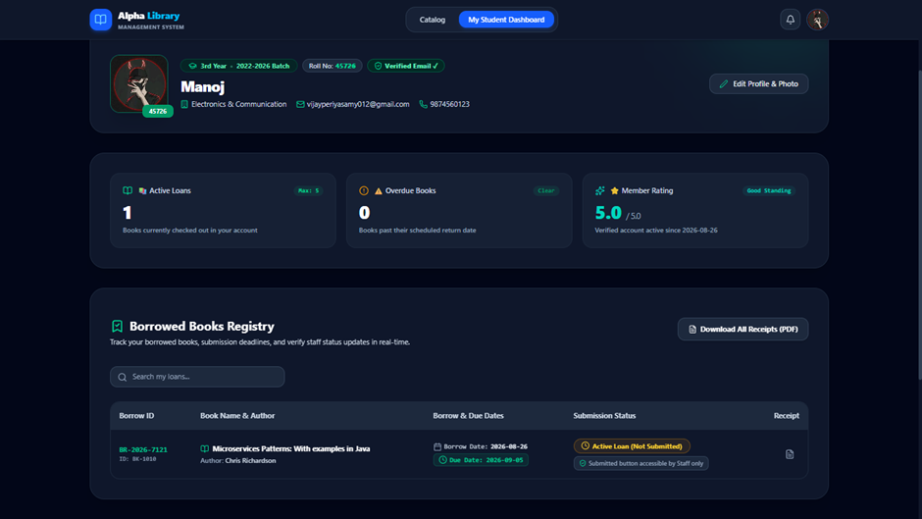

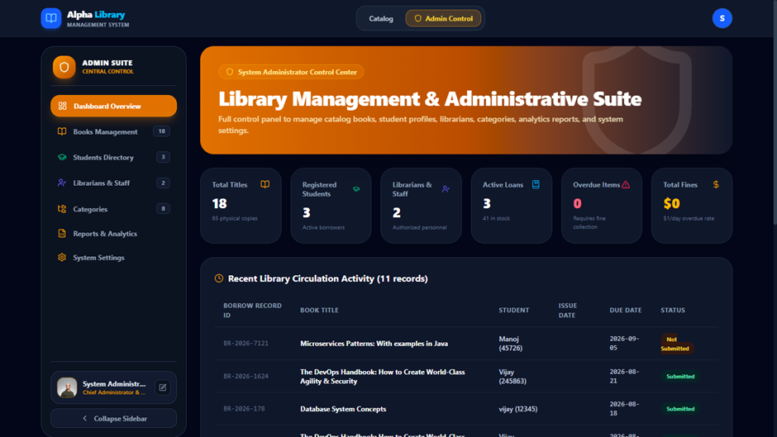

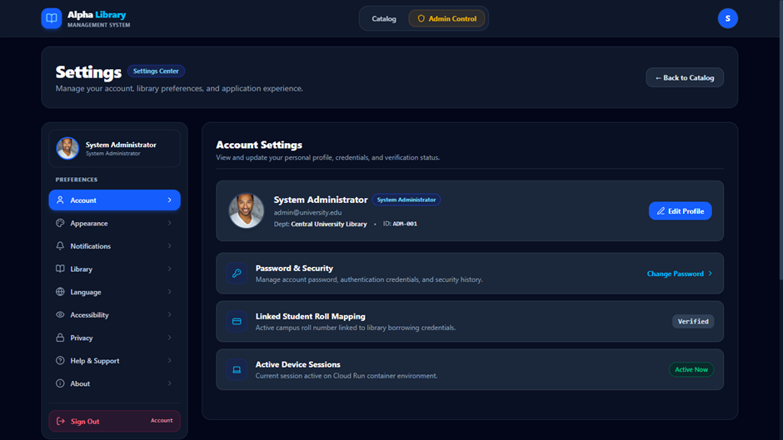

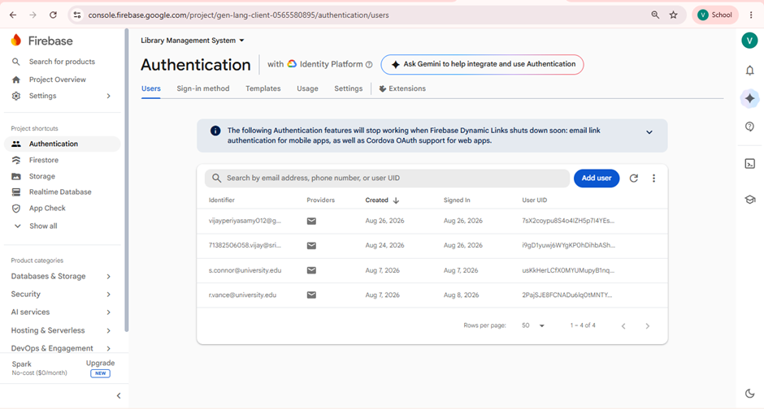

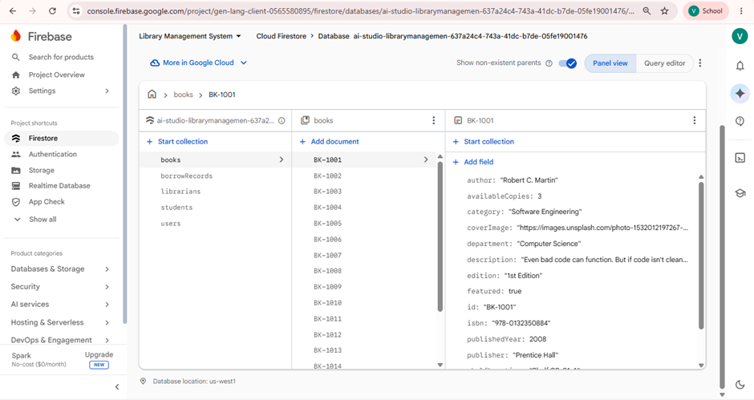

Source code

import React, { useState } from 'react';
import { LibraryProvider, useLibrary } from './context/LibraryContext';
import { Navbar } from './components/Navbar';
import { HeroBanner } from './components/HeroBanner';
import { BookCard } from './components/Catalog/BookCard';
import { BookDetailsModal } from './components/Catalog/BookDetailsModal';
import { AddEditBookModal } from './components/Catalog/AddEditBookModal';
import { StudentDashboard } from './components/Dashboards/StudentDashboard';
import { StaffDashboard } from './components/Dashboards/StaffDashboard';
import { AdminDashboard } from './components/Dashboards/AdminDashboard';
import { DevOpsPanel } from './components/DevOpsPanel';
import { SettingsCenter } from './components/SettingsCenter';
import { AccessDeniedView } from './components/AccessDeniedView';
import { LoginModal } from './components/Auth/LoginModal';
import { ToastContainer } from './components/ToastContainer';
import { Footer } from './components/Footer';
import { SplashScreen } from './components/SplashScreen';
import { CATEGORIES, DEPARTMENTS } from './data/mockData';
import { Book } from './types';
import {
Grid,
List as ListIcon,
Filter,
SlidersHorizontal,
RotateCcw,
BookOpen,
CheckCircle2,
XCircle,
Plus
} from 'lucide-react';
import { motion, AnimatePresence } from 'motion/react';

const CatalogView: React.FC = () => {
const { books, filters, setFilters, resetFilters, setSelectedBook, currentRole } = useLibrary();
const [viewMode, setViewMode] = useState<'grid' | 'list'>('grid');
const [isAddBookModalOpen, setIsAddBookModalOpen] = useState(false);
const [bookToEdit, setBookToEdit] = useState<Book | null>(null);

// Apply filters
const filteredBooks = books.filter(book => {
const query = filters.searchQuery.toLowerCase().trim();
const matchesQuery =
!query ||
book.title.toLowerCase().includes(query) ||
book.author.toLowerCase().includes(query) ||
book.id.toLowerCase().includes(query) ||
book.isbn.toLowerCase().includes(query) ||
book.category.toLowerCase().includes(query);

const matchesCategory =
filters.category === 'All Categories' || book.category === filters.category;

const matchesDepartment =
filters.department === 'All Departments' || book.department === filters.department;

const matchesAvailability =
filters.availability === 'all' ||
(filters.availability === 'available' && book.availableCopies > 0) ||
(filters.availability === 'out_of_stock' && book.availableCopies === 0);

return matchesQuery && matchesCategory && matchesDepartment && matchesAvailability;
});
// Sort books
const sortedBooks = [...filteredBooks].sort((a, b) => {
if (filters.sortBy === 'title') return a.title.localeCompare(b.title);
if (filters.sortBy === 'newest') return b.publishedYear - a.publishedYear;
if (filters.sortBy === 'available') return b.availableCopies - a.availableCopies;
return b.totalCopies - a.totalCopies; // 'popular'
});

return (
<div className="space-y-8">
{/* Hero Banner */}
<HeroBanner />

{/* Catalog Control Bar */}
<div className="bg-white dark:bg-slate-900 border border-slate-200 dark:border-slate-800 rounded-3xl p-6 shadow-xl space-y-4 text-slate-900 dark:text-white transition-colors">
<div className="flex flex-col md:flex-row md:items-center justify-between gap-4">
<div>
<h2 className="text-xl font-bold flex items-center gap-2">
<BookOpen className="w-5 h-5 text-emerald-600 dark:text-emerald-400" />
Library Catalog ({sortedBooks.length} books)
</h2>
<p className="text-xs text-slate-500 dark:text-slate-400 mt-0.5">
Browse physical books, check live shelf availability, or filter by engineering departments.
</p>
</div>

<div className="flex items-center gap-3">
{/* View Mode Switcher */}
<div className="flex p-1 bg-slate-100 dark:bg-slate-800 border border-slate-200 dark:border-slate-700 rounded-xl">
<button
id="btn-view-grid"
onClick={() => setViewMode('grid')}
className={`p-2 rounded-lg text-xs font-semibold transition-all cursor-pointer ${
viewMode === 'grid'
? 'bg-emerald-600 text-white shadow-md'
: 'text-slate-500 dark:text-slate-400 hover:text-slate-900 dark:hover:text-white'
}`}
title="Grid View" >
<Grid className="w-4 h-4" />
</button>
<button
id="btn-view-list"
onClick={() => setViewMode('list')}
className={`p-2 rounded-lg text-xs font-semibold transition-all cursor-pointer ${
viewMode === 'list'
? 'bg-emerald-600 text-white shadow-md'
: 'text-slate-500 dark:text-slate-400 hover:text-slate-900 dark:hover:text-white'
}`}
title="List View>
<ListIcon className="w-4 h-4" />
</button>
</div>

{/* Staff Add Book Button */}
{currentRole === 'staff' && (
<button
id="btn-catalog-add-book"
onClick={() => {
setBookToEdit(null);
setIsAddBookModalOpen(true);
}}
className="py-2 px-4 bg-emerald-600 hover:bg-emerald-500 text-white text-xs font-bold rounded-xl shadow-lg shadow-emerald-600/25 border border-emerald-500/30 transition-all flex items-center gap-1.5 cursor-pointer >
<Plus className="w-4 h-4" /> Add Book
</button>
)}
</div>
</div>

{/* Filters Controls */}
<div className="grid grid-cols-1 sm:grid-cols-2 md:grid-cols-4 gap-3 pt-4 border-t border-slate-200 dark:border-slate-800">
{/* Category */}
<div>
<label className="block text-[11px] font-semibold text-slate-500 dark:text-slate-400 mb-1">
Category
</label>
<select
id="catalog-filter-category"
value={filters.category}
onChange={e => setFilters(prev => ({ ...prev, category: e.target.value }))}
className="w-full px-3 py-2 text-xs bg-slate-50 dark:bg-slate-800 border border-slate-200 dark:border-slate-700 rounded-xl outline-none font-medium cursor-pointer text-slate-800 dark:text-slate-100" >
{CATEGORIES.map((c, idx) => (
<option key={`catalog-filter-cat-${c}-${idx}`} value={c} className="bg-white dark:bg-slate-900 text-slate-900 dark:text-white">
{c}
</option>
))}
</select>
</div>

{/* Department */}
<div>
<label className="block text-[11px] font-semibold text-slate-500 dark:text-slate-400 mb-1">
Department
</label>
<select
id="catalog-filter-department"
value={filters.department}
onChange={e => setFilters(prev => ({ ...prev, department: e.target.value }))}
className="w-full px-3 py-2 text-xs bg-slate-50 dark:bg-slate-800 border border-slate-200 dark:border-slate-700 rounded-xl outline-none font-medium cursor-pointer text-slate-800 dark:text-slate-100 >
{DEPARTMENTS.map((d, idx) => (
<option key={`catalog-filter-dept-${d}-${idx}`} value={d} className="bg-white dark:bg-slate-900 text-slate-900 dark:text-white">
{d}
</option>
))}
</select>
</div>

{/* Availability */}
<div>
<label className="block text-[11px] font-semibold text-slate-500 dark:text-slate-400 mb-1">
Availability
</label>
<select
id="catalog-filter-availability"
value={filters.availability}
onChange={e => setFilters(prev => ({ ...prev, availability: e.target.value as any }))}
className="w-full px-3 py-2 text-xs bg-slate-50 dark:bg-slate-800 border border-slate-200 dark:border-slate-700 rounded-xl outline-none font-medium cursor-pointer text-slate-800 dark:text-slate-100>
<option value="all" className="bg-white dark:bg-slate-900 text-slate-900 dark:text-white">All Items</option>
<option value="available" className="bg-white dark:bg-slate-900 text-slate-900 dark:text-white">In Stock (Available)</option>
<option value="out_of_stock" className="bg-white dark:bg-slate-900 text-slate-900 dark:text-white">Out of Stock</option>
</select>
</div>

{/* Sort By */}
<div>
<label className="block text-[11px] font-semibold text-slate-500 dark:text-slate-400 mb-1">
Sort Order
</label>
<select
id="catalog-filter-sort"
value={filters.sortBy}
onChange={e => setFilters(prev => ({ ...prev, sortBy: e.target.value as any }))}
className="w-full px-3 py-2 text-xs bg-slate-50 dark:bg-slate-800 border border-slate-200 dark:border-slate-700 rounded-xl outline-none font-medium cursor-pointer text-slate-800 dark:text-slate-100 >
<option value="popular" className="bg-white dark:bg-slate-900 text-slate-900 dark:text-white">Most Popular (Total Copies)</option>
<option value="available" className="bg-white dark:bg-slate-900 text-slate-900 dark:text-white">Highest Available Copies</option>
<option value="newest" className="bg-white dark:bg-slate-900 text-slate-900 dark:text-white">Publication Year (Newest)</option>
<option value="title" className="bg-white dark:bg-slate-900 text-slate-900 dark:text-white">Book Title (A-Z)</option>
</select>
</div>
</div>
</div>

{/* Book Grid / List */}
{sortedBooks.length === 0 ? (
<div className="bg-white dark:bg-slate-900 border border-slate-200 dark:border-slate-800 rounded-3xl p-12 text-center space-y-4 shadow-xl">
<BookOpen className="w-12 h-12 text-slate-400 mx-auto" />
<h3 className="text-lg font-bold text-slate-900 dark:text-white">No Books Found</h3>
<p className="text-xs text-slate-500 dark:text-slate-400 max-w-md mx-auto">
No library catalog items matched your filter search criteria. Try clearing search keywords or selecting all categories.
</p>
<button
id="btn-clear-empty-filters"
onClick={resetFilters}
className="py-2.5 px-4 bg-emerald-600 hover:bg-emerald-500 text-white text-xs font-bold rounded-xl inline-flex items-center gap-2 shadow-lg shadow-emerald-600/25 transition-all border border-emerald-500/30 cursor-pointer"
>
<RotateCcw className="w-4 h-4" /> Reset Filters
</button>
</div>
) : viewMode === 'grid' ? (
<div className="grid grid-cols-1 sm:grid-cols-2 lg:grid-cols-3 xl:grid-cols-4 gap-6">
{sortedBooks.map((book, idx) => (
<BookCard key={`catalog-grid-${book.id}-${idx}`} book={book} />
))}
</div>
) : (
/* List View */
<div className="bg-white dark:bg-slate-900 border border-slate-200 dark:border-slate-800 rounded-3xl overflow-hidden shadow-xl divide-y divide-slate-200 dark:divide-slate-800">
{sortedBooks.map((book, idx) => (
<div
key={`catalog-list-${book.id}-${idx}`}
className="p-4 sm:p-5 flex flex-col sm:flex-row items-start sm:items-center justify-between gap-4 hover:bg-slate-50 dark:hover:bg-slate-800/50 transition-colors"
>
<div className="flex items-center gap-4">
<img
src={book.coverImage}
alt={book.title}
className="w-12 h-16 object-cover rounded-lg shadow shrink-0 border border-slate-200 dark:border-slate-700"
/>
<div className="space-y-1">
<div className="flex items-center gap-2 text-xs">
<span className="font-bold text-emerald-600 dark:text-emerald-400">{book.category}</span>
<span className="text-slate-400">•</span>
<span className="text-slate-500 dark:text-slate-400">{book.department}</span>
</div>
<h3 className="text-base font-bold text-slate-900 dark:text-white">{book.title}</h3>
<p className="text-xs text-slate-500 dark:text-slate-400">
By <span className="font-semibold text-slate-700 dark:text-slate-200">{book.author}</span> • Shelf:{' '}
<span className="font-mono text-emerald-600 dark:text-emerald-400">{book.shelfLocation}</span>
</p>
</div>
</div>

<div className="flex items-center gap-3 shrink-0 w-full sm:w-auto justify-between sm:justify-end">
<span
className={`inline-flex items-center gap-1 px-3 py-1 rounded-full text-[11px] font-bold border ${
book.availableCopies > 0
? 'bg-emerald-500/10 text-emerald-600 dark:text-emerald-400 border-emerald-500/30'
: 'bg-rose-500/10 text-rose-600 dark:text-rose-400 border-rose-500/30'
}`}
>
{book.availableCopies > 0 ? (
<>
<CheckCircle2 className="w-3.5 h-3.5" /> {book.availableCopies} available
</>
) : (
<>
<XCircle className="w-3.5 h-3.5" /> Out of stock
</>
)}
</span>

<button
onClick={() => setSelectedBook(book)}
className="py-2 px-4 bg-slate-100 dark:bg-slate-800 hover:bg-slate-200 dark:hover:bg-slate-700 border border-slate-200 dark:border-slate-700 text-xs font-semibold rounded-xl text-slate-800 dark:text-slate-200 transition-all cursor-pointer"
>
Details
</button>
</div>
</div>
))}
</div>
)}

{/* Book Details Modal */}
<BookDetailsModal
onEditRequested={() => {
setSelectedBook(null);
setBookToEdit(books.find(b => b.id === bookToEdit?.id) || null);
setIsAddBookModalOpen(true);
}}
/>

{/* Add/Edit Modal */}
<AddEditBookModal
isOpen={isAddBookModalOpen}
onClose={() => {
setIsAddBookModalOpen(false);
setBookToEdit(null);
}}
bookToEdit={bookToEdit}
/>
</div>
);
};

const MainAppContent: React.FC = () => {
const { activeTab, currentRole } = useLibrary();

return (
<div className="min-h-screen bg-slate-50 dark:bg-slate-950 text-slate-900 dark:text-slate-100 font-sans flex flex-col transition-colors">
<Navbar />

<main className="flex-1 max-w-7xl w-full mx-auto px-4 sm:px-6 lg:px-8 py-4">
{activeTab === 'catalog' && <CatalogView />}
{activeTab === 'student-dashboard' && (
currentRole === 'student' ? (
<StudentDashboard />
) : (
<AccessDeniedView requiredRole="student" targetTitle="Student Dashboard" />
)
)}
{activeTab === 'staff-dashboard' && (
currentRole === 'staff' ? (
<StaffDashboard />
) : (
<AccessDeniedView requiredRole="staff" targetTitle="Staff Dashboard (Archivist Portal)" />
)
)}
{activeTab === 'admin-dashboard' && (
currentRole === 'admin' ? (
<AdminDashboard />
) : (
<AccessDeniedView requiredRole="admin" targetTitle="Admin Management Dashboard" />
)
)}
{activeTab === 'devops-panel' && (
currentRole === 'admin' ? (
<DevOpsPanel />
) : (
<AccessDeniedView requiredRole="admin" targetTitle="DevOps Infrastructure Panel" />
)
)}
{activeTab === 'settings' && <SettingsCenter />}
</main>

<Footer />
<LoginModal />
<ToastContainer />
</div>
);
};

export default function App() {
const [isLoading, setIsLoading] = useState(true);

return (
<LibraryProvider>
{isLoading && <SplashScreen onComplete={() => setIsLoading(false)} />}
<MainAppContent />
</LibraryProvider>
);
}

Feature Scope
The proposed system focuses on improving the maintainability, readability, and quality of the existing Library Management System through clean-code-based refactoring. The functional behavior of the system is preserved while unnecessary comments and poorly structured code are removed.
The major feature scope includes:
- Book Management: Add, update, delete, and maintain book records.
- Member Management: Register members and maintain member information.
- Book Search: Search and retrieve books based on relevant details such as book ID or name.
- Issue and Return Management: Manage book issuing, returning, and availability status.
- Inventory Management: Track available and borrowed books and maintain accurate inventory records.
- Comment Refactoring: Identify and remove obsolete, redundant, misleading, and unnecessary comments.
- Code Refactoring: Replace duplicate code, unused code, lengthy methods, and complex logic with cleaner implementations.
- Meaningful Naming: Improve variable, function, class, and module names so that the code becomes self-explanatory.
- Modularization: Divide the system into logical modules such as books, members, search, issue/return, and inventory.
- Data Analysis: Use Pandas to analyze book borrowing and comment-related data.
- Visualization: Use Matplotlib and Seaborn to visualize relationships such as borrowing frequency and comment count.
- Testing and Validation: Verify that refactoring does not change the original functionality.
- Version Control: Track code improvements and maintain previous versions for review and recovery.
- DevOps Planning: Use Mural for collaborative planning, brainstorming, and organizing the development workflow.

Result
The refactoring of the Library Management System results in a cleaner, more readable, and more maintainable software system without changing its core functionality.
The expected results are:
- Reduction in outdated and redundant comments.
- Improved source-code readability through meaningful names and consistent formatting.
- Reduction of duplicate and unnecessary code.
- Smaller and more focused functions that are easier to understand and test.
- Simplified conditional logic and reduced code complexity.
- Better separation of responsibilities through modular design.
- Easier identification and correction of defects during maintenance.
- Improved developer productivity because less time is required to understand the source code.
- Preservation of existing library operations such as adding books, searching, issuing, returning, and managing members.
- Better understanding of library data through Pandas-based analysis and Matplotlib/Seaborn visualizations.
- Improved readiness for future feature development and system enhancement.
- Better support for collaborative development through version control and DevOps practices.
The data analysis also provides useful observations. From the given dataset, Machine Learning has the highest borrow count (75) and the highest comment count (25), while the average comment count across the five books is 14.6. This can be used to demonstrate the relationship between system usage and the amount of associated commenting/documentation.
Overall, the project demonstrates that well-structured, self-explanatory code can reduce unnecessary dependence on comments while improving maintainability, scalability, reliability, and long-term software quality.
References
- Martin, R. C. Clean Code: A Handbook of Agile Software Craftsmanship. Prentice Hall, 2008.
— Reference for meaningful naming, small functions, duplicate-code removal, formatting, and self-explanatory code.
- Martin Fowler. Refactoring: Improving the Design of Existing Code. 2nd Edition, Addison-Wesley, 2018.
— Reference for improving internal code structure while preserving existing functionality.
- GitHub Documentation. GitHub Documentation – About GitHub and Version Control.
— Reference for repository management, version control, collaboration, and maintaining project history.
Link: GitHub Repository
- Octopus Deploy. DevOps Lifecycle and DevOps Practices.
— Reference for the DevOps lifecycle stages such as Planning, Code, Build, Test, Release, Deploy, Operate, and Monitor, and for DevOps practices and deployment automation.
- Mural. Mural – Visual Collaboration and Digital Workspace.
— Reference for collaborative planning, brainstorming, digital sticky notes, templates, and visual project planning.
- Pandas Documentation. pandas – Python Data Analysis Library.
— Reference for analyzing library borrowing and comment-related datasets.
- Matplotlib Documentation. Matplotlib – Visualization with Python.
— Reference for generating graphs and visual representations of project data.
- Seaborn Documentation. seaborn – Statistical Data Visualization.
— Reference for statistical visualization and relationship analysis.
- Library Management System Application. Library Management System – React, Firebase, and DevOps-based Application.
— Reference for the application's features, including student/staff/admin management, book management, book search, issue and return operations, authentication, database management, and deployment.
Application Link: Alpha Library
Source Code: Alpha Library – GitHub Repository

