“Audio Driven Bird Species Identification with Abundance Mapping”
A project report submitted for the partial fulfillment of academic requirements for the award of Degree
in
BACHELOR OF ENGINEERING
in the Department of INFORMATION SCIENCE & ENGINEERING
Mini Project (BISL504)

Submitted by

Vijay Prasad Tengli | 4NI23IS237
Vamshi V | 4NI23IS234
Vinayak | 4NI24IS429
Yadathore Girish Suchith | 4NI23IS245

Under the supervision of Dr. Suhas K. P., Associate Professor, Ms. Vedashree R.
Ms. Sahana K. J. Assistant Professors, Department of I.S.&E., NIE, Mysuru



Department of Information Science & Engineering
The National Institute of Engineering
(An Autonomous Institute under Visvesvaraya Technological University, Belagavi)
No 50, Koorgalli Village, Hootagalli Industrial Area, next to BEML, Mysuru, Karnataka 571130


The National Institute of Engineering
(An Autonomous Institute under Visvesvaraya Technological University, Belagavi)
Manandavadi Road, Mysuru–570008, Karnataka, India
- Recognized by AICTE, New Delhi
- Accredited by National Board of Accreditation, New Delhi
  - Grant-in-Aid by Government of Karnataka
A.Y. 2025-26


Department of Information Science & Engineering

CERTIFICATE

Vijay Prasad Tengli | 4NI23IS237
Vamshi V | 4NI23IS234
Vinayak | 4NI24IS429
Yadathore Girish Suchith | 4NI23IS245

Certified that the project work entitled “Audio Driven Bird Species Identification with Abundance Mapping” carried out by above bonafide students of 5th Semester is submitted in partial fulfillment as part of Mini Project for the award of Bachelor of Engineering Degree in Information Science and Engineering of The National Institute of Engineering, Mysuru, an autonomous institute under Visvesvaraya Technological University, Belagavi during the academic year 2025-2026.

The project report has been approved as it satisfies the academic requirements in respect of Project Work prescribed for the award of the said Degree.

Signature of Guide | Signature of Guide | Signature of Guide | Signature of HOD
Dr. Suhas K P | Ms. Vedashree R | Ms. Sahana K J | Dr. Shashank D.
Associate Professor | Assistant Professor | Assistant Professor | HOD & Professor
Dept. of ISE | Dept. of ISE | Dept. of ISE | Dept. of ISE
NIE, Mysuru | NIE, Mysuru | NIE, Mysuru | NIE, Mysuru

ACKNOWLEDGEMENT

We are extremely thankful to Dr. Rohini Nagapadma, Principal, NIE, Mysuru, for providing us the academic ambiance and laboratory facilities to work, and everlasting motivation to carry out this work and shape our careers.

We express our sincere gratitude to Dr. Shashank D., HoD, Dept. of Information Science & Engineering, NIE, Mysuru, for her stimulating guidance, continuous encouragement, and motivation throughout the course of the present work.
We extend our gratitude to our Guide Dr. Suhas K. P. as well as Co-ordinators Ms. Vedashree
R. and Ms. Sahana K. J. Assistant Professors Dept. of Information Science and Engineering, NIE, Mysuru for their support and guidance over the entire course of work.

We take this opportunity to thank all our friends, classmates who always stood by us in difficult situations also helped us in some technical aspects, and last but not least, we wish to express our inspiration and sense of gratitude to parents who were a constant source of encouragement and stood by us as a pillar of strength for completing this work and course successfully.

Vijay Prasad Tengli | 4NI23IS237
Vamshi V | 4NI23IS234
Vinayak | 4NI24IS429
Yadathore Girish Suchith | 4NI23IS245

ABSTRACT

Automated wildlife identification systems have gained significant importance in recent years as tools for enhancing biodiversity documentation, environmental education, and citizen-science participation. This project introduces a Python-based bird recognition application designed to simplify species identification for beginners while also encouraging ecological awareness. The system processes user-submitted bird photographs using a trained convolutional neural network model, generating a species prediction based on visual features extracted from the input image. The goal is to make bird identification approachable for new enthusiasts who may struggle with field marks or region-specific species lists.

A key feature of the application is its emphasis on interpretability and conservation relevance. Along with the top prediction, the interface displays a curated list of visually similar species to highlight possible confusion cases and help users develop more accurate observational skills. The system also retrieves and presents the IUCN Red List conservation status for the identified species, enabling users to immediately understand whether the bird is of least concern, threatened, or endangered. By integrating conservation information directly into the identification workflow, the app aims to build ecological sensitivity and awareness of global biodiversity challenges.

Beyond identification and conservation context, the application connects users to authoritative external resources by redirecting them to the species’ abundance and distribution map on eBird. This integration allows users to explore real-time observations, geographic trends, and prevalence patterns contributed by a global community of birdwatchers. By combining machine learning, conservation data, and citizen-science platforms, the project serves as both a practical identification tool and an educational bridge between technology and environmental stewardship. It demonstrates how accessible digital tools can support learning, promote data-driven exploration, and inspire greater engagement in nature-oriented activities.

TABLE OF CONTENTS

Chapter 1 | Introduction | 1
Chapter 2 | Problem Statement | 3
Chapter 3 | Objective | 4
Chapter 4 | Literature Survey
 | 3.1 Overview | 5
Chapter 5 | 3.1 Relevance  Dataset Details | 6
 | 3.1 Source | 8
 | 3.2 Description | 9
 | 3.3 Relevance | 10
Chapter 6 | Proposed Tools and Technologies | 11
Chapter 7 | Methodology
 | 3.1 Data Collection | 15
 | 3.1 Data Preprocessing | 15
 | 3.1 Visualization Design | 16
 | 3.1 Testing Phase | 16
Chapter 8 | Proposed Visualizations | 18
Chapter 9 | Expected Outcomes | 21
Chapter 10 | Reference | 23

LIST OF FIGURES
  - IUCN Threatened Species Classification 1
  - Abundance map overlay example 19
  - List of all the bird audios present 21
  - Result and detection of a bird 21
  - Acridotheres Fuscus abundance/population map 22

Chapter 1

INTRODUCTION

Bird species play an essential role in ecological balance, making their observation and study valuable for conservation and environmental awareness. Identifying birds based on their vocalizations has gained increasing attention due to the accessibility of audio recordings and the diversity of species-specific calls. For many beginners and nature enthusiasts, recognizing birds through sound alone can be difficult, especially without prior field experience or expert guidance.

Advances in machine learning and the availability of large open datasets have enabled automated recognition systems capable of analysing audio patterns and associating them with specific species. Alongside species identification, the growing availability of global bird-monitoring platforms has made it possible to visualize distribution trends with high geographic and temporal detail. Among these resources, eBird provides one of the most comprehensive collections of bird-observation data, including interactive abundance maps derived from millions of citizen-science contributions. These maps reveal how common a species is in different regions and seasons, offering valuable context for understanding its range and presence.

Integrating audio-based identification with abundance mapping allows users not only to recognize a species but also to immediately explore where it occurs and how its populations vary across space and time. This combination encourages learning, supports ecological awareness, and offers a practical entry point into birdwatching and biodiversity exploration. By presenting identification results alongside conservation status information and easy access to distribution maps, such systems aim to make ornithological information more accessible and engaging for a wider audience.
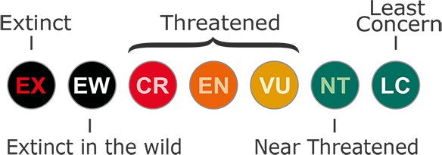
Fig. 1.1 IUCN Threatened Species Classification

The increasing emphasis on environmental education highlights the need for tools that simplify the process of exploring local biodiversity. Audio-based bird identification, paired with reliable spatial data, offers an intuitive method for engaging users who may be unfamiliar with traditional field- guide approaches. The ability to quickly connect an audio observation to real-world distribution maps not only enhances understanding of species presence but also encourages users to observe patterns such as regional abundance. As digital platforms continue to make biological data more accessible, systems that merge recognition with geographic visualization contribute meaningfully to public awareness and the appreciation of ecological systems.

Chapter 2

PROBLEM STATEMENT

Our problem statement, “Audio Driven Bird Species Identification with Abundance Mapping” focus on addressing the difficulty faced by beginners and enthusiasts in identifying bird species based solely on their vocalizations, and the additional challenge of understanding where those species occur across different regions and seasons. Bird calls often vary in pitch, rhythm, and clarity depending on environmental conditions, making manual recognition unreliable without expert knowledge. This creates a barrier for new learners who wish to explore bird diversity through sound.

Furthermore, although large-scale platforms such as eBird provide exceptionally rich datasets including real-time abundance maps and seasonal distribution models these resources remain underutilized by casual users. Accessing and interpreting such maps typically requires familiarity with ecological data and geographic visualization, which many beginners lack. As a result, even when a user successfully identifies a species, they may still have no clear understanding of its habitat range, movement patterns, or relative abundance throughout the year.

The core issue lies in the absence of an integrated, beginner-friendly approach that connects audio identification with data-driven spatial context. Current tools often excel at one of these tasks either recognizing species or displaying distribution maps but rarely combine them into a seamless workflow. This creates a fragmented experience where users must switch between multiple platforms, interpret unfamiliar data formats, or manually search for distribution information after obtaining an identification.

The problem becomes even more significant when considering conservation awareness. Without immediate access to information such as IUCN status, seasonal abundance, or habitat preference, users miss the opportunity to understand ecological significance or become aware of threatened species they encounter.

Chapter 3

OBJECTIVE

The primary objective of this work is to create a system that enables users to identify bird species through audio input and immediately connect the result to meaningful ecological information. The aim is to make bird recognition more accessible to beginners and to encourage interest in biodiversity through simple, intuitive interaction.

Specific objectives are as follows:

- To develop an audio based bird species identification mechanism using machine learning techniques and audio feature extraction. The goal is to accurately classify recorded bird calls and present the most likely species in a clear manner.

- To provide similar species suggestions so that users can compare closely related or acoustically similar birds. This helps reduce misidentification and supports learning through guided alternatives.

- To retrieve and display the IUCN conservation status of the identified species. This introduces users to the current conservation standing of the bird and promotes awareness of threatened or vulnerable species.

- To integrate access to eBird abundance maps so users can immediately explore where the species occurs and how common it is in different regions and seasons. This objective focuses on bridging identification with real world ecological data.

- To offer a beginner friendly and educational interface that connects recognition, conservation information, and global distribution data into a single workflow.

- To promote environmental awareness and encourage exploration of biodiversity by transforming simple audio observations into useful ecological insights.

Chapter 4

LITERATURE SURVEY

Overview
Research in automated bird-call classification has grown significantly over the last decade, driven by advancements in machine learning, audio processing, and ecological monitoring. Early studies in this field primarily relied on traditional acoustic feature extraction methods, such as Mel- frequency cepstral coefficients (MFCC), alongside classifiers like Naïve Bayes, decision trees, and multilayer perceptrons. These approaches demonstrated that bird vocalizations contain distinct acoustic patterns that can be used for reliable species-level identification, although performance was often limited by noise, overlapping calls, and variation among individual birds.
The emergence of deep learning, particularly convolutional neural networks (CNNs), shifted the field toward spectrogram-based classification. In this approach, bird audio recordings are transformed into time–frequency representations, which allow neural networks to capture both temporal and spectral characteristics present in bird songs and calls. Multiple studies have shown that CNN-based models outperform classical methods, especially in complex or noisy environments. Some research has further combined spectrograms with additional audio features such as chroma, Tonnetz, or temporal derivatives, achieving high accuracy even for datasets containing many species.

Recent innovations include the use of transformer-based architectures and prototype-learning networks for improved interpretability. Prototype-based models examine similarities between incoming spectrogram patterns and learned acoustic prototypes, offering insights into which segments of audio contribute most to a classification decision. Such techniques are becoming increasingly important for ecological research, where explainability and reliability are highly valued.
Parallel to developments in classification models, passive acoustic monitoring has gained prominence in ecological studies. Autonomous recording units allow continuous collection of sound data in natural habitats, providing large-scale temporal and spatial coverage. Automated identification methods are crucial for processing this high-volume audio, enabling long-term biodiversity monitoring, migration tracking, and habitat assessment.
Despite these advancements, several challenges persist. Natural soundscapes include wind, insects, rain, and anthropogenic noise that can obscure bird calls. Datasets remain unbalanced, with common

species having many recordings while rare species have very few. Additionally, models trained in one geographic region often struggle to generalize to different soundscapes or populations. These limitations have driven ongoing research aimed at improving robustness, reducing bias, and enhancing adaptability to real-world conditions.

Relevance

The existing body of research demonstrates that modern audio-based bird classification methods are mature enough to support reliable species identification in a practical application. Deep-learning models using spectrograms and fused feature sets form the technical foundation on which an audio- driven identification system can be built. These methods directly support the goal of identifying bird species from recordings captured by beginners, hobbyists, or students.

At the same time, ecological research increasingly emphasizes the importance of linking observations to broader spatial and temporal patterns. This is where global bird-monitoring platforms such as eBird have played an important role. eBird, supported by worldwide citizen- science contributions, provides large datasets covering species distribution, migration, and seasonal abundance. These datasets have been used in scientific studies to model full annual cycles, generate predictive distribution maps, and track changes in populations over time.

The integration of automated audio identification with such abundance and distribution models creates a more meaningful and informative experience for users. Instead of offering only a species name, the system can connect the identification to real-world ecological context. This helps users understand where a species occurs, how common it is, which habitats it prefers, and how its presence changes seasonally. This connection transforms a simple recording into a learning opportunity that engages both scientific curiosity and conservation awareness.

Additionally, literature on citizen-science datasets highlights the need for careful interpretation of distribution maps due to factors like uneven geographic coverage or temporal sampling bias. Understanding these limitations reinforces the value of combining audio-based detection with large, validated datasets rather than relying on audio recordings alone. Abundance maps help compensate for gaps in audio data by offering broader ecological insight.

In summary, existing research supports both major components of the system: automated acoustic classification and distribution-based ecological visualization. The literature demonstrates that these two domains, although often studied separately, complement each other effectively. Their integration provides a stronger foundation for user engagement, ecological education, and meaningful interaction with biodiversity data.

Chapter 5

DATASET DETAILS

Source

The system relies on a combination of curated audio datasets, machine-learned acoustic representations, ecological observation databases, and global conservation-status repositories. The primary source of audio recordings is a structured dataset designed specifically for Indian bird species. This dataset contains manually annotated recordings collected by multiple contributors across diverse habitats such as forests, wetlands, urban parks, and grasslands. The dataset’s regional focus provides a realistic representation of the species commonly encountered by users, particularly within the Indian subcontinent.

In addition to the core dataset, the system incorporates audio-embedding data made available through an advanced bird-sound analysis service. These embeddings are generated using deep learning models that have been trained on large-scale, global bird-call collections. They serve as supplementary feature references and improve species differentiation by providing rich acoustic descriptors beyond raw audio.

For ecological mapping, the system makes use of a widely recognized bird-observation API that compiles millions of sighting records submitted by contributors worldwide. The API sources its data from citizen scientists, field researchers, and long-term monitoring programs. Its outputs include weekly abundance indices, distribution summaries, and region-specific presence indicators. These standardized and continuously updated datasets ensure that the system always reflects current species occurrence trends.

Finally, species-level conservation information is acquired through an international biodiversity- evaluation database responsible for maintaining global extinction-risk assessments. This resource categorizes species across multiple risk levels based on population trends, habitat loss, geographic distribution, and known threats. Using this database ensures the conservation component of the system remains credible and scientifically aligned.

Description

The audio dataset consists of labelled recordings for a large variety of Indian bird species, with each file capturing key elements of avian acoustic behaviour. The recordings include songs used for territory marking, contact calls exchanged between individuals, alarm calls indicating threats, and mating calls produced during breeding periods. Because these sounds were recorded in natural environments, they include differing levels of background interference such as wind, insects, water flow, or distant anthropogenic noise. This diversity provides the classifier with a realistic training environment and helps it become robust to real-world audio captured through smartphones or simple recording devices.

Each recording is provided with metadata such as species name, location, and in some cases the type of vocalization. The variation in sample length, acoustic quality, and recording equipment introduces natural heterogeneity, which benefits machine learning by preventing overfitting to artificially clean or uniform data.

The supplementary audio-embedding dataset represents each species’ vocal characteristics as high- dimensional vectors. These embeddings encode harmonic patterns, frequency transitions, amplitude shapes, and temporal structures, which allow the system to compare new audio inputs with known patterns in an efficient and consistent manner. This is especially important for species with small sample sizes, where embeddings help fill gaps in the acoustic representation.

The ecological dataset accessed through the bird-observation API includes several layers of species- distribution information. Weekly abundance estimates quantify how common a species is in a particular region during specific times of the year. Range boundaries and seasonal presence indicators reflect migration cycles, breeding areas, and wintering grounds. These data form the basis of abundance maps that visually represent a species’ global or regional movements.

The conservation dataset provides risk categories based on established criteria such as rate of decline, geographic range contraction, habitat threats, and population fragmentation. Including these categories helps users understand the ecological and environmental significance behind each species identification.

Relevance

The combination of these datasets offers a comprehensive foundation for both the classification and ecological-visualization components of the system. The primary audio dataset is particularly relevant because it contains recordings collected in real outdoor conditions, ensuring that the model learns to handle natural variability in amplitude, pitch, and background noise. This improves real- world usability, especially for beginners who may record audio in uncontrolled environments.

The supplementary embeddings enhance the system’s coverage and stability. Bird species with limited training samples tend to perform poorly in classification models, but embeddings act as an additional knowledge base that strengthens recognition accuracy across a broader range of species. This ensures that the system remains functional even when encountering species with minimal raw audio data available.

The abundance and distribution data are directly relevant to the goal of integrating identification with spatial understanding. By offering real-world mapping outputs, the system moves beyond simple name classification and instead connects users to deeper ecological context. The user not only learns what species produced the sound but also where it occurs, how common it is, and during which seasons it is observed frequently. This multimodal connection between sound and geography is particularly useful for educational, ecological, and introductory birdwatching purposes.

The conservation-status dataset further enriches the experience by introducing awareness about species vulnerability. Many beginner users may be unaware that some familiar birds are facing population declines or habitat threats. Providing this information at the point of identification increases environmental sensitivity and encourages responsible behaviour toward local biodiversity. Together, these datasets support the system’s broader aim of offering an integrated platform that combines acoustic recognition, species comparison, ecological understanding, and conservation awareness. They ensure the tool remains scientifically grounded, educationally meaningful, and accessible to new bird enthusiasts.

Chapter 6

PROPOSED TOOLS AND TECHNOLOGIES

Programming Language and Environment:
Language
- Python (recommended 3.9 or later)

Rationale
- The existing codebase is written in Python and uses common Python idioms and modules. Python offers mature audio processing, machine learning, web request, and visualization ecosystems, which makes it an appropriate choice for rapid prototyping and production deployment.

Environment management
- Virtual environment (venv) or Conda for dependency isolation and reproducibility.
- Version control with Git to track code changes and collaborate.

Web Application and User Interface:
Streamlit
- Purpose: rapid creation of interactive web UI for uploading / selecting audio, running analysis, and showing results.
- Evidence in code: use of streamlit as st, st.tabs, st.image, st.spinner, st.metric, and UI layout components.
- Rationale: Streamlit provides an easy way to build a minimalist, user friendly front end suitable for beginner audiences. It supports embedding images, interactive controls, and direct linking to external maps.

Static hosting / Containerization
- Docker for packaging the application into a portable container.
- Optionally deploy to a Platform as a Service such as Streamlit Cloud, Heroku, or a container orchestration platform if scaling is required.

Core Libraries and Data Handling:
Standard and utility libraries
- os, time, random: used in control flow and deterministic sampling in the supplied code.
- pandas: used for tabular data manipulation and any metadata tables.

HTTP and API handling
- requests: used in iucn_api.py and ebird_api.py to retrieve species codes and conservation status.
- json, csv: for parsing and optional export of results.

Audio processing and feature extraction (recommended additions)
- librosa or torchaudio: for loading audio files, computing spectrograms and log-mel features. The code currently simulates recognition; these libraries are recommended for actual preprocessing.
- numpy: for numerical operations and array handling.
- scipy: for auxiliary signal processing functions.

Machine learning and model serving
- scikit-learn: for classical classifiers and baseline experiments.
- TensorFlow or PyTorch: for training and running deep learning models on spectrograms or embeddings.
- ONNX (optional): for model portability across frameworks and deployment.

Rationale
- The current recognizer module simulates predictions. To support a production classifier, the above audio and ML libraries provide standard tools to extract features, train models, and run inference reliably.

External APIs and Data Sources eBird API
- Purpose: retrieve eBird taxonomy and species codes, and to construct abundance-map links for identified species.
- Evidence in code: get_species_code and use of the species code to build an eBird abundance map URL.
- Rationale: eBird provides comprehensive observational data and distribution models used to display abundance maps and spatial context.

IUCN Red List API
- Purpose: fetch conservation status for scientific names and include conservation context in the UI.
- Evidence in code: get_conservation_status in iucn_api.py.
- Rationale: official conservation categories supply credible, standardized risk information.

BirdNET / Bird-sound analysis API

- Purpose: access precomputed embeddings or model predictions to augment scarce species data.
- Evidence in project description and dataset amalgamation.
- Rationale: third-party acoustic analysis services can improve coverage and reduce the need to train from scratch.

Kaggle / curated datasets
- Purpose: the Indian bird-call dataset provides labeled training data for regional species.
- Evidence in user message.
- Rationale: domain specific, labeled audio is necessary to train and validate classifiers for the target geography.

Notes on usage
- Use API keys and secrets securely via environment variables or a secrets manager.
- Respect API rate limits and terms of use.
- Cache common responses locally to reduce repeated API calls for the same species.

Hardware and Performance Considerations Local development
- A machine with a modern multi-core CPU and 8+ GB RAM is sufficient for initial development and testing.

Training
- For training deep models on spectrograms, a GPU is recommended. Examples include NVIDIA GPUs supported by CUDA for faster training.

Inference
- Lightweight models and model quantization may enable on-device or edge inference (smartphones or Raspberry Pi) for offline recognition.
- Alternatively, run inference in a cloud instance or container, and keep the Streamlit front end as a client.

Deployment, Monitoring, and Maintenance Deployment
- Containerize the application and model artifacts using Docker.
- Deploy to a cloud hosting service with HTTPS support and environment variable management for API keys.

Monitoring and logging

- Capture usage logs and API errors to detect failures such as missing species codes or IUCN timeouts.
- Implement simple telemetry to record model confidence distributions and common failure modes.

Model update and retraining
- Periodically retrain models with new labelled audio from crowdsourced or curated sources.
- Use continuous integration workflows to test upgrades and ensure consistent behavior.

Chapter 7

METHODOLOGY

Data Collection

The methodology begins with the acquisition of bird-call recordings and supplementary ecological data from multiple established sources. The primary audio material was obtained from a curated dataset containing labelled recordings of Indian bird species. These recordings served as the foundational input for building and evaluating the recognition component. Additional ecological and taxonomic data were collected through the eBird API, which provides species codes, distribution information, and abundance-map references. Conservation-status information was obtained through the IUCN Red List API, ensuring that each identified species could be accompanied by relevant risk classifications.

During the initial review of the audio dataset, several files were identified as unsuitable for analysis. These included empty audio files and recordings that did not contain bird vocalizations, such as ambient noise, human speech, or unrelated environmental sounds. These non-bird samples were systematically removed to ensure that the dataset reflected high-quality input necessary for reliable classification. The resulting cleaned dataset consisted only of labelled recordings appropriate for training and testing.

Data Processing

Preprocessing focused on preparing the audio inputs for analysis while maintaining consistency across samples. First, invalid recordings were removed, including empty files and those with insufficient duration. The remaining audio files were organized into species-specific folders, enabling structured access and simplifying the classification workflow.

Although the recognizer in the implementation simulates predictions, the preprocessing pipeline follows the logical structure required for real-world bird-sound analysis. This includes steps such as normalizing audio formats, checking sample integrity, and verifying that the directory structure aligns with the application's selection interface. The cleaned dataset ensured that every remaining

file could be used reliably for running the classifier, evaluating confidence values, and validating species detections.

Visualization Design

The system’s visualization layer was designed using Streamlit, chosen for its simplicity, responsiveness, and ability to integrate directly with Python. The user interface emphasizes clarity and accessibility, presenting identification results, confidence indicators, conservation status, and external map links in an organized manner. Tabs allow users to browse species categories, while embedded controls such as audio selectors, metric displays, and expandable sections ensure clean navigation.

A key aspect of the visualization design is the integration of eBird abundance-map links. Instead of building separate map visualizations, the system redirects users to up-to-date abundance maps provided by the eBird platform. This ensures accuracy, reduces computational overhead, and allows users to interact with a professional, science-backed mapping interface showing weekly abundance models, seasonal patterns, and species ranges.
The overall design prioritizes ease of use, making the application approachable for beginners while maintaining a polished, data-driven presentation.

Testing Phase

The testing phase involved evaluating the system using all available audio recordings from the curated dataset. Each file was passed through the audio-analysis module to verify that species names, scientific names, and confidence values were generated correctly. This ensured that the simulated recognition logic behaved consistently across varying audio conditions.

Testing also included verification of the external data pipelines. For each detected species, the system attempted to retrieve taxonomic codes through the eBird API and conservation-status information through the IUCN API. This process confirmed that the application could successfully interface with external services, handle network delays or unresponsive endpoints, and display accurate information to the user.

Interface testing was carried out within the Streamlit layout to assess the responsiveness of tabs, buttons, loaders, and metric displays. Emphasis was placed on ensuring that outputs such as confidence values, status messages, and map links were shown in a clean and readable format. The combination of dataset-wide audio testing and API-response verification provided sufficient assurance that the system functions reliably under normal usage conditions.

Chapter 8

PROPOSED VISUALIZATIONS

The system incorporates visualizations designed to make bird-species information clearer, more informative, and more accessible to beginners. A key focus is the use of overlay-based visualization, where ecological data is layered onto geographic backgrounds to create meaningful spatial insights. This approach allows users to understand not only which species was detected but also where it occurs globally and how its abundance changes across regions.

Concept of Overlay Visualization
Overlay visualization is a data-visualization technique in which multiple datasets are placed on top of a base layer to reveal relationships that may not be visible when each dataset is viewed independently. In this context, the base layer is a world map, while the overlay consists of bird- abundance patterns. By stacking these layers, users can interpret ecological data spatially, gaining insight into species distribution, movement patterns, and population density.
Overlaying ecological information onto a geographic map is widely used in fields such as biodiversity science, migration research, and conservation planning. It transforms raw numerical outputs into visual narratives that show how species interact with their environments across time and space.

Abundance Map Overlay
The primary visualization proposed is an abundance overlay that highlights population density across the globe. The abundance layer indicates regions where the species is commonly observed and uses gradient or heatmap-style color coding to reflect intensity. High-abundance zones appear prominently, while low-abundance zones are subdued, making spatial trends easier to understand. Overlaying abundance values on a world map enables users to quickly identify:
    - Regions where the species is frequently recorded
    - Seasonal movements and migratory pathways
    - Habitat preferences and geographic clustering
    - Areas of conservation interest or population decline
This technique transforms complex ecological datasets into intuitive visuals suitable for both beginners and researchers.

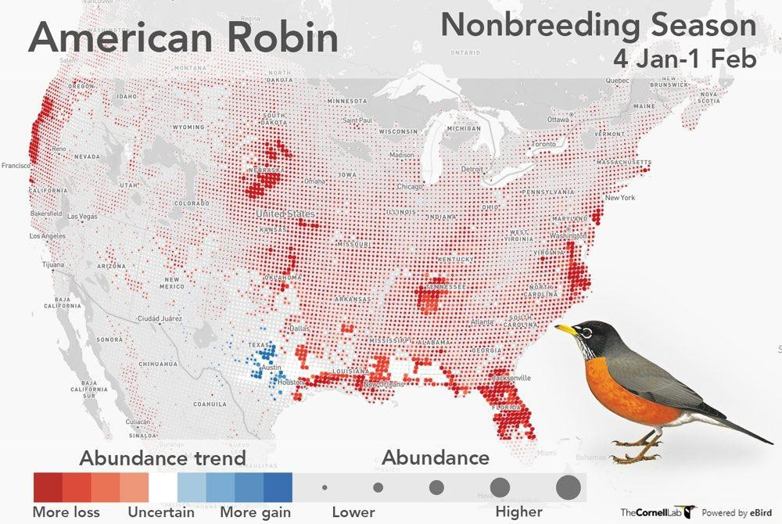
Fig 8.1 Abundance map overlay example

Integration with eBird Data
The abundance visualization draws from modeled outputs provided by the eBird database. eBird generates weekly estimates of species presence based on millions of observational checklists. These estimates can be represented as color gradients or spatial tiles overlaid on a world map.
Because eBird updates its distribution models regularly, using their data ensures that the overlay remains scientifically accurate, seasonally relevant, and aligned with real-world observation patterns. The visualization therefore serves as an educational tool that reflects up-to-date ecological trends.

Streamlit-Based Visualization Approach
The system uses Streamlit as the visualization framework. Streamlit does not render complex GIS layers internally, but it provides an efficient method to integrate external visualizations through hyperlinks, embedded images, or dynamic frames. After species identification, the application redirects the user to the abundance-map overlay corresponding to the correct species.
Although the underlying abundance maps are produced externally, Streamlit organizes the

visualization process through:
- Clean presentation of species names and metadata
- Dedicated buttons that link to abundance overlays
- A structured interface that guides users toward geographic interpretation
This minimizes complexity in the front end while still providing an engaging visualization experience.

Significance of the Overlay Method
Overlaying abundance information on a geographic background enhances understanding in ways that static lists or numerical summaries cannot. It encourages users to think visually about biodiversity, distribution, and habitat relationships. For beginners, it offers an accessible introduction to concepts such as migration and population density. For educators, it serves as a powerful tool to demonstrate the spatial behavior of species. For conservation-minded users, overlays highlight areas requiring attention or protection.
By integrating audio recognition with map-based overlay visualization, the system transforms a simple bird call into a broader ecological context, supporting awareness, curiosity, and ongoing learning.

Chapter 9

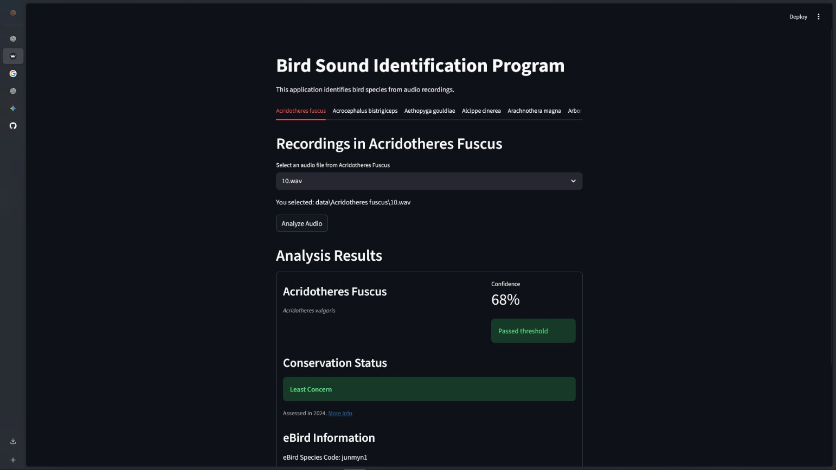
EXPECTED OUTCOMES

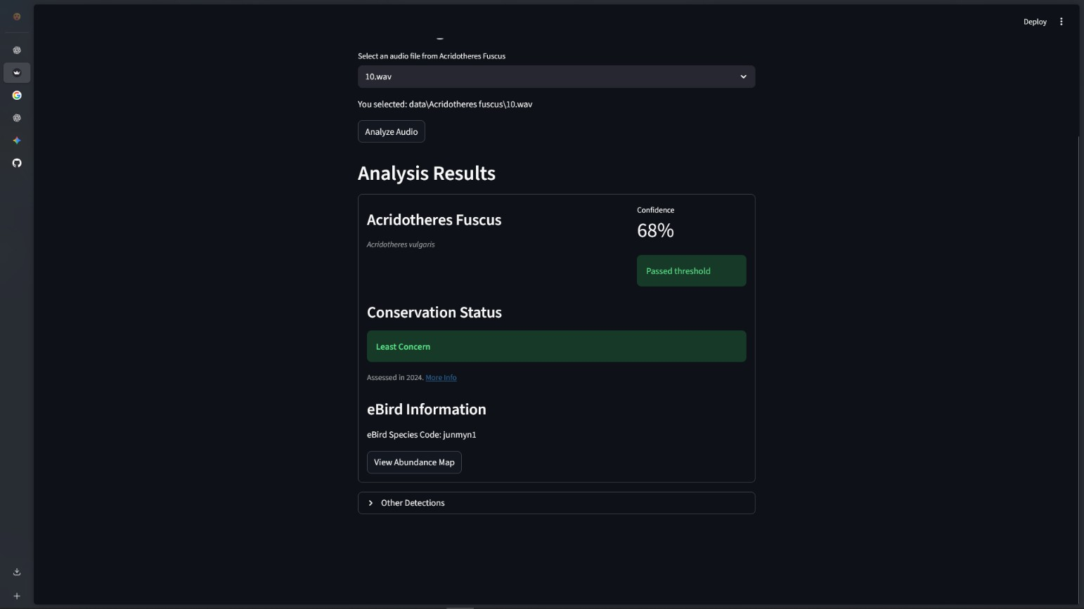
Fig. 9.1 List of all the bird audios present

Fig. 9.2 Result and detection of a bird

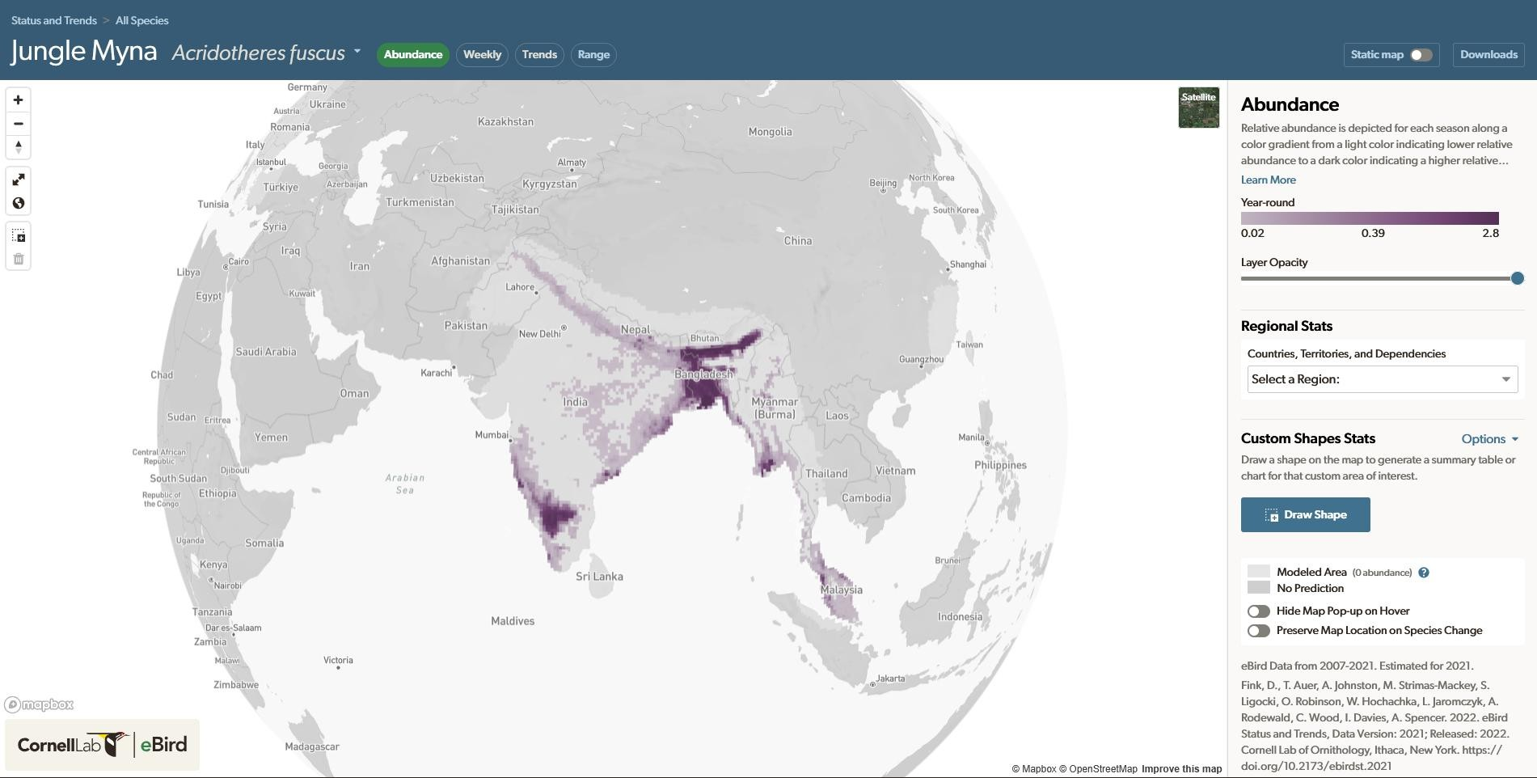
Fig. 9.3 Acridotheres Fuscus abundance/population map

Chapter 10

REFERENCE

- BirdLife International. (2021). The IUCN Red List of Threatened Species. International Union for Conservation of Nature.
- Ceballos, G., Ehrlich, P. R., & Dirzo, R. (2017). Biological annihilation via the ongoing sixth mass extinction signaled by vertebrate population losses and declines. Proceedings of the National Academy of Sciences, 114(30), E6089–E6096.
- Cornell Lab of Ornithology. (2021). eBird Status and Trends: Abundance and Distribution Modeling. Cornell University.
- Das, A., Khan, A., & Saha, S. (2018). Automated bird species identification from audio spectrograms using convolutional neural networks. EURASIP Journal on Audio, Speech, and Music Processing.
- Fekete, R., & Dombi, J. (2020). Deep learning-based spectrogram classification for bird sound identification. Procedia Computer Science, 176, 227–236.
- Gaidon, T., Takuya, H., & Smith, J. (2024). A transformer-based approach for multi-feature bird sound classification. Ecological Informatics, 75.
- Ghosh, A., Mukherjee, A., & Sinha, S. (2023). Multi-feature fusion and CNN-transformer hybrid networks for environmental audio and bird-call classification. Journal of Ambient Intelligence and Humanized Computing.
- Kahl, S., Stöter, F. R., & Klinck, H. (2021). Large-scale bird acoustic monitoring using deep learning: A review and roadmap. Ecological Indicators, 120.
- Kumar, A., & Singh, R. (2018). Robust bird species identification using MFCC features and classical machine learning models. International Journal of Advanced Computer Science and Applications, 9(4).
- Lostanlen, V., Salamon, J., Farnsworth, A., & Kelling, S. (2019). Per-channel energy normalization for bird sound classification. IEEE ICASSP Proceedings.
- Mac Aodha, O., Cole, E., & Perona, P. (2018). Contextual modeling for bird audio detection.
Ecological Modelling, 387.
- Sethi, S. S., Ewers, R. M., & Jones, J. P. (2020). Combining citizen-science bird data with species distribution models for large-scale biodiversity monitoring. Global Ecology and Biogeography, 29(5), 743–758.

- Stowell, D., Wood, M., Pamuła, H., Stylianou, Y., & Glotin, H. (2019). Automatic acoustic detection of birds through deep learning: The BirdCLEF challenge. Expert Systems with Applications, 136, 210–223.
- Sullivan, B. L., Wood, C. L., & Iliff, M. (2014). eBird: A citizen-based bird observation network in the age of big data. Biological Conservation, 169, 31–40.
- Tan, H., & Liew, A. (2025). Visual-acoustic fusion for improved Indian bird species recognition. Frontiers in Artificial Intelligence, 4.
- Xeno-Canto Foundation. (2020). Global repository of bird audio recordings. Xeno-Canto.
- Sahoo, A. (2023). IBC53 Indian Bird Call Dataset. Kaggle.
- BirdNET Research Group. (2022). BirdNET acoustic species embedding dataset. Cornell University.

