The page INDEX.HTML contains an introduction about me and a basic working calculator. The page was built with the use of HTML, JavaScript and CSS. The upper half of the webpage contains the introduction and the lower half is the calculator. The design of the calculator is an effort to closely resemble the Android 4.4.4 one.

The following is screenshot of the Android 4.4.4 calculator:

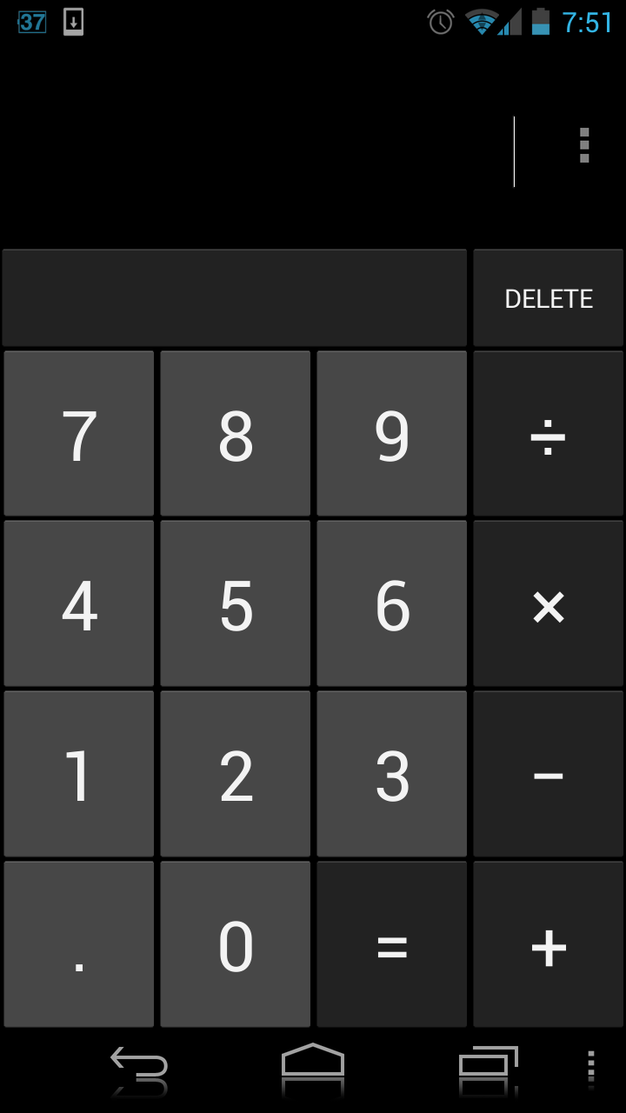

The following is a screenshot of the calculator on the wepage.

