 W

**Centre For Desing Thinking**

**3rd Design Thinking Project Contest – 23.04.2025**

**Department of Electronics and Communication Engineering**

**SIGN SPEAK   
Smart Keypad For Mute People Communication**

**OBJECTIVE**

Developing a T9 keypad-based system for multilingual text-to-voice conversion to help mute individuals communicate in English or Tamil. It uses a simple multi-press input method with natural audio playback for efficient, offline interaction. Designed for accessibility in resource-limited or embedded environments.

**EMPATHIZE**

This project provides a T9 keypad-based communication tool for mute individuals, enabling offline, accessible interaction with natural audio playback in English and Tamil. It fosters confidence and ease in expressing thoughts through a familiar input method.

**DEFINE**

Mute individuals struggle with daily communication, while existing solutions are costly or require internet. This project provides an offline, multilingual T9 keypad-based text-to-voice system with natural audio playback.

**IDEATE**

Design a compact, T9 keypad-based speech device to aid mute individuals in communication. Users enter predefined phrases, pick English or Tamil, and hear clear voice playback. The offline, user-friendly system enhances accessibility and autonomy.

**PROTOTYPE**

Users enter sentences word-by-word using a multi-press keypad, switching between English and Tamil for easy communication. Predefined phrases play natural audio through a speaker, enabling real-time interaction in various settings. The compact, offline device includes emergency phrases and an optional screen for sentence confirmation.

**TEST**

Verify T9 keypad input accuracy, sentence formation, language switching, and natural audio playback. Check emergency phrase activation, offline stability, battery operation, and display feedback reliability.

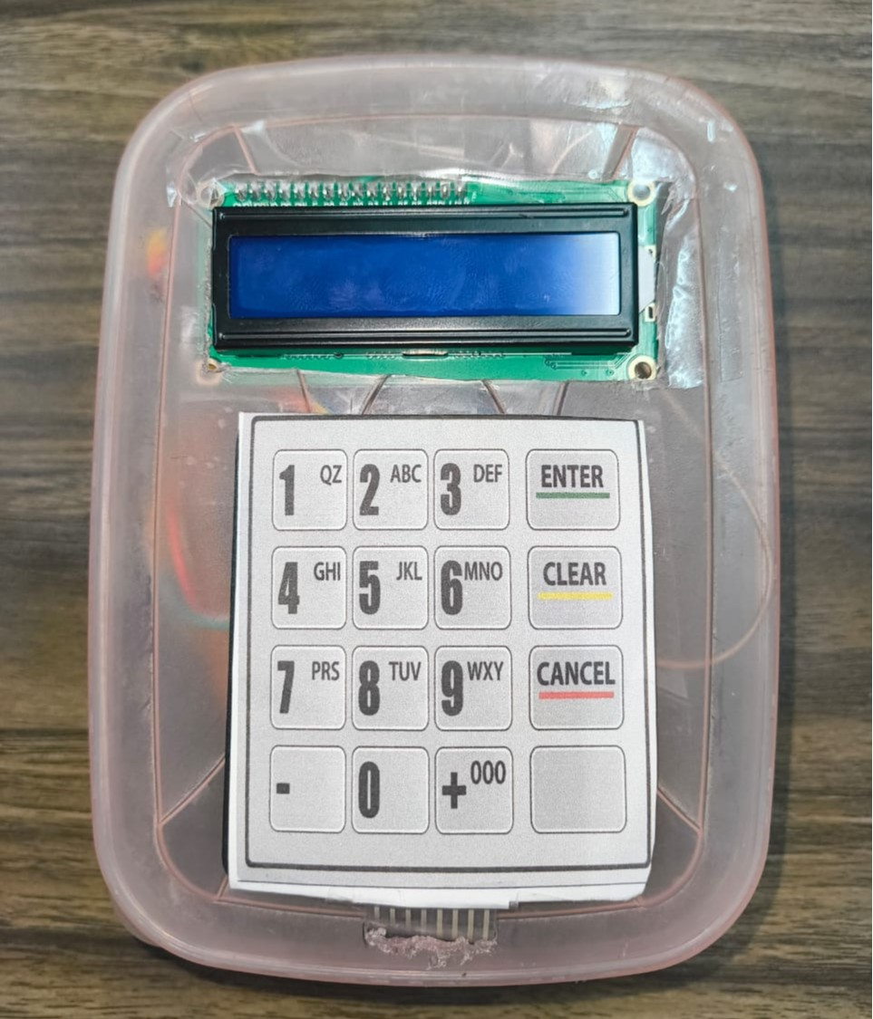 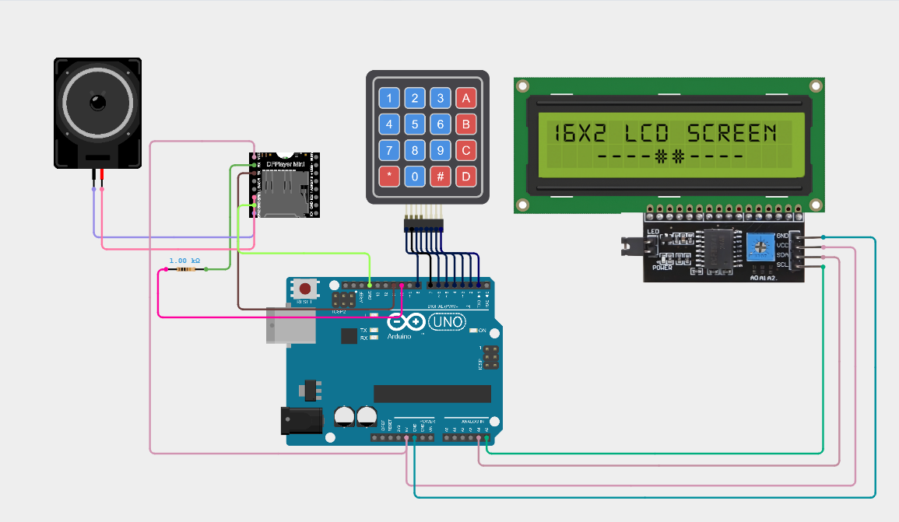

**TEAM MEMBERS : VIJAYRAM S [220901116], MARAN ELANTHIRAIAN MK [220901125]**

**MENTOR : DR D. SHYAM / EEE / ASSISTANT PROFESSOR (SG)**