**MONGODB SERVER INSTALLATION**

Download Mongodb server from the below mentioned URL(Do not try this in your official system without the knowledge of IT support and your manager approval)

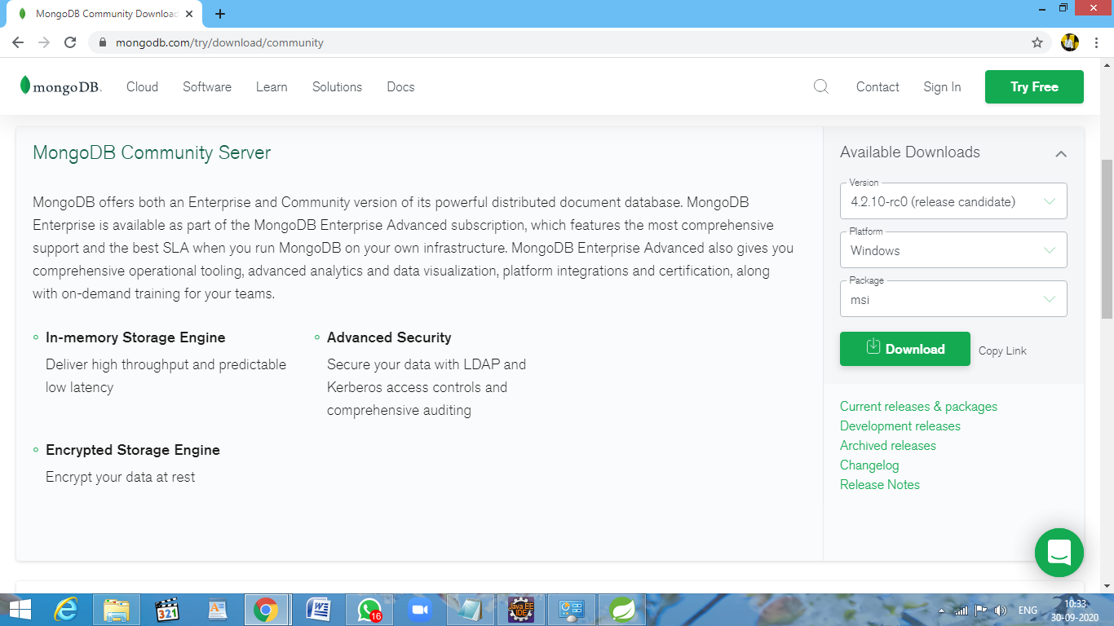

Run the downloaded application

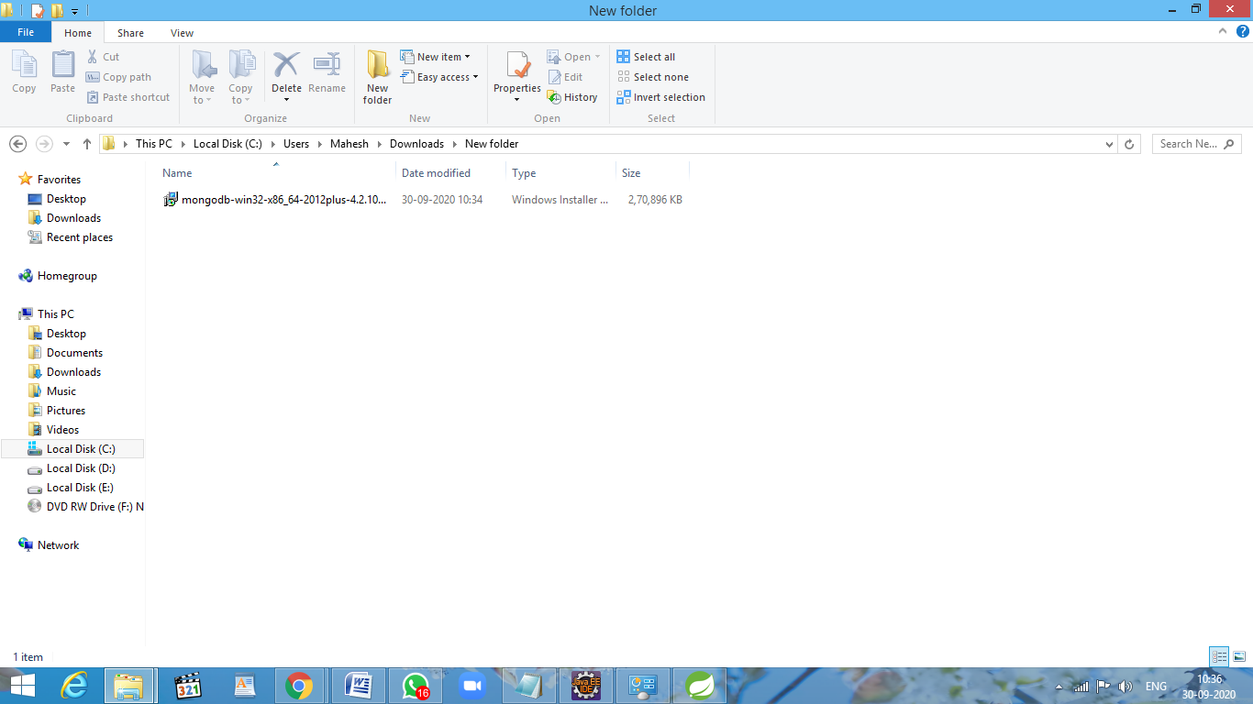

Click run to start the Installation program.

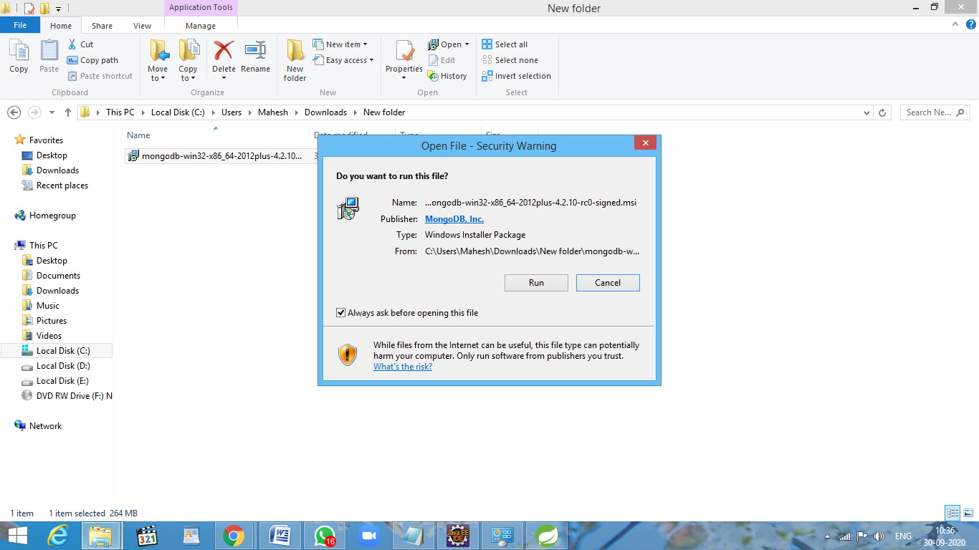

Click next

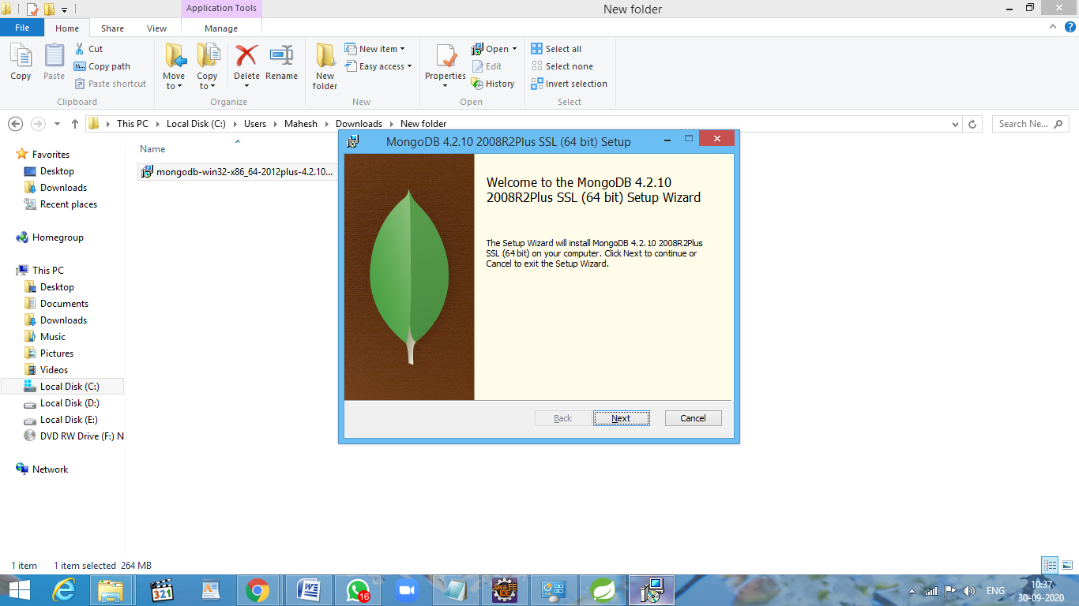

Accept the License Agreement and click next

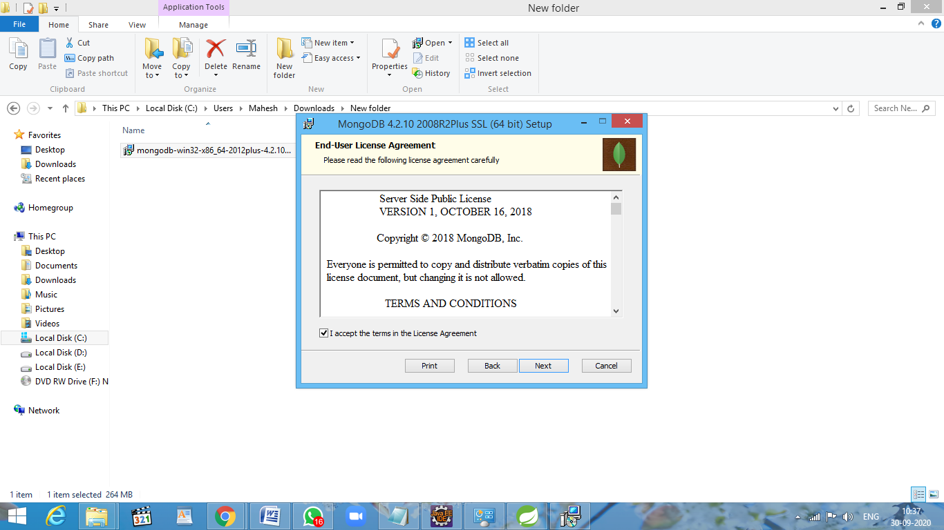

Select Complete or custom.

* Select Complete for Installing both server and client.
* Select Custom for your customized requirement.

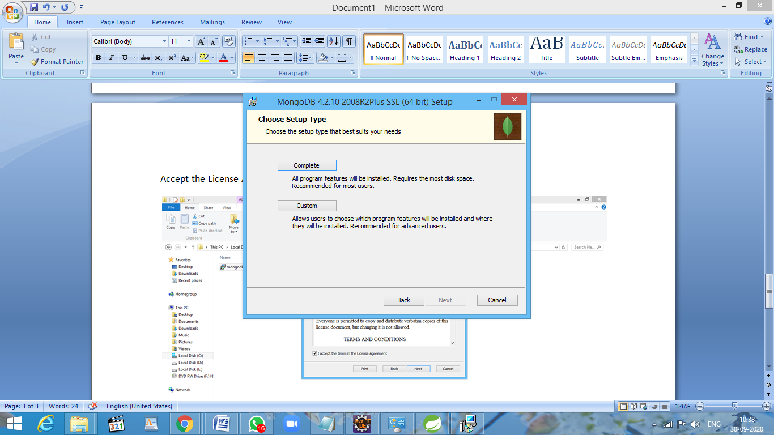

Do not change anything.

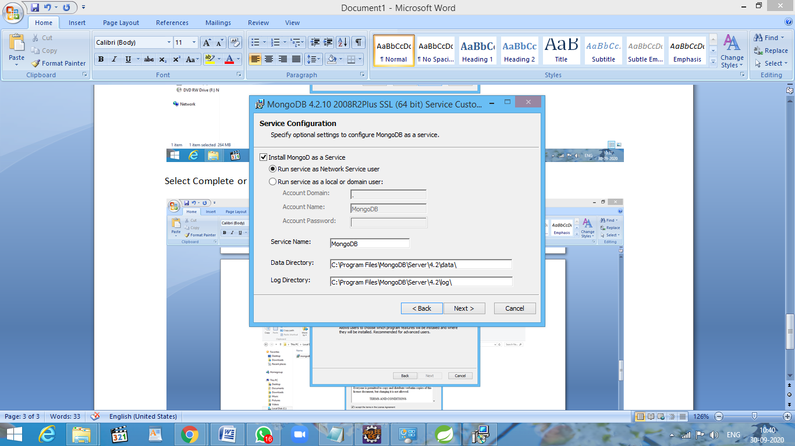

Mongodb Compass is user interface. you can install or skip.

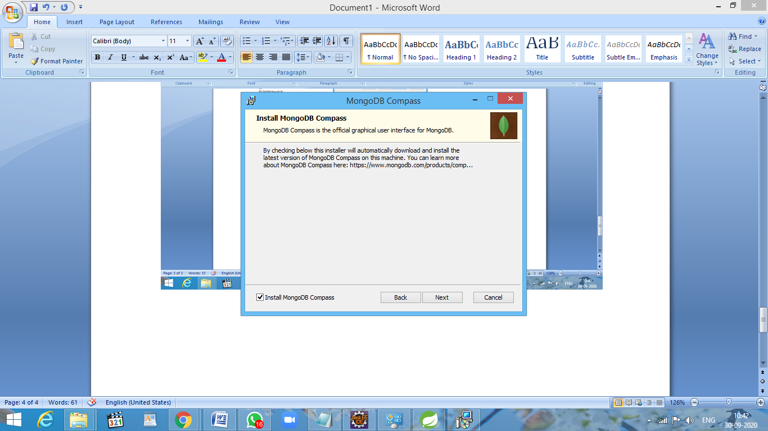

Click Install to start installation.

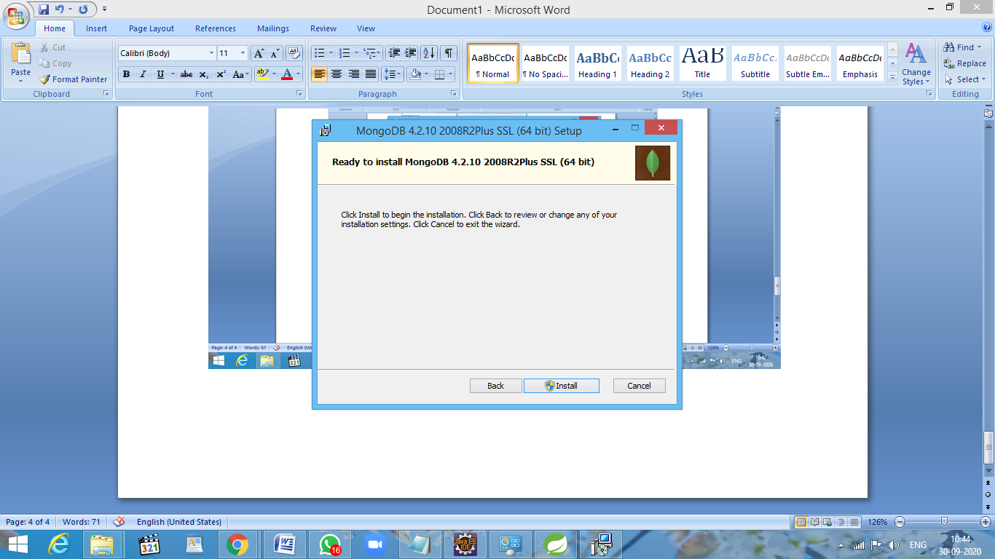

Installation Progress

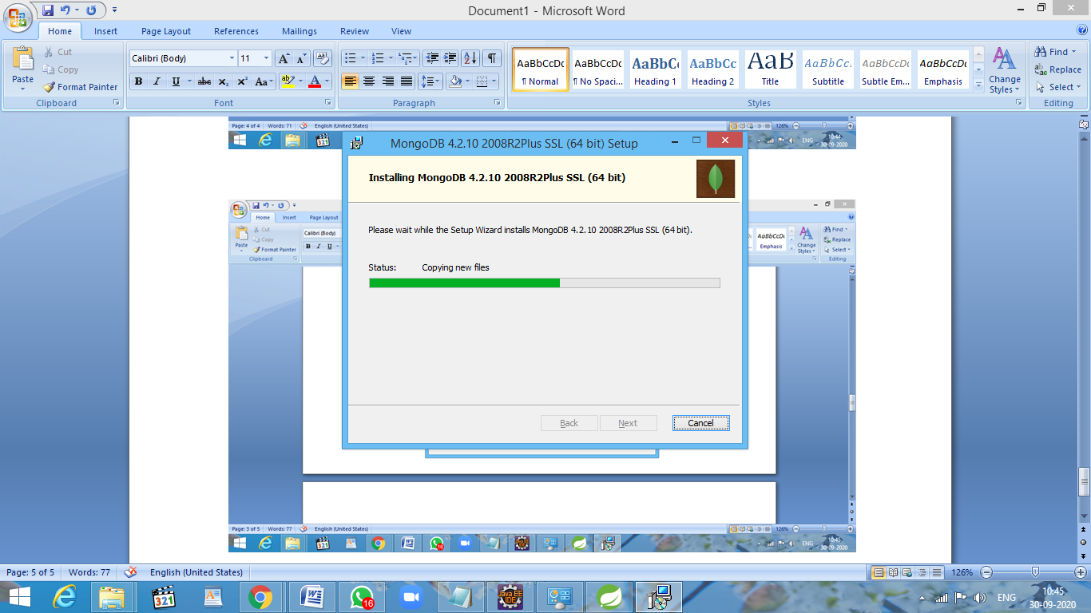

Click Finish

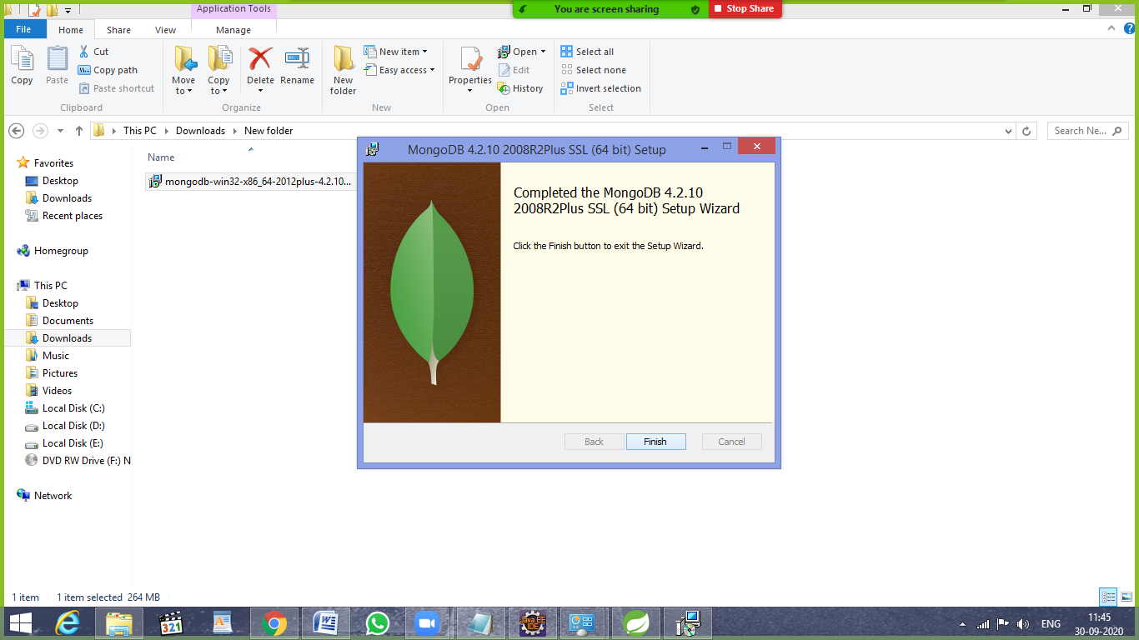

In this location (C:\Program Files\MongoDB\Server\4.2\bin), You will find the mongo application

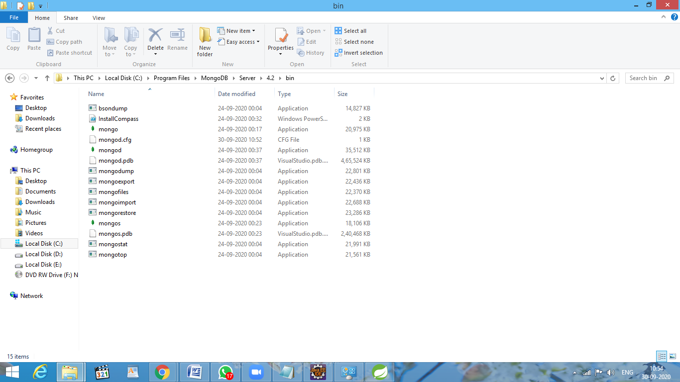

Run mongo application to open Mongo Shell.

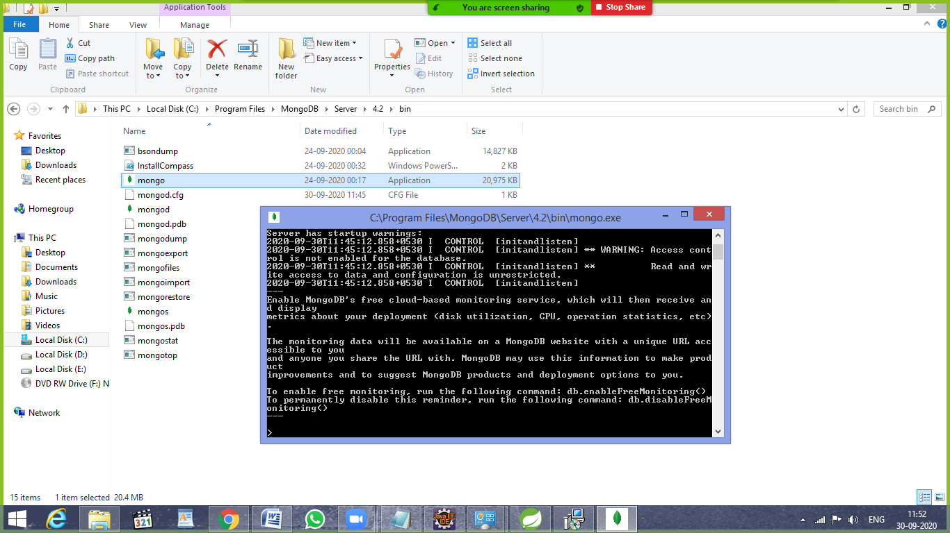

Show dbs will list out the database what we have.(you may not get the same output when you execute show dbs)

