**NOSQLBOOSTER INSTALLATION**

Go to the below mentioned URL to download NoSql booster.(Do not try this in your official system without the knowledge of IT support and your manager approval)

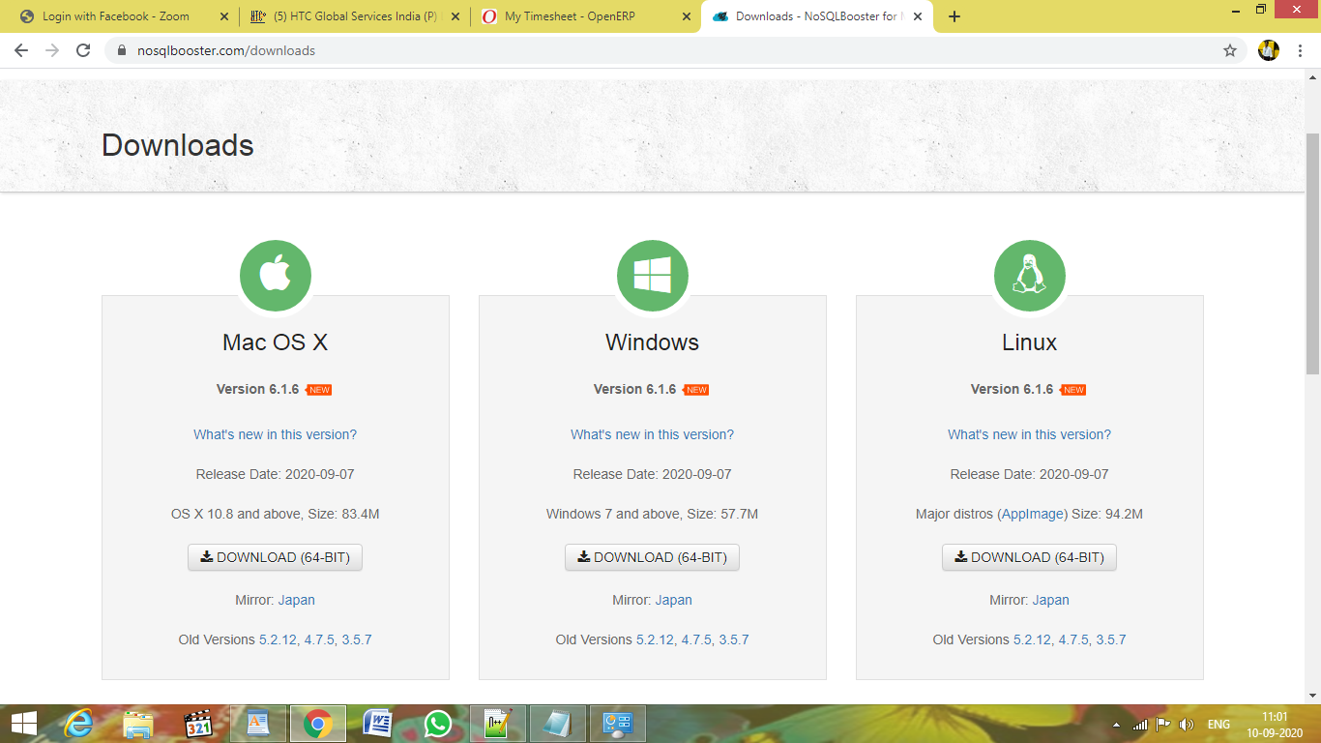

Download NoSqlBooster with respect to the OS in your system.

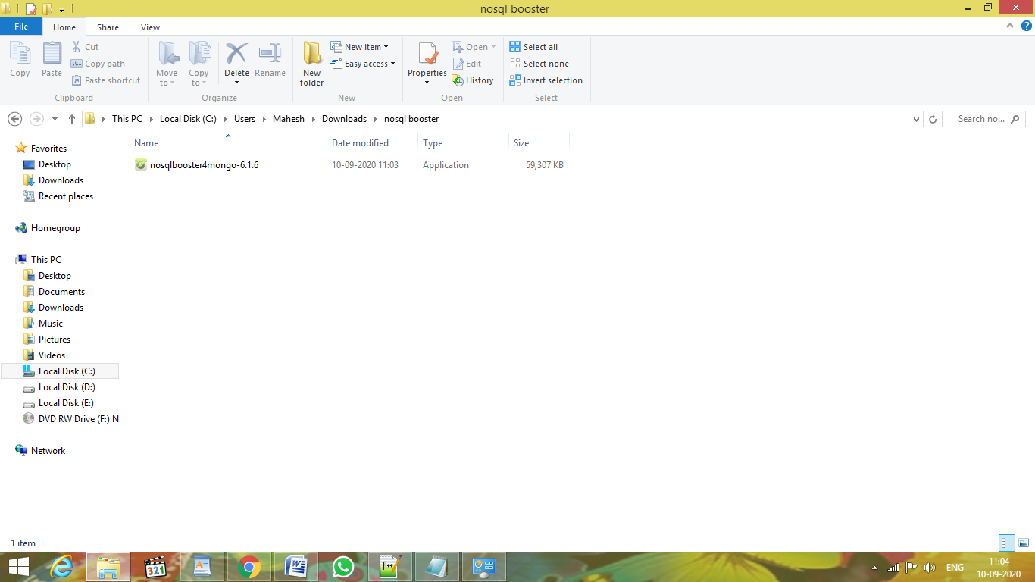

Click the downloaded nosqlbooster application.

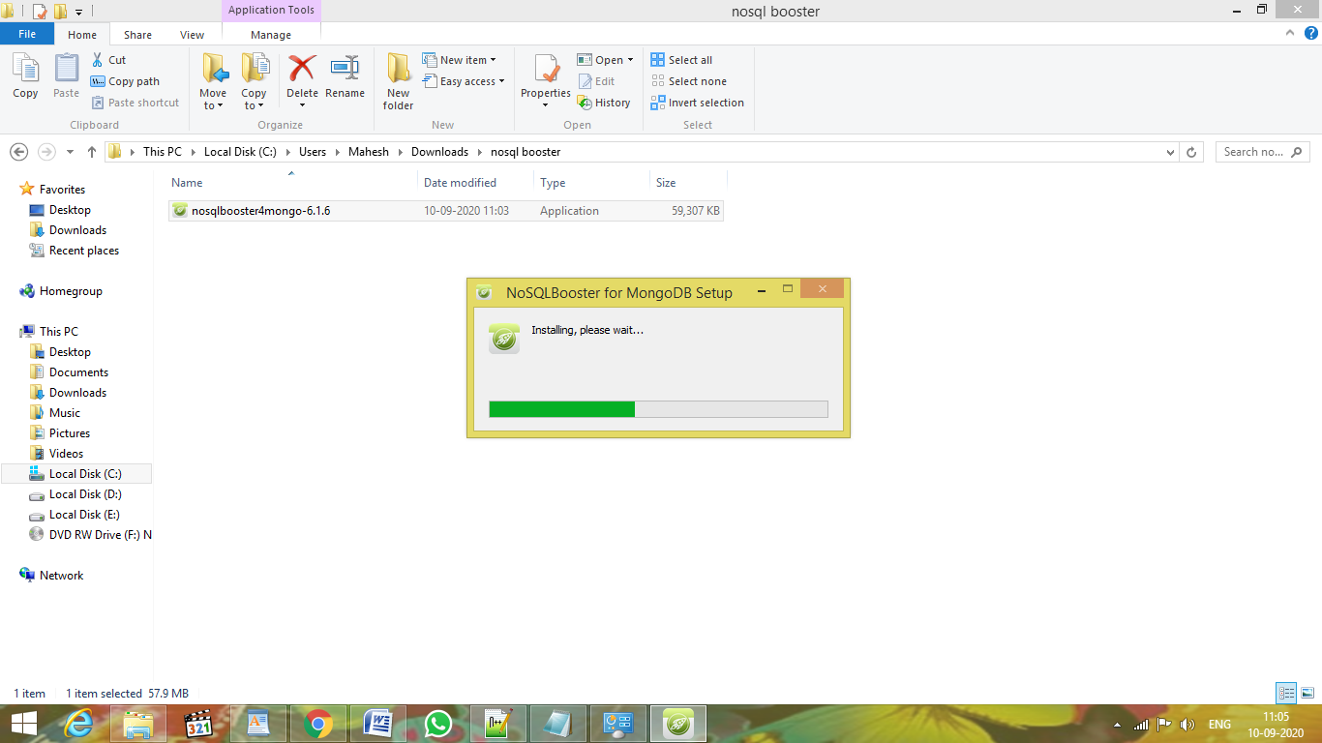

Once the installation is complete, launch NoSQLBooster.

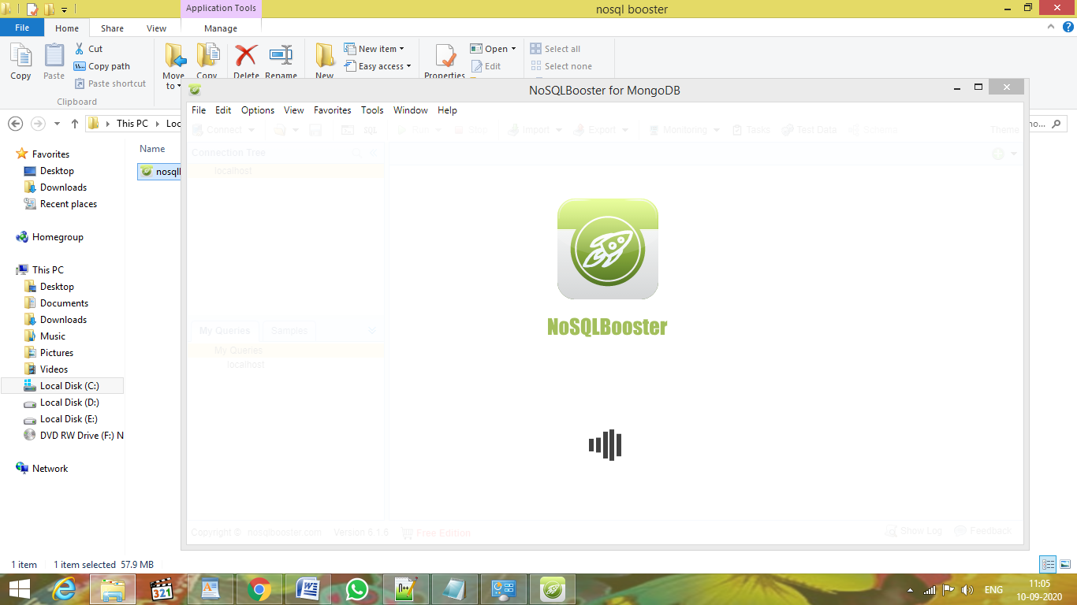

Click the Connect button to establish connection.

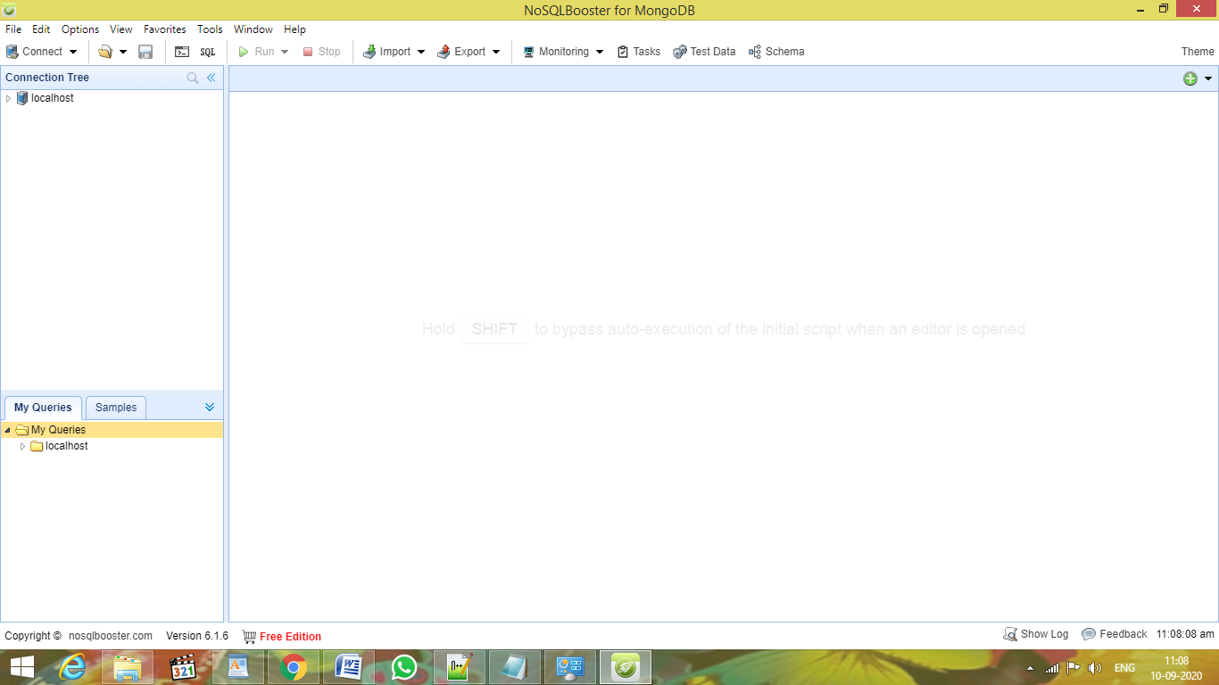

Click Create button to give connection details.

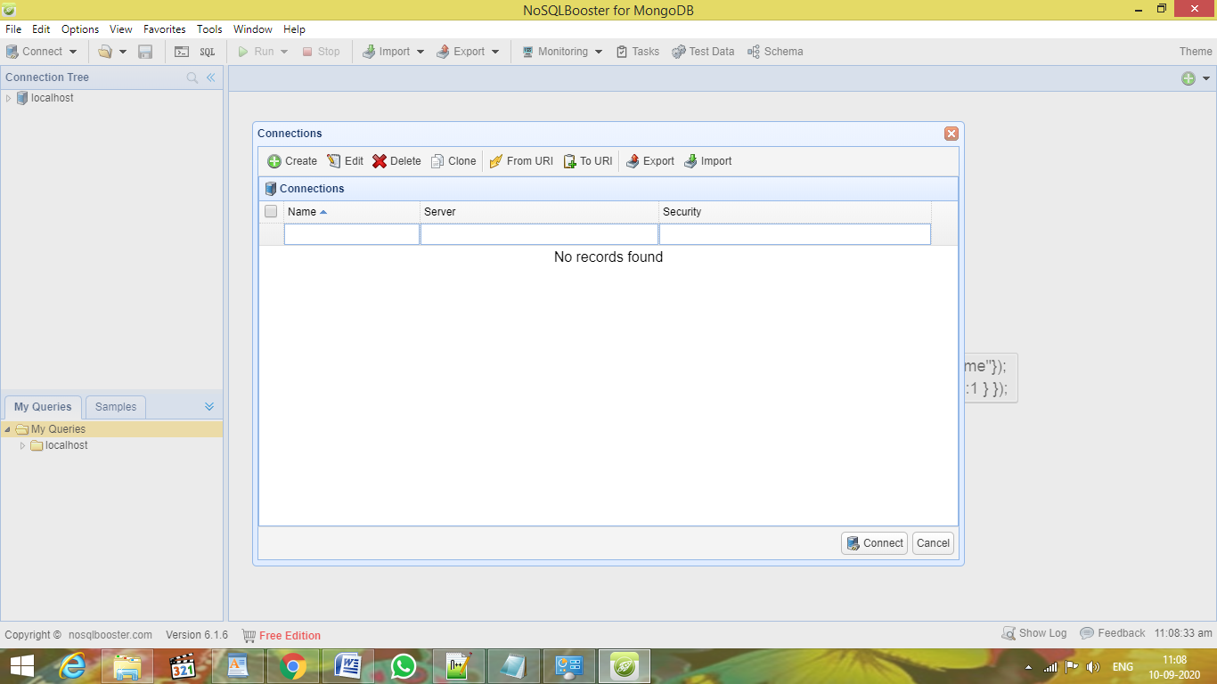

Enter server IP address(if same machine,enter localhost) and port number (example 27017) .Then,click test connection.

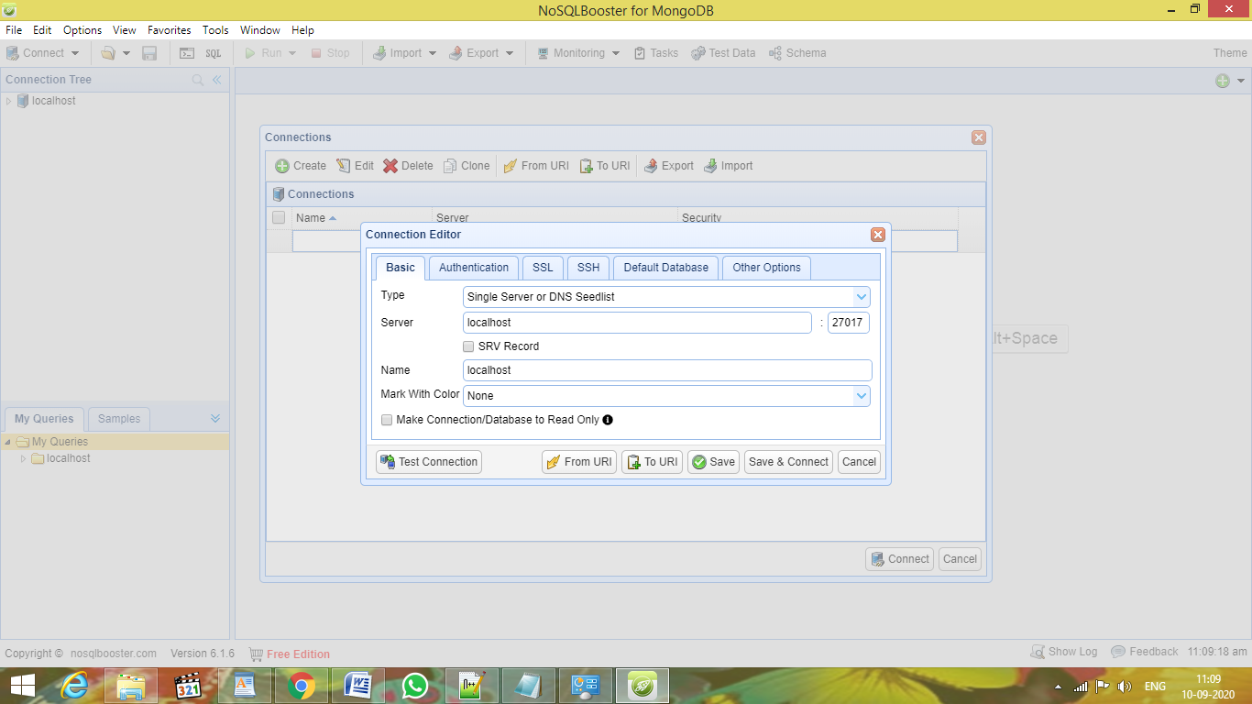

Check whether the status is ok. Then save and connect.

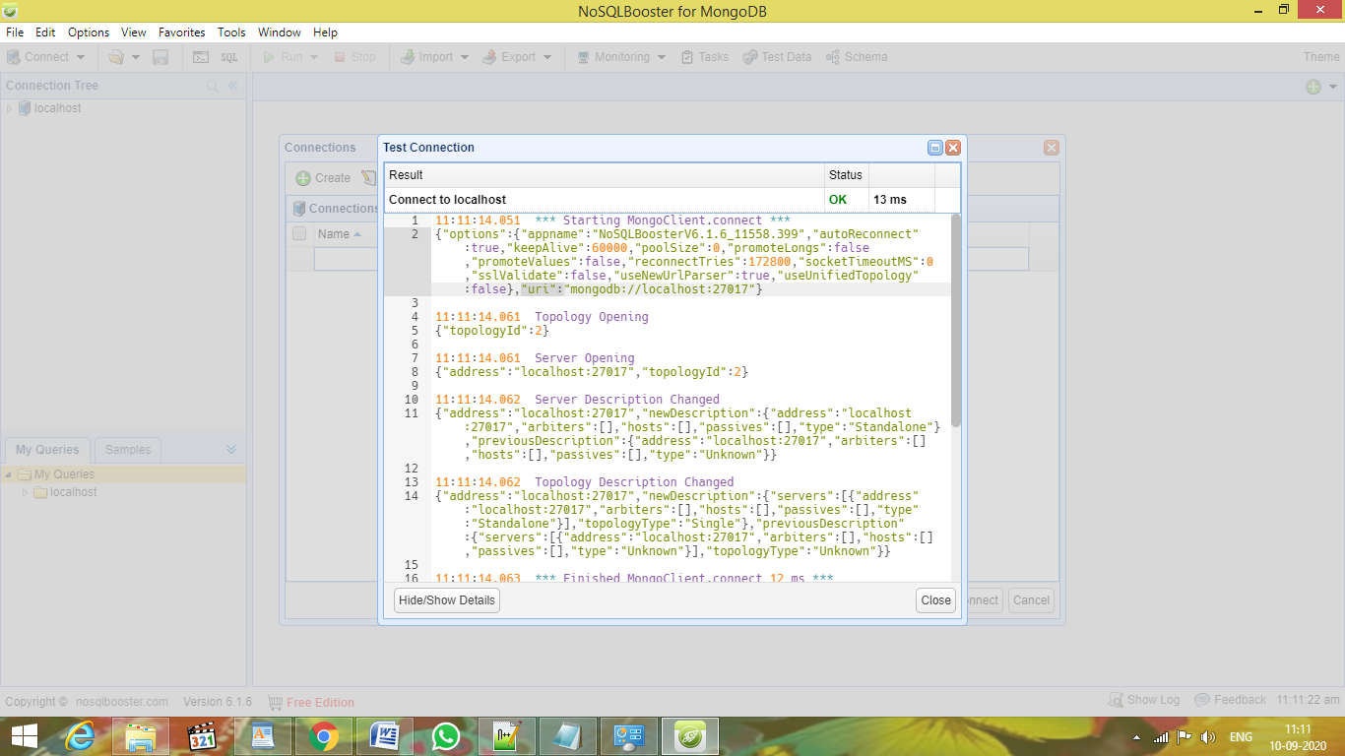

- Sample Codes will be available under the Samples Tab,select the queries and click Run button.

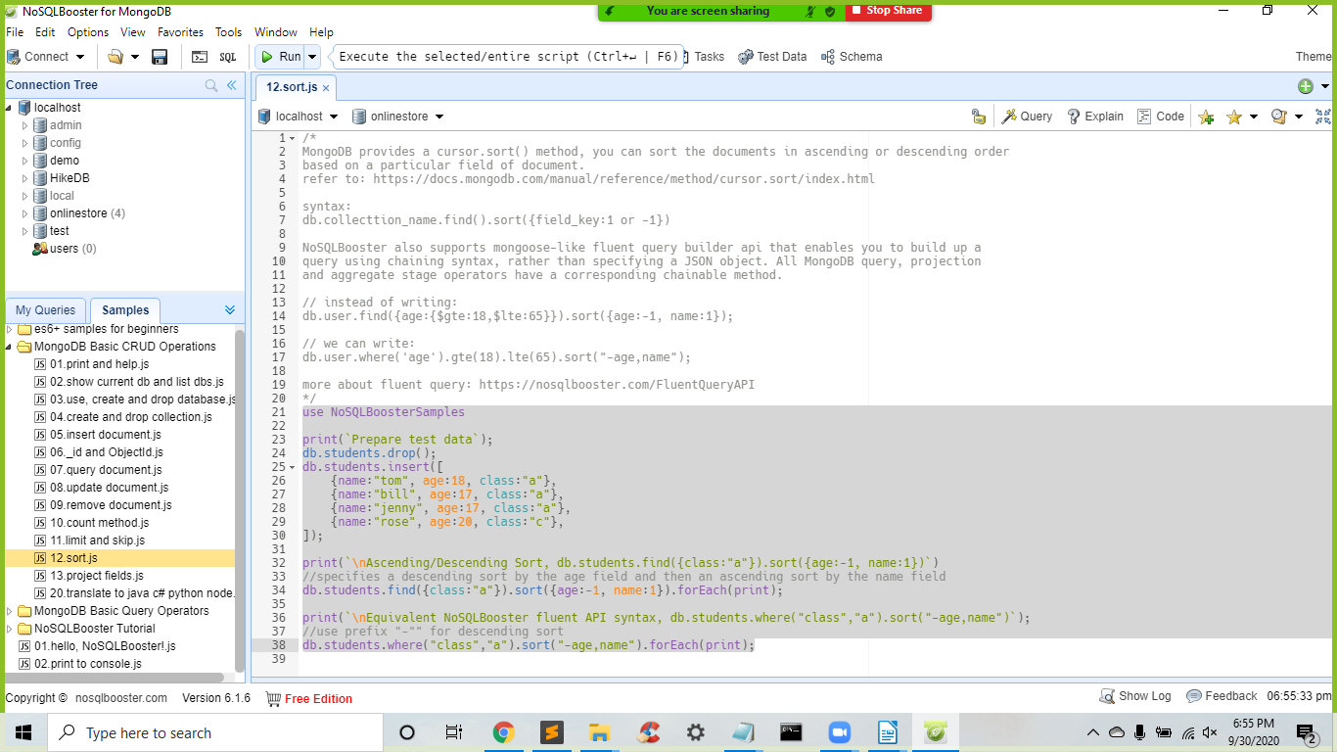

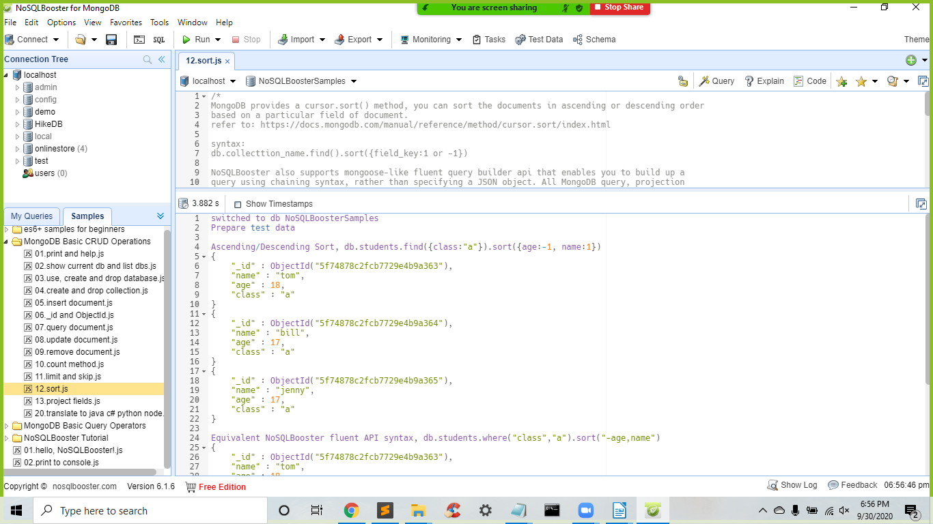Below is the sample output after you click the Run button.