1. Validate the below html form. (Using plain javascript)
- All fields are mandatory.
- Password should contains minimum 8 characters. Should contains combinations of letters, numbers and special characters.
- Use regular expression to validate emails and contactno
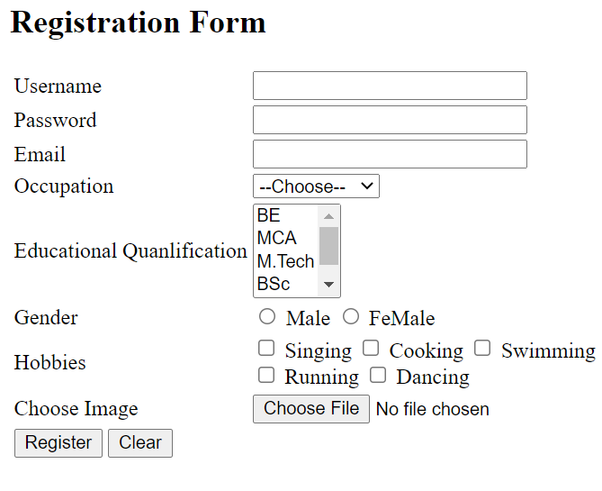

2. Design the following screen. Add the input name to drop down box below.
Also choose a name from dropdown box and display below.
