Index of Libraries Used
# | Library | Category
1 | linklist.h | Singly linked list
2 | stack.h | LIFO stack
3 | double_ll.h | Doubly linked list
4 | queue.h | FIFO queue
5 | list.h | Dynamic array
6 | bst.h | Binary Search Tree (AVL-balanced)
7 | heap.h | Binary max-heap
8 | hash.h | Chained hash table
9 | set.h | Hash set
10 | sort.h | Sorting algorithms

Libraries Used — Description
1. linklist.h — Singly linked list. Generic, void*-based singly linked list providing head/indexed insert and delete operations, an optional per-element free_ele destructor, and O(n) traversal helpers. Forms the underlying storage for stack.h.
2. stack.h — LIFO stack. A thin LIFO wrapper (init, push, pop, peek, isempty, free) around linklist.h: stack_t is simply a linklist_t, and every push/pop happens at the head of the list.
3. double_ll.h — Doubly linked list. Generic doubly linked list with O(1) head and tail insert/delete and bidirectional node links (dll_node), used as the underlying storage for queue.h.
4. queue.h — FIFO queue. A thin FIFO wrapper (init, enqueue, dequeue, peek, isempty, size, free) around double_ll.h: queue_t is a double_ll_t, with enqueue inserting at the tail and dequeue removing from the head.
5. list.h — Dynamic array. A generic, growable dynamic array (init, add, set, get, size, free) that stores elements as raw byte copies and doubles its capacity on growth.
6. bst.h — Binary Search Tree (AVL-balanced). A self-balancing BST — insert/delete perform AVL rotations to keep the tree height-balanced — supporting insert, get, contains and delete, all O(log n), driven by a user-supplied comparator.
7. heap.h — Binary max-heap. An array-free, pointer-based binary max-heap (init, insert, peek, popmax). Ordering is fully customizable via a comparator, letting it double as a min-heap or a priority queue.
8. hash.h — Chained hash table. A separate-chaining hash table (init, put, get, remove) built on an array of linklist.h buckets, with a built-in djb2-style byte hash and pluggable custom hash/comparator functions for non-trivial key types such as C strings. Internally underlies set.h.
9. set.h — Hash set. A minimal hash-set wrapper (init, insert, contains, remove, free) built directly on top of hash.h (a set is just a hash table whose values are an unused placeholder byte).
10. sort.h — Sorting algorithms. A collection of independent, qsort-style generic (void*, element-size, comparator) sorting algorithms — insertion, selection, merge, bubble and quick sort — each enabled by its own macro.

Library — linklist.h (Singly linked list)
// linklist.h

#ifndef LINKLIST_H
#define LINKLIST_H

#include <stddef.h> //size_t

typedef struct linklist_t linklist_t;

typedef struct ll_node ll_node;

int ll_init(linklist_t *l, size_t elem_sz, void (*free_ele)(void *));
void ll_free(linklist_t *l);

int ll_isempty(const linklist_t *l);
size_t ll_size(const linklist_t *l);

int ll_insert(linklist_t *l, size_t i, const void *elem);
int ll_inserthead(linklist_t *l, const void *elem);
int ll_inserttail(linklist_t *l, const void *elem);

int ll_delete(linklist_t *l, size_t i, void *out_elem);
int ll_deletehead(linklist_t *l, void *out_elem);
int ll_deletetail(linklist_t *l, void *out_elem);

int ll_getelem(const linklist_t *l, size_t i, void *out_elem);
int ll_gethead(const linklist_t *l, void *out_elem);
int ll_gettail(const linklist_t *l, void *out_elem);

#ifdef LL_IMPLEMENTATION

struct ll_node {
void *data;
struct ll_node *next;
};

struct linklist_t {
ll_node *head;
size_t elem_sz;
void (*__free_ele)(void *);
};

#include <stdlib.h>
#include <string.h>

static void __ll_free_node(ll_node *n, void (*free_ele)(void *)) {
if (!n)
return;
if (n->data) {
if (free_ele)
free_ele(n->data);
free(n->data);
}
free(n);
}

static ll_node *__ll_create_node(const void *elem, size_t elem_sz) {
ll_node *n = (ll_node *)malloc(sizeof(ll_node));
if (!n)
return NULL;
n->data = malloc(elem_sz);
if (!n->data) {
__ll_free_node(n, NULL);
return NULL;
}
memcpy(n->data, elem, elem_sz);
n->next = NULL;
return n;
}

int ll_init(linklist_t *l, size_t elem_sz, void (*free_ele)(void *)) {
if (!l || elem_sz == 0)
return 0;

l->head = NULL;
l->elem_sz = elem_sz;
l->__free_ele = free_ele;
return 1;
}

static void __ll_node_rec_delete(ll_node *node, void (*free_ele)(void *)) {
if (!node)
return;
__ll_node_rec_delete(node->next, free_ele);
__ll_free_node(node, free_ele);
}

void ll_free(linklist_t *l) {
if (!l)
return;

__ll_node_rec_delete(l->head, l->__free_ele);

l->head = NULL;
return;
}

int ll_isempty(const linklist_t *l) { return !l || !l->head; }

size_t ll_size(const linklist_t *l) {
size_t s = 0;
for (const ll_node *cur = l->head; cur; cur = cur->next)
s++;
return s;
}

int ll_inserthead(linklist_t *l, const void *elem) {
if (!l)
return 0;

ll_node *n = __ll_create_node(elem, l->elem_sz);
if (!n)
return 0;

n->next = l->head;
l->head = n;
return 1;
}

int ll_inserttail(linklist_t *l, const void *elem) {
if (!l)
return 0;

if (!l->head)
return ll_inserthead(l, elem);

ll_node *n = __ll_create_node(elem, l->elem_sz);
if (!n)
return 0;

ll_node *prev;
for (prev = l->head; prev->next; prev = prev->next)
;

prev->next = n;
return 1;
}

int ll_insert(linklist_t *l, size_t i, const void *elem) {
if (!l)
return 0;

if (i == 0)
return ll_inserthead(l, elem);

ll_node *prev;
for (prev = l->head; prev && --i; prev = prev ? prev->next : NULL)
;
if (!prev)
return 0;

ll_node *n = __ll_create_node(elem, l->elem_sz);
if (!n)
return 0;

n->next = prev->next;
prev->next = n;
return 1;
}

int ll_deletehead(linklist_t *l, void *out_elem) {
if (ll_isempty(l) || !out_elem)
return 0;

ll_node *tmp = l->head;
l->head = tmp->next;
memcpy(out_elem, tmp->data, l->elem_sz);
__ll_free_node(tmp, l->__free_ele);
return 1;
}

int ll_deletetail(linklist_t *l, void *out_elem) {
if (ll_isempty(l) || !out_elem)
return 0;

if (l->head->next == NULL)
return ll_deletehead(l, out_elem);

ll_node *prev, *tmp;
for (prev = l->head; prev->next->next; prev = prev->next)
;

tmp = prev->next;
prev->next = NULL;
memcpy(out_elem, tmp->data, l->elem_sz);
__ll_free_node(tmp, l->__free_ele);
return 1;
}

int ll_delete(linklist_t *l, size_t i, void *out_elem) {
if (ll_isempty(l) || !out_elem)
return 0;

if (i == 0)
return ll_deletehead(l, out_elem);

ll_node *prev, *tmp;
for (prev = l->head; prev && --i; prev = prev ? prev->next : NULL)
;
if (!prev)
return 0;

tmp = prev->next;
if (!tmp)
return 0;
prev->next = tmp->next;
memcpy(out_elem, tmp->data, l->elem_sz);
__ll_free_node(tmp, l->__free_ele);
return 1;
}

int ll_gethead(const linklist_t *l, void *out_elem) {
if (ll_isempty(l) || !out_elem)
return 0;
memcpy(out_elem, l->head->data, l->elem_sz);
return 1;
}

int ll_gettail(const linklist_t *l, void *out_elem) {
if (ll_isempty(l) || !out_elem)
return 0;
const ll_node *last;
for (last = l->head; last->next; last = last->next)
;
memcpy(out_elem, last->data, l->elem_sz);
return 1;
}

int ll_getelem(const linklist_t *l, size_t i, void *out_elem) {
if (ll_isempty(l) || !out_elem)
return 0;

if (i == 0)
return ll_gethead(l, out_elem);

const ll_node *n;
for (n = l->head; n && i--; n = n ? n->next : NULL)
;
if (!n)
return 0;

memcpy(out_elem, n->data, l->elem_sz);
return 1;
}

#endif // LL_IMPLEMENTATION

#endif // LINKLIST_H

Library — stack.h (LIFO stack)
// stack.h
#ifndef STACK_H
#define STACK_H

#include <stddef.h> // size_t

typedef struct linklist_t stack_t;

int stack_init(stack_t *s, size_t elem_sz, void (*free_ele)(void *));
void stack_free(stack_t *s);

int stack_isempty(const stack_t *s);

int stack_push(stack_t *s, const void *elem);
int stack_pop(stack_t *s, void *out);
int stack_peek(const stack_t *s, void *out);

#ifdef STACK_IMPLEMENTATION

#ifdef STACK_IMPLEMENTATION
#ifndef LL_IMPLEMENTATION
#define LL_IMPLEMENTATION
#endif // LL_IMPLEMENTATION
#endif // STACK_IMPLEMENTATION

#include "linklist.h"

int stack_init(stack_t *s, size_t elem_sz, void (*free_ele)(void *)) {
return ll_init(s, elem_sz, free_ele);
}

void stack_free(stack_t *s) { ll_free(s); }

int stack_isempty(const stack_t *s) { return ll_isempty(s); }

int stack_push(stack_t *s, const void *elem) { return ll_inserthead(s, elem); }

int stack_pop(stack_t *s, void *out) { return ll_deletehead(s, out); }

int stack_peek(const stack_t *s, void *out) { return ll_gethead(s, out); }

#endif // STACK_IMPLEMENTATION

#endif // STACK_H

Library — double_ll.h (Doubly linked list)
// double_ll.h

#ifndef DOUBLE_LL_H
#define DOUBLE_LL_H

#include <stddef.h> // size_t

typedef struct dll_node dll_node;
typedef struct double_ll_t double_ll_t;

int dll_init(double_ll_t *l, size_t elem_sz, void (*free_ele)(void *));
void dll_free(double_ll_t *l);

int dll_isempty(const double_ll_t *l);
size_t dll_size(const double_ll_t *l);

dll_node *dll_insert(double_ll_t *l, size_t i, const void *elem);
dll_node *dll_inserthead(double_ll_t *l, const void *elem);
dll_node *dll_inserttail(double_ll_t *l, const void *elem);

int dll_delete(double_ll_t *l, size_t i, void *out_elem);
int dll_deletehead(double_ll_t *l, void *out_elem);
int dll_deletetail(double_ll_t *l, void *out_elem);
int dll_delete_node(double_ll_t *l, dll_node *n, void *out_elem);

int dll_getelem(const double_ll_t *l, size_t i, void *out_elem);
int dll_gethead(const double_ll_t *l, void *out_elem);
int dll_gettail(const double_ll_t *l, void *out_elem);

#ifdef DLL_IMPLEMENTATION

struct dll_node {
void *data;
struct dll_node *next;
struct dll_node *prev;
};

struct double_ll_t {
dll_node *head;
dll_node *tail;
size_t elem_sz;
void (*__free_ele)(void *);
};

#include <stdlib.h>
#include <string.h>

static void __dll_free_node(dll_node *n, void (*free_ele)(void *)) {
if (!n)
return;
if (n->data) {
if (free_ele)
free_ele(n->data);
free(n->data);
}
free(n);
}

static dll_node *__dll_create_node(const void *elem, size_t elem_sz) {
dll_node *n = (dll_node *)malloc(sizeof(dll_node));
if (!n)
return NULL;
n->data = malloc(elem_sz);
if (!n->data) {
__dll_free_node(n, NULL);
return NULL;
}
memcpy(n->data, elem, elem_sz);
n->next = NULL;
n->prev = NULL;
return n;
}

int dll_init(double_ll_t *l, size_t elem_sz, void (*free_ele)(void *)) {
if (!l || elem_sz == 0)
return 0;

l->head = NULL;
l->tail = NULL;
l->elem_sz = elem_sz;
l->__free_ele = free_ele;
return 1;
}

static void __dll_node_rec_delete(dll_node *node, void (*free_ele)(void *)) {
if (!node)
return;
__dll_node_rec_delete(node->next, free_ele);
__dll_free_node(node, free_ele);
}

void dll_free(double_ll_t *l) {
if (!l)
return;

__dll_node_rec_delete(l->head, l->__free_ele);
l->head = NULL;
l->tail = NULL;
l->elem_sz = 0;
l->__free_ele = NULL;
}

int dll_isempty(const double_ll_t *l) { return !l || !l->head; }

size_t dll_size(const double_ll_t *l) {
size_t s = 0;
for (const dll_node *cur = l->head; cur; cur = cur->next)
s++;
return s;
}

dll_node *dll_inserthead(double_ll_t *l, const void *elem) {
if (!l)
return NULL;

dll_node *n = __dll_create_node(elem, l->elem_sz);
if (!n)
return NULL;

n->next = l->head;
n->prev = NULL;
if (l->head) {
l->head->prev = n;
} else {
l->tail = n;
}
l->head = n;
return n;
}

dll_node *dll_inserttail(double_ll_t *l, const void *elem) {
if (!l)
return NULL;
if (!l->head)
return dll_inserthead(l, elem);

dll_node *n = __dll_create_node(elem, l->elem_sz);
if (!n)
return NULL;

l->tail->next = n;
n->prev = l->tail;
l->tail = n;
return n;
}

dll_node *dll_insert(double_ll_t *l, size_t i, const void *elem) {
if (!l)
return NULL;
if (i == 0)
return dll_inserthead(l, elem);

dll_node *cur = l->head;
while (cur && i > 1) {
cur = cur->next;
i--;
}
if (!cur)
return NULL;

dll_node *n = __dll_create_node(elem, l->elem_sz);
if (!n)
return NULL;

n->next = cur->next;
n->prev = cur;
if (cur->next) {
cur->next->prev = n;
} else {
l->tail = n;
}
cur->next = n;
return n;
}

int dll_delete_node(double_ll_t *l, dll_node *n, void *out_elem) {
if (!l || !n)
return 0;
if (n == l->head) {
l->head = n->next;
}
if (n == l->tail) {
l->tail = n->prev;
}
if (n->prev) {
n->prev->next = n->next;
}
if (n->next) {
n->next->prev = n->prev;
}
if (out_elem) {
memcpy(out_elem, n->data, l->elem_sz);
}
__dll_free_node(n, l->__free_ele);
return 1;
}

int dll_deletehead(double_ll_t *l, void *out_elem) {
if (dll_isempty(l) || !out_elem)
return 0;
memcpy(out_elem, l->head->data, l->elem_sz);
return dll_delete_node(l, l->head, out_elem);
}

int dll_deletetail(double_ll_t *l, void *out_elem) {
if (dll_isempty(l) || !out_elem)
return 0;
memcpy(out_elem, l->tail->data, l->elem_sz);
return dll_delete_node(l, l->tail, out_elem);
}

int dll_delete(double_ll_t *l, size_t i, void *out_elem) {
if (dll_isempty(l) || !out_elem)
return 0;
if (i == 0)
return dll_deletehead(l, out_elem);

dll_node *cur = l->head;
while (cur && i > 0) {
cur = cur->next;
i--;
}
if (!cur)
return 0;
memcpy(out_elem, cur->data, l->elem_sz);
return dll_delete_node(l, cur, out_elem);
}

int dll_gethead(const double_ll_t *l, void *out_elem) {
if (dll_isempty(l) || !out_elem)
return 0;
memcpy(out_elem, l->head->data, l->elem_sz);
return 1;
}

int dll_gettail(const double_ll_t *l, void *out_elem) {
if (dll_isempty(l) || !out_elem)
return 0;
memcpy(out_elem, l->tail->data, l->elem_sz);
return 1;
}

int dll_getelem(const double_ll_t *l, size_t i, void *out_elem) {
if (dll_isempty(l) || !out_elem)
return 0;
if (i == 0)
return dll_gethead(l, out_elem);
dll_node *cur = l->head;
while (cur && i > 0) {
cur = cur->next;
i--;
}
if (!cur)
return 0;

memcpy(out_elem, cur->data, l->elem_sz);
return 1;
}

#endif // DLL_IMPLEMENTATION
#endif // DOUBLE_LL_H

Library — queue.h (FIFO queue)
// queue.h

#ifndef QUEUE_H
#define QUEUE_H

#include <stddef.h> // size_t

typedef struct double_ll_t queue_t;

int q_init(queue_t *q, size_t elem_sz, void (*free_ele)(void *));
void q_free(queue_t *q);
int q_isempty(const queue_t *q);
size_t q_size(const queue_t *q);
int enqueue(queue_t *q, const void *elem);
int dequeue(queue_t *q, void *out);
int peek(const queue_t *q, void *out);

#ifdef QUEUE_IMPLEMENTATION

#ifdef QUEUE_IMPLEMENTATION
#ifndef DLL_IMPLEMENTATION
#define DLL_IMPLEMENTATION
#endif // DLL_IMPLEMENTATION
#endif // QUEUE_IMPLEMENTATION

#include "double_ll.h"

int q_init(queue_t *q, size_t elem_sz, void (*free_ele)(void *)) {
return dll_init(q, elem_sz, free_ele);
}

void q_free(queue_t *q) { dll_free(q); }

int q_isempty(const queue_t *q) { return dll_isempty(q); }

size_t q_size(const queue_t *q) { return dll_size(q); }

int enqueue(queue_t *q, const void *elem) {
return dll_inserttail(q, elem) != NULL;
}

int dequeue(queue_t *q, void *out) { return dll_deletehead(q, out); }

int peek(const queue_t *q, void *out) { return dll_gethead(q, out); }
#endif // QUEUE_IMPLEMENTATION
#endif // QUEUE_H

Library — list.h (Dynamic array)
// list.h

#ifndef LIST_H
#define LIST_H

#include <stddef.h> // size_t

typedef struct list_t list_t;

int list_init(list_t *l, size_t initial_cap, size_t elem_sz,
void (*free_ele)(void *));
void list_free(list_t *l);

size_t list_size(const list_t *l);

int add(list_t *l, const void *elem);

int set(list_t *l, size_t i, const void *elem);

int get(const list_t *l, size_t i, void *out);

#ifdef LIST_IMPLEMENTATION

struct list_t {
unsigned char *data;
size_t cap;
size_t size;
size_t elem_sz;
void (*__free_ele)(void *);
};

#include <stdlib.h>
#include <string.h>

int list_init(list_t *l, size_t initial_cap, size_t elem_sz,
void (*free_ele)(void *)) {
if (!l || initial_cap == 0 || elem_sz == 0)
return 0;

l->data = calloc(initial_cap, elem_sz);
if (!l->data)
return 0;

l->cap = initial_cap;
l->size = 0;
l->elem_sz = elem_sz;
l->__free_ele = free_ele;
return 1;
}

void list_free(list_t *l) {
if (!l)
return;

if (l->data) {
if (l->__free_ele)
for (size_t i = 0; i < l->size; i++)
l->__free_ele(&l->data[i * l->elem_sz]);
free(l->data);
}

l->data = NULL;
l->cap = 0;
l->size = 0;
l->elem_sz = 0;
l->__free_ele = NULL;
}

size_t list_size(const list_t *l) {
if (!l)
return 0;
return l->size;
}

static int __grow_list(list_t *l) {
size_t new_cap = 2 * l->cap;

void *new_data = reallocarray(l->data, new_cap, l->elem_sz);
if (!new_data)
return 0;

l->data = new_data;
l->cap = new_cap;
return 1;
}

int add(list_t *l, const void *elem) {
if (!l || !elem)
return 0;
if (l->size == l->cap && !__grow_list(l))
return 0;

memcpy(&l->data[l->size++ * l->elem_sz], elem, l->elem_sz);
return 1;
}

int set(list_t *l, size_t i, const void *elem) {
if (!l || !elem)
return 0;
if (i > l->size)
return 0;
if (i == l->size)
return add(l, elem);

if (l->__free_ele)
l->__free_ele(&l->data[i * l->elem_sz]);
memcpy(&l->data[i * l->elem_sz], elem, l->elem_sz);
return 1;
}

int get(const list_t *l, size_t i, void *out) {
if (!l || !out)
return 0;
if (i >= l->size)
return 0;

memcpy(out, &l->data[i * l->elem_sz], l->elem_sz);
return 1;
}

#endif // LIST_IMPLEMENTATION
#endif // LIST_H

Library — bst.h (Binary Search Tree (AVL-balanced))
// bst.h

#ifndef BST_H
#define BST_H

#include <stddef.h>

typedef struct bst_node bst_node;
typedef struct bst_t bst_t;

int bst_init(bst_t *b, size_t elem_sz, int (*cmp)(const void *, const void *),
void (*free_ele)(void *));
void bst_free(bst_t *b);

int bst_insert(bst_t *b, const void *elem);
int bst_delete(bst_t *b, const void *elem);
int bst_contains(const bst_t *b, const void *elem);
int bst_get(const bst_t *b, const void *elem, void *out);

#ifdef BST_IMPLEMENTATION

struct bst_t {
bst_node *root;
size_t elem_sz;
int (*cmp)(const void *, const void *);
void (*free_ele)(void *);
};

struct bst_node {
void *val;
bst_node *left;
bst_node *right;
size_t __ht; // AVL implementation
};

#include <stdlib.h>
#include <string.h>

int bst_init(bst_t *b, size_t elem_sz, int (*cmp)(const void *, const void *),
void (*free_ele)(void *)) {
if (elem_sz == 0 || !cmp || !b)
return 0;
b->root = NULL;
b->elem_sz = elem_sz;
b->cmp = cmp;
b->free_ele = free_ele;
return 1;
}

static void __free_bst_node(bst_node *n, void (*free_ele)(void *)) {
if (!n)
return;
if (free_ele)
free_ele(n->val);
free(n->val);
free(n);
}

static void __rec_free(bst_node *n, void (*free_ele)(void *)) {
if (!n)
return;
__rec_free(n->left, free_ele);
__rec_free(n->right, free_ele);
__free_bst_node(n, free_ele);
}

void bst_free(bst_t *b) {
if (!b)
return;
__rec_free(b->root, b->free_ele);
b->root = NULL;
b->elem_sz = 0;
b->cmp = NULL;
b->free_ele = NULL;
}

static bst_node *__bst_create_node(const void *elem, size_t elem_sz) {
bst_node *n = (bst_node *)malloc(sizeof(bst_node));
if (!n)
return NULL;
void *val = malloc(elem_sz);
if (!val) {
free(n);
return NULL;
}
n->val = val;
memcpy(n->val, elem, elem_sz);
n->left = NULL;
n->right = NULL;
n->__ht = 1;
return n;
}

static size_t __get_ht(const bst_node *n) {
if (!n)
return 0;
return n->__ht;
}

static void __update_ht(bst_node *n) {
if (!n)
return;
size_t a, b;
a = __get_ht(n->left);
b = __get_ht(n->right);
n->__ht = (a > b ? a : b) + 1;
}

static int __bf(const bst_node *n) {
if (!n)
return 0;
return __get_ht(n->left) - __get_ht(n->right);
}

static bst_node *__rot_left(bst_node *n) {
/* left rotation: pivot is right child */
bst_node *x, *s;

x = n->right;
if (!x)
return n;
s = x->left;

x->left = n;
n->right = s;

__update_ht(n);
__update_ht(x);

return x;
}

static bst_node *__rot_right(bst_node *n) {
/* right rotation: pivot is left child */
bst_node *x, *s;
x = n->left;
if (!x)
return n;
s = x->right;
x->right = n;
n->left = s;
__update_ht(n);
__update_ht(x);
return x;
}

static bst_node *__rebal(bst_node *n) {
__update_ht(n);

int bf = __bf(n);

// left heavy
if (bf > 1) {
if (__bf(n->left) < 0)
n->left = __rot_left(n->left); // LR
return __rot_right(n); // LL
}

// right heavy
if (bf < -1) {
if (__bf(n->right) > 0)
n->right = __rot_right(n->right); // RL
return __rot_left(n); // RR
}

return n;
}

static bst_node *__rec_insert(bst_node *n, const void *elem, size_t elem_sz,
int (*cmp)(const void *, const void *)) {
if (!n)
return __bst_create_node(elem, elem_sz);

int k = cmp(elem, n->val);
if (k == 0)
return n;
if (k > 0)
n->right = __rec_insert(n->right, elem, elem_sz, cmp);
if (k < 0)
n->left = __rec_insert(n->left, elem, elem_sz, cmp);
return __rebal(n);
}

int bst_insert(bst_t *b, const void *elem) {
if (!b)
return 0;

b->root = __rec_insert(b->root, elem, b->elem_sz, b->cmp);
return 1; // Doesnt guarantee insert success
}

static int __rec_contains(const bst_node *n, const void *elem,
int (*cmp)(const void *, const void *)) {
if (!n)
return 0;
int k = cmp(elem, n->val);
if (k == 0)
return 1;
if (k > 0)
return __rec_contains(n->right, elem, cmp);
if (k < 0)
return __rec_contains(n->left, elem, cmp);
__builtin_unreachable();
}

int bst_contains(const bst_t *b, const void *elem) {
if (!b)
return 0;
return __rec_contains(b->root, elem, b->cmp);
}

static int __rec_get(const bst_node *n, const void *elem,
int (*cmp)(const void *, const void *), void *out, size_t elem_sz) {
if (!n)
return 0;
int k = cmp(elem, n->val);
if (k == 0) {
memcpy(out, n->val, elem_sz);
return 1;
}
if (k > 0)
return __rec_get(n->right, elem, cmp, out, elem_sz);
if (k < 0)
return __rec_get(n->left, elem, cmp, out, elem_sz);
__builtin_unreachable();
}

int bst_get(const bst_t *b, const void *elem, void *out) {
if (!b)
return 0;
return __rec_get(b->root, elem, b->cmp, out, b->elem_sz);
}

static bst_node *__rec_delete(bst_node *n, const void *elem, size_t elem_sz,
int (*cmp)(const void *, const void *),
void (*free_ele)(void *)) {
if (!n)
return NULL;

int k = cmp(elem, n->val);

if (k > 0)
n->right = __rec_delete(n->right, elem, elem_sz, cmp, free_ele);
else if (k < 0)
n->left = __rec_delete(n->left, elem, elem_sz, cmp, free_ele);
else {
if (!n->right || !n->left) {
bst_node *c;
if (!n->left && !n->right)
c = NULL;
else
c = !n->left ? n->right : n->left;
__free_bst_node(n, free_ele);
return c;
}
bst_node *suc = n->right;
while (suc->left)
suc = suc->left;

if (free_ele)
free_ele(n->val);
memcpy(n->val, suc->val, elem_sz);
n->right = __rec_delete(n->right, suc->val, elem_sz, cmp, free_ele);
}

return __rebal(n);
}

int bst_delete(bst_t *b, const void *elem) {
if (!b)
return 0;

b->root = __rec_delete(b->root, elem, b->elem_sz, b->cmp, b->free_ele);
return 1; // Doesnt guarantee success
}

#endif // BST_IMPLEMENTATION
#endif // BST_H

Library — heap.h (Binary max-heap)
// heap.h

#ifndef HEAP_H
#define HEAP_H

#include <stddef.h> // size_t

typedef struct heap_node hp_node;
typedef struct heap_t hp_t;

int hp_init(hp_t *h, size_t elem_sz, int (*cmp)(const void *, const void *),
void (*free_ele)(void *));
void hp_free(hp_t *h);

int hp_insert(hp_t *h, const void *elem);
int hp_peek(const hp_t *h, void *out);
int hp_popmax(hp_t *h, void *out);

#ifdef HEAP_IMPLEMENTATION

struct heap_t {
hp_node *root;
size_t elem_sz;
size_t size;
int (*cmp)(const void *, const void *);
void (*free_ele)(void *);
};

struct heap_node {
void *val;
hp_node *left;
hp_node *right;
hp_node *parent;
};

#include <math.h>
#include <stdlib.h>
#include <string.h>

int hp_init(hp_t *h, size_t elem_sz, int (*cmp)(const void *, const void *),
void (*free_ele)(void *)) {
if (!h || !cmp || elem_sz == 0)
return 0;

h->root = NULL;
h->elem_sz = elem_sz;
h->size = 0;
h->cmp = cmp;
h->free_ele = free_ele;
return 1;
}

static void __hp_free_node(hp_node *n, void (*free_ele)(void *)) {
if (!n)
return;
if (free_ele)
free_ele(n->val);
free(n->val);
free(n);
}

static void __rec_free(hp_node *n, void (*free_ele)(void *)) {
if (!n)
return;
__rec_free(n->left, free_ele);
__rec_free(n->right, free_ele);
__hp_free_node(n, free_ele);
}

void hp_free(hp_t *h) {
if (!h)
return;
__rec_free(h->root, h->free_ele);
h->root = NULL;
h->elem_sz = 0;
h->size = 0;
h->cmp = NULL;
h->free_ele = NULL;
}

static hp_node *__hp_create_node(const void *elem, size_t elem_sz) {
/* allocate node struct correctly */
hp_node *n = (hp_node *)malloc(sizeof(hp_node));
if (!n)
return NULL;
void *val = malloc(elem_sz);
if (!val) {
free(n);
return NULL;
}
n->val = val;
memcpy(n->val, elem, elem_sz);
n->left = NULL;
n->right = NULL;
n->parent = NULL;
return n;
}

static void __swap_val(hp_node *a, hp_node *b) {
void *t = a->val;
a->val = b->val;
b->val = t;
}

static void __bubble_up(hp_node *n, int (*cmp)(const void *, const void *)) {
while (n->parent && cmp(n->val, n->parent->val) > 0) {
__swap_val(n, n->parent);
n = n->parent;
}
}

static void __bubble_down(hp_node *n, int (*cmp)(const void *, const void *)) {
while (1) {
hp_node *l = n;

if (n->left && cmp(n->left->val, l->val) > 0)
l = n->left;
if (n->right && cmp(n->right->val, l->val) > 0)
l = n->right;
if (l == n)
break;

__swap_val(l, n);
n = l;
}
}

static hp_node *__get_node(const hp_node *n, size_t i, size_t d) {
if (d == 0)
return (hp_node *)n;

size_t div = (size_t)1 << (d - 1); // 2 ^ (d - 1)

if (i >= div)
return __get_node(n->right, i - div, d - 1); // Right subtree
else
return __get_node(n->left, i, d - 1); // Left subtree
}

int hp_insert(hp_t *h, const void *elem) {
if (!h || !elem)
return 0;
hp_node *n = __hp_create_node(elem, h->elem_sz);
if (!n)
return 0;

h->size++;

if (!h->root) {
h->root = n;
return 1;
}

size_t k = h->size / 2;
size_t d = floor(log2(k));
size_t o = k - ((size_t)1 << d);

hp_node *p = __get_node(h->root, o, d);

n->parent = p;

if (!p->left)
p->left = n;
else
p->right = n;

__bubble_up(n, h->cmp);
return 1;
}

int hp_peek(const hp_t *h, void *out) {
if (!h || !h->root || !out)
return 0;
memcpy(out, h->root->val, h->elem_sz);
return 1;
}

int hp_popmax(hp_t *h, void *out) {
if (!h || !h->root || !out)
return 0;
memcpy(out, h->root->val, h->elem_sz);

if (h->size == 1) {
__hp_free_node(h->root, h->free_ele);
h->root = NULL;
h->size = 0;
return 1;
}

size_t k = h->size;
size_t d = floor(log2(k));
size_t o = k - ((size_t)1 << d);

hp_node *last = __get_node(h->root, o, d);
__swap_val(h->root, last);
hp_node *p = last->parent;

if (p->left == last)
p->left = NULL;
else
p->right = NULL;

__hp_free_node(last, h->free_ele);
h->size--;

__bubble_down(h->root, h->cmp);
return 1;
}

#endif // HEAP_IMPLEMENTATION
#endif // HEAP_H

Library — hash.h (Chained hash table)
// hash.h

#ifndef HASH_H
#define HASH_H

#include <stddef.h>

typedef struct hash_t hash_t;

int ht_init(hash_t *h, size_t key_sz, size_t val_sz, size_t buckets,
void (*key_free)(void *), void (*val_free)(void *));
void set_hash(hash_t *h, size_t (*hash)(const void *, size_t));
void set_cmp(hash_t *h, int (*cmp)(const void *, const void *, size_t));
void ht_free(hash_t *h);

int ht_put(hash_t *h, const void *key, const void *val);
int ht_get(const hash_t *h, const void *key, void *out);
int ht_rem(hash_t *h, const void *key);

#ifdef HASH_IMPLEMENTATION

#ifdef HASH_IMPLEMENTATION
#ifndef LL_IMPLEMENTATION
#define LL_IMPLEMENTATION
#endif // LL_IMPLEMENTATION
#endif // HASH_IMPLEMENTATION

#include "linklist.h"

struct __ctx {
void (*key_free)(void *);
void (*val_free)(void *);
};

typedef struct __entry_t __entry_t;
struct __entry_t {
void *key;
void *val;
struct __ctx *ctx;
};

struct hash_t {
linklist_t *arr; // hash_t is an array of linked-list of __entry_t
size_t key_sz;
size_t val_sz;
size_t buckets;
struct __ctx __ctx;
size_t (*hash_fn)(const void *, size_t);
int (*cmp_fn)(const void *, const void *, size_t);
};

#include <stdlib.h>
#include <string.h>

// djb2 hash
size_t __hash(const void *key, size_t size) {
const unsigned char *p = key;
size_t h = 5381;

for (size_t i = 0; i < size; i++)
h = ((h << 5) + h) + p[i];
return h;
}

int __create_entry(const void *key, const void *val, size_t key_sz,
size_t val_sz, __entry_t *out, struct __ctx *ctx) {
if (!key || !val || !out)
return 0;

out->key = malloc(key_sz);
if (!out->key)
return 0;
memcpy(out->key, key, key_sz);

out->val = malloc(val_sz);
if (!out->val) {
free(out->key);
return 0;
}
memcpy(out->val, val, val_sz);

out->ctx = ctx;

return 1;
}

void __destroy_entry(void *p) {
__entry_t *entry = (__entry_t *)p;

if (!entry)
return;
if (entry->ctx->key_free)
entry->ctx->key_free(entry->key);
free(entry->key);
if (entry->ctx->val_free)
entry->ctx->val_free(entry->val);
free(entry->val);
}

int ht_init(hash_t *h, size_t key_sz, size_t val_sz, size_t buckets,
void (*key_free)(void *), void (*val_free)(void *)) {
if (!h || buckets == 0 || key_sz == 0 || val_sz == 0)
return 0;

linklist_t *arr = (linklist_t *)calloc(buckets, sizeof(linklist_t));
if (!arr)
return 0;

for (size_t i = 0; i < buckets; ++i)
if (!ll_init(&arr[i], sizeof(__entry_t), __destroy_entry)) {
for (size_t j = 0; j < i; ++j)
ll_free(&arr[j]);
free(arr);
return 0;
}

h->arr = arr;
h->key_sz = key_sz;
h->val_sz = val_sz;
h->buckets = buckets;
h->__ctx = (struct __ctx){key_free, val_free};
h->hash_fn = __hash;
h->cmp_fn = memcmp;
return 1;
}

void set_hash(hash_t *h, size_t (*hash)(const void *, size_t)) {
if (hash)
h->hash_fn = hash;
}

void set_cmp(hash_t *h, int (*cmp)(const void *, const void *, size_t)) {
if (cmp)
h->cmp_fn = cmp;
}

void ht_free(hash_t *h) {
if (!h)
return;
for (size_t i = 0; i < h->buckets; ++i)
ll_free(&h->arr[i]);
free(h->arr);

h->arr = NULL;
h->key_sz = 0;
h->val_sz = 0;
h->buckets = 0;
h->__ctx = (struct __ctx){NULL, NULL};
}

int ht_put(hash_t *h, const void *key, const void *val) {
size_t i = h->hash_fn(key, h->key_sz) % h->buckets;
if (ht_get(h, key, NULL))
return 0; // key is already occupied
__entry_t e;
if (!__create_entry(key, val, h->key_sz, h->val_sz, &e, &h->__ctx))
return 0;
return ll_inserthead(&h->arr[i], &e);
}

int ht_get(const hash_t *h, const void *key, void *out) {
size_t i = h->hash_fn(key, h->key_sz) % h->buckets;
linklist_t *l = h->arr + i;
for (ll_node *cur = l->head; cur; cur = cur->next) {
__entry_t *e = (__entry_t *)cur->data;
if (h->cmp_fn(e->key, key, h->key_sz) == 0) {
if (out)
memcpy(out, e->val, h->val_sz);
return 1;
}
}
return 0;
}

int ht_rem(hash_t *h, const void *key) {
size_t i = h->hash_fn(key, h->key_sz) % h->buckets;
linklist_t *l = h->arr + i;
int j = 0;
for (ll_node *cur = l->head; cur; cur = cur->next, j++) {
__entry_t *e = (__entry_t *)cur->data;
if (h->cmp_fn(e->key, key, h->key_sz) == 0) {
__entry_t removed;
return ll_delete(l, j, &removed);
}
}
return 0;
}

#endif // HASH_IMPLEMENTATION
#endif // HASH_H

Library — set.h (Hash set)
// set.h

#ifndef SET_H
#define SET_H

#include <stddef.h> // size_t
typedef struct hash_t set_t;

int set_init(set_t *s, size_t elem_sz, void (*free_ele)(void *));
// tip: use set_hash set_cmp for more complex datatypes
int set_insert(set_t *s, const void *elem);
int set_contains(const set_t *s, const void *elem);
int set_remove(set_t *s, const void *elem);
void set_free(set_t *s);

#ifdef SET_IMPLEMENTATION

#ifndef HASH_IMPLEMENTATION
#define HASH_IMPLEMENTATION
#endif // HASH_IMPLEMENTATION
#include "hash.h"

const char val = 'y';

int set_init(set_t *s, size_t elem_sz, void (*free_ele)(void *)) {
return ht_init(s, elem_sz, sizeof(char), 30, free_ele, NULL);
}

int set_insert(set_t *s, const void *elem) {
return ht_put(s, elem, &val);
}

int set_contains(const set_t *s, const void *elem) {
return ht_get(s, elem, NULL);
}

int set_remove(set_t *s, const void *elem) {
return ht_rem(s, elem);
}

void set_free(set_t *s) {
ht_free(s);
}

#endif // SET_IMPLEMENTATION
#endif // SET_H

Library — sort.h (Sorting algorithms)
// sort.h
#ifndef SORT_H
#define SORT_H

#include <stddef.h>

void insertion_sort(void *base, size_t nmemb, size_t size,
int (*cmp)(const void *, const void *));
void selection_sort(void *base, size_t nmemb, size_t size,
int (*cmp)(const void *, const void *));
void merge_sort(void *base, size_t nmemb, size_t size,
int (*cmp)(const void *, const void *));
void bubble_sort(void *base, size_t nmemb, size_t size,
int (*cmp)(const void *, const void *));
void quick_sort(void *base, size_t nmemb, size_t size,
int (*cmp)(const void *, const void *));
#endif // SORT_H

#include <string.h>

#define ELE_ADDR(arr, sz, idx) \
((void *)((unsigned char *)(arr) + ((size_t)(idx) * (size_t)(sz))))

static void bswap(void *a, void *b, size_t sz) {
unsigned char tmp[sz];
memcpy(tmp, a, sz);
memcpy(a, b, sz);
memcpy(b, tmp, sz);
}

#ifdef INSERT_SORT_IMPL

static size_t bsearch_left(void *base, size_t nmemb, size_t size,
int (*cmp)(const void *, const void *),
const void *key) {
size_t l, r, m;
l = 0;
r = nmemb;
while (l < r) {
m = (l + r) / 2;
if (cmp(ELE_ADDR(base, size, m), key) < 0)
l = m + 1;
else
r = m;
}
return l;
}

void insertion_sort(void *base, size_t nmemb, size_t size,
int (*cmp)(const void *, const void *)) {
if (!base || !cmp || nmemb < 2 || size == 0)
return;
unsigned char tmp[size];

size_t sorted = 1;

while (sorted != nmemb) {
size_t i = bsearch_left(
base, sorted, size, cmp,
ELE_ADDR(base, size, sorted)); // Search in the sorted subsequence
memcpy(tmp, ELE_ADDR(base, size, sorted), size);
memmove(ELE_ADDR(base, size, i + 1), ELE_ADDR(base, size, i),
(sorted - i) * size);
memcpy(ELE_ADDR(base, size, i), tmp, size);
sorted++;
}
}

#endif // INSERT_SORT_IMPL

#ifdef SELECT_SORT_IMPL

void selection_sort(void *base, size_t nmemb, size_t size,
int (*cmp)(const void *, const void *)) {
if (!base || !cmp || size == 0 || nmemb < 2)
return;

for (size_t i = 0; i < nmemb - 1; ++i) {
size_t min_idx = i;
for (size_t j = i + 1; j < nmemb; ++j)
if (cmp(ELE_ADDR(base, size, j), ELE_ADDR(base, size, min_idx)) < 0)
min_idx = j;
// swap arr[i] and arr[min_idx]
bswap(ELE_ADDR(base, size, i), ELE_ADDR(base, size, min_idx), size);
}
}

#endif // SELECT_SORT_IMPL

#ifdef MERGE_SORT_IMPL

static void merge_arr(void *base, size_t size, size_t left, size_t middle,
size_t right, int (*cmp)(const void *, const void *)) {
size_t m, n;
m = middle - left;
n = right - middle;
unsigned char left_part[m * size];
unsigned char right_part[n * size];

memcpy(left_part, ELE_ADDR(base, size, left), m * size);
memcpy(right_part, ELE_ADDR(base, size, middle), n * size);

size_t i, j, k;
i = 0;
j = 0;
k = left;

while (i < m && j < n) {
if (cmp(ELE_ADDR(left_part, size, i), ELE_ADDR(right_part, size, j)) <=
0) {
memcpy(ELE_ADDR(base, size, k), ELE_ADDR(left_part, size, i), size);
++i;
} else {
memcpy(ELE_ADDR(base, size, k), ELE_ADDR(right_part, size, j),
size);
++j;
}
++k;
}

while (i < m) {
memcpy(ELE_ADDR(base, size, k), ELE_ADDR(left_part, size, i), size);
++i;
++k;
}

while (j < n) {
memcpy(ELE_ADDR(base, size, k), ELE_ADDR(right_part, size, j), size);
++j;
++k;
}
}

void merge_sort(void *base, size_t nmemb, size_t size,
int (*cmp)(const void *, const void *)) {
if (!base || !cmp || size == 0)
return;
size_t w, l, r, m;
w = 1;

while (w < nmemb) {
l = 0;

while (l < nmemb) {
m = (l + w) < nmemb ? (l + w) : nmemb; // min(l + w, nmemb)
r = (l + 2 * w) < nmemb ? (l + 2 * w)
: nmemb; // min(l + 2 * w, nmemb)

merge_arr(base, size, l, m, r, cmp);

l += 2 * w;
}
w <<= 1;
}
}

#endif // MERGE_SORT_IMPL

#ifdef BUBBLE_SORT_IMPL

void bubble_sort(void *base, size_t nmemb, size_t size,
int (*cmp)(const void *, const void *)) {
if (!base || !cmp || size == 0)
return;

for (size_t i = 0; i < nmemb; ++i) {
int swapped = 0;

for (size_t j = 0; j < nmemb - i - 1; ++j) {
if (cmp(ELE_ADDR(base, size, j), ELE_ADDR(base, size, j + 1)) > 0) {
bswap(ELE_ADDR(base, size, j), ELE_ADDR(base, size, j + 1),
size);
swapped = 1;
}
}

if (!swapped)
break;
}
}

#endif // BUBBLE_SORT_IMPL

#ifdef QUICK_SORT_IMPL

static size_t partition(void *base, size_t size, size_t low, size_t high,
int (*cmp)(const void *, const void *)) {
void *pivot = ELE_ADDR(base, size, high);
size_t i = low;

for (size_t j = low; j < high; ++j) {
if (cmp(ELE_ADDR(base, size, j), pivot) <= 0) {
bswap(ELE_ADDR(base, size, i), ELE_ADDR(base, size, j), size);
++i;
}
}

bswap(ELE_ADDR(base, size, i), ELE_ADDR(base, size, high), size);

return i;
}

static void __qsort_rec(void *base, size_t size, size_t low, size_t high,
int (*cmp)(const void *, const void *)) {
if (low >= high)
return;
size_t p_idx = partition(base, size, low, high, cmp);
if (p_idx > low)
__qsort_rec(base, size, low, p_idx - 1, cmp);
if (p_idx < high)
__qsort_rec(base, size, p_idx + 1, high, cmp);
}

void quick_sort(void *base, size_t nmemb, size_t size,
int (*cmp)(const void *, const void *)) {
if (!base || !cmp || size == 0 || nmemb < 2)
return;
__qsort_rec(base, size, 0, nmemb - 1, cmp);
}

#endif // QUICK_SORT_IMPL
#undef ELE_ADDR

Program 1 — Book Allocation Problem

Question
These days, many students show little interest in reading textbooks. Instead, they often rely on AI tools to develop superficial or vague concepts, whereas textbooks provide a more comprehensive and structured understanding of various topics. Assume I recommend some excellent books on Data structures and algorithms and ask you to read them in a collaborative way – each student reads only a subset of the book pool, to help maintain focus (especially for beginners). Help me allocate books such that the maximum number of pages assigned to any student is minimized.
You are given an integer s, the number of students, and a sorted array pages such that pages[i] denotes the number of pages in book i. Assume there are n books.
Sample run
Input:
pages = [10, 20, 30, 40, 50, 60]
s = 4

Output:
Student 1: [10, 20, 30] -> 60 pages
Student 2: [40] -> 40 pages
Student 3: [50] -> 50 pages
Student 4: [60] -> 60 pages

Data Structures / Algorithm Used
• Data structure: a plain integer array arr[n] holding the page counts, declared using a variable-length array.
• Algorithm: Binary search on the answer. The minimum possible value of the "maximum pages assigned to one student" lies between max(books) and sum(books). For any candidate value m in this range, a greedy feasibility check (is_feasible) determines whether the books can be split among s students so that no student gets more than m pages. Binary search narrows this range to find the smallest feasible m, after which the same greedy partitioning is replayed once more to print the actual allocation.

Program 1 — Pseudocode
ALGORITHM: MinimizeMaxPages (Binary Search on the Answer)

INPUT: n - number of books
pages[0..n-1] - pages in each book
s - number of students
OUTPUT: the minimum possible value of "maximum pages given to
one student", together with the actual allocation

--------------------------------------------------------------
STEP 0: PRECOMPUTE THE SEARCH BOUNDS
--------------------------------------------------------------
1. maxPage <- -infinity
2. totalPages <- 0
3. FOR i <- 0 TO n - 1 DO
4. maxPage <- MAX(maxPage, pages[i])
5. totalPages <- totalPages + pages[i]
6. END FOR
// The answer can never be smaller than the largest single
// book, and never needs to exceed giving everything to one
// student, so the search space is [maxPage, totalPages].
7. low <- maxPage
8. high <- totalPages

--------------------------------------------------------------
STEP 1: FEASIBILITY TEST (can 's' students manage a given limit?)
--------------------------------------------------------------
9. FUNCTION IsFeasible(pages, n, s, limit) RETURNS BOOLEAN
10. studentsUsed <- 1
11. pagesInHand <- 0
12. FOR i <- 0 TO n - 1 DO
13. IF pagesInHand + pages[i] > limit THEN
14. studentsUsed <- studentsUsed + 1
15. pagesInHand <- pages[i]
16. IF studentsUsed > s THEN
17. RETURN FALSE // ran out of students
18. END IF
19. ELSE
20. pagesInHand <- pagesInHand + pages[i]
21. END IF
22. END FOR
23. RETURN TRUE // s students were enough
24. END FUNCTION

--------------------------------------------------------------
STEP 2: BINARY SEARCH THE SMALLEST FEASIBLE LIMIT
--------------------------------------------------------------
25. WHILE low < high DO
26. mid <- low + (high - low) / 2
27. IF IsFeasible(pages, n, s, mid) = TRUE THEN
28. high <- mid // mid works; try to do better
29. ELSE
30. low <- mid + 1 // mid is too small; relax it
31. END IF
32. END WHILE
33. answer <- low // == high, the minimum feasible limit
34. OUTPUT "Maximum pages assigned to a student:", answer

--------------------------------------------------------------
STEP 3: RECONSTRUCT THE ACTUAL ALLOCATION (greedy replay)
--------------------------------------------------------------
35. currentLoad <- 0
36. studentNo <- 1
37. OUTPUT "Student", studentNo, ":"
38. FOR i <- 0 TO n - 1 DO
39. IF currentLoad + pages[i] > answer THEN
40. studentNo <- studentNo + 1
41. OUTPUT NEWLINE, "Student", studentNo, ":"
42. currentLoad <- pages[i]
43. ELSE
44. currentLoad <- currentLoad + pages[i]
45. END IF
46. OUTPUT pages[i]
47. END FOR

--------------------------------------------------------------
COMPLEXITY: O(n * log(totalPages - maxPage)) time for the
search, with an O(n) feasibility check at every step;
O(n) auxiliary space.
--------------------------------------------------------------

Program 1 — Code
#include <stdio.h>
#include <stdbool.h>
#include <limits.h>

bool is_feasible(const int *books, int n, int s, int max) {
// Returns if it is possibile to distribute n books to s children such that pages alloted for each children <=max
int curr = 0;
for (int i = 0; i < n; ++i) {
if (curr + books[i] > max) {
s--;
if (!s) return false;
curr = books[i];
} else {
curr += books[i];
}
}
return true;
}

int main() {
int n, s, c, max, sum;
printf("#Books: ");
scanf("%d", &n);
int arr[n];
max = INT_MIN;
sum = 0;
for (int i = 0; i < n; ++i) {
printf("Pages in book-%d: ", i + 1);
scanf("%d", &c);
arr[i] = c;
max = c > max ? c : max;
sum += c;
}
printf("#Students: ");
scanf("%d", &s);

// Binary search: the minimum max_pages lies between max(books) and sum(books)
// All value >= the minimum return true on feasibility check and the rest don't
int l, r, m;
l = max;
r = sum;
while (l < r) {
m = (l + r) / 2;

if (is_feasible(arr, n, s, m)) r = m;
else l = m + 1;

}

// Our answer is in m
// Reconstruct the book allocation
printf("Maximum: %d\n", m);
int curr = 0;
int st = 1;
printf("Student-1: ");
for (int i = 0; i < n; ++i) {
if (curr + arr[i] > m) {
st++;
printf("\nStudent-%d: %d ", st, arr[i]);
curr = arr[i];
} else {
printf("%d ", arr[i]);
curr += arr[i];
}
}
printf("\n");

return 0;
}

Program 1 — Output
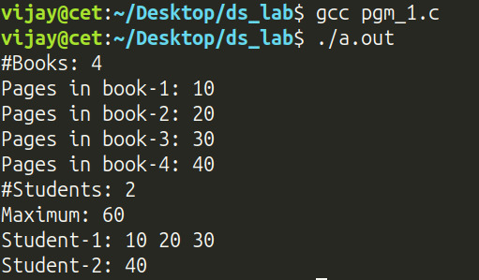

Program 2 — NTRU Polynomial Addition (Nth Degree Truncated Polynomial Ring Unit)

Question
Cryptography is the science of securing confidential messages exchanged between two entities by encoding them to prevent unauthorized access. More often, the messages are represented as polynomials (forget about how this is actually done) for easy encoding and in some modern cryptosystems, to make the system efficient, these polynomials are often sparse. Consider a simplified version of such a system NTRU (Nth degree Truncated polynomial Ring Unit), wherein the polynomial coefficients are in 𝕫₃, i.e., only allowed values are 0, 1, 2 and the polynomial degree is at most 6. For encoding a message m, first a polynomial m(x) is constructed. The encoded message c(x) called cipher is found as
c(x) = m(x) + k(x)
where k(x) is called the private key polynomial. Operations are done like normal addition, but modulo 3. Your task now is to input m(x), k(x) and compute c(x).
Sample run
Input:
k(x) = x^5 + x^2 + 1 m(x) = x^6 + x^2 + 2

Output:
c(x) = x^6 + x^5 + 2x^2

Data Structures / Algorithm Used
• Data structure: a fixed-size array of 7 integers (coeff[7]) wrapped inside a struct ntru (aliased as poly_t), representing coefficients for degrees 0 through 6 of a truncated polynomial over 𝕫₃.
• Algorithm: straightforward element-wise (index-wise) array addition of the two coefficient arrays, followed by a mod 3 reduction ((a[i] + b[i]) % 3) applied to every coefficient — this directly implements polynomial addition over the ring 𝕫₃.
• Input coefficients are also individually reduced mod 3 at read time so that any raw input is normalized into the valid {0, 1, 2} range.

Program 2 — Pseudocode
ALGORITHM: NTRU-PolyAdd (Z3[x] truncated polynomial ring, degree <= 6)

DATA STRUCTURE
poly_t = RECORD
coeff[0..6] : INTEGER // coeff[i] holds the coefficient of x^i,
END RECORD // always kept reduced to the set {0, 1, 2}

--------------------------------------------------------------
STEP 0: HELPER — READ ONE POLYNOMIAL
--------------------------------------------------------------
1. FUNCTION ReadPoly() RETURNS poly_t p
2. FOR degree <- 6 DOWNTO 0 DO
3. OUTPUT "coefficient of x^", degree, "? "
4. READ rawValue
5. p.coeff[degree] <- rawValue MOD 3 // normalise into {0,1,2}
6. END FOR
7. RETURN p
8. END FUNCTION
--------------------------------------------------------------
STEP 1: HELPER — ADD TWO POLYNOMIALS (mod 3, term by term)
--------------------------------------------------------------
9. FUNCTION AddPoly(a: poly_t, b: poly_t) RETURNS poly_t c
10. FOR i <- 0 TO 6 DO
11. c.coeff[i] <- (a.coeff[i] + b.coeff[i]) MOD 3
12. END FOR
13. RETURN c
14. END FUNCTION
--------------------------------------------------------------
STEP 2: HELPER — PRINT A POLYNOMIAL (highest degree first)
--------------------------------------------------------------
15. PROCEDURE PrintPoly(p: poly_t)
16. FOR degree <- 6 DOWNTO 0 DO
17. OUTPUT (WITH EXPLICIT SIGN) p.coeff[degree], "x^", degree, " "
18. END FOR
19. OUTPUT NEWLINE
20. END PROCEDURE
--------------------------------------------------------------
STEP 3: MAIN DRIVER
--------------------------------------------------------------
21. OUTPUT "Enter coefficients of private key k(x): "
22. k <- ReadPoly()
23. PrintPoly(k)
24. OUTPUT "Enter coefficients of message m(x): "
25. m <- ReadPoly()
26. PrintPoly(m)
27. c <- AddPoly(k, m) // c(x) = k(x) + m(x) (mod 3)
28. OUTPUT "Encoded cipher c(x): "
29. PrintPoly(c)

--------------------------------------------------------------
COMPLEXITY: O(1) — exactly seven coefficient slots are
processed on every call, regardless of input, since the ring
is deliberately truncated at degree 6.
--------------------------------------------------------------

Program 2 — Code
#include <stdio.h>

// Nth degree truncated polynomial unit
struct ntru {
int coeff[7]; // Max degree is 6
};

typedef struct ntru poly_t;

void poly_read(poly_t *p) {
// Accept input as sequence of doubles from degree 6 to 0
for (int i = 6; i >= 0; --i)
scanf("%d", &p->coeff[i]);
getc(stdin);
// Convert to mod 3
for (int i = 0; i < 7; ++i)
p->coeff[i] = p->coeff[i] % 3;
}

poly_t poly_add(poly_t a, poly_t b) {
poly_t c;
for (int i = 0; i < 7; ++i)
c.coeff[i] = (a.coeff[i] + b.coeff[i]) % 3;
return c;
}

void poly_print(poly_t p) {
for (int i = 6; i >= 0; --i)
printf("%+dx^%d ", p.coeff[i], i);
printf("\n");
}

int main() {
poly_t k, m, c;
printf("Enter coeffs of k(x): ");
poly_read(&k);
poly_print(k);
printf("Enter coeffs of m(x): ");
poly_read(&m);
poly_print(m);
printf("c(x): ");
c = poly_add(k, m);
poly_print(c);
return 0;
}

Program 2 — Output
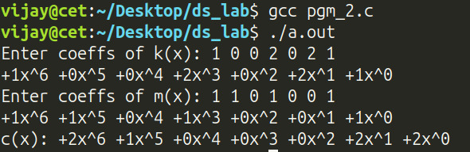

Program 3 — Sparse Matrix Addition and Transpose

Question
You have been hired for developing animation games by RoboGames Ltd. The game environment has multiple layers of objects as follows:
Layer 1: Static buildings
Layer 2: Moving vehicles
Layer 3: Animated characters
Each object has a position represented on a 2D grid. Since most positions are empty (no object), sparse matrices are employed to represent updates from different layers of a virtual scene. The individual matrices are added to compute the total transformation for the frame. The final transformation matrix is transposed before sending to the GPU (Graphical Processing Unit) for rendering. This is to match the column-major format expected by shaders. (Shaders are small programs that run on a GPU to determine how objects and scenes are rendered on the screen).
Your job now is to input the updates from a scene and feed them to the shader.

Data Structures / Algorithm Used
• Data structure: Sparse matrix — triplet (array of tuples) representation. Each non-zero cell is stored as a struct tuple { i, j, v } (row, column, value) in a dynamically allocated array, inside a struct sparse_matrix { n, r, c, tuple nonzeroes[] }.
• Algorithms used:
• get_elem — linear search through the triplet array to fetch the value at a given (i, j), returning 0 for any position not explicitly stored (i.e., an implicit zero).
• mat_add — computes the sum of two sparse matrices of equal dimensions by iterating over every (i, j) cell of the dense index space, summing the corresponding elements from both matrices via get_elem, and storing only the non-zero results as new triplets.
• mat_trans — computes the transpose of a sparse matrix in O(n) by simply swapping the row and column index of every stored triplet.
• destroy_mat — frees the dynamically allocated triplet array.
• The main function chains these operations: t = a + b, d = t + c, then t = transpose(d), matching the "sum three layers, then transpose for the GPU" requirement.

Program 3 — Pseudocode
ALGORITHM: SparseMatrix-AddAndTranspose (triplet representation)

DATA STRUCTURE
tuple = RECORD row, col, value END RECORD
spmat_t = RECORD
rows, cols : INTEGER
count : INTEGER // number of stored (nonzero) tuples
nonzero[0..count-1] : ARRAY OF tuple
END RECORD

--------------------------------------------------------------
STEP 0: READ A SPARSE MATRIX IN TRIPLET FORM
--------------------------------------------------------------
1. FUNCTION ReadMatrix() RETURNS spmat_t sp
2. READ sp.rows, sp.cols, sp.count
3. ALLOCATE sp.nonzero[0 .. sp.count - 1]
4. FOR k <- 0 TO sp.count - 1 DO
5. READ value "@" row "," col
6. sp.nonzero[k] <- (row, col, value)
7. END FOR
8. RETURN sp
9. END FUNCTION

--------------------------------------------------------------
STEP 1: LOOK UP A SINGLE CELL (implicit zero elsewhere)
--------------------------------------------------------------
10. FUNCTION GetElement(sp: spmat_t, i, j) RETURNS INTEGER
11. FOR k <- 0 TO sp.count - 1 DO
12. IF sp.nonzero[k].row = i AND sp.nonzero[k].col = j THEN
13. RETURN sp.nonzero[k].value
14. END IF
15. END FOR
16. RETURN 0 // cell was never stored
17. END FUNCTION

--------------------------------------------------------------
STEP 2: ADD TWO SPARSE MATRICES OF EQUAL DIMENSION
--------------------------------------------------------------
18. FUNCTION AddMatrices(a: spmat_t, b: spmat_t) RETURNS spmat_t c
19. ASSERT a.rows = b.rows AND a.cols = b.cols
20. c.rows <- a.rows; c.cols <- a.cols; c.count <- 0
21. ALLOCATE c.nonzero[0 .. a.count + b.count - 1] // worst-case size
22. FOR i <- 0 TO a.rows - 1 DO
23. FOR j <- 0 TO a.cols - 1 DO
24. sum <- GetElement(a,i,j) + GetElement(b,i,j)
25. IF sum <> 0 THEN
26. c.nonzero[c.count] <- (i, j, sum)
27. c.count <- c.count + 1
28. END IF
29. END FOR
30. END FOR
31. RETURN c
32. END FUNCTION

--------------------------------------------------------------
STEP 3: TRANSPOSE A SPARSE MATRIX
--------------------------------------------------------------
33. FUNCTION TransposeMatrix(a: spmat_t) RETURNS spmat_t t
34. t.rows <- a.cols; t.cols <- a.rows; t.count <- a.count
35. ALLOCATE t.nonzero[0 .. a.count - 1]
36. FOR k <- 0 TO a.count - 1 DO
37. t.nonzero[k] <- (a.nonzero[k].col, a.nonzero[k].row, a.nonzero[k].value)
38. END FOR
39. RETURN t
40. END FUNCTION

--------------------------------------------------------------
STEP 4: MAIN DRIVER — SUM THREE SCENE LAYERS, THEN TRANSPOSE
--------------------------------------------------------------
41. a <- ReadMatrix() // Layer 1: static buildings
42. b <- ReadMatrix() // Layer 2: moving vehicles
43. cLayer <- ReadMatrix() // Layer 3: animated characters
44. temp <- AddMatrices(a, b)
45. merged <- AddMatrices(temp, cLayer)
46. final <- TransposeMatrix(merged) // column-major, ready for the GPU
47. OUTPUT final (dense form, via GetElement over every i, j)

--------------------------------------------------------------
COMPLEXITY: GetElement is O(count); AddMatrices is
O(rows * cols * count) because it probes every dense cell of
the output; TransposeMatrix is O(count). Space is O(count)
per matrix, where count = number of nonzero entries.
--------------------------------------------------------------

Program 3 — Code
#include <stdio.h>
#include <stdlib.h> // calloc, free
#include <string.h> // memset
#include <assert.h>
struct tuple {
int i; // row
int j; // column
int v; // value
};
struct sparse_matrix {
int n; // Number of non-zero tuples
int r; // Number of rows
int c; // Number of cols
struct tuple *nonzeroes;
};
typedef struct sparse_matrix spmat_t;
void read_mat(spmat_t *sp) {
printf("#Rows: ");
scanf("%d", &sp->r);
printf("#Column: ");
scanf("%d", &sp->c);
int n;
printf("#Nonzeroes: ");
scanf("%d", &n);
sp->n = n;
sp->nonzeroes = (struct tuple *)calloc(n, sizeof(struct tuple));
while (n--) {
printf(">>");
struct tuple *c = &sp->nonzeroes[n];
scanf("%d@%d,%d", &c->v, &c->i, &c->j);
}
}
void destroy_mat(spmat_t *sp) {
if (sp->nonzeroes) free(sp->nonzeroes);
memset(sp, 0, sizeof(spmat_t));
}
int get_elem(spmat_t sp, int i, int j) {
for (int k = 0; k < sp.n; ++k)
if (sp.nonzeroes[k].i == i && sp.nonzeroes[k].j == j)
return sp.nonzeroes[k].v;
return 0;
}
void print_mat(spmat_t sp) {
for (int i = 0; i < sp.r; ++i) {
for (int j = 0; j < sp.c; ++j)
printf("%d ", get_elem(sp, i, j));
printf("\n");
}
}

void mat_add(spmat_t a, spmat_t b, spmat_t *c) {
assert(a.r == b.r && a.c == b.c);
c->r = a.r;
c->c = a.c;
int cnt = 0;
int v;
c->nonzeroes = (struct tuple *)calloc(a.n + b.n, sizeof(struct tuple));
for (int i = 0; i < a.r; ++i)
for (int j = 0; j < a.c; ++j)
if ( (v = get_elem(a, i, j) + get_elem(b, i, j)) != 0)
c->nonzeroes[cnt++] = (struct tuple) {
.i = i,
.j = j,
.v = v
};
c->n = cnt;
}

void mat_trans(spmat_t a, spmat_t *t) {
t->r = a.c;
t->c = a.r;
t->n = a.n;
t->nonzeroes = (struct tuple*)calloc(a.n, sizeof(struct tuple));
for (int i = 0; i < a.n; ++i) {
struct tuple n = a.nonzeroes[i];
t->nonzeroes[i] = (struct tuple) {
.i = n.j,
.j = n.i,
.v = n.v
};
}
}

int main() {
spmat_t a, b, c, t, d;
printf("Static Building: \n");
read_mat(&a);
print_mat(a);

printf("Moving Vehicle: \n");
read_mat(&b);
print_mat(b);

printf("Animated Characters: \n");
read_mat(&c);
print_mat(c);

printf("Transformation Matrix: \n");
mat_add(a, b, &t);
mat_add(t, c, &d);
destroy_mat(&t); // free up t before reuse
mat_trans(d, &t);
print_mat(t);

destroy_mat(&a);
destroy_mat(&b);
destroy_mat(&c);
destroy_mat(&t);
destroy_mat(&d);
return 0;
}

Program 3 — Output
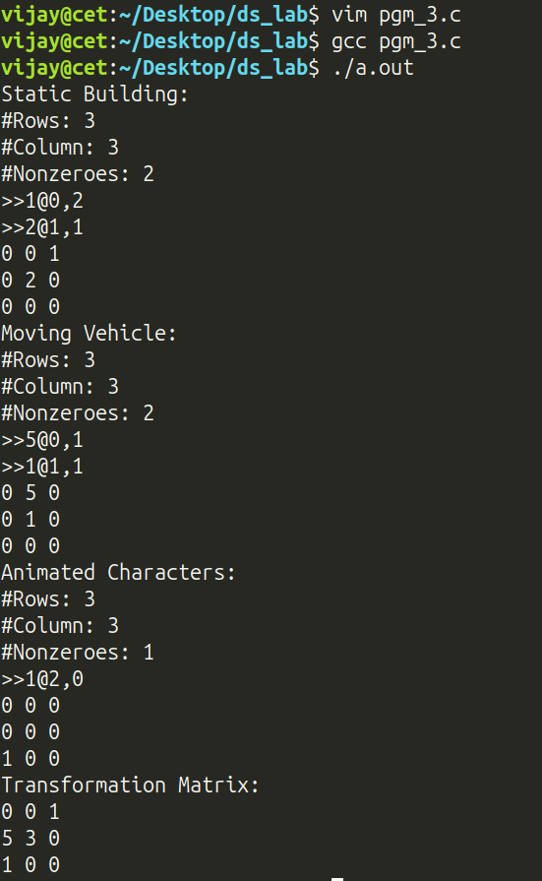

Program 4 — Infix to Postfix Conversion and Evaluation

Question
Write a menu-driven program for the following operations:
(a) Convert an infix expression to a postfix expression.
(b) Evaluate the postfix expression.

Data Structures / Algorithm Used
• Data structure: a stack is used twice — once holding char operators during infix→postfix conversion, and once holding double operands during postfix evaluation.
• Algorithms used:
• Infix-to-Postfix conversion (operator-precedence): digits are appended directly to the output; ‘(‘ is pushed onto the operator stack; on ‘)’, operators are popped and appended to the output until the matching ‘(‘ is found and discarded; for any other operator, operators of higher-or-equal precedence are popped from the stack to the output before the current operator is pushed. Precedence is decided by the helper precedence() (+ - = 1, * / = 2, ^ = 3). Any operators remaining on the stack at the end are appended to the output.
• Postfix evaluation: the postfix string is scanned left to right; digits are pushed onto an operand stack; on encountering an operator, the top two operands are popped, the operator is applied, and the result is pushed back. The final value left on the stack is the result.

Program 4 — Pseudocode
ALGORITHM: InfixToPostfix-And-Evaluate

DATA STRUCTURE
cstck : STACK OF CHARACTER // holds pending operators and '('
dstck : STACK OF REAL // holds operands during evaluation

--------------------------------------------------------------
STEP 0: OPERATOR PRECEDENCE TABLE
--------------------------------------------------------------
1. FUNCTION Precedence(op) RETURNS INTEGER
2. IF op IN {'+', '-'} THEN RETURN 1
3. IF op IN {'*', '/'} THEN RETURN 2
4. IF op = '^' THEN RETURN 3
5. RETURN 0
6. END FUNCTION

--------------------------------------------------------------
STEP 1: INFIX -> POSTFIX (operator-precedence / Shunting-Yard)
--------------------------------------------------------------
7. FUNCTION InfixToPostfix(infix) RETURNS postfix
8. CREATE empty stack cstck
9. output <- empty string
10. FOR EACH character ch IN infix (left to right) DO
11. IF ch is whitespace THEN
12. SKIP
13. ELSE IF ch is a digit THEN
14. APPEND ch TO output // operand -> straight out
15. ELSE IF ch = '(' THEN
16. PUSH ch ONTO cstck
17. ELSE IF ch = ')' THEN
18. WHILE TOP(cstck) <> '(' DO
19. APPEND POP(cstck) TO output
20. END WHILE
21. POP(cstck) // discard matching '('
22. ELSE // ch is an operator
23. WHILE cstck NOT EMPTY AND
24. Precedence(TOP(cstck)) >= Precedence(ch) DO
25. APPEND POP(cstck) TO output
26. END WHILE
27. PUSH ch ONTO cstck
28. END IF
29. END FOR
30. WHILE cstck NOT EMPTY DO // drain remaining operators
31. APPEND POP(cstck) TO output
32. END WHILE
33. RETURN output
34. END FUNCTION

--------------------------------------------------------------
STEP 2: EVALUATE A POSTFIX EXPRESSION
--------------------------------------------------------------
35. FUNCTION EvaluatePostfix(postfix) RETURNS REAL
36. CREATE empty stack dstck
37. FOR EACH character ch IN postfix (left to right) DO
38. IF ch is a digit THEN
39. PUSH (numeric value of ch) ONTO dstck
40. ELSE // ch is a binary operator
41. b <- POP(dstck)
42. a <- POP(dstck)
43. result <- Apply(ch, a, b) // + - * / or ^ (power)
44. PUSH result ONTO dstck
45. END IF
46. END FOR
47. RETURN POP(dstck) // the single value left
48. END FUNCTION

--------------------------------------------------------------
STEP 3: MENU-DRIVEN MAIN
--------------------------------------------------------------
49. LOOP
50. DISPLAY MENU: 1) Infix->Postfix 2) Evaluate 3) Exit
51. READ choice
52. CASE choice OF
53. 1: READ infix; postfix <- InfixToPostfix(infix); OUTPUT postfix
54. 2: OUTPUT EvaluatePostfix(postfix)
55. 3: EXIT LOOP
56. END CASE
57. END LOOP

--------------------------------------------------------------
COMPLEXITY: both routines run in O(length of expression) time;
every character is pushed onto, and popped from, a stack at
most once.
--------------------------------------------------------------

Program 4 — Code
#include <stdio.h>
#include <ctype.h>
#include <math.h>
#define STACK_IMPLEMENTATION
#include "stack.h"

#define BUFFER_LEN 64

int precedence(char op) {
switch (op) {
case '+':
case '-':
return 1;
case '*':
case '/':
return 2;
case '^':
return 3;
default:
return 0; // shouldn't be reached
}
}

void itopfix(const char infix[BUFFER_LEN], char res[BUFFER_LEN]) {
stack_t cstck; // stack of operator
int i = 0; // current string index
stack_init(&cstck, sizeof(char), NULL);

for (int j = 0; infix[j] != '\0'; ++j) {
char c = infix[j];
if (isspace(c)) continue;

if (isdigit(c)) res[i++] = c;

else if (c == '(') stack_push(&cstck, &c);

else if (c == ')') {
char d;
stack_peek(&cstck, &d);
while (d != '(') {
stack_pop(&cstck, &d);
res[i++] = d;
stack_peek(&cstck, &d);
}
stack_pop(&cstck, &d); // pop '('
}
// Assume invalid characters will not be entered
// Assume no variables
else {
char d;
if (!stack_isempty(&cstck)) {
stack_peek(&cstck, &d);
while (precedence(d) >= precedence(c)) {
stack_pop(&cstck, &d);
res[i++] = d;
if (stack_isempty(&cstck)) break;
stack_peek(&cstck, &d);
}
}
stack_push(&cstck, &c);
}
}
while (!stack_isempty(&cstck)) {
char d;
stack_pop(&cstck, &d);
res[i++] = d;
}
res[i] = '\0'; // terminate the string
stack_free(&cstck);
}

int ctoi(char c) {
return c - '0';
}

double peval(char postfix[BUFFER_LEN]) {
stack_t dstck;
stack_init(&dstck, sizeof(double), NULL);

for (int i = 0; postfix[i] != '\0'; ++i) {
char c = postfix[i];
if (isdigit(c)) {
double i = (double)ctoi(c); // Assume single digit integers
stack_push(&dstck, &i);
}
// Operator otherwise
else {
// Only binary operators supported
double a, b, d;
stack_pop(&dstck, &b);
stack_pop(&dstck, &a);
switch (c) {
case '+':
d = a + b;
break;
case '-':
d = a - b;
break;
case '*':
d = a * b;
break;
case '/':
d = a / b;
break;
case '^':
d = pow(a, b);
break;
default:
d = -1; // shouldn't reach here
break;
}
stack_push(&dstck, &d);
}
}
double r;
stack_pop(&dstck, &r);
stack_free(&dstck);
return r;
}

int main() {
char infix[BUFFER_LEN] = {0};
char postfix[BUFFER_LEN] = {0};
int c, r;
r = 1;
printf( "1. Infix to Postfix\n"
"2. Evaluate stored postfix\n"
"3. Exit\n"
);
do {
printf("Option: ");
scanf("%d", &c);
getc(stdin);
switch (c) {
case 1:
printf("Enter infix: ");
fgets(infix, BUFFER_LEN - 1, stdin);
itopfix(infix, postfix);
printf("Stored postfix: %s\n", postfix);
break;
case 2:
printf("Evaluating %s ( %s )\n", infix, postfix);
printf("Result: %g\n", peval(postfix));
break;
case 3:
r = 0;
break;
default:
printf("Invalid option\n");
break;
}
} while (r);
return 0;
}

Program 4 — Output
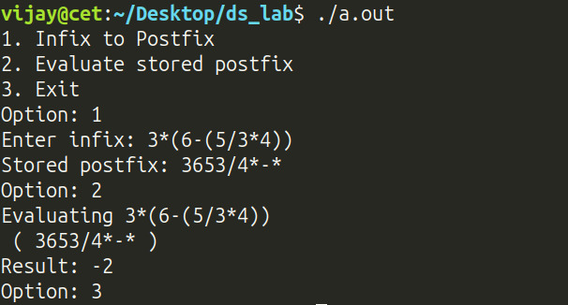

Program 5 — Printer Queue Simulation

Question
In a faculty room, several teachers share a single WiFi-enabled printer. Each teacher sends PDF documents to the printer which are placed into the printer spool where the documents wait to be printed in the order they arrive. The printer operates at a speed of 30 ppm (pages per minute). Simulate this printing scenario with a menu to display the following:
(a) name of the teacher whose PDF is currently being printed
(b) waiting time for the prof. who submitted the doc
(c) name of the teacher who has to wait the most.

Data Structures / Algorithm Used
• Data structure: a queue is used to model the printer spool in strict FIFO order. Each element stored is a struct print_job { teacher, filename, pages }.
• Algorithms used:
• Enqueue / Dequeue (FIFO): new print jobs are added at the tail (enqueue) and the job currently printing is removed from the head (dequeue), matching first-come-first-served printer behaviour.
• Peek: viewing the current job without removing it from the queue.
• Linear traversal for wait-time computation: the time (in seconds) a job must wait is computed by walking the queue from the head up to (but not including) the target job, summing pages * SECS_PER_PAGE (with SECS_PER_PAGE = 2, i.e. the printer's 30 ppm rate) for every job ahead of it in the queue.

Program 5 — Pseudocode
ALGORITHM: PrinterSpool-Simulation (strict FIFO queue)

DATA STRUCTURE
job_t = RECORD teacher, filename, pages END RECORD
pq : QUEUE OF job_t // first-come-first-served spool
SECS_PER_PAGE <- 2 // printer speed: 30 pages / minute

--------------------------------------------------------------
STEP 0: WAIT-TIME HELPER (shared logic for options 4 and 5)
--------------------------------------------------------------
1. FUNCTION WaitTimeUpTo(pq, stopCondition) RETURNS (seconds, node)
2. seconds <- 0
3. node <- HEAD(pq)
4. WHILE node EXISTS AND NOT stopCondition(node) DO
5. seconds <- seconds + node.job.pages * SECS_PER_PAGE
6. node <- NEXT(node)
7. END WHILE
8. RETURN (seconds, node) // node is the job that stopped us
9. END FUNCTION

--------------------------------------------------------------
STEP 1: MENU-DRIVEN MAIN
--------------------------------------------------------------
10. CREATE empty queue pq
11. LOOP
12. DISPLAY MENU:
13. 1) Add job 2) View current job 3) Print current job
14. 4) Last job's wait 5) Named job's wait 6) Exit
15. READ choice
16. CASE choice OF
17. -- Option 1: a teacher submits a document -------------------
18. 1: READ teacher, filename, pages
19. job <- (teacher, filename, pages)
20. ENQUEUE(pq, job) // insert at TAIL
21. OUTPUT "queued:", job
22. -- Option 2: peek at what is printing right now ------------
23. 2: IF EMPTY(pq) THEN OUTPUT "Empty queue"
24. ELSE OUTPUT PEEK(pq) // HEAD, not removed
25. -- Option 3: finish printing the current job -----------------
26. 3: IF EMPTY(pq) THEN OUTPUT "Empty queue"
27. ELSE OUTPUT DEQUEUE(pq) // removes HEAD
28. -- Option 4: seconds until the LAST job in line prints -------
29. 4: (seconds, node) <- WaitTimeUpTo(pq, isTailNode)
30. OUTPUT node.job, seconds, "secs left"
31. -- Option 5: seconds until a NAMED job prints -----------------
32. 5: READ targetFilename
33. (seconds, node) <- WaitTimeUpTo(pq, matchesFilename(targetFilename))
34. OUTPUT node.job, seconds, "secs left"
35. -- Option 6: quit -----------------------------------------------
36. 6: EXIT LOOP
37. END CASE
38. END LOOP
39. DESTROY pq

--------------------------------------------------------------
COMPLEXITY: Enqueue / Dequeue / Peek are O(1); a wait-time
query walks at most the whole queue, so it costs O(number of
jobs ahead of the target).
--------------------------------------------------------------

Program 5 — Code
#include <stdio.h>
#define QUEUE_IMPLEMENTATION
#include "queue.h"

#define MAX_LEN 64
#define SECS_PER_PAGE 2 // 30 ppm

struct print_job {
char teacher[MAX_LEN];
char filename[MAX_LEN];
int pages;
};

typedef struct print_job job_t;

void print_job(job_t j) {
printf("%s's %s(%d)\n", j.teacher, j.filename, j.pages);
}

int main() {
queue_t pq; // printer queue
q_init(&pq, sizeof(job_t), NULL);
printf( "1. Add job\n"
"2. View current job\n"
"3. Print current job\n"
"4. Print last wait time\n"
"5. Print specific wait time\n"
"6. Exit\n\n");
char tmp[MAX_LEN];
job_t j;
int ch, s, r;
dll_node *cur;
r = 1;
do {
printf("Choice: ");
scanf("%d", &ch);
getc(stdin);
switch (ch) {
case 1:
printf("Enter teacher's name: ");
fgets(j.teacher, MAX_LEN, stdin);
j.teacher[strcspn(j.teacher, "\n")] = '\0';
printf("Enter file name: ");
fgets(j.filename, MAX_LEN, stdin);
j.filename[strcspn(j.filename, "\n")] = '\0';

printf("Enter #pages: ");
scanf("%d", &j.pages);
getc(stdin);
enqueue(&pq, &j);
printf("queued: ");
print_job(j);
memset(&j, 0, sizeof(job_t));
break;
case 2:
if (q_isempty(&pq)) printf("Empty queue\n");
else {
peek(&pq, &j);
print_job(j);
}
break;
case 3:
if (q_isempty(&pq)) printf("Empty queue\n");
else {
dequeue(&pq, &j);
print_job(j);
}
break;
case 4:
s = 0;
cur = pq.head;
for (; cur && cur->next; cur = cur->next) s += ((job_t *)(cur->data))->pages * SECS_PER_PAGE;
print_job(*(job_t *)cur->data);
printf("%d secs left\n", s);
break;
case 5:
printf("Enter filename you want to check: ");
fgets(tmp, MAX_LEN, stdin);
tmp[strcspn(tmp, "\n")] = '\0';
cur = pq.head;
s = 0;
for (; cur && strcmp(tmp, ((job_t *)(cur->data))->filename); cur = cur->next)
s += ((job_t *)(cur->data))->pages * SECS_PER_PAGE;
print_job(*(job_t *)cur->data);
printf("%d secs left\n", s);
break;
case 6:
r = 0;
break;
}
} while (r);
q_free(&pq);
return 0;
}

Program 5 — Output
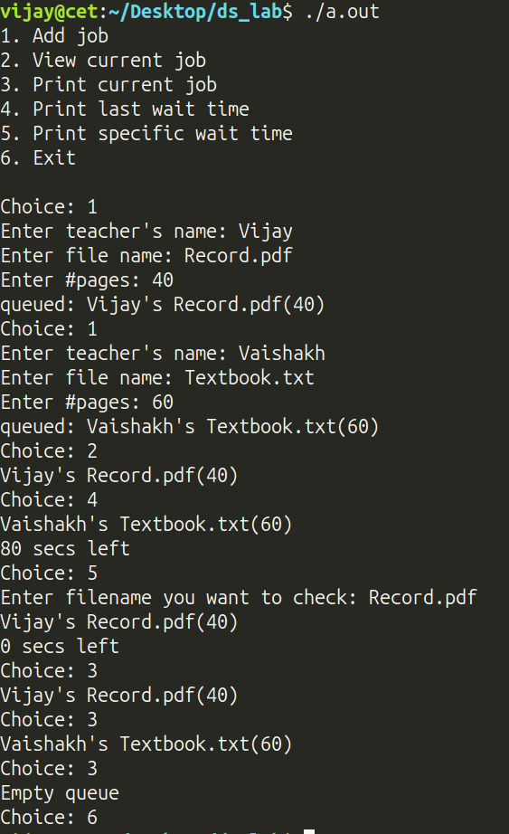

Program 6 — Railway Ticket Booking Token Queue

Question
In earlier days, online train ticket reservations were less popular. Everyone used to book tickets at railway station reservation counters by filing a form and waiting for their turn in a queue. For every ticket to be booked, you had to fill out separate forms. Indian Railways has a rule that only one form will be accepted from a customer at a time. If a person has to book multiple tickets, he has to book one ticket during his turn, then go to the tail of the queue and wait for his next turn. There is a token machine at the reservation office entrance where the customer is prompted for the number of tickets to be booked. The machine then issues him a token bearing a token number and the number of tickets to be booked. The customers are served in the token number order. A customer needs to take a token only once even if he has multiple tickets to book. Implement this scenario in a program with a menu to display the following:
(a) the current customer being served
(b) number of customers waiting
(c) list all customers in the queue with the number of forms they have.

Data Structures / Algorithm Used
• Data structure: a queue holding struct token { token_no, tickets, name } in strict FIFO (token-number) order.
• Algorithms used:
• Request token (enqueue): a new customer's details are pushed onto the tail of the queue with a monotonically increasing token_no.
• Fill form (partial dequeue + re-queue): the head of the queue is removed and served for one ticket; if the customer still has remaining tickets to book, the same customer (with tickets decremented) is re-enqueued at the tail — directly implementing the rule that a customer must go to the back of the line after each single form.
• Current customer (peek) and waiting count (q_size) are simple O(1)/O(n) queries.
• List all customers: a linear traversal of the underlying doubly linked list from head to NULL, printing every queued token.

Program 6 — Pseudocode
ALGORITHM: TokenQueue-RailwayBooking (FIFO with re-queueing)

DATA STRUCTURE
token_t = RECORD tokenNo, ticketsRemaining, name END RECORD
q : QUEUE OF token_t

--------------------------------------------------------------
STEP 0: INITIALISATION
--------------------------------------------------------------
1. CREATE empty queue q
2. nextTokenNo <- 1

--------------------------------------------------------------
STEP 1: MENU-DRIVEN MAIN
--------------------------------------------------------------
3. LOOP
4. DISPLAY MENU:
5. 1) Request token 2) Fill one form (serve)
6. 3) Current customer 4) #customers waiting
7. 5) List all customers 6) Exit
8. READ choice
9. CASE choice OF
10. -- Option 1: a new customer arrives ---------------------------
11. 1: READ name, ticketsRemaining
12. token <- (nextTokenNo, ticketsRemaining, name)
13. nextTokenNo <- nextTokenNo + 1
14. ENQUEUE(q, token)
15. -- Option 2: serve exactly one ticket for HEAD ----------------
16. 2: IF EMPTY(q) THEN OUTPUT "Empty queue"
17. ELSE
18. token <- DEQUEUE(q)
19. OUTPUT token
20. token.ticketsRemaining <- token.ticketsRemaining - 1
21. IF token.ticketsRemaining > 0 THEN
22. ENQUEUE(q, token) // rejoin at the TAIL
23. END IF
24. END IF
25. -- Option 3: who is being served right now ----------------------
26. 3: IF EMPTY(q) THEN OUTPUT "Empty queue"
27. ELSE OUTPUT PEEK(q)
28. -- Option 4: how many customers are waiting -----------------------
29. 4: IF EMPTY(q) THEN OUTPUT "Empty queue"
30. ELSE OUTPUT SIZE(q)
31. -- Option 5: list everyone, head to tail ---------------------------
32. 5: FOR EACH node FROM HEAD(q) TO TAIL(q) DO
33. OUTPUT node.token
34. END FOR
35. -- Option 6: quit -------------------------------------------------
36. 6: EXIT LOOP
37. END CASE
38. END LOOP
39. DESTROY q

--------------------------------------------------------------
COMPLEXITY: Enqueue / Dequeue / Peek / Size are all O(1);
listing all customers is O(number waiting). Re-queueing a
partially-served customer at the tail after each single form
is exactly what enforces the "one form per turn" fairness rule.
--------------------------------------------------------------

Program 6 — Code
#include <stdio.h>
#include <string.h>
#define QUEUE_IMPLEMENTATION
#include "queue.h"

#define MAX_LEN 32

typedef struct token {
int token_no;
int tickets;
char name[MAX_LEN];
} token_t;

void print_token(token_t t) {
printf("%d. %s(%d)\n", t.token_no, t.name, t.tickets);
}

int main() {
queue_t q;
q_init(&q, sizeof(token_t), NULL);

printf("1. Request token\n"
"2. Fill form\n"
"3. Current cust.\n"
"4. No. of waiting cust.\n"
"5. List cust.\n"
"6. Exit\n\n");
int ch, r, n;
token_t t = {0};
n = 1; // token no
r = 1;
do {
printf("Choice: ");
scanf("%d", &ch);
getc(stdin);
switch (ch) {
case 1:
t.token_no = n++;

printf("Enter name: ");
fgets(t.name, MAX_LEN, stdin);
t.name[strcspn(t.name, "\n")] = '\0';

printf("Enter #tickets: ");
scanf("%d", &t.tickets);

enqueue(&q, &t);
printf("Queued: ");
print_token(t);
memset(&t, 0, sizeof(token_t));
break;
case 2:
if (q_isempty(&q))
printf("Empty queue\n");
else {
dequeue(&q, &t);
print_token(t);
if (--t.tickets)
enqueue(&q, &t);
}
break;
case 3:
if (q_isempty(&q))
printf("Empty queue\n");
else {
peek(&q, &t);
print_token(t);
}
break;
case 4:
if (q_isempty(&q))
printf("Empty queue\n");
else
printf("Waiting: %zu\n", q_size(&q));
break;
case 5:
for (dll_node *cur = q.head; cur; cur = cur->next)
print_token(*(token_t *)(cur->data));
break;
case 6:
r = 0;
break;
default:
printf("Invalid option\n");
break;
}
} while (r);

q_free(&q);
return 0;
}

Program 6 — Output
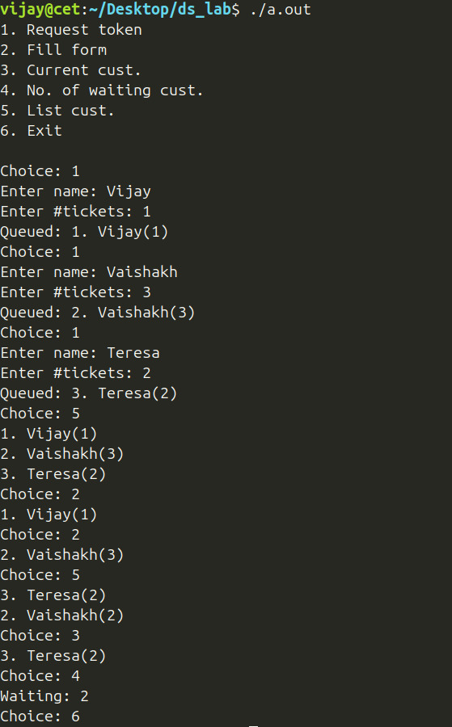

Program 7 — Browser Back/Forward Navigation

Question
You follow this sequence (by clicking appropriate hyperlinks or tabs) for your course registration:
KTU homepage >>> E-Governance Application >>> Course/Semester Exam Registration >>> Register New Courses
In the midst, you also want to download your grade card for the second semester examination the result of which got published recently. For this, you may have to click on the "Results" tab. Each hyperlink or tab has an associated address or URL that will take you to the pertinent web page when clicked. To navigate back and forth between the web pages already visited, you will be using the '→' and '←' buttons of the browser. Identify what data structure is appropriate for implementing these "Back" and "Forward" buttons. You are supposed to code those button functionalities in terms of the chosen data structure operations. [Hint: You may have to store the URLs (https://ktu.edu.in/, https://app.ktu.edu.in/login.htm etc.) in the data structure.]

Data Structures / Algorithm Used
• Data structure: two stacks — undo holding the browsing history up to and including the current page, and redo holding pages that were undone via "Back" and are available for "Forward".
• Algorithms used: this is the standard two-stack browser history technique:
• Goto (new navigation): push the new URL/path onto undo; clear redo entirely, since visiting a fresh page invalidates any previously "forward"-able history.
• Back: pop the top of undo and push it onto redo.
• Forward: pop the top of redo and push it back onto undo.
• Print: since a stack only exposes its top, the history is printed in visiting order by recursively walking the stack's underlying linked list from tail to head.

Program 7 — Pseudocode
ALGORITHM: BrowserHistory-BackForward (two-stack technique)

DATA STRUCTURE
undo : STACK OF url_t // pages visited; TOP = current page
redo : STACK OF url_t // pages undone via Back; available to Forward

--------------------------------------------------------------
STEP 0: INITIALISATION
--------------------------------------------------------------
1. CREATE empty stacks undo, redo
--------------------------------------------------------------
STEP 1: PRINT VISITED HISTORY IN CHRONOLOGICAL ORDER
--------------------------------------------------------------
// A stack only exposes its TOP, so printing the history in
// the order it was actually visited requires walking the
// underlying list from its tail back up to its head.
2. PROCEDURE PrintChronological(node) // recursive, tail-to-head
3. IF node = NULL THEN RETURN
4. PrintChronological(node.next) // recurse toward the oldest entry
5. OUTPUT node.url // print on the way back up
6. END PROCEDURE

--------------------------------------------------------------
STEP 2: MENU-DRIVEN MAIN
--------------------------------------------------------------
7. LOOP
8. DISPLAY MENU: 1) Goto 2) Back 3) Forward 4) Print history 5) Exit
9. READ choice
10. CASE choice OF
11. -- Option 1: navigate to a brand-new page ------------------
12. 1: READ path
13. PUSH(undo, path)
14. CLEAR(redo) // a fresh navigation invalidates all forward history
15. -- Option 2: go Back -------------------------------------------
16. 2: IF EMPTY(undo) THEN OUTPUT "Empty URL"
17. ELSE
18. path <- POP(undo)
19. PUSH(redo, path)
20. END IF
21. -- Option 3: go Forward ----------------------------------------
22. 3: IF EMPTY(redo) THEN OUTPUT "Empty history"
23. ELSE
24. path <- POP(redo)
25. PUSH(undo, path)
26. END IF
27. -- Option 4: show the trail in the order visited --------------
28. 4: PrintChronological(TOP-NODE(undo))
29. -- Option 5: quit ------------------------------------------------
30. 5: EXIT LOOP
31. END CASE
32. END LOOP
33. DESTROY undo, redo

--------------------------------------------------------------
COMPLEXITY: Goto / Back / Forward are all O(1); printing the
full trail is O(pages visited). Clearing redo on every fresh
Goto is precisely what prevents "Forward" from resurrecting a
now-invalid page.
--------------------------------------------------------------

Program 7 — Code
#include <stdio.h>
#include <string.h>
#define STACK_IMPLEMENTATION
#include "stack.h"

#define LEN 32

typedef char url_t[LEN];

void __ll_rev_print(ll_node *n) {
if (!n)
return;
__ll_rev_print(n->next);
printf("%s", *(url_t *)(n->data));
}

void print_url(stack_t s) {
__ll_rev_print(s.head);
printf("\n");
}

int main() {
stack_t undo, redo; // undo stack holds the actual URL
stack_init(&undo, sizeof(url_t), NULL);
stack_init(&redo, sizeof(url_t), NULL);
int ch, r;
url_t tmp;

r = 1;
printf("1. Goto\n"
"2. Back\n"
"3. Forward\n"
"4. Print\n"
"5. Exit\n\n");
do {
printf("Choice: ");
scanf("%d", &ch);
getc(stdin);
switch (ch) {
case 1:
printf("Enter next path (eg: home/): ");
fgets(tmp, LEN, stdin);
tmp[strcspn(tmp, "\n")] = '\0';
stack_push(&undo, tmp);

stack_free(&redo);
stack_init(&redo, sizeof(url_t), NULL); // reinit redo
break;
case 2:
if (stack_isempty(&undo))
printf("Empty URL\n");
else {
stack_pop(&undo, tmp);
stack_push(&redo, tmp);
}
break;
case 3:
if (stack_isempty(&redo))
printf("Empty history\n");
else {
stack_pop(&redo, tmp);
stack_push(&undo, tmp);
}
break;
case 4:
print_url(undo);
break;
case 5:
r = 0;
break;
default:
printf("Invalid option\n");
break;
}
} while (r);

stack_free(&undo);
stack_free(&redo);
return 0;
}

Program 7 — Output
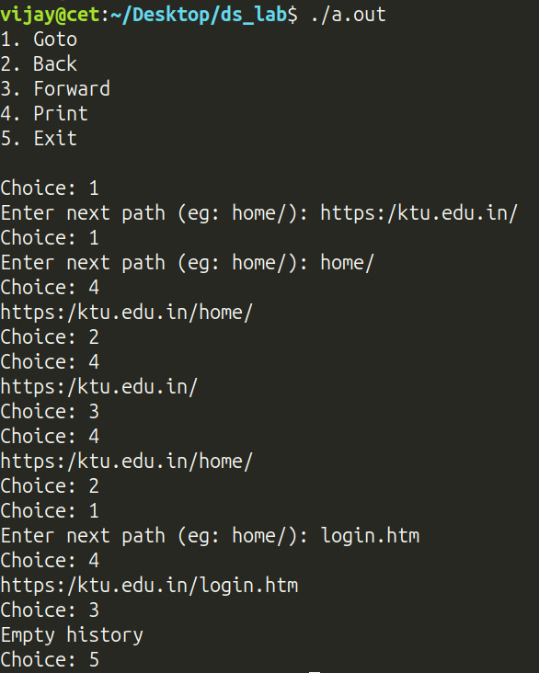

Program 8 — Find and Replace in a Text Document

Question
In GUI based text editors like gedit, the Find and Replace feature allows you to search for all occurrences of a specific word or phrase and optionally replace them with a new one. Your task is to simulate this functionality in a simplified context as follows – The editor holds the text document as a list of words. Given a key term and a replacement word, your program should:
(a) replace each occurrence of term with word
(b) display the number of replacements made
(c) display the updated document.

Data Structures / Algorithm Used
• Data structure: a dynamic array storing each word of the document as a fixed-size char[64] element, automatically growing as more words are appended.
• Algorithms used:
• Tokenizing input: each line read from stdin is split on whitespace using strtok, and every token is added to the list, building an in-memory word-array representation of the "document".
• Find and Replace (replace_words): a single linear scan (O(n)) over the word list; every element that exactly matches the search term is overwritten in place, and a counter is incremented for each replacement made.
• Display: a linear traversal prints every word of the document in order.

Program 8 — Pseudocode
ALGORITHM: FindAndReplace-InWordList

DATA STRUCTURE
words : DYNAMIC ARRAY OF STRING // grows (doubles) as words are appended

--------------------------------------------------------------
STEP 0: READ COMMAND-LINE ARGUMENTS
--------------------------------------------------------------
1. ASSERT exactly 2 arguments were supplied: oldWord, newWord
--------------------------------------------------------------
STEP 1: TOKENISE THE DOCUMENT INTO THE WORD LIST
--------------------------------------------------------------
2. CREATE empty dynamic array words
3. WHILE a line can be read from standard input DO
4. FOR EACH whitespace-delimited token w IN the line DO
5. APPEND w TO words
6. END FOR
7. END WHILE
--------------------------------------------------------------
STEP 2: REPLACE EVERY EXACT OCCURRENCE (single linear scan)
--------------------------------------------------------------
8. FUNCTION ReplaceWords(words, oldWord, newWord) RETURNS count
9. count <- 0
10. FOR i <- 0 TO SIZE(words) - 1 DO
11. IF words[i] = oldWord THEN
12. words[i] <- newWord
13. count <- count + 1
14. END IF
15. END FOR
16. RETURN count
17. END FUNCTION
--------------------------------------------------------------
STEP 3: MAIN DRIVER
--------------------------------------------------------------
18. replacements <- ReplaceWords(words, oldWord, newWord)
19. OUTPUT "(", replacements, " replacements made)"
20. FOR i <- 0 TO SIZE(words) - 1 DO
21. OUTPUT words[i], " "
22. END FOR
23. OUTPUT NEWLINE
--------------------------------------------------------------
COMPLEXITY: tokenising costs O(total characters read); the
replace pass and the final display are each O(number of
words). Overall the whole program runs in O(n) time.
--------------------------------------------------------------

Program 8 — Code
#include <assert.h>
#include <stdio.h>
#include <string.h>
#define LIST_IMPLEMENTATION
#include "list.h"
#define LINE 1024
#define LEN 64
typedef char word_t[LEN];

void print_words(list_t words) {
word_t w;
for (int i = 0; i < list_size(&words); ++i) {
get(&words, i, &w);
printf("%s ", w);
}
printf("\n");
}

int replace_words(list_t words, word_t old, word_t new) {
word_t w;
int n = 0;
for (int i = 0; i < list_size(&words); ++i) {
get(&words, i, &w);
if (!strcmp(w, old))
set(&words, i, new) && n++;
}
return n;
}

int main(int argc, char **argv) {
assert(argc == 3 && "Use: ./a.out 'old' 'new'\n");
list_t words;
list_init(&words, 20, LEN, NULL);
char line[LINE];

while (fgets(line, LINE, stdin) != NULL) {
char *w;
char delim[] = " \t\n\r";
w = strtok(line, delim);
while (w) {
add(&words, w);
w = strtok(NULL, delim);
}
}
word_t old, new;
int n;
strncpy(old, argv[1], LEN);
strncpy(new, argv[2], LEN);
n = replace_words(words, old, new);
printf("(%d replacements made)\n", n);
print_words(words);
list_free(&words);
return 0;
}

Program 8 — Output
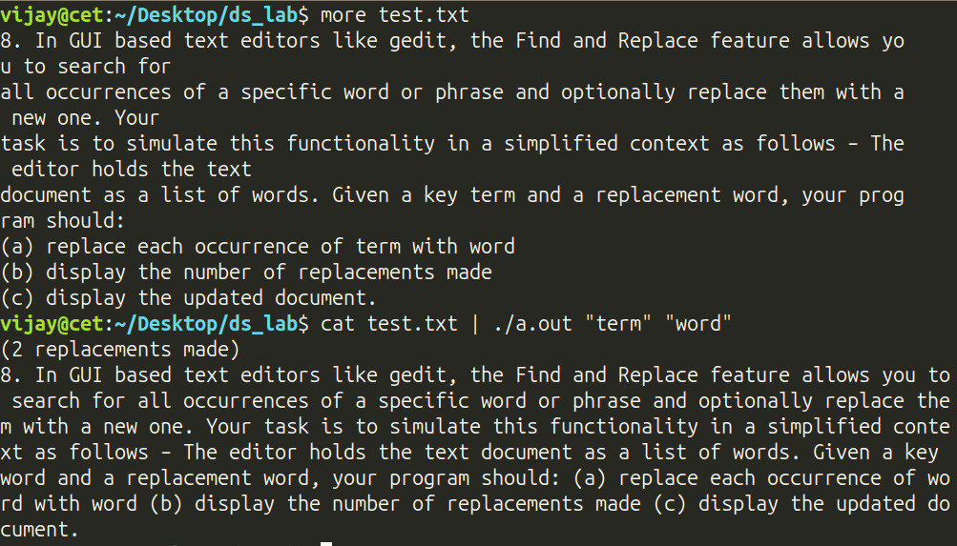

Program 9 — Sparse Polynomial Multiplication

Question
In architectural modeling and CAD-based terrain design, curves are often used to represent features such as elevation contours, road profiles. When two such curve segments (say a curved elevation ramp and a sloped road boundary) need to be blended or analyzed for interaction such as overlapping regions or transition zones, their mathematical representations (typically polynomials) are symbolically multiplied. The resulting product captures combined geometric behavior, aiding in tasks like contour merging, surface shaping, or pattern generation. Your task is to input two curve segments given as sparse univariate polynomials (polynomials in single variable x) and compute their composite curve (product).

Data Structures / Algorithm Used
• Data structure: a singly linked list of term_t { coeff, exp } nodes, kept sorted by descending exponent at all times.
• Algorithm used — sparse polynomial multiplication: for every pair of terms (r ∈ a, s ∈ b), the product term (r.coeff*s.coeff, r.exp+s.exp) is computed and merged into the sorted result list c: the list is scanned from the head until either a node with the same exponent is found (its coefficient is simply incremented — like-term collection) or a node with a smaller exponent is found (the new term is inserted just before it, preserving descending-exponent order). This is the classic sparse-polynomial (linked-list, non-zero-terms-only) multiplication algorithm, with overall cost O(n·m·k) where n, m are the term counts of the two operands and k is the length of the growing result list.

Program 9 — Pseudocode
ALGORITHM: SparsePolynomialMultiply (sorted linked list)

DATA STRUCTURE
term_t = RECORD coeff, exp END RECORD
a, b : LINKED LIST OF term_t // the two input polynomials (as entered)
c : LINKED LIST OF term_t // result, always kept sorted by DESCENDING exp
--------------------------------------------------------------
STEP 0: READ A POLYNOMIAL AS A LIST OF (coeff, exp) TERMS
--------------------------------------------------------------
1. FUNCTION ReadPoly() RETURNS list l
2. CREATE empty list l
3. LOOP
4. ASK "continue entering terms?"
5. IF answer = no THEN RETURN l
6. READ coeff, exp
7. INSERT (coeff, exp) AT TAIL OF l
8. END LOOP
9. END FUNCTION
--------------------------------------------------------------
STEP 1: MULTIPLY TWO SPARSE POLYNOMIALS, TERM BY TERM
--------------------------------------------------------------
10. PROCEDURE MultiplyPoly(c, a, b) // c starts out empty
11. FOR EACH term r IN a DO
12. FOR EACH term s IN b DO
13. prodCoeff <- r.coeff * s.coeff
14. prodExp <- r.exp + s.exp
15. found <- FALSE
16. pos <- 0
17. FOR EACH term t IN c (tracking index pos) DO
18. IF t.exp = prodExp THEN
// combine like terms
19. t.coeff <- t.coeff + prodCoeff
20. found <- TRUE
21. BREAK
22. ELSE IF t.exp < prodExp THEN
23. BREAK // insertion point found
24. END IF
25. pos <- pos + 1
26. END FOR
27. IF NOT found THEN
28. INSERT (prodCoeff, prodExp) AT position pos IN c
29. END IF // keeps c sorted, desc. exp
30. END FOR
31. END FOR
32. END PROCEDURE
--------------------------------------------------------------
STEP 2: MAIN DRIVER
--------------------------------------------------------------
33. a <- ReadPoly(); b <- ReadPoly()
34. OUTPUT a; OUTPUT b
35. CREATE empty list c
36. MultiplyPoly(c, a, b)
37. OUTPUT c // the composite curve / product polynomial

--------------------------------------------------------------
COMPLEXITY: O(n * m * k), where n, m are the term counts of a
and b, and k is the (growing) length of the result list c,
since every candidate product term is merged via a linear scan
of c.
--------------------------------------------------------------

Program 9 — Code
#include <stdio.h>
#include <string.h>
#define LL_IMPLEMENTATION
#include "linklist.h"

typedef struct {
double c;
int e;
} term_t;

void init_poly(linklist_t *l) { ll_init(l, sizeof(term_t), NULL); }

void read_poly(linklist_t *l) {
while (1) {
int c;
printf("Want to continue?(1): ");
scanf("%d", &c);
getc(stdin);
if (c != 1)
return;
term_t t;
scanf("%lf", &t.c);
scanf("%d", &t.e);
getc(stdin);
ll_inserttail(l, &t);
}
}

void mul_poly(linklist_t *c, linklist_t *a, linklist_t *b) {
double coeff;
int exp;
for (ll_node *i = a->head; i; i = i->next) {
for (ll_node *j = b->head; j; j = j->next) {
term_t r = *(term_t *)i->data;
term_t s = *(term_t *)j->data;
coeff = r.c * s.c;
exp = r.e + s.e;

int found = 0;
int y = 0;

for (ll_node *k = c->head; k; k = k->next, y++) {
term_t *t = (term_t *)k->data;
if (t->e == exp) {
t->c += coeff;
found = 1;
break;
} else if (t->e < exp)
break;
}
if (!found) {
term_t x = (term_t){.c = coeff, .e = exp};
ll_insert(c, y, &x);
}
}
}
}

void print_poly(linklist_t *l) {
for (ll_node *cur = l->head; cur; cur = cur->next) {
term_t t = *(term_t *)cur->data;
printf("%+gx%d ", t.c, t.e);
}
printf("\n");
}

int main() {

linklist_t a, b, c;
init_poly(&a);
init_poly(&b);
init_poly(&c);
read_poly(&a);
read_poly(&b);
print_poly(&a);
print_poly(&b);

mul_poly(&c, &a, &b);
print_poly(&c);

ll_free(&a);
ll_free(&b);
ll_free(&c);

return 0;
}

Program 9 — Output
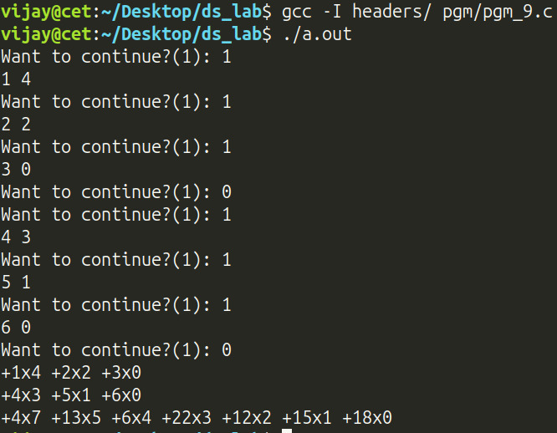

Program 10 — App Cleaner (Most/Least Frequently Used Apps)

Question
App Cleaner is a sort of utility that comes handy to remove "unwanted apps" when your mobile runs out of storage. It basically works by uninstalling those apps that are less frequently used. For this, the utility requires to know which apps are more frequently used and which are less frequently used. Identify a suitable data structure to implement such an utility. Also, come up with an implementation in terms of the chosen data structure operations. Note that when you open an app, it becomes a "more frequently used app".

Data Structures / Algorithm Used
• Data structure: a singly linked list used as a simple MRU/LRU list — the head is always the most-recently-used app and the tail is always the least-recently-used one.
• Algorithms used:
• Open app: the list is scanned for the app name; if found, its node is deleted from its current position and re-inserted at the head (marking it most-recently-used); if not found, it is simply inserted at the head as a brand-new entry. This is the standard move-to-front technique used by LRU-style caches.
• Clean: the tail of the list — i.e. the least-recently-used app — is deleted, directly implementing the "remove the least frequently used app" behaviour the App Cleaner needs.

Program 10 — Pseudocode
ALGORITHM: AppCleaner-MRU-List (move-to-front linked list)

DATA STRUCTURE
freqUsed : LINKED LIST OF appName // HEAD = most-recently-used,
// TAIL = least-recently-used

--------------------------------------------------------------
STEP 0: INITIALISATION
--------------------------------------------------------------
1. CREATE empty list freqUsed

--------------------------------------------------------------
STEP 1: MENU-DRIVEN MAIN
--------------------------------------------------------------
2. LOOP
3. DISPLAY MENU: 1) Open app 2) Clean 3) Exit
4. READ choice
5. CASE choice OF
6. -- Option 1: the user opens an app ------------------------------
7. 1: READ appName
8. found <- FALSE
9. i <- 0
10. FOR EACH node IN freqUsed DO
11. IF node.name = appName THEN
12. DELETE node AT position i FROM freqUsed
13. INSERT appName AT HEAD OF freqUsed // move to front
14. found <- TRUE
15. BREAK
16. END IF
17. i <- i + 1
18. END FOR
19. IF NOT found THEN
20. INSERT appName AT HEAD OF freqUsed //opened for first time
21. END IF
22. -- Option 2: uninstall the least-recently-used app -------------
23. 2: IF DELETE TAIL OF freqUsed SUCCEEDS (an app was removed) THEN
24. OUTPUT "Deleted app:", app.name
25. ELSE
26. OUTPUT "Empty"
27. END IF
28. -- Option 3: quit -------------------------------------------------
29. 3: EXIT LOOP
30. END CASE
31. END LOOP
32. DESTROY freqUsed

--------------------------------------------------------------
COMPLEXITY: Open costs O(n) in the worst case (linear search,
then an O(1) move-to-front); Clean (evict the least-used app)
needs the tail of a singly linked list, which also costs O(n).
Here n = number of apps currently tracked.
--------------------------------------------------------------

Program 10 — Code
#include <stdio.h>
#include <string.h>
#define LL_IMPLEMENTATION
#include "linklist.h"
#define LEN 64

typedef struct {
char app_name[LEN];
} app_t;
int main() {
linklist_t freq_used;
ll_init(&freq_used, sizeof(app_t), NULL);
int c, f, r, i;
char tmp[LEN];
app_t app;
r = 1;
printf("1. Open\n"
"2. Clean\n"
"3. Exit\n\n");
do {
scanf("%d", &c);
getc(stdin);

switch (c) {
case 1:
printf("Enter name of app to open: ");
fgets(tmp, LEN, stdin);
tmp[strcspn(tmp, "\n")] = '\0';
f = 0;
i = 0;
for (ll_node *cur = freq_used.head; cur; cur = cur->next, i++) {
app = *(app_t *)cur->data;
if (!strcmp(tmp, app.app_name)) {
ll_delete(&freq_used, i, &app);
ll_inserthead(&freq_used, &app);
f = 1;
}
}
if (!f) {
strcpy(app.app_name, tmp);
ll_inserthead(&freq_used, &app);
}
memset(tmp, 0, LEN);
break;
case 2:
i = ll_deletetail(&freq_used, &app);
if (i)
printf("Deleted app: %s\n", app.app_name);
else
printf("Empty\n");
break;
case 3:
r = 0;
break;
default:
printf("Invalid option\n");
break;
}
} while (r);

ll_free(&freq_used);
return 0;
}

Program 10 — Output
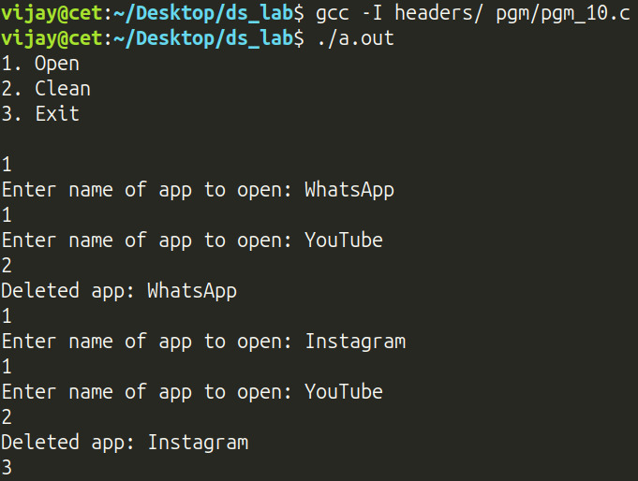

Program 11 — Memory Allocation Strategies (First/Best/Worst Fit)

Question
At one instant, the memory map of a 4MB (4000KB) RAM looks as in Figure 1. Processes (P1, P2, etc.) request the operating system for memory and also release the allocated memory after completing execution. A sample execution trace is shown below:
P7 requests for 115 KB
P10 requests for 650 KB
P3 completes execution
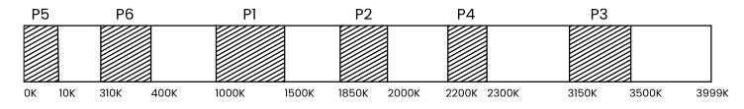Figure 1
P1 completes execution
P6 completes execution
P8 requests for 200 KB
P5 completes execution
P2 completes execution
P9 requests for 37 KB
P10 completes execution
P9 completes execution
P4 completes execution

Which strategy among the first fit, best fit, and worst fit performs the best here?

Data Structures / Algorithm Used
• Data structure: a singly linked list of chunk_t { name, start, size, alloc } nodes, kept in ascending address order, together modelling the entire 4000 KB memory map as a sequence of free/allocated contiguous chunks.
• Algorithms used:
• __alloc locates the chunk containing the target start address and splits it into up to three pieces — an optional leftover-before free chunk, the new allocated chunk, and an optional leftover-after free chunk — replacing the single original list node with these pieces.
• __free marks the named chunk free and, under AUTO_COMPACT, coalesces it with any immediately adjacent free chunks (both backward and forward), preventing external fragmentation from lingering.
• First Fit: scans from the head and allocates in the first free chunk large enough.
• Best Fit: scans all free chunks and allocates in the smallest one that still fits the request.
• Worst Fit: scans all free chunks and allocates in the largest one available.
• test_alloc_strat replays the exact sample execution trace from the question against all three strategies in turn so their resulting memory layouts can be compared.

Program 11 — Pseudocode
ALGORITHM: MemoryAllocation-FirstBestWorstFit

DATA STRUCTURE
chunk_t = RECORD name, start, size, allocated(BOOLEAN) END RECORD
mem : LINKED LIST OF chunk_t, kept in ASCENDING address order,
together spanning the full 4000 KB memory space

--------------------------------------------------------------
STEP 0: SPLIT A FREE CHUNK TO SATISFY A REQUEST (Allocate)
--------------------------------------------------------------
1. PROCEDURE Allocate(mem, name, start, size)
2. LOCATE the chunk C in mem whose [C.start, C.start + C.size)
3. covers the address range [start, start + size)
4. ASSERT C is free
5. before <- (start = C.start) ? NONE
6. : chunk(C.start, start - C.start, free)
7. middle <- chunk(name, start, size, ALLOCATED)
8. after <- (start + size = C.start + C.size) ? NONE
9. : chunk(start + size, C.start + C.size - (start + size), free)
10. REPLACE C in mem WITH the (up to 3) pieces: before, middle, after
11. END PROCEDURE

--------------------------------------------------------------
STEP 1: RELEASE MEMORY AND COALESCE NEIGHBOURS (Free)
--------------------------------------------------------------
12. PROCEDURE Free(mem, name)
13. FIND the chunk C in mem with C.name = name
14. C.allocated <- FALSE
15. -- auto-compaction: merge with adjacent free chunks ------------
16. WHILE the PREVIOUS chunk P exists AND P is free DO
17. C.start <- P.start; C.size <- C.size + P.size
18. REMOVE P FROM mem
19. END WHILE
20. WHILE the NEXT chunk N exists AND N is free DO
21. C.size <- C.size + N.size
22. REMOVE N FROM mem
23. END WHILE
24. END PROCEDURE

--------------------------------------------------------------
STEP 2: FIRST FIT — take the FIRST big-enough free chunk
--------------------------------------------------------------
25. PROCEDURE FirstFit(mem, name, size)
26. FOR EACH chunk C FROM HEAD(mem) TO TAIL(mem) DO
27. IF C is free AND C.size >= size THEN
28. Allocate(mem, name, C.start, size); RETURN
29. END IF
30. END FOR
31. OUTPUT "No space!"
32. END PROCEDURE

--------------------------------------------------------------
STEP 3: BEST FIT — take the SMALLEST big-enough free chunk
--------------------------------------------------------------
33. PROCEDURE BestFit(mem, name, size)
34. best <- NONE
35. FOR EACH chunk C IN mem DO
36. IF C is free AND C.size >= size THEN
37. IF best = NONE OR C.size < best.size THEN best <- C
38. END IF
39. END FOR
40. IF best <> NONE THEN Allocate(mem, name, best.start, size)
41. ELSE OUTPUT "No space!"
42. END PROCEDURE

--------------------------------------------------------------
STEP 4: WORST FIT — take the LARGEST free chunk available
--------------------------------------------------------------
43. PROCEDURE WorstFit(mem, name, size)
44. worst <- NONE
45. FOR EACH chunk C IN mem DO
46. IF C is free AND C.size >= size THEN
47. IF worst = NONE OR C.size > worst.size THEN worst <- C
48. END IF
49. END FOR
50. IF worst <> NONE THEN Allocate(mem, name, worst.start, size)
51. ELSE OUTPUT "No space!"
52. END PROCEDURE

--------------------------------------------------------------
STEP 5: REPLAY THE SAMPLE TRACE AGAINST ONE STRATEGY
--------------------------------------------------------------
53. PROCEDURE RunStrategy(strategyFn)
54. mem <- a single free chunk covering [0, 4000) KB
55. PRE-ALLOCATE P5, P6, P1, P2, P4, P3 at their given offsets
56. OUTPUT starting layout
57. FOR EACH event IN the sample trace (in order given) DO
58. IF event = "<P> requests <size> KB" THEN
59. strategyFn(mem, P, size)
60. ELSE IF event = "<P> completes execution" THEN
61. Free(mem, P)
62. END IF
63. END FOR
64. OUTPUT final layout
65. END PROCEDURE

--------------------------------------------------------------
STEP 6: MAIN DRIVER — COMPARE ALL THREE STRATEGIES
--------------------------------------------------------------
66. RunStrategy(FirstFit)
67. RunStrategy(BestFit)
68. RunStrategy(WorstFit)

--------------------------------------------------------------
COMPLEXITY: Allocate and Free are each O(n); First/Best/Worst
Fit cost O(n) per request, where n = number of chunks currently
tracked in mem.
--------------------------------------------------------------

Program 11 — Code
#include <assert.h>
#include <stdio.h>
#include <string.h>
#define LL_IMPLEMENTATION
#include "linklist.h"

#define AUTO_COMPACT // remove to disable auto-compaction on free

typedef struct {
char name[10];
int start;
int size;
int alloc;
} chunk_t;

void __alloc(linklist_t *mem, char name[10], int start, int size) {
int i = 0;
for (ll_node *cur = mem->head; cur; cur = cur->next, i++) {
chunk_t *ch = (chunk_t *)cur->data;
int st, sz;
st = ch->start;
sz = ch->size;
if (start < st)
continue;
if (start >= st + sz)
continue;
assert(!ch->alloc);
chunk_t prev;
prev.start = st;
prev.size = start - st;
prev.alloc = 0;
chunk_t new;
memcpy(new.name, name, 10);
new.start = start;
new.size = size;
new.alloc = 1;
chunk_t left;
left.start = start + size;
left.size = sz - prev.size - new.size;
left.alloc = 0;
chunk_t tmp;
ll_delete(mem, i, &tmp);
if (prev.size > 0)
ll_insert(mem, i, &prev);
else
i--;
ll_insert(mem, i + 1, &new);
if (left.size > 0)
ll_insert(mem, i + 2, &left);
break;
}
#ifdef DEBUG
printf("Allocated %s: %dKB\n", name, size);
#endif
}

void __free(linklist_t *mem, char name[10]) {
int i = 0;
ll_node *cur = mem->head;
for (; cur; cur = cur->next, ++i) {
chunk_t *ch = (chunk_t *)cur->data;
if (ch->alloc && !strcmp(ch->name, name)) {
ch->alloc = 0;
#ifdef AUTO_COMPACT
chunk_t prev;
while (ll_getelem(mem, i - 1, &prev) && !prev.alloc) {
ch->start = prev.start;
ch->size += prev.size;
ll_delete(mem, i - 1, &prev);
if (!i--)
break;
}
ll_node *next = cur->next;
chunk_t nxtch = *(chunk_t *)next->data;
while (!nxtch.alloc) {
ch->size += nxtch.size;
next = next->next;
if (!next) {
ll_delete(mem, i + 1, &prev);
break;
}
nxtch = *(chunk_t *)next->data;
ll_delete(mem, i + 1, &prev);
}
#endif
#ifdef DEBUG
printf("Freed: %s\n", name);
#endif
return;
}
}
}

void ff(linklist_t *mem, char name[10], int size) {
for (ll_node *cur = mem->head; cur; cur = cur->next) {
chunk_t *ch = (chunk_t *)cur->data;
if (!ch->alloc && ch->size >= size)
return __alloc(mem, name, ch->start, size);
}
printf("No space!\n");
}

void bf(linklist_t *mem, char name[10], int size) {
chunk_t *cand = NULL;
for (ll_node *cur = mem->head; cur; cur = cur->next) {
chunk_t *ch = (chunk_t *)cur->data;
if (!ch->alloc && ch->size >= size) {
if (cand)
cand = cand->size > ch->size ? ch : cand;
else
cand = ch;
}
}
if (cand)
return __alloc(mem, name, cand->start, size);
else
printf("No space!\n");
}

void wf(linklist_t *mem, char name[10], int size) {
chunk_t *cand = NULL;
for (ll_node *cur = mem->head; cur; cur = cur->next) {
chunk_t *ch = (chunk_t *)cur->data;
if (!ch->alloc && ch->size >= size) {
if (cand)
cand = cand->size < ch->size ? ch : cand;
else
cand = ch;
}
}
if (cand)
return __alloc(mem, name, cand->start, size);
else
printf("No space!\n");
}

void __print(linklist_t *mem) {
for (ll_node *cur = mem->head; cur; cur = cur->next) {
chunk_t ch = *(chunk_t *)cur->data;
printf("%s: start: %d, end: %d\n", ch.alloc ? ch.name : "Free",
ch.start, ch.start + ch.size);
}
printf("==================================\n");
}

void test_alloc_strat(linklist_t *mem,
void (*alloc_fn)(linklist_t *mem, char name[10],
int size)) {

ll_init(mem, sizeof(chunk_t), NULL);
chunk_t init = (chunk_t){.name = {0}, .start = 0, .size = 4000, .alloc = 0};
ll_inserthead(mem, &init);

char name[10];

strcpy(name, "P5");
__alloc(mem, name, 0, 10);
strcpy(name, "P6");
__alloc(mem, name, 310, 90);
strcpy(name, "P1");
__alloc(mem, name, 1000, 500);
strcpy(name, "P2");
__alloc(mem, name, 1850, 150);
strcpy(name, "P4");
__alloc(mem, name, 2200, 100);
strcpy(name, "P3");
__alloc(mem, name, 3150, 350);

printf("\n\nStarting mem: ");
__print(mem);
strcpy(name, "P7");
alloc_fn(mem, name, 115);
strcpy(name, "P10");
alloc_fn(mem, name, 650);
strcpy(name, "P3");
__free(mem, name);
strcpy(name, "P1");
__free(mem, name);
strcpy(name, "P6");
__free(mem, name);
strcpy(name, "P8");
alloc_fn(mem, name, 200);
strcpy(name, "P5");
__free(mem, name);
strcpy(name, "P2");
__free(mem, name);
strcpy(name, "P9");
alloc_fn(mem, name, 37);
strcpy(name, "P10");
__free(mem, name);
strcpy(name, "P9");
__free(mem, name);
strcpy(name, "P4");
__free(mem, name);

printf("Final Memory Layout:\n");
__print(mem);

ll_free(mem);
}

int main() {
linklist_t mem;
#ifdef AUTO_COMPACT
printf("Please note: In this implementation"
"memory frees auto-compact.\n\n");
#endif
printf("\nFirst fit: ");
test_alloc_strat(&mem, ff);
printf("\nBest fit: ");
test_alloc_strat(&mem, bf);
printf("\nWorst fit: ");
test_alloc_strat(&mem, wf);

return 0;
}

Program 11 — Output
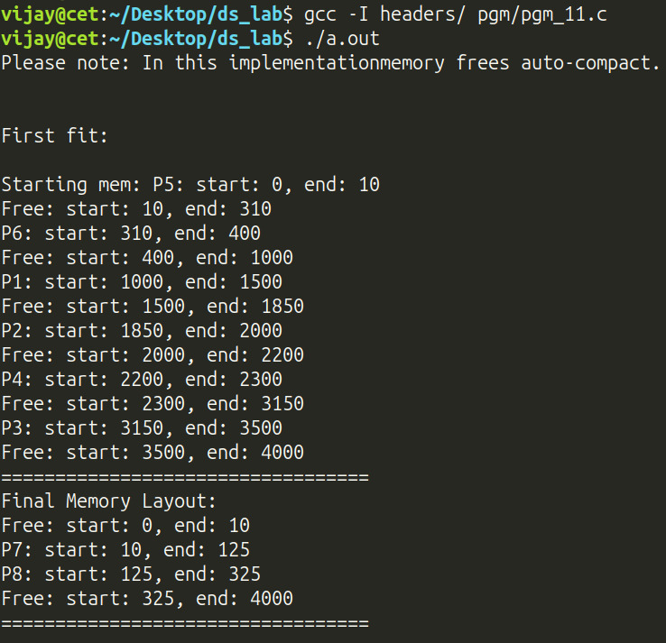
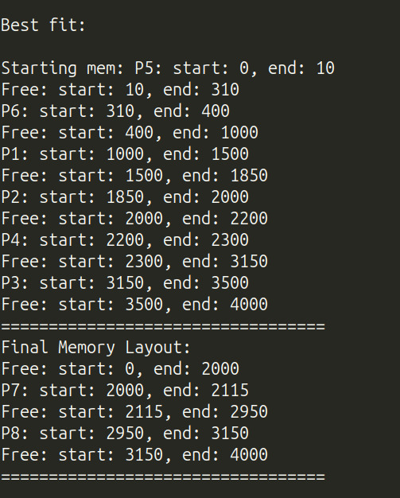
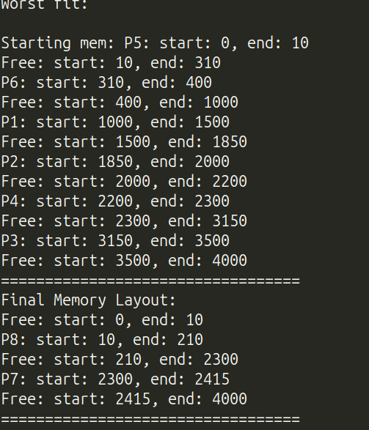

Program 12 — Expression Tree Construction

Question
An expression tree is a tree that represents an arithmetic expression. The leaves of the tree are operands such as constants or variables whereas the internal nodes are all operators. The children of an operator node are its operands. Your job now is to input an arithmetic expression and then
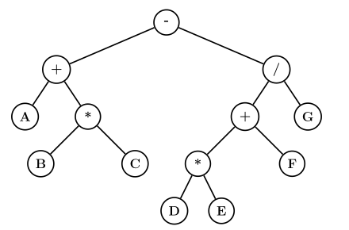Figure 2

(a) construct an expression tree for the input. [algorithm given below]
(b) display the input expression's prefix and postfix notations. [Hint: think in terms of traversals!]
You may assume that the expression has only binary operands. Construct-Expression-Tree is the algorithm for constructing a tree for the given expression. It calls an auxiliary procedure Build-Subtree to create a subtree. Two stacks viz. an operatorStack to hold the operators and a nodeStack to hold the tree nodes are used by the construction procedure.
Build-Subtree(operatorStack, nodeStack)
1 root = Pop(operatorStack)
2 rightChild = Pop(nodeStack)
3 leftChild = Pop(nodeStack)
4 root.left = leftChild
5 root.right = rightChild
6 Push(nodeStack, root)

Construct-Expression-Tree(expression)
1 operatorStack = a new empty stack
2 nodeStack = a new empty stack
3 for each char in expression
4 if IsOperand(char)
5 newNode = Create-Leaf-Node(char)
6 Push(nodeStack, newNode)
7 elseif char == '('
8 Push(operatorStack, char)
9 elseif char == ')'
10 while Top(operatorStack) != '('
11 Build-Subtree(operatorStack, nodeStack)
12 Pop(operatorStack) // Discard the matching '('
13 else // an operator
14 while (! IsEmpty(operatorStack) and Top(operatorStack) != '(' and
Precedence(Top(operatorStack)) >= Precedence(char))
15 Build-Subtree(operatorStack, nodeStack)
16 Push(operatorStack, char)
17 while ! IsEmpty(operatorStack)
18 Build-Subtree(operatorStack, nodeStack)
19 return Pop(nodeStack) // The root of the completed tree

Data Structures / Algorithm Used
• Data structure: two stacks in sequence — (1) an operator stack, and (2) a stack of tree-node pointers used while building the expression tree from the resulting postfix string.
• Algorithm used — Construct-Expression-Tree / Build-Subtree (exactly as specified in the lab sheet, expressed here in terms of the already-computed postfix string rather than scanning the infix expression a second time): each operand character becomes a new leaf node pushed onto the node stack; each operator pops its two most-recently-pushed subtrees as its left/right children, creates a new internal node for itself, and pushes that subtree back onto the stack. The single node left on the stack at the end is the root of the completed expression tree, which print_tree then displays with a recursive, indentation-based pre-order traversal.

Program 12 — Pseudocode
ALGORITHM: ConstructExpressionTree (from a postfix expression)

DATA STRUCTURE
node_t = RECORD value, left(pointer), right(pointer) END RECORD
dstck : STACK OF node_t POINTERS

--------------------------------------------------------------
STEP 0: RE-USE INFIX -> POSTFIX FROM PROGRAM 4
--------------------------------------------------------------
1. FUNCTION InfixToPostfix(infix) RETURNS postfix
2. // identical operator-precedence conversion as Program 4;
3. // any alphanumeric character is treated as a single-char operand
4. ... (see Program 4, Steps 0-1) ...

--------------------------------------------------------------
STEP 1: BUILD-SUBTREE (exactly as given in the lab specification)
--------------------------------------------------------------
5. PROCEDURE BuildSubtree(operatorStack, nodeStack)
6. root <- POP(operatorStack)
7. rightChild <- POP(nodeStack)
8. leftChild <- POP(nodeStack)
9. root.left <- leftChild
10. root.right <- rightChild
11. PUSH(nodeStack, root)
12. END PROCEDURE

--------------------------------------------------------------
STEP 2: BUILD THE TREE FROM THE POSTFIX STRING
--------------------------------------------------------------
// Expressed directly over the postfix string, this performs
// the same work as scanning the infix expression a second
// time and calling BuildSubtree at every operator.
13. FUNCTION BuildTreeFromPostfix(postfix) RETURNS root
14. CREATE empty stack dstck // holds node pointers
15. FOR EACH character ch IN postfix DO
16. IF ch is alphanumeric (an operand) THEN
17. leaf <- NEW node_t(value = ch, left = NULL, right = NULL)
18. PUSH(dstck, leaf)
19. ELSE // ch is a binary operator
20. rightChild <- POP(dstck)
21. leftChild <- POP(dstck)
22. root <- NEW node_t(value = ch, left = leftChild, right = rightChild)
23. PUSH(dstck, root) // equivalent to BuildSubtree
24. END IF
25. END FOR
26. RETURN POP(dstck) // sole remaining node = tree root
27. END FUNCTION

--------------------------------------------------------------
STEP 3: DISPLAY THE TREE (pre-order, indented by depth)
--------------------------------------------------------------
28. PROCEDURE PrintTree(node, depth)
29. IF node = NULL THEN RETURN
30. OUTPUT (depth * indent-spaces), node.value
31. PrintTree(node.left, depth + 1)
32. PrintTree(node.right, depth + 1)
33. END PROCEDURE

--------------------------------------------------------------
STEP 4: MENU-DRIVEN MAIN
--------------------------------------------------------------
34. LOOP
35. DISPLAY MENU: 1) Infix->Postfix 2) Build & show tree 3) Exit
36. READ choice
37. CASE choice OF
38. 1: READ infix; postfix <- InfixToPostfix(infix); OUTPUT postfix
39. 2: root <- BuildTreeFromPostfix(postfix)
40. PrintTree(root, 0)
41. DESTROY root (post-order free)
42. 3: EXIT LOOP
43. END CASE
44. END LOOP

--------------------------------------------------------------
COMPLEXITY: conversion is O(length of expression); tree
construction and printing are each O(number of nodes), i.e.
O(number of operands and operators in the expression).
--------------------------------------------------------------

Program 12 — Code
#include <ctype.h>
#include <stdio.h>
#include <stdlib.h>
#define STACK_IMPLEMENTATION
#include "stack.h"

#define BUFFER_LEN 64

typedef struct tree_node {
char val;
struct tree_node *left;
struct tree_node *right;
} node_t;

void create_node(node_t *n, char val) {
n->val = val;
n->left = NULL;
n->right = NULL;
}

void print_tree(node_t *n, int d) {
if (!n)
return;
for (int i = 0; i < d; ++i)
printf(" ");
printf("%c\n", n->val);
print_tree(n->left, d + 1);
print_tree(n->right, d + 1);
}

void free_tree(node_t *n) {
if (!n)
return;
free_tree(n->left);
free_tree(n->right);
free(n);
}

int precedence(char op) {
switch (op) {
case '+':
case '-':
return 1;
case '*':
case '/':
return 2;
case '^':
return 3;
default:
return 0; // shouldn't be reached
}
}

void itopfix(const char infix[BUFFER_LEN], char res[BUFFER_LEN]) {
stack_t cstck; // stack of operator
int i = 0; // current string index
stack_init(&cstck, sizeof(char), NULL);
for (int j = 0; infix[j] != '\0'; ++j) {
char c = infix[j];
if (isspace(c))
continue;
if (isalnum(c))
res[i++] = c;
else if (c == '(')
stack_push(&cstck, &c);

else if (c == ')') {
char d;
stack_peek(&cstck, &d);
while (d != '(') {
stack_pop(&cstck, &d);
res[i++] = d;
stack_peek(&cstck, &d);
}
stack_pop(&cstck, &d); // pop '('
}
// Assume invalid characters will not be entered
// Assume no variables
else {
char d;
if (!stack_isempty(&cstck)) {
stack_peek(&cstck, &d);
while (precedence(d) >= precedence(c)) {
stack_pop(&cstck, &d);
res[i++] = d;
if (stack_isempty(&cstck))
break;
stack_peek(&cstck, &d);
}
}
stack_push(&cstck, &c);
}
}
while (!stack_isempty(&cstck)) {
char d;
stack_pop(&cstck, &d);
res[i++] = d;
}
res[i] = '\0'; // terminate the string
stack_free(&cstck);
}

node_t *peval(char postfix[BUFFER_LEN]) {
stack_t dstck;
stack_init(&dstck, sizeof(node_t *), NULL);

for (int i = 0; postfix[i] != '\0'; ++i) {
char c = postfix[i];
if (isalnum(c)) {
node_t *a = malloc(sizeof(node_t));
create_node(a, c);
stack_push(&dstck, &a);
}
// Operator otherwise
else {
// Only binary operators supported
node_t *a, *b, *d;
d = malloc(sizeof(node_t));
stack_pop(&dstck, &b);
stack_pop(&dstck, &a);
create_node(d, c);
d->left = a;
d->right = b;
stack_push(&dstck, &d);
}
}
node_t *r;
stack_pop(&dstck, &r);
stack_free(&dstck);
return r;
}

int main() {
char infix[BUFFER_LEN] = {0};
char postfix[BUFFER_LEN] = {0};
int c, r;
r = 1;
printf("1. Infix to Postfix\n"
"2. Evaluate stored postfix\n"
"3. Exit\n");
do {
printf("Option: ");
scanf("%d", &c);
getc(stdin);
switch (c) {
case 1:
printf("Enter infix: ");
fgets(infix, BUFFER_LEN - 1, stdin);
itopfix(infix, postfix);
printf("Stored postfix: %s\n", postfix);
break;
case 2:
printf("Evaluating %s ( %s )\n", infix, postfix);
printf("Result: \n");
node_t *res = peval(postfix);
print_tree(res, 0);
free_tree(res);
break;
case 3:
r = 0;
break;
default:
printf("Invalid option\n");
break;
}
} while (r);
return 0;
}

Program 12 — Output
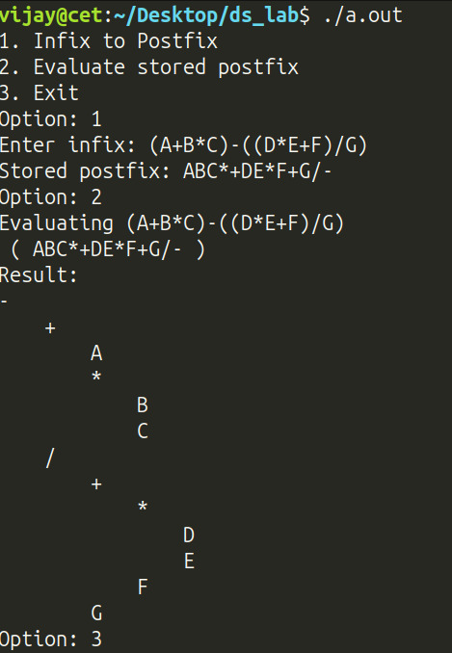

Program 13 — Word–Meaning Dictionary using a BST

Question
Construct a binary tree to efficiently implement a dictionary of ⟨word, meaning⟩ pairs. Have a menu to:
(a) find the meaning of a given word
(b) insert a new ⟨word, meaning⟩ pair
(c) remove an existing ⟨word, meaning⟩ pair.

Data Structures / Algorithm Used
• Data structure: a self-balancing Binary Search Tree, keyed by the dictionary word via the comparator cmp_entry (strcmp on word), storing dict_entry_t { word, meaning } pairs (heap-allocated strings, released through the free_ele callback free_entry on deletion).
• Algorithms used: the three menu operations map directly onto standard BST operations — insert (O(log n) thanks to AVL rebalancing), search (an O(log n) binary search down the tree that copies out the matching entry or reports "Not found"), and delete.

Program 13 — Pseudocode
ALGORITHM: WordMeaningDictionary (AVL-balanced Binary Search Tree)

DATA STRUCTURE
entry_t = RECORD word, meaning END RECORD
dict : SELF-BALANCING BST OF entry_t, keyed and ordered by word

--------------------------------------------------------------
STEP 0: COMPARATOR (defines the BST's ordering)
--------------------------------------------------------------
1. FUNCTION CompareEntry(a, b) RETURNS INTEGER
2. RETURN StringCompare(a.word, b.word)
3. END FUNCTION
--------------------------------------------------------------
STEP 1: INSERT A NEW (word, meaning) PAIR
--------------------------------------------------------------
4. PROCEDURE InsertMeaning(dict, word, meaning)
5. entry <- (word, meaning)
6. BST-INSERT(dict, entry, CompareEntry) // O(log n), AVL-rebalanced
7. END PROCEDURE

--------------------------------------------------------------
STEP 2: LOOK UP THE MEANING OF A WORD
--------------------------------------------------------------
8. FUNCTION GetMeaning(dict, word) RETURNS STRING
9. key <- (word, meaning = UNDEFINED)
10. IF BST-SEARCH(dict, key, CompareEntry) FOUND entry THEN
11. RETURN entry.meaning
12. END IF
13. RETURN "Not found"
14. END FUNCTION

--------------------------------------------------------------
STEP 3: REMOVE AN EXISTING PAIR
--------------------------------------------------------------
15. PROCEDURE RemoveMeaning(dict, word)
16. key <- (word, meaning = UNDEFINED)
17. BST-DELETE(dict, key, CompareEntry)
18. // if the deleted node had two children, its in-order
19. // successor replaces it before rotations rebalance the tree
20. END PROCEDURE

--------------------------------------------------------------
STEP 4: MENU-DRIVEN MAIN
--------------------------------------------------------------
21. CREATE empty dict
22. LOOP
23. DISPLAY MENU: 1) Insert 2) Get meaning 3) Remove 4) Exit
24. READ choice
25. CASE choice OF
26. 1: READ word, meaning; InsertMeaning(dict, word, meaning)
27. 2: READ word; OUTPUT GetMeaning(dict, word)
28. 3: READ word; RemoveMeaning(dict, word)
29. 4: EXIT LOOP
30. END CASE
31. END LOOP
32. DESTROY dict

--------------------------------------------------------------
COMPLEXITY: insert, search and delete are all O(log n) thanks
to the AVL height-balance invariant, where n is the number of
dictionary entries currently stored.
--------------------------------------------------------------

Program 13 — Code
#include <stdio.h>
#include <stdlib.h>
#include <string.h>
#define BST_IMPLEMENTATION
#include "bst.h"

#define W_LEN 32
#define M_LEN 256

struct word_meaning_pair {
char *word;
char *meaning;
};

typedef struct word_meaning_pair dict_entry_t;
typedef bst_t dict_t;

void create_entry(dict_entry_t *e, const char *word, const char *meaning) {
e->word = strdup(word);
e->meaning = strdup(meaning);
}

void free_entry(void *a) {
dict_entry_t *e = (dict_entry_t *)a;
free(e->word);
free(e->meaning);
}

int cmp_entry(const void *a, const void *b) {
const dict_entry_t *e1, *e2;
e1 = (const dict_entry_t *)a;
e2 = (const dict_entry_t *)b;
return strcmp(e1->word, e2->word);
}

void dict_init(dict_t *d) {
bst_init(d, sizeof(dict_entry_t), cmp_entry, free_entry);
}

const char *get_meaning(const dict_t *d, char *word) {
dict_entry_t e;
dict_entry_t k = {.word = word};
int s = bst_get(d, &k, &e);
return s ? e.meaning : "Not found";
}

void insert_meaning(dict_t *d, const char *word, const char *meaning) {
dict_entry_t e;
create_entry(&e, word, meaning);
bst_insert(d, &e);
}

void remove_meaning(dict_t *d, char *word) {
dict_entry_t k;
k.word = word;
bst_delete(d, &k);
}

int main() {
dict_t dict;
dict_init(&dict);

printf("1. Insert meaning\n"
"2. Get meaning\n"
"3. Remove meaning\n"
"4. Exit\n\n");
int r = 1;
int c;
char w[W_LEN], m[M_LEN];
do {
scanf("%d", &c);
getc(stdin);

switch (c) {
case 1:
printf("Word: ");
fgets(w, W_LEN, stdin);
w[strcspn(w, "\n")] = '\0';

printf("Meaning: ");
fgets(m, M_LEN, stdin);
m[strcspn(m, "\n")] = '\0';

insert_meaning(&dict, w, m);
break;
case 2:
printf("Word: ");
fgets(w, W_LEN, stdin);
w[strcspn(w, "\n")] = '\0';

printf("Meaning: %s\n", get_meaning(&dict, w));
break;
case 3:
printf("Word: ");
fgets(w, W_LEN, stdin);
w[strcspn(w, "\n")] = '\0';

remove_meaning(&dict, w);
break;
case 4:
r = 0;
break;
default:
printf("Invalid option\n");
break;
}
} while (r);
bst_free(&dict);
return 0;
}

Program 13 — Output
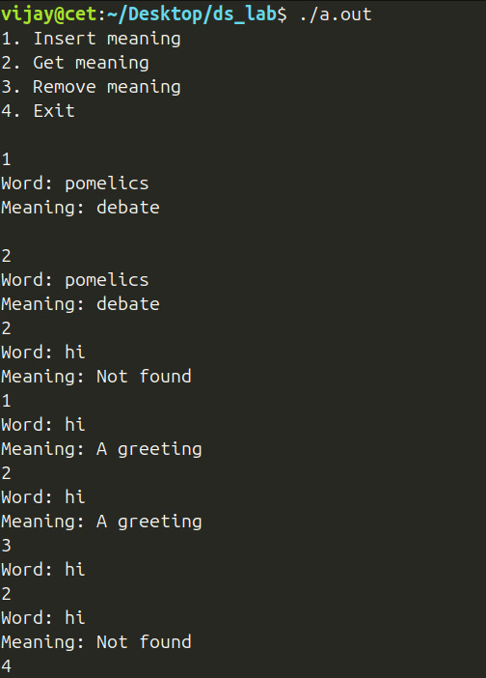

Program 14 — Post Office Priority Queue

Question
The General post office wishes to give preferential treatment to its customers. The Postmaster has identified four categories of customers viz. Defence personnel, Differently abled persons, Senior citizens, and normal persons. Customers come to the post office, get their job done, and leave. As a customer enters the post office, he proceeds to a token machine which prompts for his category and then issues him a token bearing a number (in the increasing order of the time at which the customer arrived). The customers are to be given preference in the decreasing order - Differently abled persons, Senior citizens, Defence personnel, and Normal persons. Customers within the same category are to be served in the order of arrival. Implement this scenario for N customers. You may assume that there is only one service counter in the post office.

Data Structures / Algorithm Used
• Data structure: a max-heap of token_t { token_id, priority, name }.
• Algorithm used: the heap's ordering is driven entirely by a custom comparator token_cmp that first compares category priority (Differently-abled > Senior citizen > Defence personnel > Normal, per the question's required preference order) and, for two tokens of equal category, compares token ids so that the earlier-arrived customer (smaller token_id) is treated as "greater" — this makes popmax always extract the highest-priority, earliest-arrived customer, correctly implementing multi-level (category, then FIFO-within-category) priority scheduling with a single binary heap.

Program 14 — Pseudocode
ALGORITHM: PostOffice-MultilevelPriorityQueue (binary max-heap)

CATEGORY ORDER (ascending importance):
NORMAL < DEFENCE < SENIOR CITIZEN < DIFFERENTLY ABLED

DATA STRUCTURE
token_t = RECORD tokenId, priority, name END RECORD
pq : MAX-HEAP OF token_t, ordered by TokenCompare

--------------------------------------------------------------
STEP 0: CUSTOM COMPARATOR — CATEGORY FIRST, THEN FIFO
--------------------------------------------------------------
1. FUNCTION TokenCompare(t1, t2) RETURNS INTEGER
2. diff <- t1.priority - t2.priority
3. IF diff <> 0 THEN RETURN diff // higher category wins outright
4. RETURN t2.tokenId - t1.tokenId // else the SMALLER (earlier) id
5. END FUNCTION // is treated as "greater" by the heap

--------------------------------------------------------------
STEP 1: INITIALISATION
--------------------------------------------------------------
6. CREATE empty max-heap pq WITH comparator TokenCompare
7. nextTokenId <- 1

--------------------------------------------------------------
STEP 2: MENU-DRIVEN MAIN
--------------------------------------------------------------
8. LOOP
9. DISPLAY MENU: 1) Take token 2) Serve customer 3) Exit
10. READ choice
11. CASE choice OF
12. -- Option 1: a customer arrives and receives a token ----------
13. 1: READ name, category
14. token <- (nextTokenId, category, name)
15. nextTokenId <- nextTokenId + 1
16. HEAP-INSERT(pq, token) // O(log n) sift-up
17. -- Option 2: serve the single service counter ------------------
18. 2: IF HEAP-POP-MAX(pq) RETURNS token THEN
19. OUTPUT "Served:", token // O(log n) sift-down
20. ELSE
21. OUTPUT "Empty"
22. END IF
23. -- Option 3: quit --------------------------------------------------
24. 3: EXIT LOOP
25. END CASE
26. END LOOP
27. DESTROY pq

--------------------------------------------------------------
COMPLEXITY: Take token and Serve customer are each O(log n),
where n is the number of customers currently waiting, because
TokenCompare encodes both "category first" and "earliest
arrival breaks ties" in a single total order the heap can act
on directly.
--------------------------------------------------------------

Program 14 — Code
#include <stdio.h>
#include <string.h>
#define HEAP_IMPLEMENTATION
#include "heap.h"

#define LEN 64

enum Priority { NORMAL, DEFENCE, SENIOR, DIFFERENTLY_ABLED };

const char *ptos[4] = {"NORMAL", "DEFENCE", "SENIOR", "DIFFERENTLY ABLED"};

struct post_office_token {
int token_id;
enum Priority p;
char name[LEN];
};

typedef struct post_office_token token_t;

int token_cmp(const void *a, const void *b) {
const token_t *t1, *t2;
t1 = (const token_t *)a;
t2 = (const token_t *)b;
int d = t1->p - t2->p;
return d ? d : t2->token_id - t1->token_id;
}

void print_token(token_t t) {
printf("%d. %s: %s\n", t.token_id, t.name, ptos[t.p]);
}

int main() {
hp_t pq;
hp_init(&pq, sizeof(token_t), token_cmp, NULL);

printf("Normal: 0\n"
"Defense: 1\n"
"Senior: 2\n"
"Differently abled: 3\n\n");

printf("1. Take token\n"
"2. Serve customer\n"
"3. Exit\n\n");
int c, r, t, s;
token_t tk;
t = 1;
r = 1;

do {
scanf("%d", &c);
getc(stdin);
switch (c) {
case 1:
printf("Enter name: ");
fgets(tk.name, LEN, stdin);
tk.name[strcspn(tk.name, "\n")] = '\0';

printf("Enter priority: ");
scanf("%d", (int *)&tk.p);
getc(stdin);

tk.token_id = t++;
hp_insert(&pq, &tk);
printf("Inserted: ");
print_token(tk);
break;
case 2:
s = hp_popmax(&pq, &tk);
printf("Served: ");
if (s)
print_token(tk);
else
printf("Empty\n");
break;
case 3:
r = 0;
break;
default:
printf("Invalid choice\n");
break;
}

} while (r);

hp_free(&pq);
return 0;
}

Program 14 — Output
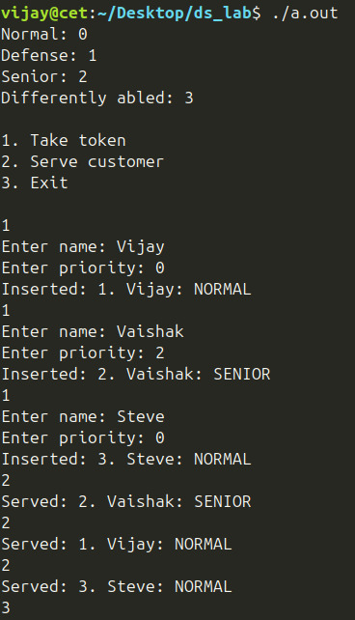

Program 15 — Merge K Sorted Lists using a Min-Heap

Question
Merge K sorted lists into a single sorted list using a heap. Use a min-heap to keep track of the smallest element from each list. Repeatedly extract the smallest element and insert the next element from the corresponding list into the heap until all lists are merged.

Data Structures / Algorithm Used
• Data structure: a binary heap of arr_view { arr, i, n } structs, one per input list, each tracking a pointer to that list's (pre-sorted) array along with a "current position" cursor i. The heap's comparator min_cmp is deliberately inverted, so that the library's max-heap (popmax) behaves as the min-heap the algorithm needs.
• Algorithm used — K-way merge with a heap: every one of the k input arrays is first sorted independently (quick sort), and an arr_view positioned at its smallest element is pushed into the heap. The loop then repeatedly: pops the view whose current element is the smallest among all k lists, appends that element to the output, advances that view's cursor by one, and (if the list isn't exhausted) re-inserts the view into the heap — this is exactly the textbook O((n·k)·log k) K-way merge using a min-heap, where n·k is the total number of elements across all lists.

Program 15 — Pseudocode
ALGORITHM: MergeKSortedLists (K-way merge via min-heap)

DATA STRUCTURE
arrView = RECORD arr(pointer), cursor, length END RECORD
heap : BINARY HEAP OF arrView, using an INVERTED comparator so
the library's max-heap behaves like the MIN-heap we need

--------------------------------------------------------------
STEP 0: INVERTED COMPARATOR (max-heap -> effective min-heap)
--------------------------------------------------------------
1. FUNCTION MinCompare(x, y) RETURNS INTEGER
2. RETURN y.arr[y.cursor] - x.arr[x.cursor] // NOTE the reversed order
3. END FUNCTION // smallest "current" value wins

--------------------------------------------------------------
STEP 1: LOAD AND PRE-SORT EACH OF THE K LISTS
--------------------------------------------------------------
4. READ k
5. total <- 0
6. CREATE empty heap WITH comparator MinCompare
7. FOR i <- 1 TO k DO
8. READ length[i] and its elements INTO arr[i]
9. QuickSort(arr[i]) // sort each list independently first
10. HEAP-INSERT(heap, arrView(arr[i], cursor = 0, length[i]))
11. total <- total + length[i]
12. END FOR

--------------------------------------------------------------
STEP 2: REPEATEDLY EXTRACT THE OVERALL SMALLEST ELEMENT
--------------------------------------------------------------
13. CREATE result[0 .. total - 1]
14. idx <- 0
15. WHILE HEAP-POP-MAX(heap) RETURNS view v DO // "max" here really means MIN
16. IF v.cursor = v.length THEN
17. CONTINUE // this list is fully consumed, drop it
18. END IF
19. result[idx] <- v.arr[v.cursor]
20. idx <- idx + 1
21. v.cursor <- v.cursor + 1
22. HEAP-INSERT(heap, v) // push the SAME list back, one step ahead
23. END WHILE

--------------------------------------------------------------
STEP 3: OUTPUT
--------------------------------------------------------------
24. OUTPUT result[0 .. total - 1] // the fully merged, sorted sequence

--------------------------------------------------------------
COMPLEXITY: O((n*k) log k) overall, where n*k is the total
number of elements across all k lists — each of the n*k
elements is inserted into, and popped from, a heap of size
<= k exactly once.
--------------------------------------------------------------

Program 15 — Code
#include <alloca.h> // alloca
#include <stddef.h> // size_t
#include <stdio.h>
#define HEAP_IMPLEMENTATION
#include "heap.h"
#define QUICK_SORT_IMPL
#include "sort.h"

struct arr_view {
int *arr; // array start
size_t i; // current view
size_t n; // capacity
};

int min_cmp(const void *a, const void *b) {
const struct arr_view *c, *d;
c = (const struct arr_view *)a;
d = (const struct arr_view *)b;
return d->arr[d->i] - c->arr[c->i];
}

int int_cmp(const void *a, const void *b) {
return *(const int *)a - *(const int *)b;
}

int main() {
int k, c, i;
struct arr_view av;
hp_t heap;
hp_init(&heap, sizeof(struct arr_view), min_cmp, NULL);
printf("Enter k: ");
scanf("%d", &k);
int *arrs[k];
for (i = 0; i < k; ++i) {
int n;
printf("Enter length of %dth arr: ", i + 1);
scanf("%d", &n);
arrs[i] = alloca(sizeof(int) * n);
for (int j = 0; j < n; ++j)
scanf("%d", &arrs[i][j]);
quick_sort(arrs[i], n, sizeof(int), int_cmp);
av.arr = arrs[i];
av.i = 0;
av.n = n;
hp_insert(&heap, &av);
c += n;
}

int res[c];
i = 0;
while (hp_popmax(&heap, &av)) {
if (av.i == av.n)
continue;
res[i++] = av.arr[av.i++];
hp_insert(&heap, &av);
}

for (i = 0; i < c; ++i)
printf("%d ", res[i]);
printf("\n");
hp_free(&heap);
return 0;
}

Program 15 — Output
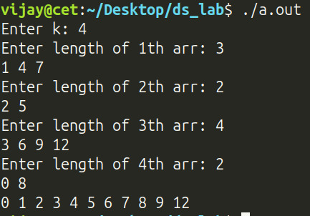

Program 16 — Shortest Path in a Maze (A* Search)

Question
Assume our department owns a robot DotSlash and you arrange a "Robo-show" to showcase its maze solving capability!! At one instant of the show, the robo is currently at a point as shown in Figure 3. The poor guy is running out of charge and somehow wants to reach the charging source (shown in the figure). It now seeks your help for the same. Since the robo has got only a few units of charge left in its battery, you want to make sure that the robo consumes the least amount of charge in its journey to the power source. Assume that the charge consumed is directly proportional to the distance traversed. Help DotSlash to find a path to the charging point, minimizing the battery power consumed.
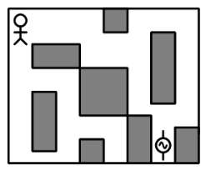Figure 3

Data Structures / Algorithm Used
• Data structure: a binary max-heap used as a priority queue ("open set") ordered by ascending f-score via an inverted comparator, plus 2-D arrays for gScore, fScore, and cameFrom, all sized to the maze's dimensions; the reconstructed path is collected into a dynamic array.
• Algorithm used — A* path finding algorithm: Starting from the robot's position, it repeatedly extracts the open-set cell with the lowest f-score (= cost so far, g-score plus a Manhattan-distance heuristic to the goal) and relaxes each of its 4 grid neighbours (skipping obstacles and out-of-bounds cells): if reaching a neighbour through the current cell is cheaper than any route found so far, its g-score, f-score and came-from pointer are updated and it is pushed into the open set. The search stops as soon as the goal cell is popped, and the shortest path is reconstructed by following the came-from pointers back to the start and reversing the result.

Program 16 — Pseudocode
ALGORITHM: MazeShortestPath-AStar (grid A* search, Manhattan-distance heuristic)

DATA STRUCTURE
point = RECORD x, y END RECORD
open : BINARY HEAP OF (point, fScore), ordered so the LOWEST
fScore is always popped first
gScore, fScore, cameFrom : 2-D ARRAYS sized to the maze (rows x cols)
path : DYNAMIC ARRAY (LIST) of point, built in reverse then flipped

--------------------------------------------------------------
STEP 0: HEURISTIC AND HELPERS
--------------------------------------------------------------
1. FUNCTION Dist(a, b) RETURNS INTEGER
2. RETURN |a.x - b.x| + |a.y - b.y| // Manhattan distance
3. END FUNCTION
4. FUNCTION IsValid(point p) RETURNS BOOLEAN
5. RETURN p WITHIN grid bounds AND grid[p] is not an obstacle
6. END FUNCTION

--------------------------------------------------------------
STEP 1: INITIALIZATION
--------------------------------------------------------------
7. FOR EACH cell c IN the maze DO
8. gScore[c] <- INFINITY; fScore[c] <- INFINITY; cameFrom[c] <- NONE
9. END FOR
10. gScore[start] <- 0
11. fScore[start] <- Dist(start, goal)
12. CREATE empty heap open, WITH comparator "lowest fScore wins"
13. HEAP-INSERT(open, (start, fScore[start]))

--------------------------------------------------------------
STEP 2: MAIN SEARCH LOOP
--------------------------------------------------------------
14. WHILE open is NOT EMPTY DO
15. current <- HEAP-EXTRACT-MIN(open)
16. IF current = goal THEN
17. GOTO STEP 3 // path found
18. END IF
19. FOR EACH of the 4 grid neighbours n of current DO
20. IF NOT IsValid(n) THEN CONTINUE
21. tentative <- gScore[current] + 1 // uniform edge cost
22. IF tentative < gScore[n] THEN
23. cameFrom[n] <- current
24. gScore[n] <- tentative
25. fScore[n] <- tentative + Dist(n, goal)
26. HEAP-INSERT(open, (n, fScore[n]))
27. END IF
28. END FOR
29. END WHILE
30. OUTPUT "No path exists"; STOP

--------------------------------------------------------------
STEP 3: PATH RECONSTRUCTION
--------------------------------------------------------------
31. path <- EMPTY LIST
32. APPEND goal TO path
33. WHILE cameFrom[current] != NONE DO
34. current <- cameFrom[current]
35. APPEND current TO path
36. END WHILE
37. REVERSE path // now start -> goal
38. OUTPUT path

--------------------------------------------------------------
COMPLEXITY: O(E log V) where V is the number of maze cells and E
is the number of grid edges explored (each of the 4 neighbours per
cell) — every cell is pushed onto/popped from the heap at most a
constant number of times, dominated by the O(log V) heap operations.
--------------------------------------------------------------

Program 16 — Code
#include <stdio.h>
#include <stdlib.h> // abs
#include <limits.h>
#define HEAP_IMPLEMENTATION
#include "heap.h"
#define LIST_IMPLEMENTATION
#include "list.h"

#define MAP_VAL(map, pt) ((map)[(pt).x][(pt).y])

typedef struct {
int x;
int y;
} point_t;

struct heap_struct {
point_t p;
int score;
};

int heap_cmp(const void *a, const void *b) {
return ((const struct heap_struct *)b)->score - ((const struct heap_struct *)a)->score;
}

int dist(const point_t src, const point_t dst) {
return abs(src.x - dst.x) + abs(src.y - dst.y);
}

int cmp(const point_t a, const point_t b) {
return dist(a, b) == 0;
}

void rev(point_t *p, int n) {
for (int i = 0; i < n / 2; ++i) {
point_t t = p[i];
p[i] = p[n - 1 - i];
p[n - 1 - i] = t;
}
}

int is_valid(int m, int n, int grid[m][n], point_t p) {
if (p.x < 0 || p.x >= m) return 0;
if (p.y < 0 || p.y >= n) return 0;
return grid[p.x][p.y] != 1;
}

list_t a_star(int m, int n, int grid[m][n], point_t start, point_t goal) {
hp_t open;
hp_init(&open, sizeof(struct heap_struct), heap_cmp, NULL);

point_t (*cameFrom)[n] = malloc(sizeof(point_t) * m * n);
int (*gscore)[n] = malloc(sizeof(int) * m * n);
int (*fscore)[n] = malloc(sizeof(int) * m * n);

for(int i = 0; i < m; ++i) {
for (int j = 0; j < n; ++j) {
cameFrom[i][j] = (point_t) {.x = -1, .y = -1};
gscore[i][j] = INT_MAX;
fscore[i][j] = INT_MAX;
}
}

MAP_VAL(gscore, start) = 0;
MAP_VAL(fscore, start) = dist(start, goal);

struct heap_struct cur = (struct heap_struct) {.p = start, .score = MAP_VAL(fscore, start)};
hp_insert(&open, &cur);

list_t path;
list_init(&path, 3, sizeof(point_t), NULL);

while (hp_peek(&open, NULL)) {
hp_popmax(&open, &cur);
point_t cur_p = cur.p;

if (cmp(cur_p, goal))
goto path_reconstruct;

point_t neighbours[4];

neighbours[0].x = cur_p.x + -1;
neighbours[0].y = cur_p.y + 0;

neighbours[1].x = cur_p.x + 0;
neighbours[1].y = cur_p.y + -1;

neighbours[2].x = cur_p.x + 0;
neighbours[2].y = cur_p.y + 1;

neighbours[3].x = cur_p.x + 1;
neighbours[3].y = cur_p.y + 0;

for (int i = 0; i < 4; ++i) {
point_t neighbour = neighbours[i];
if (!is_valid(m, n, grid, neighbour))
continue;
int tentative_gscore = MAP_VAL(gscore, cur_p) + 1;

if (tentative_gscore < MAP_VAL(gscore, neighbour)) {
MAP_VAL(cameFrom, neighbour) = cur_p;
MAP_VAL(gscore, neighbour) = tentative_gscore;
MAP_VAL(fscore, neighbour) = tentative_gscore + dist(neighbour, goal);

struct heap_struct nxt = { .p = neighbour, .score = MAP_VAL(fscore, neighbour) };

hp_insert(&open, &nxt);
}

}
}
goto free_ret;

point_t cur_p;
path_reconstruct:
cur_p = cur.p;
add(&path, &cur_p);
while (MAP_VAL(cameFrom, cur_p).x != -1) {
cur_p = MAP_VAL(cameFrom, cur_p);
add(&path, &cur_p);
}
rev((point_t *)path.data, path.size);
free_ret:
free(gscore);
free(fscore);
free(cameFrom);
hp_free(&open);
return path;
}

int main() {
int maze[8][8] = {
{0, 0, 0, 0, 1, 0, 0, 0},
{0, 0, 0, 0, 0, 0, 1, 0},
{0, 1, 1, 0, 0, 0, 1, 0},
{0, 0, 0, 1, 1, 0, 1, 0},
{0, 1, 0, 1, 1, 0, 0, 0},
{0, 1, 0, 0, 0, 1, 0, 0},
{0, 1, 0, 1, 0, 1, 0, 1},
{0, 1, 0, 1, 0, 1, 0, 1}
};
point_t start = (point_t) {.x = 0, .y = 0};
point_t goal = (point_t) {.x = 7, .y = 6};
list_t result = a_star(8, 8, maze, start, goal);

for (int i = 0; i < list_size(&result); ++i) {
point_t c;
get(&result, i, &c);
printf(" (%d, %d) -> ", c.y, c.x); // x and y got inverted;
}
printf(list_size(&result) ? "!\n" : "X\n");

return 0;
}

Program 16 — Output
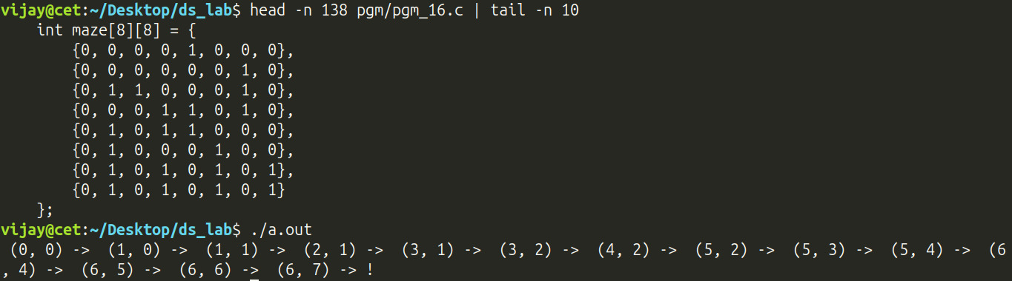

Program 17 — The Water Jug Problem (BFS State-Space Search)

Question
The water jug problem is a classic puzzle in the domain of Artificial Intelligence. It involves determining how to measure a specific quantity of water using two or more jugs with different capacities. The challenging part is that none of the jugs have any volume markings on them. The goal here is to find a sequence of actions (filling, emptying, or pouring between the jugs) that leads to the desired measurement. Now let me make it formal:
You are given three containers whose sizes are 10 litres, 7 litres, and 4 litres, respectively. The 7-litre and 4-litre containers start out full of water, but the 10-litre container is initially empty. You are allowed to perform only one type of operation: pouring the contents of one container into another, stopping when the source container is empty or the destination container is full. Your task is to determine if there is a sequence of pourings that leaves exactly 2 litres in the 7-litre or 4-litre container.

Data Structures / Algorithm Used
• Data structure: a queue holding overall_state { js, prev } nodes for BFS, plus a hash-based set of already-visited jug_state triples to prevent re-exploring the same configuration.
• Algorithm used — Breadth-First Search over the state space of the three jugs (10L, 7L, 4L): starting from the initial state, the six possible pour operations (each jug into each of the other two) are used to generate successor states, which are enqueued together with a prev pointer back to their parent state (for path reconstruction). States are dequeued in FIFO order (guaranteeing BFS explores states in increasing number of pours, i.e. finds the shortest sequence), and the visited set ensures each distinct (c10, c7, c4) configuration is expanded at most once. As soon as a dequeued state satisfies the target condition (c7 == 2 or c4 == 2), the prev chain is walked backwards and reversed into a list to reconstruct and print the actual sequence of pourings from the start state to the target.

Program 17 — Pseudocode
ALGORITHM: WaterJugProblem-BFS (shortest-path state-space search)

DATA STRUCTURE
jugState = RECORD c10, c7, c4 END RECORD // litres currently held
overallState = RECORD state(jugState), prev(pointer) END RECORD
frontier : QUEUE OF overallState // BFS frontier
visited : HASH SET OF jugState // configurations already expanded

--------------------------------------------------------------
STEP 0: GENERATE ALL SUCCESSOR STATES OF A GIVEN STATE
--------------------------------------------------------------
1. FUNCTION Successors(s: jugState) RETURNS 6 states
2. amt <- MIN(s.c10, 7 - s.c7);s1 <- s WITH c10 -= amt, c7 += amt //10->7
3. amt <- MIN(s.c10, 4 - s.c4);s2 <- s WITH c10 -= amt, c4 += amt //10->4
4. amt <- MIN(s.c7, 10 – s.c10);s3 <- s WITH c7 -= amt, c10 += amt//7->10
5. amt <- MIN(s.c7, 4 - s.c4);s4 <- s WITH c7 -= amt, c4 += amt // 7->4
6. amt <- MIN(s.c4, 10 – s.c10);s5 <- s WITH c4 -= amt, c10 += amt// 4->10
7. amt <- MIN(s.c4, 7 - s.c7);s6 <- s WITH c4 -= amt, c7 += amt // 4->7
8. RETURN {s1, s2, s3, s4, s5, s6}
9. END FUNCTION

--------------------------------------------------------------
STEP 1: BREADTH-FIRST SEARCH OF THE STATE SPACE
--------------------------------------------------------------
10. FUNCTION SearchSpace(initial, IsTarget) RETURNS path
11. CREATE empty queue frontier, empty set visited
12. ENQUEUE(frontier, overallState(initial, prev = NULL))
13. WHILE frontier NOT EMPTY DO
14. cur <- DEQUEUE(frontier)
15. IF cur.state IN visited THEN CONTINUE // already expanded
16. IF IsTarget(cur.state) THEN
17. GOTO ReconstructPath // shortest path found!
18. END IF
19. ADD cur.state TO visited
20. FOR EACH successor s IN Successors(cur.state) DO
21. ENQUEUE(frontier, overallState(s, prev = pointer to cur))
22. END FOR
23. END WHILE
24. RETURN empty path // target unreachable
25.
26. ReconstructPath:
27. path <- empty list
28. WHILE cur.prev <> NULL DO
29. PREPEND cur.state TO path
30. cur <- *(cur.prev)
31. END WHILE
32. PREPEND cur.state TO path // the initial state
33. RETURN path
34. END FUNCTION

--------------------------------------------------------------
STEP 2: MAIN DRIVER
--------------------------------------------------------------
35. initial <- (c10 = 0, c7 = 7, c4 = 4) // 7 L and 4 L jugs start full
36. IsTarget(s) <- (s.c7 = 2 OR s.c4 = 2) // exactly 2 L in either jug
37. path <- SearchSpace(initial, IsTarget)
38. IF path is empty THEN
39. OUTPUT "unreachable"
40. ELSE
41. FOR EACH state IN path DO
42. OUTPUT "(", state.c10, state.c7, state.c4, ") -> "
43. END FOR
44. END IF

--------------------------------------------------------------
COMPLEXITY: BFS visits each distinct (c10, c7, c4) configuration
at most once (bounded by 11 * 8 * 5 = 440 reachable states),
giving O(states) time and space; FIFO ordering guarantees the
FIRST path found uses the fewest possible pourings.
--------------------------------------------------------------

Program 17 — Code
#include <stdio.h>
#define LIST_IMPLEMENTATION
#include "list.h"
#define QUEUE_IMPLEMENTATION
#include "queue.h"
#define SET_IMPLEMENTATION
#include "set.h"

int min(int a, int b) { return a < b ? a : b; }
struct jug_state {
int c10;
int c7;
int c4;
};
struct overall_state {
struct jug_state js;
struct overall_state *prev;
};
typedef struct jug_state state_t;

void rev(state_t *a, int n) {
for (int i = 0; i < n / 2; ++i) {
state_t t = a[i];
a[i] = a[n - 1 - i];
a[n - 1 - i] = t;
}
}

list_t search_space(state_t init, int (*istarget)(const state_t)) {
queue_t bfs;
set_t visited;

q_init(&bfs, sizeof(struct overall_state), NULL);
set_init(&visited, sizeof(state_t), NULL);

struct overall_state cur_state = {.js = init, .prev = NULL};
enqueue(&bfs, &cur_state);
while (!q_isempty(&bfs)) {
state_t cur;
dequeue(&bfs, &cur_state);
cur = cur_state.js;
if (set_contains(&visited, &cur))
continue;
if (istarget(cur))
goto path_construct;
set_insert(&visited, &cur);

struct overall_state nxt_states[12];
int amt;
for (int i = 0; i < 6; ++i) {
nxt_states[i].prev = malloc(sizeof(struct overall_state));
*nxt_states[i].prev = cur_state;
nxt_states[i].js = cur;
}
// Pour c10 to c7
amt = min(cur.c10, 7 - cur.c7);
nxt_states[0].js.c10 -= amt;
nxt_states[0].js.c7 += amt;

// Pour c10 to c4
amt = min(cur.c10, 4 - cur.c4);
nxt_states[1].js.c10 -= amt;
nxt_states[1].js.c4 += amt;

// Pour c7 to c10
amt = min(cur.c7, 10 - cur.c10);
nxt_states[2].js.c7 -= amt;
nxt_states[2].js.c10 += amt;

// Pour c7 to c4
amt = min(cur.c7, 4 - cur.c4);
nxt_states[3].js.c7 -= amt;
nxt_states[3].js.c4 += amt;

// Pour c4 to c10
amt = min(cur.c4, 10 - cur.c10);
nxt_states[4].js.c4 -= amt;
nxt_states[4].js.c10 += amt;

// Pour c4 to c7
amt = min(cur.c4, 7 - cur.c7);
nxt_states[5].js.c4 -= amt;
nxt_states[5].js.c7 += amt;

for (int i = 0; i < 6; ++i)
enqueue(&bfs, &nxt_states[i]);
}
goto free_ret;
list_t path;
path_construct:
list_init(&path, 3, sizeof(state_t), NULL);
do {
add(&path, &cur_state.js);
cur_state = *cur_state.prev;
} while (cur_state.prev != NULL);
add(&path, &cur_state.js);
rev((state_t *)path.data, path.size);
free_ret:
q_free(&bfs);
set_free(&visited);
return path;
}

int istarget(const state_t s) {
#ifdef ORIGINAL
return s.c7 == 2 || s.c4 == 2;
#endif
#ifdef DBG1
return s.c10 == 2 && s.c7 == 5 && s.c4 == 3; // unreachable
#endif
#ifdef DBG2
return s.c10 == 8 && s.c7 == 3 && s.c4 == 0; // reachable
#endif
return 0;
}

int main() {
list_t result;
state_t init = (state_t){.c10 = 0, .c7 = 7, .c4 = 4};
result = search_space(init, istarget);

printf(
#ifdef ORIGINAL
"target = (X 2 X) or (X X 2)\n"
#endif
#ifdef DBG1
"target = (2 5 3) (unreachable)\n"
#endif
#ifdef DBG2
"target = (8 3 0) (reachable)\n"
#endif
""
);

for (int i = 0; i < list_size(&result); ++i) {
state_t cur;
get(&result, i, &cur);
printf(" (%d %d %d) -> ", cur.c10, cur.c7, cur.c4);
}
printf(list_size(&result) ? " !\n" : "X\n");
return 0;
}

Program 17 — Output
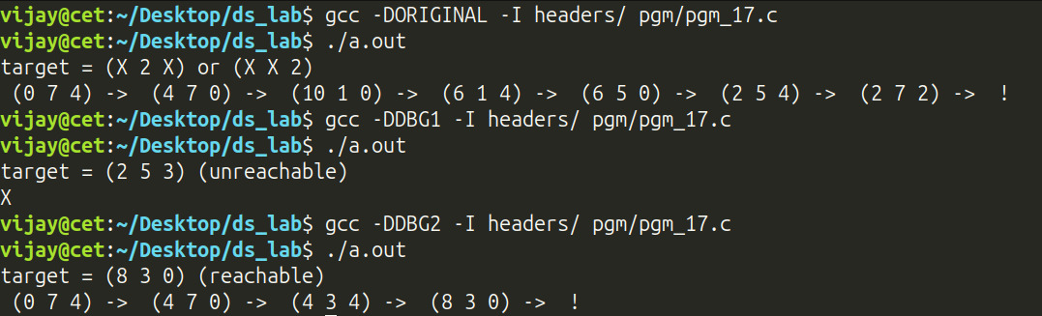

Program 18 — Sorting Algorithms and Step-Count Comparison

Question
Write a menu-driven program to read numerical data stored in a file and implement the following algorithms for sorting the numbers in descending order. Implement each algorithm as a separate function.
(a) Bubble sort
(b) Insertion Sort
(c) Radix Sort
(d) Merge Sort
(e) Quick Sort
Compare the number of steps involved in each method.

Data Structures / Algorithm Used
• Data structure: plain in-memory int arrays (numbers are read from a file given on the command line).
• Algorithms used — five classical comparison/non-comparison sorts, each producing descending order, instrumented with a step counter (cmp/shift/swp helpers increment a shared counter whenever COUNT_CMP/COUNT_SHF is enabled at compile time):
• Bubble Sort — repeated adjacent-pair comparisons/swaps, with early termination once a full pass makes no swap.
• Insertion Sort — shifts larger elements one position to the right to make room for the current key.
• Radix Sort — an LSD (least-significant-digit) radix sort built from a stable counting sort per decimal digit, repeated once per digit place of the largest number.
• Merge Sort — classic divide-and-conquer, using temporary buffers in the merge step.
• Quick Sort — partition scheme (pivot = last element), recursing on both partitions.
Each algorithm's total instrumented step count is printed so the five methods can be empirically compared on the same input.

Program 18 — Pseudocode
ALGORITHM: FiveSortingAlgorithms-StepCountComparison

DATA STRUCTURE
a[0..n-1] : ARRAY OF INTEGER // numbers read from the input file
stepCounter // incremented on every counted comparison/shift

--------------------------------------------------------------
STEP 0: LOAD THE INPUT
--------------------------------------------------------------
1. READ every integer from the file named on the command line INTO a[0..n-1]

--------------------------------------------------------------
STEP 1: BUBBLE SORT (descending, with early exit)
--------------------------------------------------------------
2. FUNCTION BubbleSort(a, n) RETURNS steps
3. FOR i <- 0 TO n - 1 DO
4. swapped <- FALSE
5. FOR j <- 0 TO n - i - 2 DO
6. IF a[j] < a[j + 1] THEN
7. SWAP a[j], a[j + 1]; swapped <- TRUE
8. END IF
9. END FOR
10. IF NOT swapped THEN BREAK // already fully sorted
11. END FOR
12. RETURN steps

--------------------------------------------------------------
STEP 2: INSERTION SORT (descending)
--------------------------------------------------------------
13. FUNCTION InsertionSort(a, n) RETURNS steps
14. FOR i <- 1 TO n - 1 DO
15. key <- a[i]; j <- i - 1
16. WHILE j >= 0 AND a[j] < key DO
17. a[j + 1] <- a[j]; j <- j – 1 //shift larger ele right
18. END WHILE
19. a[j + 1] <- key
20. END FOR
21. RETURN steps

--------------------------------------------------------------
STEP 3: RADIX SORT (LSD, digit-wise counting sort)
--------------------------------------------------------------
22. FUNCTION CountSortByDigit(a, n, place) RETURNS steps
23. count[0..9] <- 0
24. FOR i <- 0 TO n - 1 DO count[9 - (a[i] / place) MOD 10] += 1
//prefix sums
25. FOR d <- 1 TO 9 DO count[d] <- count[d] + count[d – 1]
26. FOR i <- n - 1 DOWNTO 0 DO
27. d <- 9 - (a[i] / place) MOD 10
28. output[count[d] - 1] <- a[i]; count[d] <- count[d] - 1
29. END FOR
30. a <- output // stable, descending buckets
31. END FUNCTION
32. FUNCTION RadixSort(a, n) RETURNS steps
33. maxVal <- MAX(a[0..n-1])
34. place <- 1
35. WHILE maxVal / place > 0 DO
36. CountSortByDigit(a, n, place)
37. place <- place * 10
38. END WHILE
39. RETURN steps

--------------------------------------------------------------
STEP 4: MERGE SORT (divide and conquer, descending)
--------------------------------------------------------------
40. FUNCTION MergeSort(a, l, r) RETURNS steps
41. IF l >= r THEN RETURN 0
42. m <- (l + r) / 2
43. MergeSort(a, l, m); MergeSort(a, m + 1, r)
44. Merge(a, l, m, r) // merge two sorted halves, desc.
45. RETURN steps

--------------------------------------------------------------
STEP 5: QUICK SORT (Lomuto partition, pivot = last element)
--------------------------------------------------------------
46. FUNCTION Partition(a, l, h) RETURNS pivotIndex
47. pivot <- a[h]; i <- l - 1
48. FOR j <- l TO h - 1 DO
49. IF a[j] > pivot THEN i <- i + 1; SWAP a[i], a[j]
50. END FOR
51. SWAP a[i + 1], a[h]; RETURN i + 1
52. FUNCTION QuickSort(a, l, h) RETURNS steps
53. IF l >= h THEN RETURN 0
54. p <- Partition(a, l, h)
55. QuickSort(a, l, p - 1); QuickSort(a, p + 1, h)

--------------------------------------------------------------
STEP 6: MAIN DRIVER — RUN, TIME, AND COMPARE ALL FIVE
--------------------------------------------------------------
56. FOR EACH algorithm IN {Bubble, Insertion, Radix, Merge, Quick} DO
57. b <- COPY of a
58. steps <- Run algorithm ON b, counting every comparison/shift
59. OUTPUT algorithm name, steps
60. END FOR

--------------------------------------------------------------
COMPLEXITY: Bubble / Insertion Sort are O(n^2); Radix Sort is
O(d * (n + 10)) for d decimal digit-places; Merge Sort is
O(n log n); Quick Sort is O(n log n) on average and O(n^2) in
the worst case. The step counters make these differences
empirically visible on the same input.
--------------------------------------------------------------

Program 18 — Code
#include <alloca.h>
#include <string.h>
#include <stdio.h>
#include <assert.h>

#ifdef COUNT_TOT
#define COUNT_CMP
#define COUNT_SHF
#endif

#if !defined(COUNT_CMP) && !defined(COUNT_SHF)
#error "You are not counting anything! Define COUNT_CMP, COUNT_SHF or COUNT_TOT..."
#endif

// define COUNT_CMP to count comparisons
// define COUNT_SHF to count shifts

// Due to the ambiguousity of the question on the
// definition of a 'step', you may notice double counting or
// even triple counting based on the particular definition
// adopted. But the overall growth should still be reflected
// as the differences are only linear

int cmp(int a, int b, int *s) {
#ifdef COUNT_CMP
(*s)++;
#endif
return a - b;
}

void swp(int *a, int *b, int *s) {
#ifdef COUNT_SHF
(*s) += 3;
#endif
int t = *a;
*a = *b;
*b = t;
}

void shift(int *a, int b, int *s) {
#ifdef COUNT_SHF
(*s)++;
#endif
*a = b;
}

int bubble_sort(int *a, int n) {
int c = 0;

for (int i = 0; i < n; ++i) {
int s = 0;

for (int j = 0; j < n - i - 1; ++j) {
if (cmp(a[j], a[j + 1], &c) < 0) {
swp(&a[j], &a[j + 1], &c);
s = 1;
}
}
if (!s)
break;
}

return c;
}

int insertion_sort(int *a, int n) {
if (n < 2)
return 0;
int c = 0;

for (int i = 1; i < n; ++i) {
int k = a[i];
int j;
for (j = i - 1; j >= 0 && cmp(a[j], k, &c) < 0; --j)
shift(&a[j + 1], a[j], &c);
shift(&a[j + 1], k, &c);
}

return c;
}

int count_sort_by_digit(int *a, int n, int place) {
int c = 0;

int out[n];
int cnt[10] = {0};

for (int i = 0; i < n; ++i) {
int d;
shift(&d, 9 - (a[i] / place) % 10, &c);
cnt[d]++;
}

for (int i = 1; i < 10; ++i)
cnt[i] += cnt[i - 1];

for (int i = n - 1; i >= 0; --i) {
int d;
shift(&d, 9 - (a[i] / place) % 10, &c);
shift(&out[cnt[d] - 1], a[i], &c);
cnt[d]--;
}

for (int i = 0; i < n; ++i)
shift(&a[i], out[i], &c);
return c;
}

int radix_sort(int *a, int n) {
if (n == 0)
return 0;
int c = 0;

int max = a[0];
for (int i = 1; i < n; ++i)
max = cmp(max, a[i], &c) > 0 ? max : a[i];

int place = 1;
while (max / place) {
c += count_sort_by_digit(a, n, place);
place *= 10;
}

return c;
}

int merge(int *a, int l, int m, int r) {
int c = 0;
int o, p;
o = m - l + 1;
p = r - m;
int *lp = alloca(sizeof(int) * o);
int *rp = alloca(sizeof(int) * p);

for (int i = 0; i < o; ++i)
shift(&lp[i], a[l + i], &c);
for (int i = 0; i < p; ++i)
shift(&rp[i], a[m + 1 + i], &c);

int i, j, k;
i = j = k = 0;
while (i < o && j < p) {
if (cmp(lp[i], rp[j], &c) > 0) {
shift(&a[l + k], lp[i], &c);
i++;
} else {
shift(&a[l + k], rp[j], &c);
j++;
}
k++;
}

while (i < o) {
shift(&a[l + k], lp[i], &c);
i++;
k++;
}

while (j < p) {
shift(&a[l + k], rp[j], &c);
j++;
k++;
}

return c;
}

int merge_sort(int *a, int l, int r) {
int c = 0;
if (l >= r)
return 0;
int m = (l + r) / 2;
c += merge_sort(a, l, m);
c += merge_sort(a, m + 1, r);
c += merge(a, l, m, r);
return c;
}

int partition(int *a, int l, int h, int *c) {
int p;
shift(&p, a[h], c);
int i = l - 1;
for (int j = l; j < h; ++j) {
if (cmp(a[j], p, c) > 0) {
++i;
swp(&a[i], &a[j], c);
}
}
swp(&a[i + 1], &a[h], c);
return i + 1;
}

int quick_sort(int *a, int l, int h) {
if (l >= h)
return 0;
int c = 0;
int p = partition(a, l, h, &c);
c += quick_sort(a, l, p - 1);
c += quick_sort(a, p + 1, h);
return c;
}

int main(int argc, char **argv) {
assert(argc == 2 && "./a.out 'unsorted.txt'");
int n = 0;
FILE *fh = fopen(argv[1], "r");
char line[8];
while (fgets(line, 8, fh)) n++;
int *a = alloca(sizeof(int) * n);
int *b = alloca(sizeof(int) * n);
rewind(fh);
int i = 0;
while (fgets(line, 8, fh)) {
sscanf(line, "%d\n", &a[i++]);
}
fclose(fh);
int s;

#ifdef COUNT_CMP
printf("Counting Comparisons...\n");
#endif
#ifdef COUNT_SHF
printf("Counting Shifts...\n");
#endif
memcpy(b, a, n * sizeof(int));
s = bubble_sort(b, n);
printf("bubble sort: ");
printf("\nsteps: %d\n\n", s);

memcpy(b, a, n * sizeof(int));
s = insertion_sort(b, n);
printf("insertion sort: ");
printf("\nsteps: %d\n\n", s);

memcpy(b, a, n * sizeof(int));
s = radix_sort(b, n);
printf("radix sort: ");
printf("\nsteps: %d\n\n", s);

memcpy(b, a, n * sizeof(int));
s = merge_sort(b, 0, n - 1);
printf("merge sort: ");
printf("\nsteps: %d\n\n", s);

memcpy(b, a, n * sizeof(int));
s = quick_sort(b, 0, n - 1);
printf("quick sort: ");
printf("\nsteps: %d\n\n", s);

return 0;
}

Program 18 — Output
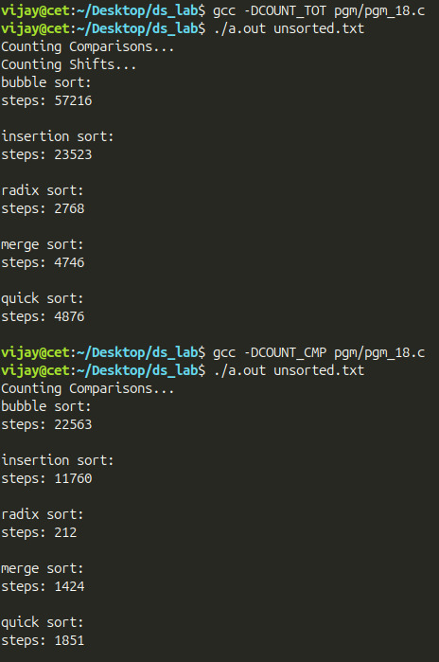

Program 19 — Maximum Activity Points with At Most K Events

Question
Our department is organizing a tech fest with so many exciting events. By participating in an event, you can claim for activity points as stipulated by KTU. Each event i gives you A[i] activity points where A is an array. If you are not allowed to participate in more than k events, what's the max number of points that you can earn?

Data Structures / Algorithm Used
• Data structure: a small fixed-size auxiliary array B[k], always kept sorted in descending order, representing the current best k activity-point values seen so far.
• Algorithm used — "keep the top-k" via insertion: for every incoming event value a, it is compared left-to-right against B; the first position j where a > B[j] is found, all elements from j onward are shifted one place to the right (discarding the smallest currently-kept value, B[k-1]), and a is written into B[j]. Since there is no ordering/adjacency restriction on which events may be chosen, the optimal strategy is simply to select the k highest-valued events — which is exactly what this insertion-based "maintain the top-k" array achieves in O(n·k) time — and the final answer is sum(B).

Program 19 — Pseudocode
ALGORITHM: TopKActivityPoints (maintain a sorted top-k via insertion)

DATA STRUCTURE
B[0..k-1] : ARRAY OF INTEGER, always kept in DESCENDING order,
holding the best k activity values seen so far

--------------------------------------------------------------
STEP 0: READ INPUT AND INITIALISE
--------------------------------------------------------------
1. READ k // max events a student may attend
2. READ n, A[0..n-1] // activity points offered by each event
3. B[0..k-1] <- 0 // no events picked yet

--------------------------------------------------------------
STEP 1: SCAN EVERY EVENT, KEEPING B AS THE CURRENT TOP-K
--------------------------------------------------------------
4. FOR EACH value a IN A[0..n-1] DO
5. FOR j <- 0 TO k - 1 DO
6. IF a > B[j] THEN
7. -- a beats the j-th best value seen so far --------
8. FOR m <- k - 1 DOWNTO j + 1 DO
9. B[m] <- B[m - 1] // shift smaller values right,
10. END FOR // discarding B[k-1] (old min)
11. B[j] <- a // insert a in its sorted place
12. BREAK // stop scanning B for this a
13. END IF
14. END FOR
15. END FOR

--------------------------------------------------------------
STEP 2: OUTPUT THE MAXIMUM ACHIEVABLE TOTAL
--------------------------------------------------------------
16. sum <- 0
17. FOR j <- 0 TO k - 1 DO sum <- sum + B[j]
18. OUTPUT "Maximum activity points:", sum

--------------------------------------------------------------
COMPLEXITY: O(n * k) time, O(k) auxiliary space. Since events
may be attended in any order (no adjacency constraint in the
problem), simply retaining the k largest values encountered is
provably optimal.
--------------------------------------------------------------

Program 19 — Code
#include <stdio.h>

int main() {
int n, k;
printf("Enter max events participatable: ");
scanf("%d", &k);
printf("Enter number of events: ");
scanf("%d", &n);
int A[n + k];
int *B = &A[n];

for (int i = 0; i < n; ++i)
scanf("%d", &A[i]);

for (int i = 0; i < k; ++i)
B[i] = 0;

for (int i = 0; i < n; ++i) {
int a = A[i];
for (int j = 0; j < k; ++j) {
if (a > B[j]) {
for (int m = k - 1; m > j; --m)
B[m] = B[m - 1];
B[j] = a;
break;
}
}
}

int sum = 0;
for (int i = 0; i < k; ++i)
sum += B[i];
printf("\n\nsum = %d\n", sum);

return 0;
}

Program 19 — Output
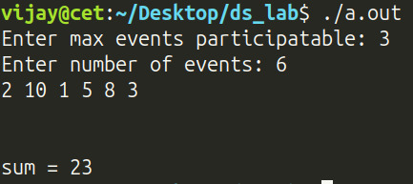

Program 20 — Spell Checker using a Hash Table

Question
Hash tables have a plethora of applications. Let us now explore one. You are given the task of implementing a spell checker. First, read a file vocabulary.txt containing valid words. Use an appropriate hash function to index them into a hash table sized 29, employing chaining for collision resolution. Next, read a second file myDocument.txt, and determine the count of misspelt words in it. Also suggest corrections for the misspelt words. You may assume that myDocument.txt consists only of (possibly misspelt) valid words.

Data Structures / Algorithm Used
• Data structure: a hash set with a custom string hash and comparator, storing the vocabulary as a set of unique words; a dynamic array separately holds every vocabulary word (needed to scan candidates for correction suggestions, since a hash set cannot be iterated in a useful order).
• Algorithm used: every word of vocabulary.txt is inserted into both the hash set (for O(1) average membership testing) and the list (for iteration). Every word of myDocument.txt is looked up in the hash set; any word not found is counted as a misspelling, and the Levenshtein edit distance is computed against every word in the vocabulary list — if the closest match is within an edit distance of 3, it is offered as a suggested correction.

Program 20 — Pseudocode
ALGORITHM: SpellChecker-HashSetWithSuggestions (hash set + edit distance)

DATA STRUCTURE
dict : HASH SET, keys = words (char*), custom hash StringHash + StringEqual
all_words : DYNAMIC ARRAY (LIST) of every vocabulary word, in insertion order

--------------------------------------------------------------
SUB-ALGORITHM: EditDistance(a, b) (Levenshtein Distance, DP)
--------------------------------------------------------------
1. FUNCTION EditDistance(a, b) RETURNS INTEGER
2. m <- LENGTH(a); n <- LENGTH(b)
3. CREATE table D[0..m][0..n]
4. FOR j <- 0 TO n DO D[0][j] <- j END FOR //cost of inserting all of b
5. FOR i <- 0 TO m DO D[i][0] <- i END FOR //cost of deleting all of a
6. FOR i <- 1 TO m DO
7. FOR j <- 1 TO n DO
8. cost <- 0 IF a[i] = b[j] ELSE 1
9. D[i][j] <- MIN(
10. D[i-1][j] + 1, //delete a character from a
11. D[i][j-1] + 1, //insert a character into a
12. D[i-1][j-1] + cost // substitute (or match)
13. )
14. END FOR
15. END FOR
16. RETURN D[m][n]
17. END FUNCTION

--------------------------------------------------------------
STEP 0: HASH FUNCTION (djb2-style byte hash)
--------------------------------------------------------------
1. FUNCTION StringHash(word) RETURNS bucketIndex
2. h <- djb2(bytes of word)
3. RETURN h
4. END FUNCTION

--------------------------------------------------------------
STEP 1: BUILD THE VOCABULARY SET AND LIST
--------------------------------------------------------------
5. CREATE empty hash set dict, hash = StringHash, cmp = StringEqual
6. CREATE empty list all_words
7. FOR EACH word (one per line) IN vocabulary.txt DO
8. SET-INSERT(dict, word) // O(1) average-case
9. LIST-APPEND(all_words, word)
10. END FOR

--------------------------------------------------------------
STEP 2: CHECK THE DOCUMENT AND SUGGEST CORRECTIONS
--------------------------------------------------------------
11. mistakes <- 0
12. FOR EACH word (one per line) IN myDocument.txt DO
13. IF SET-CONTAINS(dict, word) = FALSE THEN
14. bestWord <- all_words[0]
15. bestDist <- EditDistance(word, bestWord)
16. FOR EACH candidate IN all_words (from index 1) DO
17. d <- EditDistance(word, candidate)
18. IF d < bestDist THEN
19. bestWord <- candidate; bestDist <- d
20. END IF
21. END FOR
22. IF bestDist < 4 THEN
23. OUTPUT "You typed '", word, "'. Did you mean '", bestWord, "'?"
24. END IF
25. mistakes <- mistakes + 1
26. END IF
27. END FOR

--------------------------------------------------------------
STEP 3: REPORT AND CLEAN UP
--------------------------------------------------------------
28. OUTPUT "Mistakes:", mistakes
29. DESTROY dict, all_words

--------------------------------------------------------------
COMPLEXITY: building the set/list costs O(V) for V vocabulary
words; checking the document costs O(D) average-case lookups,
plus, for each of the M misspelt words, an O(V*L) scan for the
closest vocabulary word by edit distance (L = word length), using
the classic O(len(a)*len(b)) Levenshtein dynamic-programming
algorithm for EditDistance(a, b).
--------------------------------------------------------------

Program 20 — Code
#include <assert.h>
#include <stdio.h>
#include <string.h>
#define SET_IMPLEMENTATION
#include "set.h"
#define LIST_IMPLEMENTATION
#include "list.h"
#define LEN 64

int min(size_t a, size_t b, size_t c) {
return (a < b) ? ((a < c) ? a : c) : ((b < c) ? b : c);
}

// Levenshtein Distance
size_t edit_dist(const char *a, const char *b) {
size_t m, n;
m = strlen(a);
n = strlen(b);
size_t D[m + 1][n + 1];
size_t i, j;
for (j = 0; j <= n; ++j)
D[0][j] = j;
for (i = 0; i <= m; ++i)
D[i][0] = i;
size_t c;
for (i = 1; i <= m; ++i) {
for (j = 1; j <= n; ++j) {
c = (a[i - 1] == b[j - 1]) ? 0 : 1;
D[i][j] = min(
D[i - 1][j] + 1, // delete
D[i][j - 1] + 1, // insert
D[i - 1][j - 1] + c // substitute
);
}
}
return D[m][n];
}

size_t string_hash(const void *a, size_t size) {
size_t h = __hash(*(const char **)a, strlen(*(const char **)a));
return h;
}

int string_cmp(const void *a, const void *b, size_t s) {
const char *s1 = *(const char **)a;
const char *s2 = *(const char **)b;
int r = strcmp(s1, s2);
return r;
}

void string_free(void *a) { free(*(char **)a); }

int main(int argc, char **argv) {
assert(argc == 3 && "Usage: ./a.out 'vocabulary.txt' 'document.txt'");

set_t dict;
list_t all_words;
set_init(&dict, sizeof(char *), string_free);
set_hash(&dict, string_hash);
set_cmp(&dict, string_cmp);
list_init(&all_words, 3, sizeof(char *), NULL); // set will free
FILE *fh;
char line[LEN];
// fill dictionary
fh = fopen(argv[1], "r");
assert(fh);

while (fgets(line, LEN, fh)) {
line[strcspn(line, "\n")] = '\0';
char *s = strdup(line);
set_insert(&dict, &s);
add(&all_words, &s);
}

fclose(fh);
// now read and count mistakes
int c = 0;
fh = fopen(argv[2], "r");
assert(fh);

while (fgets(line, LEN, fh)) {
line[strcspn(line, "\n")] = '\0';
char *s = strdup(line);
if (!set_contains(&dict, &s)) {
char *min_word;
get(&all_words, 0, &min_word);
int min_dist = edit_dist(s, min_word);
for (int i = 1; i < list_size(&all_words); ++i) {
char *cur;
int cur_dist;
get(&all_words, i, &cur);
cur_dist = edit_dist(s, cur);
if (cur_dist < min_dist) {
min_word = cur;
min_dist = cur_dist;
}
}
if (min_dist < 4) {
printf("You typed '%s'. Did you mean '%s'?\n", s, min_word);
}
c++;
}
free(s);
}

set_free(&dict);
list_free(&all_words);
fclose(fh);
printf("Mistakes: %d\n", c);
return 0;
}

Program 20 — Output
