Home page



1)Here we will enter our article for classification

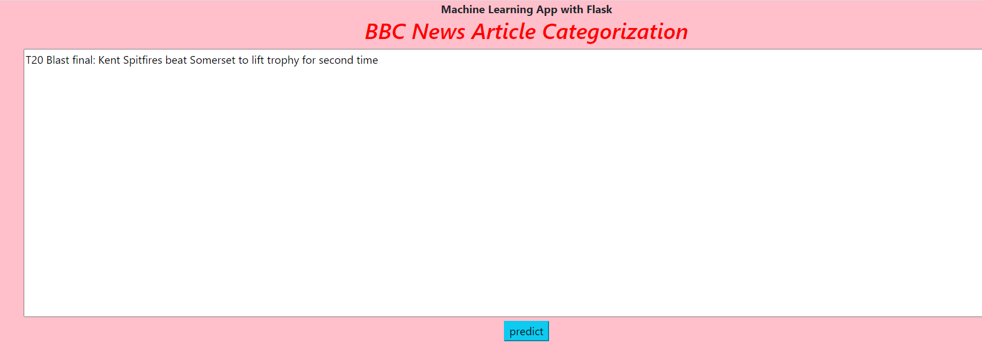

2) we have entered the data and it is ready for classification

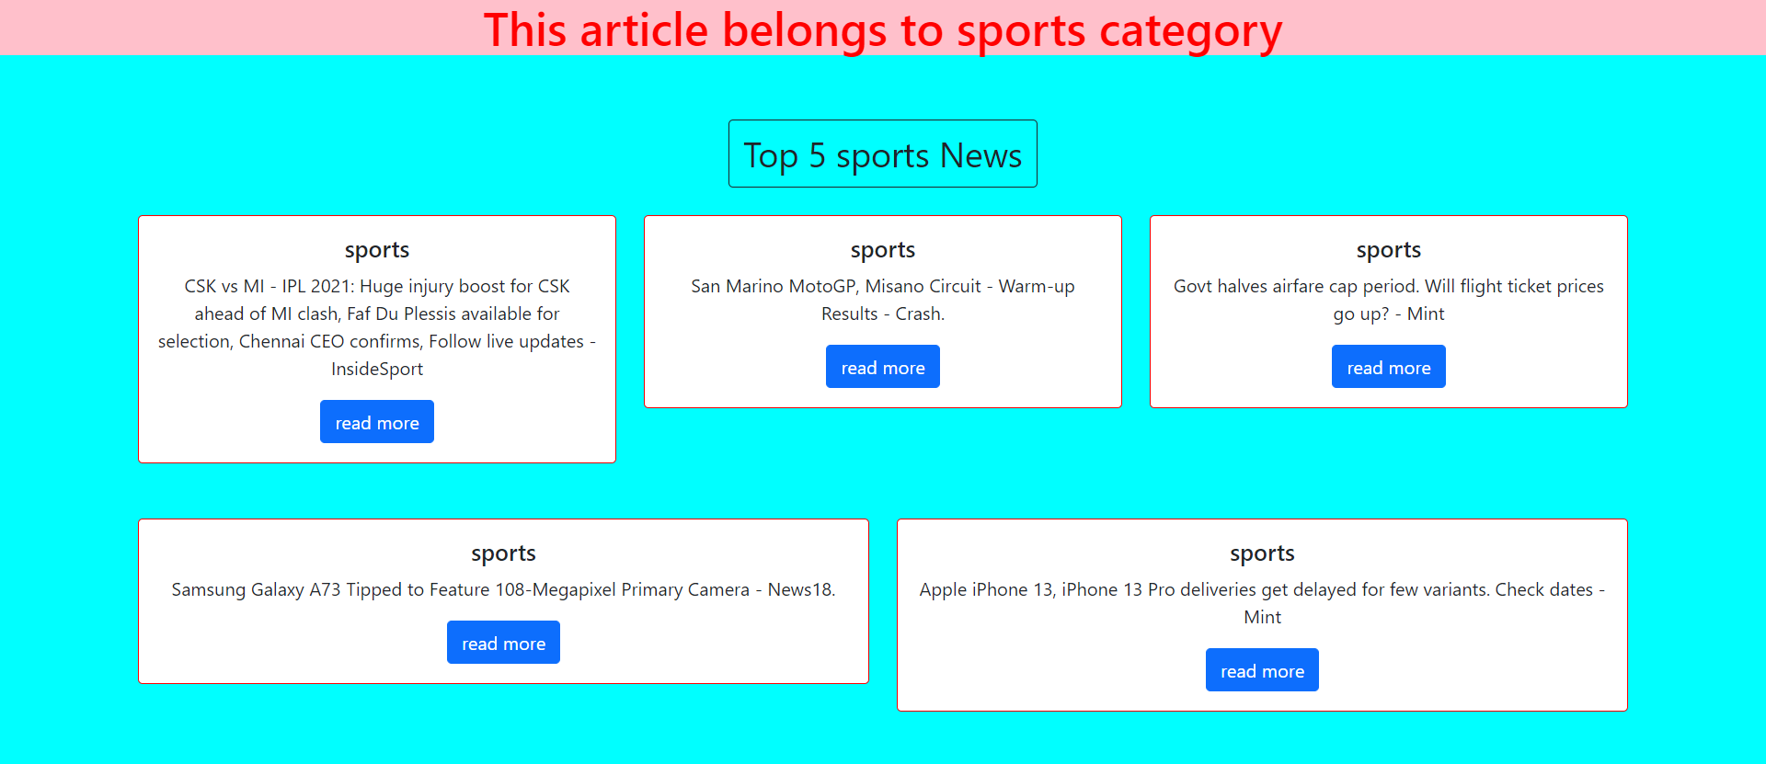

3) The model had correctly classified the article as sports category



4) The above figure describes the read more section