**NETWORK CONFIGURATION AND SETUP REPORT**

**Name:** Vijaysingh Puwar

**Objective**

The objective of this assignment is to configure and establish communication between multiple LANs using three routers by implementing the Routing Information Protocol (RIP) in Cisco Packet Tracer. This setup enables inter-network communication across different network segments, ensuring proper data routing.

**Network Topology Overview**

The network consists of the following components:

* **Three routers:** Router0, Router1, and Router2
* **Two switches:** Switch0 and Switch1
* **Four PCs:** PC0, PC1, PC2, and PC3
* **Interconnections:**
  + PCs are connected to switches using **Copper Straight-Through** cables.
  + Switches are connected to their respective routers using **Copper Straight-Through** cables.
  + Routers are connected to each other using **Fiber cables**.

**Steps Completed**

**Step 1: Device Addition**

* Added the required network devices in Cisco Packet Tracer, including routers, switches, and PCs.

**Step 2: Device Interconnections**

* Connected PCs to their respective switches.
* Connected switches to the routers using proper interfaces.
* Established connections between the three routers using **Fiber cables**.

**Step 3: PC IP Address Configuration**

Each PC was configured with the following IP addresses:

* **PC0:**
  + IP Address: 192.168.0.2
  + Subnet Mask: 255.255.255.0
  + Default Gateway: 192.168.0.1
* **PC1:**
  + IP Address: 192.168.0.3
  + Subnet Mask: 255.255.255.0
  + Default Gateway: 192.168.0.1
* **PC2:**
  + IP Address: 192.168.10.2
  + Subnet Mask: 255.255.255.0
  + Default Gateway: 192.168.10.1
* **PC3:**
  + IP Address: 192.168.10.3
  + Subnet Mask: 255.255.255.0
  + Default Gateway: 192.168.10.1

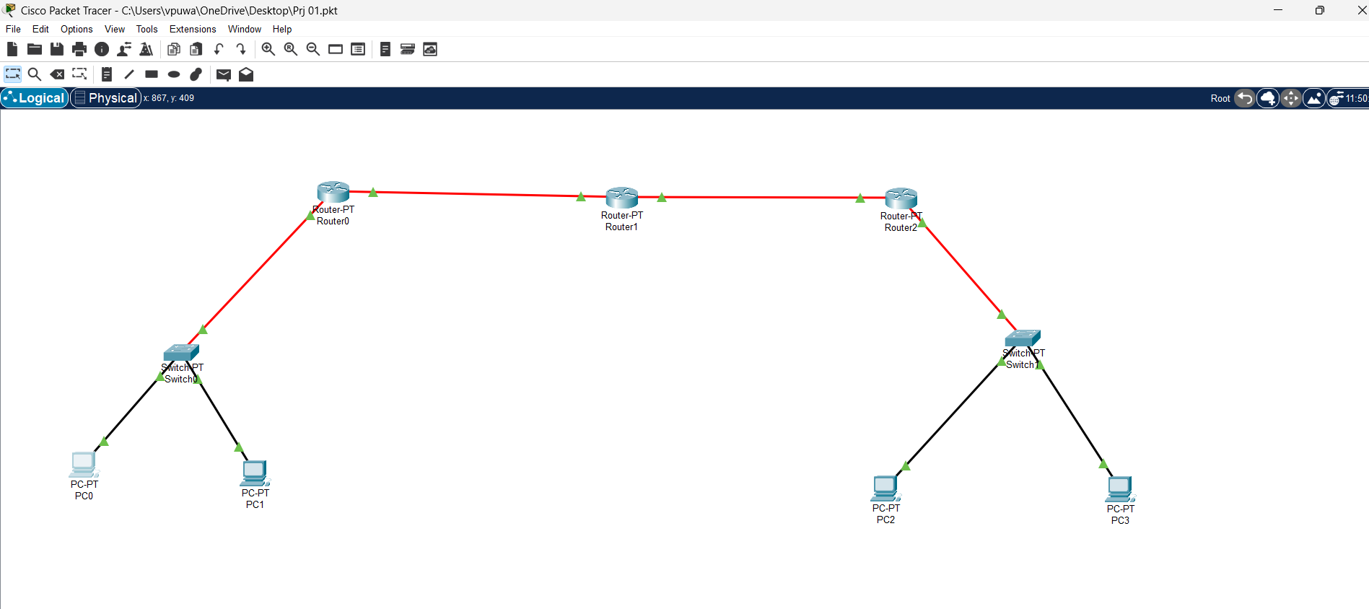

Here I have connected Router 0 and Router 2 With fiber cable to the switches.

**Step 4: Router Interface Configuration**

Each router was configured with the following interfaces:

* **Router0:**
  + LAN Interface: 192.168.0.1 / 255.255.255.0
  + WAN Interface (to Router1): 172.168.0.1 / 255.255.255.0
* **Router1:**
  + Interface to Router0: 172.168.0.2 / 255.255.255.0
  + Interface to Router2: 172.168.10.2 / 255.255.255.0
* **Router2:**
  + WAN Interface (to Router1): 172.168.10.1 / 255.255.255.0
  + LAN Interface: 192.168.10.1 / 255.255.255.0

**Step 5: Initial Connectivity Testing**

* Successfully established basic connectivity within individual LANs.
* Tested PC-to-PC connectivity within the same subnet.
* Attempted to ping between PCs across different routers, but no communication was established yet (as RIP has not been configured yet).

**Step 6: Ping Test Results and Explanation**

1. **Ping from PC0 to 172.168.0.2 (Router1's interface) - FAILED**
   * This indicates that Router1 is not yet configured to handle packets from PC0.
   * Possible causes: Incorrect IP assignment or missing RIP configuration.

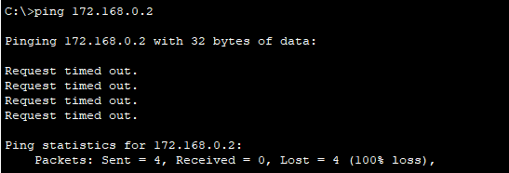

1. **Ping from PC0 to 192.168.10.3 (PC3) - FAILED (Destination Host Unreachable)**
   * The response came from 192.168.0.1 (Router0), indicating that Router0 has no route to the 192.168.10.0 network.
   * This means that RIP is not propagating routes between the routers yet.

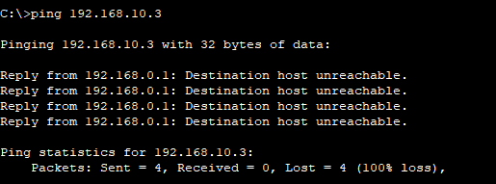

1. **Ping from PC0 to 192.168.10.2 (PC2) - FAILED (Destination Host Unreachable)**
   * Similar to the previous failure, Router0 does not know how to reach the 192.168.10.0 network.
   * RIP needs to be configured for dynamic routing.

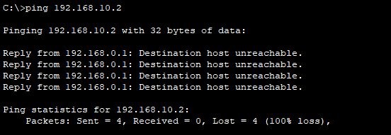

1. **Ping from PC0 to 192.168.0.3 (PC1) - SUCCESS**
   * Since PC0 and PC1 are on the same subnet, they can communicate without any routing issues.

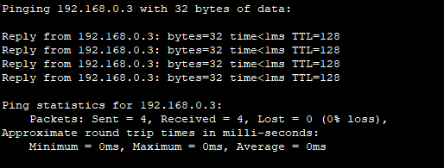

1. **Ping from PC0 to 172.168.10.2 (Router2’s WAN Interface) - FAILED**
   * Indicates that Router2 is not advertising its networks yet.
   * Likely reason: RIP is not configured, or interfaces are down.

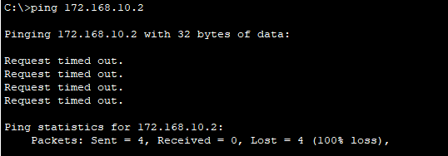

**Step 7: Entering Global Configuration Mode in Router0**

To configure RIP, the following commands were executed in Router0:

Router> enable

Router# configure terminal

Router (config)#

This placed the router in global configuration mode, allowing us to modify routing settings.

**Step 8: Configuring RIPv2 on Router0**

The following commands were used to enable RIP:

Router (config)# router rip

Router (config-router)# version 2

Router (config-router)# no auto-summary

Router (config-router)# network 192.168.0.0

Router (config-router)# network 172.168.0.0

Router (config-router)# end

This configuration ensures that RIP is running and advertising directly connected networks.

**Step 9: Saving the Configuration**

The configuration was saved using:

Router# copy running-config startup-config

This prevents the settings from being lost after a reboot.

**Step 10: Verifying RIP Configuration**

To check if Router0 learned routes via RIP, the command:

Router# show ip route rip

was executed. Initially, the routing table may be empty, but after a short period, routes from Router1 and Router2 should start appearing.

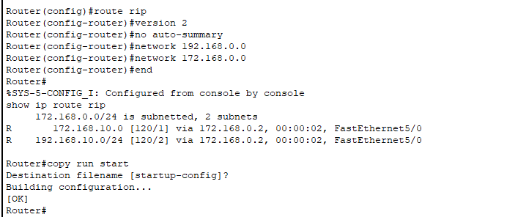

**Step 10: Repeating RIP Configuration for Other Routers**

The same configuration process was applied to Router1 and Router2:

**Router1:**

Router> enable

Router# configure terminal

Router (config)# router rip

Router (config-router)# version 2

Router (config-router)# no auto-summary

Router (config-router)# network 172.168.0.0

Router (config-router)# network 172.168.10.0

Router (config-router)# end

Router# copy running-config startup-config

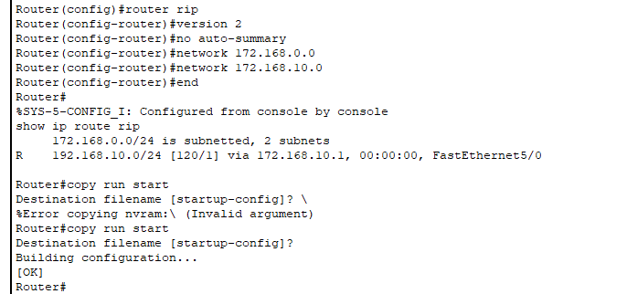

**Router2:**

Router> enable

Router# configure terminal

Router (config)# router rip

Router (config-router)# version 2

Router (config-router)# no auto-summary

Router (config-router)# network 172.168.10.0

Router (config-router)# network 192.168.10.0

Router (config-router)# end

Router# copy running-config startup-config

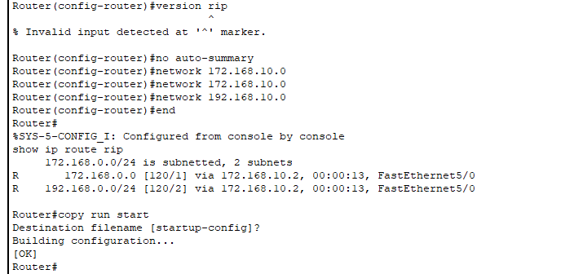

**Step 11: Ping Test Results and Explanation**

After configuring RIP, connectivity was tested again. The expected results were:

* **PC0 to PC1: Success**



* **PC0 to Router1’s interfaces: Success**

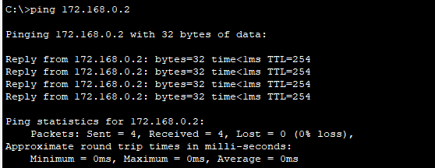

* **PC0 to Router2’s interfaces: Success**

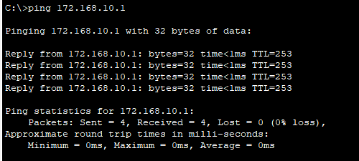

* **PC0 to PC3: Success**

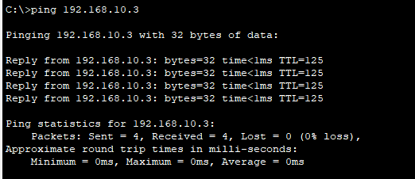

**This confirms that RIP is successfully advertising routes between all routers, allowing full**

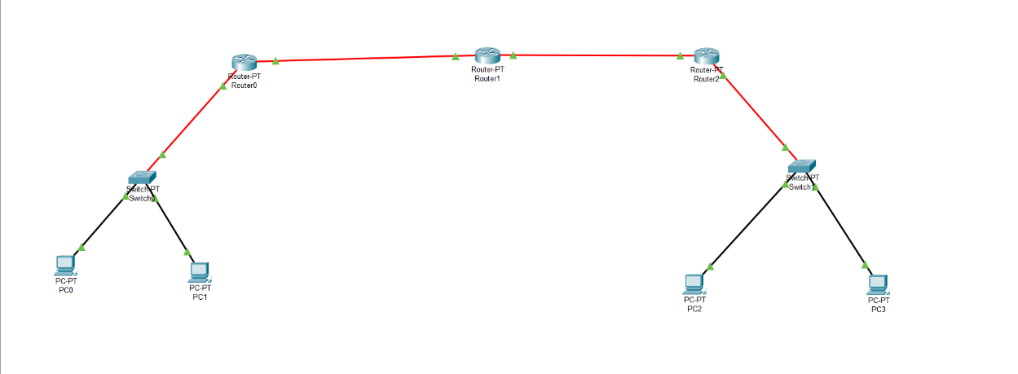

**Conclusion:**

The successful implementation of RIPv2 on all three routers facilitated seamless communication between multiple LAN segments, demonstrating the effectiveness of dynamic routing in enterprise networks. By properly configuring router interfaces, implementing RIP, and verifying routing tables, all devices were able to communicate efficiently across the network.

This project provided valuable hands-on experience in network configuration, troubleshooting, and protocol implementation. Through structured testing and debugging, the importance of accurate IP addressing, routing protocol selection, and command execution was reinforced. Additionally, it highlighted the role of Packet Tracer as a powerful tool for simulating real-world networking scenarios.

The final connectivity test confirmed that all routing paths were properly established, ensuring reliable data transmission between connected devices. This project successfully met the learning objectives by integrating theoretical networking concepts with practical application, strengthening my understanding of network design and troubleshooting methodologies.