1)

2)

3)

4)

5)

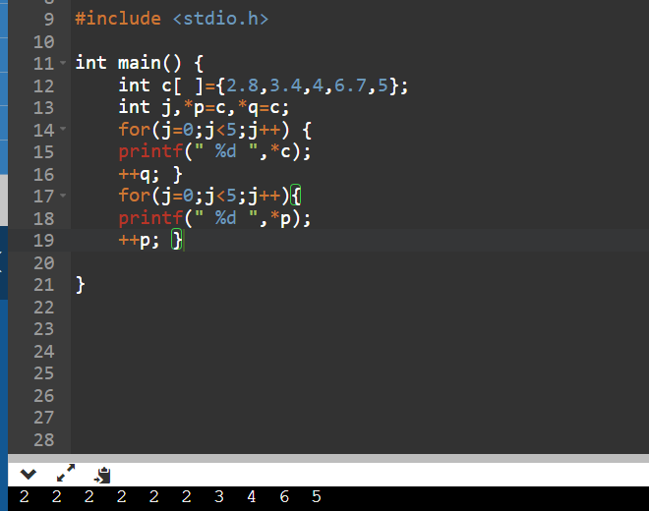

6)

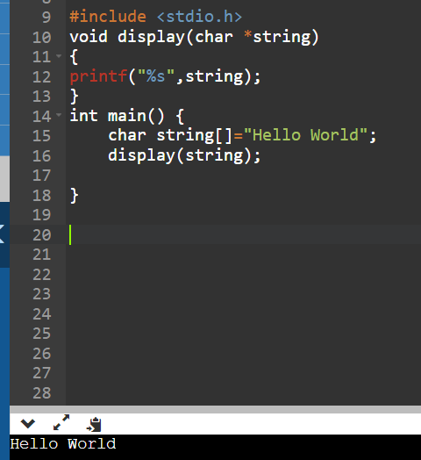

7)

8)

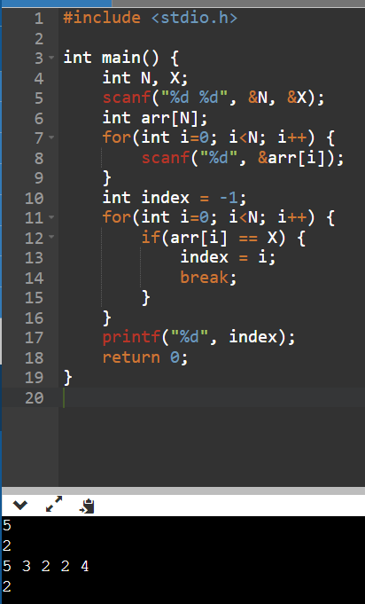

9)

10)

