TOPOLOGY

## PROCEDURE:

*first,open the cisco packet tracer desktop and select the devices that are needed

*we have to take a switch and link to the devices

*link every devices with the switch

*provide the Ip address to each device

*transfer message from one device to another and check the table foe validation

# STAR TOPOLOGY:

All the devices are connected to a single hub through a cable

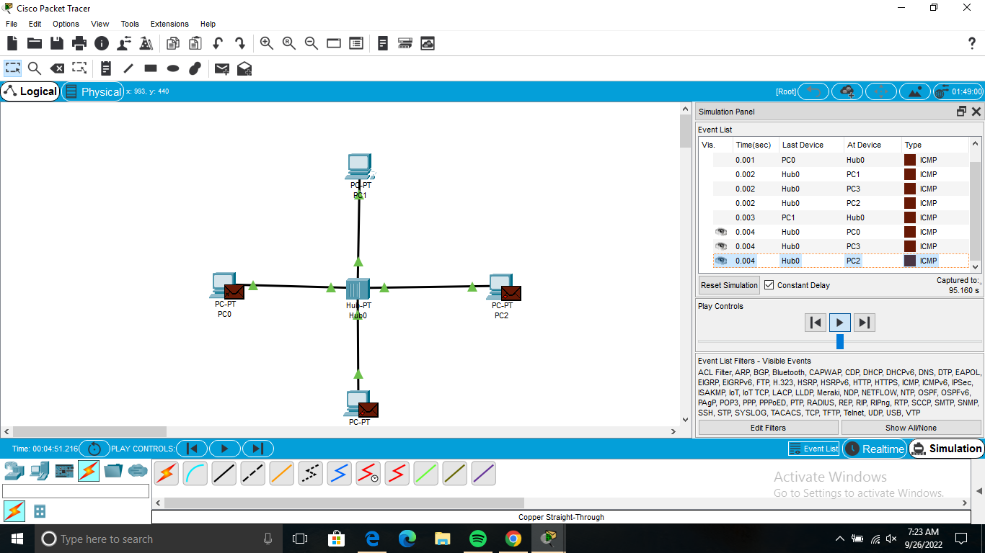

### MESH TOPOLOGY:

Every device is connected to another device via a particular channel

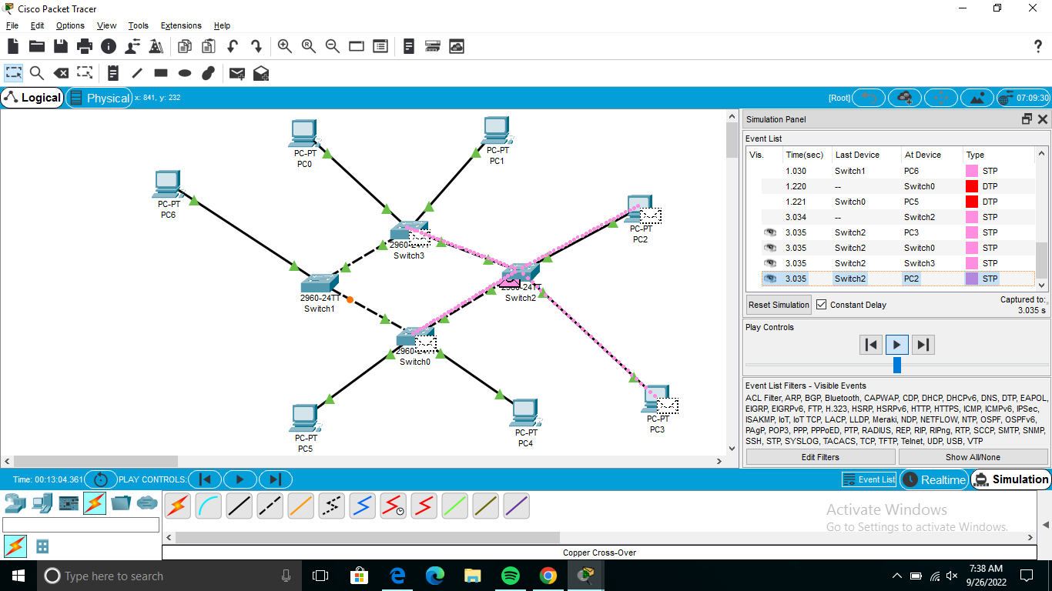

### TREE TOPOLOGY:

It is the variation of short topology and as hierarcheal flow of data.

