Step 1: Initialize a Git Repository
Command:
git init
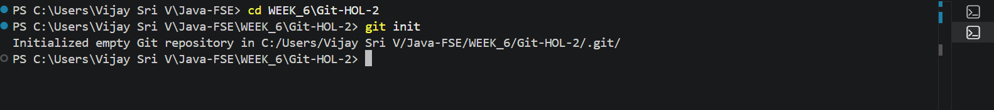
Step 2: Create Required Files
Created the following files:
- README.md
- .gitignore
- sample.log
- log/test.txt
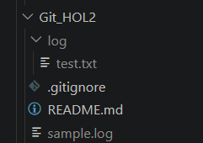
Step 3: Check Git Status
Command:
git status
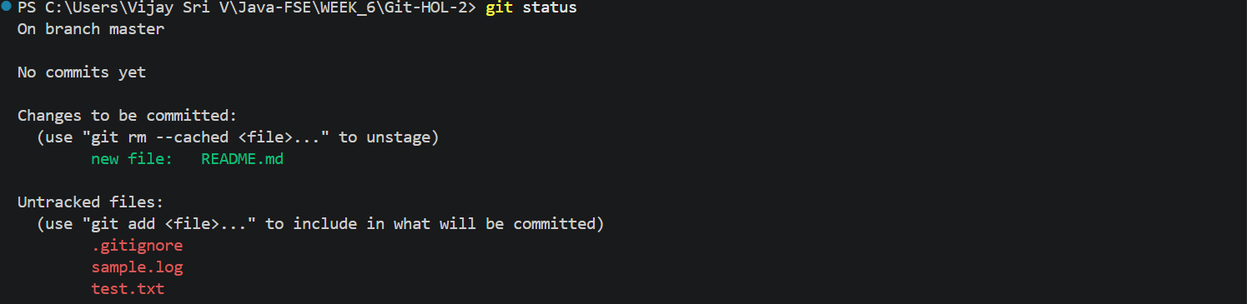
Step 4: Add Files to Staging Area
Command:
git add README.md .gitignore
git status
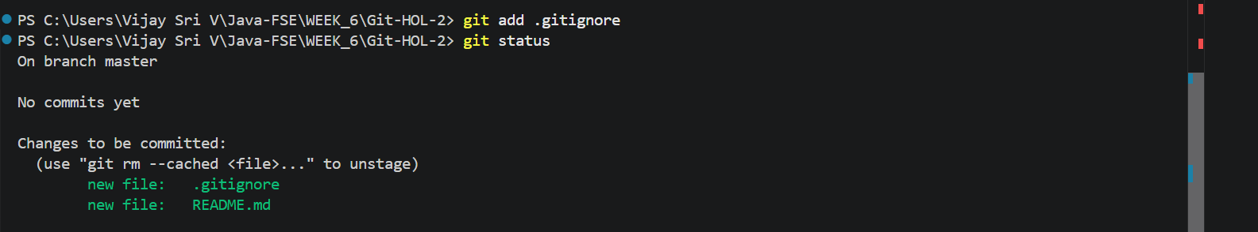
Step 5: Commit the Changes
Command:
git commit -m "Added Git HOL2"
Step 6: View Commit History
Command:
git log --oneline

