Step 1: Go to Git_HOL3 folder
cd Week6\Git_HOL3
Step 2: Initialize Repository
git init
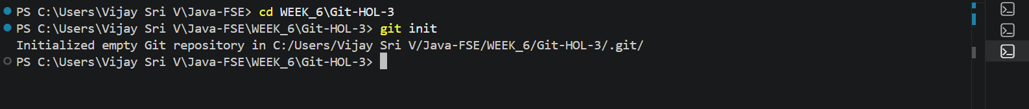
Step 3: Create README
echo "# Git HOL3" > README.md
git add README.md
git commit -m "Initial commit"
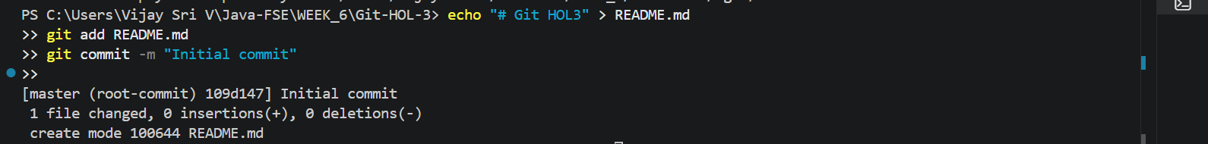
Step 4: Create New Branch
git branch GitNewBranch
Step 5: List Branches
git branch
Step 6: Switch to New Branch
git checkout GitNewBranch
Step 7: Create a File
echo "This file is created in GitNewBranch" > branch.txt
Step 8: Commit in Branch
git add .
git commit -m "Added branch file"
Step 9: Check Status
git status
Merging
Step 10: Switch to Master
git checkout master
Step 11: Compare Branches
git diff master GitNewBranch
Step 12: Merge Branch
git merge GitNewBranch
Step 13: View Log
git log --oneline --graph --decorate
Step 14: Delete Branch
git branch -d GitNewBranch

Step 15: Check Status
git status

