Step 1: Initialize the Git Repository
Commands:
git init
echo "# Git HOL4" > README.md
git add README.md
git commit -m "Initial commit"
git branch
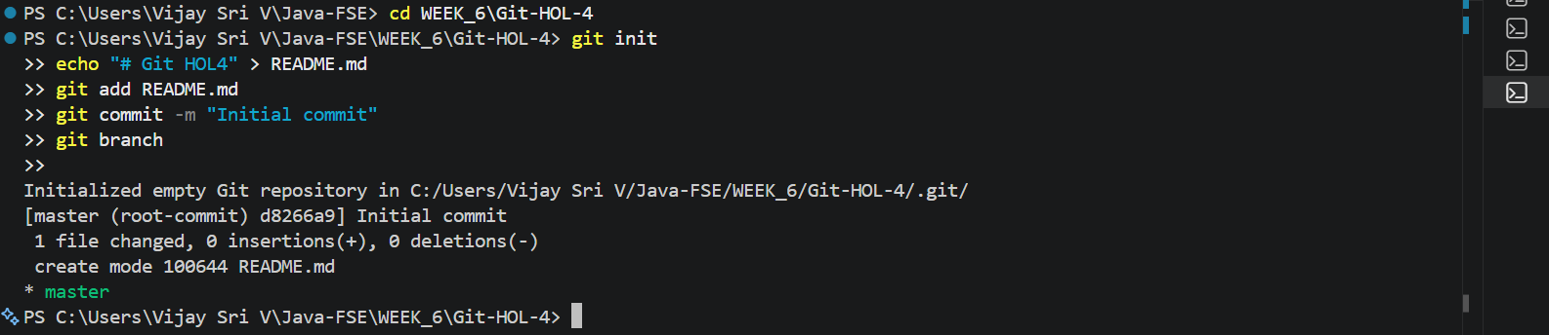
Step 2: Create a New Branch and Commit Changes
Commands:
git branch GitWork
git checkout GitWork
echo "<message>Hello from GitWork</message>" > hello.xml
git status
git add hello.xml
git commit -m "Added hello.xml in GitWork"
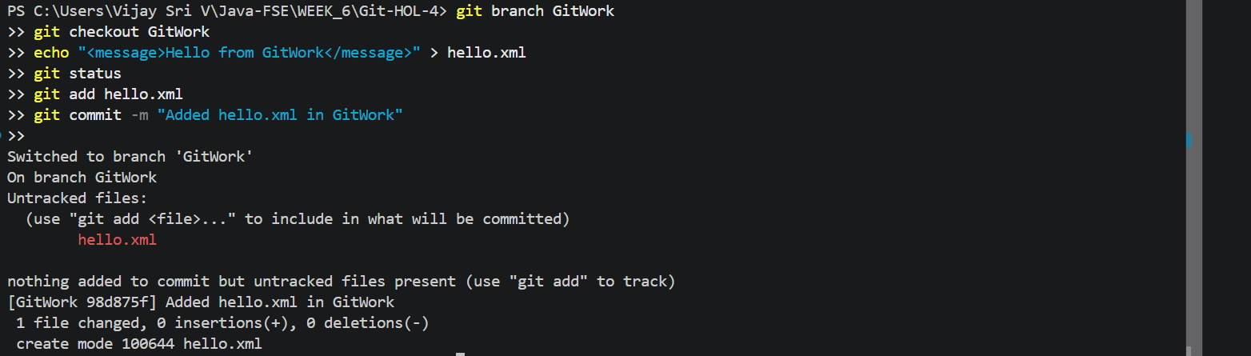
Step 3: Switch to Master and Commit Changes
Commands:
git checkout master
echo "<message>Hello from Master</message>" > hello.xml
git add hello.xml
git commit -m "Added hello.xml in master"
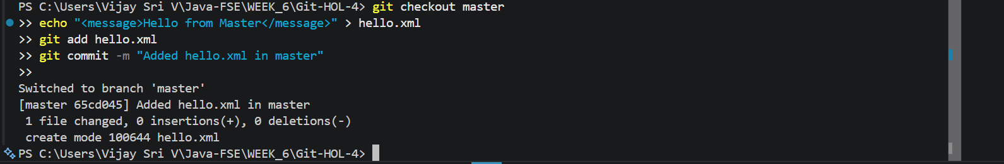
Step 4: View Commit History
Command:
git log --oneline --graph --decorate --all
Step 5: Compare the Branches
Command:
git diff master GitWork
Step 6: Merge the Branch and Resolve the Conflict
Commands:
git merge GitWork
Resolve the conflict in hello.xml, then run:
git add hello.xml
git commit -m "Resolved merge conflict"
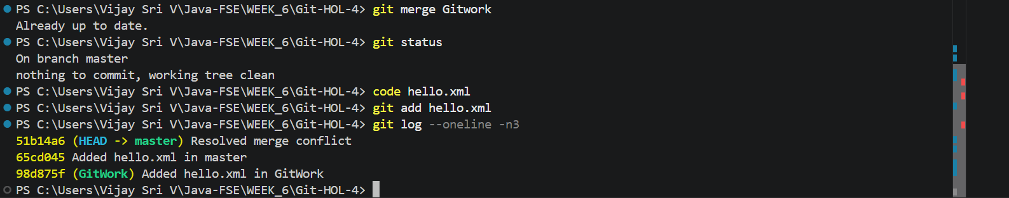
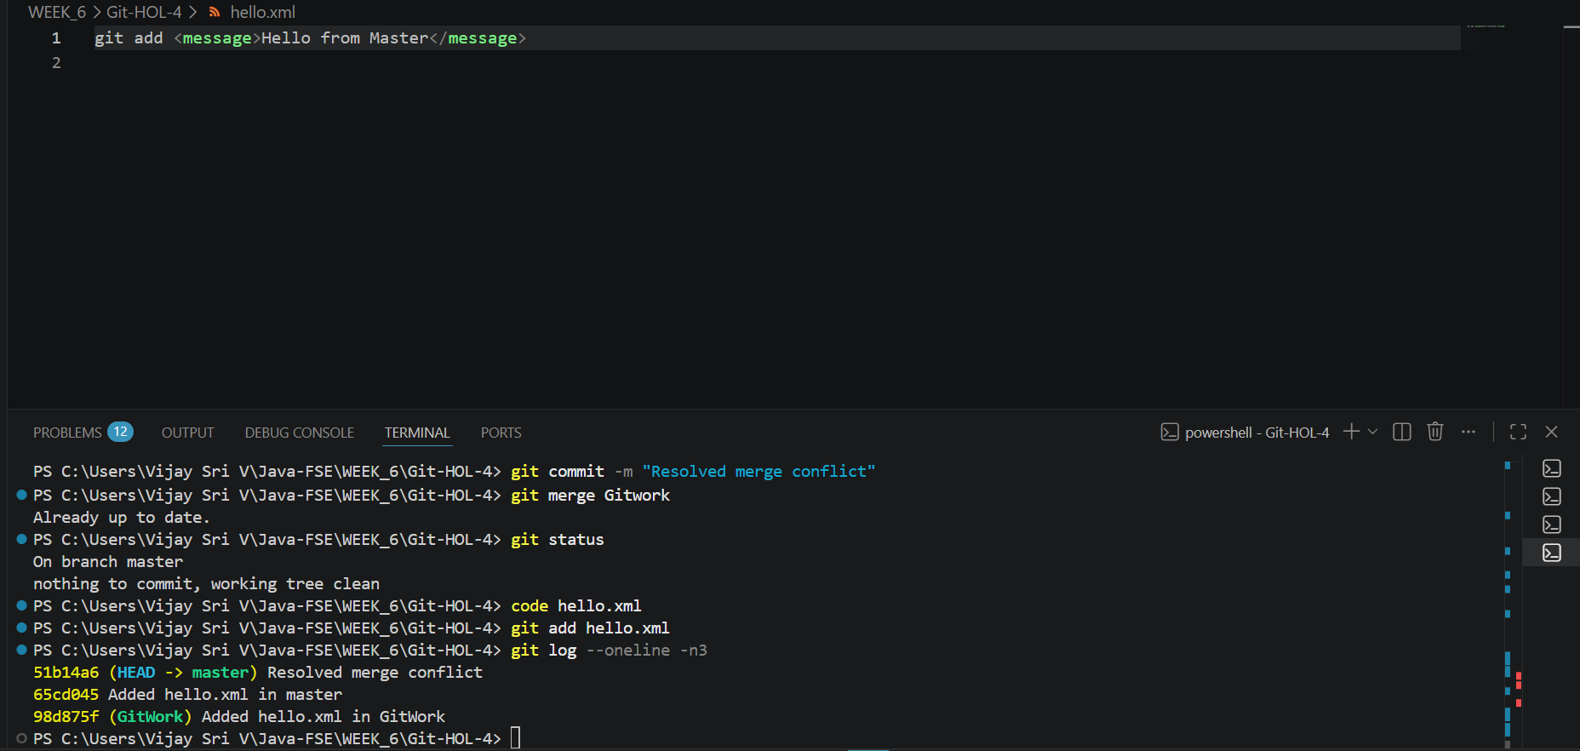
Step 7: Add .gitignore
Commands:
echo "*.orig" > .gitignore
git add .gitignore
git commit -m "Added .gitignore"
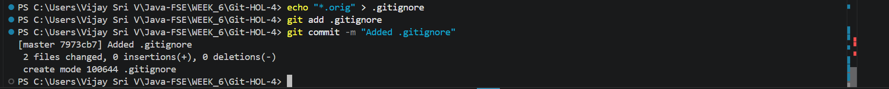
Step 8: Delete the Branch and Verify
Commands:
git branch
git branch -d GitWork
git branch
git log --oneline --graph --decorate
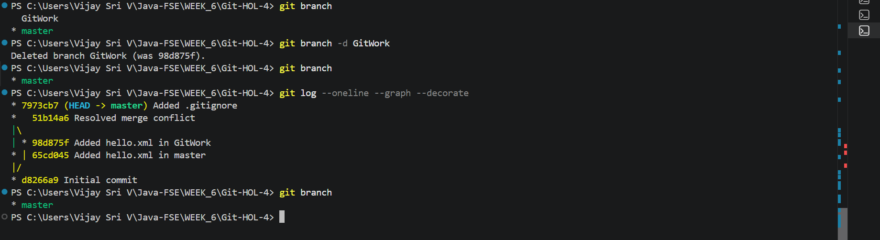
Result
The merge conflict was resolved successfully. The changes were merged into the master branch, the .gitignore file was added, and the merged branch was deleted successfully.

