|  |  |
| --- | --- |
| **Ex:No:3** |  |
| **Date:** |

**Aim:**

**Procedure:**

**Program**

**LOGIN.HTML**

<!DOCTYPE html>

<html lang="en">

<head>

<meta charset="UTF-8">

<meta name="viewport" content="width=device-width, initial-scale=1.0">

<title>Login - Quizz GO!</title>

<link rel="stylesheet" href="https://maxcdn.bootstrapcdn.com/bootstrap/4.5.2/css/bootstrap.min.css">

<style>

body {

background-image: url('loginbg.jpg');

background-size: cover;

background-repeat: no-repeat;

}

.container {

background-color: #ffffff;

position: relative;

top:90px;

padding: 20px;

border-radius: 10px;

box-shadow: 0px -25px 80px -20px rgba(227, 19, 189, 0.886),

0px 60px 80px -15px rgba(227, 19, 189, 0.886),0px -25px 80px -20px rgba(227, 19, 189, 0.886),0px -25px 80px -20px rgba(227, 19, 189, 0.886);

}

</style>

</head>

<body>

<div class="container mt-5">

<center><h2>Login</h2></center>

<form id="loginForm" action="succes.html" >

<div class="form-group">

<label for="email">Email:</label>

<input type="text" class="form-control" id="email" placeholder="Enter your email" required>

<small id="emailError" class="form-text text-danger"></small>

</div>

<div class="form-group">

<label for="password">Password:</label>

<input type="password" class="form-control" id="password" placeholder="Enter your password" required>

<small id="passwordError" class="form-text text-danger"></small>

</div>

<button type="submit" class="btn btn-primary">Login</button>

<div class="mt-3">

<p>Don't have an account? <a href="signup.html">Sign up here</a></p>

<p>Continue with Google: <a href="https://accounts.google.com/">Login with Google</a></p>

</div>

</form>

</div>

<script src="https://code.jquery.com/jquery-3.5.1.slim.min.js"></script>

<script src="https://cdn.jsdelivr.net/npm/@popperjs/core@2.9.3/dist/umd/popper.min.js"></script>

<script src="https://maxcdn.bootstrapcdn.com/bootstrap/4.5.2/js/bootstrap.min.js"></script>

<script>

var flag = 1;

$(document).ready(function () {

$(document).ready(function () {

$('#loginForm').submit(function (event) {

event.preventDefault();

$('#emailError').text('');

$('#passwordError').text('');

var email = $('#email').val();

if(email.length==0)

{

$('#emailError').text('Please fill out this field');

flag=0;

event.preventDefault();

}

else if(email.length<3)

{

$('#emailError').text('Invalid email address');

flag=0;

event.preventDefault();

}

if (!isValidEmail(email)) {

$('#emailError').text('Invalid email address');

flag=0;

event.preventDefault();

}

var password = $('#password').val();

if (password.length ==0) {

$('#passwordError').text('Please fillout this field');

flag=0;

event.preventDefault();

}

else if (password.length < 6) {

$('#passwordError').text('Password must be at least 6 characters');

flag=0;

event.preventDefault();

}

if(flag==1)

{

alert("Login successfull");

window.location.href="index.html";

}

});

function isValidEmail(email) {

var emailRegex = /^[a-zA-Z][a-zA-Z0-9.-]+@[a-zA-Z0-9.-]+\.[a-zA-Z]{2,}$/;

return emailRegex.test(email);

}});

});

</script>

</body>

</html>

**Output**

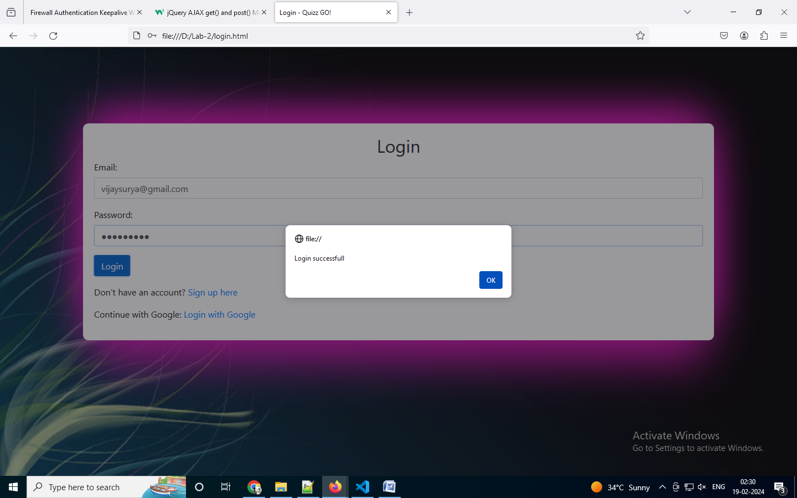

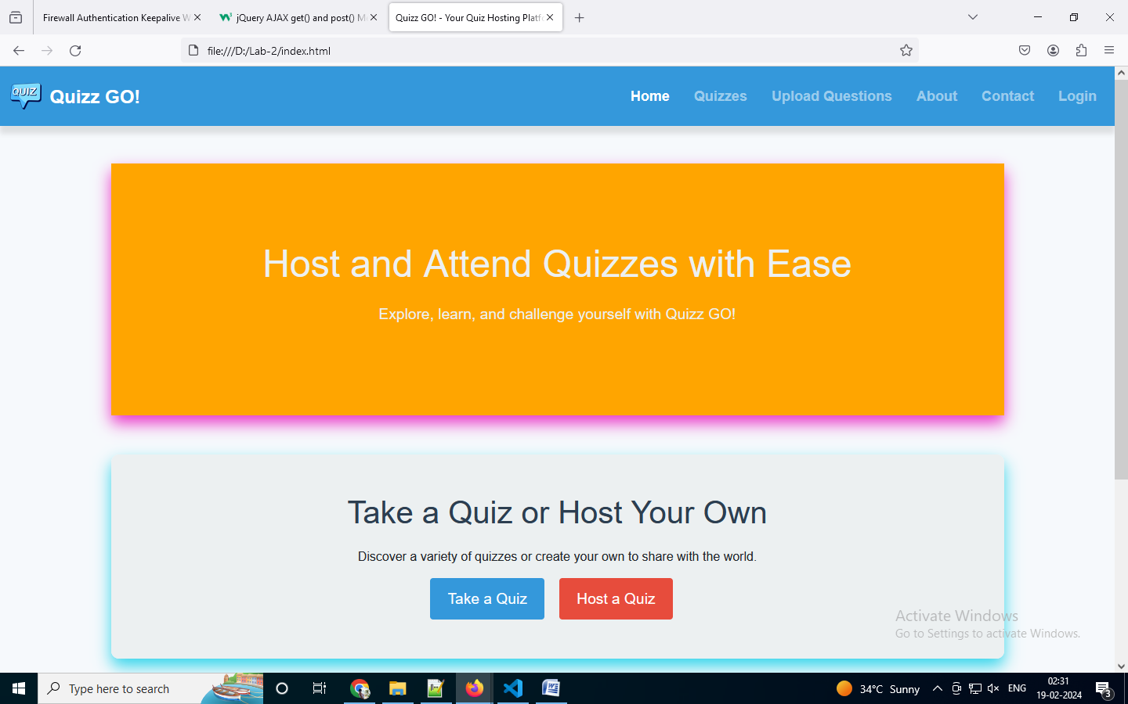

**Result**