|  |  |
| --- | --- |
| **Ex:No:4** |  |
| **Date:** |

**Aim:**

**Procedure:**

**Program**

**LOGIN.HTML**

<!DOCTYPE html>

<html lang="en">

<head>

<meta charset="UTF-8">

<meta name="viewport" content="width=device-width, initial-scale=1.0">

<title>Login - Quizz GO!</title>

<link rel="stylesheet" href="https://maxcdn.bootstrapcdn.com/bootstrap/4.5.2/css/bootstrap.min.css">

<style>

body {

background-image: url('loginbg.jpg');

background-size: cover;

background-repeat: no-repeat;

}

.container {

background-color: #ffffff;

position: relative;

top: 90px;

padding: 20px;

border-radius: 10px;

box-shadow: 0px -25px 80px -20px rgba(227, 19, 189, 0.886),

0px 60px 80px -15px rgba(227, 19, 189, 0.886),0px -25px 80px -20px rgba(227, 19, 189, 0.886),0px -25px 80px -20px rgba(227, 19, 189, 0.886);

}

</style>

</head>

<body>

<div class="container mt-5">

<center><h2>Login</h2></center>

<form id="loginForm">

<div class="form-group">

<label for="email">Email:</label>

<input type="email" class="form-control" id="email" placeholder="Enter your email" required>

<small id="emailError" class="form-text text-danger"></small>

</div>

<div class="form-group">

<label for="password">Password:</label>

<input type="password" class="form-control" id="password" placeholder="Enter your password" required>

<small id="passwordError" class="form-text text-danger"></small>

</div>

<button type="submit" class="btn btn-primary">Login</button>

<div class="mt-3">

<p>Don't have an account? <a href="signup.html">Sign up here</a></p>

<p>Continue with Google: <a href="https://accounts.google.com/">Login with Google</a></p>

</div>

</form>

</div>

<script src="https://code.jquery.com/jquery-3.5.1.min.js"></script>

<script>

$(document).ready(function () {

$('#loginForm').submit(function (event) {

event.preventDefault();

$('#emailError').text('');

$('#passwordError').text('');

var email = $('#email').val();

var password = $('#password').val();

var flag = true;

if (email.length === 0) {

$('#emailError').text('Please fill out this field');

flag = false;

} else if (!isValidEmail(email)) {

$('#emailError').text('Invalid email address');

flag = false;

}

if (password.length === 0) {

$('#passwordError').text('Please fill out this field');

flag = false;

} else if (password.length < 6) {

$('#passwordError').text('Password must be at least 6 characters');

flag = false;

}

$.ajax({

type: "POST",

url: "login.php",

data: {email: email, password: password},

success: function(response) {

console.log(response);

if (response === "success") {

window.location.href = "succes.html";

} else if (response === "failure") {

alert("Incorrect email or password. Please try again.");

} else {

alert("An error occurred. Please try again later.");

}

},

error: function(xhr, status, error) {

console.error(xhr.responseText);

alert("An error occurred. Please try again later.");

}

});});

function isValidEmail(email) {

var emailRegex = /^[a-zA-Z][a-zA-Z0-9.-]+@[a-zA-Z0-9.-]+\.[a-zA-Z]{2,}$/;

return emailRegex.test(email);

}

});

</script>

</body>

</html>

**LOGIN.PHP**

<?php

if ($_SERVER["REQUEST_METHOD"] == "POST") {

if(isset($_POST['email']) && isset($_POST['password'])) {

$email = $_POST['email'];

$password = $_POST['password'];

$valid_email = "vijay123@gmail.com";

$valid_password = "123456";

if ($email === $valid_email && $password === $valid_password) {

echo "success";

exit;

} else {

echo "failure";

exit;

}

} else {

echo "invalid";

exit;

}

} else {

header("HTTP/1.1 403 Forbidden");

exit;

}

?>

**Output**

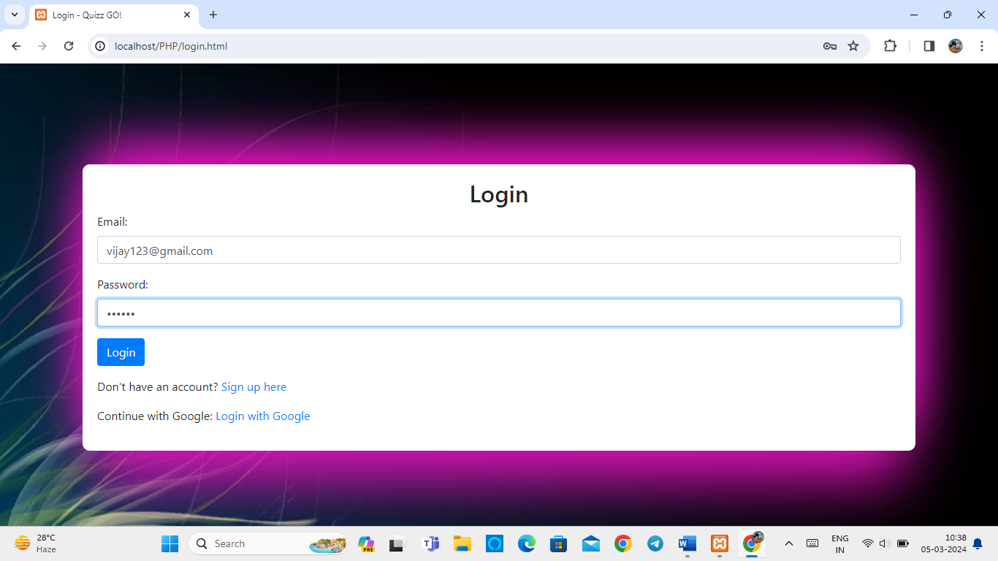

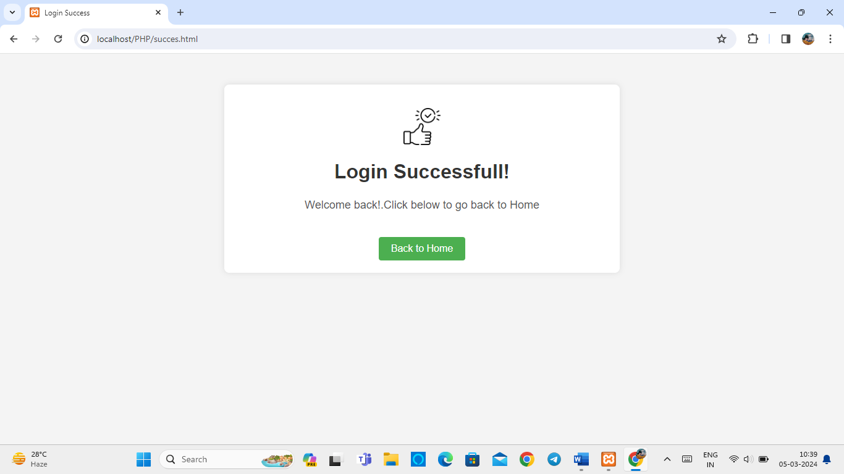

|  |  |  |
| --- | --- | --- |
| COE | 30 |  |
| RECORD | 15 |  |
| VIVA | 15 |  |
| TOTAL | 60 |  |

**Result**