|  |  |
| --- | --- |
| **Ex:No:05** | **Create Web Form with AngularJS** |
| **Date:** |

**Aim:**

**Procedure:**

**Program**

**FEEDBACK.HTML**

<!DOCTYPE html>

<html>

<head>

<title>Feedback Form</title>

<link rel="stylesheet" href="https://cdnjs.cloudflare.com/ajax/libs/font-awesome/5.15.4/css/all.min.css">

<script src="https://ajax.googleapis.com/ajax/libs/angularjs/1.6.9/angular.min.js"></script>

<style>

body {

font-family: Arial, sans-serif;

background-color: #f4f4f4;

margin: 0;

padding: 0;

}

.container {

max-width: 600px;

margin: 50px auto;

padding: 20px;

background-color: #fff;

border-radius: 8px;

box-shadow: 0 0 10px rgba(0, 0, 0, 0.1);

transition: all 0.3s ease;

}

.container:hover {

transform: translateY(-5px);

box-shadow: 0 10px 20px rgba(0, 0, 0, 0.2);

}

h2 {

text-align: center;

color: #333;

}

form {

margin-top: 20px;

}

input[type="text"],

input[type="email"],

textarea {

width: 100%;

padding: 10px;

margin-bottom: 15px;

border: 1px solid #ccc;

border-radius: 5px;

box-sizing: border-box;

font-size: 16px;

transition: all 0.3s ease;

}

input[type="text"]:focus,

input[type="email"]:focus,

textarea:focus {

border-color: #4CAF50;

}

textarea {

resize: vertical;

height: 150px;

}

button[type="submit"] {

background-color: #4CAF50;

color: white;

padding: 12px 20px;

border: none;

border-radius: 4px;

cursor: pointer;

width: 100%;

font-size: 16px;

transition: background-color 0.3s ease;

}

button[type="submit"]:hover {

background-color: #45a049;

}

.confirmation {

margin-top: 20px;

background-color: #dff0d8;

border: 1px solid #d6e9c6;

color: #3c763d;

padding: 15px;

border-radius: 4px;

}

.error {

color: #d9534f;

margin-top: 5px;

font-size: 14px;

}

.icon {

position: relative;

top: 6px;

margin-right: 5px;

}

.feedback-item {

margin-top: 20px;

border-top: 1px solid #ccc;

padding-top: 15px;

transition: all 0.3s ease;

}

.feedback-item:hover {

background-color: #f9f9f9;

transform: translateY(-5px);

box-shadow: 0 5px 10px rgba(0, 0, 0, 0.1);

}

</style>

</head>

<body>

<div ng-app="feedbackApp" ng-controller="FeedbackController" class="container">

<h2>Feedback Form</h2>

<form ng-submit="submitFeedback()" name="feedbackForm" novalidate>

<p>Name: <input type="text" ng-model="formData.name" placeholder="Enter your name" required></p>

<div class="error" ng-show="feedbackForm.name.$error.required && feedbackForm.name.$dirty">

<i class="fas fa-exclamation-circle icon"></i> Name is required

</div>

<p>Email: <input type="email" ng-model="formData.email" placeholder="Enter your email" required></p>

<div class="error" ng-show="feedbackForm.email.$error.required && feedbackForm.email.$dirty">

<i class="fas fa-exclamation-circle icon"></i> Email is required

</div>

<div class="error" ng-show="feedbackForm.email.$error.email && feedbackForm.email.$dirty">

<i class="fas fa-exclamation-circle icon"></i> Please enter a valid email address

</div>

<p>Message: <textarea ng-model="formData.message" placeholder="Enter your message" required></textarea></p>

<div class="error" ng-show="feedbackForm.message.$error.required && feedbackForm.message.$dirty">

<i class="fas fa-exclamation-circle icon"></i> Message is required

</div>

<button type="submit" ng-disabled="feedbackForm.$invalid">Submit</button>

</form>

<div ng-show="showConfirmation" class="confirmation">{{confirmationMessage}}</div>

<div ng-repeat="feedback in feedbackList" class="feedback-item">

<p><strong>Name:</strong> {{ feedback.name }}</p>

<p><strong>Email:</strong> {{ feedback.email }}</p>

<p><strong>Message:</strong> {{ feedback.message }}</p>

</div>

</div>

<script>

angular.module('feedbackApp', [])

.controller('FeedbackController', ['$scope', function($scope) {

$scope.formData = {};

$scope.feedbackList = [];

$scope.showConfirmation = false;

$scope.submitFeedback = function() {

var newFeedback = {

name: $scope.formData.name,

email: $scope.formData.email,

message: $scope.formData.message

};

$scope.feedbackList.push(newFeedback);

$scope.showConfirmation = true;

$scope.confirmationMessage = "Thank you for your message, " + $scope.formData.name + "! We'll get back to you soon.";

$scope.formData = {};

$scope.feedbackForm.$setPristine();

$scope.feedbackForm.$setUntouched();

};

}]);

</script>

</body>

</html>

**Output**

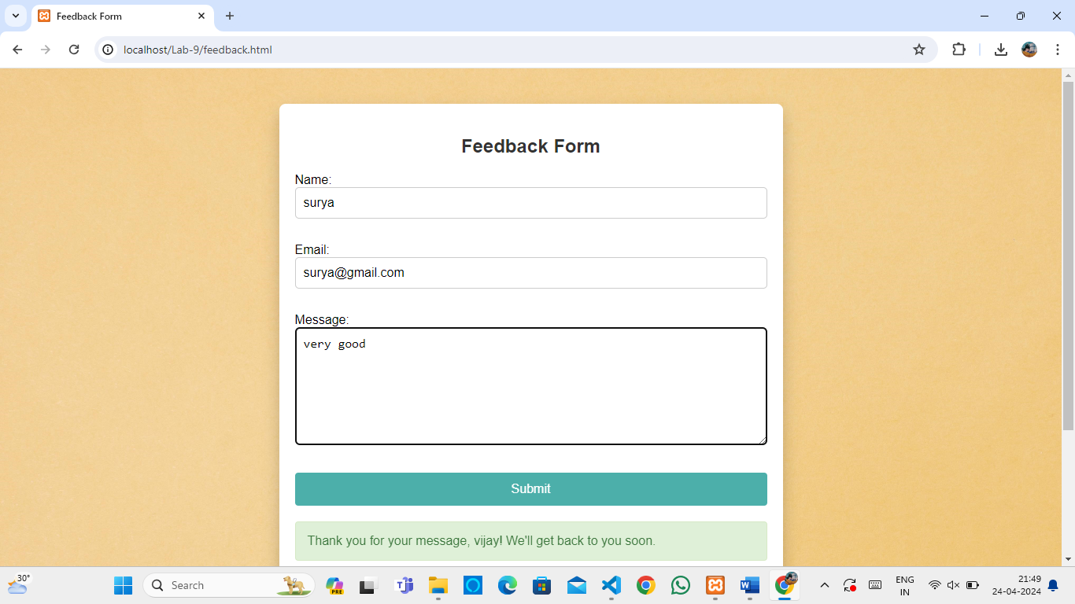

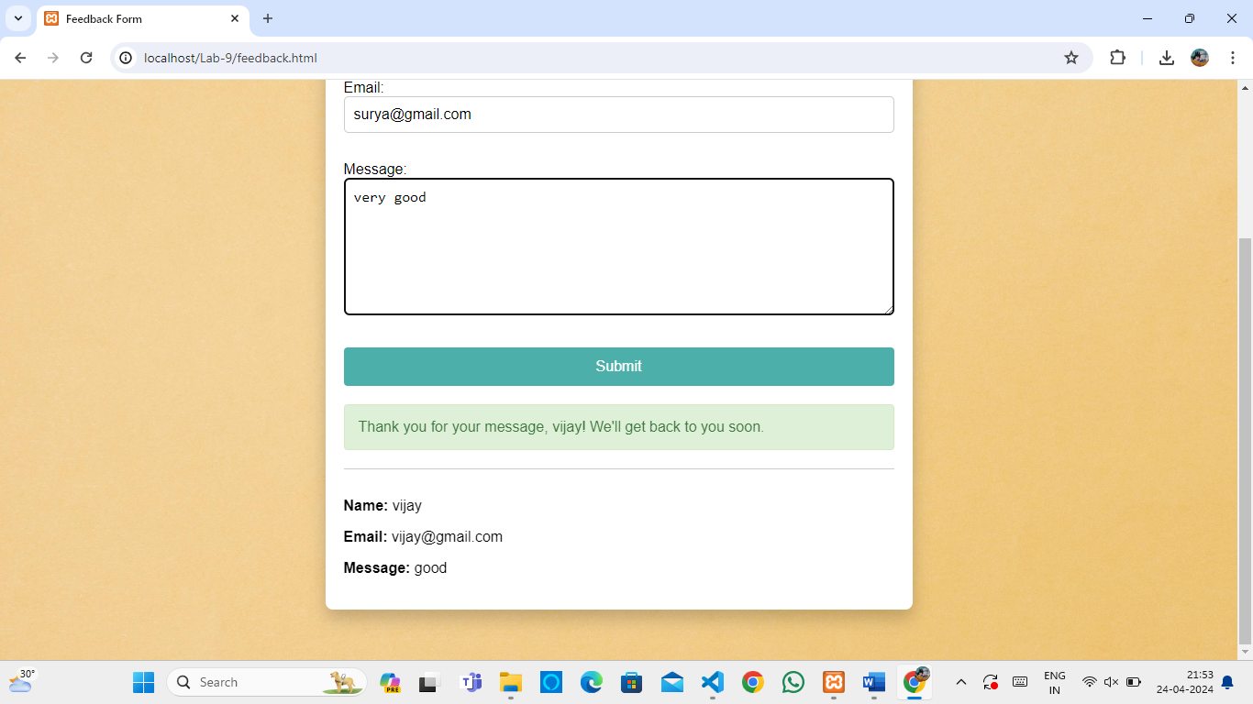

|  |  |  |
| --- | --- | --- |
| COE | 30 |  |
| RECORD | 15 |  |
| VIVA | 15 |  |
| TOTAL | 60 |  |

**Result**