|  |  |
| --- | --- |
| **Ex:No:08** |  |
| **Date:** |

**Aim:**

**Procedure:**

**Program**

**QUIZ_HANDLER.TS**

class QuizHandler

{

constructor() {}

displayQuizCreatedAlert()

{

alert(`Quiz created successfully!`);

}

redirectToTakeQuizPage()

{

window.location.href = "takequiz.html";

}

}

const quizHandler = new QuizHandler();

// quizHandler.displayQuizCreatedAlert();

// quizHandler.redirectToTakeQuizPage();

**QUIZ_HANDLER.JS**

var QuizHandler = /** @class */ (function ()

{

function QuizHandler() {

}

QuizHandler.prototype.displayQuizCreatedAlert = function ()

{

alert("Quiz created successfully!");

};

QuizHandler.prototype.redirectToTakeQuizPage = function ()

{

window.location.href = "takequiz.html";

};

return QuizHandler;

}());

var quizHandler = new QuizHandler();

// quizHandler.displayQuizCreatedAlert();

// quizHandler.redirectToTakeQuizPage();

**Output**

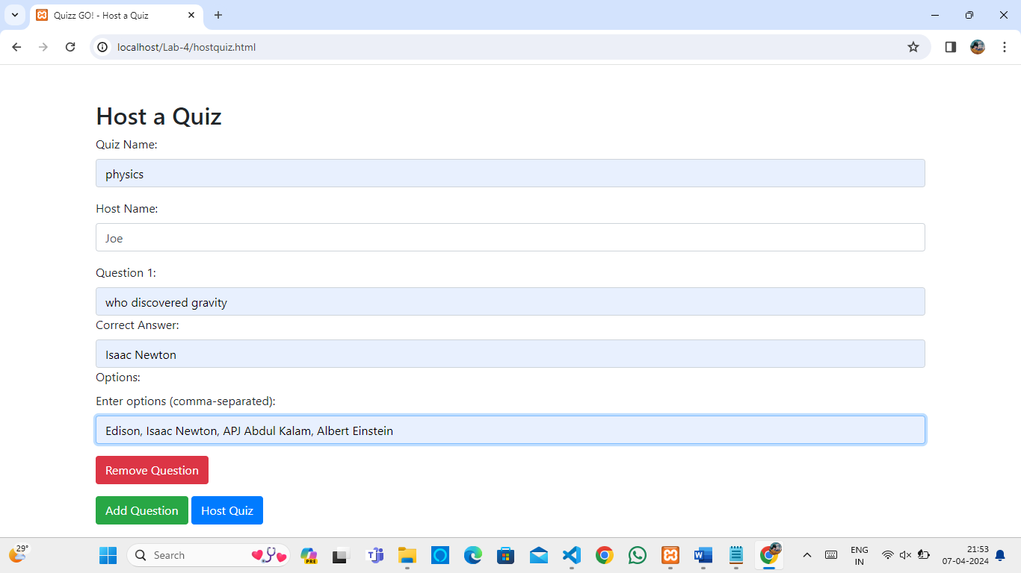

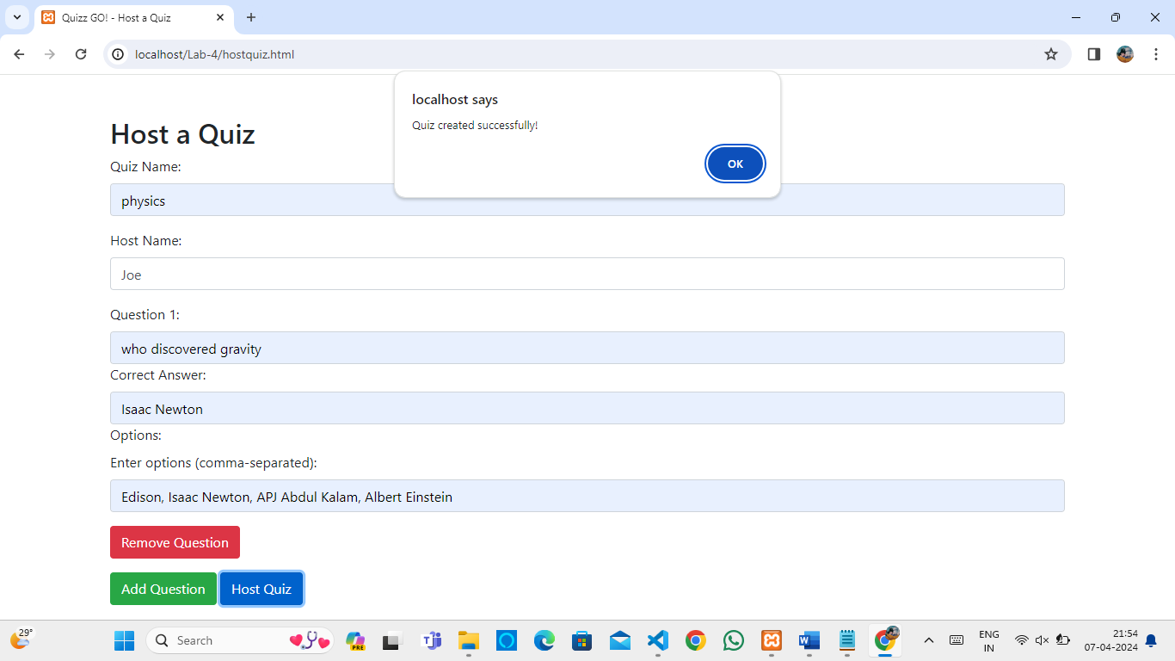

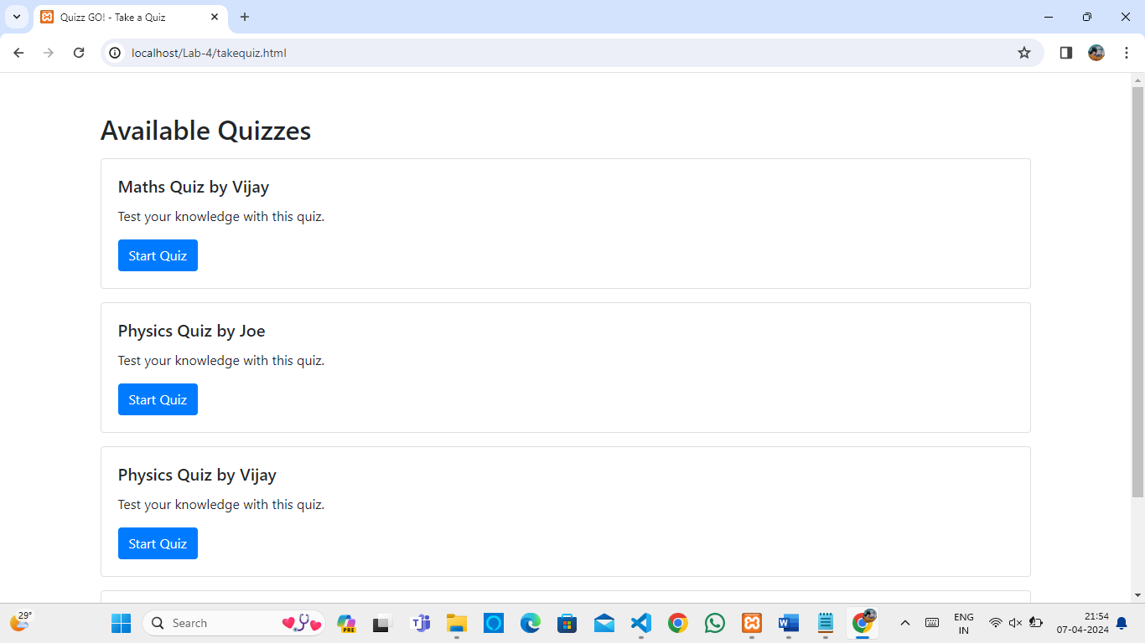

|  |  |  |
| --- | --- | --- |
| COE | 30 |  |
| RECORD | 15 |  |
| VIVA | 15 |  |
| TOTAL | 60 |  |

**Result**