|  |  |
| --- | --- |
| **Ex:No:09** |  |
| **Date:** |

**Aim:**

**Procedure:**

**Program**

**ABOUT.HTML**

<!DOCTYPE html>

<html lang="en">

<head>

<meta charset="UTF-8">

<meta name="viewport" content="width=device-width, initial-scale=1.0">

<title>About Us - QuizzGO!</title>

<script src="about.js" defer></script>

<link rel="stylesheet" href="about.css">

</head>

<body>

<header>

<h1>About Us</h1>

<nav>

<a href="index.html" id="homeLink">Home</a>

</nav>

</header>

<main>

<section id="missionSection">

<h2>Our Mission</h2>

<p id="mission"></p>

</section>

<section id="contactSection">

<h2>Contact Us</h2>

<ul id="contactInfo">

<li>Email: <span id="email"></span></li>

<li>Phone: <span id="phone"></span></li>

<li>Address: <span id="address"></span></li>

</ul> </section>

</main>

</body>

</html>

**ABOUT.TS**

document.addEventListener('DOMContentLoaded', () => {

const missionSection = document.getElementById('missionSection');

const mission = document.getElementById('mission');

const contactSection = document.getElementById('contactSection');

const email = document.getElementById('email');

const phone = document.getElementById('phone');

const address = document.getElementById('address');

if (mission && contactSection && email && phone && address) {

mission.innerHTML = "<span style='color: #EEC511;'>QuizGO!</span> is dedicated to providing a platform that enhances learning through interactive quizzes. Our quizzes are designed to engage users and promote knowledge retention in a fun and entertaining way. We believe in the power of gamification to make learning enjoyable for everyone.";

email.innerText = "quizzgo@gmail.com";

phone.innerText = "+1-123-456-7890";

address.innerText = "123 Park Avenue, Perundurai, Erode, Tamilnadu, 638112";

}

});

**Output**

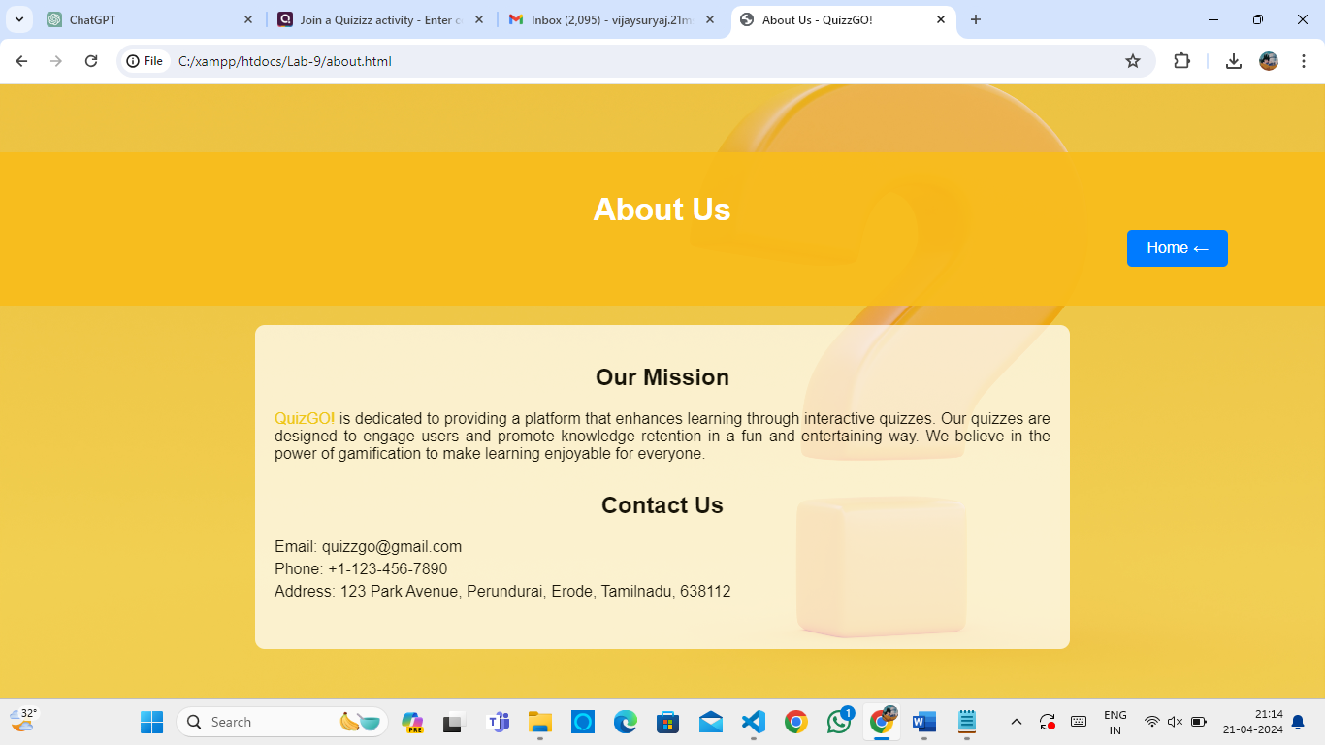

|  |  |  |
| --- | --- | --- |
| COE | 30 |  |
| RECORD | 15 |  |
| VIVA | 15 |  |
| TOTAL | 60 |  |

**Result**