Uber Supply-Demand Gap Analysis Report

1. Executive Summary
This comprehensive report details an exploratory data analysis of Uber's ride request data, specifically focusing on the supply-demand gap for trips between the city and the airport. The analysis reveals that Uber currently fulfills only approximately 42% of total ride requests, indicating a significant opportunity for operational improvement and revenue growth. The primary disruptions are categorized into driver cancellations and the unavailability of vehicles, both of which exhibit distinct temporal and spatial patterns.

2. Problem Statement and Objectives
The core challenge facing Uber's airport-city service is a persistent imbalance between rider demand and driver supply. This imbalance manifests as high cancellation rates and frequent "No Cars Available" messages, leading to lost revenue and diminished customer satisfaction. The objective of this analysis is to pinpoint the exact time slots and locations where these gaps are most severe and to provide data-driven recommendations to bridge these gaps.

Metric | Value
Total Ride Requests | 6,745
Overall Trip Completion Rate | 41.9%
Primary Failure Reason (Airport) | No Cars Available
Primary Failure Reason (City) | Driver Cancellations

3. Detailed Visual Analysis

3.1 Temporal Distribution of Demand and Supply
The relationship between hourly demand and supply is a critical indicator of service reliability. As shown in the analysis, demand is not uniform throughout the day but peaks during specific windows.

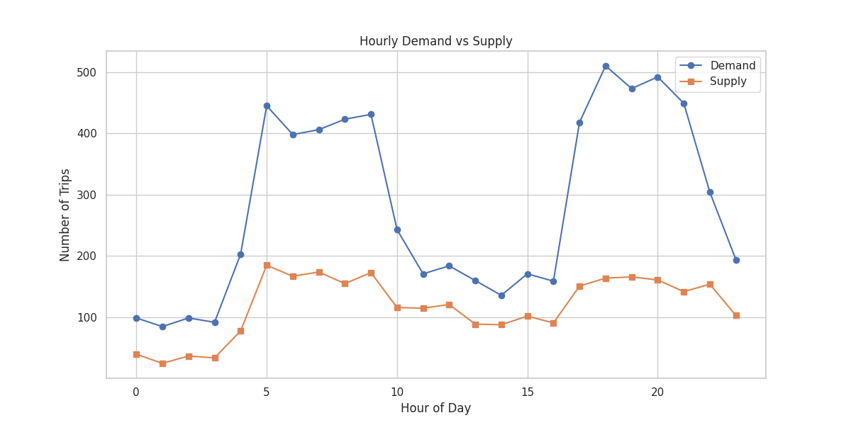

Chart Explanation: This visualization compares the total number of ride requests (Demand) against the number of completed trips (Supply) for each hour of the day. The widening gap between the two lines during peak hours highlights the periods of maximum service failure.

Insights and Business Impact: The data reveals two distinct peak periods: the early morning (5 AM - 10 AM) and the evening (5 PM - 10 PM). During these times, the supply line fails to track the demand line, particularly in the evening. Identifying these specific hours allows management to focus resource allocation and incentive programs where they are most needed, rather than applying a one-size-fits-all approach.

3.2 Spatial Analysis of Trip Status
The nature of service failures varies significantly depending on the pickup location, suggesting that different underlying factors are at play in the city versus the airport.

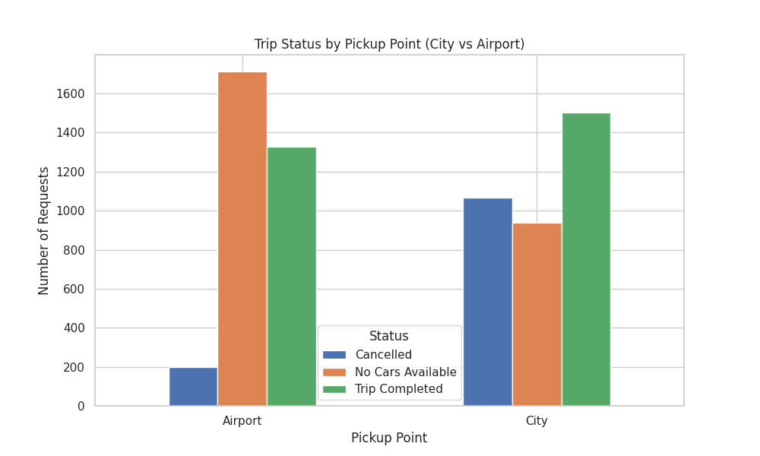

Chart Explanation: This bar chart breaks down the status of all requests—Completed, Cancelled, or No Cars Available—based on whether the pickup point was the City or the Airport.

Insights and Business Impact: In the City, the most prominent issue is driver cancellations. Conversely, at the Airport, the primary challenge is a total lack of available vehicles. This distinction is crucial for business strategy; solving the City gap requires addressing driver behavior, while solving the Airport gap requires increasing the physical presence of vehicles.

3.3 Analysis of Vehicle Unavailability
The "No Cars Available" status represents a structural failure where demand exists but no supply is present to meet it.

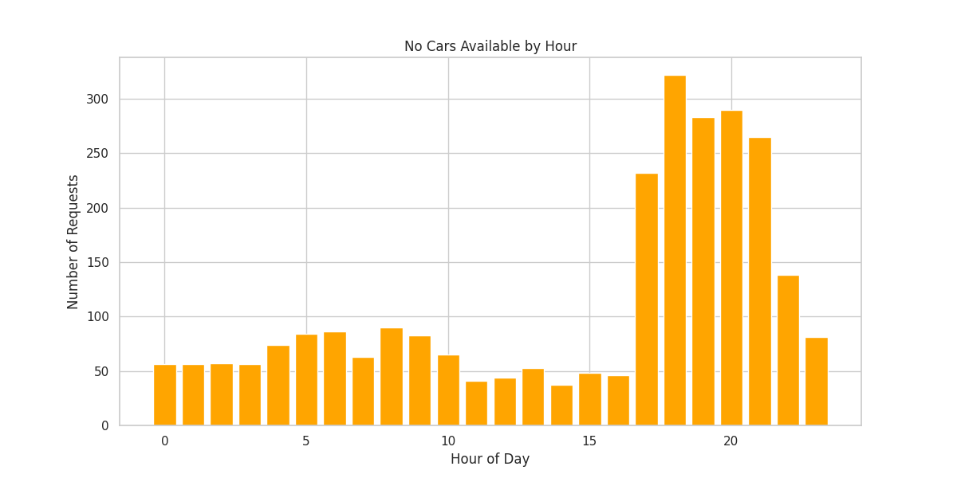

Chart Explanation: This chart isolates the "No Cars Available" status and plots its frequency across the 24-hour cycle.

Insights and Business Impact: A massive spike in vehicle unavailability occurs between 5 PM and 10 PM, primarily at the airport. This coincides with peak flight arrival times. The inability to provide cars during this high-demand period results in significant lost revenue and pushes customers toward competitors.

3.4 Driver Cancellation Patterns
Cancellations represent a behavioral gap where drivers are present but choose not to fulfill specific requests.

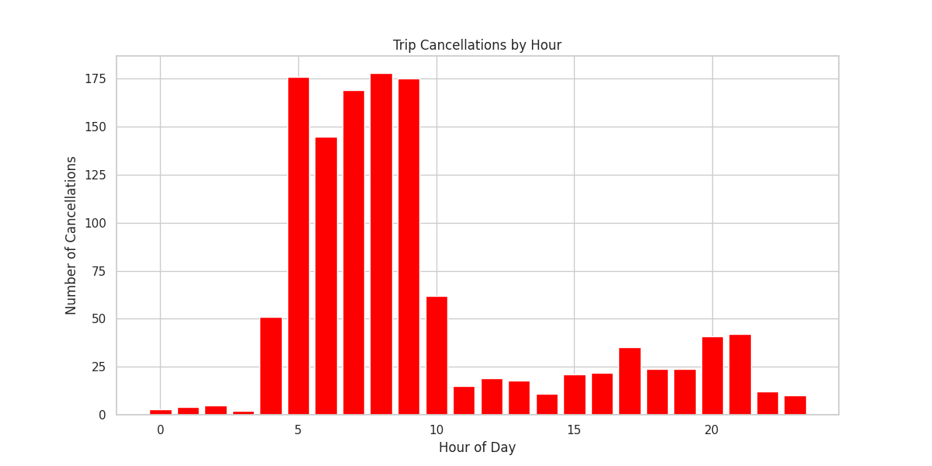

Chart Explanation: This visualization tracks the number of cancellations by hour, revealing when drivers are most likely to reject trips.

Insights and Business Impact: Cancellations peak sharply in the early morning hours (5 AM - 9 AM), mostly for trips originating in the City. This suggests that drivers avoid airport runs in the morning, likely because they anticipate a long wait for a return fare from the airport back to the city. Addressing this through "return trip" guarantees could significantly reduce these cancellations.

3.5 Overall Service Health
The overall distribution of trip outcomes provides a high-level view of the current state of Uber's airport-city operations.

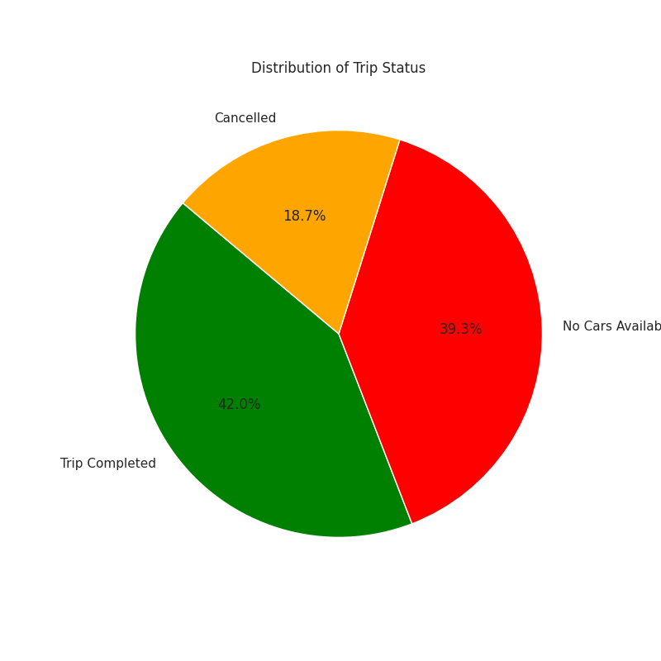

Chart Explanation: This pie chart illustrates the percentage breakdown of all ride requests by their final status.

Insights and Business Impact: With only 41.9% of trips being completed, more than half of all potential business is being lost. The fact that "No Cars Available" (39.3%) is a larger issue than "Cancelled" (18.7%) suggests that increasing the total supply of active drivers is the most pressing priority.

4. Key Findings and Strategic Recommendations
The analysis identifies two primary "bottlenecks" that severely impact Uber's performance in the airport-city segment. These findings are summarized in the table below:

Peak Period | Location | Primary Issue | Root Cause
Early Morning | City | Cancellations | Drivers avoid long airport trips with no guaranteed return fare.
Evening | Airport | No Cars Available | High arrival demand exceeds the local supply of drivers.

4.1 Strategic Recommendations
To address these findings, the following data-driven strategies are recommended:

- Incentivize Airport Presence: Implement targeted surge pricing or "waiting bonuses" for drivers at the airport during the 5 PM - 10 PM window to attract more supply from the city.
- Morning Return Guarantees: For drivers who accept airport trips from the city between 5 AM and 10 AM, provide a "priority queue" or a guaranteed return fare to the city to mitigate the risk of idle time.
- Dynamic Shift Scheduling: Use these insights to advise drivers on the most profitable times and locations to be active, aligning their shifts with the identified peak demand periods.

5. Conclusion
The supply-demand gap in Uber's airport-city service is a multi-faceted problem with clear temporal and spatial characteristics. By implementing targeted interventions—specifically addressing morning cancellations in the city and evening vehicle shortages at the airport—Uber can significantly improve its trip completion rates, optimize driver earnings, and enhance the overall reliability of its brand.

