# Organic Food and Farming:

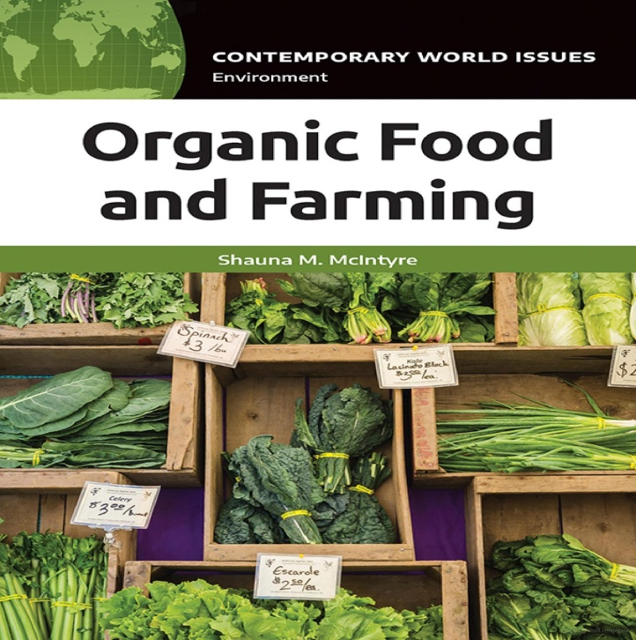

[Shauna M. McIntyre](https://www.google.co.in/search?tbo=p&tbm=bks&q=inauthor:%22Shauna+M.+McIntyre%22)

Bloomsbury Publishing USA, 17-Mar-2021 - [Social Science](https://www.google.co.in/search?tbo=p&tbm=bks&q=subject:%22Social+Science%22&source=gbs_ge_summary_r&cad=0) - 360 pages

***Organic Food and Farming: A Reference Handbook* is a valuable resource for students and general readers curious about the history, evolution, and growth of the organic food movement.**  
  
*Organic Food and Farming: A Reference Handbook* begins with a deep dive into the origins of organic farming, offering a clear discussion of what constitutes organic production and how that has changed over time. Next, the volume provides a comprehensive overview of growth of organics as both an industry and a social movement and the inherent challenges that occur from trying to be both. The book additionally covers controversial issues and challenges, along with good news about what is working and what is possible.  
  
Included are essays by scholars, farmers, and experts working with NGOs as well as profiles of key people and organizations in the organic sector. Additional chapters include data and documents, a comprehensive resource list, and a detailed chronology of the key events in the history of the organic sector. Distinguishing it from others that laud or dismiss organic food and farming practices is this book's objective nature, which allows it to be used as a definitive resource on the topic.

Principles of Organic Farming

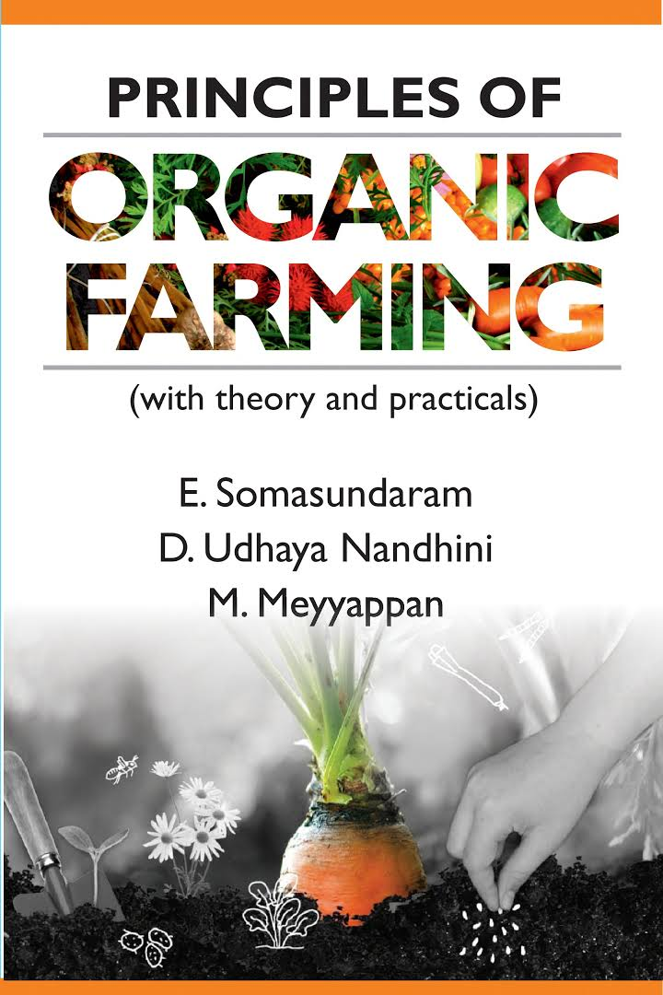

Book by D. Udhaya Nandhini, E. Somasundaram, and M. Meyyappan

The book “Principles of Organic Farming: Textbook” has been designed to fulfill the requirement of undergraduate students of agriculture faculty considering the syllabus of 5th Dean's committee of ICAR. This book makes an attempt to present the available information on organic agriculture in a very simple and lucid language based on the experience of the author. The book contains chapters on an introduction to organic farming, promotion of organic agriculture in India, organic ecosystems and their concepts, organic nutrients resources and their management, insect pests and disease management in organic farming, weed management in organic farming, organic crop production, certification process and standards of organic farming in India, processing and labelling of organic produce, economic viability of organic farming, marketing and export potential of organic products

[Working with Nature – Shifting Paradigms](https://www.amazon.in/Working-Nature-Heide-Hermary/dp/0973568763)

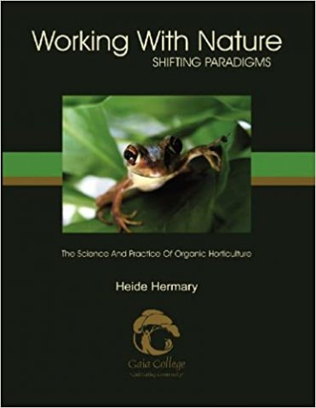

 by Heide Hermary brings together the research and scientific aspects behind organic and holistic farming methods. Heide (1948 – 2016) was president of Gaia College, Canada until 2016. Densely packed with information, this book is a quick and easy read for those who have been gardening or even new to this field. The book addresses intriguing concepts like biological transmutation, the role of mycorrhizal fungi, trade alliances between microbes and plants etc.  
  
The book gives an understanding of the interconnected processes, which control life of a farmer. Sun, water, soil, animal and plant systems everything are relevant factors. Learning to work with these systems is the key to organic success. In short, when we work in alignment with nature, we face less problems in farming as we are not trying to fight nature, and go outside the natural laws. It is prudent to realize our horticultural objectives, by identifying the existing environmental envelope and working with nature rather than building and controlling a synthetic environment.  
  
The book mentions a few mesmerizing facts about how plants and weeds work together. You can learn about the helpful strategies on how to renew the ground. If you are in doubt about organic farming then this book has the potential to change your viewpoint. You can purchase this book on amazon for INR 4,184..

[Gardener’s A – Z to Growing Organic Food](https://www.amazon.in/Guide-Growing-Organic-Potting-Bench-Reference/dp/1580173705/ref=pd_rhf_se_s_pd_crcd_3/258-0556681-3626250?pd_rd_w=EEdF3&pf_rd_p=a62021ef-ed94-4c60-92cc-5878fb8afd3c&pf_rd_r=QRVMR9478QA4W02M5010&pd_rd_r=3f518a98-3af6-4157-8345-97ea9c765759&pd_rd_wg=3fZTu&pd_rd_i=1580173705&psc=1)

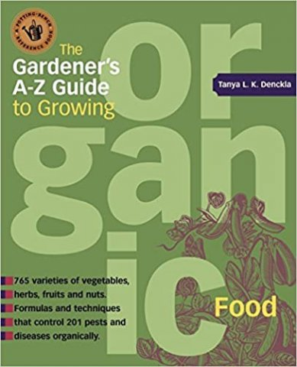

If you want to enjoy the pleasure of growing organic food then the [Gardener’s A – Z to Growing Organic Food](https://www.amazon.in/Guide-Growing-Organic-Potting-Bench-Reference/dp/1580173705/ref=pd_rhf_se_s_pd_crcd_3/258-0556681-3626250?pd_rd_w=EEdF3&pf_rd_p=a62021ef-ed94-4c60-92cc-5878fb8afd3c&pf_rd_r=QRVMR9478QA4W02M5010&pd_rd_r=3f518a98-3af6-4157-8345-97ea9c765759&pd_rd_wg=3fZTu&pd_rd_i=1580173705&psc=1) by Tanya Denckla is the book you must definitely read. Besides the expert advice on selecting tasty varieties of fruits, herbs, vegetables and nuts to grow, the book is also an invaluable resource to know how to harvest and store them. It mentions tried and tested organic remedies to fight off pests and diseases. Discover how easy it is to grow your own organic and healthy food by reading this book. Check out for this book on amazon. The price of the book is INR 2,526.

[Secrets of the Soil](https://www.flipkart.com/secrets-of-the-soil/p/itmczymyzhcv76h4?pid=9788129105639&lid=LSTBOK9788129105639HM3YOA&marketplace=FLIPKART&cmpid=content_book_15083003945_u_8965229628_gmc_pla&tgi=sem,1,G,11214002,u,,,556262839325,,,,c,,,,,,,&gclid=Cj0KCQiAr5iQBhCsARIsAPcwROOvgHnqQwjUbTi90mx3Mw55Kc4fHZeT_Hio5IHIy0rB0q6lhyBI1IMaAmPtEALw_wcB)

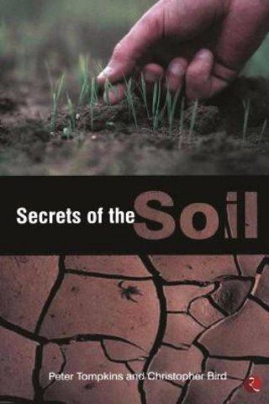

The [Secrets of the Soil](https://www.flipkart.com/secrets-of-the-soil/p/itmczymyzhcv76h4?pid=9788129105639&lid=LSTBOK9788129105639HM3YOA&marketplace=FLIPKART&cmpid=content_book_15083003945_u_8965229628_gmc_pla&tgi=sem,1,G,11214002,u,,,556262839325,,,,c,,,,,,,&gclid=Cj0KCQiAr5iQBhCsARIsAPcwROOvgHnqQwjUbTi90mx3Mw55Kc4fHZeT_Hio5IHIy0rB0q6lhyBI1IMaAmPtEALw_wcB) is written by the best-selling authors Peter Tompkins and Christopher Bird. The book is extremely informative and tells us about the non-traditional and innovative methods to be used in farming to enhance and renew soil. The emphasis is laid on using biodynamic agriculture, rock dust fertilizer and other unusual fertilizers. The book is a wonderful guide to anyone aspiring to do organic farming. It is highly recommended to those interacting with land as you will see our health, soil and earth, in a whole new light. You can purchase this book on Flipkart for INR 267.

T[he Non-Toxic Farming Handbook](https://www.amazon.in/Non-Toxic-Farming-Handbook-Philip-Wheeler/dp/0911311564)

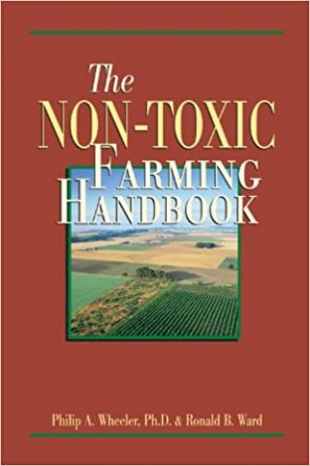

T[he Non-Toxic Farming Handbook](https://www.amazon.in/Non-Toxic-Farming-Handbook-Philip-Wheeler/dp/0911311564) is a must-read for all entry-level organic farmers. There are research insights about weed control and soil recovery, which is very important to an organic farmer. The book is best read for those who want to practice organic gardening and farming as it addresses the problems faced during organic farming like plant diseases, pest eradication or issues concerning to planning. The book also covers various other things like foliar feeding, tillage, moon cycles, subtle energies, in-the-field testing, refractometers, livestock nutrition, fertility inputs and much more. The book is a result of an extensive research and eco-consulting and is a must read for all those who want to venture into organic farming. You can purchase this informative book on amazon for INR 4,013.

[The Organic Method Primer](https://www.amazon.in/Organic-method-primer-update-Conservation/dp/0915966018)

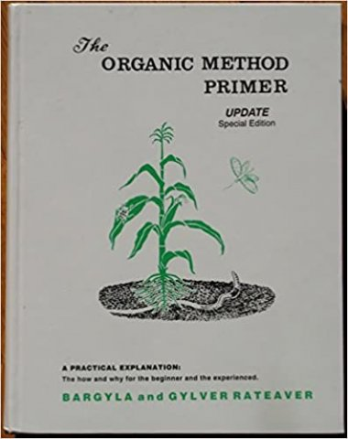

[The Organic Method Primer](https://www.amazon.in/Organic-method-primer-update-Conservation/dp/0915966018) is one of the best book for organic gardening and farming as it provides a complete insight into organic agriculture. There are many esoteric secrets mentioned in the book that is of course backed by science. The author of the book Dr. Bargyla Rateaver was a pioneer and crusader of organic farming. She was born in Madagascar and is indisputably the mother of organic movement.  
  
The author implemented the organic farming methods in California and was the first to organize the organic conference. The book includes rich facts concerning organic farming. Although, the book may be overwhelming for a casual reader or a beginner, it is the best read for those who want to shift to organic farming. You can purchase this book on amazon for INR 13,006.

[The Holistic Orchard: Tree Fruits and Berries the Biological Way](https://www.amazon.in/Holistic-Orchard-fruits-berries-biological/dp/1933392134)

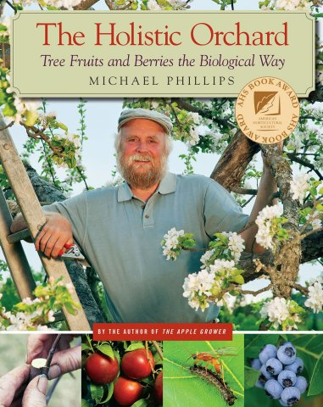

Who doesn’t want to relish on tasty and organic fruits? [The Holistic Orchard: Tree Fruits and Berries the Biological Way](https://www.amazon.in/Holistic-Orchard-fruits-berries-biological/dp/1933392134) by Michael Phillips shows how to grow the most delicious delicacies in the natural way. Orchard farming needs more than just space. If you have the right dedication and passion then you can become a successful orchardist. The book illustrates how to grow berries and fruits in a holistic way without manipulating nature, but by fostering nature.  
  
The book mentions the basic skills to know about the orchard ecosystem like Planting, Pruning, Grafting, Soil Biology, Orchard Design, Organic health management and choosing the right variety based on the climate. With this wonderful book, you can confidently plant your next fruit tree and successfully harvest the produce in few years. Check out for this wonderful book on amazon. The price of the book is INR 2,619.

[‘The Rodale Book of Composting’](https://www.amazon.in/Rodale-Book-Composting-Methods-Gardener/dp/0878579915)

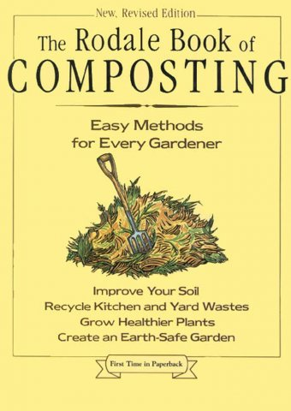

These days, composting has become a household word as gardeners know that it is the best way to improve nutrition of the soil. A few of them turn to composting to dispose of their leaves, tree trimmings or grass clippings. Composting is the best method to generate natural fertilizers, which can be easily made on the farm. However, not every biodegradable ingredient can be included in the compost pile. That is when, the book [‘The Rodale Book of Composting’](https://www.amazon.in/Rodale-Book-Composting-Methods-Gardener/dp/0878579915) by Grace Gershuny comes handy. The book gives a clear idea about the things to be added into compost.  
  
The book also gives detailed information on the latest tools and techniques to be used to make mulch. city-dwellers who have limited space can follow the non-traditional method of composting mentioned in the book. In short, it makes a versatile read and is one among the best organic farming books. You can purchase this book on amazon for INR 1,340.

[Rodale's Basic Organic Gardening: A Beginner's Guide to Starting a Healthy Garden](https://www.amazon.in/Rodales-Basic-Organic-Gardening-Beginners-ebook/dp/B00DVF12VW)

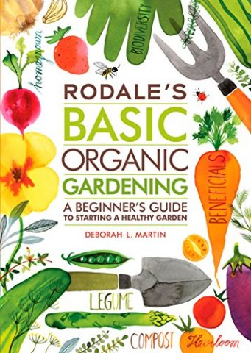

If you are inspired to start an organic garden, but you are still a novice then it is important to read a guidebook that provides solid information about the organic gardening methods. [Rodale's Basic Organic Gardening: A Beginner's Guide to Starting a Healthy Garden](https://www.amazon.in/Rodales-Basic-Organic-Gardening-Beginners-ebook/dp/B00DVF12VW) by Deborah L Martin gives readers an insight into garden-building skills, specific techniques, garden planning and planting, growing to harvesting. The book also defines common garden terms, simple garden layouts, no-dig garden methods, and many more hints and tips. You can purchase this useful organic gardening book on amazon for INR 836.