Role based access to hr and hiring team
Company admin / recruiter
Super admin
We pratap ai innovations give subscription to all the recruiter

SUMMARY
Name Tagline: The AI-First Recruitment Operating System
RecruitAI Enterprise is a cloud-based, AI-powered, multi-tenant Recruitment Operating System designed to transform how organizations attract, assess, hire, and onboard talent. Rather than functioning as a traditional Applicant Tracking System (ATS), RecruitAI Enterprise combines recruitment management, candidate relationship management (CRM), AI-driven hiring assistance, technical assessments, interview management, workflow automation, analytics, and enterprise administration into a unified platform.
The platform enables organizations of all sizes—from startups to large enterprises—to manage their complete hiring lifecycle through a centralized, secure, and scalable solution.
Built as a Software-as-a-Service (SaaS) platform, RecruitAI Enterprise supports multiple companies (tenants) while maintaining strict data isolation, customizable workflows, and role-based access control RBAC. This allows organizations to operate independently within their own workspaces while being managed centrally by a Super Admin.
Problem statement RecruitAI Enterprise addresses these challenges by integrating every stage of recruitment into one intelligent platform.

Software mod super admin ------ admin ------- hr/selector.
Admin works on Subscription model
Payment ---- admin successful having all access-----create multiple role based sub admin.
Admin having all the access there will one more option create sub admin there will one two right now hr and interview team.
In the settings options there will option to create a hr and teams.
That option will role based only few access will be provided to talent acquisition team and HR.

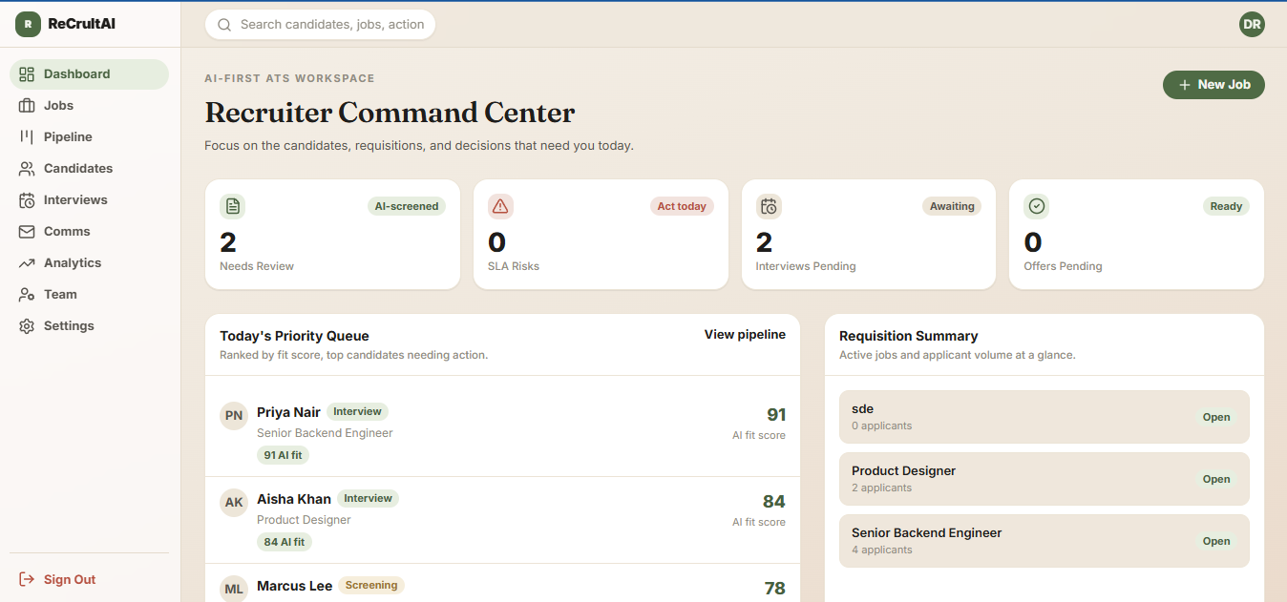

- Every organization has a unique Organization ID.
- Every organization belongs to one subscription plan.
- Organizations cannot access another organization's data.
- Organization data must be isolated using Tenant ID.
- An organization may contain multiple branches.

Crud to super admin – pratap ai

- Create Organization
- Update Organization
- Suspend Organization
- Delete Organization (Soft Delete)
- Restore Organization

Now come to admin registration or company registration
- Company Name
- Registration Number
- GST/VAT
- Industry
- Company Size
- Headquarters
- Website
- Logo
- Timezone
- Currency
- Language
- Business Email
- Phone
- Address

There is will one twist here company having more than one branch will have to take another subscription and other than there is another form page and payment page for multiple admins

Lets the Super Admin onboard new companies onto the platform and charge them a recurring or one-time platform fee. This is the tenant-creation entry point for everything else in the system.
Give the Super Admin a dashboard listing all companies, their plan, and their payment status.
- Company Admin — subscription activated / renewal due / overdue
- Once a company is on boarded, its Admin sets up the internal team structure: HR and Talent Acquisition sub-admins, with Talent Acquisition further split into Tech and Non-Tech or more.

On that form there will extra these option will be there
- Branch Name
- Branch Code
- Address
- Country
- State
- City
- Timezone
- Contact Person
Billing – razorpay
A Subscription represents the commercial agreement between RecruitAI Enterprise and a customer company.
It determines what features, limits, and services are available.
After that company or admin can owns this software according to their plan
Admin can create multiple subadmins according to the role there will be many role in talent acquisition and hr will.

Job posting
Covers creating a job requisition, tagging it Tech or Non-Tech, routing it to the correct TA team for JD approval, and then auto-publishing it to external job boards once approved.
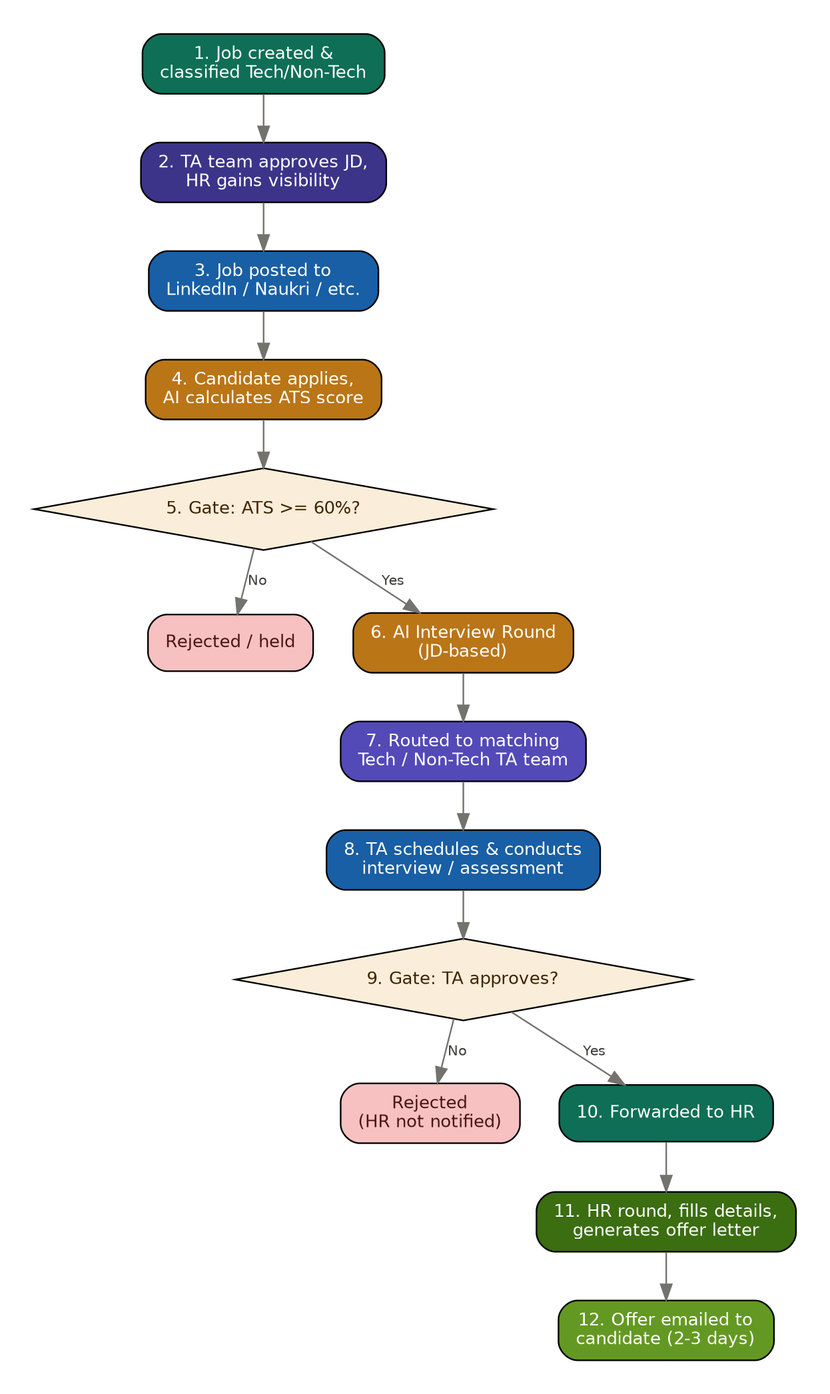
The recruitment process begins when a recruiter or HR creates a new job requisition. This step defines all the information required to hire for a position and determines which Talent Acquisition (TA) team will manage the recruitment process

• HR or Recruiter creates a new job requisition by entering complete job information such as title, department, experience, salary range, required skills, responsibilities, and job description.
• The job is classified as either Tech or Non-Tech, and this classification becomes mandatory because it determines which Talent Acquisition team will own the recruitment process.
• The system validates all mandatory information before saving the job to ensure incomplete or incorrect job postings cannot enter the recruitment workflow.

The Talent Acquisition team reviews the job before it becomes publicly available to ensure quality, accuracy, and hiring readiness.

• The system assigns the job to the correct TA team based entirely on the Tech/Non-Tech classification selected during job creation.
• The assigned TA team reviews and improves the Job Description (JD) by verifying skills, responsibilities, qualifications, and hiring criteria.

After approval, the system publishes the job to recruitment channels where candidates can discover and apply.

• The system publishes the approved job automatically to the company's career portal and configured external job boards.
• The same job can be distributed across multiple recruitment platforms such as LinkedIn, Naukri, Indeed, and other integrated job boards.
• Each published job receives a unique public application link so candidates can submit applications directly.
• Publication history and source information are recorded to measure recruitment effectiveness and application sources.
• Once published, the job becomes available for candidate applications, which starts the hiring process.
The ATS score determines whether the candidate proceeds to the AI Interview stage or is automatically held or rejected according to the configured threshold.
Candidates submit their applications, after which the AI engine begins evaluating their suitability for the job.

• Candidates submit their personal information and resume through the career portal or external job board application link.
• The system validates the submitted information, checks for duplicate candidate profiles, and stores the application securely.
• The AI Resume Parser extracts structured information such as education, work experience, technical skills, certifications, and projects from the uploaded resume.
• The AI compares the extracted resume information with the job description to calculate an ATS Match Score representing how closely the candidate matches the job requirements.

ATS PARSER
This decision point filters candidates based on their AI-generated ATS score.
- The AI compares the candidate's ATS score with the configured qualification threshold, which may be company-specific or job-specific.
- Candidates whose score meets or exceeds the threshold are automatically qualified to continue in the recruitment pipeline.
- Candidates scoring below the threshold are automatically placed in Hold or Rejected status, preventing unnecessary recruiter effort.
- The complete ATS analysis, including matched skills and missing requirements, is stored for recruiter review and reporting.
- Qualified candidates automatically receive an AI Interview invitation, while rejected candidates exit the recruitment pipeline unless manually overridden.
AI INTERVIEW ROUND
The AI Interview performs the first automated evaluation before involving human recruiters.
- The AI generates interview questions dynamically based on the approved job description and required skills.
- Candidates complete the interview through voice, video, or text interactions, depending on company configuration.
- The AI evaluates candidate responses by measuring technical knowledge, communication ability, confidence, reasoning, and problem-solving skills.
- Interview recordings, transcripts, AI feedback, and evaluation scores are permanently stored within the candidate profile.
- Candidates who successfully pass the AI Interview are automatically forwarded to the appropriate Talent Acquisition team for manual evaluation.
CANDIDATE ROUND
The system assigns candidates to the appropriate recruitment team.
- Candidate routing depends exclusively on the job classification, ensuring consistent recruitment ownership.
- Candidates applying for Tech jobs are assigned only to the Tech Talent Acquisition team, while Non-Tech candidates are assigned only to the Non-Tech team.
- Data isolation rules prevent recruiters from viewing candidates outside their assigned hiring domain, ensuring secure access control.
- Recruiters receive real-time notifications whenever a qualified candidate enters their recruitment queue.
- The assigned recruiter becomes responsible for scheduling interviews, assessments, and further candidate evaluation.
TA INTERVIEW ASSESMENT
The TA team's decision determines whether HR becomes involved.
- The Talent Acquisition team's approval acts as the final technical screening checkpoint.
- Approved candidates are transferred into the HR recruitment queue together with their interview history and evaluation results.
- Rejected candidates are marked as closed, and no further recruitment activities are initiated.
- HR users cannot view candidates rejected during TA evaluation, preserving recruitment workflow integrity.
- The complete recruitment history is preserved for auditing and future reporting purposes.
FORWARED TO HR
- HR receives only candidates approved by the Talent Acquisition team.
- HR reviews compensation expectations, notice period, location preference, and organizational fit.
- Additional HR interviews or discussions may be conducted before making the final hiring decision.
- Candidate records are updated with employment-related information required for offer generation.
- Successful HR evaluation triggers the offer preparation process.
HR OFFER LETTER PROCESS
TEMPLETE ALREADY SET FOR THE OFFER LETTER
UPDATE THE ROLE AND STIPEND / SMALL CHNAGES ACCORDIBGLY AND OFFERLETTER GENERATED

TEMPLATE WILL BE SELECTD ACCORDINGLY
FOR EVERY ROLE THERE WILL BE TEMPLETE AND HR CAN DIRECTLY SELECT THE TEMPLATE OR ON THE BASIS OF ROLE TEMPLETE WILL SELECTED FOR OFFER LETTER IT WILL REDUCE TIME AND ERROR.

OFFER EMAILED TO CANDIDATES
- The system automatically sends the approved offer letter to the candidate through email and other configured communication channels.
- The platform tracks delivery status, email opening, and candidate response for complete visibility.
- Candidates can accept, reject, or request modifications to the offer through the candidate portal.
- Offer acceptance automatically initiates the employee onboarding workflow, including document collection and joining formalities.
- The recruitment process concludes successfully, and the candidate transitions into the onboarding module as a future employee.

AFTER THAT THERE WILL BE ANALYTICS OF THE EVERY HIRING AND PEOPLE WHO ARE APPLYING FOR THE EVERY PARTICULAR JOB ROLE
EX number of candidates applying for the job role and then
For backend dev – 200 candid
For frontend – 100 candidates.

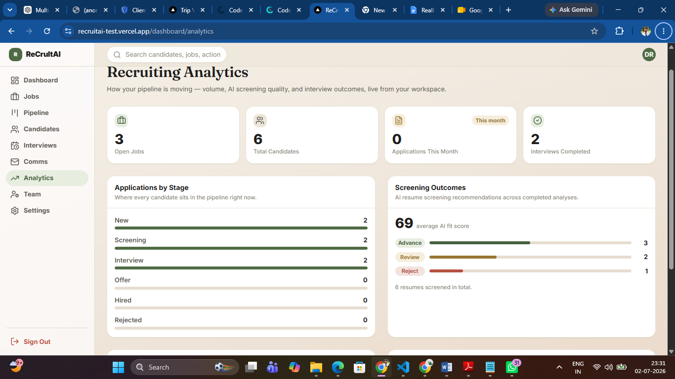

Our software should work very fast because there be 1000 of application per day of each role for each company
Assume this realistic load:
- 1,000 companies
- 50 active jobs per company
- 1,000 applications per job per day
- AI resume parsing, AI interviews, emails, notifications, and dashboards all running simultaneously
That's millions of records and thousands of concurrent operations. A simple CRUD application will not handle this.
Risks after creating this

• Server becomes overloaded.
• API response times increase.
• Database locks.
• Users experience delays.
AI processing blocks new requests.

1.Create Job

↓

API

↓

Save in Database

↓

Status = Draft

2. jobs

----------------------------------

id

company_id

department_id

title

description

status

classification

created_by

created_at

3.Publish Queue

↓

Worker

↓

LinkedIn API

↓

Indeed API

↓

Career Portal

↓

Naukri API

Save Candidate

↓

Save Resume Metadata

↓

Save Application

↓

Return Success
Within seconds candidates will see application submitted successfully

Now in backend
Candidate
↓
Resume Uploaded
↓
Queue Created
↓
Resume Worker
↓
Parse Resume
↓
Save Skills
↓
Create ATS Task
↓
ATS Worker
↓
Calculate ATS Score
↓
Save Result

Save result in things works in backend after a time it will stop taking resume and according to the result and best match candidates will be selected for the further process of the hiring

Sql recommended after reseach

Datasets
organizations

users

roles

permissions

branches

departments

teams

jobs

job_skills

applications

candidates

candidate_skills

resumes

resume_analysis

ats_scores

interviews

interview_sessions

feedback

offers

notifications

subscriptions

payments

audit_logs

