RecruitAI Enterprise
Multi-Tenant Hiring Pipeline — System Design & Module Specification
Developer handoff document

1. Overview
This document specifies the multi-tenant hiring pipeline: how the platform owner (Super Admin) onboards companies, how each company's HR and Talent Acquisition teams are structured and isolated, and the exact end-to-end path a job and a candidate take — from job creation through AI screening to the final offer letter. It is written for direct handoff to development: every module below has a clear owner, a set of functional requirements, and the gates/thresholds that control the flow.

1.1 End-to-end pipeline at a glance
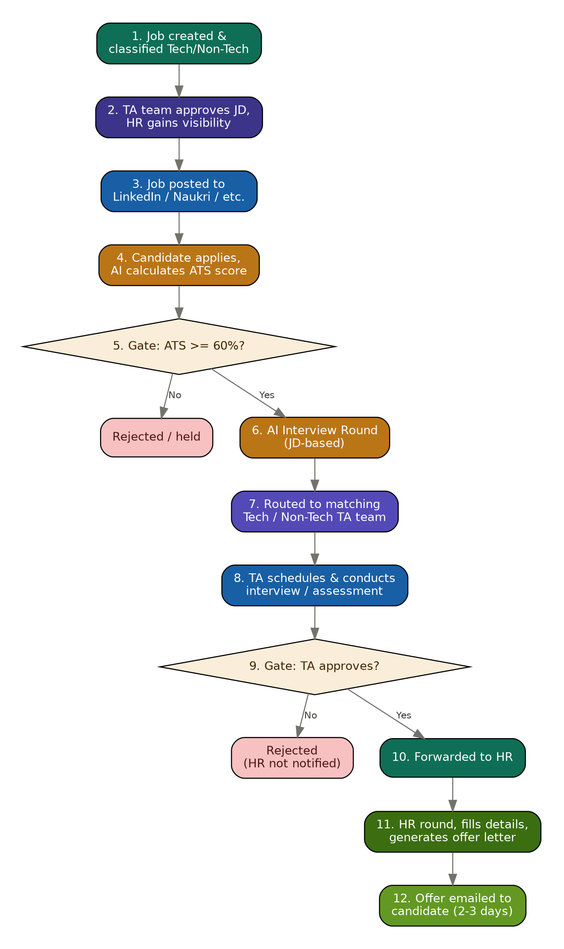
Figure 0 — Master pipeline: job creation through offer letter delivery

1.2 Roles in this system
Role | Scope | Key responsibility
Super Admin | Platform-wide | Onboards companies, manages subscription/billing, has no visibility into any company's candidates or jobs
Company Admin | One company (tenant) | Pays platform fee, creates HR and Talent Acquisition sub-admins, configures the company workspace
HR (sub-admin) | One company | Sees jobs only after TA approval, conducts the HR round, generates and sends offer letters
Talent Acquisition (parent) | One company | Owns the TA function; splits into Tech and Non-Tech teams
Tech Acquisition Team | Tech jobs only | Approves tech JDs, interviews AI-screened tech candidates, approves/rejects before HR
Non-Tech Acquisition Team | Non-Tech jobs only | Approves non-tech JDs, interviews AI-screened non-tech candidates, approves/rejects before HR
Candidate | Self (public) | Applies, completes AI interview, attends TA/HR rounds, receives offer
AI Engine | System actor | Scores resumes against JD, conducts the first-round AI interview, evaluates pass/fail
Hard rule: Tech Acquisition and Non-Tech Acquisition are data-isolated from each other. Neither team can view the other's job postings, JDs, or candidates at any point in the pipeline. This must be enforced at the data/query layer (row-level scoping by job category), not just hidden in the UI.

2. Platform & subscription management (Super Admin)
Owned by: Super Admin
Depends on: None — this is the root module
Lets the Super Admin onboard new companies onto the platform and charge them a recurring or one-time platform fee. This is the tenant-creation entry point for everything else in the system.

Key business rules
1. Every company is a fully isolated tenant — no data (jobs, candidates, users) is ever shared across companies.
2. A company cannot use any hiring feature until its subscription/fee status is active.
3. Only the Super Admin can suspend or reinstate a company's access.

Functional requirements
ID | The system shall... | Priority
FR-2.1 | Allow the Super Admin to create a new company (tenant) with a name, billing contact, and plan. | P0
FR-2.2 | Charge and track a platform fee per company (one-time, monthly, or usage-based, per business decision). | P0
FR-2.3 | Suspend a company's access automatically if its fee/subscription is overdue past a configurable grace period. | P1
FR-2.4 | Give the Super Admin a dashboard listing all companies, their plan, and their payment status. | P1

Notifications triggered by this module
- Company Admin — subscription activated / renewal due / overdue

3. Company admin & team management
Owned by: Company Admin
Depends on: Module 2 (company must exist and be active)
Once a company is onboarded, its Admin sets up the internal team structure: HR and Talent Acquisition sub-admins, with Talent Acquisition further split into Tech and Non-Tech.
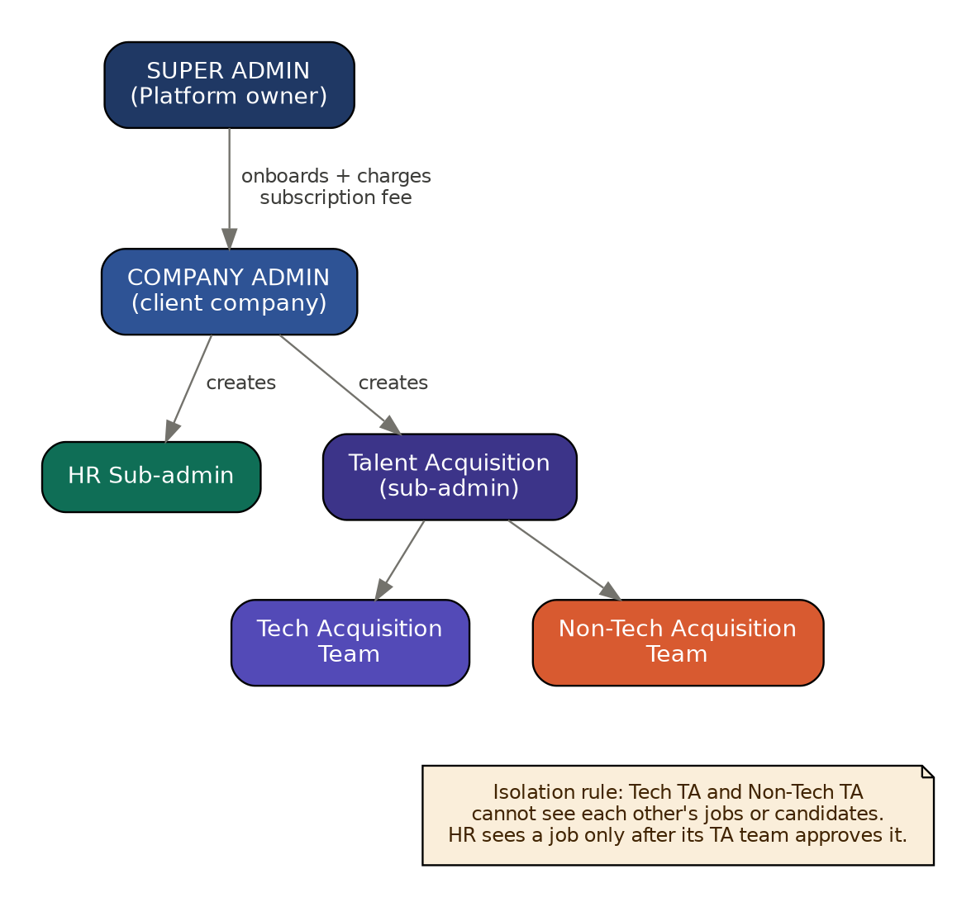
Figure 1 — Role hierarchy and data-isolation rule

Key business rules
1. A Company Admin can create any number of HR and TA sub-admin accounts.
2. Every TA sub-admin must be tagged Tech or Non-Tech at creation — this tag determines everything they can see afterward.
3. A single person cannot be both Tech TA and Non-Tech TA on the same account (must be two separate logins if a company wants one person covering both).
4. HR accounts see every job/candidate only after the owning TA team has approved it — HR has no early visibility.

Functional requirements
ID | The system shall... | Priority
FR-3.1 | Allow the Company Admin to invite/create HR sub-admin accounts. | P0
FR-3.2 | Allow the Company Admin to invite/create TA sub-admin accounts tagged as Tech or Non-Tech. | P0
FR-3.3 | Enforce row-level data scoping so Tech TA queries never return Non-Tech jobs/candidates and vice versa. | P0
FR-3.4 | Allow the Company Admin to deactivate or reassign a sub-admin without deleting their historical actions (audit trail preserved). | P1

Notifications triggered by this module
- New sub-admin — account created, credentials/invite link

4. Job requisition, classification & publishing
Owned by: HR (creates) → Tech/Non-Tech TA (approves)
Depends on: Module 3 (team must exist to route to)
Covers creating a job requisition, tagging it Tech or Non-Tech, routing it to the correct TA team for JD approval, and then auto-publishing it to external job boards once approved.
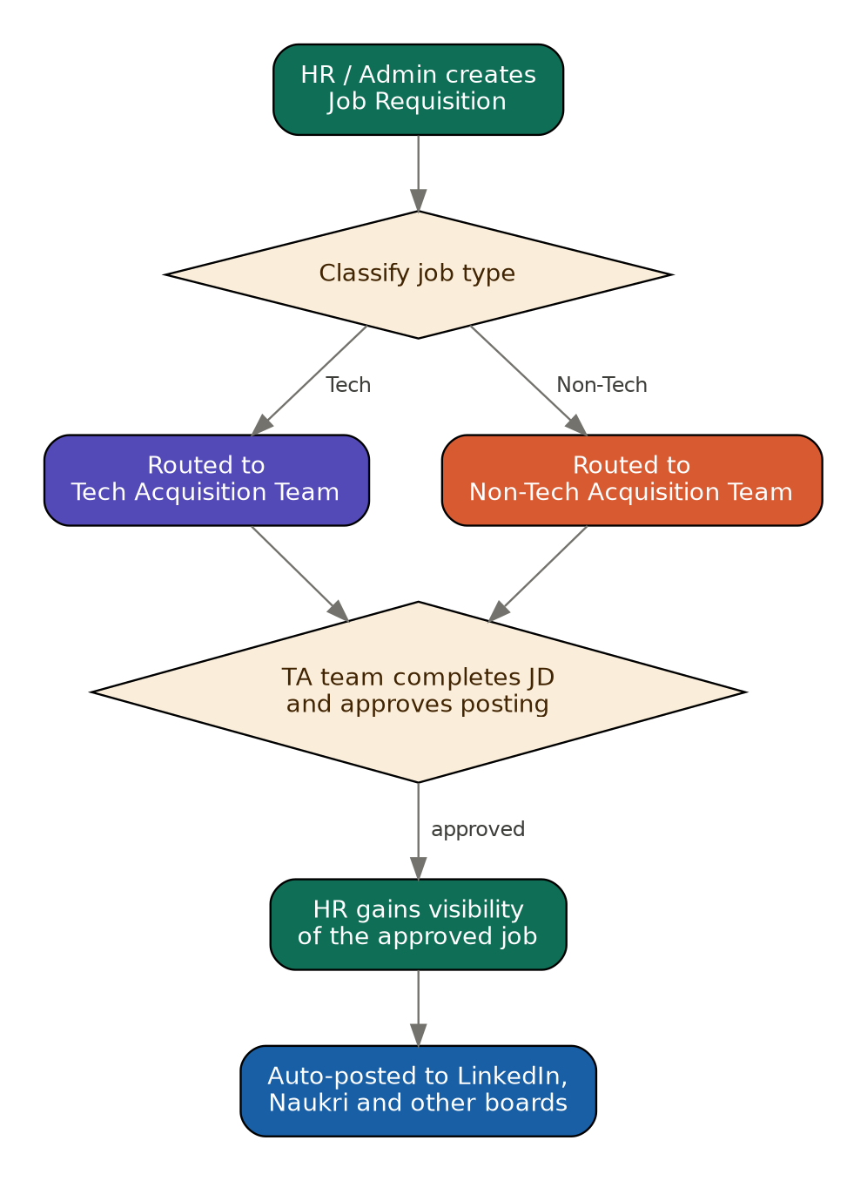
Figure 2 — Job creation, classification & publishing flow

Key business rules
1. Every job must be classified Tech or Non-Tech at creation — this single field drives all downstream routing for that job.
2. A Tech job is visible only to the Tech Acquisition Team until approved; a Non-Tech job is visible only to the Non-Tech Acquisition Team. HR cannot see either until the owning TA team approves.
3. A job cannot be published to external boards until its owning TA team has approved the JD.
4. The same job posting can be pushed to multiple external boards (LinkedIn, Naukri, company career page, etc.) from a single approval.

Functional requirements
ID | The system shall... | Priority
FR-4.1 | Provide a job creation form capturing title, department, description, requirements, and a required Tech / Non-Tech classification field. | P0
FR-4.2 | Route a newly created job to only the matching TA team's queue based on its classification. | P0
FR-4.3 | Let the owning TA team edit/finalize the JD and approve or reject it before publishing. | P0
FR-4.4 | On approval, make the job visible to HR and trigger publishing to configured external job boards via their APIs. | P0
FR-4.5 | Support an AI-assisted JD generator/co-writer as an optional aid during job creation (does not replace TA approval). | P2

Notifications triggered by this module
- Owning TA team — new job awaiting approval
- HR — job approved and now visible
- Company Admin — job published externally (optional digest)

5. Candidate application intake
Owned by: Candidate (self-service) / System
Depends on: Module 4 (job must be published)
Public-facing application capture: a candidate finds the job on an external board or the company's career page and submits their application and resume.

Key business rules
1. Applications are only accepted against a job that is in Published/Open status.
2. One candidate profile can hold multiple applications across different jobs, but each application is tracked independently through the pipeline.
3. Resume file, contact email, and phone are mandatory fields at submission — the candidate's email is what all later interview/offer emails go to.

Functional requirements
ID | The system shall... | Priority
FR-5.1 | Provide a public application form (name, email, phone, resume upload, optional cover note) against a specific job listing. | P0
FR-5.2 | Deduplicate candidates by email so a repeat applicant is linked to their existing profile rather than creating a duplicate. | P1
FR-5.3 | Confirm receipt to the candidate by email immediately on submission. | P1

Notifications triggered by this module
- Candidate — application received confirmation

6. AI resume screening (ATS scoring)
Owned by: AI Engine
Depends on: Module 5 (application + resume must exist)
Automatically parses the submitted resume, compares it against the job's JD/requirements, and produces a 0-100 ATS match score that gates progression to the AI interview round.
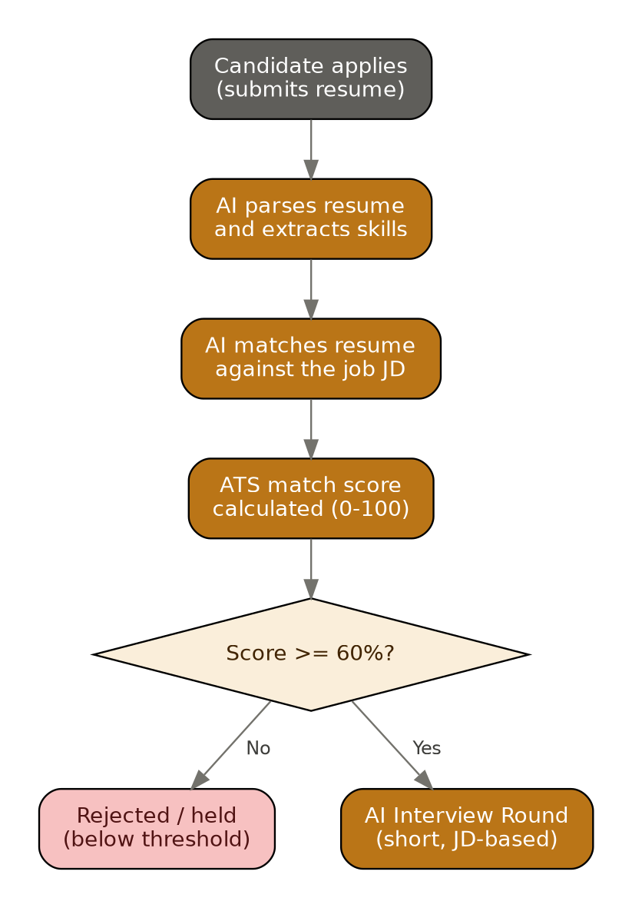
Figure 3 — AI resume screening and the ATS threshold gate

Key business rules
1. The qualifying ATS threshold is 60% by default (configurable per company, since the description mentioned both 60% and 65%) — recommend this be a per-company or per-job setting, not hardcoded.
2. Candidates scoring below the threshold are held/rejected automatically and do not proceed to the AI interview.
3. The ATS score and the reasoning behind it (matched skills, gaps) must be stored, not just the final pass/fail — TA and HR need to see this later.

Functional requirements
ID | The system shall... | Priority
FR-6.1 | Parse uploaded resumes into structured data (skills, experience, education) on submission. | P0
FR-6.2 | Compute an ATS match score comparing parsed resume data against the job's requirements/JD. | P0
FR-6.3 | Apply the qualifying threshold (default 60%, configurable) and set application status to Qualified or Held accordingly. | P0
FR-6.4 | Store the score breakdown (matched skills, missing skills) for later display to TA/HR. | P1

Notifications triggered by this module
- Candidate — optional status update if held/rejected at this stage

7. AI interview round
Owned by: AI Engine
Depends on: Module 6 (candidate must have passed the ATS gate)
A short, automated interview conducted by the AI, built from the job's JD, to filter candidates before they reach a human recruiter.

Key business rules
1. The AI interview's question set is generated from the same JD used for the ATS match — the two must stay in sync if a JD is edited after publishing.
2. The AI produces a pass/fail (or score) outcome that determines whether the candidate is routed onward to a human TA team.
3. A transcript/recording and the AI's evaluation notes must be saved so the receiving TA team has full context, not just a pass/fail flag.

Functional requirements
ID | The system shall... | Priority
FR-7.1 | Generate a short structured interview (voice or text) from the job's JD once a candidate passes the ATS gate. | P0
FR-7.2 | Invite the candidate to complete the AI interview by email with a time-bound link. | P0
FR-7.3 | Evaluate the completed interview and produce a pass/fail outcome plus a summary for the TA team. | P0
FR-7.4 | Store the transcript/recording against the application record. | P1

Notifications triggered by this module
- Candidate — AI interview invite with link
- Candidate — reminder if not completed within a configurable window

8. Talent acquisition routing, scheduling & assessment
Owned by: Tech Acquisition Team / Non-Tech Acquisition Team
Depends on: Module 7 (candidate must have passed the AI interview)
Hands the AI-screened candidate to the correct human TA team (by the job's Tech/Non-Tech tag), who schedule and conduct their own interview or assessment and make the approve/reject call before HR ever sees the candidate.
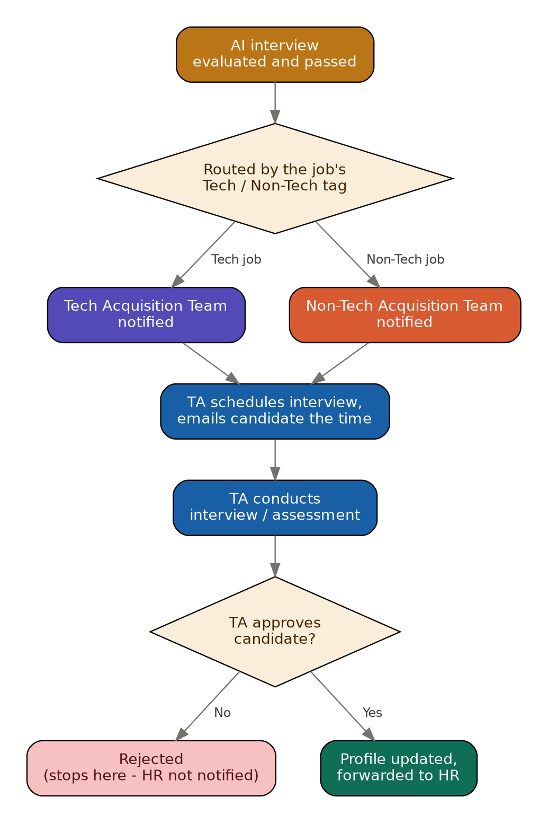
Figure 4 — TA routing, scheduling, and the approve/reject gate

Key business rules
1. Routing is determined solely by the job's Tech/Non-Tech tag set at job creation (Module 4) — never by any property of the candidate.
2. The isolation rule from Module 3 applies here too: a Tech TA member only ever sees candidates for Tech jobs.
3. If the TA team rejects the candidate, the pipeline stops immediately — HR is never notified and never sees this candidate for this application.
4. If approved, the candidate's round-clearance status is saved (which rounds they cleared, TA's notes) before forwarding to HR — this history must not be lost.

Functional requirements
ID | The system shall... | Priority
FR-8.1 | Route an AI-passed candidate to the queue of the TA team matching the job's classification. | P0
FR-8.2 | Let the TA team pick and confirm an interview/assessment time, which triggers an email to the candidate's registered address. | P0
FR-8.3 | Provide a decision action (Approve / Reject) after the TA interview, with optional notes. | P0
FR-8.4 | On Reject, close the application at this stage and do not create any HR-visible record. | P0
FR-8.5 | On Approve, persist round-clearance details and forward the application to the HR queue. | P0

Notifications triggered by this module
- TA team — new candidate routed to their queue
- Candidate — interview/assessment time confirmation
- HR — candidate forwarded (only on TA approval)

9. HR round & offer management
Owned by: HR
Depends on: Module 8 (candidate must be TA-approved and forwarded)
The final human stage: HR conducts their own round (call or interview), finalizes candidate details, and generates and sends the offer letter.
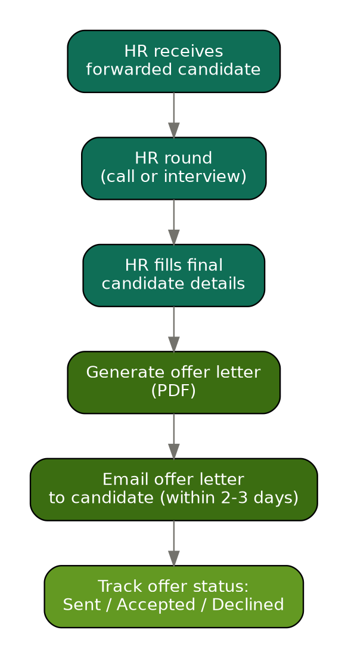
Figure 5 — HR round through offer letter delivery

Key business rules
1. HR only ever sees candidates that a TA team has already approved — this queue is never populated any other way.
2. HR can conduct their round as a call or a formal interview — both must be loggable, not just one fixed format.
3. The offer letter is generated as a PDF from candidate + role + compensation details entered by HR.
4. The offer letter must be emailed to the candidate within 2-3 business days of HR completing their round (service-level target, should be tracked, not just aspirational).

Functional requirements
ID | The system shall... | Priority
FR-9.1 | Show HR a queue of only TA-approved, forwarded candidates. | P0
FR-9.2 | Let HR log the outcome of their round (call or interview) against the candidate record. | P0
FR-9.3 | Let HR enter final offer details (title, compensation, joining date) and generate a PDF offer letter. | P0
FR-9.4 | Email the generated offer letter to the candidate's registered address and timestamp the send. | P0
FR-9.5 | Track offer status (Sent / Accepted / Declined / Expired) and flag offers unsent 3+ days after HR round completion. | P1

Notifications triggered by this module
- Candidate — offer letter email with PDF attachment
- HR — SLA reminder if offer not sent within 2-3 days

10. Application status model
A single, unambiguous status field should track every application through the pipeline. Recommended states, in order:
Status | Set by | Meaning
applied | System (on submission) | Candidate has applied; not yet AI-screened
ats_held | AI Engine | Below the ATS threshold — pipeline stops unless manually overridden
ats_qualified | AI Engine | Passed ATS gate, awaiting AI interview
ai_interview_invited | AI Engine | AI interview link sent, awaiting candidate
ai_interview_failed | AI Engine | Did not pass the AI interview — pipeline stops
ta_review | AI Engine | Passed AI interview, routed to matching TA team
ta_scheduled | TA team | Interview/assessment time confirmed with candidate
ta_rejected | TA team | TA declined the candidate — pipeline stops, HR not notified
hr_review | TA team (on approval) | Forwarded to HR queue
hr_round_complete | HR | HR call/interview logged
offer_sent | HR | Offer letter emailed to candidate
offer_accepted / offer_declined | Candidate response / HR | Terminal states

11. Open questions for you to confirm before development starts
1. Is the ATS qualifying threshold fixed at 60%, or configurable per company / per job? (Your description mentioned both 60% and 65%.)
2. Can a Company Admin manually override an AI rejection (ATS hold or AI interview fail) and push a candidate forward anyway?
3. Should the Tech/Non-Tech split extend further later (e.g. Tech split into Engineering vs. Data), or is a two-way split final?
4. Which external job boards need direct API integration at launch (LinkedIn, Naukri confirmed — any others)?
5. Does HR's "call or interview" round need its own scoring/scorecard, or is a free-text outcome note sufficient for v1?
6. Should the 2-3 day offer SLA trigger an automatic escalation/reminder, or is it a soft target for now?

