|  |  |
| --- | --- |
| Notations | Abbreviations |

|  |  |
| --- | --- |
| **FLE-CNN** | Federated learning-based Ensemble CNN scheme to detect intrusions in the industry 5.0-driven healthcare system |
| **DL** | Deep learning |
| **DoS** | Denial-of-service attack |
| **IDS** | Intrusion detection systems |
| **CNN** | Convolutional neural network |
| **SVM** | Support Vector Machine |
| **KNN** | *k*-nearest neighbours |
| **TP** | True positive |
| **FP** | False positive |
| **TN** | True negative |
| **FN** | False negative |

**Input**: Local dataset Di​ at hospital  
**Parameters**:

* k for KNN
* Number of communication rounds R
* Real-time packet stream P

**Output**: Local model weights wSVM,wKNN,wDT

**Training Phase:**

1. **For** each hospital client Hi∈HH_i \in HHi​∈H:  
   2. Load the local dataset DiD_iDi​  
   3. Remove duplicate records  
   4. Split into features XXX and labels yyy  
   5. Train/test split (70/30)  
   6. Standard scale numerical features  
   7. One-hot encode categorical features in XXX  
   8. Label encode target variable yyy  
   9. Apply PCA for dimensionality reduction  
   10. Train base models: SVM, KNN(kkk), Decision Tree, CNN  
   11. Evaluate and get local model accuracies:  
     aSVM,aKNN,aDT,aCNNa_{SVM}, a_{KNN}, a_{DT}, a_{CNN}aSVM​,aKNN​,aDT​,aCNN​  
   12. Compute normalized ensemble weights:  
     wj=ajaSVM+aKNN+aDT+aCNN∀j∈{SVM,KNN,DT,CNN}w_j = \frac{a_j}{a_{SVM} + a_{KNN} + a_{DT} + a_{CNN}} \quad \forall j \in \{SVM, KNN, DT, CNN\}wj​=aSVM​+aKNN​+aDT​+aCNN​aj​​∀j∈{SVM,KNN,DT,CNN}  
   13. Send local weights wjw_jwj​ to the cloud server
2. **End For**

| **Model** | **Accuracy** | **Precision** | **Recall** | **F1-Score** |
| --- | --- | --- | --- | --- |
| Decision Tree | 95.33% | 96.86% | 94.35% | 94.10% |
| SVM | 92.00% | 90.96% | 88.62% | 91.77% |
| KNN | 94.78% | 92.17% | 94.24% | 95.00% |
| EIDS-HS | 95.12% | 93.11% | 95.27% | 94.18% |
| FLE-CNN (Proposed) | **97.67%** | **95.33%** | **94.27%** | **95.52** |
|  |  |  |  |  |

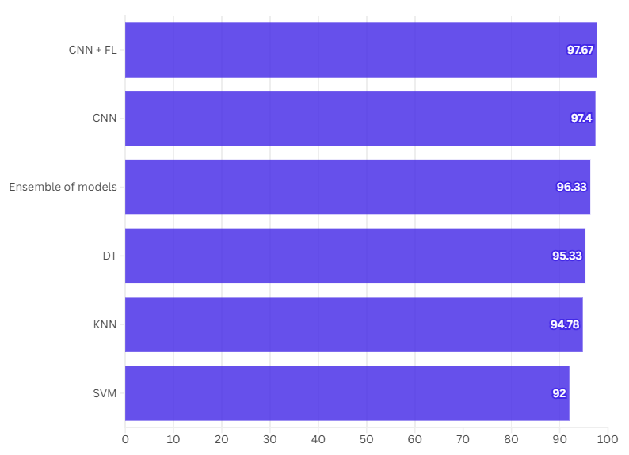

EIDS-HS

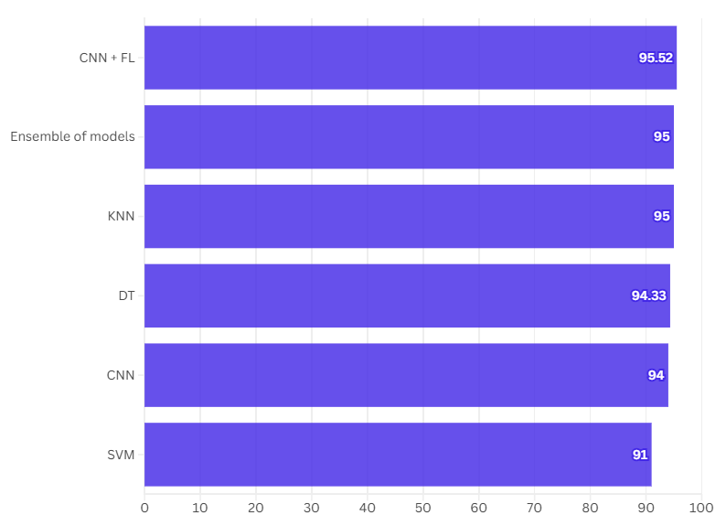

EIDS-HS

| **Features** | **Sherin et al. [28]** | **Esmaeili et al. [29]** | **Zou et al. [30]** | **Ketepalli et al. [31]** | **EIDS-HS [10]** | **FLE-CNN (Proposed)** |
| --- | --- | --- | --- | --- | --- | --- |
| 𝛶F1 | 81.67% | 82.80% | 85.95% | 94.74% | 95.12% | **97.67%** |
| 𝛶F2 | NO | NO | NO | NO | YES | **YES** |
| 𝛶F3 | NO | NO | NO | NO | YES | **YES** |
| 𝛶F4 | NO | NO | NO | NO | YES | **YES** |
| 𝛶F5 | NO | NO | NO | NO | YES | **YES** |
| 𝛶F6 | NO | NO | NO | NO | YES | **YES** |
| 𝛶F7 | YES | YES | YES | YES | YES | **YES** |
| 𝛶F8 | NO | NO | NO | NO | YES | **YES** |
| 𝛶F9 | NO | NO | NO | NO | NO | **YES** |