  

**TAMILNADU SKILL DEVELOPMENT CORPORATION**

**Naan Mudhalvan Niral Thiruvizha Review - 2**

1. Name of the College: Mepco Schlenk Engineering College, Sivakasi
2. College code: 9517
3. Theme: Solid Waste/ Bio-waste/ E-waste
4. Problem statement: How might we design a cost-effective, compact, and user-friendly device to help households easily segregate wet and dry waste, improving source segregation, recycling efficiency, and reducing environmental impact at the ward level?
5. Faculty Guide Details: Dr. T. Revathi, HoD and Senior Professor, Information Technology Department, Mepco Schlenk Engineering College.

|  |  |  |  |  |
| --- | --- | --- | --- | --- |
| **Team Leader Name** | **AU Reg.No** | **Year** | **Department** | **Mobile No** |
| 1. Vijesh Pethuram K | 9517202106056 | Final Year | Information Technology | 8637480351 |
| **Team members** | | | | |
| 1. Kanishkaran K | 9517202106021 | Final Year | Information Technology | 84898 34410 |
| 1. Rajkarna G | 9517202106252 | Final Year | Information Technology | 90259 50243 |

1. Attach photos of the prototype/App/Software:

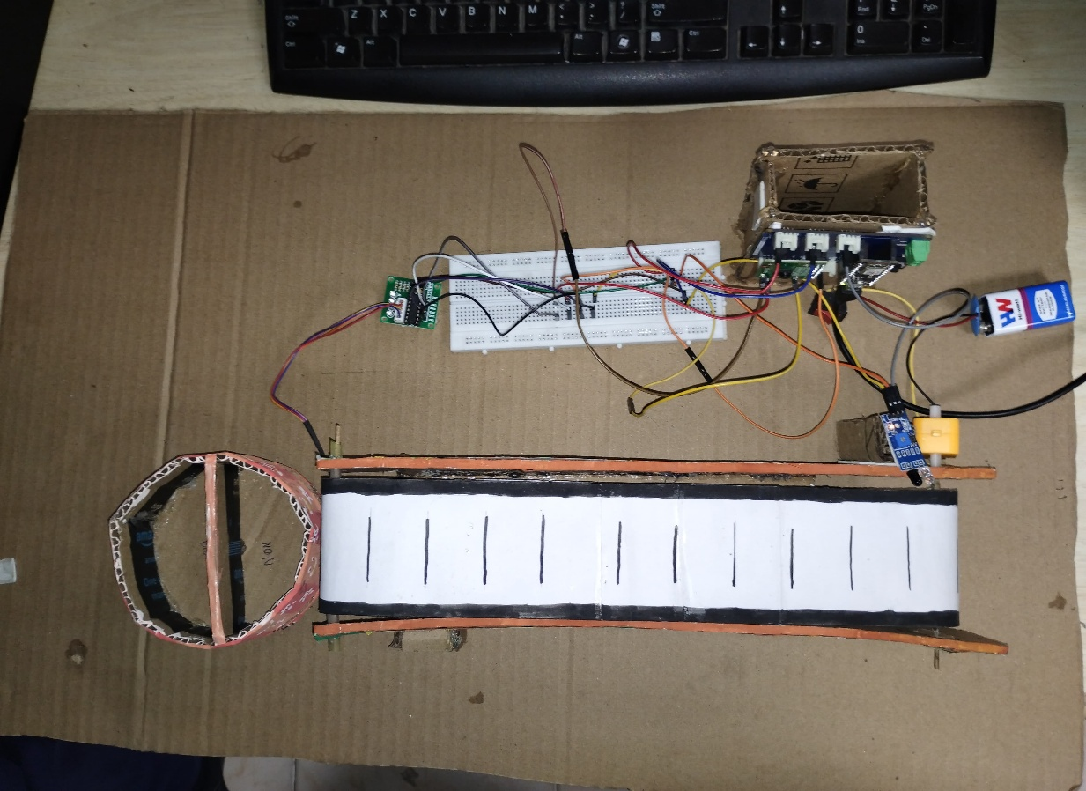

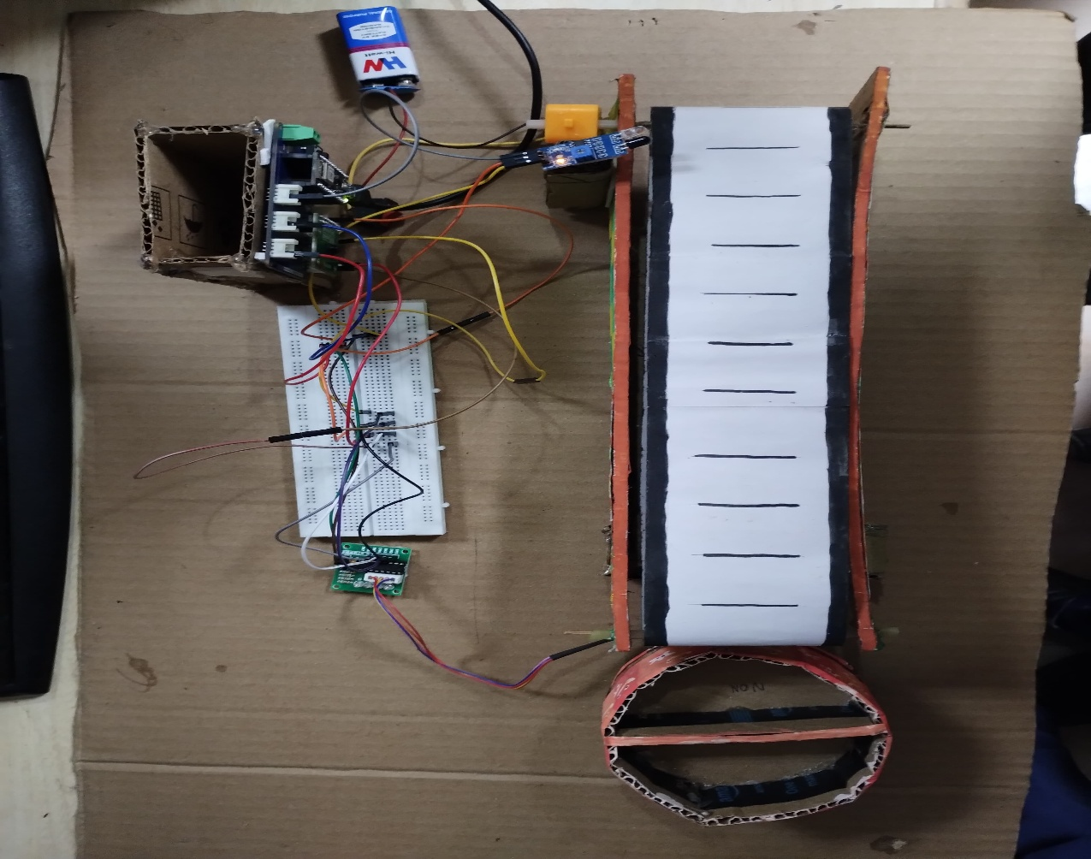

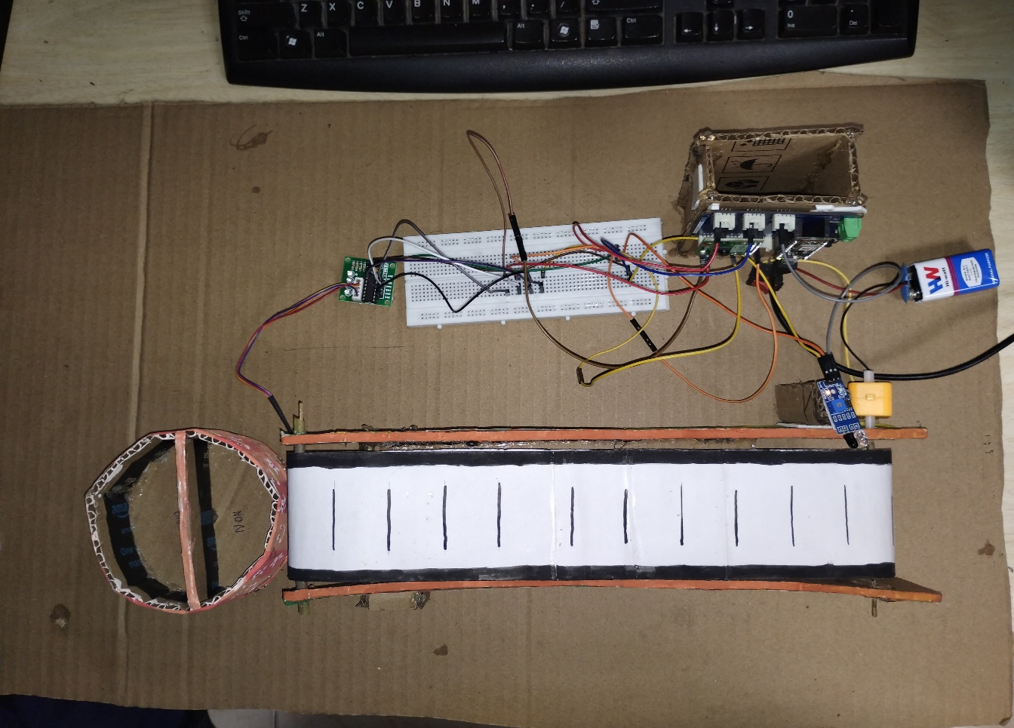

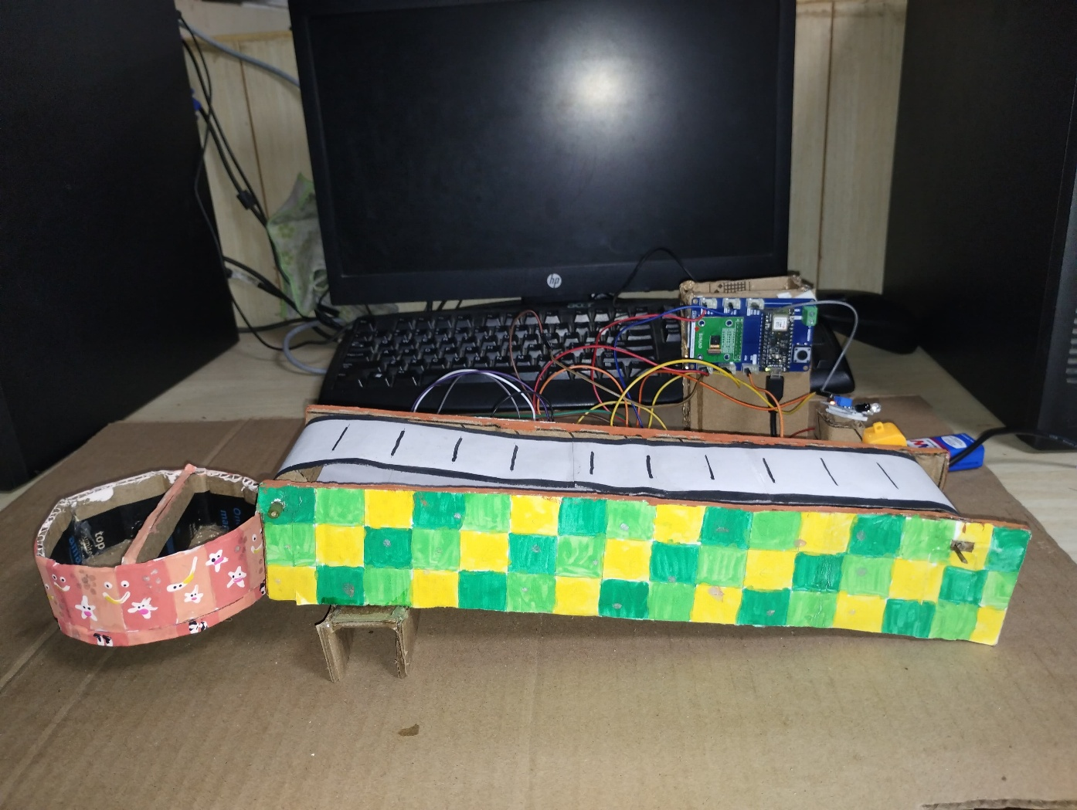

1. Attach photos of the 2nd review being conducted:

**UNDERTAKING**

1. The college will provide the basic infrastructure and other required facilities to the students for timely completion of their projects.
2. The college will undertake the financial and other management responsibilities of the project also; college will be responsible in following the time lines.
3. The college will ensure that the funds provided are utilized only for the purpose provided and any remaining amount will be returned back to the University after the time of completion of the project.
4. I hereby declare that the details furnished above are true and correct.

**Signature of Faculty Guide Signature of Principal**