Software Architecture and Design Specification (SAD)
Project: Traffic Management System (Simulation)
Version: 1.0
Authors: Aarya, Vijeth, Vaibhav, Vainik
Date: 12-10-2026
Status: Final – for team review
Approvals
Role | Name | Signature/Date
Course Coordinator

1. Introduction

1.1 Purpose
This document specifies the architecture and design of the Traffic Management System (TMS) Simulation, a C++17 discrete-time traffic simulator.

1.2 Scope
Covers scenario loading, vehicle generation and queues, adaptive signal control, road network and routing, movement, congestion and incident handling, metrics and reporting through a console interface.

1.3 Audience
Developers, testers, reviewers, instructors and maintainers.

1.4 Definitions
TMS, SRS, FR, NFR, RTM, Tick, Lane Queue, Signal Phase, RAII, ADR, STRIDE.

2. Document Overview

2.1 How to use this document
Section 3 describes architecture (components, pattern, traceability, security). Section 4 describes design (sequence diagrams, API, error handling).

2.2 Related Documents
TMS SRS v1.0, TMS Software Test Plan v1.0, project plan in the repository.

3. Architecture

3.1 Goals & Constraints
- Goals: modular, testable, deterministic, safe (no conflicting greens), reproducible.
- Constraints: C++17 and CMake on Linux; in-process modules only; no real hardware; no mutable globals except a controlled simulation context (NFR-01, NFR-05).

3.2 Stakeholders & Concerns
Stakeholder | Concerns
Scenario Designer / Operator | Usability, clear errors, repeatable runs
Traffic Analyst | Correct metrics and reports
Developers / Testers | Modularity, testability, deterministic behaviour
Evaluators | Traceability to SRS, quality, security

3.3 Component (UML) Diagram
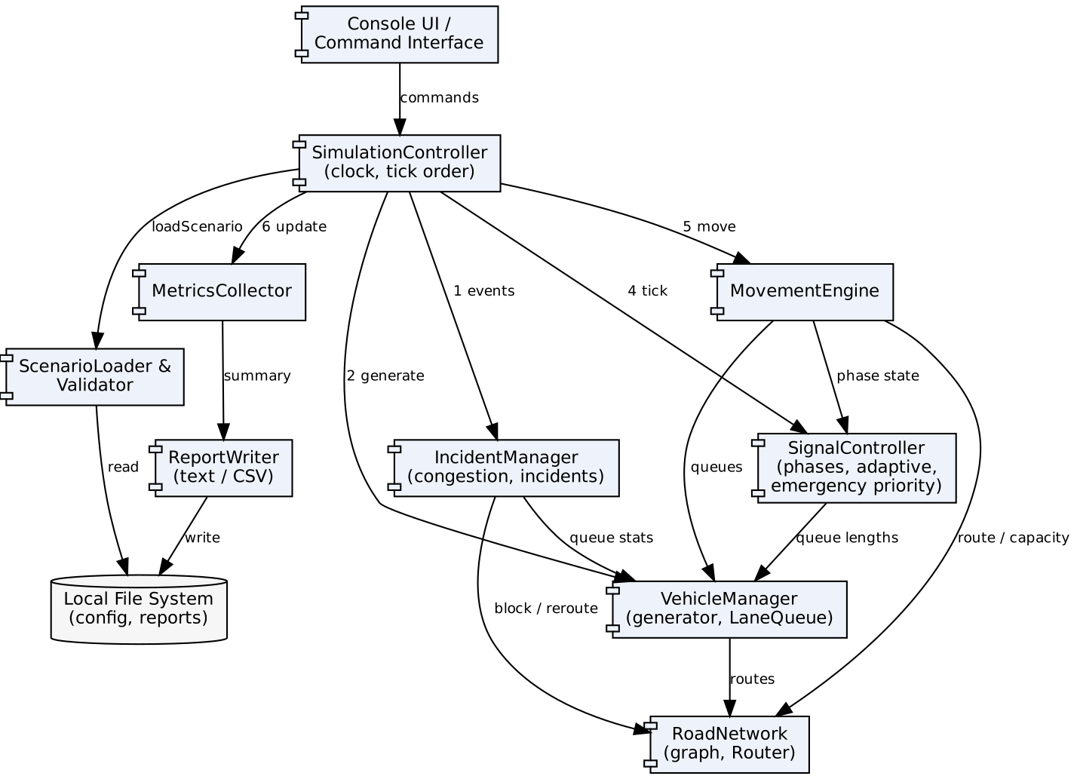
Figure 1: Component diagram. Numbers on SimulationController edges show the fixed tick-processing order.

3.4 Component Descriptions
Component | Responsibility | Key operations
Console UI | Menu/command interface, input prompts, status display | showMenu(), parseCommand()
SimulationController | Owns clock, tick order, run/stop/reset; the controlled simulation context and seeded RNG | loadScenario(), step(), run(), reset()
ScenarioLoader & Validator | Reads and validates scenario files | load(path), validate()
VehicleManager (Vehicle, LaneQueue) | Generates vehicles, assigns IDs/routes, enforces entry-lane capacity | generateVehicle(), insertAtEntry(), validateVehicle()
SignalController | Phases, timers, adaptive green, emergency priority; never enables conflicts | tick(), requestPriority(), isGreen()
RoadNetwork (Road, Router) | Graph of nodes/edges, capacities, availability, shortest-path routing | addRoad(), neighbors(), findRoute(), isRoadAvailable()
MovementEngine | Moves vehicles when signal, route and capacity allow; completes trips | advanceVehicles(), crossIntersection(), enterRoad(), completeTrip()
IncidentManager | Congestion detection, incident scheduling/clearing, triggers rerouting | scheduleIncident(), applyIncident(), clearIncident(), congestionStatus()
MetricsCollector | Throughput, waiting time, queue statistics, trip counts | recordWait(), recordDeparture(), buildSummary()
ReportWriter | Text and CSV export | writeText(), writeCsv()

3.5 Chosen Architecture Pattern and Rationale
Pattern: Modular, layered architecture with a central orchestrator (SimulationController) and a time-stepped (tick-based) simulation loop. Layers: Presentation (Console UI) → Orchestration (SimulationController) → Domain modules (Vehicle, Signal, Network, Movement, Incident) → Services (Metrics, Report, file I/O).
Rationale: separates concerns, lets each team member own one module, allows each module to be unit-tested through its interface (NFR-01, NFR-02), and keeps a single stable tick order that makes runs deterministic (FR-18). Rejected alternatives: event-driven/actor model (more complex, harder to make deterministic); microservices (unnecessary for a standalone simulator).
ADR-1: Use Dijkstra on an adjacency list (small sparse graph). ADR-2: Single seeded std::mt19937 in the simulation context for reproducibility. ADR-3: Fixed tick order – (1) apply incidents, (2) generate vehicles, (3) update congestion, (4) tick signals, (5) move vehicles in deterministic order, (6) update metrics, (7) advance clock.

3.6 Technology Stack & Data Stores
Concern | Choice
Language / build | C++17, CMake
Testing | GoogleTest, CTest, gcov/lcov
Quality | clang-format, clang-tidy/cppcheck, ASan/UBSan
CI/CD | GitHub Actions now (build, test, static analysis on every PR); Jenkins pipeline, Docker image and SonarQube planned per course guidelines
Data structures | std::deque (lane queues), adjacency list (graph), std::priority_queue (Dijkstra), std::unordered_map (registries)
Persistence | Text scenario files in config/; text/CSV reports on local file system (no database)

3.7 Risks & Mitigations
Risk | Mitigation
Inconsistent module integration | Documented fixed tick order; integration tests
Non-determinism | Single seeded RNG; ordered containers for iteration
Safety violation (conflicting greens) | Conflict matrix checked inside SignalController before any phase change; assertions in tests
Invalid input crashes the program | Central validation in ScenarioLoader and Console UI (NFR-04, NFR-07)

3.8 Traceability to Requirements
Requirement(s) | Component(s)
FR-01, NFR-04 | ScenarioLoader & Validator, SimulationController
FR-02, FR-03, FR-04 | VehicleManager (Vehicle, LaneQueue)
FR-05, FR-06, FR-07, FR-08 | SignalController
FR-09, FR-12 | RoadNetwork (Router)
FR-10, FR-11 | MovementEngine
FR-13, FR-14, FR-15 | IncidentManager
FR-16 | MetricsCollector
FR-17 | ReportWriter
FR-18, NFR-10 | SimulationController (seeded RNG)
NFR-01, NFR-02, NFR-08 | All modules via interfaces; RTM
NFR-03 | Simulation loop, MovementEngine, Router
NFR-05, NFR-09 | CMake, CI, static analysis
NFR-06 | Console UI, ReportWriter
NFR-07, SEC-01 to SEC-04 | Console UI and ScenarioLoader validation, SignalController safety check, RAII throughout

3.9 Security Architecture
The system is a local, standalone, single-user simulator, so the main threats come from malformed inputs and misuse of commands. Threat model (STRIDE):
Threat | Example | Control | Req
Spoofing | Not applicable (no authentication, local use) | N/A – documented assumption | –
Tampering | Edited scenario file with impossible values | Schema and range validation; reject on any error | SEC-01, SEC-02
Repudiation | Untraceable run | Log seed and config in every report | NFR-10
Information disclosure | Path leaks in error messages | Messages state cause only, no internal paths/memory | NFR-06
Denial of service | Huge file or extreme parameters hang the run | Size and value limits; capacity/duration caps | SEC-01, SEC-02
Elevation of privilege / safety bypass | Emergency request forces conflicting greens | Conflict check inside SignalController, cannot be bypassed by callers | SEC-04

Security objectives: SO-1 Integrity, SO-2 Availability, SO-3 Safety. Secure coding: RAII, std::string/std::vector only, no raw owning pointers, compiler warnings and sanitizers in CI (SEC-03).

3.10 Division of Work and Module Ownership
Member | Module ownership | Requirements | Interfaces documented
Aarya | Vehicle, LaneQueue, VehicleManager, input validation | FR-01 to FR-04 | IVehicleManager
Vijeth | SignalPhase, SignalController, signal policy | FR-05 to FR-08 | ISignalController
Vaibhav | Road, RoadNetwork, Router, MovementEngine | FR-09 to FR-12 | IRoadNetwork
Vainik | IncidentManager, MetricsCollector, ReportWriter | FR-13 to FR-17 | IMetricsCollector, IReportWriter
All | SimulationController integration, FR-18, NFRs, CI | FR-18, NFR-01 to NFR-10 | Tick-order contract

3.11 Interface Stability and ABI
The TMS builds as a single statically linked C++17 executable (plus test binaries), so there is no shared-library ABI to preserve. Stability is managed at source (API) level: public headers under include/<module>/ are the only cross-module contract; changes to them need a PR approved by the module owner and a reviewer. Interfaces are pure abstract classes (virtual destructor, no data members, no templates in signatures that cross modules) so tests can substitute mocks. If a module is later built as a shared library, only the abstract interfaces and plain value types (ids, Route, Vehicle) would form the ABI, and compiler/standard-library versions would have to match across modules.

4. Design

4.1 Design Overview
Each module is a C++ class (or small group) behind an interface in include/<module>/. The SimulationController calls modules in the fixed tick order. Data is exchanged via validated value objects (Vehicle, Road, Phase), not shared globals.

4.2 UML Sequence Diagrams
Figure 2 – Sequence 1 – Normal tick: vehicle generation, signalling and movement (FR-02 to FR-06, FR-10, FR-11, FR-16).
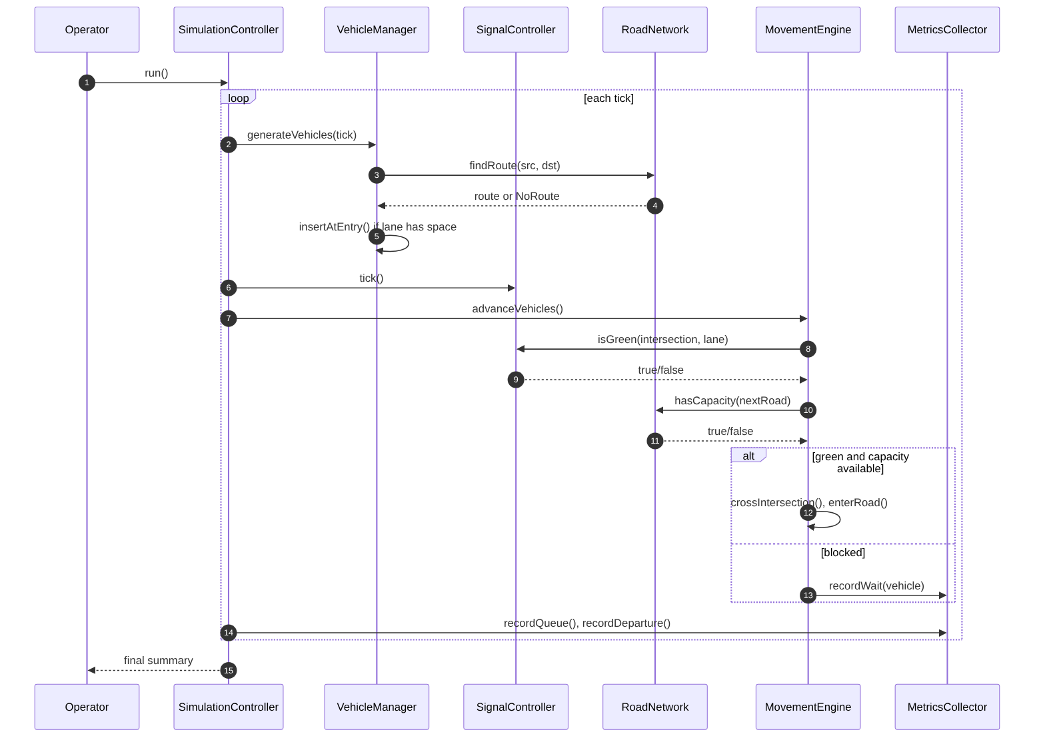
Figure 3 – Sequence 2 – Incident injection, congestion detection and rerouting (FR-12 to FR-15).
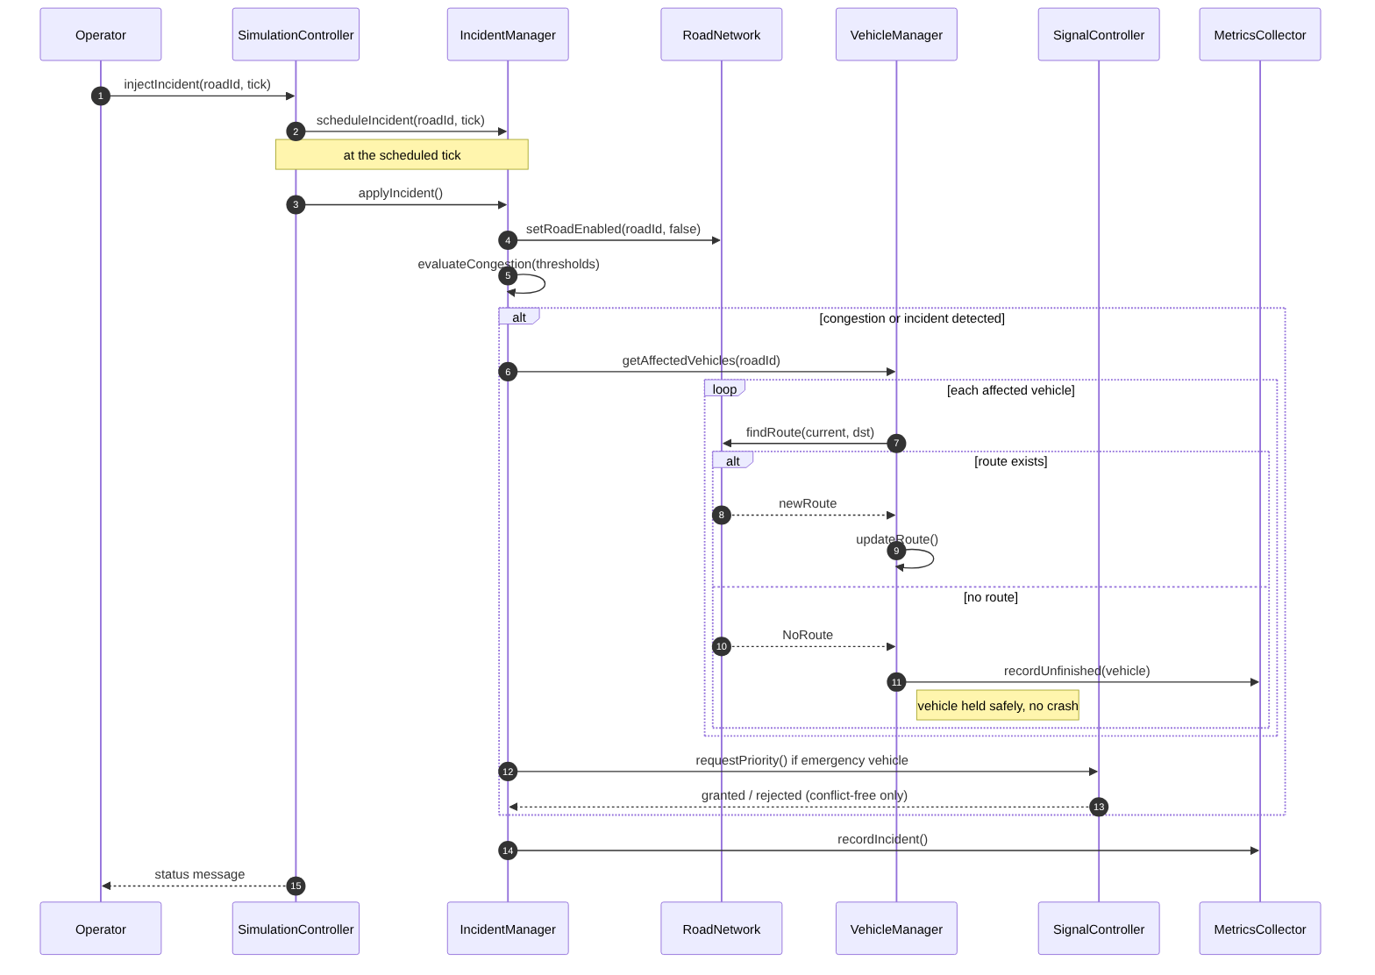

4.3 API Design
Because all communication is in-process (see SRS "Communications"), APIs are C++ module interfaces. Two key interfaces:
Interface | Method | Inputs | Returns / Errors
IRoadNetwork | findRoute(src, dst) | NodeId, NodeId | Result<Route> – error NoRoute, UnknownNode
IRoadNetwork | hasCapacity(roadId) | RoadId | bool; error UnknownRoad
IRoadNetwork | setRoadEnabled(roadId, bool) | RoadId, bool | void; error UnknownRoad
ISignalController | tick() | – | void
ISignalController | isGreen(intersectionId, laneId) | ids | bool
ISignalController | requestPriority(intersectionId, approach) | id, approach | Granted / Rejected(ConflictingPhase)
IVehicleManager | generateVehicles(tick) | tick | vector<VehicleId>
IVehicleManager | insertAtEntry(vehicle) | Vehicle | Ok / Rejected(LaneFull)
IMetricsCollector | recordWait / recordDeparture / buildSummary | vehicleId, tick | Summary
IReportWriter | writeCsv(path, summary) | path, Summary | Ok / Error(IoFailure)

Console command interface: load <file>, run [ticks], status, incident <road> <tick>, priority <intersection> <approach>, stats, export <path>, quit.

4.4 Error Handling, Logging & Monitoring
- Errors are returned as typed results (e.g. std::variant / custom Result or enum) at module boundaries; exceptions used only for fatal setup failures and caught in main.
- Standard error format: [ERROR][Module][Code] message. Example: [ERROR][Scenario][E101] Road R3 capacity must be > 0.
- Invalid configuration: reject, leave state unchanged, report cause, exit code non-zero for batch runs (NFR-04).
- No-route and full-lane situations are normal outcomes, not crashes (FR-11, FR-15).
- Logging: levels INFO/WARN/ERROR to console and optional log file; seed and scenario name logged at start; no sensitive or internal path data.
- Monitoring: per-run counters (vehicles generated, completed, unfinished, max queue, rejected inputs) in the final report.
Code | Meaning
E1xx | Scenario/configuration error
E2xx | Vehicle/queue error (lane full, invalid vehicle)
E3xx | Signal error (conflicting phase request)
E4xx | Routing/network error (no route, unknown id)
E5xx | I/O error (file read/write)

4.5 UX Design
Console menu with numbered options, consistent labels, concise error messages and a readable summary table (NFR-06).

4.6 Module Design: Road Network, Routing and Movement
This module (FR-09 to FR-12) is the core of vehicle progression across the network.
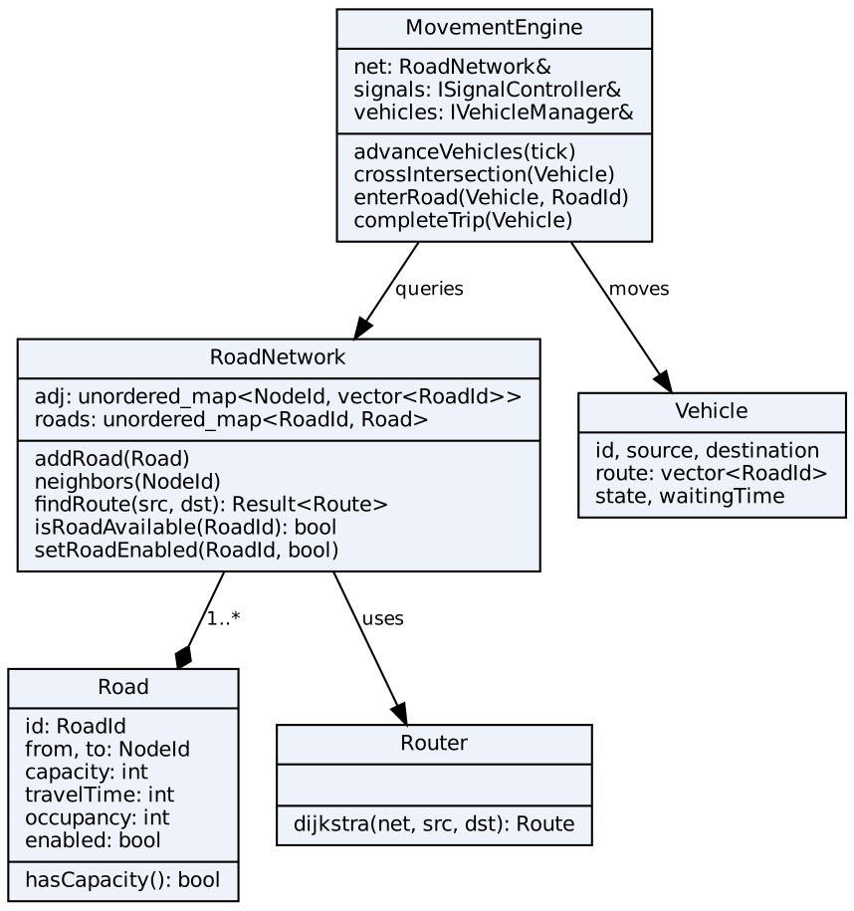
Figure 4: Class diagram of the Road Network and Movement module.
- Graph: adjacency list (unordered_map<NodeId, vector<RoadId>>), roads stored by id. Sparse graph, O(1) neighbour lookup (FR-09).
- Routing: Dijkstra with std::priority_queue; edge cost = travelTime (weighted-path policy). Disabled roads are skipped, so blocked roads are avoided automatically. Complexity O((V+E) log V). Unreachable destination returns NoRoute (FR-12, FR-15).
- Movement rule per tick, evaluated in deterministic order (ascending intersection id, then lane id): a vehicle at the front of its lane moves only if (a) its signal is green, (b) the next road on its route is enabled, and (c) the next road occupancy < capacity. Otherwise it waits and its waiting time increases (FR-10, FR-11).
- Trip completion: when a vehicle reaches its destination node it is removed, its trip time is recorded and the completed counter increments.
- Invariants: occupancy <= capacity for every road and lane at the end of every tick; a vehicle is in exactly one place (lane queue, road or completed).

4.7 Open Issues & Next Steps
- Finalise conflict matrix format for signal phases.
- Agree Result/error type shared by all modules.
- Optional: simple ASCII visualisation of queues.

5. Appendices

5.1 Glossary
See SRS Definitions and Acronyms.

5.2 References
IEEE 42010, IEEE 1016, OWASP Secure Coding Practices, NIST SP 800-160.

5.3 Tools
Graphviz, Mermaid, draw.io, GoogleTest, CMake, GitHub Actions.

