SOFTWARE ARCHITECTURE & DESIGN SPECIFICATION
Traffic Management System (Simulation)
Project: Traffic Management System (Simulation) | Version 1.0 | Date: 22 October 2026
Document status: Draft for team review — validate against the final implementation before sign-off.

Document Control
Version | Date | Prepared by | Change summary | Approval
1.0 | 22-10-2026 | Vainik / project team | Initial project-specific architecture and design specification | Pending team/instructor review

1. Introduction

1.1 Purpose
This document describes the proposed software architecture and module-level design of the Traffic Management System simulation, aligned to the supplied SRS v1.0. It defines components, responsibilities, interactions, interfaces, security/robustness controls, and traceability.

1.2 Scope
The system is a standalone C++17/CMake simulation of roads, lanes, intersections, signal phases, vehicles, congestion, incidents, routing, and traffic performance. It does not control physical traffic infrastructure or integrate live GPS/CCTV.

1.3 Audience
Developers, testers, integration coordinator, maintainers, and course evaluators.

1.4 Definitions
Term | Meaning
Tick | One discrete simulation-time step.
Road network | Graph of connected nodes and road edges.
Congestion | Queue/occupancy state meeting configured threshold.
RTM | Requirements Traceability Matrix.
RAII | C++ resource lifetime management pattern.

2. Document Overview

2.1 How to use this document
Use Section 3 to understand module boundaries and quality/security concerns. Use Section 4 for interaction sequences, interface contracts, error behavior, and implementation guidance. Requirement IDs refer to the supplied SRS.

2.2 Related documents
- Traffic_Management_SRS.docx (v1.0).
- Traffic_Management_Test_Plan.docx (v1.0, companion deliverable).
- Project repository: https://github.com/Vijeth-Madhwaraj/Traffic-Management-System-Simulation-

3. Architecture

3.1 Goals and constraints
- Keep simulation modules cohesive and connected through explicit C++ interfaces (NFR-01).
- Preserve signal safety and road/lane capacity invariants (FR-05, FR-06, FR-08, FR-11).
- Support deterministic scenarios and testable module behavior (FR-18, NFR-02, NFR-10).
- Build using C++17 and CMake; avoid compiler-specific extensions (NFR-05).
- Use local configuration and local text/CSV outputs; no external traffic-control infrastructure.

3.2 Stakeholders and concerns
Stakeholder | Primary concern
Scenario designer | Valid configuration and understandable validation errors.
Simulation operator | Stable run controls, visible traffic state and safe incident handling.
Traffic analyst | Correct metrics, congestion detection, comparable runs.
Developer/tester | Modularity, testability, reproducibility, and debuggable errors.
Evaluator | Evidence that requirements are traced to design and tests.

3.3 Component diagram
The diagram below shows a logical architecture derived from the SRS interfaces. It is a design proposal; verify component names against actual source files before final sign-off.
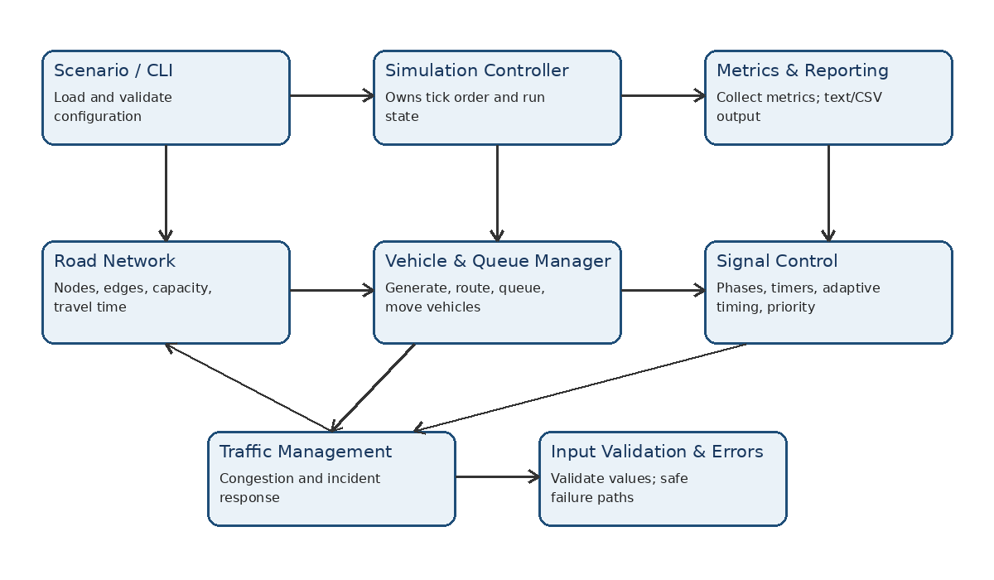
Figure 1. Logical component diagram for the Traffic Management System.

3.4 Component descriptions
Component | Responsibilities | Key requirements
Scenario / CLI | Read commands and scenario configuration; validate run parameters; display status/errors. | FR-01; NFR-04; NFR-06; NFR-07
Simulation Controller | Own simulation state and tick order; coordinate module calls; start/stop run; apply deterministic seed. | FR-18; NFR-01; NFR-10
Road Network | Represent nodes/edges, connectivity, capacities, travel times, and incident availability. | FR-09; FR-14
Vehicle & Queue Manager | Generate vehicles, assign IDs/classes/routes, maintain queues, move eligible vehicles, enforce capacity. | FR-02–FR-04; FR-10–FR-12
Signal Control | Maintain phases/timers, adapt green duration within bounds, process emergency priority safely. | FR-05–FR-08
Traffic Management | Measure congestion thresholds; respond to incidents; request rerouting and handle no-route outcomes. | FR-13–FR-15
Metrics & Reporting | Aggregate throughput, waiting time, queue statistics and trip completion; export text/CSV. | FR-16–FR-17
Input Validation & Error Handling | Validate config/commands, return explicit errors, prevent invalid state and manage resources safely. | NFR-04; NFR-07

3.5 Architecture pattern and rationale
Recommended pattern: modular layered architecture with a central simulation controller. The presentation/input layer receives scenario commands; the orchestration layer advances ticks; domain modules model the road network, vehicles/queues, signals and traffic management; the reporting layer collects and exports results. This keeps dependencies explicit and enables unit/integration tests. A distributed microservice architecture is unnecessary for the standalone, in-process C++ simulation described by the SRS.

3.6 Technology stack and data stores
- Language: C++17; build configuration: CMake; target operating environment: Linux (SRS).
- Data: in-memory graph, queues, signal states, vehicle records, and metrics during a run.
- Input/output: local scenario configuration and text/CSV reports as described by SRS; exact file formats must match implementation.
- Testing: module-level tests and integration/system scenarios; optional compiler sanitizers/static analysis where available.

3.7 Architectural risks and mitigations
Risk | Mitigation
Tight coupling between modules | Use small interfaces and pass explicit state/inputs rather than uncontrolled globals.
Signal conflict during phase change or emergency request | Centralize phase validation; test all transitions and priority paths.
Capacity race/ordering bug within a tick | Define tick update order and enforce capacity at insertion/movement boundaries.
Incident creates unreachable destination | Return explicit no-route status; keep vehicle state valid and report unresolved trip.
Metrics diverge from vehicle events | Update metrics at well-defined lifecycle events and validate with deterministic scenarios.
Invalid configuration causes undefined behavior | Validate at load time and guard invariants at module boundaries.

3.8 Traceability to requirements
SRS requirement | Design component(s) | Test reference
FR-01 | Scenario / CLI; Input Validation | TC-01, TC-02
FR-02–FR-04 | Vehicle & Queue Manager | TC-03, TC-04
FR-05–FR-08 | Signal Control | TC-05, TC-06, TC-07
FR-09–FR-12 | Road Network; Vehicle & Queue Manager | TC-04, TC-08
FR-13 | Traffic Management | TC-09
FR-14–FR-15 | Traffic Management; Road Network; routing | TC-10
FR-16–FR-17 | Metrics & Reporting | TC-11
FR-18 | Simulation Controller; vehicle generation | TC-03, TC-13
NFR-01–NFR-02 | All components / module interfaces | TC-14
NFR-03 | Simulation Controller | TC-12
NFR-04, NFR-07 | Input Validation & Error Handling | TC-02, TC-17
NFR-05, NFR-09 | Build configuration / codebase | TC-15
NFR-06 | Scenario / CLI and reports | TC-16
NFR-08 | Documentation / RTM | TC-18
NFR-10 | Controller / vehicle generation | TC-13

3.9 Security architecture and robustness
The SRS describes a local simulation and does not specify user accounts, a remote API, or sensitive personal data. Security architecture therefore focuses on input validation, memory/resource safety, integrity of simulation state, and safe file output rather than inventing authentication or TLS features.
- Threat: malformed configuration or command input → validate types, ranges, identifiers, and cross-references before use.
- Threat: invalid capacity/timing values corrupt state → enforce invariants at configuration load and at movement/phase transitions.
- Threat: unsafe memory/string handling → prefer standard library types, bounds-checked access where appropriate, and RAII.
- Threat: report path/write failure → check file open/write/close status and return a clear error without crashing.
- Threat: inconsistent signal state → centralize signal transition logic and test emergency-priority paths against conflict rules.
- Threat: corrupted or non-repeatable experiment → record configuration and seed where supported; compare same-seed runs.
- Optional verification: compiler warnings, address/undefined-behavior sanitizers, and static analysis. No network security controls are claimed unless network interfaces are added.

4. Design

4.1 Design overview
A simulation tick should follow a documented order so results are deterministic: (1) process scheduled arrivals and operator commands; (2) update incident availability and congestion observations; (3) calculate signal decisions and timers; (4) evaluate vehicle movement using route connectivity, signal permission and downstream capacity; (5) update vehicle lifecycle and metrics; (6) emit requested status/report output. The actual implementation order should be checked and documented by the team.

4.2 UML sequence diagrams
Sequence A — congestion/incident response.
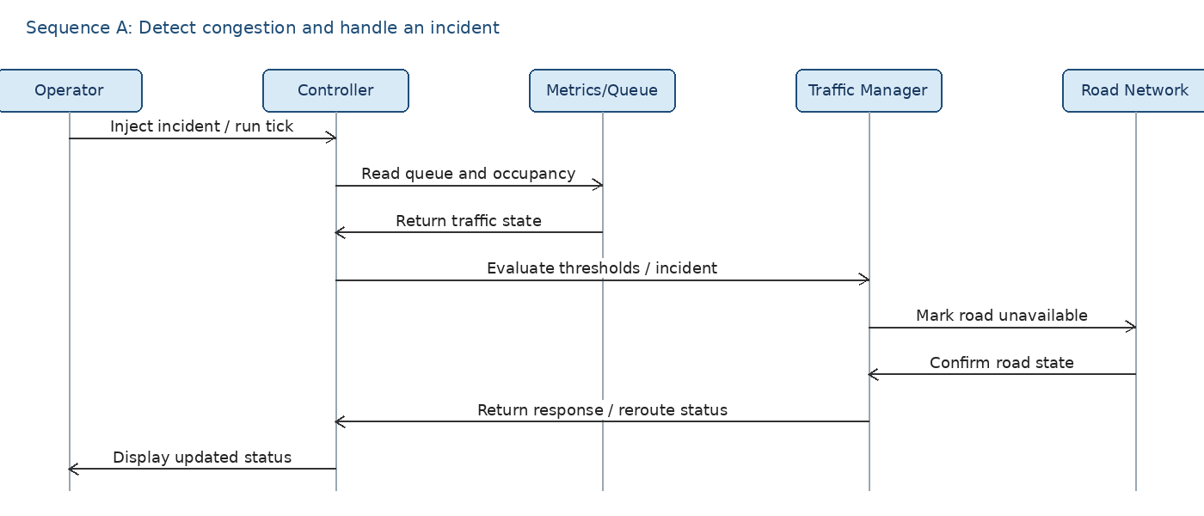
Figure 2. Proposed interaction for detecting congestion, applying an incident, and returning a safe management response.
Sequence B — simulation metrics and report export.
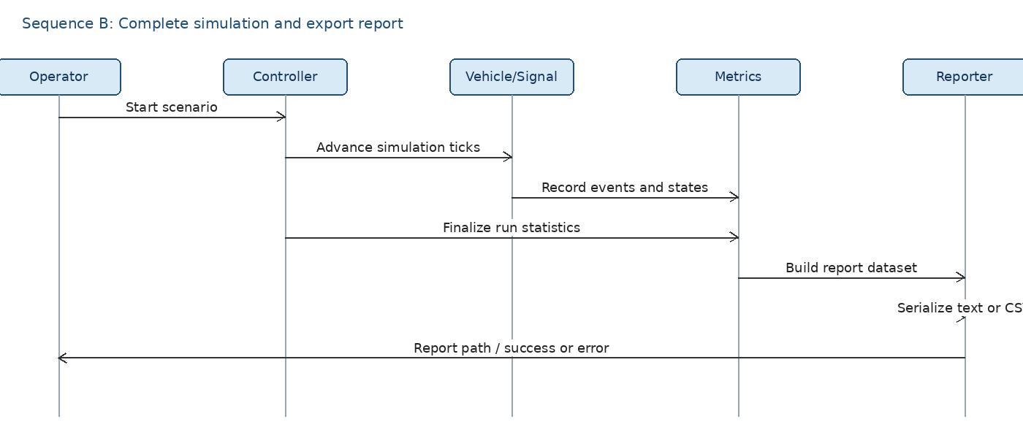
Figure 3. Proposed interaction for finalizing metrics and exporting a report.

4.3 API / component interface design
The SRS specifies in-process C++ interfaces rather than REST endpoints. The following are logical interface contracts, not claims that these exact function names already exist in the repository. Adapt names and types to the implementation.
Interface / operation (illustrative) | Input | Output / contract | Requirement
ScenarioLoader::load(path) | Scenario file path | Validated Scenario or structured error; reject unknown references and impossible values. | FR-01; NFR-04
RoadNetwork::isAvailable(edgeId) | Road/edge identifier | Boolean availability; invalid IDs return explicit error/status. | FR-09; FR-14
VehicleManager::generate(config, seed) | Arrival settings, deterministic seed | Generated vehicles with unique IDs and valid attributes. | FR-02; FR-03; FR-18
RoutingService::findRoute(source, destination, policy) | Valid node IDs and route policy | Connected route with cost, or explicit NoRoute result. | FR-12; FR-15
SignalController::advanceTick(queues, requests) | Queue summary and priority requests | Updated phase/timer; must never produce conflicting green phases. | FR-05–FR-08
TrafficManager::evaluate(state) | Queue/occupancy and incident state | Congestion flags and management/rerouting decisions. | FR-13–FR-15
MetricsCollector::record(event) | Simulation event/vehicle state | Updated throughput, waiting, queue and trip metrics. | FR-16
ReportWriter::write(metrics, format, path) | Metrics, text/CSV format, output path | Success result or structured I/O error; never silently report success on failure. | FR-17

4.4 Error handling, logging and monitoring
Condition | Expected handling
Malformed or missing scenario file | Return a clear load error; do not start a partially configured run.
Negative capacity / invalid signal timing | Reject configuration and identify the invalid field/value.
Unknown node, edge or vehicle route | Return validation or no-route status; avoid invalid memory access.
Full downstream lane | Keep vehicle in a safe prior state/queue; do not exceed capacity.
Road blocked by incident | Prevent prohibited movement; request alternate route where supported.
No alternate route exists | Mark route failure/unfinished trip or report the defined safe outcome; do not crash.
Output file cannot be opened/written | Report export failure and preserve simulation result in memory if possible.
Unexpected internal failure | Fail safely, retain useful diagnostic context, and avoid logging unnecessary configuration contents.

Monitoring is simulation-oriented: signal phase/state, queue lengths, congestion flags, incidents, completed/unfinished trips, throughput, waiting time, and report export status. Logs and labels should be consistent and readable (NFR-06).

4.5 User interaction design
- Console menu/commands should clearly distinguish load/configure, run/stop, inspect status, inject incident, submit emergency priority, view metrics, and export report.
- Print validation failures with the parameter name and acceptable constraint where practical.
- Use consistent units and metric labels; state whether values are per tick, per vehicle, or total run.
- Keep simulation operations separate from physical traffic control; clearly label the application as a simulation.

4.6 Open issues and next steps
- Confirm actual source filenames, class/function names, and current implemented modules from the repository before final submission; the provided SRS is more detailed than the repository listing currently visible online.
- Confirm configuration file format and whether text and CSV reporting are both implemented.
- Confirm exact congestion threshold definitions and incident/rerouting policy from code; do not invent numeric thresholds in the final version.
- Run and attach test evidence; all test outcomes in the companion Test Plan should remain Pending until executed.
- Review component/sequence diagrams with teammates and update them to match actual control flow.

5. Appendices

5.1 Glossary
Term | Definition
TMS | Traffic Management System.
SRS | Software Requirements Specification.
FR / NFR | Functional / Non-functional Requirement.
RTM | Requirements Traceability Matrix.
Congestion | Queue length or occupancy meeting configured thresholds.
Deterministic seed | Seed that makes pseudo-random generation repeatable under deterministic execution.

5.2 References
- Traffic_Management_SRS.docx, Version 1.0 (provided project baseline).
- IEEE 1016, Software Design Description (reference for design-description structure).
- ISO/IEC/IEEE 42010, Architecture Description (reference for architecture concerns and viewpoints).
- C++ Core Guidelines (resource safety and RAII guidance; apply as appropriate to implementation).

5.3 Tools
- Microsoft Word or LibreOffice Writer for document editing.
- PlantUML / diagrams.net for revising UML diagrams if the team prefers editable diagrams.
- CMake and a C++17 compiler for build verification; sanitizers/static analysis where available.

