Password with uppercase, lowecase and number.

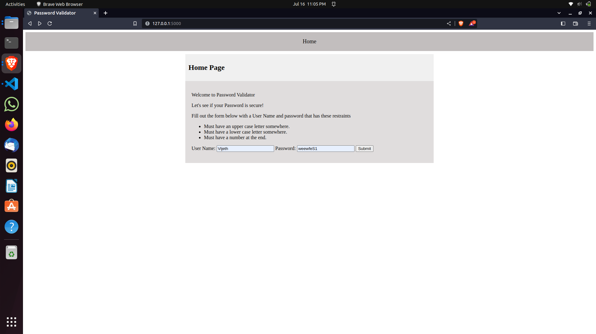

Success Scenario

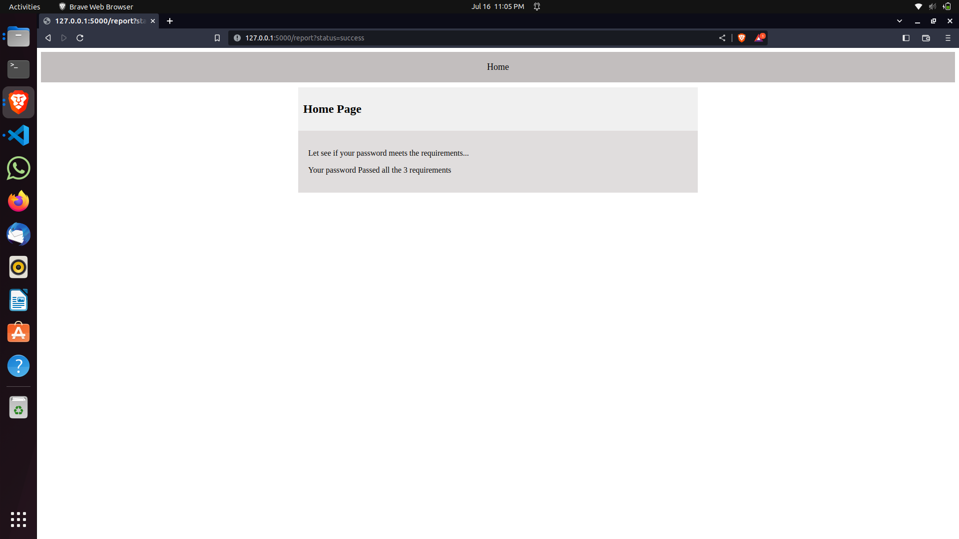

Password without uppercase and number.

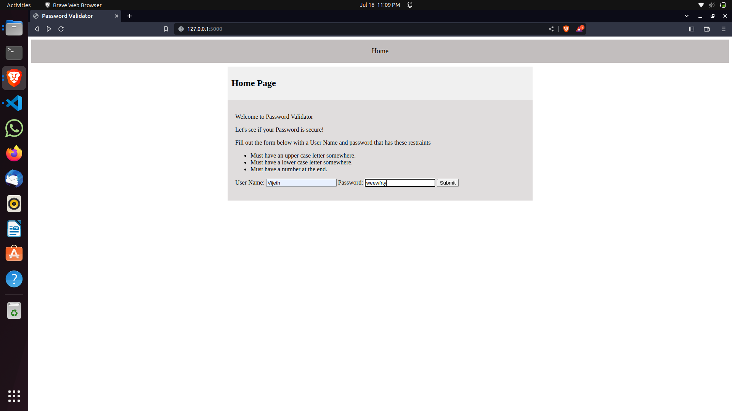

Failure scenario

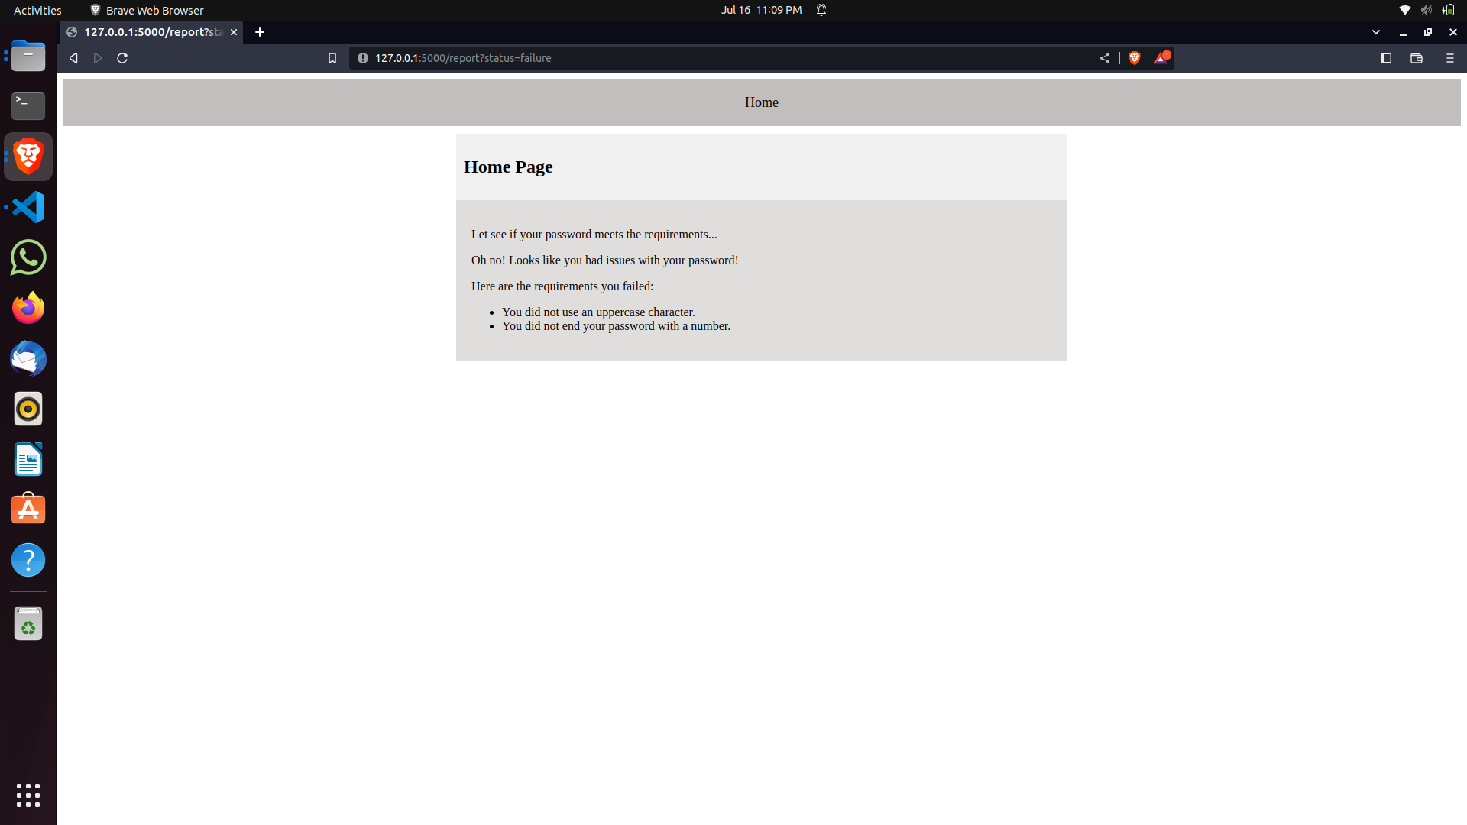

Github link

https://github.com/Vijeth-uab/Lab/tree/main/Lab6