EXPT NO:5 | DASHBOARD DESIGNING
DATE: 24.01.2026 | DASHBOARD DESIGNING

PRE-LAB QUESTIONS
- How do dashboards support strategic decision-making?
Answer: Dashboards aggregate complex, high-volume data into visual summaries (charts, graphs, KPIs). This allows decision-makers to instantly grasp current performance against goals (trends), identify outliers, and forecast future outcomes without getting lost in raw spreadsheets.
- What role do dashboards play in AI monitoring systems?
Answer: In AI systems, dashboards visualize "black box" metrics. They monitor model health (accuracy, precision, recall), track data drift (when real-world data diverges from training data), and visualize resource usage (GPU/TPU load), ensuring the AI remains reliable and efficient.
- Why is interactivity essential in modern dashboards?
Answer: Interactivity (filters, slicers, drill-downs) transforms a dashboard from a static report into an exploration tool. It allows different users (e.g., a Dean vs. a Professor) to query the data relevant to them immediately, finding "why" something happened rather than just "what" happened.
- What cognitive overload issues exist in dashboards?
Answer: Cognitive overload occurs when a dashboard displays too much information, poor color contrast, or irrelevant metrics at once. This exceeds the user's working memory, making it difficult to distinguish signal from noise and leading to decision paralysis.
- How are KPIs derived from raw data?
Answer: KPIs (Key Performance Indicators) are derived through aggregation and calculation. Raw transactional data (e.g., daily attendance logs) is grouped, summarized (sum, average, count), and often compared against a target value or time period to create a single actionable metric (e.g., "Average Monthly Attendance %").

OBJECTIVE: To design an interactive analytical dashboard for monitoring key metrics.
SCENARIO: An AI-based smart campus system requires a dashboard to monitor attendance, academic performance, and resource utilization in real time.
IN-LAB TASKS (Using PowerBI)
• Design KPI cards for attendance and performance
• Implement filters by department and semester
• Link multiple views for drill-down analysis

Procedure:

Step 1: Data Import and Preparation
- Launch Power BI Desktop.
- Navigate to the Home ribbon and select Get Data > Text/CSV.
- Locate and select the file 5.student_performance.csv.
- In the preview window, ensure the delimiter is set to "Comma" and click Load.
- Once loaded, go to the Table View (icon on the far left that looks like a table) to inspect the data.

Step 2: Creating Calculated Metrics (DAX)
- In Table View, click on Table tools > New Column.
- In the formula bar, enter the following formula to calculate the total score:
Total_Academic_Score = [Internal_Test1] + [Internal_Test2] + [Assignment_Marks]
- Press Enter. A new column named Total_Academic_Score will appear.
Step 3: Designing Key Performance Indicator (KPI) Cards
- Switch to Report View (canvas icon on the far left).
- Attendance KPI:
  - From the Visualizations pane, select the Card visual (123 icon).
  - Drag Attendance_Pct from the Data pane into the Fields well.
  - Click the dropdown arrow next to Attendance_Pct in the Fields well and select Average.
  - Formatting: Go to Format your visual (paintbrush icon) > Callout value > Label. Rename it to "Avg Attendance %".
- Performance KPI:
  - Insert a second Card visual.
  - Drag the newly created Total_Academic_Score into the Fields well.
  - Change the aggregation to Average.
  - Formatting: Rename the label to "Avg Academic Score".

Step 4: Implementing Interactive Slicers
- Click on a blank space on the canvas. Select the Slicer visual (funnel icon).
- Drag the Department field into the Field well.
- Insert a second Slicer visual.
- Drag the Semester field into the Field well.

Step 5: Configuring Drill-Down Analysis
- Select the Clustered Column Chart visual.
- X-Axis Configuration:
  - First, drag Department into the X-Axis well.
  - Next, drag Student_ID into the X-Axis well, placing it immediately below Department.
- Y-Axis Configuration:
  - Drag Attendance_Pct into the Y-Axis well. Ensure it is set to Average.
- Enabling Drill-Down:
  - On the chart header, you will see a downward-pointing arrow icon. Click it to enable "Drill mode".
  - User Action: When you click on a specific Department bar (e.g., "AI&DS"), the chart will now drill down to show the attendance of individual students within that department.

Step 6: Dashboard Formatting
- Theme Selection: Go to the View ribbon and select a professional theme (e.g., "Innovate" or "Storm").
- Title: Go to Insert > Text Box. Type "Academic Performance Monitoring Dashboard". Set the font size to 24, Bold, and center it at the top.

Output:
Overall Report:
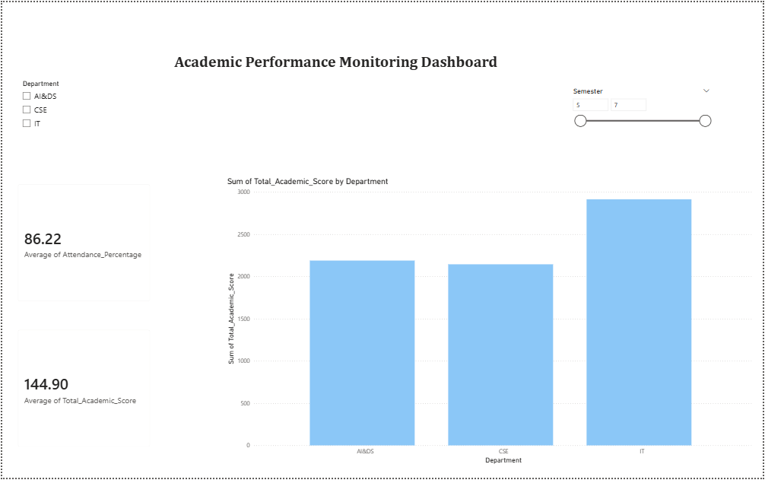
Drill Down: AI&DS
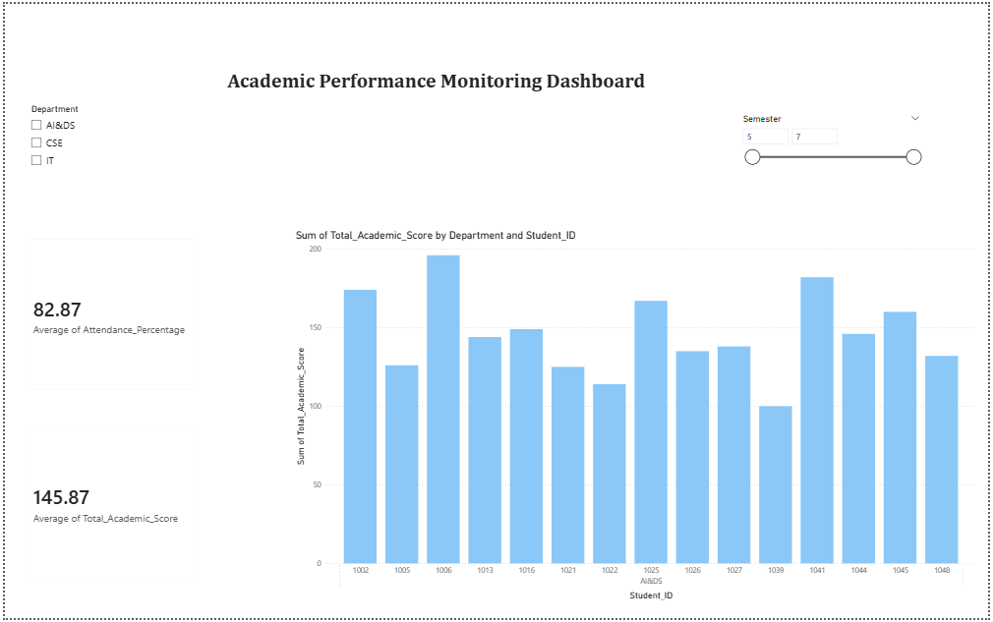

CSE, Semester 6-7
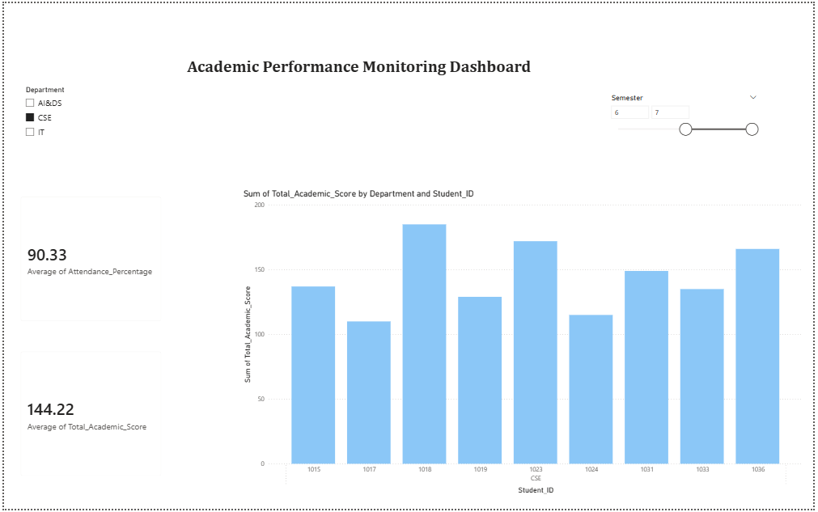
Data:
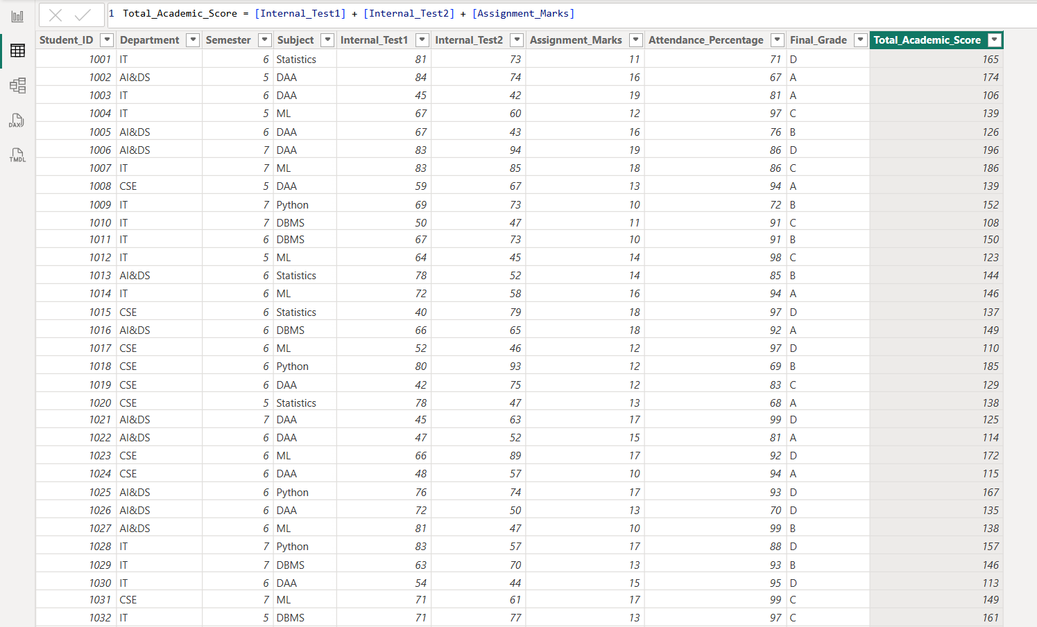

POST-LAB QUESTIONS
- How does interactivity improve analytical depth?
Answer: Interactivity moves analysis beyond static reporting by allowing users to ask "why." Features like drill-downs enable a user to start at a high level (Overall College Attendance) and investigate anomalies down to the granular level (Specific Student Attendance) instantly, revealing root causes without generating new reports.
- Which KPIs are critical for academic monitoring?
Answer: The most critical KPIs effectively combine engagement and output. Average Attendance % serves as a leading indicator of student engagement, while Average Assessment Scores (Internal/Assignment) serve as lagging indicators of mastery. Tracking the correlation between these two provides the most actionable insight for intervention.
- What design principles prevent information overload?
Answer: To prevent overload, dashboards should adhere to the "Five-Second Rule" (key data understood in 5 seconds) and use Progressive Disclosure (showing high-level KPIs first, with details available only upon interaction). Design choices like using sufficient whitespace, high-contrast colors for alerts only, and limiting the dashboard to 5-7 key visuals are essential.
- How can dashboards be integrated with AI alerts?
Answer: Dashboards can be coupled with AI models to move from descriptive to prescriptive analytics. For example, an AI algorithm can monitor live attendance trends and trigger an automated alert on the dashboard (e.g., a red highlight or notification) if a student's attendance probability drops below a critical threshold (e.g., 75%), prompting immediate faculty intervention.
- How do dashboards enhance transparency in institutions?
Answer: Dashboards democratize data access, ensuring all stakeholders—from students to deans—see the same metrics. By visualizing real-time performance and resource utilization (e.g., lab usage), institutions eliminate "siloed" information, making grading standards, attendance policies, and resource allocation clear and verifiable for everyone.

LEARNING OUTCOME: Students understand dashboard design for AI-driven environments.

ASSESSMENT
Description | Max Marks | Marks Awarded
Pre Lab Exercise | 5
In Lab Exercise | 10
Post Lab Exercise | 5
Viva | 10
Total | 30
Faculty Signature

