EXPT NO:6 | OVER-PLOTTING REDUCTION TECHNIQUES
DATE: 09.02.2026 | OVER-PLOTTING REDUCTION TECHNIQUES

PRE-LAB QUESTIONS
- Why is over-plotting common in big data visualization?
Answer: Over-plotting is common because big data often involves datasets with millions of records. When the number of data points significantly exceeds the available screen pixels, multiple points are forced to occupy the same space, resulting in overlapping and indistinguishable data.
- How does data density affect perception?
Answer: High data density distorts perception by causing occlusion, where top layers of points hide those underneath. This makes it difficult for the viewer to accurately judge the true concentration of data, as a region with 1,000 points may look visually identical to a region with 10,000 points.
- What trade-offs exist between detail and clarity?
Answer: The primary trade-off is that maintaining high detail (showing every individual point) often creates visual clutter that obscures the overall trend (low clarity). Conversely, reducing detail through aggregation improves clarity and reveals broad patterns but sacrifices the visibility of individual outliers or specific data points.
- How do AI datasets increase visualization complexity?
Answer: AI datasets increase complexity because they typically involve massive scale and high dimensionality. Visualizing these large-scale datasets requires advanced reduction techniques to interpret complex patterns without the visual noise that comes from millions of raw data points.
- Why is over-plotting a serious analytical risk?
Answer: Over-plotting is a risk because it creates visual ambiguity, potentially leading analysts to miss high-density clusters or misinterpret data distributions. This can result in false positives or negatives, leading to incorrect insights and flawed decision-making.

OBJECTIVE : To apply techniques that reduce visual clutter in large-scale datasets.

SCENARIO A social media analytics company visualizes millions of user interactions to study engagement patterns.

IN-LAB TASKS (Using R Language)
• Apply alpha blending
• Implement jittering techniques
• Use aggregation and binning

Code:
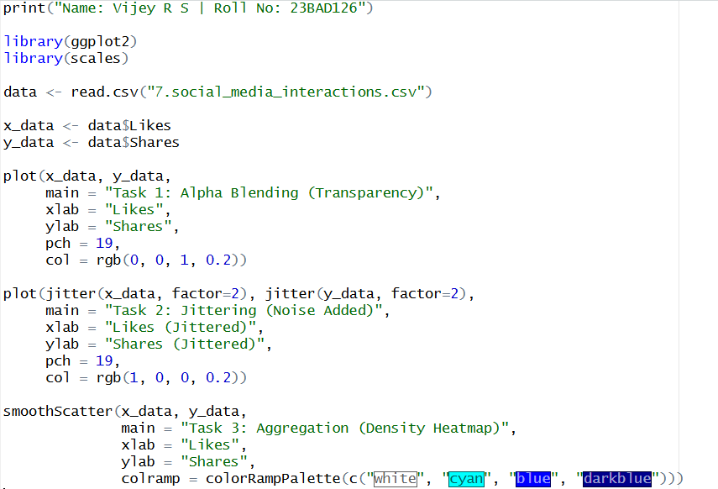

Output:

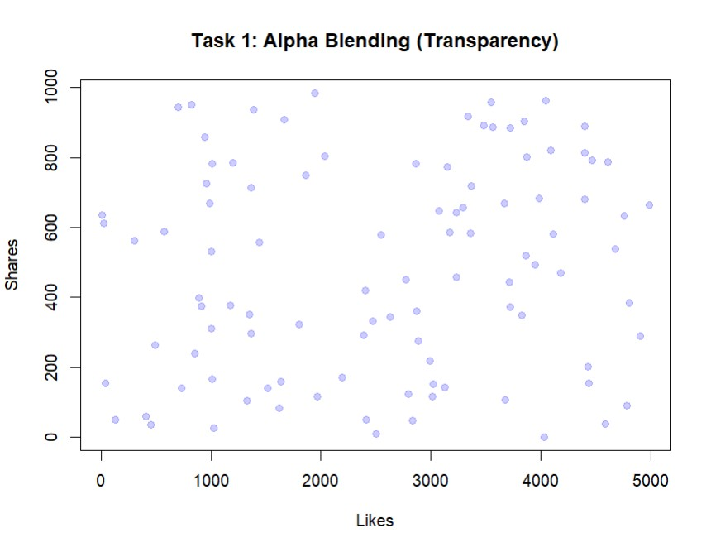
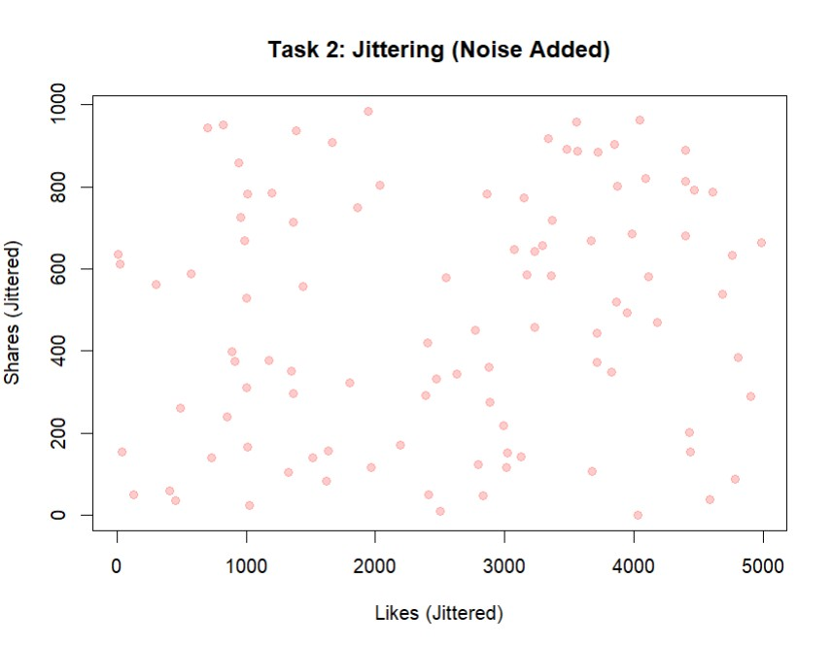

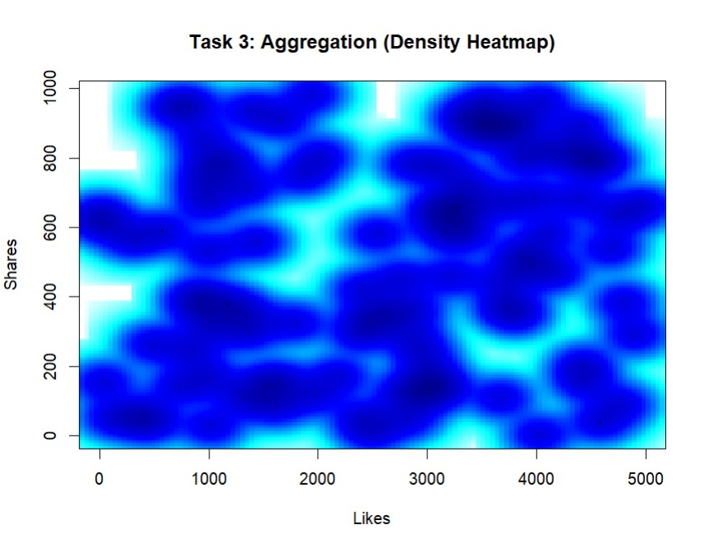

POST-LAB QUESTIONS
- Which technique provided the best clarity and why?
Answer: Aggregation (specifically binning or heatmaps) typically provided the best clarity. This is because it converts overlapping points into a color-coded density map, allowing for an immediate understanding of where the "hotspots" or highest concentrations of data are, without the confusion of overlapping dots.
- How does over-plotting distort analytical conclusions?
Answer: It distorts conclusions by masking the true volume of data in dense areas. An analyst might incorrectly assume a uniform distribution or miss a significant trend simply because the visualization fails to represent the varying density of points accurately.
- When should aggregation be preferred over raw plotting?
Answer: Aggregation should be preferred when working with large-scale datasets where individual points render as a solid mass (severe over-plotting). It is the correct choice when the analytical goal is to understand overall distributions, trends, and density rather than to inspect specific individual records.
- How do these techniques support scalable AI analytics?
Answer: These techniques support scalable AI analytics by enabling the visualization of massive datasets (like millions of user interactions) without performance lag or visual clutter. This allows data scientists to effectively validate training data and interpret model outputs at scale.
- Explain real-world consequences of ignoring over-plotting.
Answer: In the context of the social media scenario, ignoring over-plotting could cause analysts to miss critical engagement patterns. For example, they might fail to see a massive spike in user activity during a specific time window because it is hidden by general clutter, leading to missed opportunities for optimization or targeted marketing.

LEARNING OUTCOME: Students master over-plotting reduction for big data visual analytics.
ASSESSMENT
Description | Max Marks | Marks Awarded
Pre Lab Exercise | 5
In Lab Exercise | 10
Post Lab Exercise | 5
Viva | 10
Total | 30
Faculty Signature

