UIT2601-Pattern Recognition and machine Learning

Vijaya lakshmi M
IT-C
3122235002155
AIM:
The goal of this experiment is to predict the age of Abalone (type of snail) using linear regression. Also to perform Exploratory Data Analysis (EDA) on the dataset, train and evaluate the model, and analyse its performance.

TASK 1:
#importing libraries
import numpy as np
import pandas as pd
import matplotlib.pyplot as plt
#loading datasets in google colab
from google.colab import files
uploaded=files.upload()
#displaying 10 records
print(df.head(10))
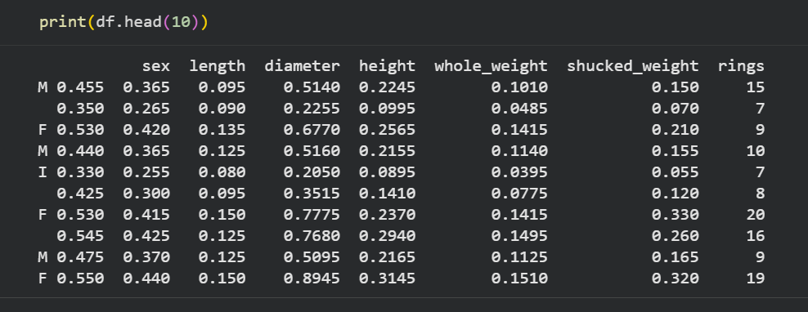
#displaying dataset shape
print("Dataset shape:",df.shape)
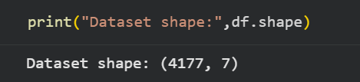
#checking for missing and duplicated values
print("missing values:\n",df.isnull().sum())
print("duplicate records:",df.duplicated().sum())
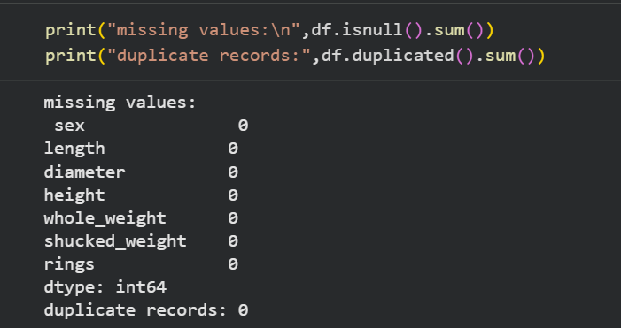

TASK 2
#converting categorical data
df_encoded=pd.get_dummies(df, columns=["sex"], drop_first=True)
#define features and target
X=df_encoded.drop("rings",axis=1)
y=df_encoded["rings"]+1.5
#train test split
from sklearn.model_selection import train_test_split
X_train,X_test,y_train,y_test=train_test_split(X,y,test_size=0.2,random_state=42)
#train linear regression model
from sklearn.linear_model import LinearRegression
model = LinearRegression()
model.fit(X_train, y_train)
#predict age on test data
y_pred = model.predict(X_test)

TASK 3
#performance metrics
from sklearn.metrics import mean_absolute_error, mean_squared_error, r2_score
mae = mean_absolute_error(y_test, y_pred)
mse = mean_squared_error(y_test, y_pred)
r2 = r2_score(y_test, y_pred)
print("Mean Absolute Error (MAE):", mae)
print("Mean Squared Error (MSE):", mse)
print("R2 Score:", r2)
