# CRYPTOCURRENCY PRICE PREDICTION USING DEEP LEARNING

### A PROJECT REPORT

***Submitted by***

|  |  |  |
| --- | --- | --- |
| **SWETHA K** |  | **211419104284** |
| **SWETHA S** |  | **211419104286** |
| **VIJAYA LAKSHMI K** |  | **211419104303** |
| ***in partial fulfillment for the*** | ***award*** | ***of the degree*** |

***of***

**BACHELOR OF ENGINEERING**

**IN**

**COMPUTER SCIENCE AND ENGINEERING**



**PANIMALAR ENGINEERING COLLEGE**

### (An Autonomous Institution, Affiliated to Anna University, Chennai)

**APRIL 2023**

# PANIMALAR ENGINEERING COLLEGE

**(An Autonomous Institution, Affiliated to Anna University, Chennai)**

## BONAFIDE CERTIFICATE

Certified that this project report **“CRYPTOCURRENCY PRICE PREDICTION USING DEEP LEARNING”** is the bonafide work of **“SWETHA K [211419104284], SWETHA S [211419104286] and**

**VIJAYALAKSHMI K [211419104303]”** who carried out the project work under my supervision.

|  |  |
| --- | --- |
| **SIGNATURE**  **Dr.L.JABASHEELA,M.E.,Ph.D HEAD OF THE DEPARTMENT,** DEPARTMENT OF CSE, PANIMALAR ENGINEERING COLLEGE,  NAZARATHPETTAI, POONAMALLEE, CHENNAI-600 123 | **SIGNATURE**  **Dr.T.TAMILVIZHI, M.Tech., Ph.D., ASSOCIATE PROFESSOR,** DEPARTMENT OF CSE, PANIMALAR ENGINEERING COLLEGE,  NAZARATHPETTAI,  POONAMALLEE, CHENNAI-600 123. |

Certified that the above candidate(s) was/ were examined in the End Semester Project Viva-Voce Examination held on...........................

**INTERNAL EXAMINER EXTERNAL EXAMINER**

## DECLARATION BY THE STUDENT

### We SWETHA K [211419104284], SWETHA S [211419104286] and

**VIJAYA LAKSHMI K [211419104303]** hereby declare that this project report titled “**CRYPTOCURRENCY PRICE PREDICTION USING DEEP**

**LEARNING”**, under the guidance of **Dr. T. TAMILVIZHI, M.Tech., Ph.D., ASSOCIATE PROFESSOR**, is the orginial work done by us and we have not plagiarized or submitted to any other degree in any university by us.

### SWETHA K SWETHA S

**VIJAYA LAKSHMI K**

**ACKNOWLEDGEMENT**

We would like to express our deep gratitude to our respected Secretary and Correspondent **Dr.P.CHINNADURAI, M.A., Ph.D.** for his kind words and enthusiastic motivation, which inspired us a lot in completing this project.

We express our sincere thanks to our beloved Directors **Tmt.C.VIJAYARAJESWARI**, **Dr.C.SAKTHI KUMAR,M.E.,Ph.D** and **Dr.SARANYASREE SAKTHI KUMAR B.E.,M.B.A.,Ph.D.,** for providing us

with the necessary facilities to undertake this project.

We also express our gratitude to our Principal **Dr.K.Mani, M.E., Ph.D.** who facilitated us in completing the project.

We thank the Head of the CSE Department, **Dr. L.JABASHEELA , M.E.,Ph.D.,**

for the support extended throughout the project.

We would like to thank my **Project Guide Dr. T. TAMILVIZHI, M.Tech., Ph.D., ASSOCIATE PROFESSOR** and all the faculty members of the Department of CSE for their advice and encouragement for the successful completion of the project.

### SWETHA K SWETHA S

**VIJAYA LAKSHMI K**

## ABSTRACT

As technology advances on a daily basis, we are advancing our lives into the digital sphere. The introduction of these cryptocurrencies aims to prevent the financial crisis. Due to its decentralized nature, high level of security, and restriction on the number of coins that may be created, cryptocurrencies have attracted investors. Predicting the future price includes several limits and determinants because it involves capital. It varies according to market share. Using block chain technology and encryption, the transactions are encrypted from beginning to end. Predicting prices to encourage consumers to invest during a specific time period and earn a profit. They include a variety of elements, such as market analysis, sentiment analysis on Twitter, trading volume, and open and closing prices. Typical models that can be used to forecast bitcoin prices include regression techniques, neural networks, and support vector machines. Predictions of cryptocurrency prices based on their closing prices give investors additional insight into whether to wait until the closing period if prices are low for the entire day or to invest the following day. Using deep learning and bidirectional LSTM, we suggested this model to anticipate the price of digital currencies including Bitcoin, Litecoin, Ethereum, and Cardano. In this model, predictions are made using historical price statistics, and the graph is created by evaluating several performance indicators.

**Keywords:** Cryptocurrency, Deep Learning, Bidirectional LSTM, Exploratory Data Analysis (EDA).

## TABLE OF CONTENTS

|  |  |  |
| --- | --- | --- |
| **CHAPTER NO.** | **TITLE** | **PAGE NO.** |
|  | **ABSTRACT** | iii |
|  | **LIST OF TABLES** | vi |
|  | **LIST OF FIGURES** | vii |
|  | **LIST OF SYMBOLS** | viii |
| **1.** | **INTRODUCTION** |  |
|  | 1.1 Problem Definition | 1 |
|  | 1.2 Scope of the project | 1 |
| **2.** | **LITERATURE SURVEY** |  |
|  | 2.1 Literature Survey | 2 |
| **3.** | **SYSTEM ANALYSIS** |  |
|  | 3.1 Existing System | 6 |
|  | 3.2 Proposed system | 6 |
|  | 3.3 Feasibility Study | 7 |
|  | 3.4 Hardware Environment | 8 |
|  | 3.5 Software Environment | 8 |
| **4.** | **SYSTEM DESIGN** |  |
|  | 4.1 Data Flow Diagram | 9 |
|  | 4.2 UML Diagrams | 10 |

|  |  |  |
| --- | --- | --- |
| **CHAPTER NO.** | **TITLE** | **PAGE NO.** |
| **5.** | **SYSTEM ARCHITECTURE** |  |
|  | 5.1 Module Design Specification | 12 |
|  | 5.2 Algorithm | 16 |
| **6.** | **SYSTEM IMPLEMENTATION** |  |
|  | 6.1 Source Code | 18 |
| **7.** | **SYSTEM TESTING / PERFORMANCE EVALUATION** | |
|  | 7.1 Test Cases & Reports | 55 |
|  | 7.2 Performance Evaluation | 56 |
| **8.** | **CONCLUSION** |  |
|  | 8.1 Conclusion | 57 |
|  | 8.2 Future Enhancements | 57 |
|  | **APPENDICES** |  |
|  | 8.3 Sample Screens | 58 |
|  | **REFERENCES** | 62 |

**LIST OF TABLES**

|  |  |  |
| --- | --- | --- |
| **TABLE NO.** | **TABLE DESCRIPTION** | **PAGE NO.** |
| 7.1 | TEST CASES AND REPORTS | 55 |
| 7.2 | PERFORMANCE EVALUATION | 56 |

## LIST OF FIGURES

|  |  |  |
| --- | --- | --- |
| **FIG NO.** | **FIGURE DESCRIPTION** | **PAGE NO.** |
| 4.1 | DFD DIAGRAM | 9 |
| 4.5 | USE-CASE DIAGRAM | 10 |
| 4.7 | ACTIVITY DIAGRAM | 11 |
| 5.1 | SYSTEM  ARCHITECTURE DIAGRAM | 12 |
| 5.2 | DATASET | 13 |
| 5.3 | VISUALISED PREPROCESSED DATA | 14 |
| 5.4 | MONTH WISE ANALYSIS OF DATASET | 14 |
| 5.5 | PREDICTED GRAPH | 15 |
| 5.6 | Bi-LSTM DIAGRAM | 16 |
| 8.1 | HOME SCREEN | 58 |
| 8.2 | PREDICTION PAGE | 58 |
| 8.3 | PREDICTION GRAPH FOR BITCOIN | 59 |
| 8.4 | PREDICTION GRPH FOR CARDANO | 59 |
| 8.5 | PREDICTION GRAPH FOR ETHEREUM | 60 |
| 8.6 | PREDICTION GRAPH FOR LITECOIN | 60 |
| 8.7 | FAQ | 61 |
| 8.8 | LIVE PRICE PAGE | 61 |

**LIST OF SYMBOLS**

|  |  |  |  |
| --- | --- | --- | --- |
| **S.NO** | **NOTATION NAME** | **NOTATION** | **DESCRIPTION** |
| 1. | Actor |  | It aggregates several classes into a single class. |
| 2. | Relations | relationships | An extension indicates that one use case may include the behaviour of another use case.  An inclusion represents one use case using the functionality of another use case. |
| 3. | Communication |  | Communication between various use cases. |
| 4. | State |  | State of the process. |
| 5. | Initial State |  | Initial State of the Object. |

|  |  |  |  |
| --- | --- | --- | --- |
| 6. | Final State |  | Final State of the object. |
| 7. | Control Flow |  | Represents various control flow between the states. |
| 8. | Fork node | Fork node shown as line segment with a single activity edge entering it, and two or more edges leaving it. | One incoming edge and multiple outgoing edges |
| 9. | Usecase |  | Interaction between the system and external environment |

# INTRODUCTION

### PROBLEM DEFINITION

People started to invest in cryptocurrency due to high security it has been decentralized, rapid growth in price of a cryptocurrency has it been a limited to certain amount of coin. Since cryptocurrency market has a lot of fluctuations in their price, it is hard to predict them with high accuracy. Thus there is a need for highly accurate forecasting models using modern techniques. The overall goal is to construct a deep learning model that can predict price trends with superior results. The prediction offers great potential and provides motivation for research in the area. The prediction helps users and investors, so that they can invest and use it more efficiently. To develop an application which will predict the four major cryptocurrency (Bitcoin, Litecoin, Cardano, Ethereum) prices in future with decent accuracy. This allows the investors to invest wisely in cryptocurrency trading as the prices of cryptocurrency have gone up to an exaggerating amount in the last ten years.

### SCOPE OF PROJECT

As cryptocurrency is one of the major investments in the world and it takes a lot of labor to predict the future prices by doing the analysis. Building a deep learning model to forecast the price of cryptocurrency is lot beneficial to the companies and other investors who invest in them and it also reduces the human labor. The main objective of the proposed system is to increase the accuracy of the price prediction.

# LITERATURE SURVEY

* + 1. **Title:** Deep Learning and Sentiment Analysis-Based Cryptocurrency Price Prediction

**Author:** R. Parekh *et al.* **Publication:** March 30, 2022 **Methodology used**:

*DL-GuesS* is divided into two phase. First phase calculates the sentiments from tweet. Second phase utilizes the price history along with the extracted features from the first phase to predict the price of the cryptocurrency. Sentiment analysis model uses twitter API and VADER to assess the sentiments of the text in the tweets. Price prediction model uses LSTM and GRU recurrent neural network to train with history of prices. **Drawbacks:**

* + - * In the proposed system the price of a single cryptocurrency is predicted by data of itself and other data as well.
      * Same or new approaches can be used to improve architecture of the system.
    1. **Title:** Improving the Cryptocurrency Price Prediction Performance Based on Reinforcement Learning

**Author:** Yung-Cheol Byun **Publication:** December 8, 2021 **Methodology used:**

Reinforcement learning is used to create the price prediction model (Litecoin & Monero). RL is based on a model-based and model-free design which gives the learning-based structure to the system. The raw data information contains four steps of pre-processing, feature engineering,

transformation, and feature selection. The dataset is split and applied into the RL procedure to train and test the price information.

**Drawbacks:**

* + - * Performance for the prediction of cryptocurrencies should be better for Litecoin and Monero.
      * Other coins cannot be predicted with this proposed system.
    1. **Title:** Time-series forecasting of Bitcoin prices using high-dimensional features: a machine learning approach

**Author:** Mohammed Mudassir, Shada Bennbaia, Devrim Unal and Mohammad Hammoudeh

**Publication:** 04 July 2020

### Methodology used:

Demonstrates high-performance machine learning- based classification (LSTM, SVM, ANN) and regression models for predicting Bitcoin price movements and prices in short and medium terms. The ML- based time-series forecast method starts with the construction of a dataset. This is followed by the training of ML models and forecasts based on these models for different horizons of forecast.

### Drawbacks:

* + - * It is possible to forecast the actual BTC price with very low error rates.
      * It is much harder to forecast its rise and fall.
    1. **Title:** A Bayesian Regularized Neural Network for Analyzing Bitcoin Trends

**Author:** R. Sujatha, V. Mareeswari, Jyotir Moy Chatterjee, Abd Allah

A. Mousa, Aboul Ella Hassanien.

**Publication:** 2 March 2021

### Methodolgy used:

The researchers suggested a prediction methodology for utilizing NARX to determine the closing price of Bitcoin. Certain attributes other than closing price are taken into account as external inputs in this model.

### Drawbacks:

* As a result, the quantity of input attributes determines the number of input nodes.
* This model's primary drawback is that it displays the closing price only for the next day.
  + 1. **Title:** An On-Chain Analysis-Based Approach to Predict Ethereum Prices

**Author:** Nishant Jagannath et al. **Publication:** December 2021 **Methodology used:**

LSTM algorithm is used to predict the price of ethereum. Onchain metrics are utilized to predict the prices of the ethereum.

### Drawbacks:

* In this work only ethereum prices are predicted.
* It could be used along with off-chain variables (Reddit, twitter) to predict prices more accurately.
  + 1. **Title:** Sentiment Analysis and Emotion Detection on Cryptocurrency Related Tweets Using Ensemble LSTM-GRU Model

**Author:** N. Aslam et al.

**Publication:** 07 April 2022

### Methodology used:

LSTM and GRU algorithm are used to build to perform sentiment analysis of the tweets on crytocurrency. Various feature extraction techniques such as BoW, TF-IDF, and Word2Vec are used.

### Drawbacks:

* In this work only sentiment analysis for cryptocurrency is made.
* Thus this sentimental analysis can be combined along with other model for price prediction in futureworks.
  + 1. **Title:** Deep Learning-Based Cryptocurrency Price Prediction Scheme With Inter-Dependent Relations

**Author:** Sudeep Tanwar, Nisarg P. Patel, Smit N. Patel, Jil R. Patel, Gulshan Sharma, Innocent E. Davidson.

**Publication:** October 2021

### Methodolgy used:

Proposed an LSTM-GRU based hybrid model with considering the inter-dependent feature of the parent coin – Bitcoin to forecast the accurate price of Litecoin and Zcash

### Drawbacks:

* Predicting the model with co-relation of the coin tend to produce the low accuracy and varies with fluctutaions.
* This model analyzed with only one performance metrics (MSE).

# SYSTEM ANALYSIS

### EXISTING SYSTEM

After the boom and bust of crypto currencies’ prices in recent years, cryptocurrency has been increasingly regarded as an investment asset. Because of its highly volatile nature, there is a need for good predictions on which to base investment decisions. Although existing studies have leveraged deep learning for more accurate cryptocurrency price prediction, few have focused on the feasibility of applying different modeling techniques to samples with different data structures and dimensional features.

### Dis-advantages:

* + - The price of a single cryptocurrency is predicted by data of itself and other data as well.
    - Performance for the prediction of cryptocurrencies should be better for Litecoin and Monero.
    - It is much harder to forecast its rise and fall.

### PROPOSED SYSTEM

Forecast of the cryptocurrency price by their closing price gives more idea to the investors to wait for the closing period to invest if its low than the whole day or to invest on the next day. We proposed this model to forecast the price of cryptocurrency coins such as Bitcoin, Litecoin, Ethereum and Cardano using Deep Learning with Bidirectional LSTM. In this model, prediction is made using the historical price datasets and the various performance metrics is evaluated to produce the graph. To enhance the visualization of graph for our model we have been displayed through a website where one can view the next 15 days prediction graph for each coin.

### FEASIBILITY:

Feasibility Study All systems are feasible when provided with unlimited resources and infinite time. But unfortunately, this condition does not prevail in the practical world. So it is both necessary and prudent to evaluate the feasibility of the system at the earliest possible time. Months or years of effort, thousands of rupees and untold professional embarrassment can be averted if an ill- conceived system is recognized early in the definition phase. Feasibility & risk analysis are related in many ways. If project risk is great, the feasibility of producing quality software is reduced. In this case three key considerations involved in the feasibility analysis are

* ECONOMICAL FEASIBILITY
* TECHNICAL FEASIBILITY
* SOCIAL FEASIBILITY

### ECONOMICAL FEASIBILITY

This study is carried out to check the economic impact that the system will have on the organization. The amount of fund that the company can pour into the research and development of the system is limited. The expenditures must be justified. Thus, the developed system as well within the budget and this was achieved because most of the technologies used are freely available. Only the customized products had to be purchased. Bitcoin Price Prediction using Machine Learning Dept. of ISE, CMRIT 2019-20 Page 18

### TECHNICAL FEASIBILITY

This study is carried out to check the technical feasibility, that is, the technical requirements of the system. Any system developed must not have a high demand on the available technical resources. This will lead to high demands on the available technical resources. This will lead to high demands being placed on the client. The developed system must have a modest requirement as only minimal or null changes are required for implementing this system.

### SOCIAL FEASIBILITY

The aspect of study is to check the level of acceptance of the system by the user. This includes the process of training the user to use the system efficiently. The user must not feel threatened by the system, instead must accept it as a necessity. The level of acceptance by the users solely depends on the methods that are employed to educate the user about the system and to make him familiar with it. His level of confidence must be raised so that he is also able to make some constructive criticism, which is welcomed, as he is the final user of the system.

### HARDWARE ENVIRONMENT:

* Hard disk : Minimum 80 GB
* RAM : Minimum 2 GB
* Processor: Intel i5

### SOFTWAREENVIRONMENT:

* + - Operating System: Windows 10 or later
    - Tools:
      * Anaconda with Jupyter Notebook
      * Python
      * Visual Studio Code

# SYSTEM DESIGN

### DATA FLOW DIAGRAM:

A Data Flow Diagram (DFD) is a graphical representation of the “flow” of data through an information system. It differs from the flowchart as it shows the data flow instead of the control flow of the program. A data flow diagram can also be used for the visualization of the data processing. The DFD is designed to show how a system is divided into smaller portions and to highlight the flow of the data between those parts.

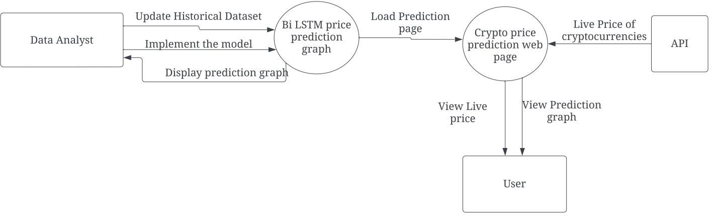

### Fig 4.1 DFD

A Data Flow Diagram (DFD) tracks processes and their data paths within the business or system boundary under investigation. A DFD defines each domain boundary and illustrates the logical movement and transformation of data within the defined boundary. The diagram shows 'what' input data enters the domain, 'what' logical processes the domain applies to that data, and 'what' output data leaves the domain. Essentially, a DFD is a tool for process modeling and one of the oldest.

### UML DIAGRAMS

* + 1. **USE CASE DIAGRAM**

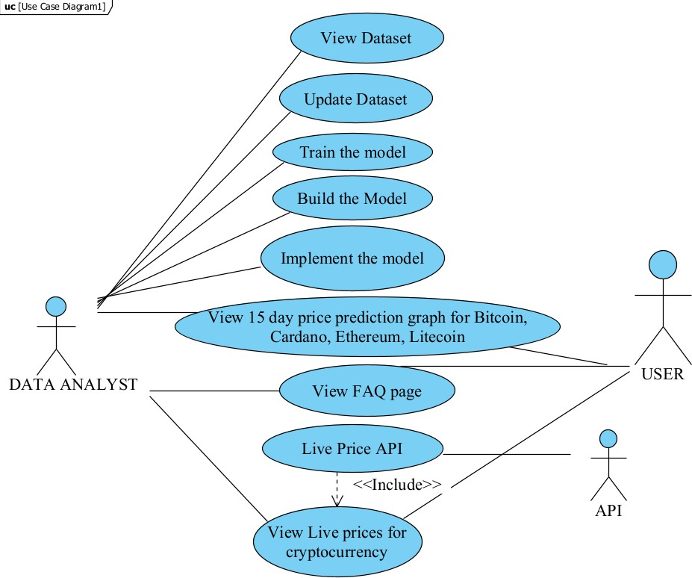

### FIG 4.2 USE CASE

Use-case diagrams describe the high-level functions and scope of a system. These diagrams also identify the interactions between the system and its actors. The use cases and actors in use-case diagrams describe what the system does and how the actors use it, but not how the system operates internally.

### ACTIVITY DIAGRAM

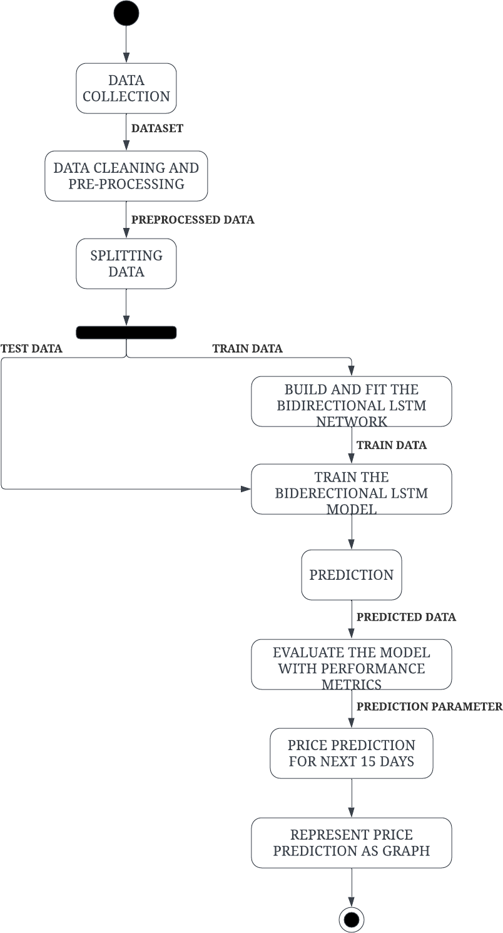

**FIG 4.3 ACTIVITY DIAGRAM**

Activity diagrams are not only used for visualizing dynamic nature of a system but they are also used to construct the executable system by using forward and reverse engineering techniques. Activity diagram is some time considered as the flow chart. Although the diagrams look like a flow chart but it is not. It shows different flow like parallel, branched, concurrent and single.

# SYSTEM ARCHITECTURE

### SYSTEM MODULE SPECIFICATION SYSTEM ARCHITECTURE

**FIG 5.1 SYSTEM ARCHITECTURE**

Predicting price of a cryptocurrency is difficult because it is quite volatile and prone to market fluctuations. Using a Bi-directional Long Short-Term Memory (Bi-LSTM) neural network is one method for creating a Cryptocurrency price prediction model.

### MODULE DESCRIPTION

There are four modules in this methodology. They are,

* + - Data Pre-processing
    - Exploratory Data Analysis
    - Training The Forecast Model
    - Prediction Model

### Data Pre-processing

* + The historical price data of the cryptocurrency such as Ethereum, Bitcoin, Litecoin and Cardano is collected from yahoo finance website.
  + Datasets contain date, open, close, high, low, adjacent close and volume.
  + Data collected is cleaned by hyper parameter tuning.

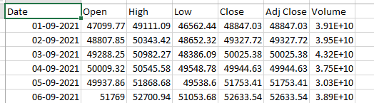

### FIG 5.2 DATASET

1. **Exploratory Data Analysis**
   * The preprocessed data is visualized using seaborn and matplotlib libraries.
   * This process is to analyze the data for highs and lows in the prices of cryptocurrency.

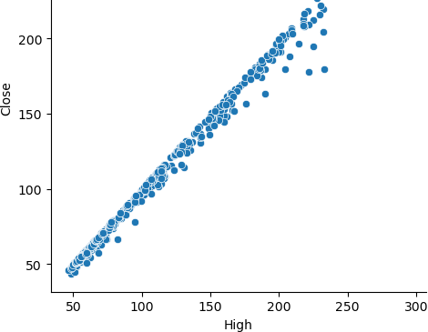

### FIG 5.3 VISUALISED PREPROCESSED DATA

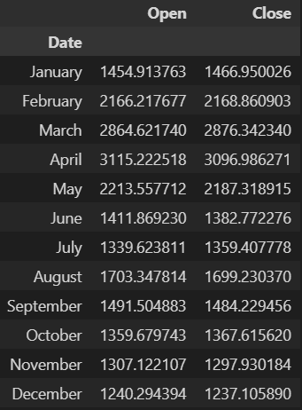

**FIG 5.4 MONTH WISE ANALYSIS OF DATASET**

### Training The Forecast Model

* + The algorithm used to train the model is Bi-LSTM as it offers better prediction.
  + The analyzed data is split into test and train data.
  + Since it’s a time series data, sequential model is used and Bidirectional LSTM layer, dropout and dense layers are added to the network.
  + The model is trained with the train data and accuracy is evaluated using the test data.

### Prediction Model

* + The parameters for the future price prediction is initialized.
  + Price prediction for the next 15 days is done by the model for each coin.
  + The predicted price is represented as a graph.

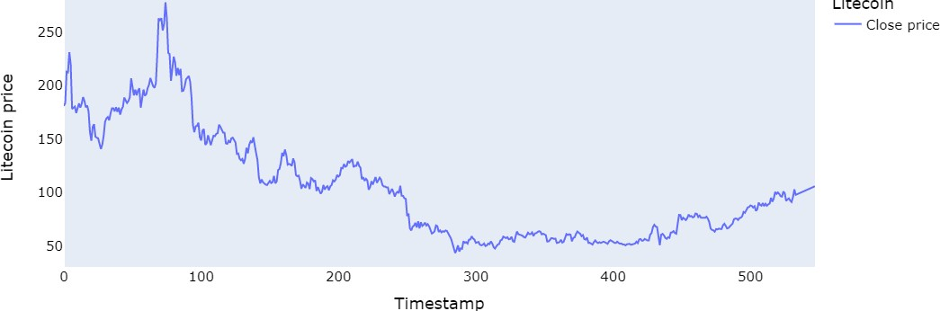

### FIG 5.5 PREDICTED GRAPH

* 1. **ALGORITHM:**

The algorithm used in cryptocurrency price prediction using deep learning

is,

* Bi-LSTM (Bidirectional Long Short-Term Memory)

### Bidirectional LSTM

A **Bidirectional LSTM**, or **bi-LSTM**, is a sequence processing model that consists of two LSTMs: one taking the input in a forward direction, and the other in a backwards direction. Bi-LSTMs effectively increase the amount of information available to the network, improving the context available to the algorithm.

In bidirectional, our input flows in two directions, making a bi-lstm different from the regular LSTM. With the regular LSTM, we can make input flow in one direction, either backwards or forward. However, in bi-directional, we can make the input flow in both directions to preserve the future and the past information. For a better explanation, let’s have an example.

In the sentence “boys go to …..” we can not fill the blank space. Still, when we have a future sentence “boys come out of school”, we can easily predict the past blank space the similar thing we want to perform by our model and bidirectional LSTM allows the neural network to perform this.

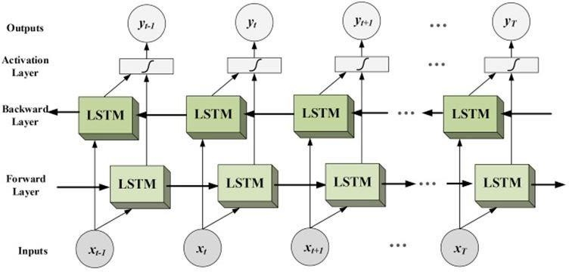

### FIG 5.6 Bi-LSTM DIAGRAM

In the diagram, we can see the flow of information from backward and forward layers. BI-LSTM is usually employed where the sequence to sequence tasks are needed. This kind of network can be used in text classification, speech recognition and forecasting models. Next in the article, we are going to make a bi-directional LSTM model using python.

# SYSTEM IMPLEMENTATION

### 6.1 Source code:

#### Bitcoin.ipynb:

# First we will import the necessary Library import os

import pandas as pd import numpy as np import math

import datetime as dt

import matplotlib.pyplot as plt import seaborn as sns

# For Evalution we will use these library

from sklearn.metrics import mean_squared_error, mean_absolute_error, explained_variance_score, r2_score

from sklearn.metrics import mean_poisson_deviance, mean_gamma_deviance, accuracy_score

from sklearn.preprocessing import MinMaxScaler # For model building we will use these library

from keras.callbacks import EarlyStopping, LearningRateScheduler from keras.optimizers import Adam

import numpy as np import tensorflow as tf

from tensorflow.keras.models import Sequential

from tensorflow.keras.layers import Dense, Dropout, LSTM, Bidirectional from keras.callbacks import ModelCheckpoint, EarlyStopping

from keras.optimizers import Adam

from sklearn.linear_model import Ridge, Lasso from sklearn.metrics import mean_squared_error from sklearn.metrics import accuracy_score

# For Potting we will use these library import matplotlib.pyplot as plt

from itertools import cycle import plotly.graph_objects as go import plotly.express as px

from plotly.subplots import make_subplots # Load our dataset maindf=pd.read_csv('BTC-USD.csv')

print('Total number of days present in the dataset: ',maindf.shape[0]) print('Total number of fields present in the dataset: ',maindf.shape[1]) #EDA

maindf.shape maindf.head() maindf.tail() maindf.info() maindf.describe() #Data Visualization

sns.relplot(x="High", y="Close", data = maindf) sns.relplot(x="Low", y="Close", data = maindf) sns.catplot(x="High", y="Close", data = maindf,dodge=True) sns.jointplot(x="High", y="Close", data = maindf) sns.jointplot(x="Low", y="Close", data = maindf)

maindf['Date'] = pd.to_datetime(maindf['Date'], format='%d-%m-%Y') y_overall = maindf.loc[(maindf['Date'] >= '15-02-2022')

& (maindf['Date'] <= '15-02-2023')]

y_overall.drop(y_overall[['Adj Close','Volume']],axis=1)

monthwise= y_overall.groupby(y_overall['Date'].dt.strftime('%B'))[['Open','Close']].mean() new_order = ['January', 'February', 'March', 'April', 'May', 'June', 'July', 'August',

'September', 'October', 'November', 'December'] monthwise = monthwise.reindex(new_order, axis=0) monthwise

names = cycle(['Bitcoin Open Price','Bitcoin Close Price','Bitcoin High Price','Bitcoin Low Price'])

fig = px.line(y_overall, x=y_overall.Date, y=[y_overall['Open'], y_overall['Close'],

y_overall['High'], y_overall['Low']],

labels={'Date': 'Date','value':'Bitcoin value'})

fig.update_layout(title_text='Bitcoin analysis chart', font_size=15, font_color='black',legend_title_text='Bitcoin Parameters')

fig.for_each_trace(lambda t: t.update(name = next(names))) fig.update_xaxes(showgrid=False) fig.update_yaxes(showgrid=False)

fig.show()

# Lets First Take all the Close Price closedf = maindf[['Date','Close']]

print("Shape of close dataframe:", closedf.shape)

fig = px.line(closedf, x=closedf.Date, y=closedf.Close,labels={'date':'Date','close':'Close Stock'})

fig.update_traces(marker_line_width=2, opacity=0.8, marker_line_color='orange')

fig.update_layout(title_text='Whole period of timeframe of Bitcoin close price 2021-2023', plot_bgcolor='white',

font_size=15, font_color='black') fig.update_xaxes(showgrid=False) fig.update_yaxes(showgrid=False) fig.show()

closedf = closedf[closedf['Date'] > '15-02-2021'] close_stock = closedf.copy()

print("Total data for prediction: ",closedf.shape[0]) closedf

fig = px.line(closedf, x=closedf.Date, y=closedf.Close,labels={'date':'Date','close':'Close Price'})

fig.update_traces(marker_line_width=2, opacity=0.8, marker_line_color='blue') fig.update_layout(title_text='Period considered to predict Bitcoin close price',

plot_bgcolor='white', font_size=15, font_color='black') fig.update_xaxes(showgrid=False) fig.update_yaxes(showgrid=False)

fig.show()

# deleting date column and normalizing using MinMax Scaler del closedf['Date']

scaler=MinMaxScaler(feature_range=(0,1)) closedf=scaler.fit_transform(np.array(closedf).reshape(-1,1)) print(closedf.shape)

# we keep the training set as 80% and 20% testing set training_size=int(len(closedf)*0.80) test_size=len(closedf)-training_size

train_data,test_data=closedf[0:training_size,:],closedf[training_size:len(closedf),:1] print("train_data: ", train_data.shape)

print("test_data: ", test_data.shape)

# convert an array of values into a dataset matrix def create_dataset(dataset, time_step=1):

dataX, dataY = [], []

for i in range(len(dataset)-time_step-1):

a = dataset[i:(i+time_step), 0] ###i=0, 0,1,2,3-----99 100 dataX.append(a)

dataY.append(dataset[i + time_step, 0]) return np.array(dataX), np.array(dataY)

time_step = 15

X_train, y_train = create_dataset(train_data, time_step) X_test, y_test = create_dataset(test_data, time_step) print("X_train: ", X_train.shape)

print("y_train: ", y_train.shape) print("X_test: ", X_test.shape) print("y_test", y_test.shape)

# reshape input to be [samples, time steps, features] which is required for LSTM X_train =X_train.reshape(X_train.shape[0],X_train.shape[1], 1)

X_test = X_test.reshape(X_test.shape[0],X_test.shape[1], 1) print("X_train: ", X_train.shape)

print("X_test: ", X_test.shape) print(X_train.shape[1]) print(X_test.shape[2])

def create_model(input_shape): model = Sequential()

model.add(Bidirectional(LSTM(units=128, return_sequences=True), input_shape=input_shape))

model.add(Dropout(0.2)) model.add(Bidirectional(LSTM(units=64))) model.add(Dense(units=1))

optimizer = Adam(learning_rate=0.001) model.compile(loss='mean_squared_error', optimizer=optimizer) return model

model = create_model((None,1))

def train_model(model, X_train, y_train, X_test, y_test):

early_stopping = EarlyStopping(patience=5, verbose=1, restore_best_weights=True) def lr_scheduler(epoch):

if epoch < 10: return 0.001

else:

return 0.001 * np.exp(0.1 * (10 - epoch)) lr_schedule = LearningRateScheduler(lr_scheduler) model.fit(X_train, y_train, batch_size=32, epochs=50,

validation_data=(X_test, y_test), callbacks=[early_stopping, lr_schedule]) return model

model.summary() model.build()

history = model.fit(X_train,y_train,validation_data=(X_test,y_test),epochs=20,batch_size=32,verbose= 1)

#Training and Validation Loss import matplotlib.pyplot as plt loss = history.history['loss']

val_loss = history.history['val_loss'] epochs = range(len(loss))

plt.plot(epochs, loss, 'r', label='Training loss') plt.plot(epochs, val_loss, 'b', label='Validation loss') plt.title('Training and validation loss') plt.legend(loc=0)

plt.figure() plt.show()

### Lets Do the prediction and check performance metrics train_predict=model.predict(X_train) test_predict=model.predict(X_test)

train_predict.shape, test_predict.shape # Transform back to original form

train_predict = scaler.inverse_transform(train_predict) test_predict = scaler.inverse_transform(test_predict) original_ytrain = scaler.inverse_transform(y_train.reshape(-1,1)) original_ytest = scaler.inverse_transform(y_test.reshape(-1,1)) """Calculate Mean Absolute Percentage Error (MAPE)"""

def mape(original_ytrain,train_predict):

original_ytrain,train_predict= np.array(original_ytrain), np.array(train_predict) return np.mean(np.abs((original_ytrain - train_predict) / original_ytrain)) * 100

mape_score = mape(original_ytrain,train_predict) print("MAPE score:", mape_score)

"""Calculate Mean Absolute Percentage Error (MAPE)""" def mape(original_ytest,test_predict):

original_ytest,test_predict= np.array(original_ytest), np.array(test_predict) return np.mean(np.abs((original_ytest - test_predict) / original_ytest)) * 100

mape_score = mape(original_ytest,test_predict) print("MAPE score:", mape_score)

# ACCURACY

# Calculate the accuracy score

mse = mean_squared_error(original_ytest,test_predict) rmse = np.sqrt(mse)

accuracy = 1 - (rmse / np.mean(original_ytest)) print("Accuracy score:", accuracy*100)

# Calculate the accuracy score

mse = mean_squared_error(original_ytrain,train_predict) rmse = np.sqrt(mse)

accuracy = 1 - (rmse / np.mean(original_ytrain))

print("Accuracy score:", accuracy*100) #VARIANCE REGRESSION SCORE

print("Train data explained variance regression score:", explained_variance_score(original_ytrain, train_predict))

print("Test data explained variance regression score:", explained_variance_score(original_ytest, test_predict))

#R2 Score

print("Train data R2 score:", r2_score(original_ytrain, train_predict)) print("Test data R2 score:", r2_score(original_ytest, test_predict)) #PREDICTION FOR NEXT 15DAYS

look_back=time_step

trainPredictPlot = np.empty_like(closedf) trainPredictPlot[:, :] = np.nan

trainPredictPlot[look_back:len(train_predict)+look_back, :] = train_predict print("Train predicted data: ", trainPredictPlot.shape)

# shift test predictions for plotting testPredictPlot = np.empty_like(closedf) testPredictPlot[:, :] = np.nan

testPredictPlot[len(train_predict)+(look_back*2)+1:len(closedf)-1, :] = test_predict print("Test predicted data: ", testPredictPlot.shape)

names = cycle(['Original close price','Train predicted close price','Test predicted close price']) plotdf = pd.DataFrame({'date': close_stock['Date'],

'original_close': close_stock['Close'],

'train_predicted_close': trainPredictPlot.reshape(1,-1)[0].tolist(), 'test_predicted_close': testPredictPlot.reshape(1,-1)[0].tolist()})

fig = px.line(plotdf,x=plotdf['date'], y=[plotdf['original_close'],plotdf['train_predicted_close'], plotdf['test_predicted_close']],

labels={'value':'Bitcoin price','date': 'Date'})

fig.update_layout(title_text='Comparision between original close price vs predicted close price',

plot_bgcolor='white', font_size=15, font_color='black', legend_title_text='Close

Price')

fig.for_each_trace(lambda t: t.update(name = next(names))) fig.update_xaxes(showgrid=False)

fig.update_yaxes(showgrid=False) fig.show()

x_input=test_data[len(test_data)-time_step:].reshape(1,-1) temp_input=list(x_input) temp_input=temp_input[0].tolist()

lst_output=[] n_steps=time_step i=0

pred_days = 15 #next prediction days while(i<pred_days):

if(len(temp_input)>time_step): x_input=np.array(temp_input[1:]) #print("{} day input {}".format(i,x_input)) x_input = x_input.reshape(1,-1)

x_input = x_input.reshape((1, n_steps, 1)) yhat = model.predict(x_input, verbose=0) #print("{} day output {}".format(i,yhat)) temp_input.extend(yhat[0].tolist()) temp_input=temp_input[1:] #print(temp_input) lst_output.extend(yhat.tolist())

i=i+1 else:

x_input = x_input.reshape((1, n_steps,1)) yhat = model.predict(x_input, verbose=0) temp_input.extend(yhat[0].tolist())

lst_output.extend(yhat.tolist()) i=i+1

print("Output of predicted next days: ", len(lst_output)) last_days=np.arange(1,time_step+1) day_pred=np.arange(time_step+1,time_step+pred_days+1) print(last_days)

print(day_pred)

from ipywidgets.widgets.interaction import interactive temp_mat = np.empty((len(last_days)+pred_days+1,1)) temp_mat[:] = np.nan

temp_mat = temp_mat.reshape(1,-1).tolist()[0] last_original_days_value = temp_mat next_predicted_days_value = temp_mat

last_original_days_value[0:time_step+1] = scaler.inverse_transform(closedf[len(closedf)- time_step:]).reshape(1,-1).tolist()[0]

next_predicted_days_value[time_step+1:] = scaler.inverse_transform(np.array(lst_output).reshape(-1,1)).reshape(1,-1).tolist()[0]

new_pred_plot = pd.DataFrame({ 'last_original_days_value':last_original_days_value, 'next_predicted_days_value':next_predicted_days_value

})

names = cycle(['Last 15 days close price','Predicted next 15 days close price']) ##

fig = px.line(new_pred_plot,x=new_pred_plot.index, y=[new_pred_plot['last_original_days_value'],

new_pred_plot['next_predicted_days_value']], labels={'value': 'Bitcoin price','index': 'Date'})

fig.update_layout(title_text='Compare last 15 days vs next 15 days',

plot_bgcolor='white', font_size=15, font_color='black',legend_title_text='Close Price') ###

fig.for_each_trace(lambda t: t.update(name = next(names))) fig.update_xaxes(showgrid=False) fig.update_yaxes(showgrid=False)

fig.show() lstmdf=closedf.tolist()

lstmdf.extend((np.array(lst_output).reshape(-1,1)).tolist()) lstmdf=scaler.inverse_transform(lstmdf).reshape(1,-1).tolist()[0] names = cycle(['Close price'])

fig = px.line(lstmdf,labels={'value': 'Bitcoin price','index':'Timestamp'}) fig.update_layout(title_text='Plotting whole closing Bitcoin price with prediction',

font_size=15, font_color='black',legend_title_text='Bitcoin') #plot_bgcolor='white'

fig.for_each_trace(lambda t: t.update(name = next(names))) fig.update_xaxes(showgrid=False) fig.update_yaxes(showgrid=False)

fig.show() fig.write_html('bitcoin.html') # Creating PKL File

import joblib joblib.dump(model,'bitcoin.pkl') **index.html**

<!DOCTYPE html>

<html lang="en">

<head>

<meta charset="UTF-8">

<meta name="viewport" content="width=device-width, initial-scale=1.0">

<link rel="stylesheet" href="style.css" />

<link rel="preconnect" href="https://fonts.googleapis.com">

<link rel="preconnect" href="https://fonts.gstatic.com" crossorigin>

<link href="[https://fonts.googleapis.com/css2?family=Josefin+Sans:ital,wght@1,300&family=Kan](https://fonts.googleapis.com/css2?family=Josefin%2BSans%3Aital%2Cwght%401%2C300&family=Kan) it:wght@300&family=Montserrat&family=Raleway:wght@100&family=Roboto:wght@300 &family=Sacramento&family=Source+Sans+3:wght@300;400&display=swap" rel="stylesheet">

<title>CryptoCurrency Price Prediction</title>

</head>

<body>

<nav class="nav">

<div class="container">

<h1 class="logo"><a href="/index.html">Crypto</a></h1>

<ul>

<li><a href="/index.html" class="current">Home</a></li>

<li><a href="/faq.html">FAQ</a></li>

<li><a href="/static/live_price.html">Live Price</a></li>

</ul>

</div>

</nav>

<div class="hero">

<div class="container">

<h1>CryptoCurrency Price Prediction</h1>

<p style="font-size:25px;">This Website gives the price prediction for crytocurrencies like <br>

Ethereum, Cardano, Litecoin, and Bitcoin

for a duration of 15 days.</p>

</div>

</div>

<div class="placeholder">

<div class="card">

<div class="card-header" id="header">

<img src="https://images.unsplash.com/photo-1624609448141- b1d3b206f668?ixlib=rb- 4.0.3&ixid=MnwxMjA3fDB8MHxzZWFyY2h8NDZ8fGV0aGVyZXVtfGVufDB8fDB8fA

%3D%3D&auto=format&fit=crop&w=500&q=60" alt="" />

</div>

<div class="card-content">

<h3 class="card-title" id="title">ETHEREUM</h3>

<br>

<button type="button" onclick="location.href='/ethereum.html'">Predict</button>

</div>

</div>

<div class="card">

<div class="card-header" id="header">

<img src="https://images.unsplash.com/photo-1641457379940- 2a6530925721?ixlib=rb- 4.0.3&ixid=MnwxMjA3fDB8MHxjb2xsZWN0aW9uLXBhZ2V8M3xnM3hjOWJXNHBfRX x8ZW58MHx8fHw%3D&auto=format&fit=crop&w=500&q=60" alt="" />

</div>

<div class="card-content">

<h3 class="card-title" id="title">CARDANO</h3>

<br>

<button type="button" onclick="location.href='/cardano.html'">Predict</button>

</div>

</div>

<div class="card">

<div class="card-header" id="header">

<img src="https://plus.unsplash.com/premium_photo-1663931932716- 3086b87f2ed1?ixlib=rb- 4.0.3&ixid=MnwxMjA3fDB8MHxzZWFyY2h8MTN8fGJpdGNvaW4lMjBjb2lufGVufDB8f DB8fA%3D%3D&auto=format&fit=crop&w=500&q=60" alt="" />

</div>

<div class="card-content">

<h3 class="card-title" id="title">BITCOIN</h3>

<br>

<button type="button" onclick="location.href='/bitcoin.html'">Predict</button>

</div>

</div>

<div class="card">

<div class="card-header" id="header">

<img src="https://images.unsplash.com/photo-1629695058932- b4bf90f4d79c?ixlib=rb- 4.0.3&ixid=MnwxMjA3fDB8MHxzZWFyY2h8MjAyfHxsaXRlY29pbiUyMGNvaW58ZW5 8MHx8MHx8&auto=format&fit=crop&w=500&q=60" alt="" />

</div>

<div class="card-content">

<h3 class="card-title" id="title">LITECOIN</h3>

<br>

<button type="button" onclick="location.href='/litecoin.html'">Predict</button>

</div>

</div>

</div>

<script src="script.js"></script>

</body>

</html>

#### style.css

@import url('https://fonts.googleapis.com/css?family=Open+Sans');

* {

box-sizing: border-box; margin: 0;

padding: 0;

}

body {

font-family: 'Kanit',sans-serif; color: #222;

}

.nav {

position: fixed; background-color:black; opacity: 0.7;

top: 0;

left: 0;

right: 0;

transition: all .3s ease-in-out;

}

.nav .container { display: flex;

justify-content: space-between; align-items: center;

padding: 20px 0;

transition: all .3s ease-in-out; max-width: 1200px;

margin: 0 auto;

}

.nav ul {

display: flex;

list-style-type: none; align-items: center; justify-content: center;

}

.nav a {

color: #fff;

text-decoration: none; padding: 7px 15px; transition: all .3s ease-in-out;

}

.nav.active {

background-color: #fff;

box-shadow: 0 2px 10px rgba(0, 0, 0, 0.3);

}

.nav.active a { color: #000;

}

.nav.active .container { padding: 10px 0;

}

.nav a.current,

.nav a:hover { color: goldenrod;

font-weight: bold;

}

.hero {

background-image: url('https://images.unsplash.com/photo-1561414927- 6d86591d0c4f?ixlib=rb- 4.0.3&ixid=MnwxMjA3fDB8MHxjb2xsZWN0aW9uLXBhZ2V8MzJ8MTM3MjM3M3x8Z W58MHx8fHw%3D&auto=format&fit=crop&w=500&q=60');

background-repeat: no-repeat; background-size: cover;

opacity: 0.9;

background-position: bottom cover; background-position: bottom center; height: 100vh;

color: #fff; display: flex;

justify-content: center; align-items: center; text-align: center; position: relative; margin-bottom: 20px; z-index: -2;

}

.hero::before { content: ''; position: absolute; top: 0;

left: 0;

width: 100%;

height: 100%;

background-color: rgba(0,0,0,0.5); z-index: -1;

}

.hero h1 {

font-size: 46px; margin: -20px 0 20px;

}

.hero p {

font-size: 20px; letter-spacing: 1px;

}

.content h2,

.content h3 {

font-size: 150%;

margin: 20px 0;

}

.content p { color: #555;

line-height: 30px; letter-spacing: 1.2px;

}

.placeholder {

font-family: 'Roboto',sans-serif; display: flex;

flex-direction: row; align-items: center;

justify-content: space-between; height: 100vh;

overflow: hidden; margin: 0;

}

img {

max-width: 100%;

}

.card {

box-shadow: 0 2px 10px rgba(0, 0, 0, 0.2); border-radius: 10px;

overflow: hidden; width: 300px; margin: 20px 20px;

font-family: 'Kanit',sans-serif;

}

.card-header { height: 200px;

}

.card-header img {

object-fit: cover; height: 100%;

width: 100%;

}

.card-content {

background-color: rgb(241, 170, 82); padding: 30px;

}

.card-title { height: 20px; margin: 0;

}

.card-excerpt {

color: blanchedalmond; margin: 10px 0 20px;

}

button {

background-color:black; color:white;

border: 1px burlywood solid; border-radius:5px;

justify-content: center; opacity: 1;

font-size: 15px;

text-transform: uppercase; letter-spacing: 2px; padding: 20px 30px; overflow: hidden;

margin: 10px 0; position: relative; display: inline;

-webkit-border-radius: 5px;

-moz-border-radius: 20px;

-ms-border-radius: 5px;

-o-border-radius: 5px;

font-family: 'Kanit',sans-serif;

}

button:hover{

background-color:black; opacity: 0.8;

}

button:focus { outline: none;

}

button:active { transform: scale(0.98);

}

#### script.js

const nav = document.querySelector('.nav') window.addEventListener('scroll', fixNav) function fixNav() {

if(wiindow.scrollY > nav.offsetHeight + 150) { nav.classList.add('active')

} else {

nav.classList.remove('active')

}

}

const button = document.querySelector("button"); button.addEventListener("click", function() {

})

#### live_price.html

<!DOCTYPE html>

<html lang="en">

<head>

<link rel="preconnect" href="https://fonts.googleapis.com">

<link rel="preconnect" href="https://fonts.gstatic.com" crossorigin>

<link href="[https://fonts.googleapis.com/css2?family=Josefin+Sans:ital,wght@1,300&family=Kan](https://fonts.googleapis.com/css2?family=Josefin%2BSans%3Aital%2Cwght%401%2C300&family=Kan) it:wght@300&family=Montserrat&family=Raleway:wght@100&family=Roboto:wght@300 &family=Sacramento&family=Source+Sans+3:wght@300;400&display=swap" rel="stylesheet">

<meta charset="UTF-8">

<meta http-equiv="X-UA-Compatible" content="IE=edge">

<meta name="viewport" content="width=device-width, initial-scale=1.0">

<title>Live Price</title>

<script src="https://code.jquery.com/jquery-3.6.4.min.js"></script>

<link rel="stylesheet" href="/style.css">

<style>

@import url('https://fonts.googleapis.com/css?family=Open+Sans');

* {

margin: 0;

padding: 0;

box-sizing: border-box;

font-family: 'Kanit',sans-serif;

}

body {

display: flex;

justify-content: center; align-items: center; min-height: 100vh;

}

.nav {

position: fixed; background-color: black; opacity: 0.7;

top: 0;

left: 0;

right: 0;

transition: all .3s ease-in-out;

}

.nav .container { display: flex;

justify-content: space-between; align-items: center;

padding: 20px 0;

transition: all .3s ease-in-out; max-width: 1200px;

margin: 0 auto;

}

.nav ul { display: flex;

list-style-type: none; align-items: center; justify-content: center;

}

.nav a {

color: #fff;

text-decoration: none; padding: 7px 15px; transition: all .3s ease-in-out;

}

.nav.active {

background-color: #fff;

box-shadow: 0 2px 10px rgba(0, 0, 0, 0.3);

}

.nav.active a { color: #000;

}

.nav.active .container { padding: 10px 0;

}

.nav a.current,

.nav a:hover {

color: goldenrod; font-weight: bold;

}

.container { display: flex;

/*align-items: center;*/ border-radius: 5px; flex-direction: row; flex-wrap: wrap; width: 100%;

justify-content: space-evenly;

}

.container .coin-price { display: flex;

justify-content: space-between 15px; align-content: flex-start;

padding: 10px 20px; border-radius: 5px;

box-shadow: 0 0 3px #ccc; width: 10px;

margin: 7px;

box-sizing: border-box;

}

.container .coin-price div { display: block;

}

.text {

font-size: 20px; float: left;

padding-left: 65px; padding-top: 5px; display: block;

}

.circular_image { width: 69px; height: 69px; border-radius: 50%; overflow: hidden;

display:inline-block; vertical-align:middle;

justify-content: space-evenly 5px;

}

.circular_image img{ width:100%;

}

</style>

</head>

<body>

<nav class="nav">

<div class="container">

<h1 class="logo"><a href="/index.html">Crypto</a></h1>

<ul>

<li><a href="/index.html" >Home</a></li>

<li><a href="/faq.html">FAQ</a></li>

<li><a href="/static/live_price.html" class="current">Live Price</a></li>

</ul>

</div>

</nav>

<div class="container">

<div class="coin-pice">

<div class="Logo">

<img class="circular_image" src="bitcoin.png">

</div>

<div>

<h3>Bitcoin</h3>

<h4>$<span id="bitcoin"></span></h4>

</div>

</div>

<div class="coin-pice">

<div class="Logo">

<img class="circular_image" src="litecoin.png">

</div>

<div>

<h3>Litecoin</h3>

<h4>$<span id="litecoin"></span></h4>

</div>

</div>

<div class="coin-pice">

<div class="Logo">

<img class="circular_image" src="cardano.png" >

</div>

<div>

<h3>Cardano</h3>

<h3>$<span id="cardano"></span></h3>

</div>

</div>

<div class="coin-pice">

<div class="Logo">

<img class="circular_image" src="ethereum.png">

</div>

<div>

<h3>Ethereum</h3>

<h4>$<span id="ethereum"></span></h4>

</div>

</div>

<div class="coin-pice">

<div class="Logo">

<img class="circular_image" src="dogecoin.png">

</div>

<div>

<h3>Dogecoin</h3>

<h4>$<span id="dogecoin"></span></h4>

</div>

</div>

<div class="coin-pice">

<div class="Logo">

<img class="circular_image" src="tether.png">

</div>

<div>

<h3>Tether</h3>

<h4>$<span id="tether"></span></h4>

</div>

</div>

<div class="coin-pice">

<div class="Logo">

<img class="circular_image" src="xrp.png">

</div>

<div>

<h3>XRP</h3>

<h4>$<span id="ripple"></span></h4>

</div>

</div>

<div class="coin-pice">

<div class="Logo">

<img class="circular_image" src="polkadot.png">

</div>

<div>

<h3>Polkadot</h3>

<h4>$<span id="polkadot"></span></h4>

</div>

</div>

<div class="coin-pice">

<div class="Logo">

<img class="circular_image" src="solana.png">

</div>

<div>

<h3>Solana</h3>

<h4>$<span id="solana"></span></h4>

</div>

</div>

<div class="coin-pice">

<div class="Logo">

<img class="circular_image" src="trx.png">

</div>

<div>

<h3>TRON</h3>

<h4>$<span id="tron"></span></h4>

</div>

</div>

</div>

<script>

var btc = document.getElementById("bitcoin"); var ltc = document.getElementById("litecoin"); var ada = document.getElementById("cardano"); var eth = document.getElementById("ethereum");

var doge = document.getElementById("dogecoin"); var teth = document.getElementById("tether");

var polka = document.getElementById("polkadot"); var sol = document.getElementById("solana");

var trx = document.getElementById("tron") var xrp = document.getElementById("ripple");

/* BITCOIN */ var btc_price= {

"async": true, "scroosDomain" : true,

"url" : "https://api.coingecko.com/api/v3/simple/price?ids=bitcoin&vs_currencies=usd",

"method" : "GET",

"headers" : {}

}

$.ajax(btc_price).done(function (response) { btc.innerHTML = response.bitcoin.usd;

})

/* LITECOIN */ var ltc_price = {

"async" : true, "scroosDomain" : true,

"url" : "https://api.coingecko.com/api/v3/simple/price?ids=litecoin&vs_currencies=usd",

"method" : "GET",

"headers" : {}

}

$.ajax(ltc_price).done(function (response) { ltc.innerHTML = response.litecoin.usd;

})

/* CARDANO */ var ada_price = {

"async" : true, "scroosDomain" : true,

"url" : "https://api.coingecko.com/api/v3/simple/price?ids=cardano&vs_currencies=usd",

"method" : "GET",

"headers" : {}

}

$.ajax(ada_price).done(function (response) { ada.innerHTML = response.cardano.usd;

})

/* ETHEREUM */ var eth_price = {

"async" : true, "scroosDomain" : true,

"url" : "https://api.coingecko.com/api/v3/simple/price?ids=ethereum&vs_currencies=usd",

"method" : "GET",

"headers" : {}

}

$.ajax(eth_price).done(function (response) { eth.innerHTML = response.ethereum.usd;

})

/* DOGECOIN */ var doge_price = {

"async" : true, "scroosDomain" : true,

"url" : "https://api.coingecko.com/api/v3/simple/price?ids=dogecoin&vs_currencies=usd",

"method" : "GET",

"headers" : {}

}

$.ajax(doge_price).done(function (response) { doge.innerHTML = response.dogecoin.usd;

})

/* TETHER */

var tether_price = { "async" : true, "scroosDomain" : true,

"url" : "https://api.coingecko.com/api/v3/simple/price?ids=tether&vs_currencies=usd",

"method" : "GET",

"headers" : {}

}

$.ajax(tether_price).done(function (response) {

teth.innerHTML = response.tether.usd;

})

/* POLKADOT */

var polkadot_price = { "async" : true, "scroosDomain" : true,

"url" : "https://api.coingecko.com/api/v3/simple/price?ids=polkadot&vs_currencies=usd",

"method" : "GET",

"headers" : {}

}

$.ajax(polkadot_price).done(function (response) { polka.innerHTML = response.polkadot.usd;

})

/* SOLANA */ var sol_price = {

"async" : true, "scroosDomain" : true,

"url" : "https://api.coingecko.com/api/v3/simple/price?ids=solana&vs_currencies=usd",

"method" : "GET",

"headers" : {}

}

$.ajax(sol_price).done(function (response) { sol.innerHTML = response.solana.usd;

})

/* TRON */

var trx_price = { "async" : true,

"scroosDomain" : true,

"url" : "https://api.coingecko.com/api/v3/simple/price?ids=tron&vs_currencies=usd", "method" : "GET",

"headers" : {}

}

$.ajax(trx_price).done(function (response) { trx.innerHTML = response.tron.usd;

})

/* RIPPLE */

var xrp_price = { "async" : true, "scroosDomain" : true,

"url" : "https://api.coingecko.com/api/v3/simple/price?ids=ripple&vs_currencies=usd",

"method" : "GET",

"headers" : {}

}

$.ajax(xrp_price).done(function (response) { xrp.innerHTML = response.ripple.usd;

})

</script>

</body>

</html>

#### faq.html

<!DOCTYPE html>

<html lang="en">

<head>

<link rel="stylesheet" href="style.css" />

<link rel="preconnect" href="https://fonts.googleapis.com">

<link rel="preconnect" href="https://fonts.gstatic.com" crossorigin>

<link href="[https://fonts.googleapis.com/css2?family=Josefin+Sans:ital,wght@1,300&family=Kan](https://fonts.googleapis.com/css2?family=Josefin%2BSans%3Aital%2Cwght%401%2C300&family=Kan) it:wght@300&family=Montserrat&family=Raleway:wght@100&family=Roboto:wght@300 &family=Sacramento&family=Source+Sans+3:wght@300;400&display=swap" rel="stylesheet">

<meta charset="UTF-8">

<meta http-equiv="X-UA-Compatible" content="IE=edge">

<meta name="viewport" content="width=device-width, initial-scale=1.0">

<link rel="stylesheet" href="https://cdnjs.cloudflare.com/ajax/libs/font- awesome/5.14.0/css/all.min.css" integrity="sha512-

1PKOgIY59xJ8Co8+NE6FZ+LOAZKjy+KY8iq0G4B3CyeY6wYHN3yt9PW0XpSriVlkMX

e40PTKnXrLnZ9+fkDaog==" crossorigin="anonymous" />

<title>FAQ</title>

<style>

@import url('https://fonts.googleapis.com/css?family=Muli&display=swap');

* {

box-sizing: border-box;

}

body {

font-family: 'Kanit', sans-serif; background-color: #f0f0f0;

/*background-image: url('https://images.unsplash.com/photo-1640340434855- 6084b1f4901c?ixlib=rb- 4.0.3&ixid=MnwxMjA3fDB8MHxzZWFyY2h8NTh8fGZpbmFuY2V8ZW58MHx8MHx8& auto=format&fit=crop&w=500&q=60');*/

}

h1 {

text-align: center;

}

.faq-container { max-width: 600px; margin: 0 auto; top: 40px;

}

.faq {

background-color: transparent; border: 1px solid black; border-radius: 10px;

margin: 20px 0; padding: 30px; position: relative; overflow: hidden; transition: 0.3s ease;

}

.faq.active {

background-color: #fff;

box-shadow: 0 3px 6px rgba(0, 0, 0, 0.1), 0 3px 6px rgba(0, 0, 0, 0.1);

}

.faq.active::before,

.faq.active::after { content: '\f075';

font-family: 'Font Awesome 5 Free'; color: violet;

font-size: 7rem; position: absolute; opacity: 0.2;

top: 20px; left: 20px; z-index: 0;

}

.faq.active::before { color: #3498db; top: -10px;

left: -30px;

transform: rotateY(180deg);

}

.faq-title {

margin: 0 35px 0 0;

color: rgb(0, 0, 0);

}

.faq-text { display: none;

margin: 30px 0 0;

}

.faq.active .faq-text { display: block;

}

.faq-toggle {

background-color: transparent; border: 0;

border-radius: 50%; cursor: pointer; display: flex;

align-items: center; justify-content: center; font-size: 16px; padding: 0;

position: absolute; top: 30px;

right: 30px; height: 30px; width: 30px;

}

.faq-toggle:focus { outline: 0;

}

.faq-toggle .fa-times { display: none;

}

.faq.active .faq-toggle .fa-times { color: #fff;

display: block;

}

.faq.active .faq-toggle .fa-chevron-down { display: none;

}

.faq.active .faq-toggle { background-color: #9fa4a8;

}

h1{

color: burlywood;

}

</style>

</head>

<body>

<nav class="nav">

<div class="container">

<h1 class="logo"><a href="/index.html">Crypto</a></h1>

<ul>

<li><a href="/index.html" >Home</a></li>

<li><a href="/faq.html">FAQ</a></li>

<li><a href="/static/live_price.html" class="current">Live Price</a></li>

</ul>

</div>

</nav>

<br><br>

<br><br>

<h1>Frequently Asked Questions</h1>

<br>

<div class="faq-container">

<div class="faq active">

<h3 class="faq-title"> What is cryptocurrency?

</h3>

<p class="faq-text">

A digital currency in which transactions are verified and records maintained by a decentralized system using cryptography, rather than by a

centralized authority.

</p>

<button class="faq-toggle">

<i class="fas fa-chevron-down"></i>

<i class="fas fa-times"></i>

</button>

</div>

<div class="faq">

<h3 class="faq-title">

What are the reasons for the popularity of cryptocurrencies?

</h3>

<p class="faq-text">

One of the most common reasons for popularity of cryptocurrencies refers to the assumptions suggesting that cryptocurrencies are the currency of the future. In addition,

cryptocurrencies also remove banks and other financial intermediaries from focusing on reducing the value of money.

</p>

<button class="faq-toggle">

<i class="fas fa-chevron-down"></i>

<i class="fas fa-times"></i>

</button>

</div>

<div class="faq">

<h3 class="faq-title">

Who controls cryptocurrencies?

</h3>

<p class="faq-text">

Blockchain does not allocate control to a single entity in the case of cryptocurrencies. The creators or developers of cryptocurrencies can set specific parameters such as rules for purchasing or selling cryptocurrency.

<br>

The identity of owners is anonymous, and you could not find any solid regulatory framework for verifying ownership of cryptocurrencies.

</p>

<button class="faq-toggle">

<i class="fas fa-chevron-down"></i>

<i class="fas fa-times"></i>

</button>

</div>

<div class="faq">

<h3 class="faq-title">

What are cryptocurrency wallets?

</h3>

<p class="faq-text">

The crypto wallets are basically platforms for secure storage of digital assets in comparison to exchanges.

You can find two distinct variants of crypto wallets such as hot wallets and cold wallets. Users can access

the hot wallets with connectivity to the internet through their desktops, mobile phones, or tablets.

On the other hand, cold wallets store private keys to cryptocurrency of users in offline storage, thereby ensuring better security.

</p>

<button class="faq-toggle">

<i class="fas fa-chevron-down"></i>

<i class="fas fa-times"></i>

</button>

</div>

<script>

const toggles = document.querySelectorAll('.faq-toggle') toggles.forEach(toggle => {

toggle.addEventListener('click', () => { toggle.parentNode.classList.toggle('active')

})

})

</script>

</body>

</html>

#### Basic styles for prediction graph page:

**litecoin.html**

<html>

<head><meta charset="utf-8" />

<link rel="stylesheet" href="style.css" />

<link rel="preconnect" href="https://fonts.googleapis.com">

<link rel="preconnect" href="https://fonts.gstatic.com" crossorigin>

<link href="[https://fonts.googleapis.com/css2?family=Josefin+Sans:ital,wght@1,300&family=Kan](https://fonts.googleapis.com/css2?family=Josefin%2BSans%3Aital%2Cwght%401%2C300&family=Kan) it:wght@300&family=Montserrat&family=Raleway:wght@100&family=Roboto:wght@300 &family=Sacramento&family=Source+Sans+3:wght@300;400&display=swap" rel="stylesheet">

<style>

/* Split the screen in half */

.split {

height: 100%;

width: 50%; position: fixed; z-index: 1; top: 76px;

overflow-x: hidden; padding-top: 20px;

}

/* Control the left side */

.left { left: 0;

background-image: url("https://images.app.goo.gl/b8fxLPDhcRN1vnTg7"); margin: 10px;

padding: 20px; padding-left:40px;

}

.centered { position: absolute; top: 50%;

left: 50%;

transform: translate(-50%, -50%); text-align: center;

}

.right {

right: 0;

object-fit:cover;

}

</style>

</head>

<body>

<nav class="nav">

<div class="container">

<h1 class="logo"><a href="/index.html">Crypto</a></h1>

<ul>

<li><a href="/index.html" class="current">Home</a></li>

<li><a href="/faq.html">FAQ</a></li>

<li><a href="/static/live_price.html">Live Price</a></li>

</ul>

</div>

</nav>

<div class="split left">

<div class="info">

<br>

<br>

<h2 style="font-size:55px;">15-DAYS <br> price prediction for <br> ETHEREUM.</h2>

</div>

</div>

<div class="split right">

<div class="centered">

<script type="text/javascript">window.PlotlyConfig = {MathJaxConfig: 'local'};</script>

<script type="text/javascript">

//output code from ipynb file is embedded.

</script>

</div>

</div>

</body>

</html**>**

# SYSTEM TESTING

### TEST CASES AND REPORTS

|  |  |  |  |  |
| --- | --- | --- | --- | --- |
| **TEST CASE ID** | **TEST CASE/ACTION TO BE**  **PERFORMED** | **EXPECTED RESULT** | **ACTUAL RESULT** | **PASS / FAIL** |
| **1.** | Display of home page. | Display of home page. | Shows home page with active nav  bar. | Pass |
| **2.** | View of  Prediction cards in prediction page. | Displays the prediction cards for each coin. | Display of prediction cards with Predict  button. | Pass |
| **3.** | Clicking on  Predict Button for corresponding coin. | Display of Prediction graph for the  corresponding coin you chose. | Shows the prediction graph for next 15 days of the corresponding coin. | Pass |
| **4.** | Click on Live Price in nav bar. | Shows the Live price of  cryptocurrency  coins. | Displays the live price of each cryptocurrency. | Pass |
| **5.** | Clicking on FAQ. | Displays the FAQ page. | Displays the FAQ that are related  cryptocurrency. | Pass |
| **6.** | Click on the drop down of each card in FAQ  page. | To display the answers for the corresponding  question. | It displays the answers for the corresponding  queries. | Pass |

**TABLE 7.1**

### PERFORMANCE EVALUATION

|  |  |  |  |  |
| --- | --- | --- | --- | --- |
| **COINS** | **ACCURACY** | **MAPE** | **R2 SCORE** | **VARIANCE REGRESSION SCORE** |
| BITCOIN | 95.00 | 3.38 | 0.87 | 0.90 |
| CARDANO | 96.30 | 2.73 | 0.93 | 0.93 |
| ETHEREUM | 97.07 | 2.09 | 0.95 | 0.95 |
| LITECOIN | 95.01 | 3.78 | 0.87 | 0.87 |

**TABLE 7.2**

# CONCLUSION

### CONCLUSION

Thus, this forecasting model predicts prices of cryptocurrency such as Bitcoin, Cardano, Ethereum and Litecoin using Bi-LSTM algorithm with high accuracy. The accuracy of the price prediction ranges from 95 to 97 percent and the other various performance metrics is evaluated for this forecast model. These predictions are represented as graph which is embedded in a website. Thus, the prediction and live prices can be viewed through the website by the users.

### FUTURE ENHANCEMENTS

Updating our datasets to ensure our forecast model to be relevant. So, we can use APIs for data collection or else it’s better to fetch the live price of the cryptocurrency data from their exchanges.

# APPENDICES

### 9.1 SAMPLE SCREENS

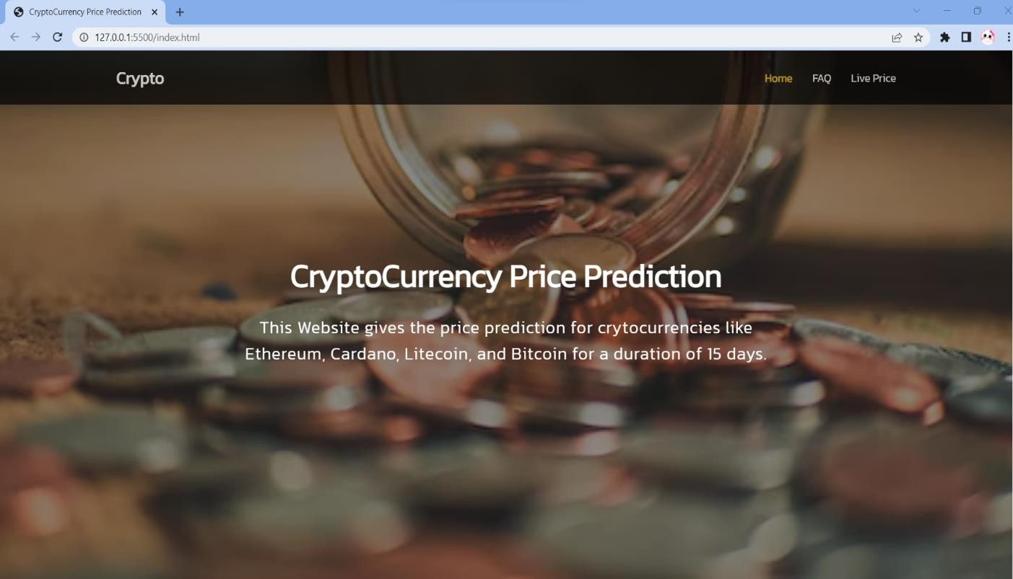

**FIG 9.1 HOME SCREEN**

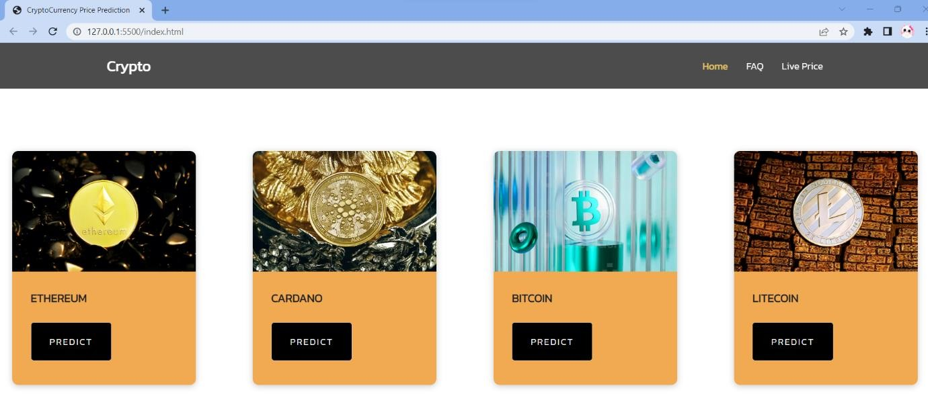

### FIG 9.2 PREDICTION PAGE

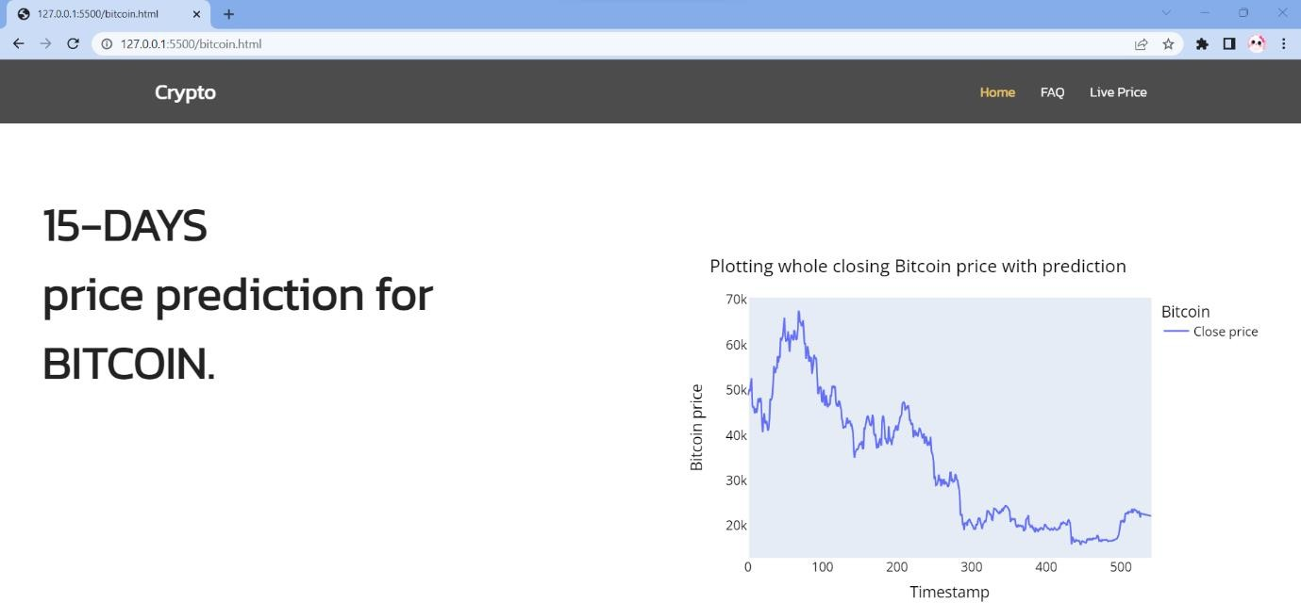

**FIG 9.3 PREDICTION GRAPH FOR BITCOIN**

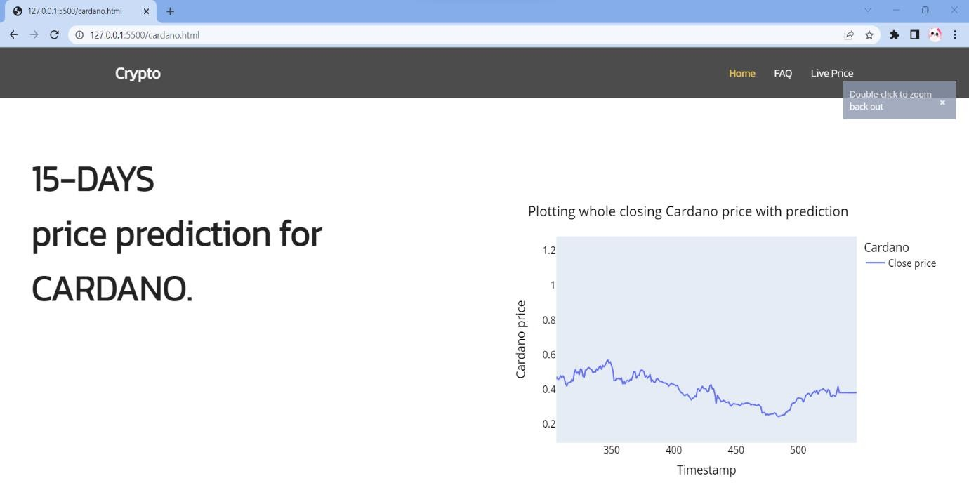

### FIG 9.4 PREDICTION GRAPH FOR CARDANO

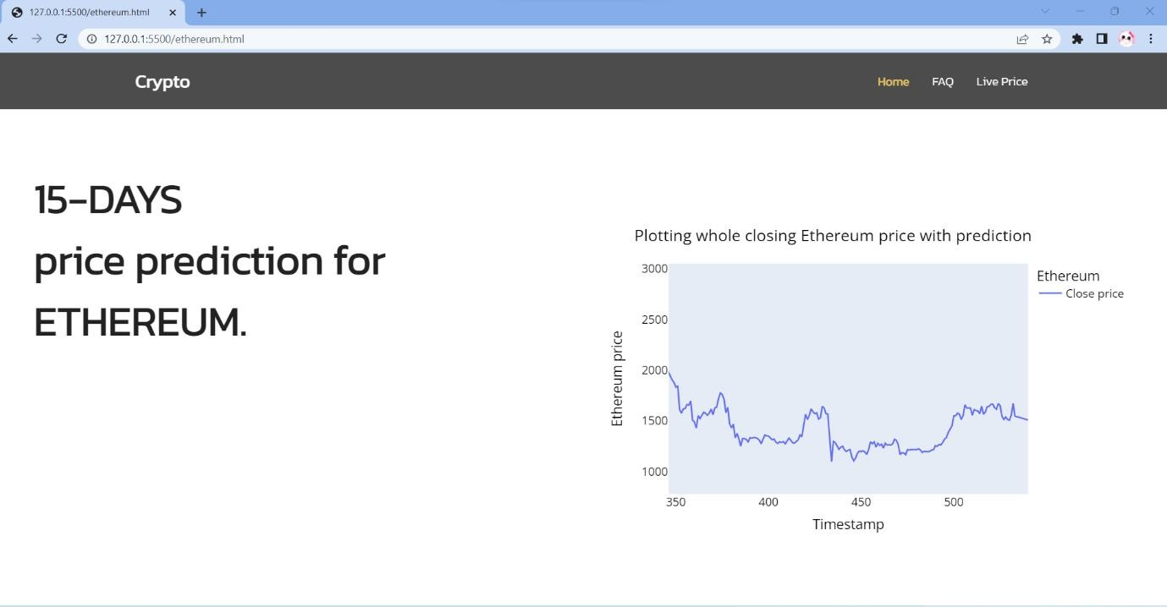

**FIG 9.5 PREDICTION GRAPH FOR ETHEREUM**

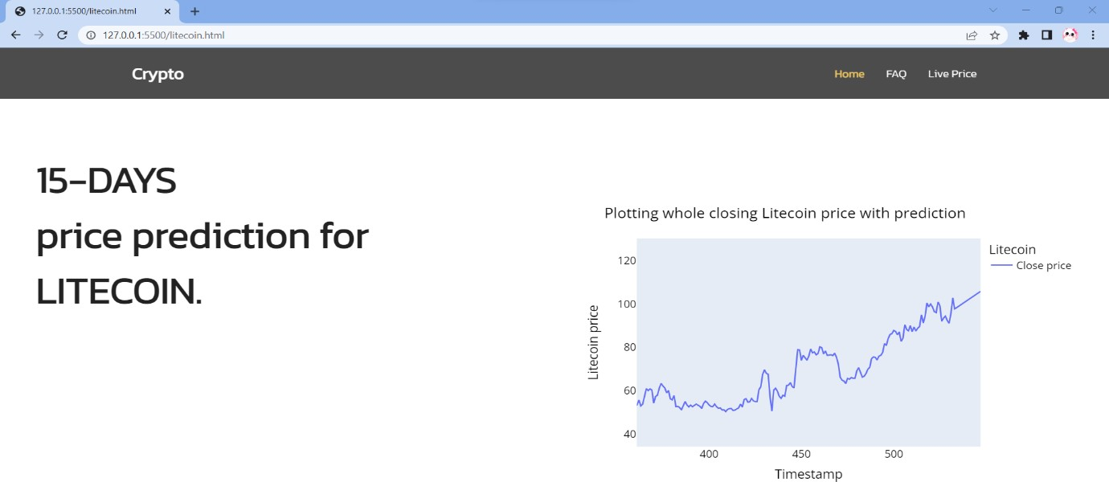

### FIG 9.6 PREDICTION GRAPH FOR LITECOIN

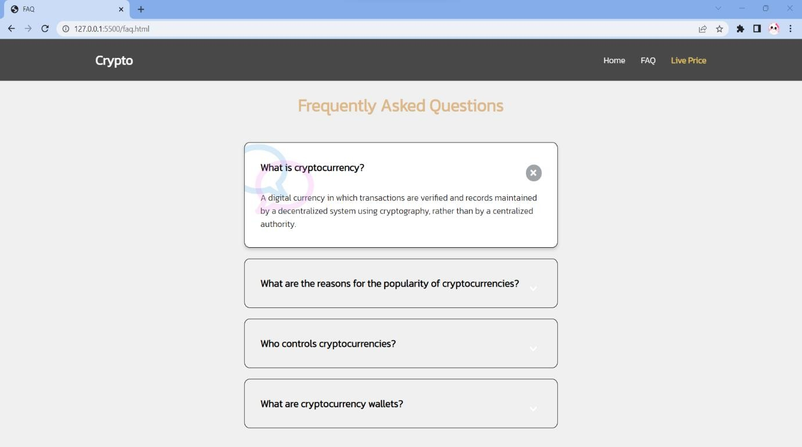

**FIG 9.7 FAQ PAGE**

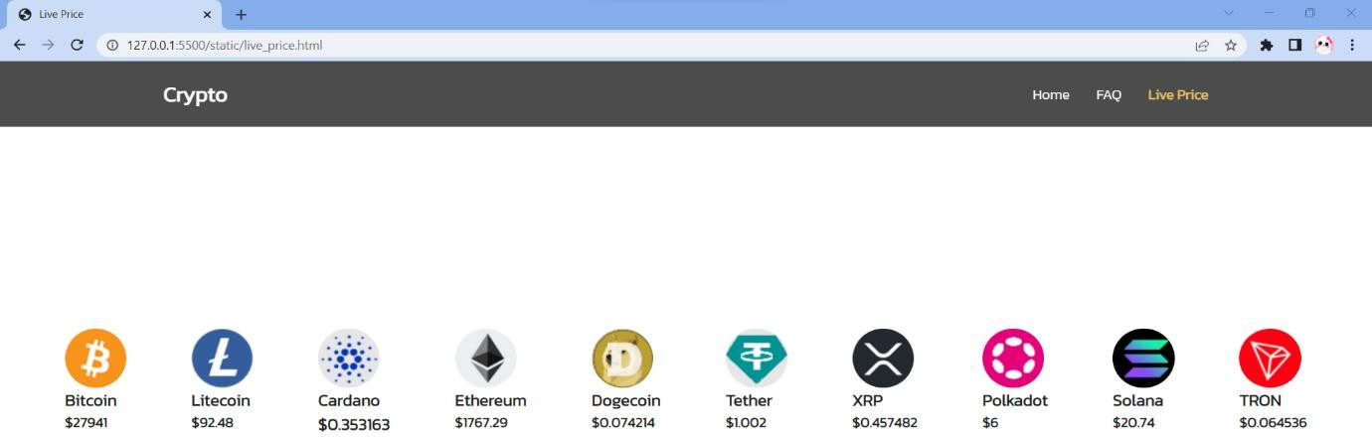

**FIG 9.8 LIVE PRICE PAGE**

**REFERENCE**

1. Aastha Agarwal, Sai Keerthana, Rahul Reddy, Afraz Moqueem (2021) “Prediction of Bitcoin, Litecoin and Ethereum trends using State-of-Art Algorithms” IEEE Access doi: 10.1109/MysuruCon52639.2021.9641735.
2. Komal Soni, Sugandha Singh (2022) “Bitcoin Price Prediction-an Analysis of Various Regression Methods” IEEE doi: 10.1109/ISCAIE54458.2022.979453.
3. Lasse Herskind, Panagiota Katsikouli & Nicola Dragoni (2020) “Privacy and Cryptocurrencies—A Systematic Literature Review” IEEE Access doi: 10.1109/ACCESS.2020.298095.
4. Mareena Fernandes, Saloni Khanna, Leandra Monteiro, Anu Thomas, Garima Tripathi (20210 “Bitcoin Price Prediction” IEEE Xplore doi: 10.1109/ICAC353642.2021.9697202.
5. Mohil Maheshkumar Patel, Sudeep Tanwar, Rajesh Gupta, Neeraj Kumar (2020) “A Deep Learning-based Cryptocurrency Price Prediction Scheme for Financial Institutions” Elsevier Vol. 55, Dec 2020, 102583.
6. Mudassir, M., Bennbaia, S., Unal, D. et al. (2020) “Time-series forecasting of Bitcoin prices using high-dimensional features: a machine learning approach”, Neural Comput & Applic. doi:10.1007/s00521-020-05129-6.
7. Naila Aslam, Furqn Rustam, Ernesto Lee, Patrick Bernard Washington, Imran Ashraf (2022) “Sentiment Analysis and Emotion Detection on Cryptocurrency Related tweets Using Ensemble LSTMGRU Model” IEEE Access Vol.10
8. N. I. Indera, I. M. Yassin, A. Zabidi and Z. I. Rizman, "Non-linear autoregressive with exogeneous input (NARX) Bitcoin price prediction model using PSO-optimized parameters and moving average technical indicators" , J. Fundam. Appl. Sci., vol. 9, no. 3, pp. 791-808, 2017.
9. Nisarg P. Patel, Raj Parekh, Nihar Thakkar, Rajesh Gupta, Sudeep Tanwar, Gulshan Sharma, Innocent E. Davidson, Ravi Sharma (2022) “Fusion in Cryptocurrency Price Prediction: A Decade Survey on Recent Advancements,

Architecture, and Potential Future Directions” IEEE Access Vol. 10

1. Patel Jay, Vasu Kalariya, Pushpendra Parmar, Sudeep Tanwar, Neeraj Kumar, Mamoun Alazab (2020) “Stochastic Neural Networks for Cryptocurrency Price Prediction” IEEE Access Vol.8
2. R. Sujatha, V. Mareeswari, Jyotir Moy Chatterjee, Abd Allah A. Mousa, Aboul Ella Hassanien (2021) “A Bayesian Regularized Neural Network for Analyzing Bitcoin Trends” IEEE Xplore Vol. 9 doi: 10.1109/ACCESS.2021.3063243
3. Raj Parekh, Nisarg P. Patel, Nihar Thakkar, Rajesh Gupta, Sudeep Tanwar, Gulshan Sharma, Innocent E. Davidson and Ravi Sharma, (2022) “DL- GuesS:Deep Learning and Sentiment Analysis-Based Cryptocurrency Price Prediction”, IEEE Access doi: 10:35398-35409.
4. Rana Muhammad Zulqarnain, Imran Siddique, Sayed M. Eldin & Shahid hussain Gurmani (2022) “Extension of Interaction Aggregation Operators for the Analysis of Cryptocurrency Market Under q-Rung Orthopair Fuzzy Hypersoft Set” IEEE Access doi: 10.1109/ACCESS.2022.3224050.
5. Salim Lahmiri & Stelios Bekiros (2021) “Deep Learning Forecasting in Cryptocurrency High-Frequency Trading” Cognitive Computation 13, 485–487 (2021).
6. Sudeep Tanwar, Nisarg P. Patel, Smit N. Patel, Jil R. Patel, Gulshan Sharma, Innocent E. Davidson (2021) “Deep Learning-Based Cryptocurrency Price Prediction Scheme With Inter-Dependent Relations” IEEE Access (Vol. 9) doi: 10.1109/ACCESS.2021.3117848.
7. Thearasak Phaladisailoed, Thanisa Numnonda (2018) “Machine Learning Models Comparison for Bitcoin price Prediction” IEEE Access doi: 10.1109/ICITEED.208.8524911.
8. Xiaoxu Du, Zhenpeng Tang, Junchuan Wu, Kaijie Chen, Yi Chai (2022) “A New Hybrid Cryptocurrency Returns Forecasting Method Based on Multiscale Decomposition and an Optimized Extreme Learning Machine Using the Sparrow Search Algorithm” IEEE Access Vol. 10
9. Zeinab Shahbazi and Yung-Cheol Byun (2022) “Machine LearningBased Analysis of Cryptocurrency Market Financial Risk Management” IEEE Access doi: 10.1109/ACCESS.2022.3162858.