File a Claim

As a policyholder
I want to submit an insurance claim online with supporting documents
So that I don't have to visit an office to start the claims process

Acceptance Criteria:
- Given I have an active policy, when I select "File a Claim," then I can enter incident details and upload documents (photos, bills, FIR, etc.)
- Given I submit a claim, when it's received, then I get a claim reference number and confirmation via SMS/email
- Given required documents are missing, when I try to submit, then the system flags missing fields before allowing submission
- Given a claim is submitted, when I check status later, then I can track it (Submitted -> Under Review -> Approved/Rejected)

Generate the test cases for the above user story

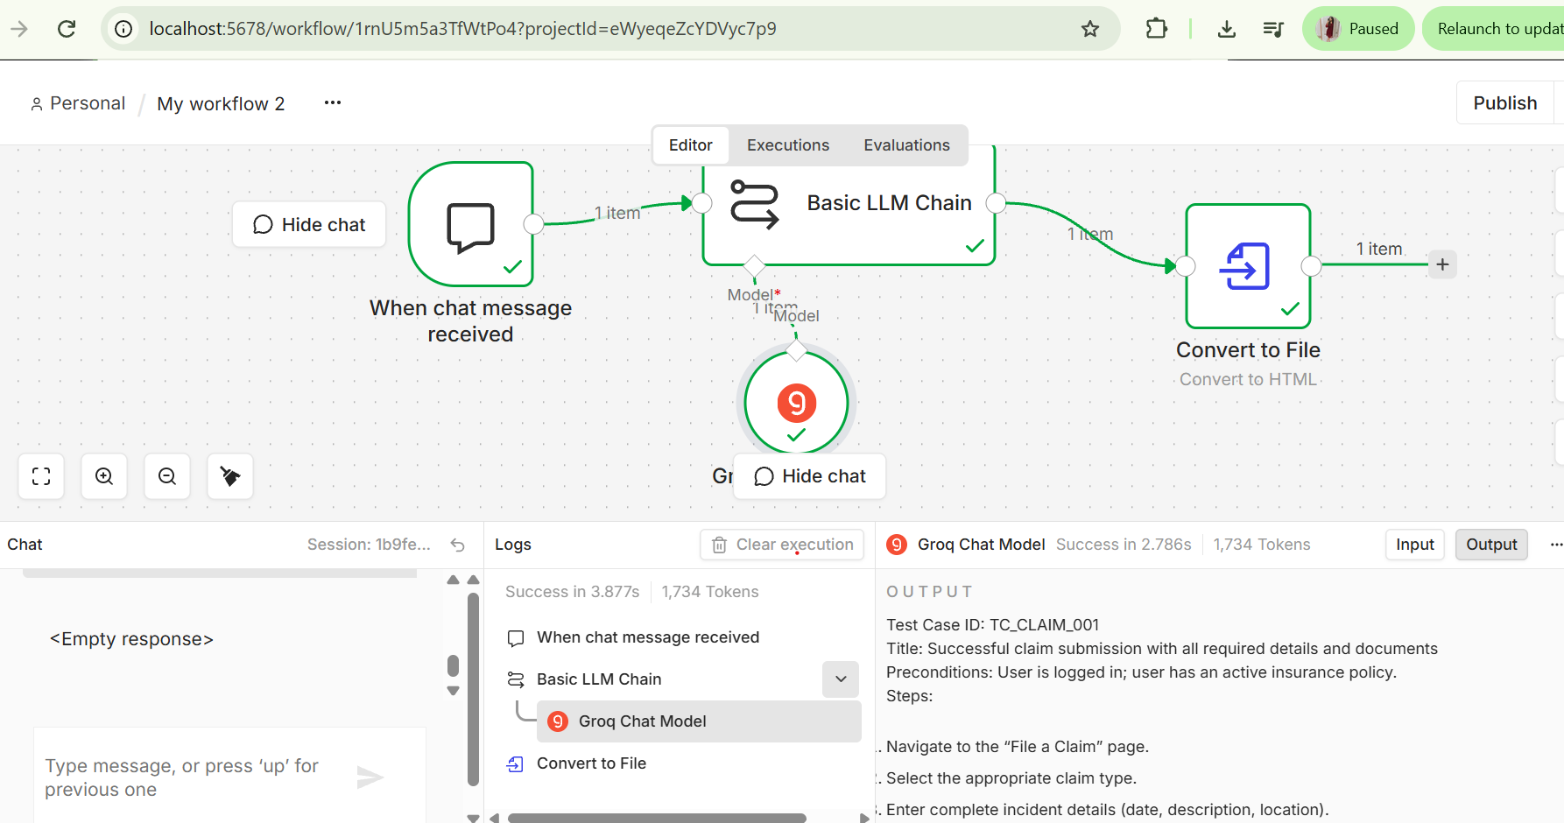

Html file

