context : Banking app's fund transfer feature , Generate test cases for transfers between two accounts within the same bank.

Instructions:
Generate fund transfer test cases within same bank
[Mandatory] Generate both positive and negative test cases.
[critical] Generate test cases of P1 and P2 priorities.
[Priority] Generate edge cases as well
[Priority] Generate 15 test cases.
[Priority] Generate Test steps in BDD Given When and Then style and in bullet format
Generate detailed Pre-conditions

Example:
Test no|Description|Test case|Pre-conditions|Test data|Test steps|Expected result|created by|Priority

Persona:
Act as a Senior Tester to design test cases

Output format:
Generate the output in a table format and also a downloadable excel format

Tone:
Professional and specific

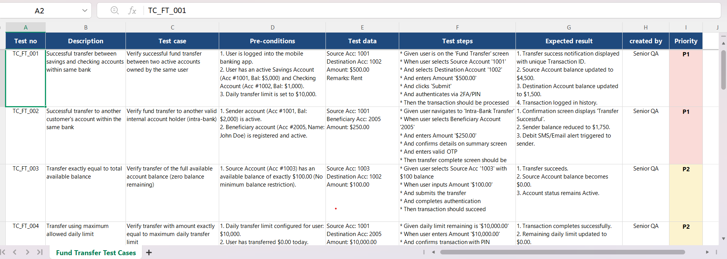

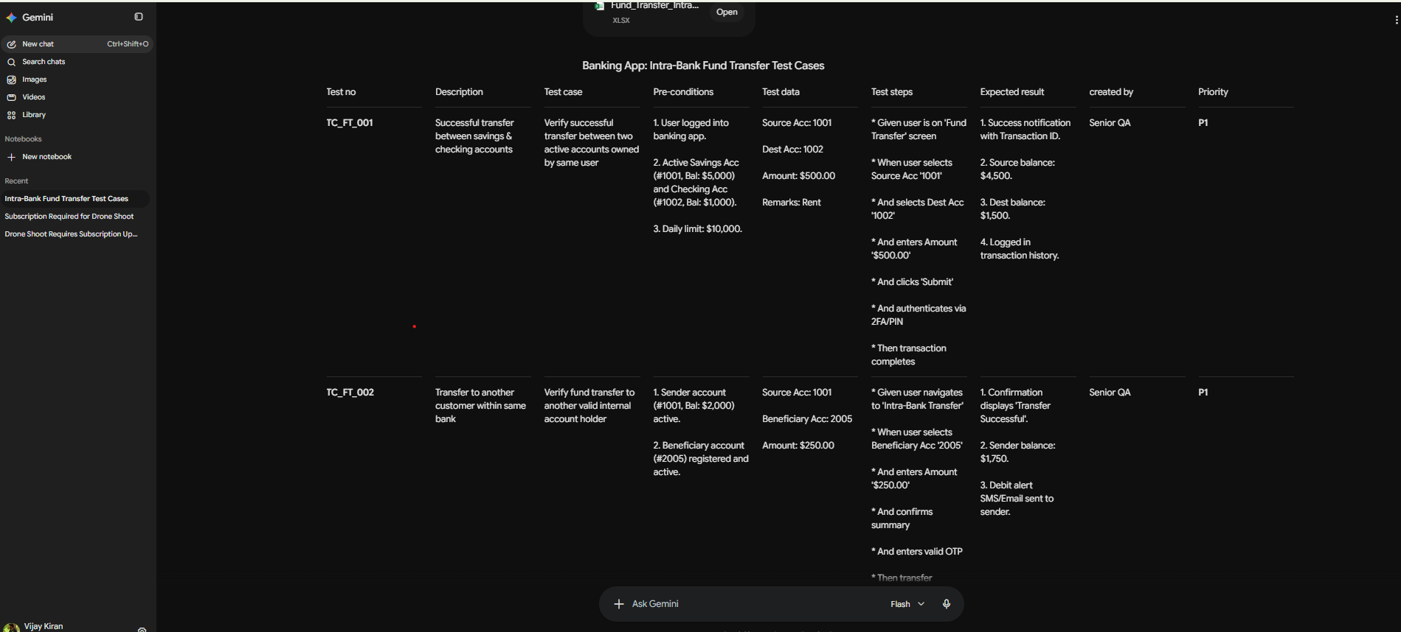

2.
context :
QA team tracks defects including both In-sprint and regression defects. Create a single page visual dashboard to review the defects.

Instructions:
create a visual dashboard which is a html file that shows the overall defects raised.
[Priority] Defects should be displayed as a pie chart
Create a pie chart on the dashboard that displays total number of defects
Create a pie chart on the dashboard for defects with respect to their status
Create a pie chart on the dashboard for defects with respect to their severity
Create a bar chart that shows number of regression defects and In-Sprint defect
create a bar chart that displays the bugs with respect to assignee

Example:
Bug ID: BUG-1111 Severity:P1 Title:Login Button not working Status:Open Assignee:Vijay

Persona:
Generate- Act as a Frontend QA engineer skilled in building HTML/CSS/JS dashboards

Output format:
one .html file- Summary on the top, chart in the middle, defects table at the bottom

Tone:
[Strict]Professional dashboard

