User Storry Reviewer-

- Manual Trigger

2.HttpRequest
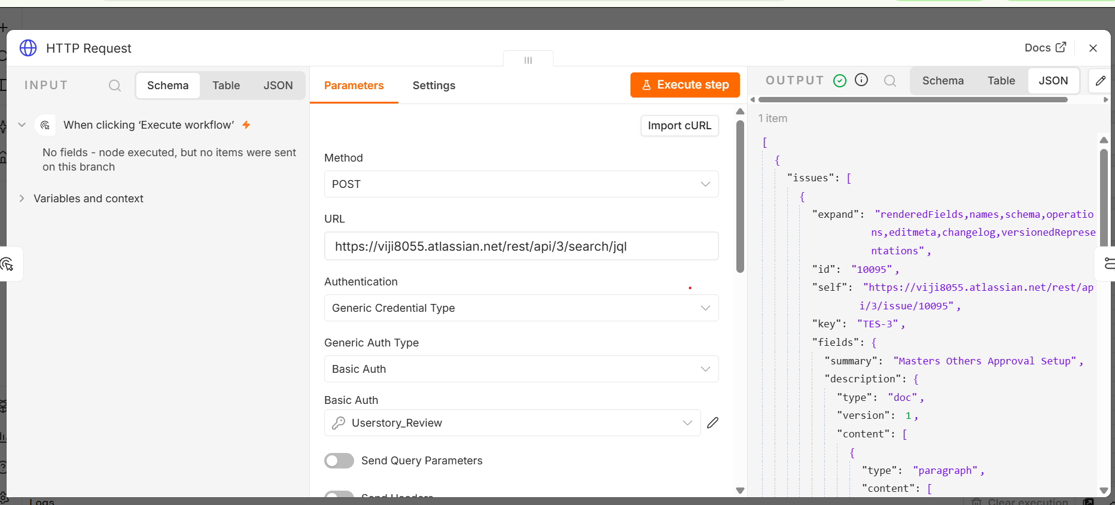

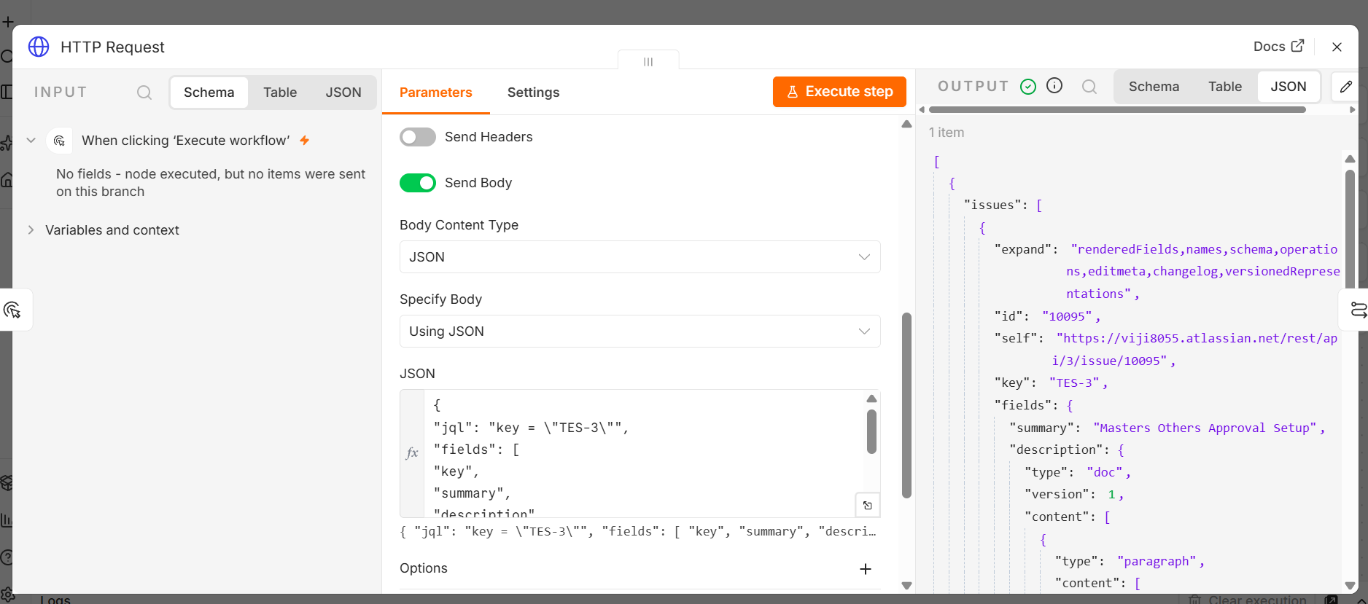

{
"jql": "key = \"TES-3\"",
"fields": [
"key",
"summary",
"description",
"status",
"reporter",
"Acceptance criteria"
]
}

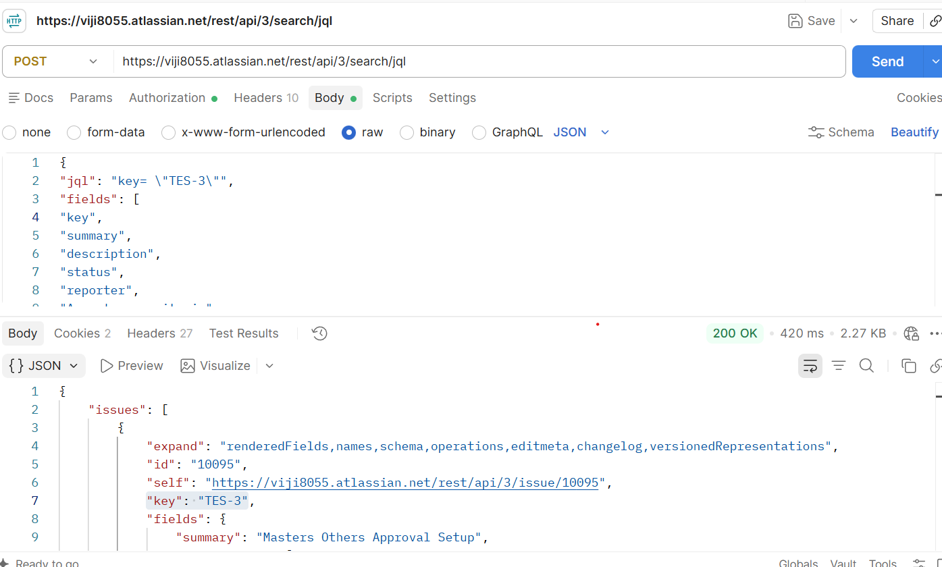

- Basic LLM

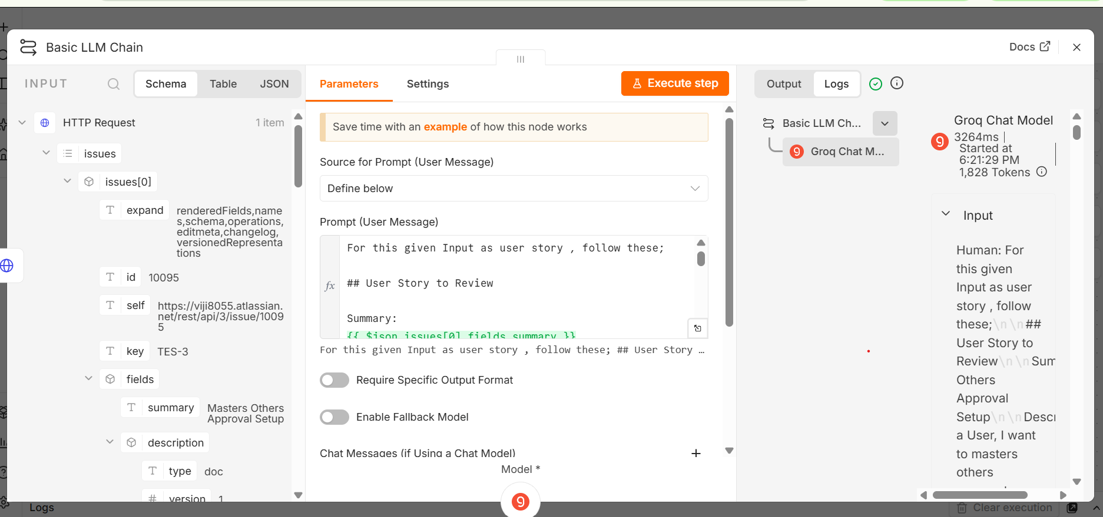

- Email
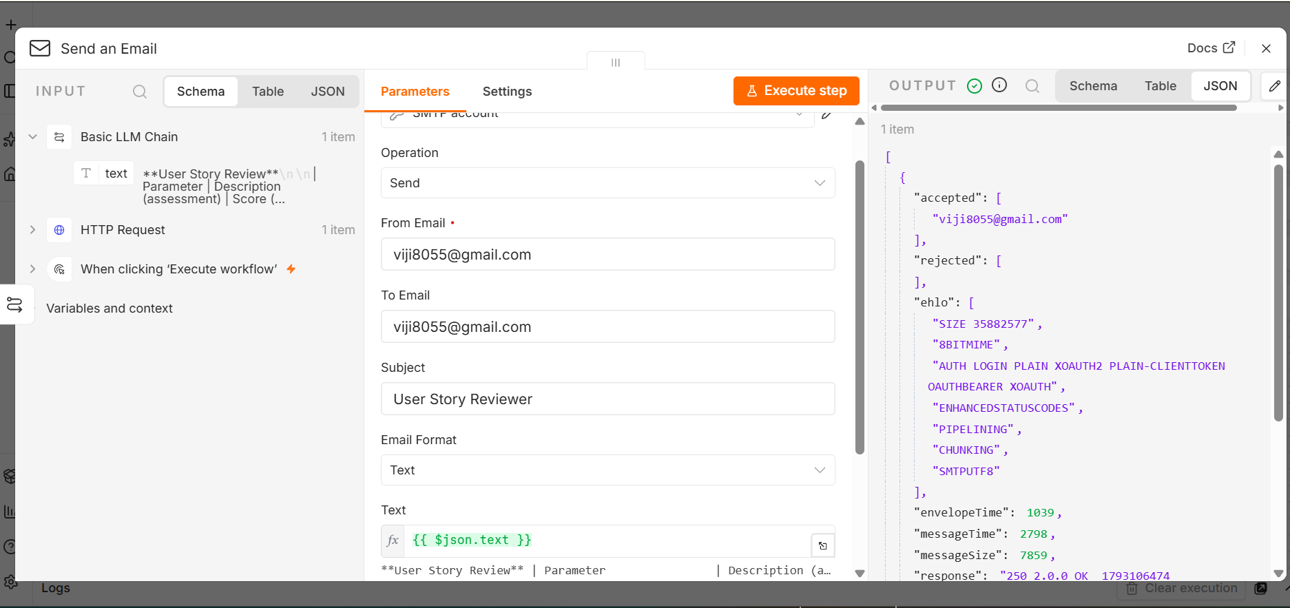

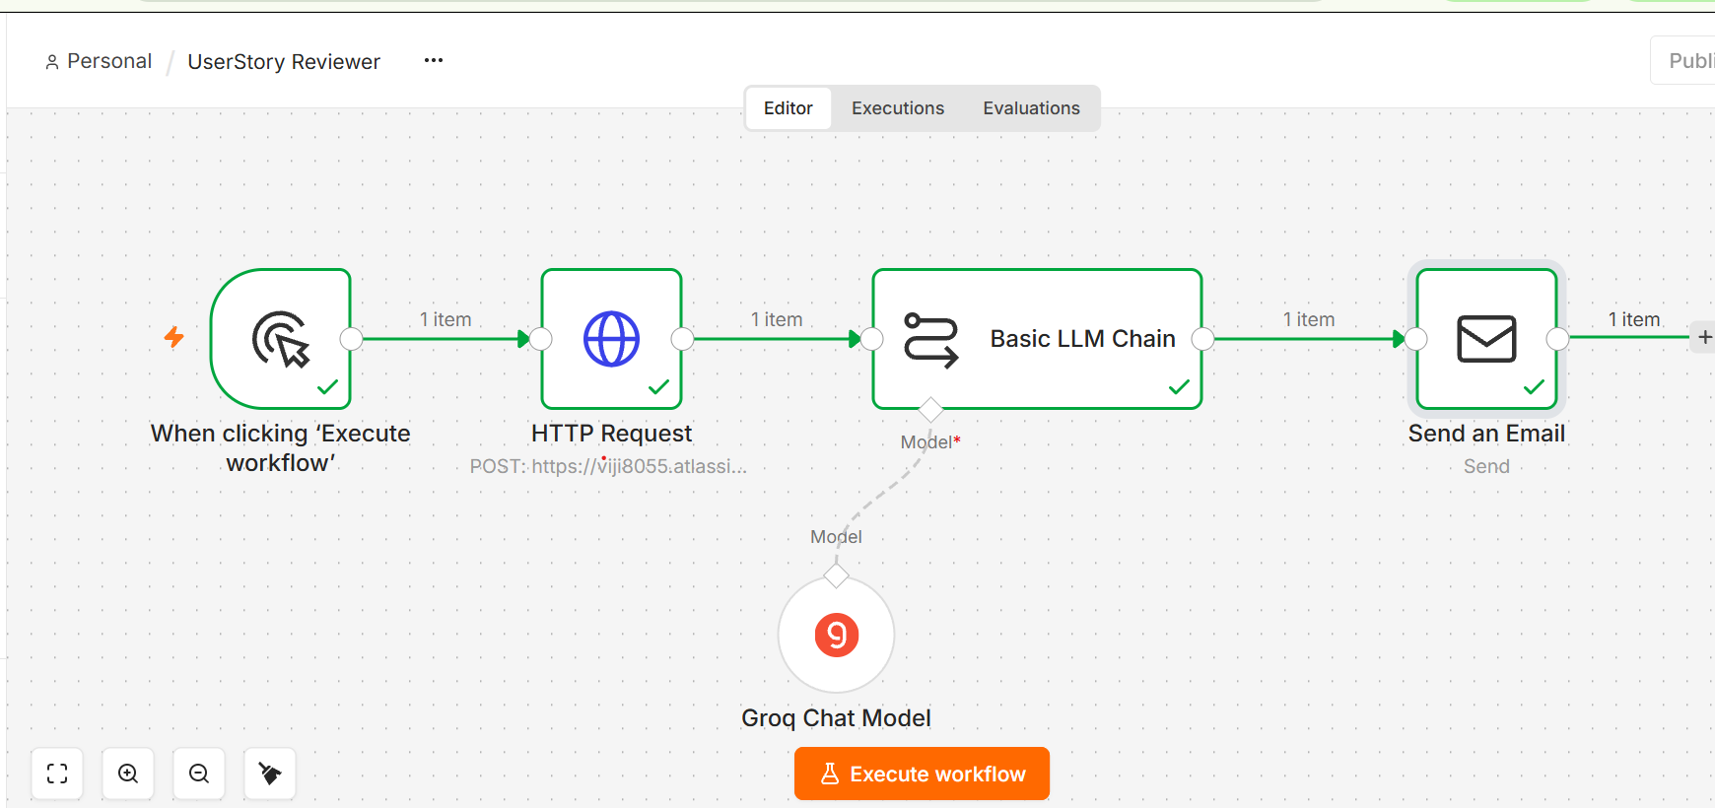

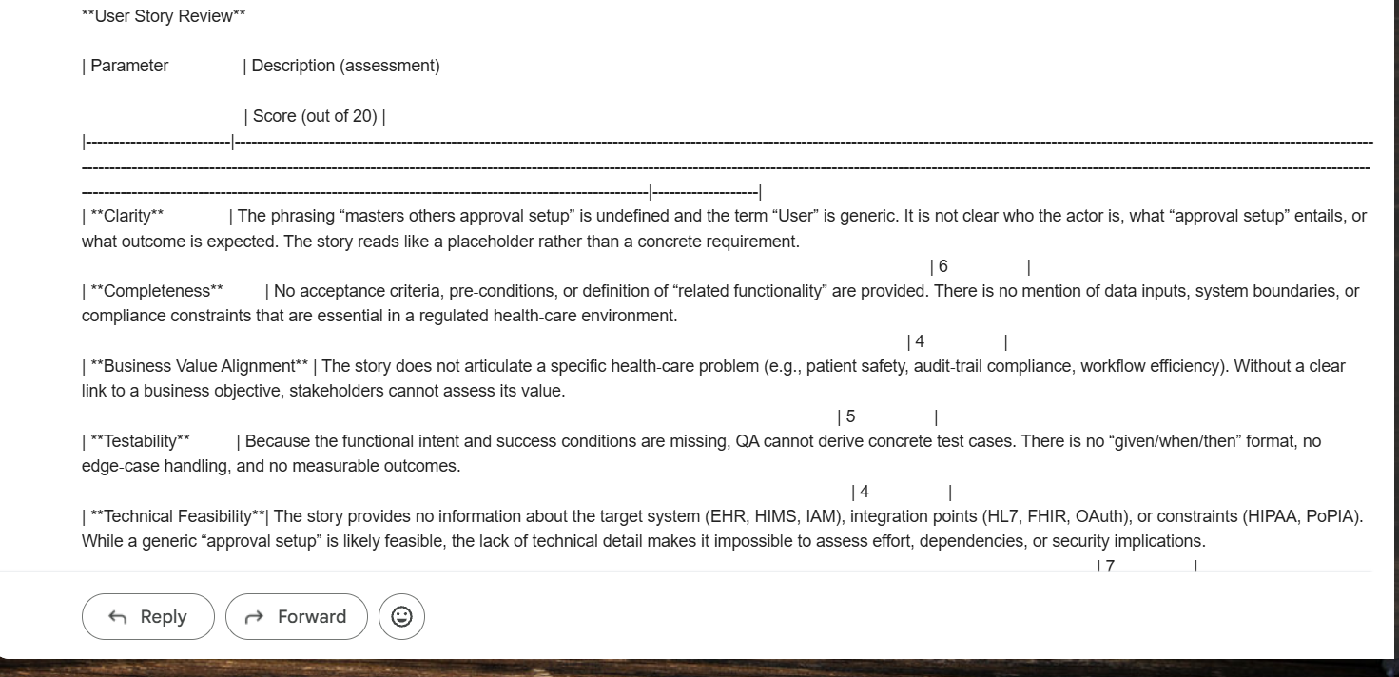

UserStory Reviewer UI Agent:

N8N flow

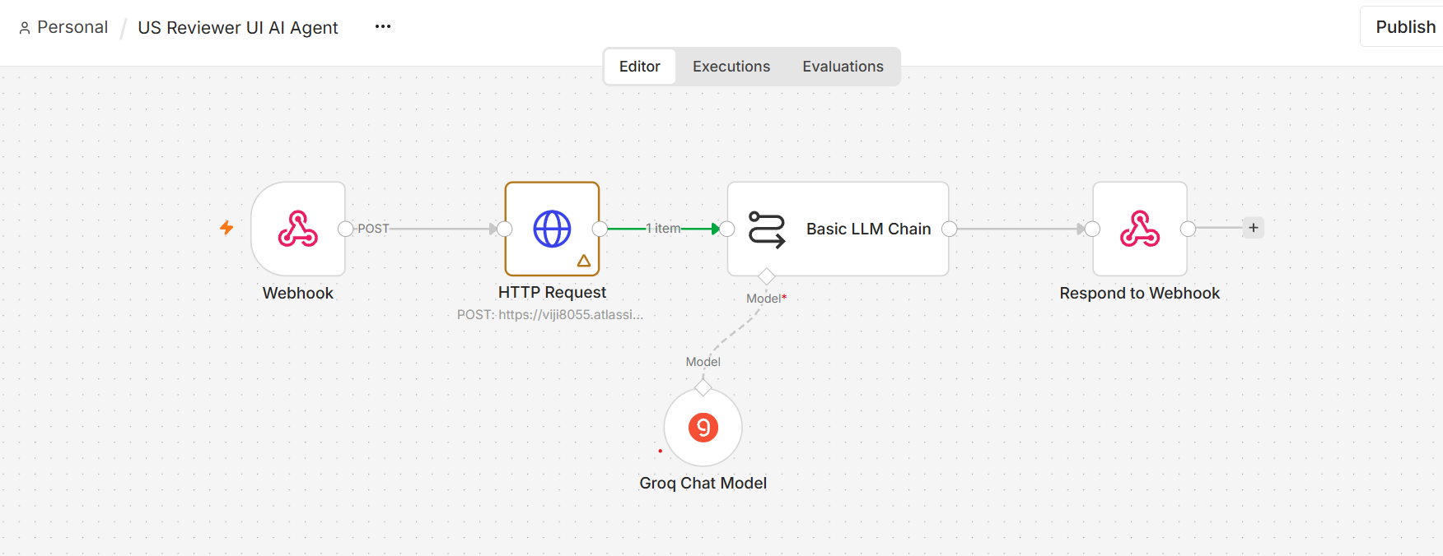

Webhook

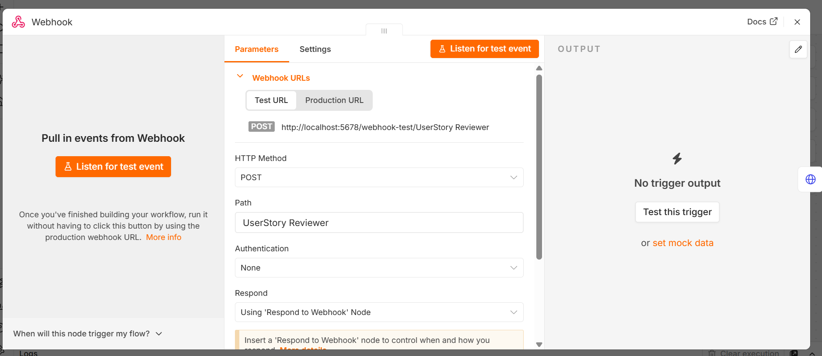

Html

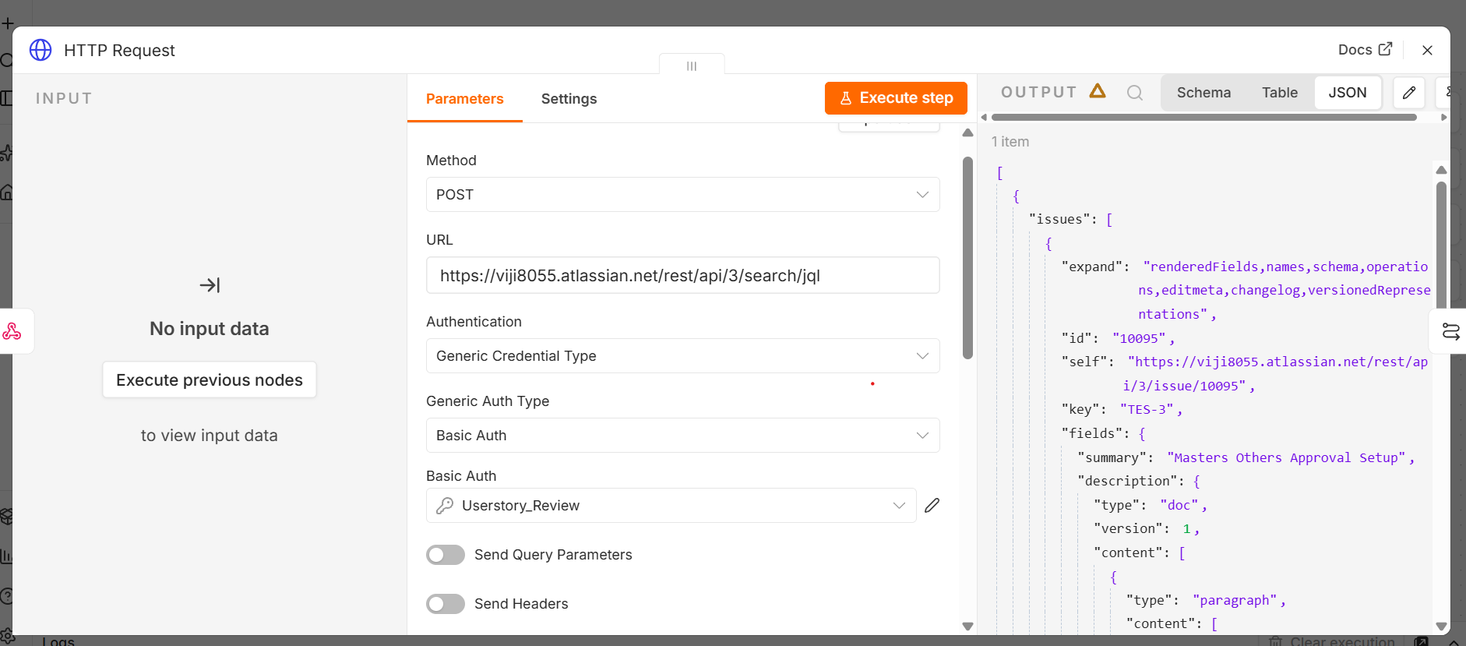

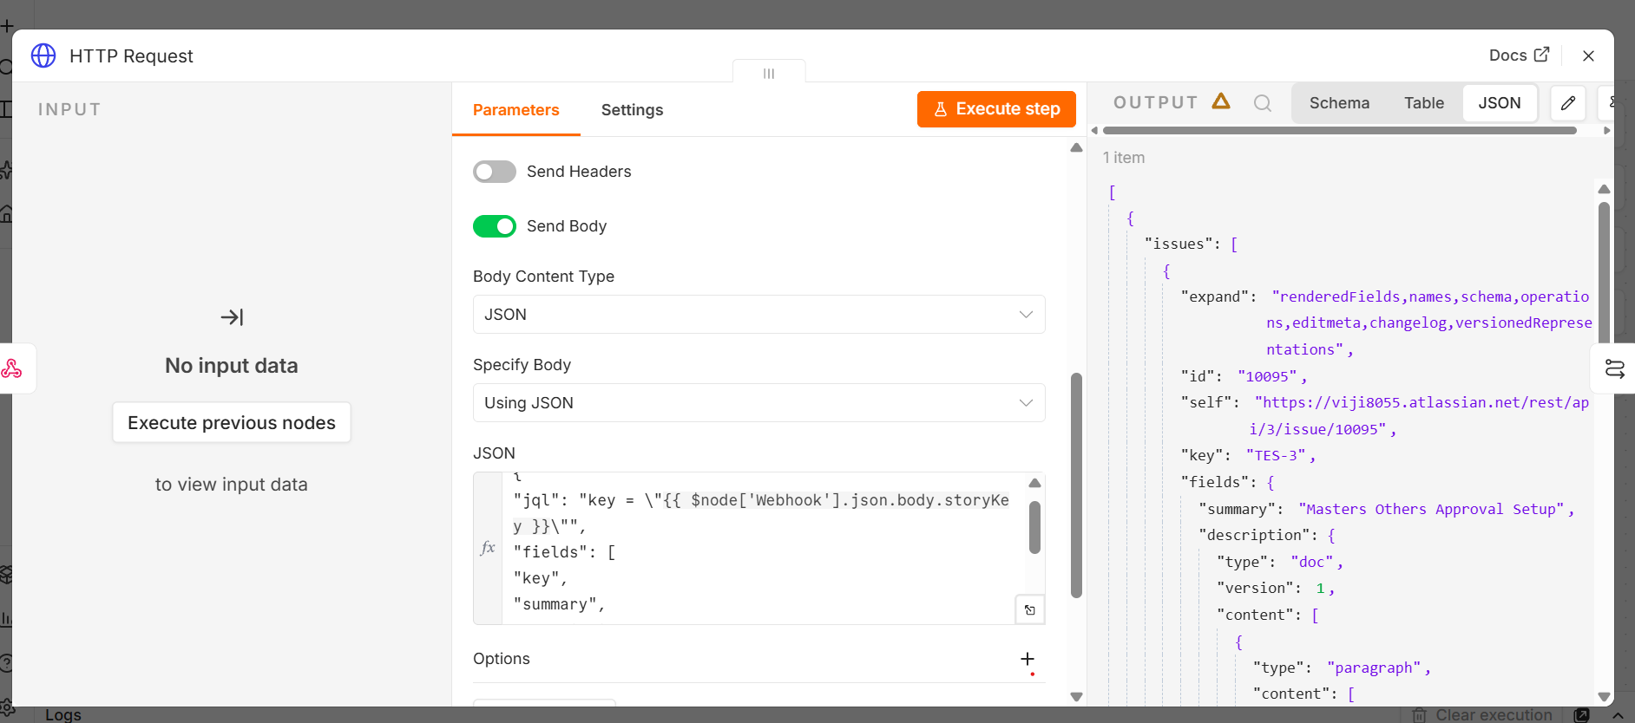

Basic LLM
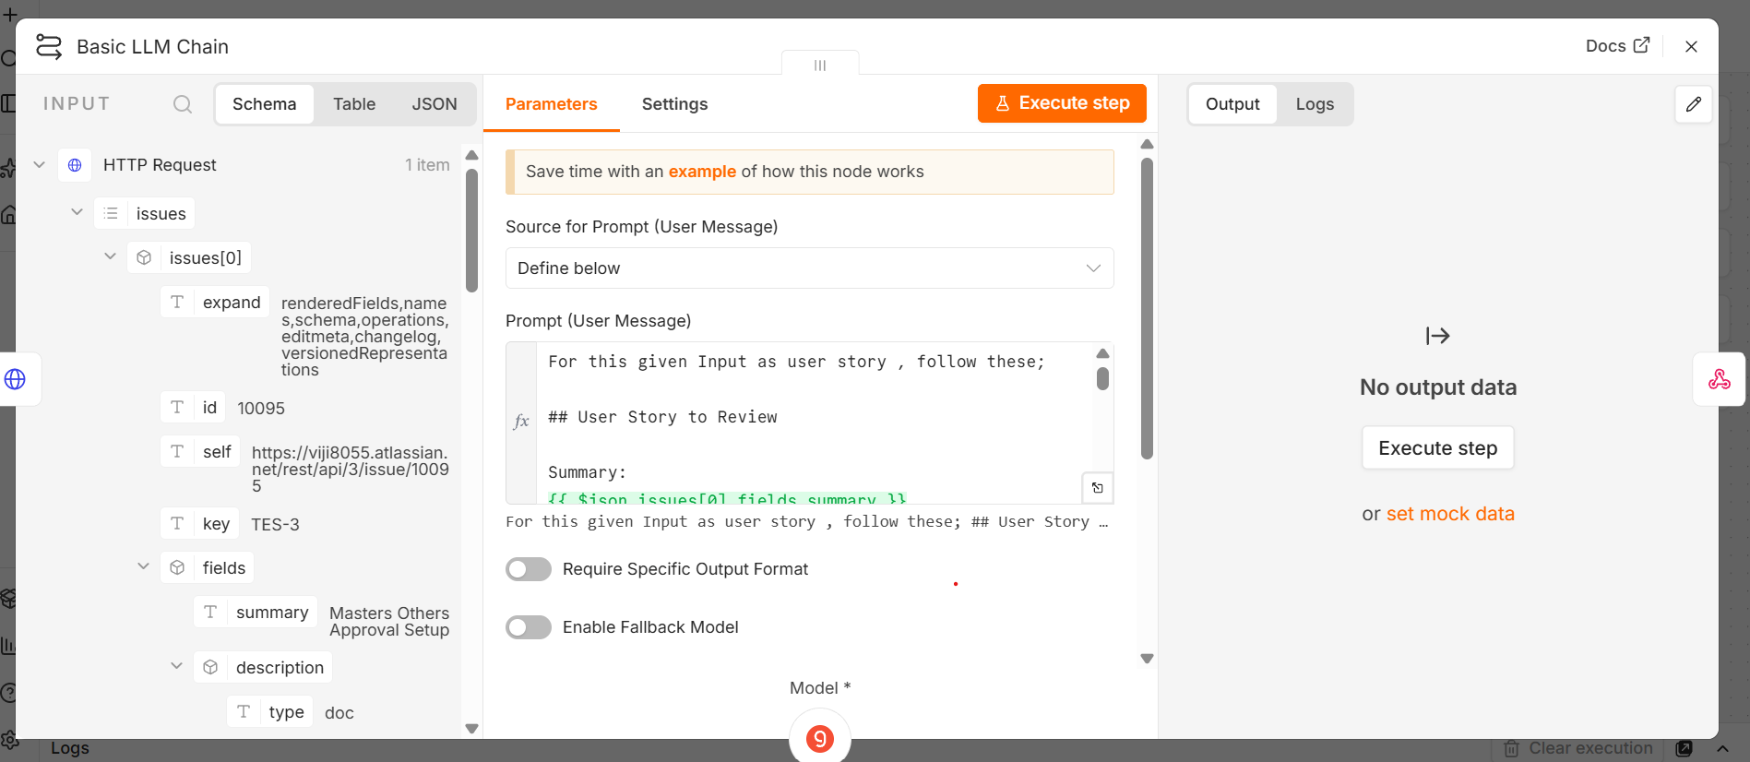

Webhook1
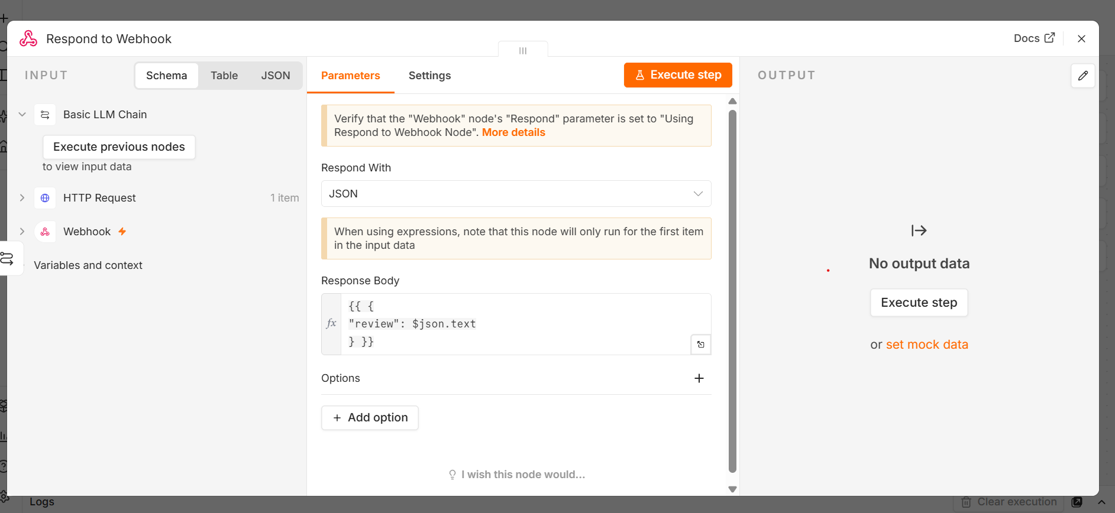

Lets ask chatgpt to give us a plan on creating a UI that will be our userstory reviewer which connects with n8n which we have created on the backend
Ask :
Hi, I'm going to build a front-end UI, simple HTML UI. Basically, on the backend, I have built a n8n workflow, where I have given a webhook. The webhook will receive an input from the front-end UI, whatever I'm gonna build it. So when I give an input in the UI, in the front-end, the webhook receives it in the backend, and the rest of the nodes in the workflow will get executed. And when the workflow is executed, it will give us an output, and the output will be sent to the front-end UI, which we are going to create. So I need to build a front-end UI, and I need to have a connection with the backend workflow, n8n workflow. So give me a plan and prompt how to do it. So I want a simple front-end UI and a connection to a backend n8n workflow.
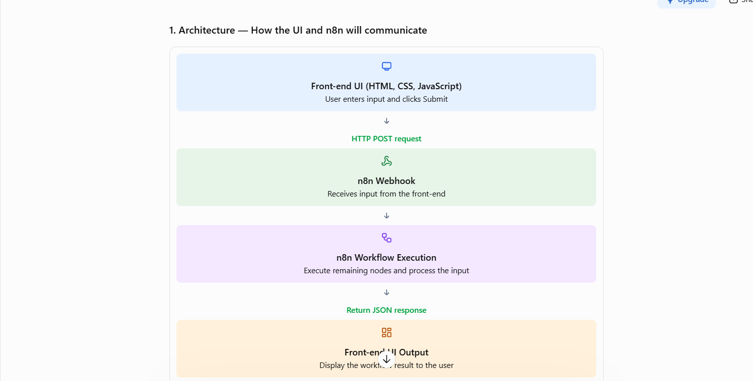
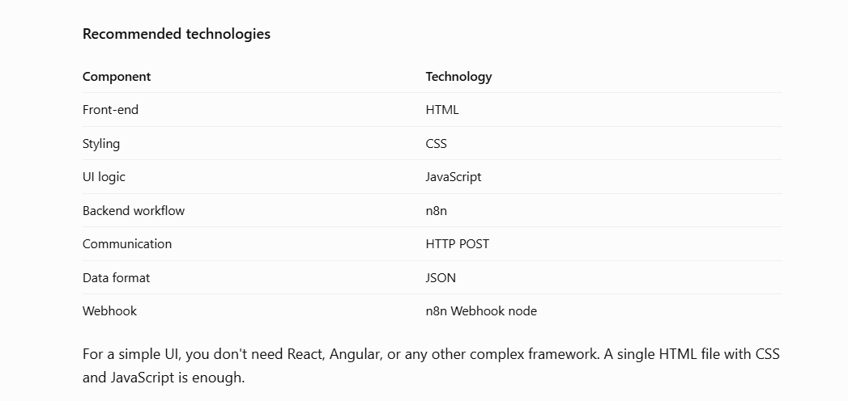

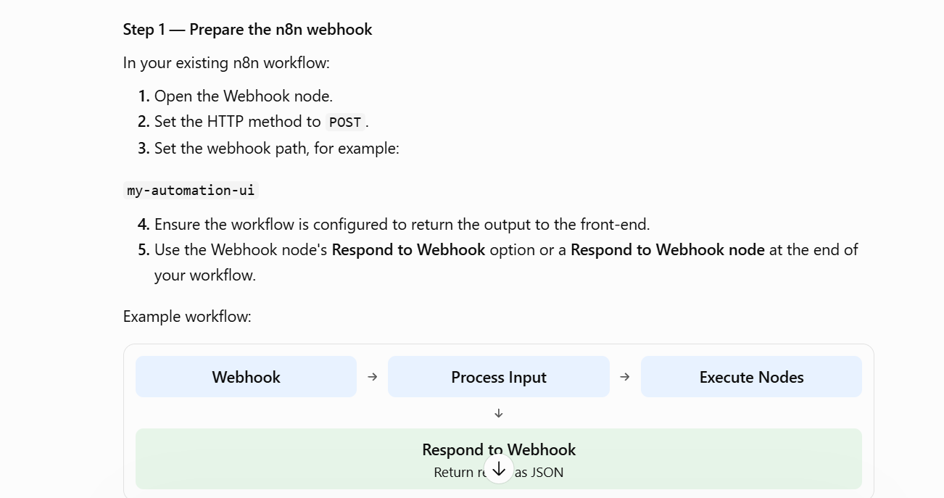

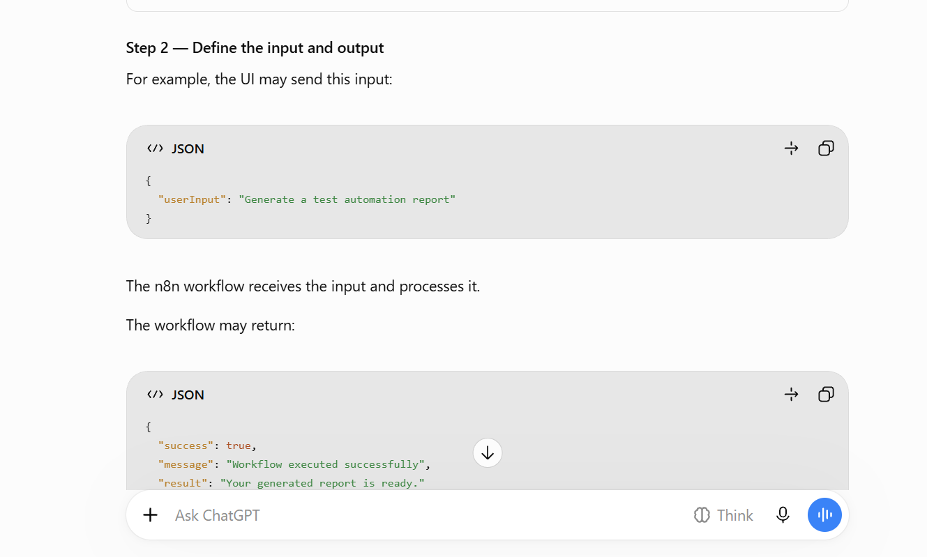
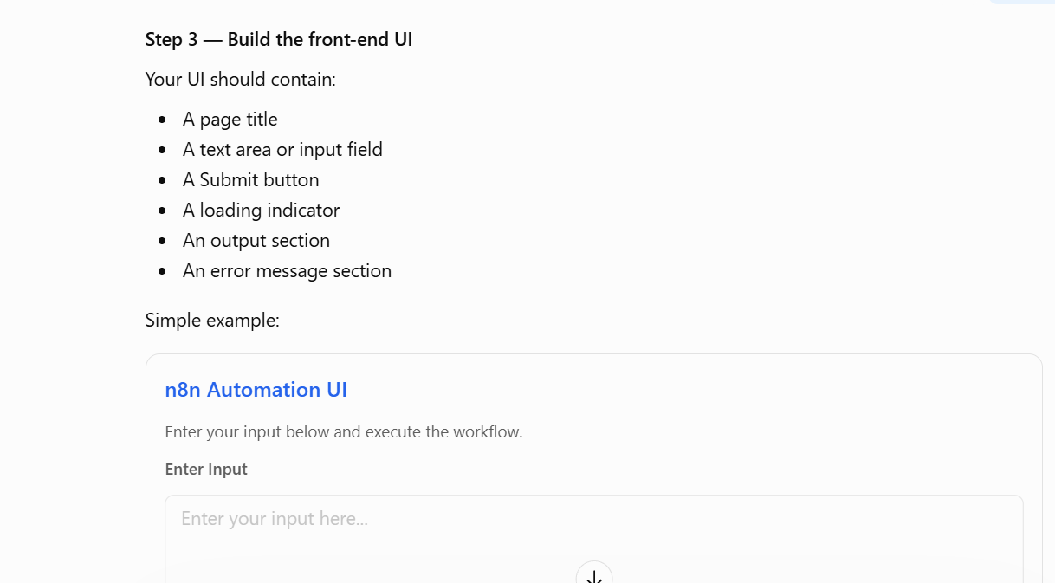

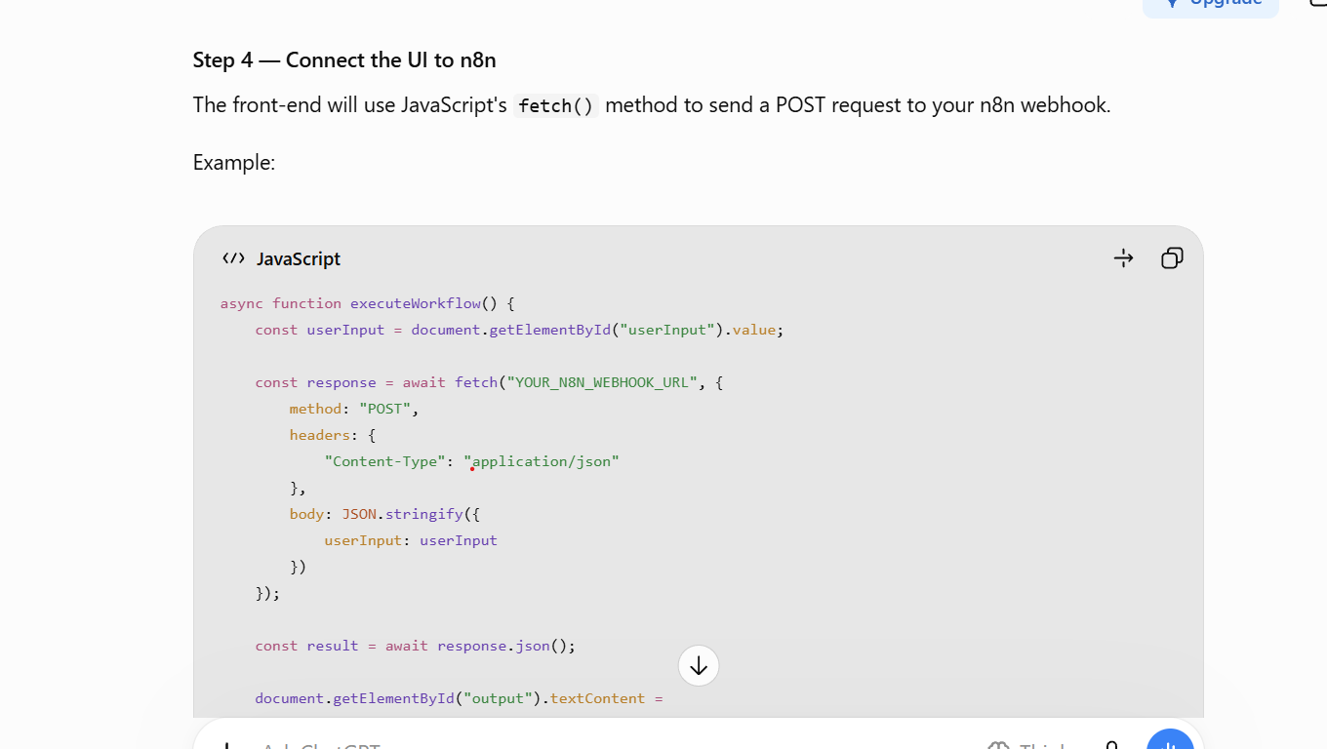
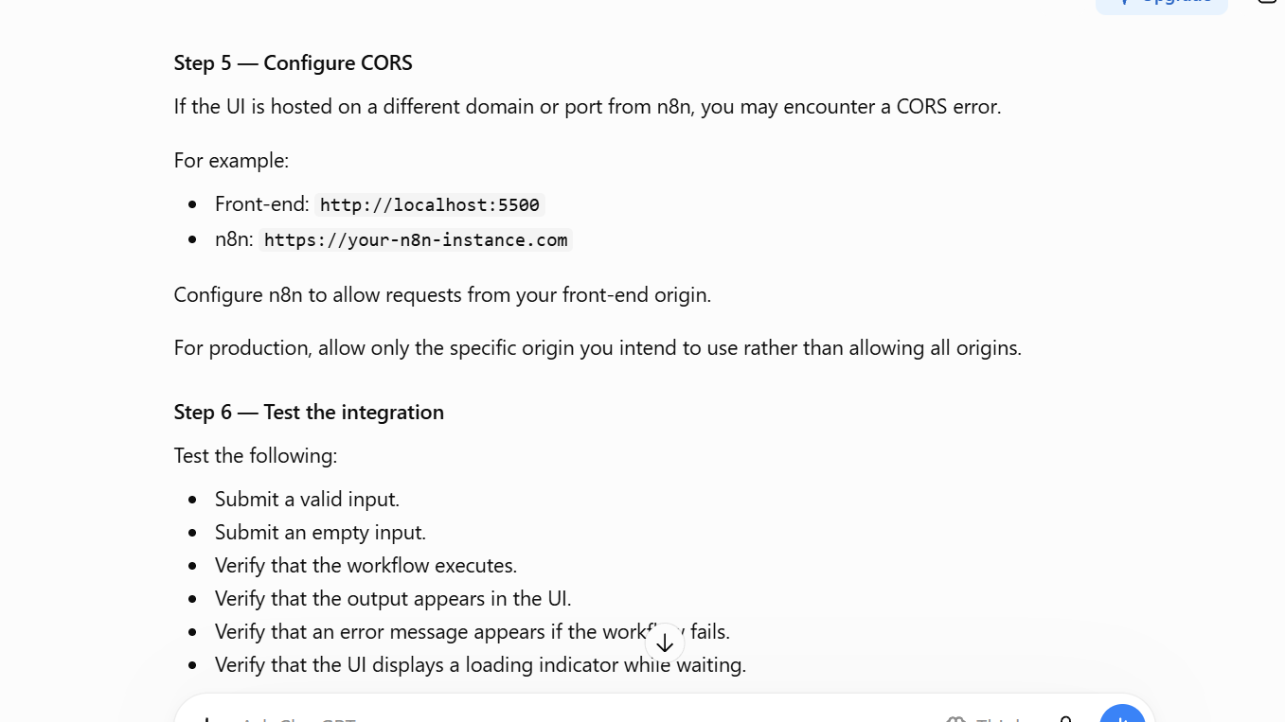

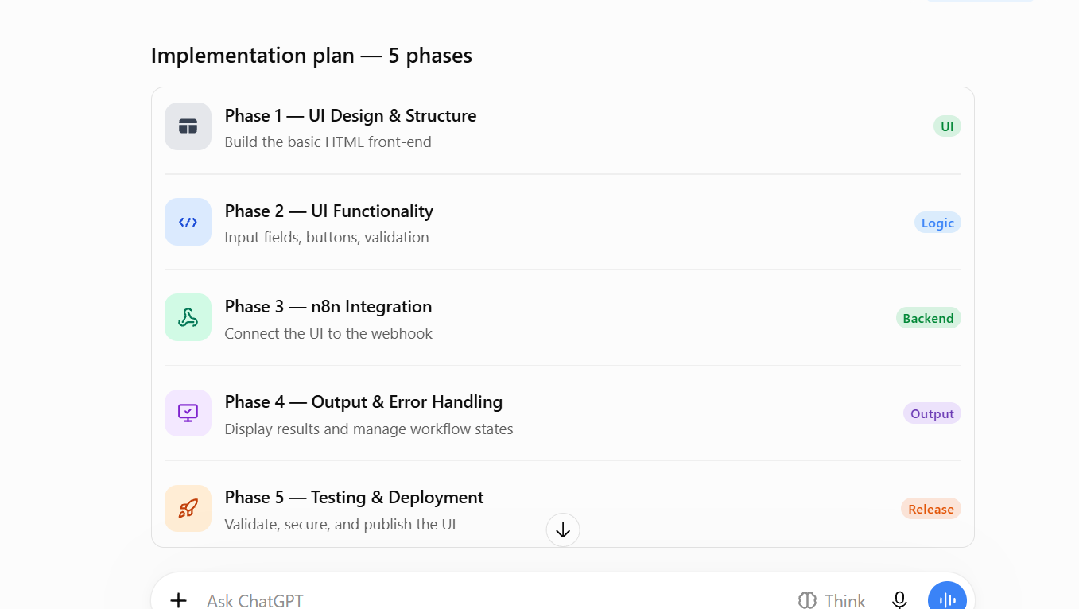

Phase 1 — UI Design & Structure
Objective: Build a simple, clean, professional HTML UI without connecting to n8n.
What to implement:
- Create a page layout.
- Add a page title.
- Add the input area.
- Add a Submit button.
- Add an output section.
- Use CSS for styling.
- Ensure the UI is responsive.
Expected result: A front-end UI that looks complete but is not yet connected to the backend
Prompt — Phase 1
I want to build a simple and professional front-end UI for an existing n8n backend workflow.
Implement Phase 1: UI Design and Structure only.
Requirements:
- Use HTML, CSS, and vanilla JavaScript.
- Do not use React, Angular, or other frameworks.
- Create a clean and modern UI.
- Make the UI responsive for desktop and mobile.
- Add a page title: "n8n Automation UI".
- Add a user input area.
- Add an Execute Workflow button.
- Add a Workflow Output section.
- Add a Clear button.
- Use appropriate spacing, colors, and typography.
- Use a simple card-based layout.
Important:
Do not connect to the n8n webhook in this phase.
Do not implement backend communication.
Use placeholder output data for the UI preview.
Provide the complete index.html file with HTML, CSS, and JavaScript.
The code should be easy to modify in future phases.
At the end, explain how to run and preview the UI locally.
Suggestion: Review the UI before proceeding. If you need changes to colors, layout, or input fields, make them in this phase.

Phase 2 — UI Functionality
Objective: Make the UI interactive without connecting to the backend.
What to implement:
- Capture user input.
- Validate input.
- Add button click functionality.
- Add a loading indicator using simulated execution.
- Add Clear button functionality.
- Prevent empty input submission.
Expected result: The UI behaves like an application, but it uses simulated workflow responses.
Prompt — Phase 2
Act as a Senior JavaScript Developer.
Continue from the existing Phase 1 implementation of my n8n Automation UI.
Implement Phase 2: UI Functionality only.
Requirements:
- Preserve the existing UI design and layout.
- Add JavaScript functionality to capture user input.
- Validate that the input is not empty.
- Add functionality to the Execute Workflow button.
- Add a loading indicator when the button is clicked.
- Disable the Execute Workflow button while processing.
- Simulate backend execution using a mock response.
- Display the mock response in the Workflow Output section.
- Add Clear button functionality.
- Display validation messages for empty input.
- Add basic error handling for the simulated execution.
Important:
Do not connect to the n8n webhook in this phase.
Do not modify the existing UI design unless required for functionality.
Provide the complete updated index.html file.
Explain the changes made and provide steps to test the functionality
Suggestion: Test valid input, empty input, and Clear button functionality before moving on
Phase 3 — n8n Webhook Integration
Objective: Connect the UI to your actual n8n workflow.
What to implement:
- Configure the webhook URL.
- Send user input through HTTP POST.
- Send the input in JSON format.
- Receive the response from n8n.
- Replace the mock response with the real workflow response.
- Handle CORS if required.
Expected result: The UI sends input to n8n, executes the workflow, and receives the actual output.
Prompt — Phase 3
gration Engineer.
Continue from the existing Phase 2 implementation of my n8n Automation UI.
Implement Phase 3: n8n Webhook Integration.
My backend workflow is already built in n8n and has a Webhook node.
Requirements:
- Preserve the existing UI design and functionality.
- Add integration with the n8n webhook using JavaScript fetch().
- Use HTTP POST.
- Send the user input as JSON.
- Use the following JSON request structure:
{
"userInput": "User-entered input"
}
- Configure the webhook URL in one centralized JavaScript constant.
- Use this placeholder webhook URL:
YOUR_N8N_WEBHOOK_URL
- Receive the actual response from n8n.
- Display the response in the Workflow Output section.
- Remove the mock response logic and use the real backend response.
- Ensure the UI waits for the webhook response before displaying the output.
- Handle network errors and non-success HTTP responses.
- Do not expose credentials or API keys in the front-end code.
Important:
Do not redesign the UI.
Do not modify the existing n8n workflow.
Assume that the n8n webhook is configured to return a response after the workflow completes.
Provide the complete updated index.html file.
Explain:
- How to configure the webhook URL.
- How to configure the n8n Webhook node.
- How to return the workflow response from n8n.
- How to handle CORS.
- How to test the UI-to-n8n integration.
Phase 4 — Output Display & Error Handling
Objective: Improve the user experience after the workflow executes.
What to implement:
- Display output in a readable format.
- Format JSON responses.
- Show success messages.
- Show meaningful error messages.
- Handle long-running workflow execution.
- Add loading and processing states.
- Prevent duplicate submissions.
Expected result: The UI handles successful execution, failed execution, and delayed responses properly.
Prompt — Phase 4
Act as a Senior JavaScript Developer specializing in API integrations.
Continue from the existing Phase 3 implementation of my n8n Automation UI.
Implement Phase 4: Output Display and Error Handling.
Requirements:
- Preserve the existing UI design and n8n webhook integration.
- Display the actual response returned by n8n.
- Format JSON responses in a readable manner.
- Display plain-text responses as readable text.
- Add clear success and failure messages.
- Show a loading indicator while the workflow is executing.
- Prevent duplicate submissions.
- Handle network errors.
- Handle HTTP error responses.
- Handle unexpected or invalid response formats.
- Add a configurable timeout for the request.
- Display an appropriate timeout message.
- Keep the output section scrollable for large responses.
- Use safe DOM rendering techniques such as textContent.
- Do not display raw technical stack traces to the end user.
If the response contains structured data, render it in a readable format without assuming a specific response schema.
Provide the complete updated index.html file.
Explain the error-handling approach and how to test the different scenarios.
Phase 5 — Testing, Security & Deployment
Objective: Validate the complete application and deploy it for actual use.
What to implement:
- Test all UI functionality.
- Test the webhook integration.
- Verify CORS configuration.
- Secure the webhook.
- Deploy the front-end UI.
- Validate the production environment.
Expected result: A working front-end application connected to your n8n backend, ready for use.

We are using phase plan provided by team and using it in VS code for implementation.
Prompt_rpadmap.md file contains the phases
Give this file along with the instruction to copilot and implement the phases one by one

Instruction given
Analyse this implementation file and implement one phase at a time.
Proceed to next phase only after my approval
[strict] Do not go to next phase until I approve
[mandatory] Do not hallucinate, go with only based on document

Phase 1

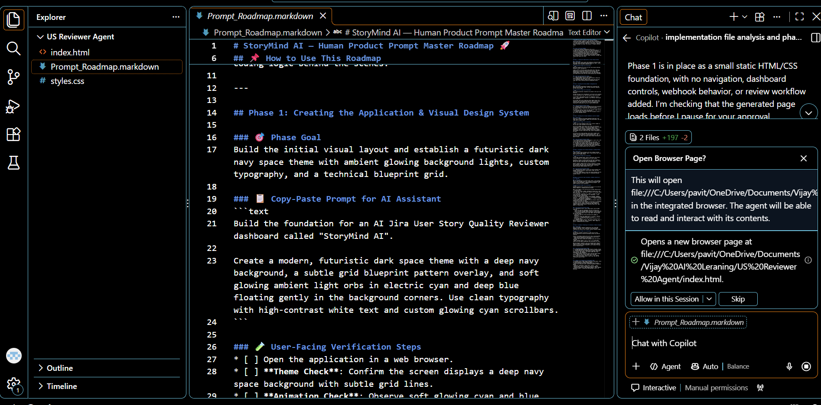
Once phase 1 is done we can see index.html and styles.css file getting created that is responsible for UI creation
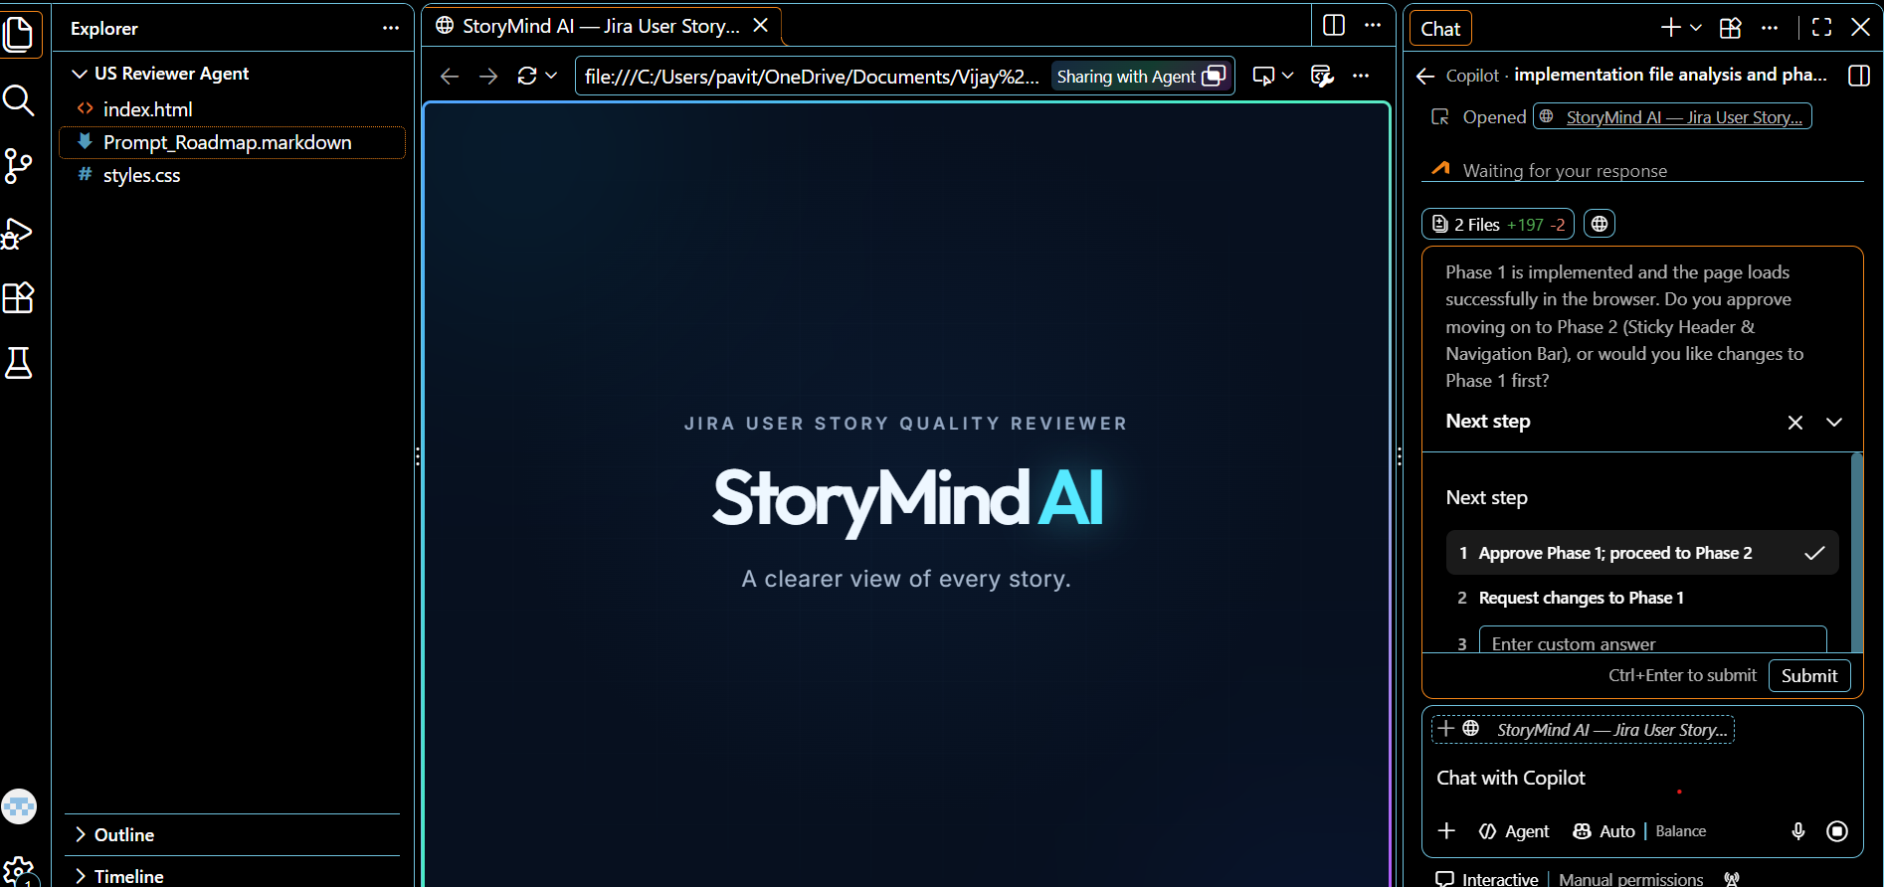

I am approving phase 1, please proceed with phase 2
Phase2
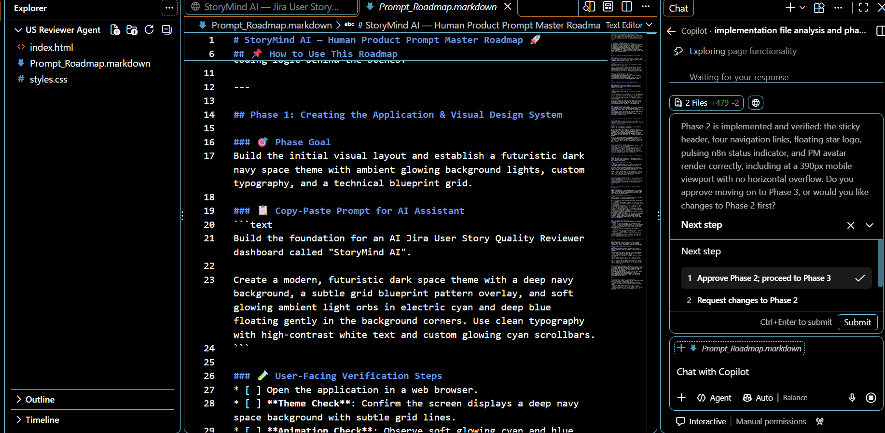

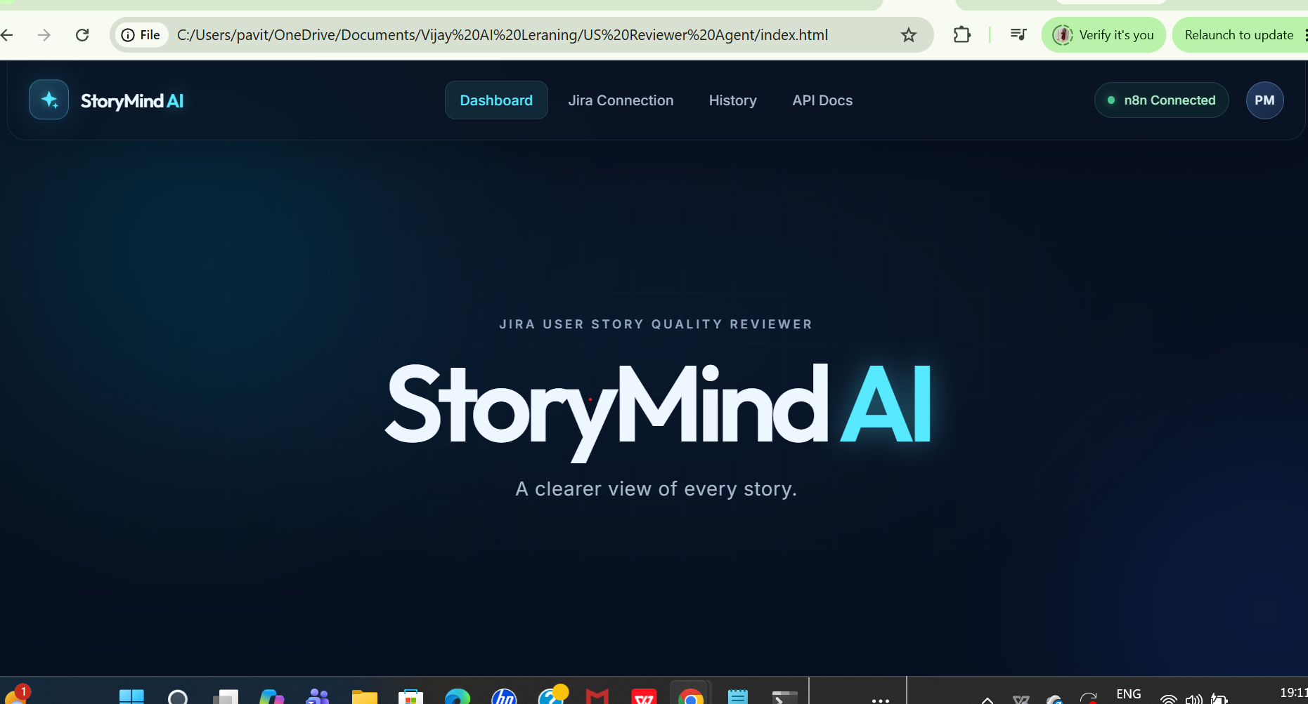

give me the command to open frontend in localhost
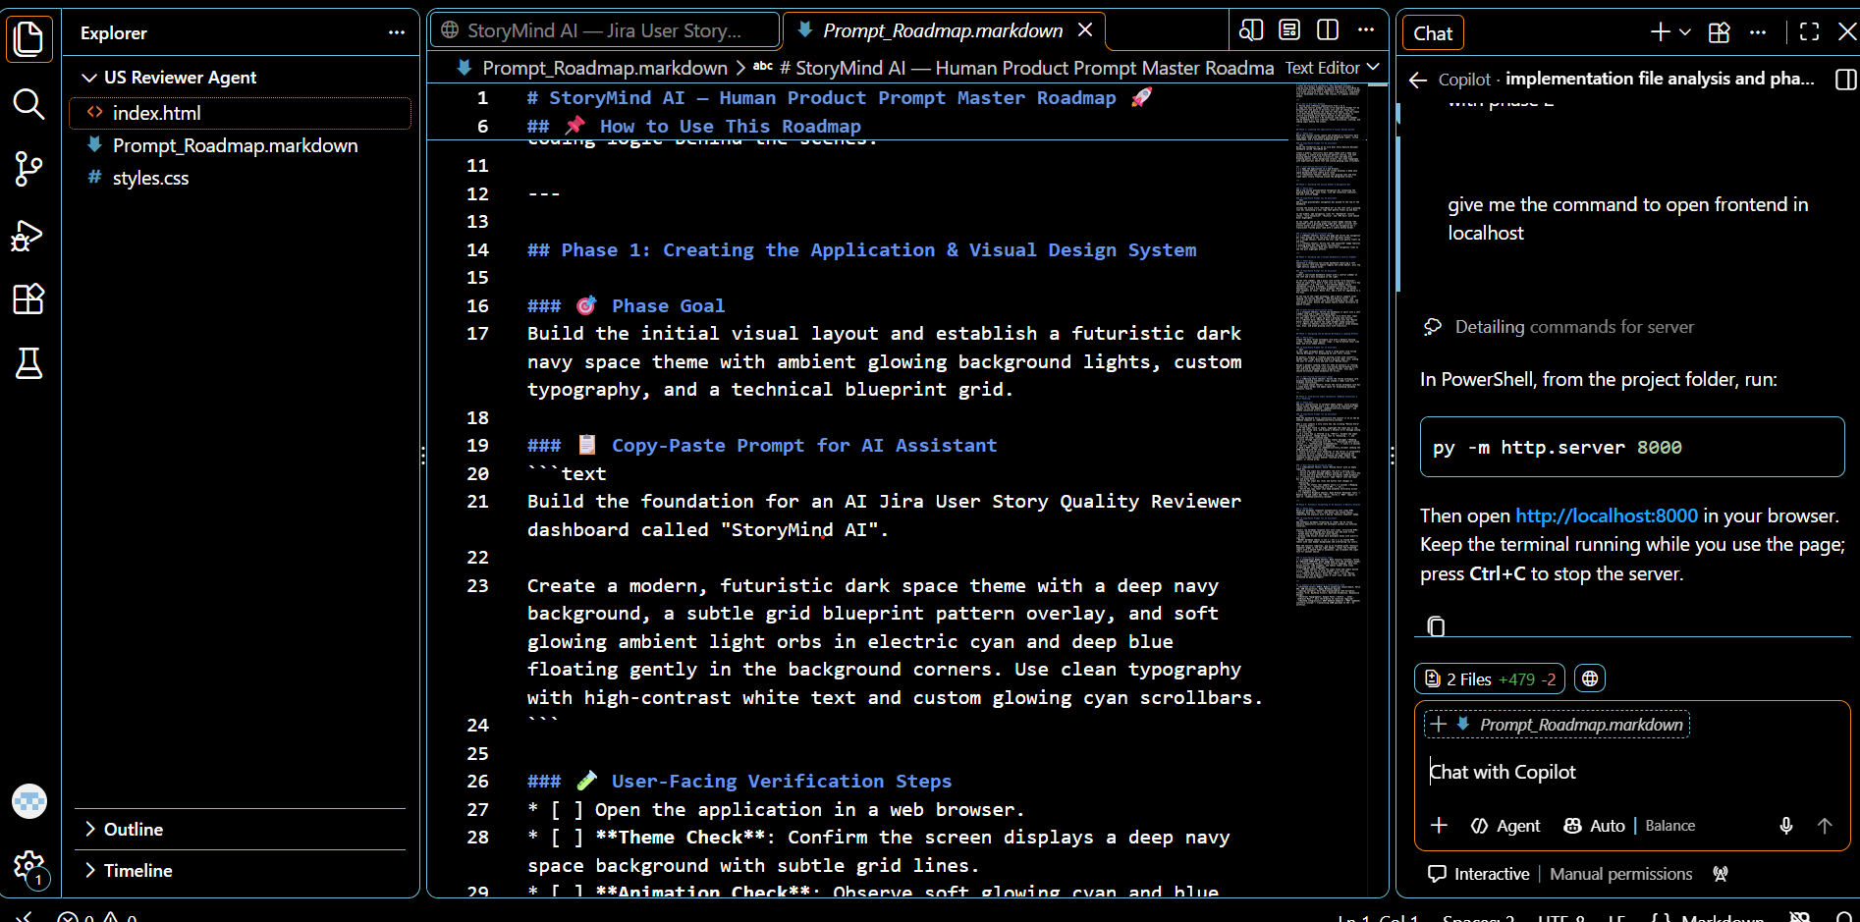
Run the code on terminal localhost
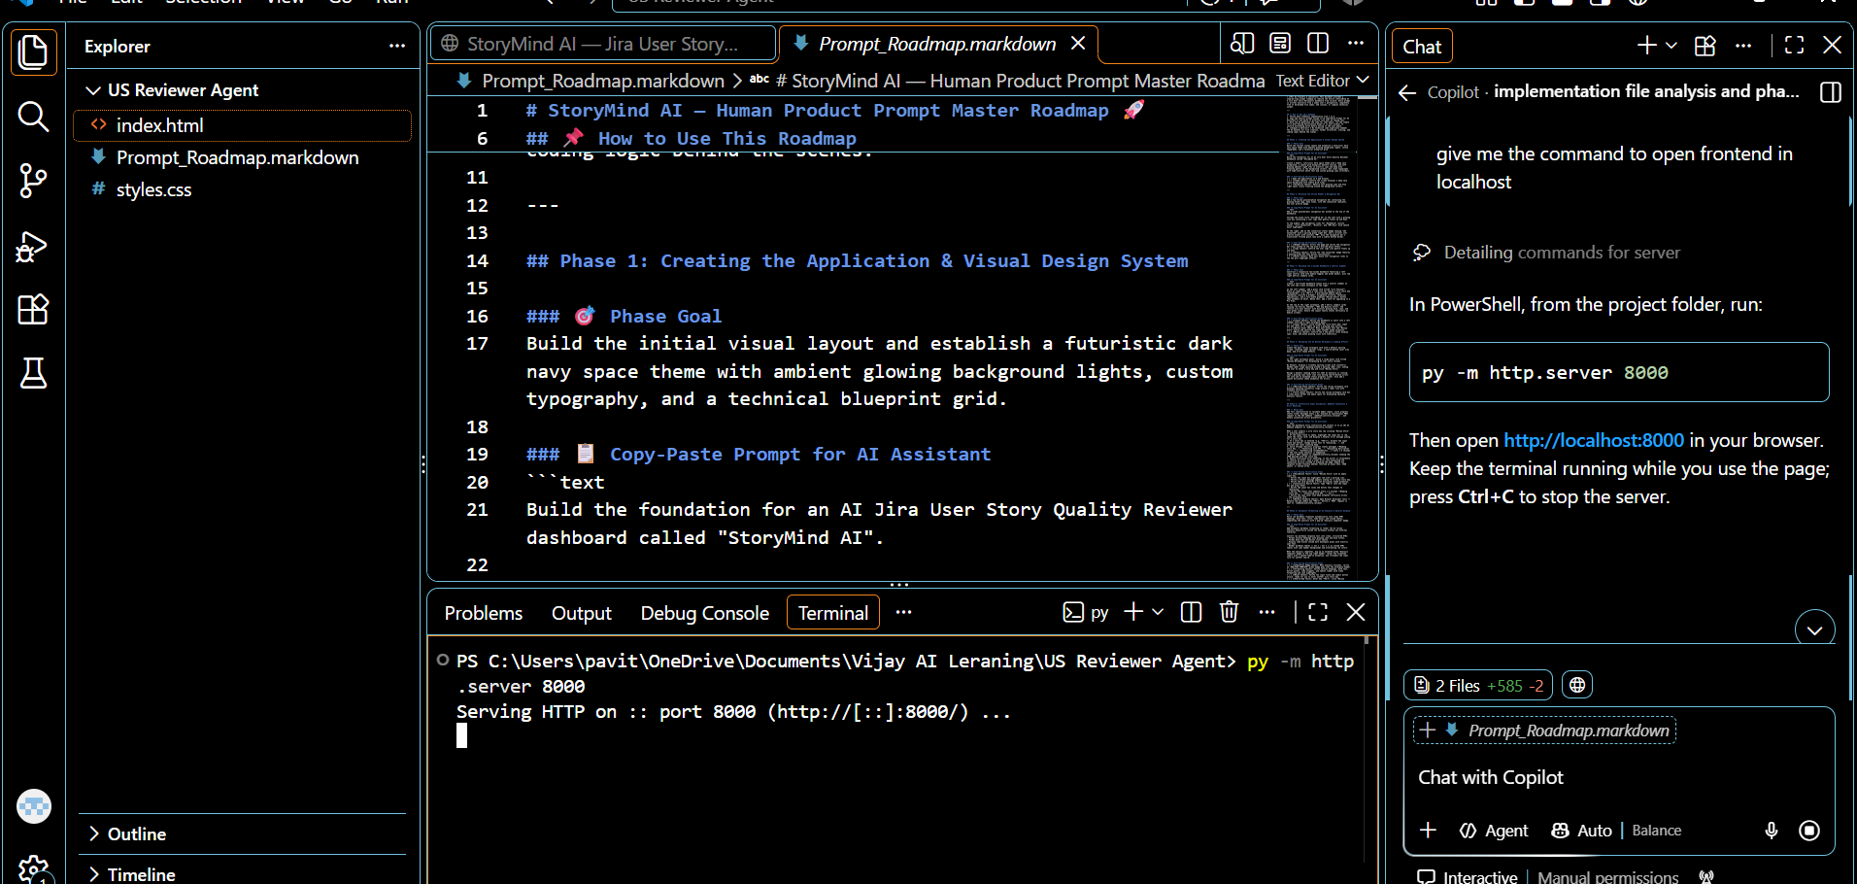

Phase 3
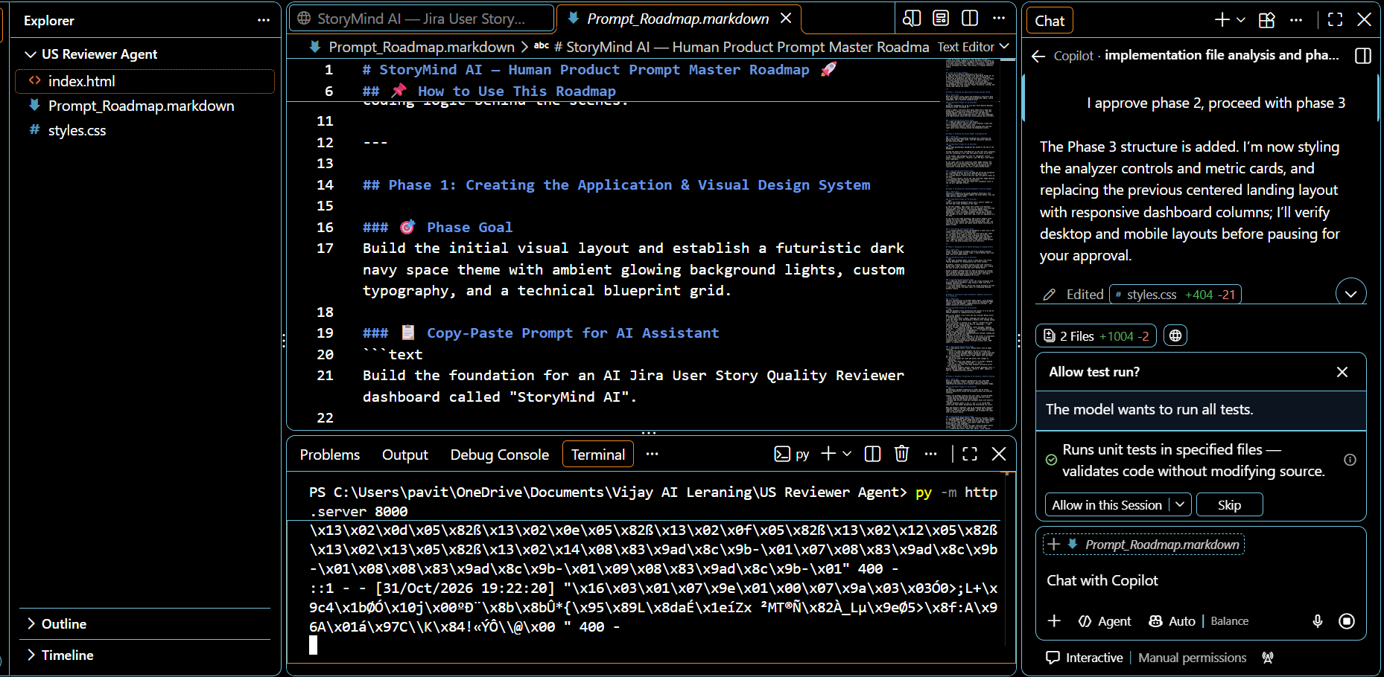

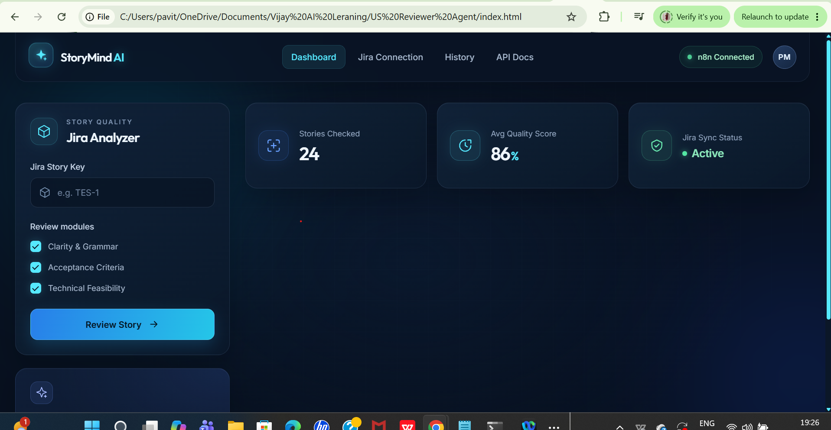

Phase 4

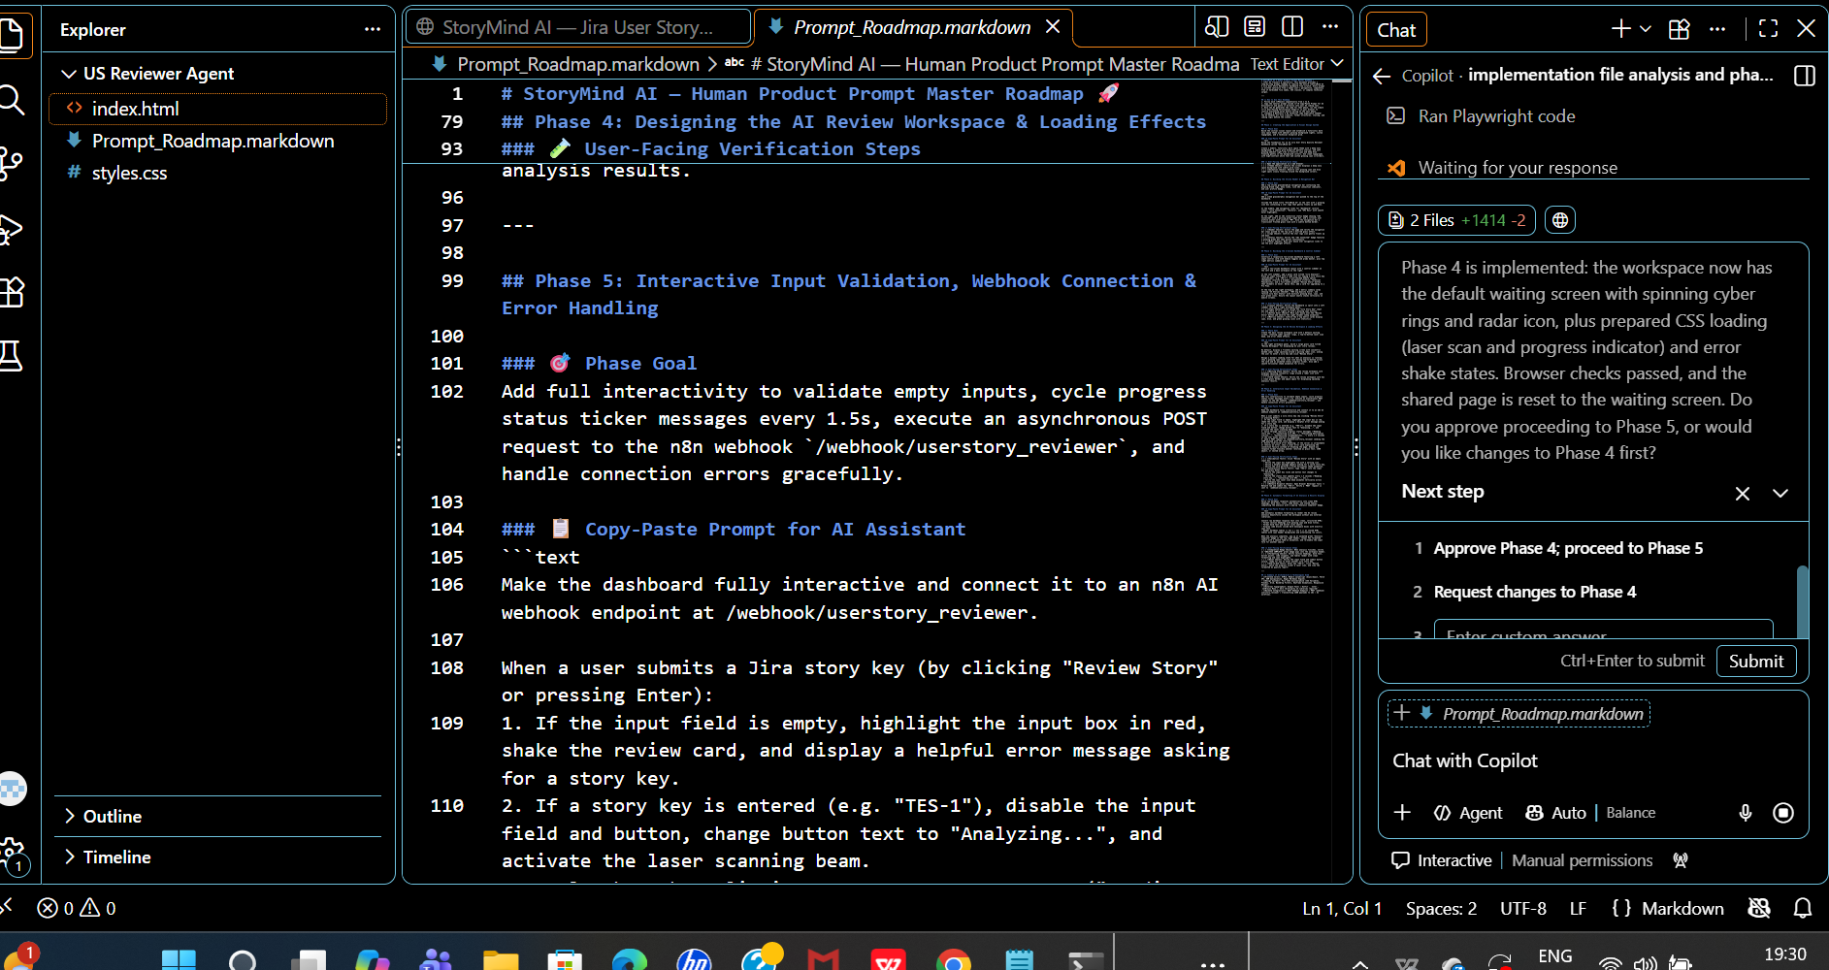
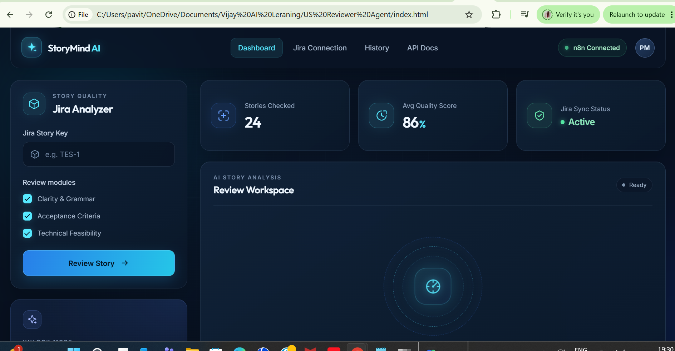

Since Phase 5 is about connecting to webhook, provide the webhook url and then proceed with phase 5

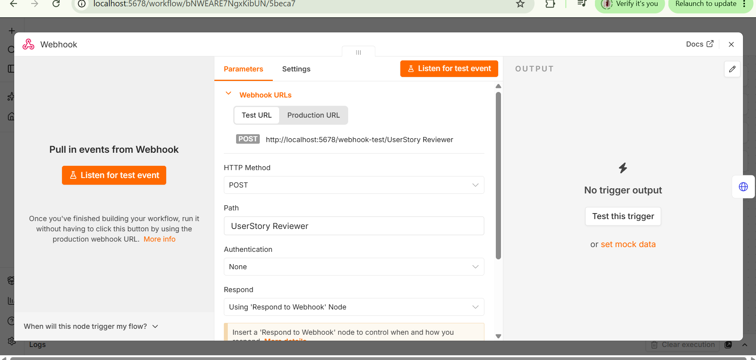
http://localhost:5678/webhook-test/UserStory Reviewer
http://localhost:5678/webhook-test/UserStory Reviewer This is the webhook url, make a connection with this url. Approving phase 4 and please with phase 5 using the above given webhook url

New file app.js got created
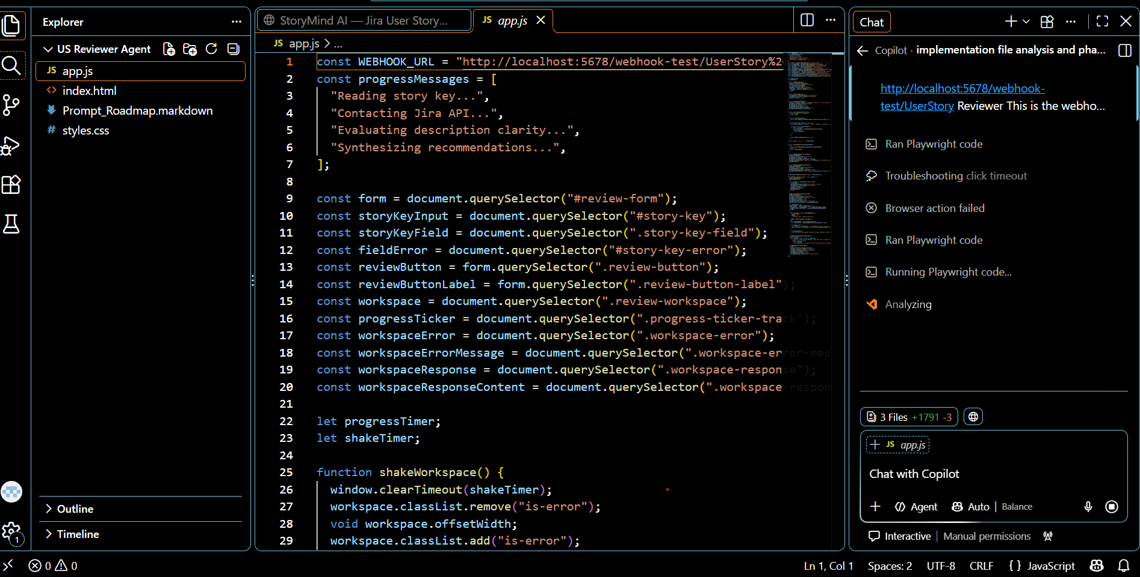
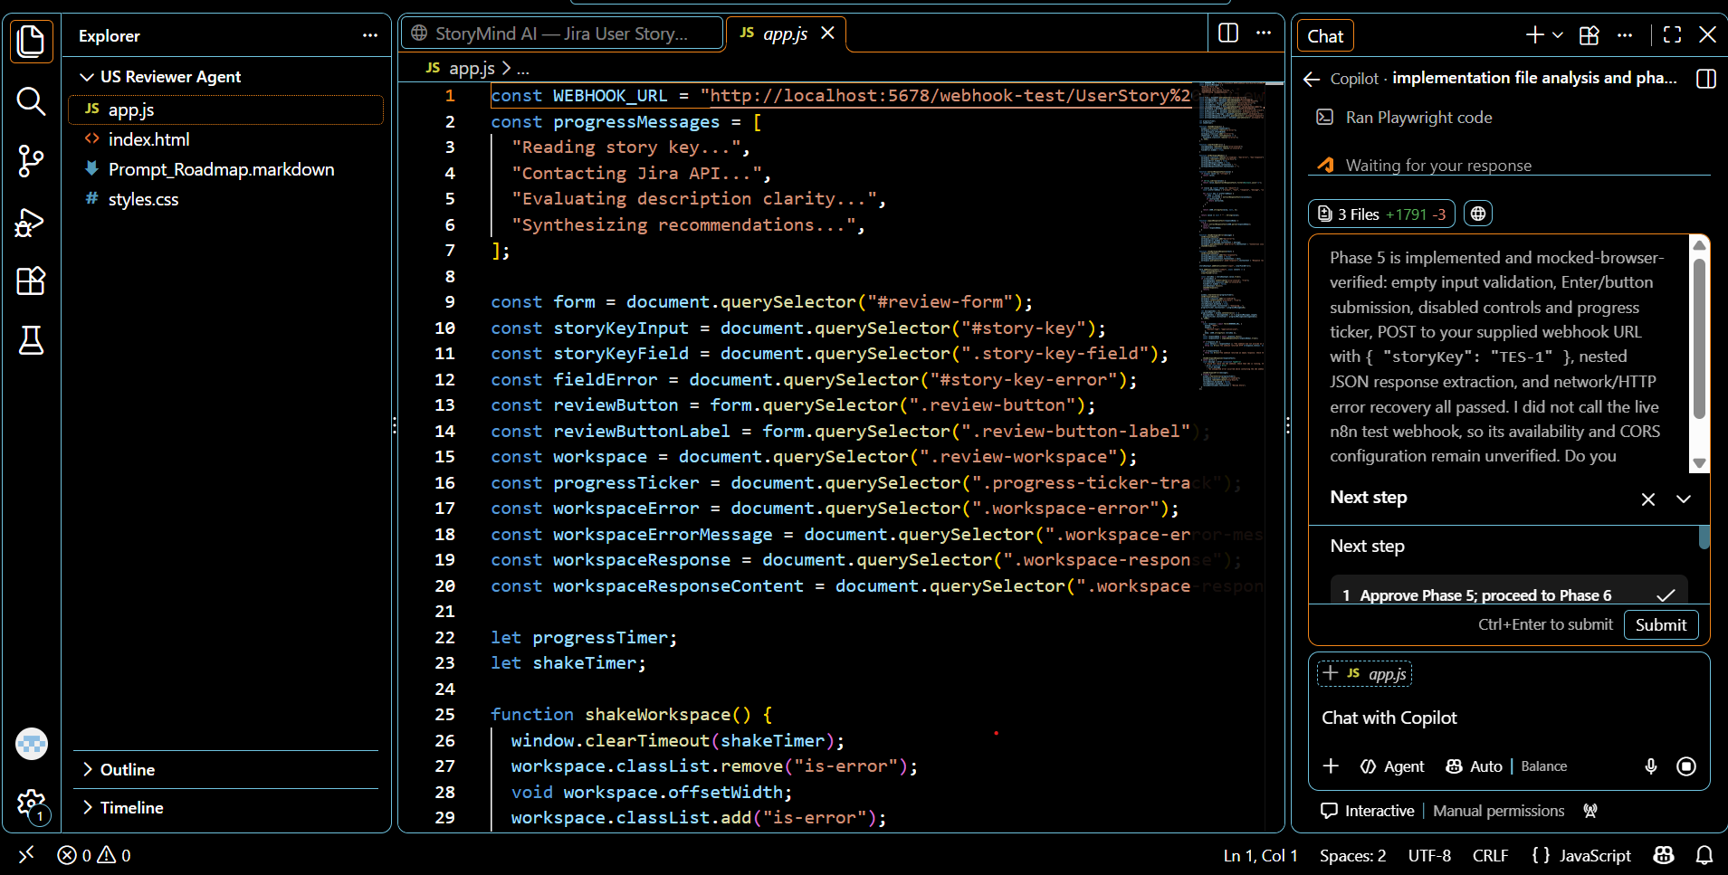

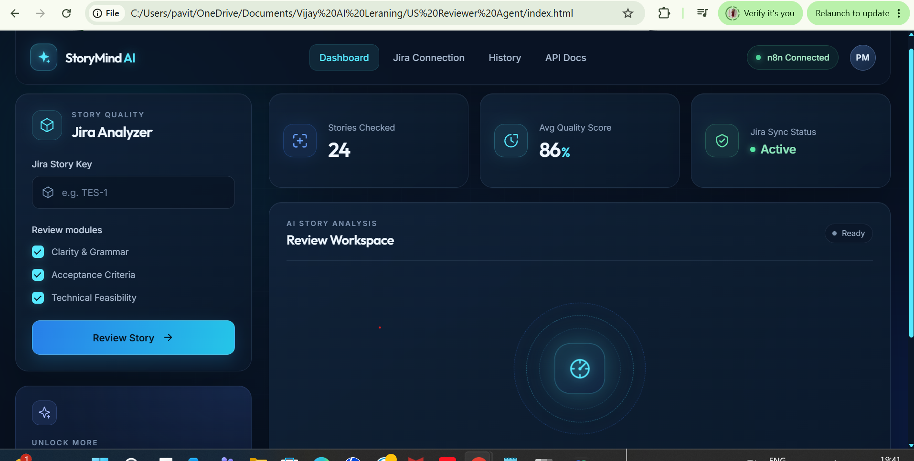

Phase 5 is completed. Proceed with phase 6
Phase 6 is completed
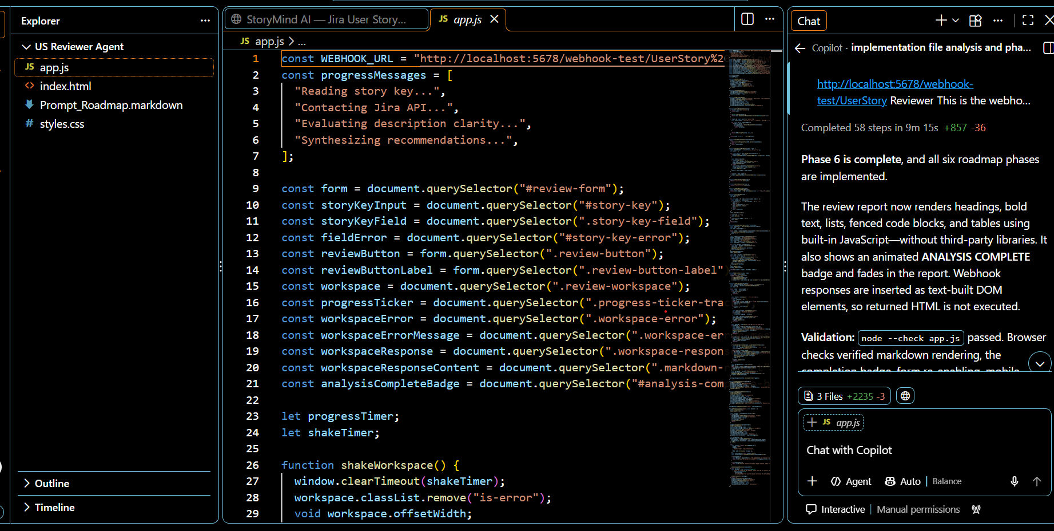

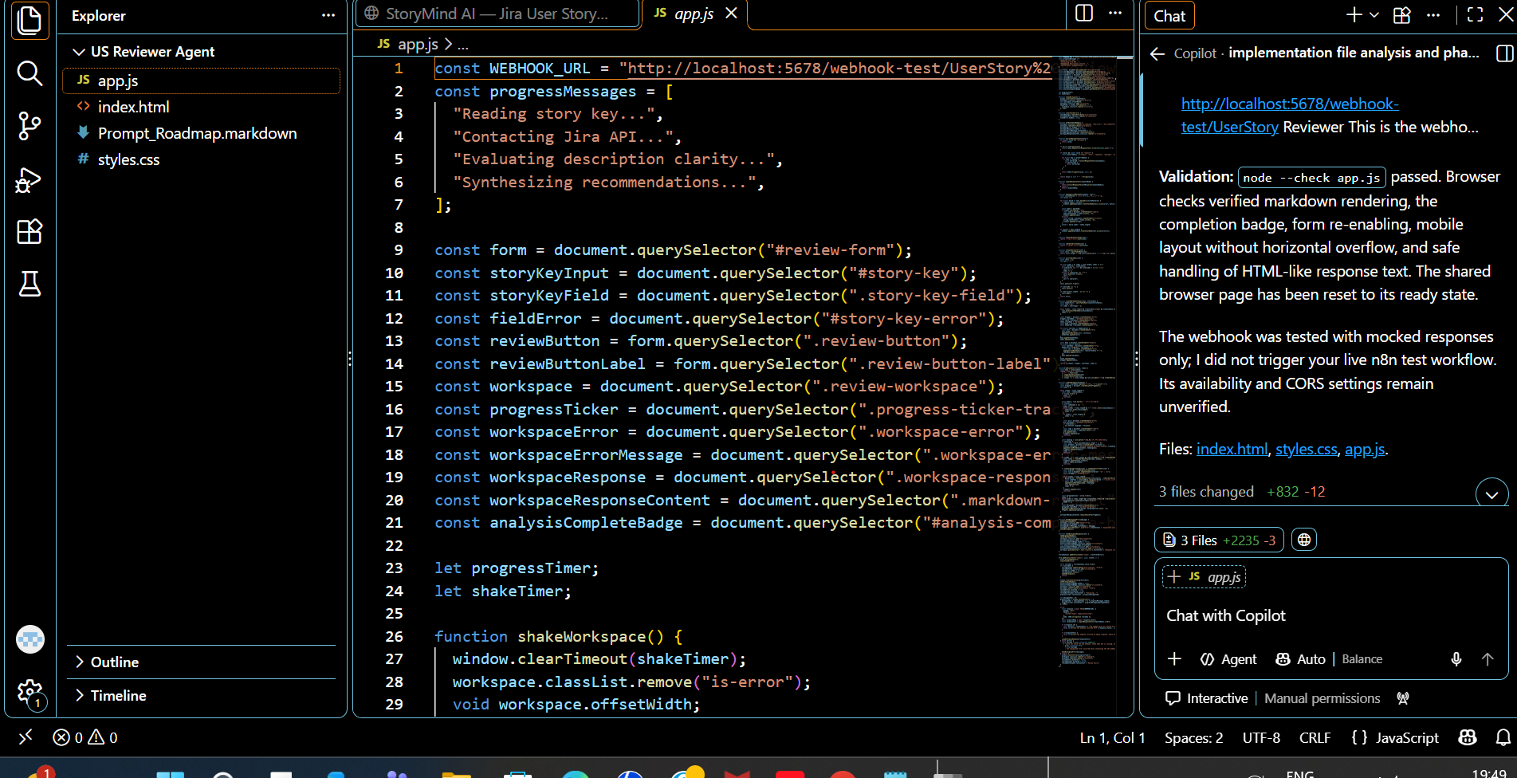

Ask:
I want to open the implemented front UI in local host instead of opening index.html file in browser

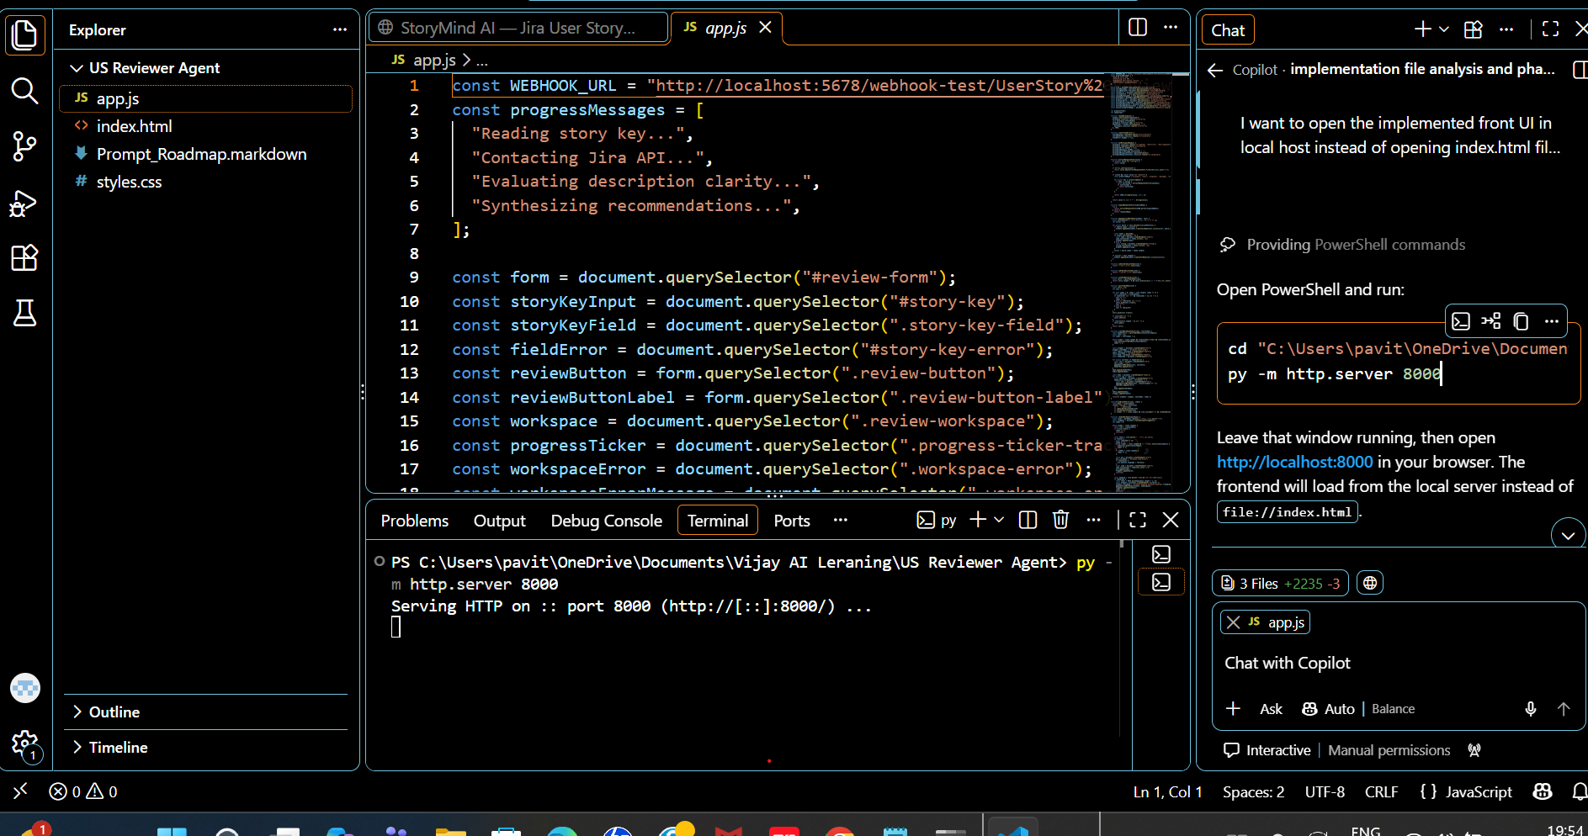
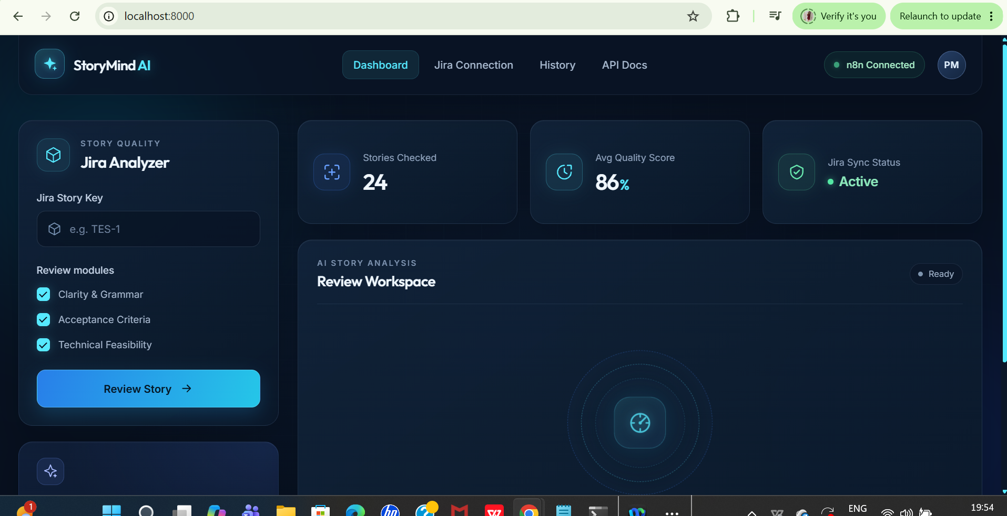

We faced errors multiple times on UI when we tried to review, we passed the error screenshot to copilot and did itirate until the error was resolved.
Copilot suggested us to replace test webhook url with production webhool url in webhook which was in server.py file
By using test url it asked to start the n8n workflow manually , but we wanted it not be manual, so as copilot suggested we asked AI to replace test url with production url in server.py file and it worked. However in the n8n workflow in webhook we still have test url .

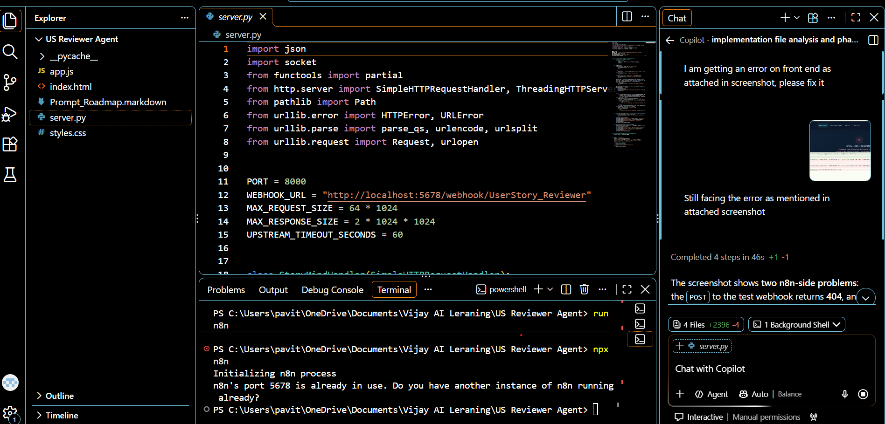

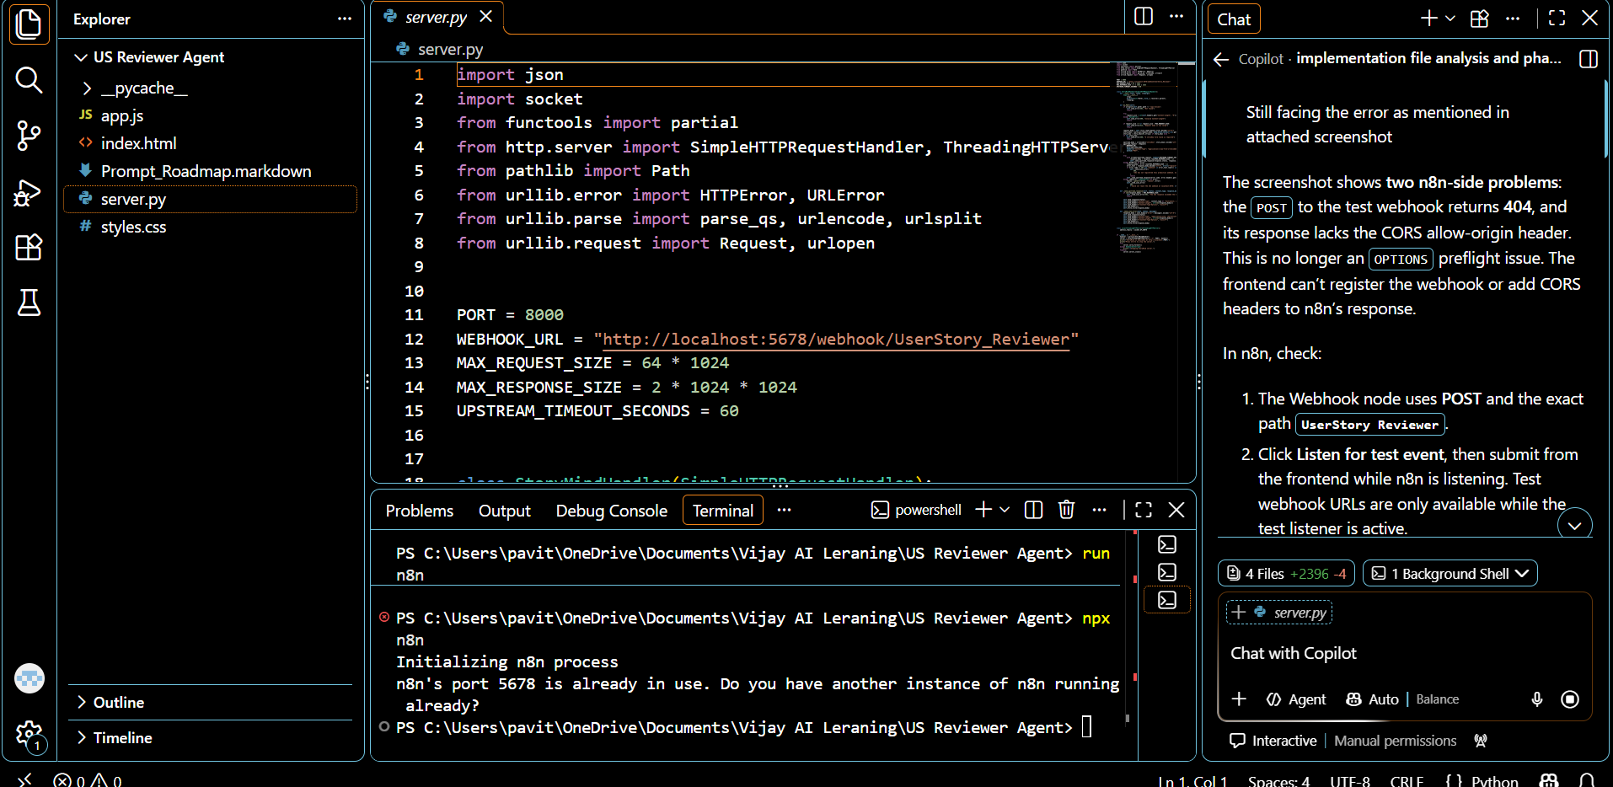

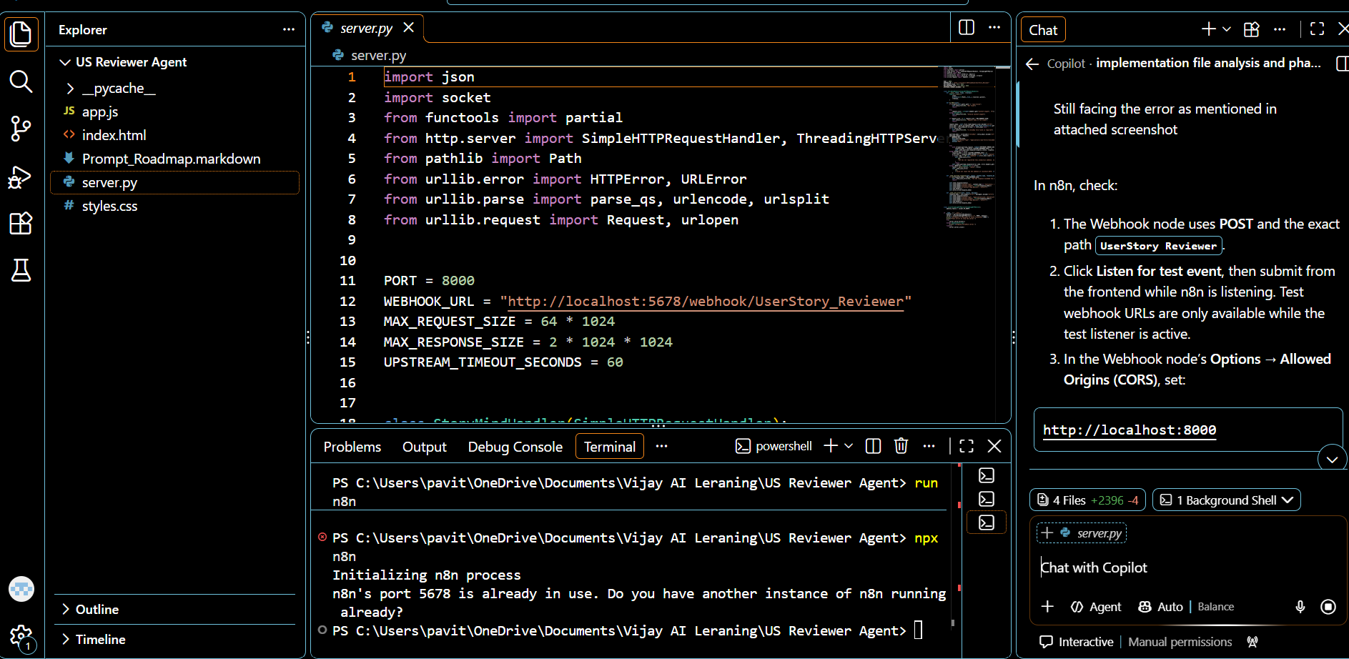

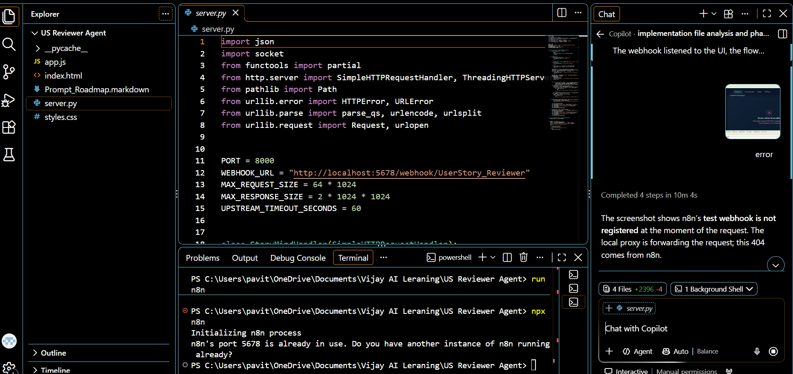

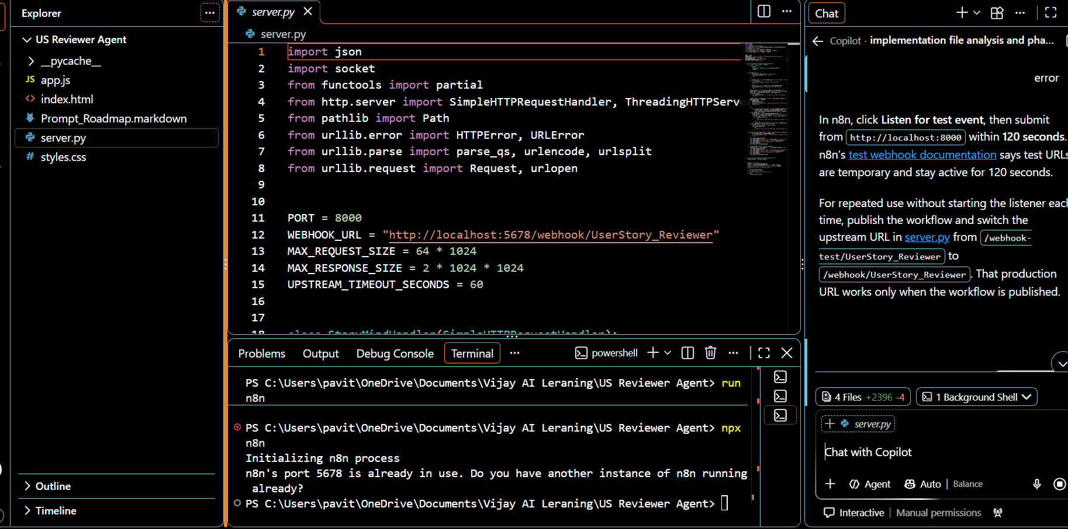
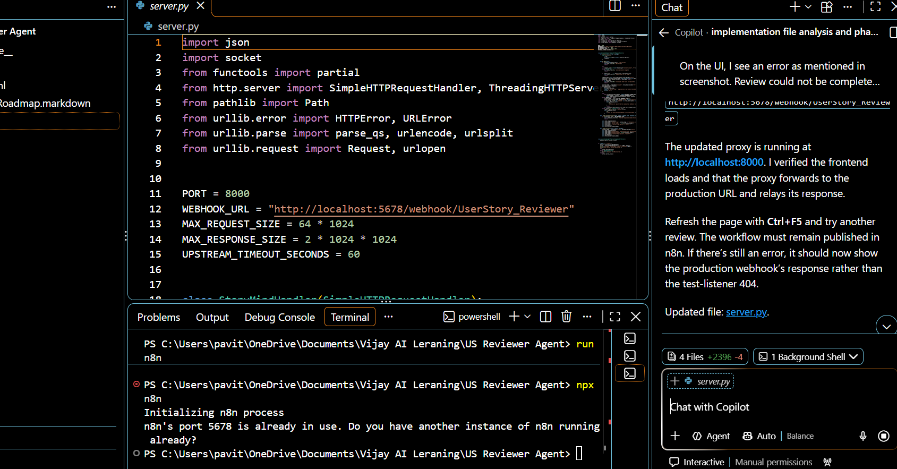
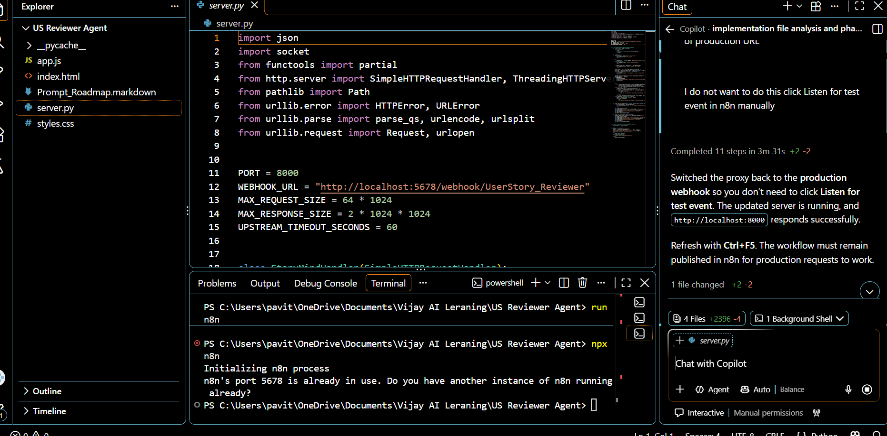
Then we asked to format the response output on UI



