GOVERNMENT COLLEGE OF ENGINEERING BARGUR

( AUTONOMOUS)

## PROJECT TITLE: Image Recognition with IBM Cloud Visual Recognition

TEAM MEMBERS:

ELAMATHY O G

PADMAPRIYA T

SATHYAPRIYA R

VIJAYALAKSHMI R

PROBLEM STATEMENT:

The project involves creating an image recognition system using IBM Cloud Visual Recognition. The goal is to develop a platform where users can upload images, and the system accurately classifies and describes the image contents. This will enable users to craft engaging visual stories with the help of AI-generated captions, enhancing their connection with the audience through captivating visuals and compelling narratives.

**TOOL USED:**

IBM Watson Visual Recognition

**WORKING:**

1. **IBM Watson Visual Recognition:** This service can be used for image recognition and description. It can recognize objects, scenes, and concepts within images and provide textual descriptions.
2. **IBM Watson Natural Language Understanding:** To analyze the sentiment and emotions conveyed by the images, you can use IBM Watson Natural Language Understanding. This service can process text data, so you would need to convert the image descriptions or labels generated by Watson Visual Recognition into text. Natural Language Understanding can then analyze the text for sentiment and emotion. It can detect emotions such as joy, sadness, anger, etc., and provide sentiment scores like positive, negative, or neutral.

Here's how you might use these services together:

1. **Image Processing:** Upload the image to IBM Watson Visual Recognition for image recognition and description. This will provide you with text-based descriptions of what is in the image.
2. **Text Analysis:** Take the descriptions or labels generated by Watson Visual Recognition and pass them to IBM Watson Natural Language Understanding for sentiment and emotion analysis. This service will analyze the text to determine the emotional tone and sentiment expressed in the image descriptions.

By combining these two IBM Watson services, you can gain insights into both the visual content of the images and the emotional context they convey. This can be useful in various applications, such as social media sentiment analysis, brand monitoring, and content analysis, where understanding the emotions and sentiments associated with visual content is essential.

**EXAMPLE:**

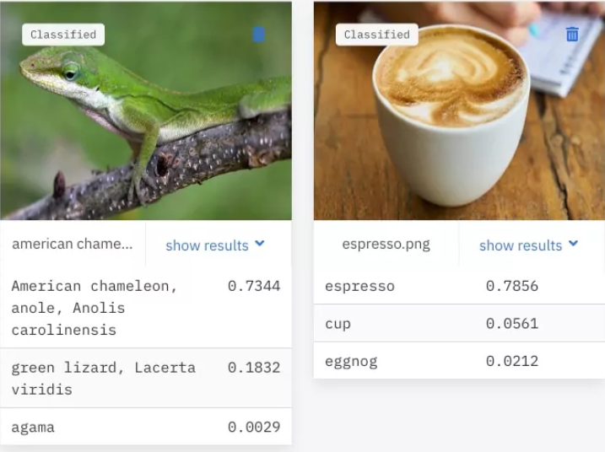

CONCLUSION:

IBM Watson Visual Recognition stands as a versatile and sophisticated tool that empowers businesses and developers to harness the capabilities of artificial intelligence for image recognition, description, and sentiment analysis.