GOVERNMENT COLLEGE OF ENGINEERING BARGUR

( AUTONOMOUS)

## PROJECT TITLE: Image Recognition with IBM Cloud Visual Recognition

TEAM MEMBERS:

ELAMATHY O G

PADMAPRIYA T

SATHYAPRIYA R

VIJAYALAKSHMI R

PROBLEM STATEMENT:

The project involves creating an image recognition system using IBM Cloud Visual Recognition. The goal is to develop a platform where users can upload images, and the system accurately classifies and describes the image contents. This will enable users to craft engaging visual stories with the help of AI-generated captions, enhancing their connection with the audience through captivating visuals and compelling narratives.

**TOOL USED:**

IBM Watson Visual Recognition

**WORKING:**

1. **IBM Watson Visual Recognition:** This service can be used for image recognition and description. It can recognize objects, scenes, and concepts within images and provide textual descriptions.
2. **IBM Watson Natural Language Understanding:** To analyze the sentiment and emotions conveyed by the images, you can use IBM Watson Natural Language Understanding. This service can process text data, so you would need to convert the image descriptions or labels generated by Watson Visual Recognition into text. Natural Language Understanding can then analyze the text for sentiment and emotion. It can detect emotions such as joy, sadness, anger, etc., and provide sentiment scores like positive, negative, or neutral.

Here's how you might use these services together:

1. **Image Processing:** Upload the image to IBM Watson Visual Recognition for image recognition and description. This will provide you with text-based descriptions of what is in the image.
2. **Text Analysis:** Take the descriptions or labels generated by Watson Visual Recognition and pass them to IBM Watson Natural Language Understanding for sentiment and emotion analysis. This service will analyze the text to determine the emotional tone and sentiment expressed in the image descriptions.

By combining these two IBM Watson services, you can gain insights into both the visual content of the images and the emotional context they convey. This can be useful in various applications, such as social media sentiment analysis, brand monitoring, and content analysis, where understanding the emotions and sentiments associated with visual content is essential.

**EXAMPLE:**

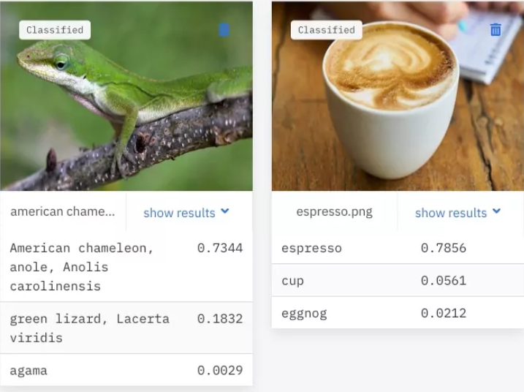

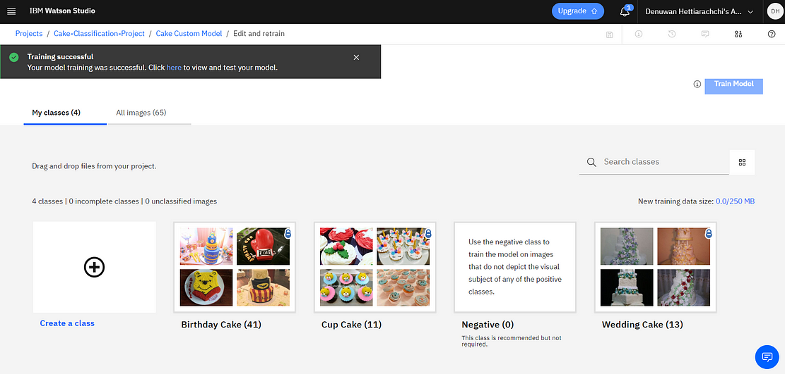

**TO LOAD AND PREPROCESSING THE DATASET:**

1. **Create an IBM Cloud Account:**

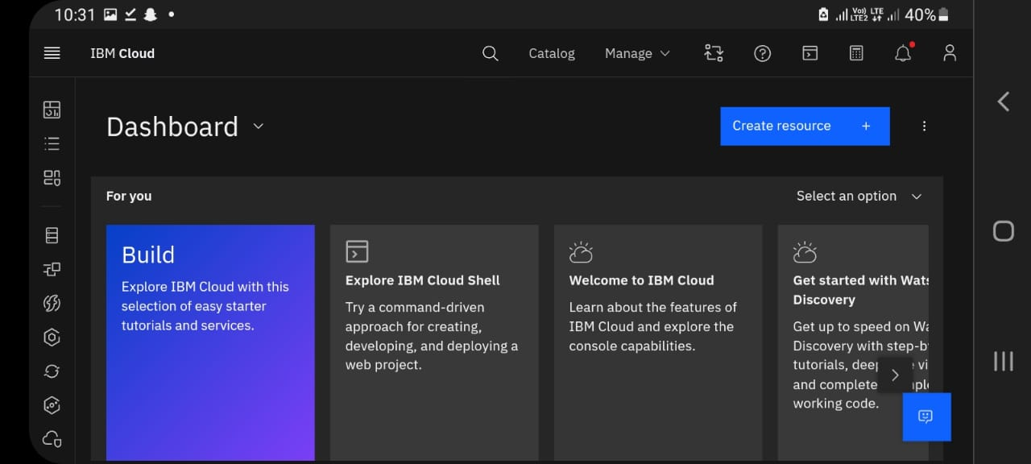

**2. Set Up the Visual Recognition Service:**

* Log in to your IBM Cloud account.
* Go to the IBM Cloud Catalog.
* Search for "Visual Recognition" and create an instance of the service.

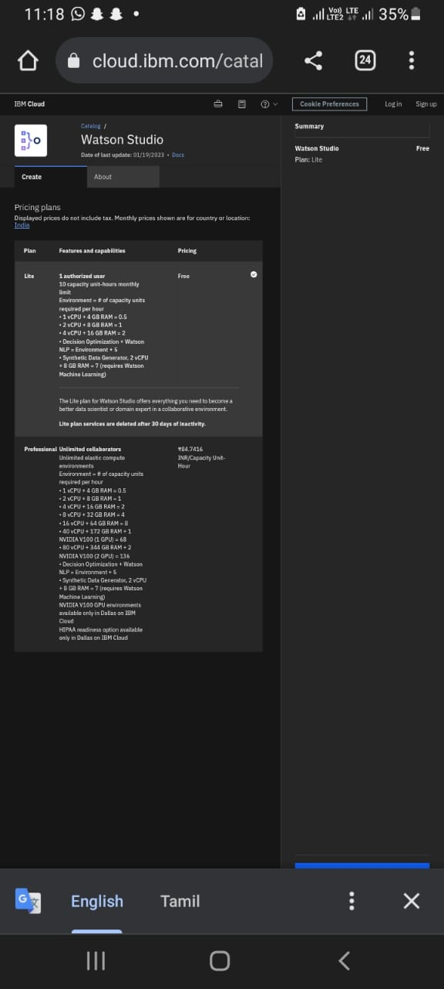

**3. Obtain API Keys:**

To obtain API keys for the Visual Recognition service, follow the steps mentioned earlier in this conversation (see the "how to obtain an API key using IBM cloud account" section).

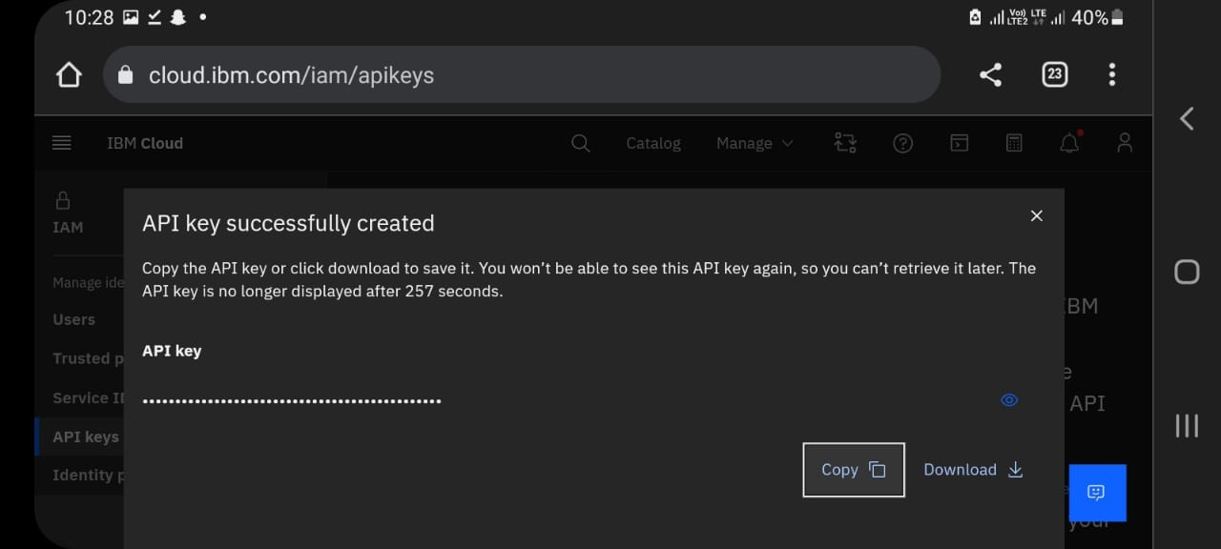Top of Form



**4.** **DESIGN A SIMPLE WEB INTERFACE:**

You can create a basic web interface for users to upload images and view AI-generated captions. Here's a simple example using HTML, JavaScript, and the Visual Recognition service:

<!DOCTYPE html>

<html>

<head>

<title>Image Recognition with IBM Visual Recognition</title>

</head>

<body>

<h1>Image Recognition with IBM Visual Recognition</h1>

<input type="file" id="imageInput" accept="image/*">

<button onclick="uploadImage()">Upload Image</button>

<div id="result">

<h2>AI-Generated Caption:</h2>

<p id="caption"></p>

<img id="uploadedImage" style="max-width: 400px;" />

</div>

<script>

function uploadImage() {

var imageInput = document.getElementById('imageInput');

var resultDiv = document.getElementById('result');

var captionDiv = document.getElementById('caption');

var uploadedImage = document.getElementById('uploadedImage');

var file = imageInput.files[0];

if (file) {

var formData = new FormData();

formData.append('image', file);

// Send the image to IBM Visual Recognition for classification

// Use the API keys and endpoints you obtained earlier

var apiKey = 'YOUR_API_KEY';

var apiUrl = 'YOUR_API_URL';

fetch(apiUrl, {

method: 'POST',

headers: {

'Accept': 'application/json',

'Authorization': 'Basic ' + btoa('apikey:' + apiKey),

},

body: formData

})

.then(response => response.json())

.then(data => {

// Display the AI-generated caption

captionDiv.innerText = data.description.captions[0].text;

// Display the uploaded image

uploadedImage.src = URL.createObjectURL(file);

})

.catch(error => console.error('Error:', error));

} else {

resultDiv.innerHTML = '<p>Please select an image to upload.</p>';

}

}

</script>

</body>

</html>

CONCLUSION:

IBM Watson Visual Recognition stands as a versatile and sophisticated tool that empowers businesses and developers to harness the capabilities of artificial intelligence for image recognition, description, and sentiment analysis.