**House price prediction**

**Phase 4:**

**Project objective :**

To develop a machine learning model that accurately predicts the sale price of residential properties based on relevant features and historical data, enabling informed real estate decisions for buyers, sellers, and investors.

**Project overview:**

The House Price Prediction project aims to develop a machine learning model that can accurately estimate the sale price of residential properties. This project is essential for both prospective buyers and sellers as well as real estate investors, as it enables data-driven decision-making in the real estate market.

A project overview for a House Price Prediction project would provide a high-level summary of the project's goals, scope, and methodology.

**Project Goals:**

1. Create an accurate and reliable house price prediction model.

2. Assist homebuyers and sellers in making informed decisions.

3. Provide real estate investors with valuable insights for property investment.

**Key component:**

- Data Collection: Gathering historical property data, including features such as square footage, location, number of bedrooms and bathrooms, and other relevant attributes.

- Data Preprocessing: Cleaning, transforming, and standardizing the data for model input.

- Feature Selection: Identifying the most influential features for price prediction.

- Model Development: Building and fine-tuning a machine learning model for accurate price predictions.

- Model Evaluation: Assessing the model's performance through various metrics, such as mean squared error and R-squared.

- Deployment: Creating a user-friendly interface or application for end-users to input property details and receive price predictions.

Expected Outcomes:

- An accurate house price prediction model with the potential to benefit homebuyers, sellers, and investors.

- Improved decision-making in the real estate market by providing data-driven insights.

- A user-friendly application for obtaining property price estimates.

**Template:**

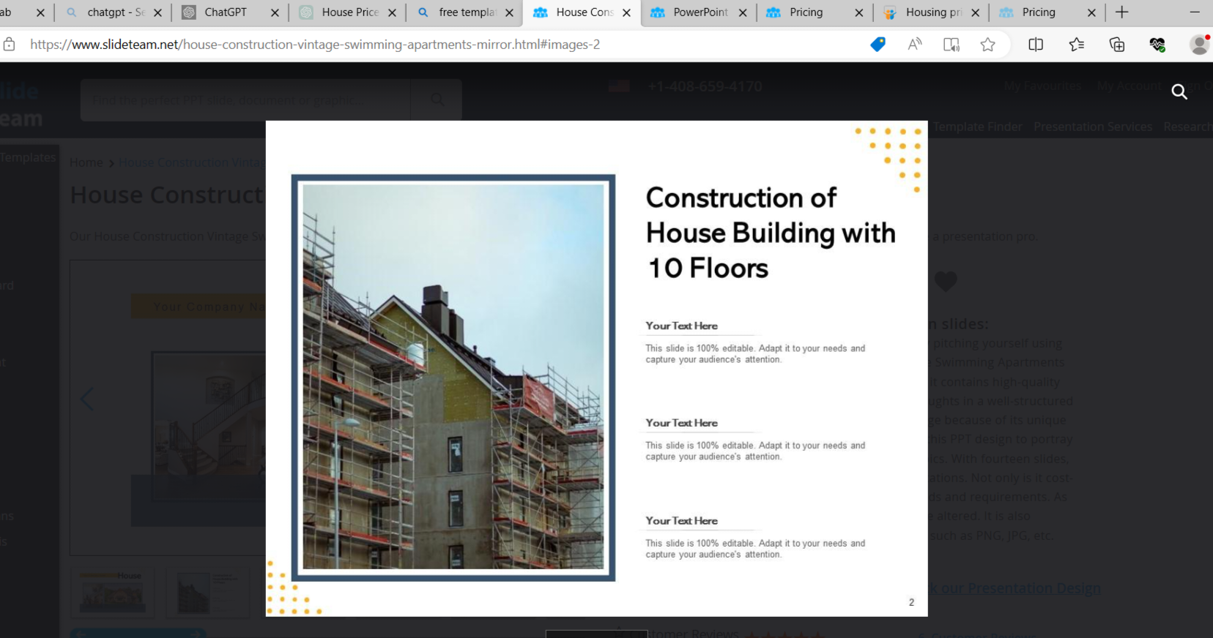

**Conclusion:**

The conclusion of a House Price Prediction project should summarize the key findings, outcomes, and implications of your work. Here's an example of a conclusion for a House Price Prediction project:

Conclusion

In conclusion, the House Price Prediction project has successfully addressed the objective of developing a machine learning model for accurate residential property price estimation. This endeavor has significant implications for homebuyers, sellers, and real estate investors, providing valuable insights and data-driven decision-making tools in the real estate market.